Lampiran 1. Screen Shots Program SPSS


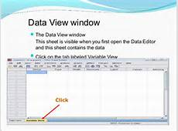

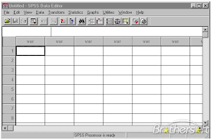

34

Lampiran 2. Lembar Laporan Data LB1
Kode dx | ICD –X | Penyakit | 0-7 hari | 0-28  hari | >29-1  thn | 1-4  thn | 5-9 thn | 10-14  thn | 15-19  thn

35
Lampiran 3. Statistik analisis data 1
Output Created |  | 26-Jul-2016 19:51:44
Comments
Input | Active Dataset | DataSet1
Input | Filter | <none>
Input | Weight | <none>
Input | Split File | <none>
Input | N of Rows in Working Data File | 5
Missing Value Handling | Definition of Missing | User defined missing values are treated as missing.
Missing Value Handling | Cases Used | Statistics for each analysis are based on the cases with no missing or out-of-range data for any variable in the analysis.
Syntax |  | T-TEST PAIRS=Sebelum WITH Sesudah (PAIRED)  /CRITERIA=CI(.9500)  /MISSING=ANALYSIS.
Resources | Processor Time | 00:00:00.000
Resources | Elapsed Time | 00:00:00.000

36
Lampiran 4. Statistik analisis data 2

Paired Samples Statistics
 |  | Mean | N | Std. Deviation | Std. Error Mean
Pair 1 | Sebelum | 10.7540 | 5 | 1.23696 | .55319
Pair 1 | Sesudah | 4.7760 | 5 | .40605 | .18159
Paired Samples Correlations
 |  | N | Correlation | Sig.
Pair 1 | Sebelum & Sesudah | 5 | .885 | .046

37

Lampiran 5. Hasil SPSS
Paired Samples Test
 |  | Paired Differences |  |  |  |  | t | Df | Sig. (2-tailed)
 |  | Mean | Std. Deviation | Std. Error Mean | 95% Confidence Interval of the Difference |  | t | Df | Sig. (2-tailed)
 |  | Mean | Std. Deviation | Std. Error Mean | Lower | Upper | t | Df | Sig. (2-tailed)
Pair 1 | Sebelum – Sesudah | 5.97800 | .89776 | .40149 | 4.86329 | 7.09271 | 14.890 | 4 | .000

38
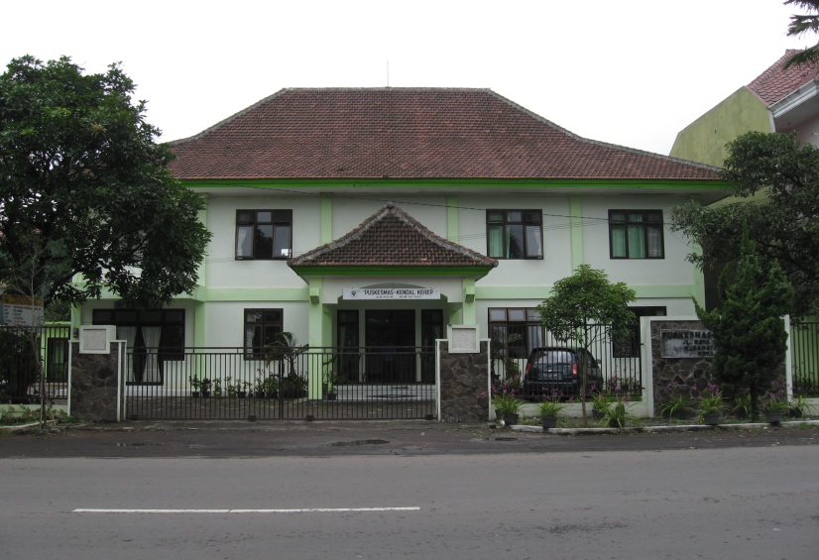
PUSKESMAS KENDAL KEREP – KEC. BLIMBING

