**JADWAL KEGIATAN PENYUSUNAN SKRIPSI**

**Lampiran 1 : Jadwal Kegiatan Penyusunan Skripsi**

|  |  |  |  |  |  |  |  |  |  |  |  |  |  |  |  |  |  |  |  |  |  |  |  |  |  |  |  |  |  |  |  |  |  |  |  |  |  |  |  |  |  |  |  |  |  |  |  |  |  |  |  |  |  |  |  |  |
| --- | --- | --- | --- | --- | --- | --- | --- | --- | --- | --- | --- | --- | --- | --- | --- | --- | --- | --- | --- | --- | --- | --- | --- | --- | --- | --- | --- | --- | --- | --- | --- | --- | --- | --- | --- | --- | --- | --- | --- | --- | --- | --- | --- | --- | --- | --- | --- | --- | --- | --- | --- | --- | --- | --- | --- | --- |
| No | Kegiatan | Agustus 2017 | | | | Sepetember 2017 | | | | Oktober 2017 | | | | November 2017 | | | | Desember 2017 | | | | Januari 2018 | | | | | Februari  2018 | | | | | Maret 2018 | | | | | April 2018 | | | | | Mei 2018 | | | | | Juni 2018 | | | | | Juli 2018 | | | | |
| 1 | 2 | 3 | 4 | 1 | 2 | 3 | 4 | 1 | 2 | 3 | 4 | 1 | 2 | 3 | 4 | 1 | 2 | 3 | 4 | | 1 | 2 | 3 | 4 | | 1 | 2 | 3 | 4 | | 1 | 2 | 3 | 4 | | 1 | 2 | 3 | 4 | | 1 | 2 | 3 | 4 | | 1 | 2 | 3 | 4 | | 1 | 2 | 3 | 4 | |
| 1 | Pengajuan Judul |  |  |  |  |  |  |  |  |  |  |  |  |  |  |  |  |  |  |  |  | |  |  |  |  | |  |  |  |  | |  |  |  |  | |  |  |  |  | |  |  |  |  | |  |  |  |  | |  |  |  |  | |
| 2 | Konsultasi Proposal |  |  |  |  |  |  |  |  |  |  |  |  |  |  |  |  |  |  |  |  | |  |  |  |  | |  |  |  |  | |  |  |  |  | |  |  |  |  | |  |  |  |  | |  |  |  |  | |  |  |  |  | |
| 3 | Seminar proposal |  |  |  |  |  |  |  |  |  |  |  |  |  |  |  |  |  |  |  |  | |  |  |  |  | |  |  |  |  | |  |  |  |  | |  |  |  |  | |  |  |  |  | |  |  |  |  | |  |  |  |  | |
| 4 | Revisi proposal |  |  |  |  |  |  |  |  |  |  |  |  |  |  |  |  |  |  |  |  | |  |  |  |  | |  |  |  |  | |  |  |  |  | |  |  |  |  | |  |  |  |  | |  |  |  |  | |  |  |  |  | |
| 5 | *Ethical Clearance* |  |  |  |  |  |  |  |  |  |  |  |  |  |  |  |  |  |  |  |  | |  |  |  |  | |  |  |  |  | |  |  |  |  | |  |  |  |  | |  |  |  |  | |  |  |  |  | |  |  |  |  | |
| 6 | Pengambilan data penelitian |  |  |  |  |  |  |  |  |  |  |  |  |  |  |  |  |  |  |  |  | |  |  |  |  | |  |  |  |  | |  |  |  |  | |  |  |  |  | |  |  |  |  | |  |  |  |  | |  |  |  |  | |
| 7 | Pengolahan hasil |  |  |  |  |  |  |  |  |  |  |  |  |  |  |  |  |  |  |  |  | |  |  |  |  | |  |  |  |  | |  |  |  |  | |  |  |  |  | |  |  |  |  | |  |  |  |  | |  |  |  |  | |
| 8 | Konsultasi Skripsi |  |  |  |  |  |  |  |  |  |  |  |  |  |  |  |  |  |  |  |  | |  |  |  |  | |  |  |  |  | |  |  |  |  | |  |  |  |  | |  |  |  |  | |  |  |  |  | |  |  |  |  | |
| 9 | Seminar Hasil |  |  |  |  |  |  |  |  |  |  |  |  |  |  |  |  |  |  |  |  | |  |  |  |  | |  |  |  |  | |  |  |  |  | |  |  |  |  | |  |  |  |  | |  |  |  |  | |  |  |  |  | |
| 10 | Revisi |  |  |  |  |  |  |  |  |  |  |  |  |  |  |  |  |  |  |  |  | |  |  |  |  | |  |  |  |  | |  |  |  |  | |  |  |  |  | |  |  |  |  | |  |  |  |  | |  |  |  |  | |
| 11 | Pengumpulan Skripsi |  |  |  |  |  |  |  |  |  |  |  |  |  |  |  |  |  |  |  |  | |  |  |  |  | |  |  |  |  | |  |  |  |  | |  |  |  |  | |  |  |  |  | |  |  |  |  | |  |  |  |  | |

Keterangan :

: Pelaksanaan Kegiatan

**Lampiran 2 : Surat Perijinan**

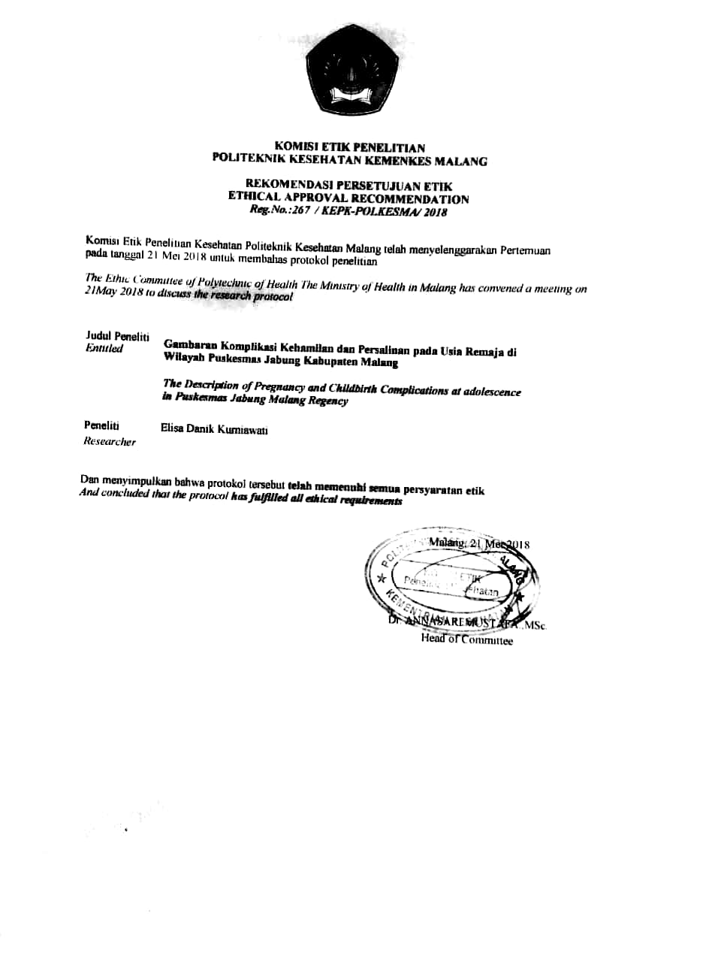

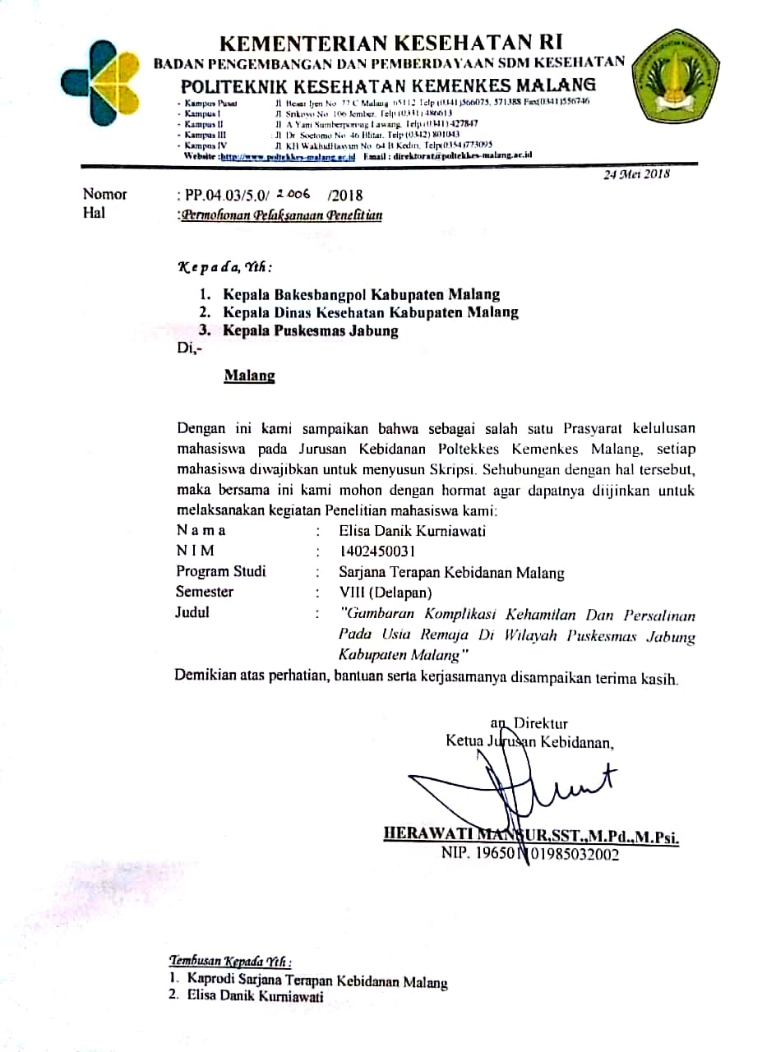

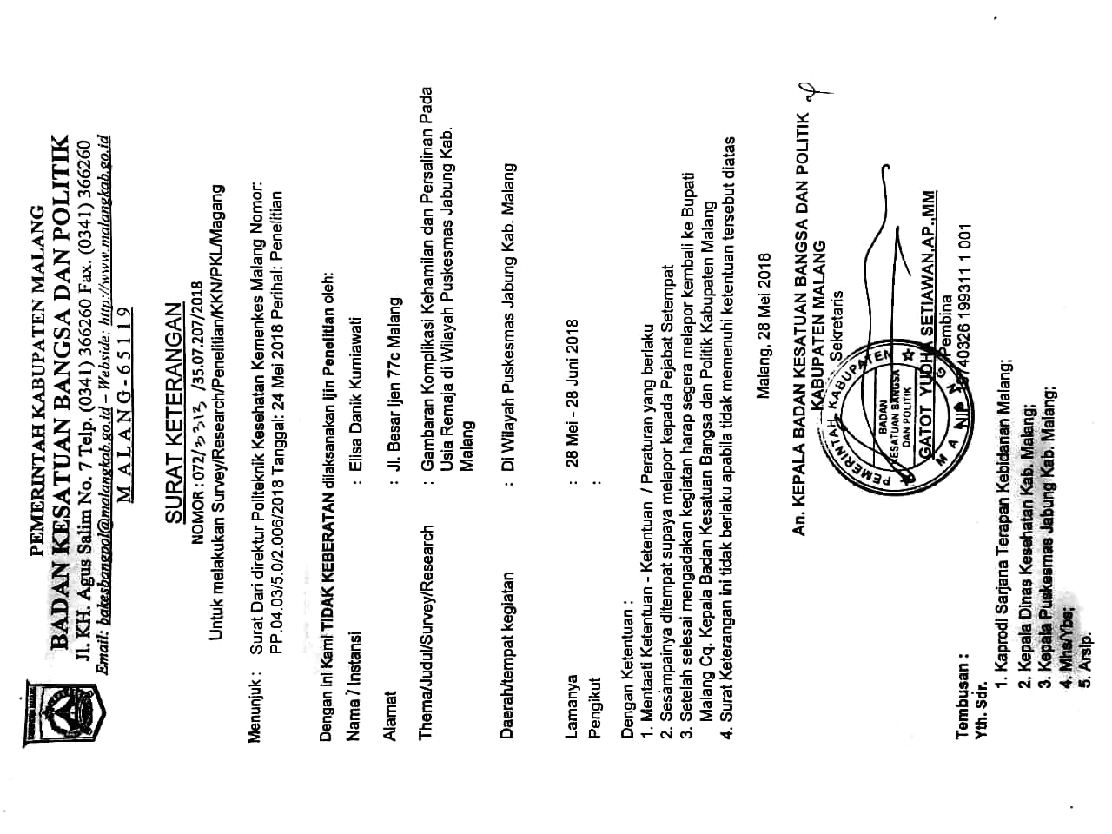

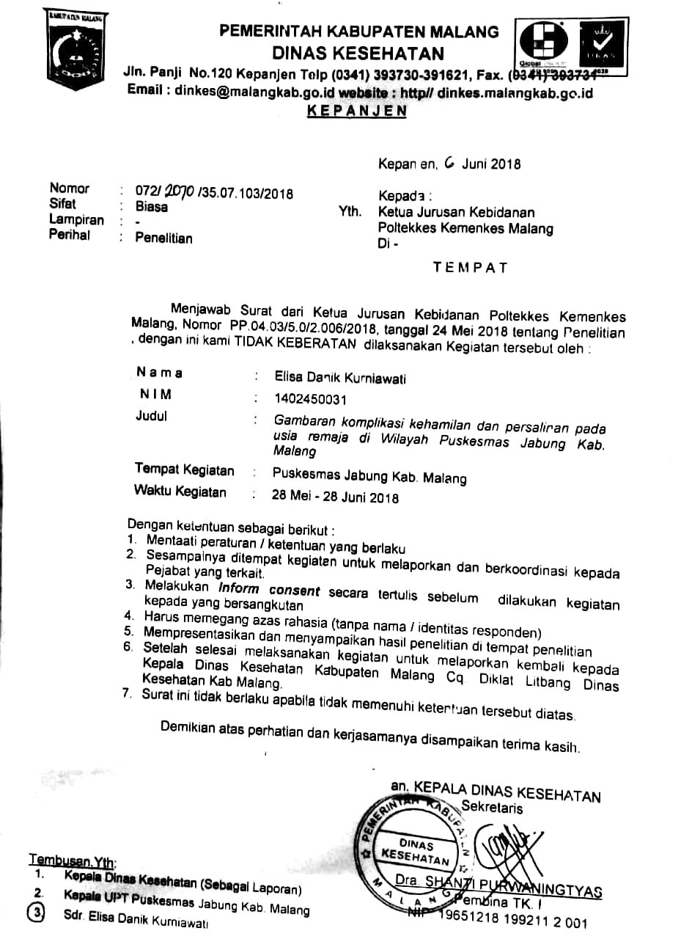

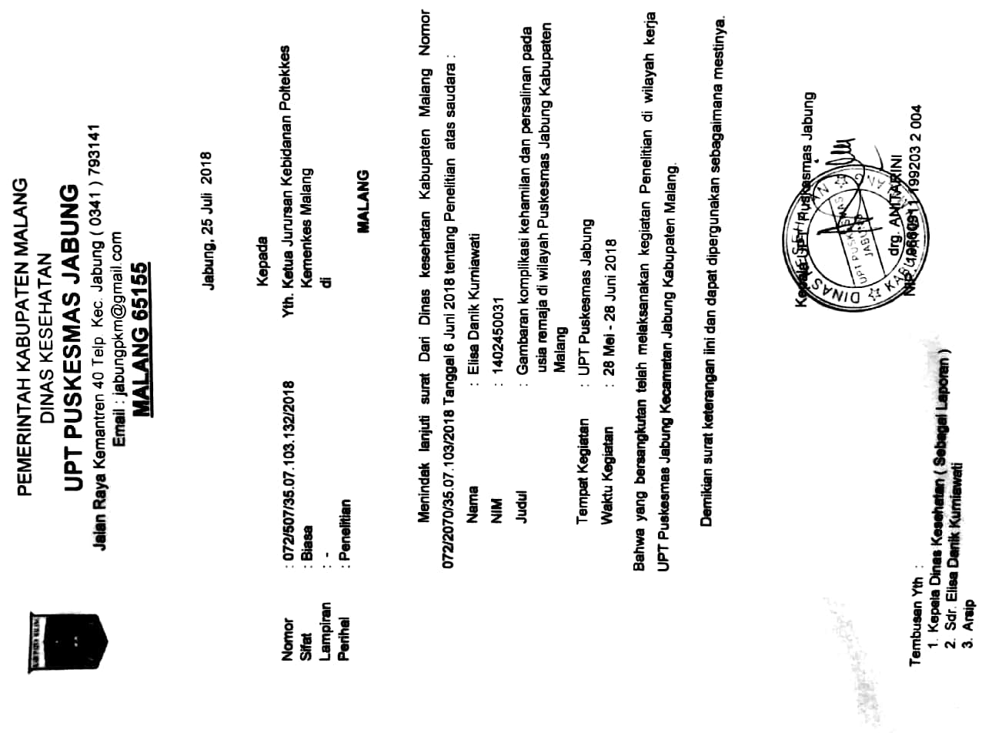

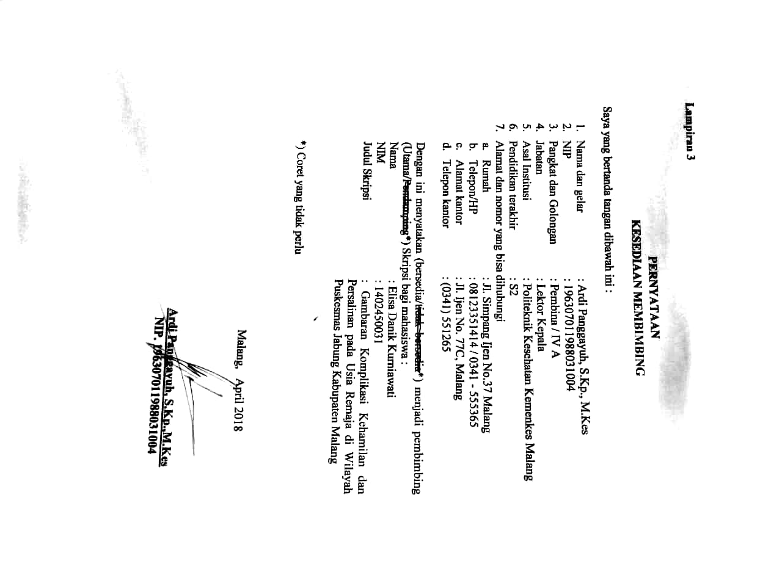

**Lampiran 3 : Pernyataan Kesediaan Membimbing**

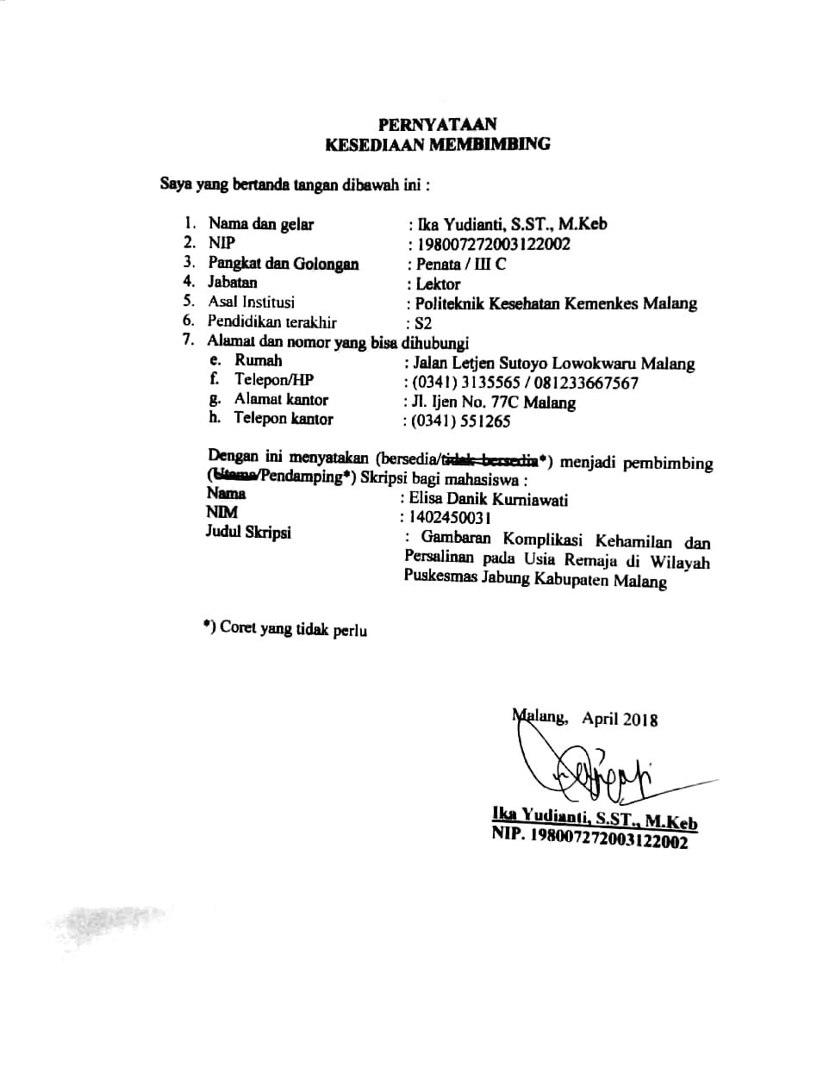

**Lampiran 4 : Instrumen Pengumpulan Data**

**DATA UMUM RESPONDEN**

**Kode Responden :**

1. Usia :
2. Pendidikan :

* SD
* SMP
* SMA

1. Pekerjaan :

* Bekerja
* Tidak bekerja

1. Frekuensi ANC

* < 4x kunjungan
* 4x kunjungan atau lebih

**DATA KHUSUS**

Lokasi/Nama Desa :

|  |  |  |  |  |
| --- | --- | --- | --- | --- |
| **No.** | **Komplikasi Kehamilan** | **Ya** | **Tidak** | **Keterangan** |
| 1 | Hiperemesis gravidarum |  |  |  |
| 2 | Anemia pada kehamilan |  |  |  |
| Ringan : Hb 9 – 10 gr% |  |  |
| Sedang : Hb 7 – 9 gr% |  |  |
| Berat : Hb 5 – 7 gr% |  |  |
| 3 | Abortus : |  |  |  |
| Spontan |  |  |
| Buatan/provokatus |  |  |
| 4 | Perdarahan antepartum : |  |  |  |
| Plasenta previa |  |  |
| Solusio plasenta |  |  |
| 5 | Pre-eklamsia/eklamsia |  |  |  |

|  |  |  |  |  |
| --- | --- | --- | --- | --- |
| **No.** | **Komplikasi Persalinan** | **Ya** | **Tidak** | **Keterangan** |
| 1 | Ketuban pecah dini |  |  |  |
| 2 | Kelahiran preterm |  |  |  |
| 3 | Partus Lama |  |  |  |
| 4 | Perdarahan Postpartum : |  |  |  |
| a. Perdarahan postpartum primer : |  |  |
| * Atonia uteri |  |  |
| * Retensio plasenta |  |  |
| * Robekan jalan lahir |  |  |
| b. Perdarahan postpartum sekunder |  |  |

**Tabulasi Data Penelitian**

**Lampiran 5 : Tabulasi Data Penelitian**

|  |  |  |  |  |  |  |
| --- | --- | --- | --- | --- | --- | --- |
| **No. Res** | **Data Umum** | | | | **Komplikasi Kehamilan** | **Komplikasi Persalinan** |
| **Umur** | **Pendidikan** | **Pekerjaan** | **Frekuensi ANC** |
| 1 | 18 | 1 | 2 | 2 | 2 | 0 |
| 2 | 18 | 2 | 2 | 2 | 2 | 0 |
| 3 | 17 | 2 | 2 | 2 | 0 | 0 |
| 4 | 19 | 1 | 2 | 2 | 0 | 1 |
| 5 | 17 | 1 | 2 | 1 | 1 | 3 |
| 6 | 17 | 1 | 2 | 2 | 0 | 3 |
| 7 | 17 | 1 | 2 | 2 | 1 | 0 |
| 8 | 17 | 2 | 2 | 1 | 0 | 0 |
| 9 | 18 | 3 | 2 | 2 | 0 | 0 |
| 10 | 18 | 1 | 2 | 2 | 1 | 0 |
| 11 | 19 | 1 | 2 | 1 | 2 | 0 |
| 12 | 17 | 2 | 2 | 1 | 0 | 1 |
| 13 | 16 | 1 | 2 | 1 | 1 | 1 |
| 14 | 19 | 2 | 2 | 2 | 1 | 0 |
| 15 | 19 | 2 | 2 | 2 | 1,3 | 3 |
| 16 | 18 | 1 | 2 | 2 | 1,2 | 2 |
| 17 | 19 | 2 | 2 | 2 | 1,2 | 1 |
| 18 | 19 | 2 | 2 | 1 | 1 | 0 |
| 19 | 18 | 2 | 2 | 2 | 0 | 4 |
| 20 | 19 | 2 | 2 | 2 | 1 | 2 |
| 21 | 19 | 2 | 2 | 2 | 1,2 | 0 |
| 22 | 18 | 2 | 2 | 2 | 1,2 | 0 |
| 23 | 17 | 2 | 2 | 2 | 1,2 | 0 |
| 24 | 15 | 1 | 2 | 2 | 2,5 | 0 |
| 25 | 17 | 2 | 2 | 2 | 1,2 | 0 |
| 26 | 18 | 2 | 2 | 2 | 1,2 | 1 |
| 27 | 16 | 2 | 2 | 1 | 1 | 1,2 |
| 28 | 18 | 1 | 2 | 2 | 1 | 2 |
| 29 | 17 | 1 | 2 | 1 | 0 | 3 |
| 30 | 17 | 1 | 2 | 1 | 2 | 4 |
| 31 | 17 | 1 | 2 | 2 | 1 | 1 |
| 32 | 16 | 1 | 2 | 2 | 0 | 1,2 |
| 33 | 17 | 1 | 2 | 2 | 0 | 0 |
| 34 | 19 | 2 | 2 | 2 | 0 | 1 |
| 35 | 17 | 1 | 2 | 1 | 1,3 | 0 |
| 36 | 18 | 2 | 2 | 1 | 1 | 3 |
| 37 | 19 | 2 | 2 | 2 | 1 | 0 |
| 38 | 17 | 2 | 2 | 2 | 1,2 | 1 |
| 39 | 18 | 2 | 2 | 1 | 1 | 2 |
| 40 | 19 | 2 | 2 | 2 | 1 | 1 |
| 41 | 19 | 2 | 2 | 2 | 1,2 | 4 |
| 42 | 19 | 2 | 2 | 2 | 2 | 0 |
| 43 | 19 | 2 | 2 | 2 | 1,2 | 0 |
| 44 | 19 | 2 | 2 | 1 | 1 | 2 |
| 45 | 19 | 2 | 2 | 1 | 5 | 1 |

**Keterangan :**

Pendidikan : 1 : SD Pekerjaan : 1 : Bekerja

2 : SMP 2 : Tidak bekerja

3 : SMA

Frekuensi ANC : 1 : < 4x kunjungan

2 : 4x kunjungan atau lebih

Komplikasi kehamilan : 0 : tidak mengalami komplikasi

1 : hiperemesis gravidarum

2 : anemia pada kehamilan

3 : abortus

4 : perdarahan antepartum

5 : pre-eklamsia/eklamsia

Komplikasi persalinan : 0 : tidak mengalami komplikasi persalinan

1 : ketuban pecah dini

2 : kelahiran preterm

3 : partus lama

4 : perdarahan postpartum

**Lampiran 6 : Tabel Distribusi Frekuensi Data Umum**

**Tabel 1. Distribusi Frekuensi Usia Remaja yang telah Bersalin di Wilayah Puskesmas Jabung pada Bulan Januari s.d Mei 2018**

|  |  |  |
| --- | --- | --- |
| **Usia** | **Frekuensi**  **(*f)*** | **Persentase**  **(%)** |
| 10 – 12 tahun | 0 | 0 |
| 13 – 16 tahun | 4 | 8,9 |
| 17 – 20 tahun | 41 | 91,1 |
| **JUMLAH** | **45** | **100** |

**Tabel 2. Distribusi Frekuensi Tingkat Pendidikan Remaja yang telah Bersalin di Wilayah Puskesmas Jabung pada Bulan Januari s.d Mei 2018**

|  |  |  |
| --- | --- | --- |
| **Tingkat Pendidikan** | **Frekuensi**  **(*f)*** | **Persentase**  **(%)** |
| SD | 17 | 37,8 |
| SMP | 27 | 60 |
| SMA | 1 | 2,2 |
| **JUMLAH** | **45** | **100** |

**Tabel 3. Distribusi Frekuensi Pekerjaan Remaja yang telah Bersalin di Wilayah Puskesmas Jabung pada Bulan Januari s.d Mei 2018**

|  |  |  |
| --- | --- | --- |
| **Pekerjaan** | **Frekuensi**  **(*f)*** | **Persentase**  **(%)** |
| Bekerja | 0 | 0 |
| Tidak bekerja | 45 | 100 |
| **JUMLAH** | **45** | **100** |

**Tabel 4. Distribusi Frekuensi Kunjungan ANC Remaja yang telah Bersalin di Wilayah Puskesmas Jabung pada Bulan Januari s.d Mei 2018**

|  |  |  |
| --- | --- | --- |
| **Frekuensi ANC** | **Frekuensi**  **(*f)*** | **Persentase**  **(%)** |
| < 4x kunjungan | 14 | 31,1 |
| 4x kunjungan atau lebih | 31 | 68,9 |
| **JUMLAH** | **45** | **100** |

**Lampiran 7 : Tabel Distribusi Frekuensi Data Khusus**

**Tabel 5. Distribusi Frekuensi Kejadian Komplikasi Kehamilan pada Remaja yang telah Hamil di Wilayah Puskesmas Jabung pada Bulan Januari s.d Mei 2018**

|  |  |  |
| --- | --- | --- |
| **Kejadian Komplikasi Kehamilan** | **Frekuensi**  **(*f)*** | **Persentase**  **(%)** |
| Mengalami komplikasi | 34 | 75,6 |
| Tidak mengalami komplikasi | 11 | 24,4 |
| **JUMLAH** | **45** | **100** |

**Tabel 6. Distribusi Frekuensi Insidens Komplikasi Kehamilan yang dialami Remaja yang telah Hamil di Wilayah Puskesmas Jabung pada Bulan Januari s.d Mei 2018**

|  |  |  |
| --- | --- | --- |
| **Insidens Komplikasi Kehamilan** | **Frekuensi**  **(*f)*** | **Persentase**  **(%)** |
| Hiperemesis Gravidarum | 27 | 57,4 |
| Anemia | 16 | 34 |
| Abortus | 2 | 4,3 |
| Perdarahan Antepartum | 0 | 0 |
| Pre-eklamsia/eklamsia | 2 | 4,3 |
| **JUMLAH** | **47** | **100** |

**Tabel 7. Distribusi Frekuensi Insidens Komplikasi Ganda dalam Kehamilan yang dialami Remaja yang telah Hamil di Wilayah Puskesmas Jabung pada Bulan Januari s.d Mei 2018**

|  |  |
| --- | --- |
| **Insidens Komplikasi Ganda dalam Kehamilan** | **Frekuensi**  **(*f)*** |
| Hiperemesis Gravidarum dan Anemia | 10 |
| Hiperemesis Gravidarum dan Abortus | 2 |
| Anemia dan Pre-eklamsia/eklamsia | 1 |
| **JUMLAH** | **13** |

**Tabel 8. Distribusi Frekuensi Kejadian Komplikasi Persalinan pada Remaja yang telah Bersalin di Wilayah Puskesmas Jabung pada Bulan Januari s.d Mei 2018**

|  |  |  |
| --- | --- | --- |
| **Kejadian Komplikasi Persalinan** | **Frekuensi**  **(*f)*** | **Persentase**  **(%)** |
| Mengalami komplikasi | 25 | 55,6 |
| Tidak mengalami komplikasi | 20 | 44,4 |
| **JUMLAH** | **45** | **100** |

**Tabel 9. Distribusi Frekuensi Insidens Komplikasi Persalinan yang dialami Remaja yang telah Bersalin di Wilayah Puskesmas Jabung pada Bulan Januari s.d Mei 2018**

|  |  |  |
| --- | --- | --- |
| **Insidens Komplikasi Persalinan** | **Frekuensi**  **(*f)*** | **Persentase**  **(%)** |
| Ketuban Pecah Dini | 12 | 44,4 |
| Kelahiran Preterm | 7 | 25,9 |
| Partus Lama | 5 | 18,5 |
| Perdarahan Postpartum | 3 | 11,1 |
| **JUMLAH** | **27** | **100** |

**Tabel 10. Distribusi Frekuensi Insidens Komplikasi Ganda dalam Persalinan yang dialami Remaja yang telah Bersalin di Wilayah Puskesmas Jabung pada Bulan Januari s.d Mei 2018**

|  |  |
| --- | --- |
| **Insidens Komplikasi Ganda dalam Persalinan** | **Frekuensi**  **(*f)*** |
| Ketuban Pecah Dini dan Kelahiran Preterm | 2 |
| **JUMLAH** | **2** |

**Lampiran 8 : Lembar Konsultasi**



