**LAMPIRAN**

Lampiran 1.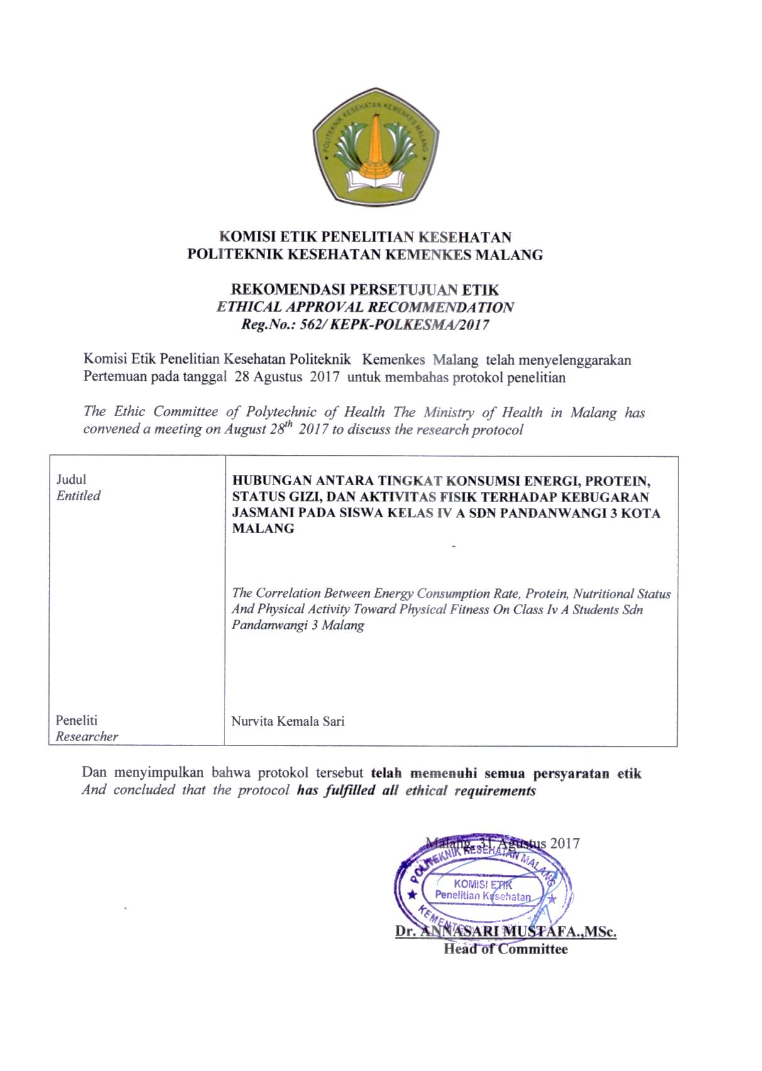

Lampiran 2.

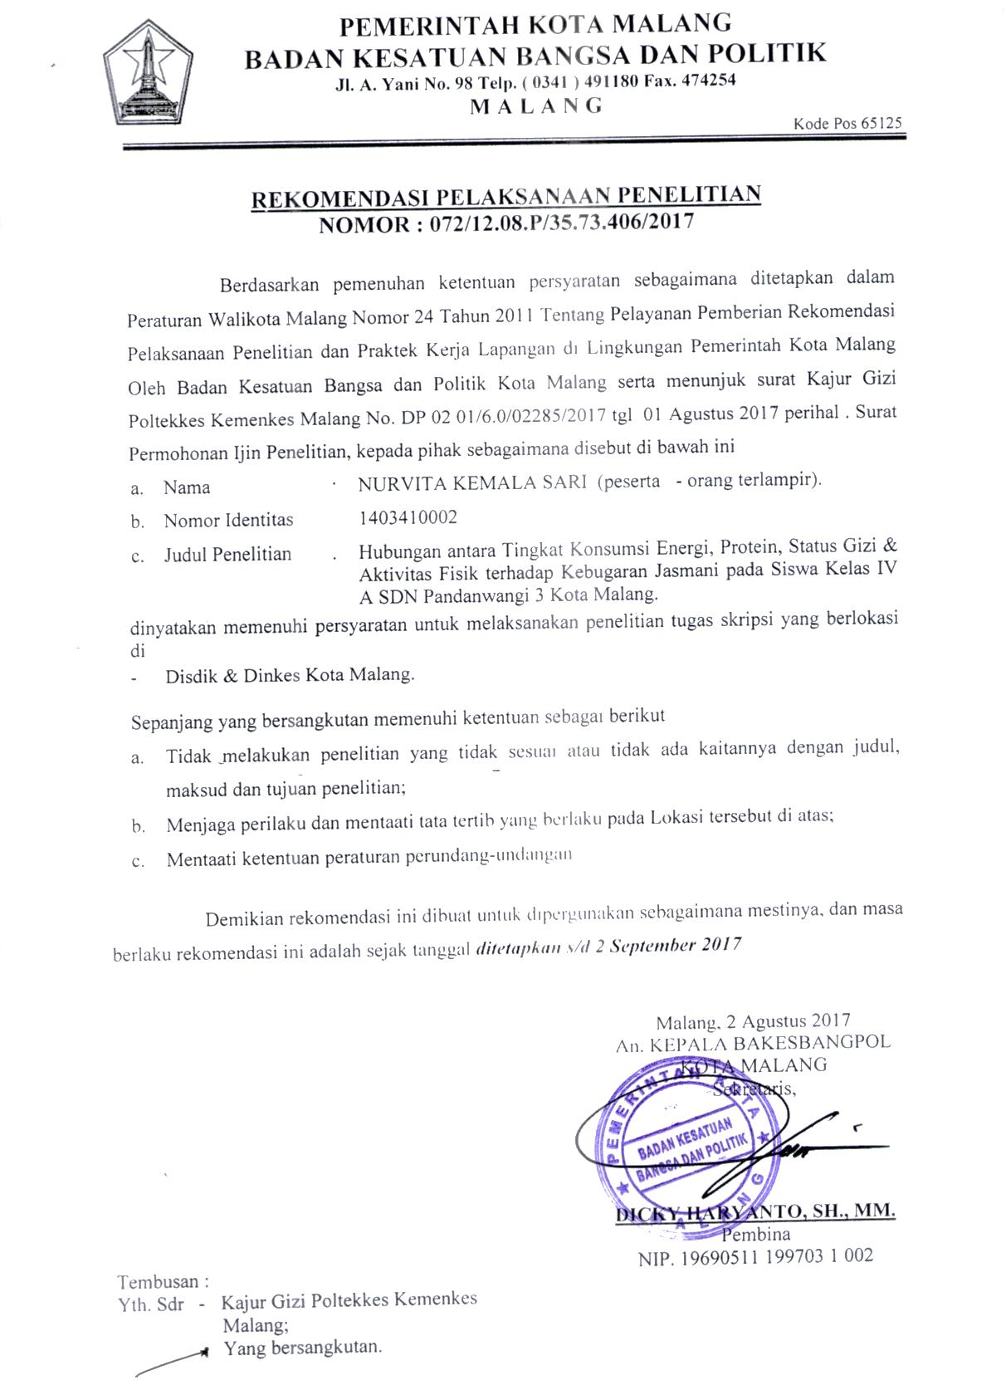

Lampiran 3.

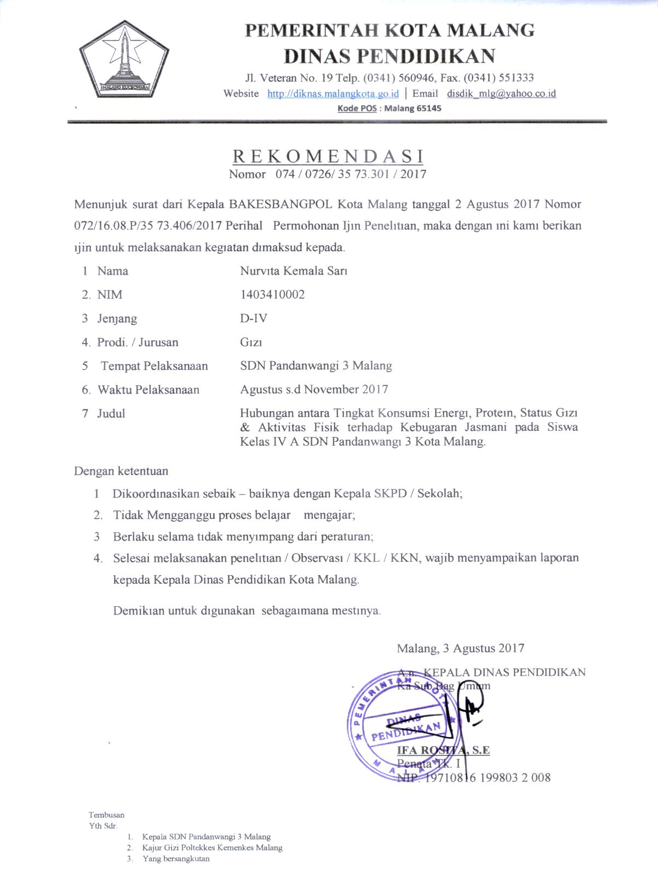

Lampiran 4.

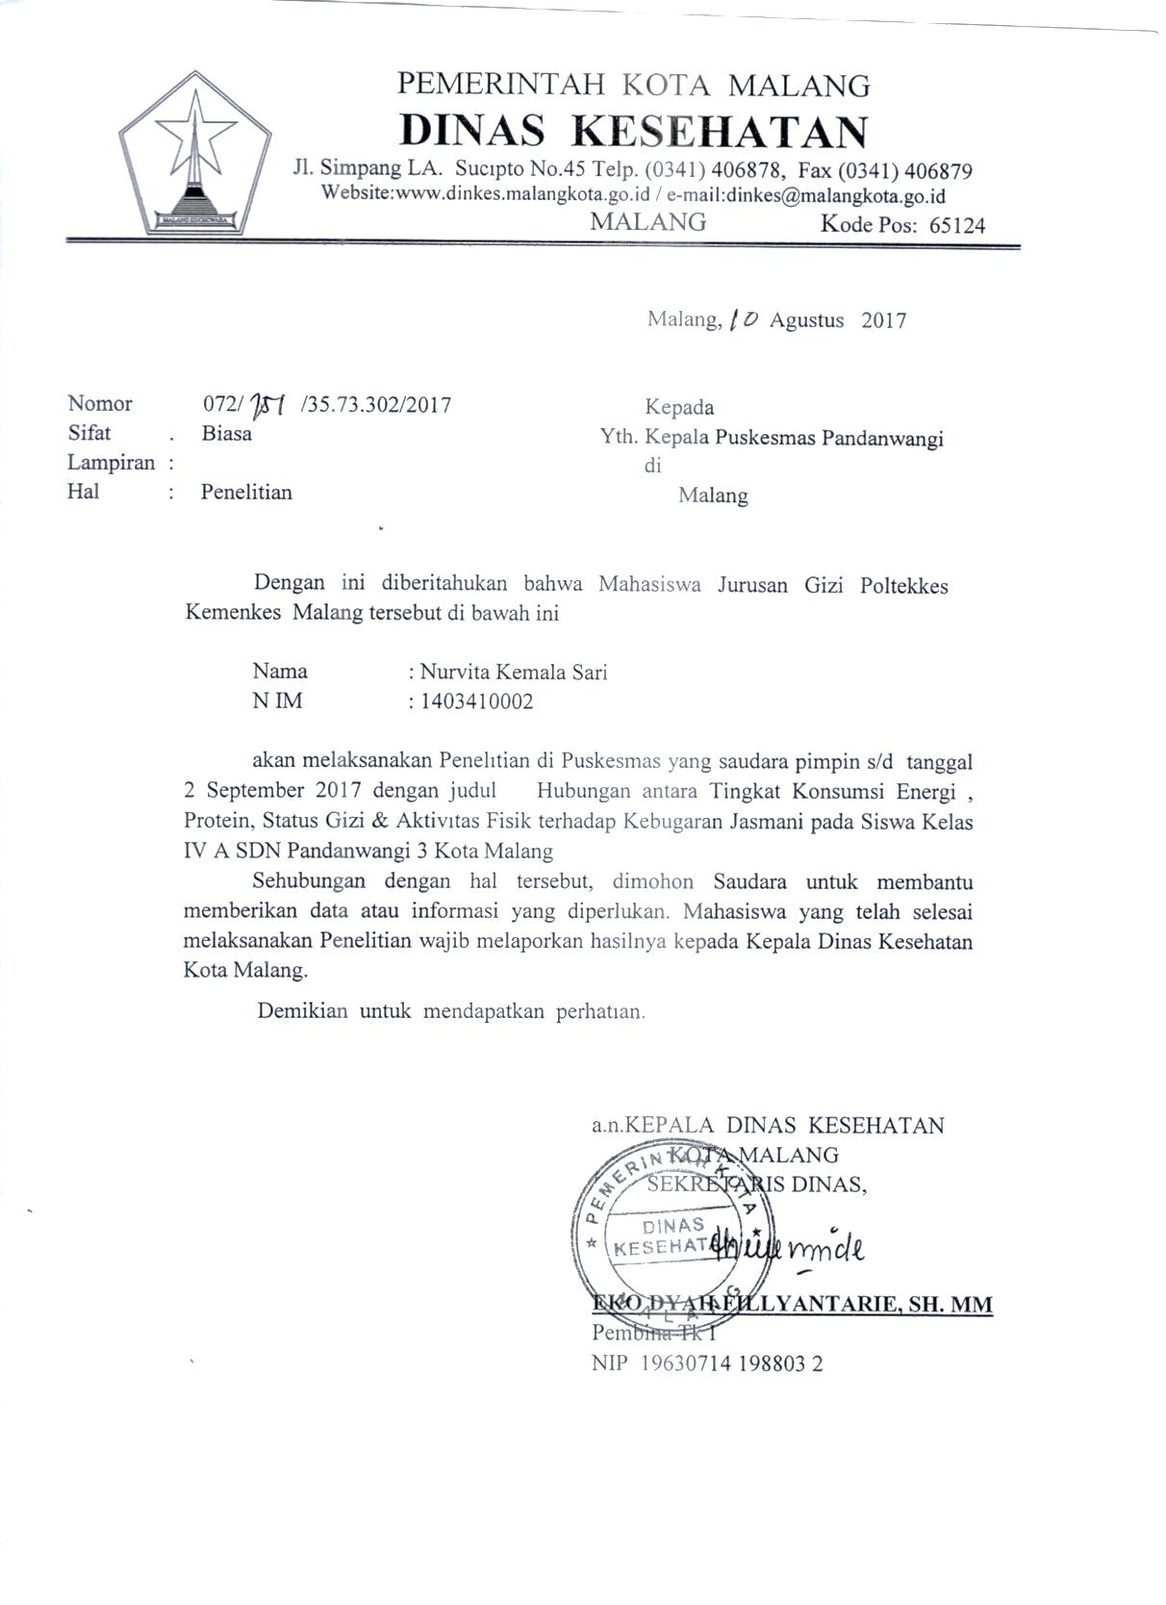

Lampiran 5. 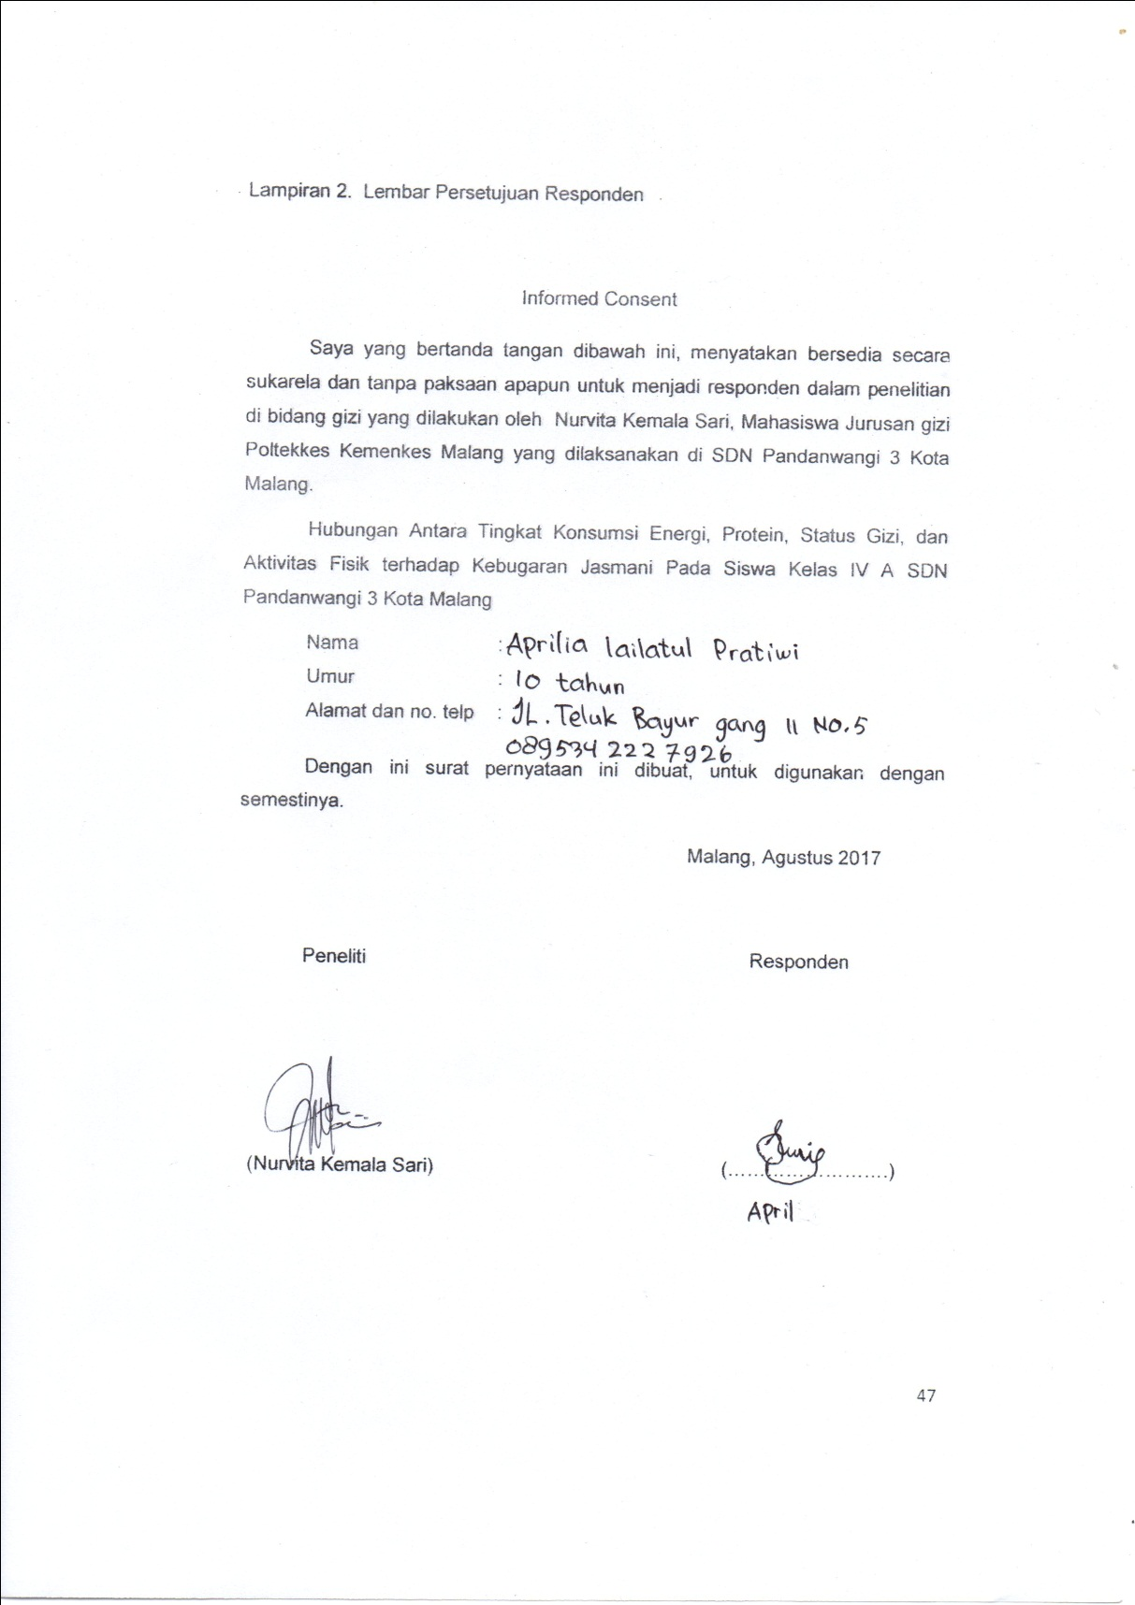

Lampiran 6.

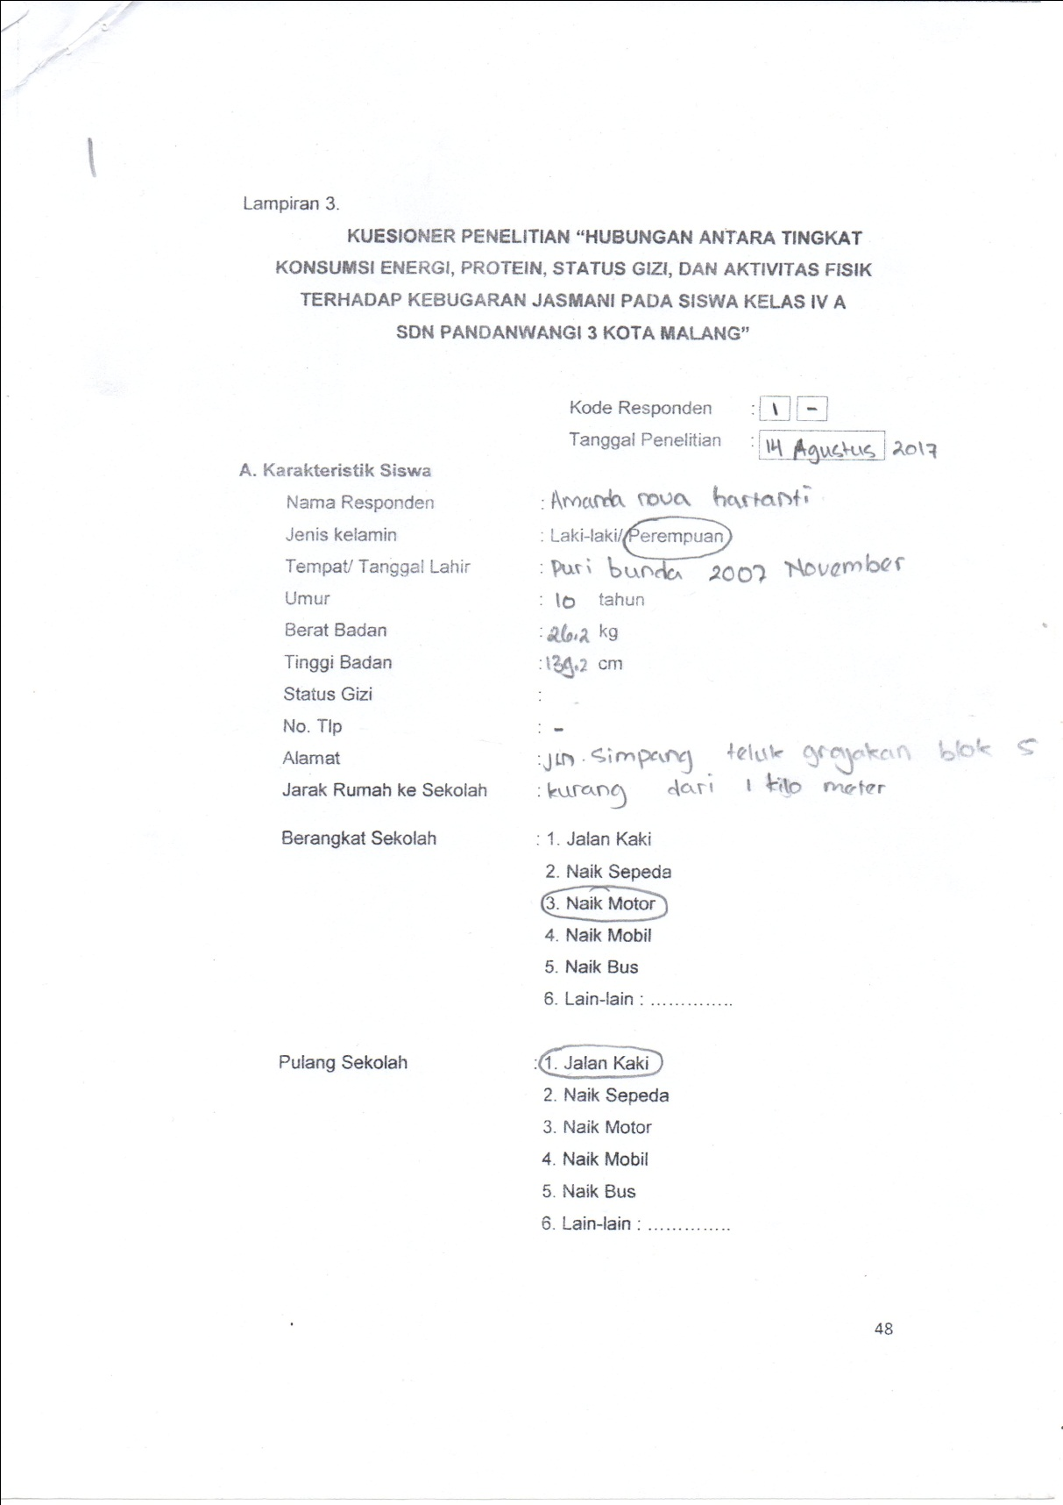

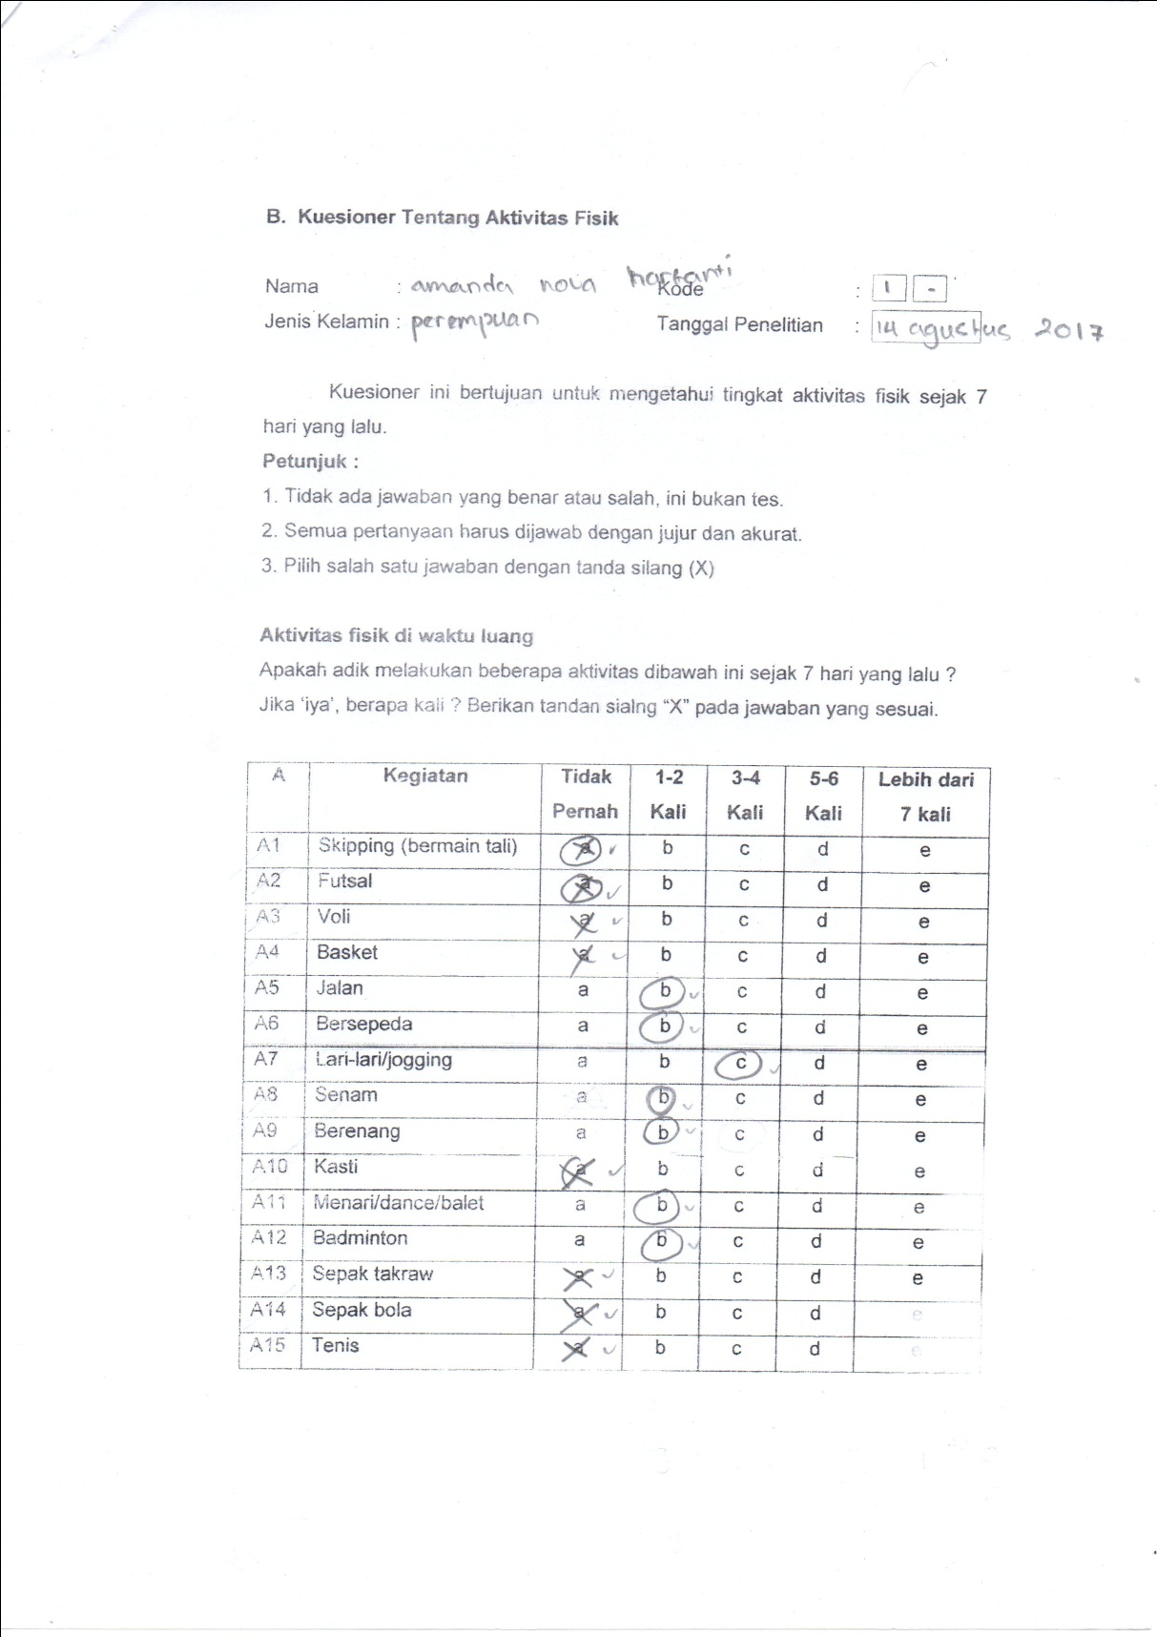

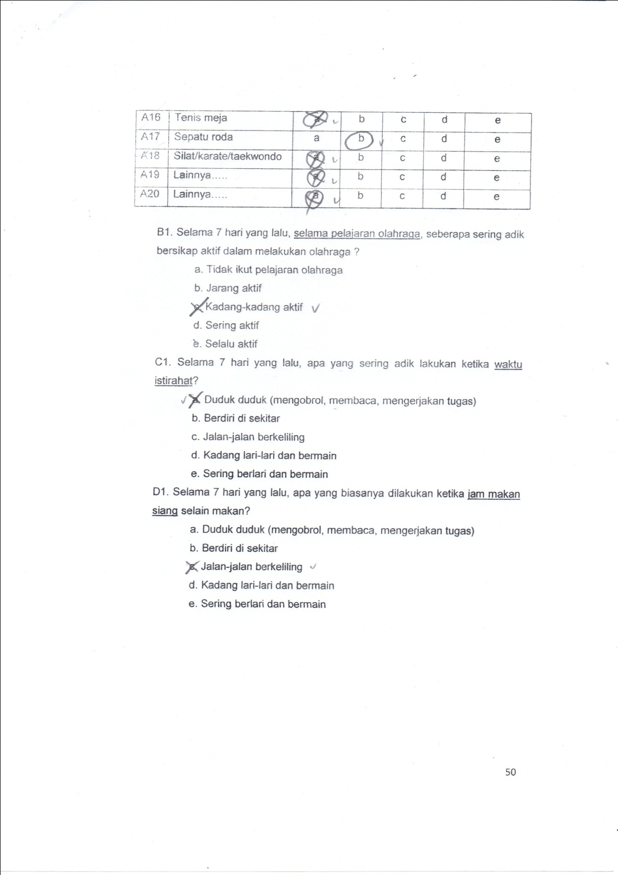

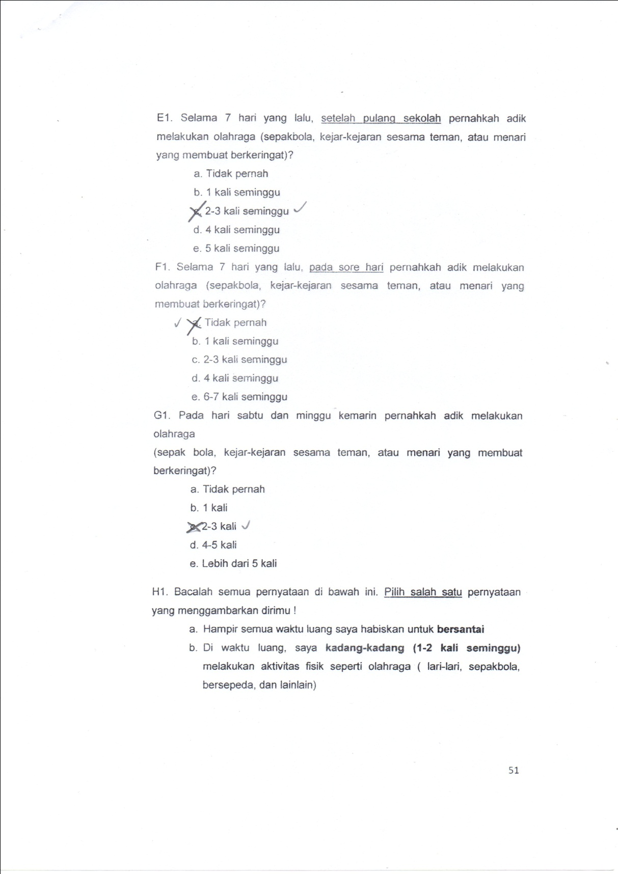

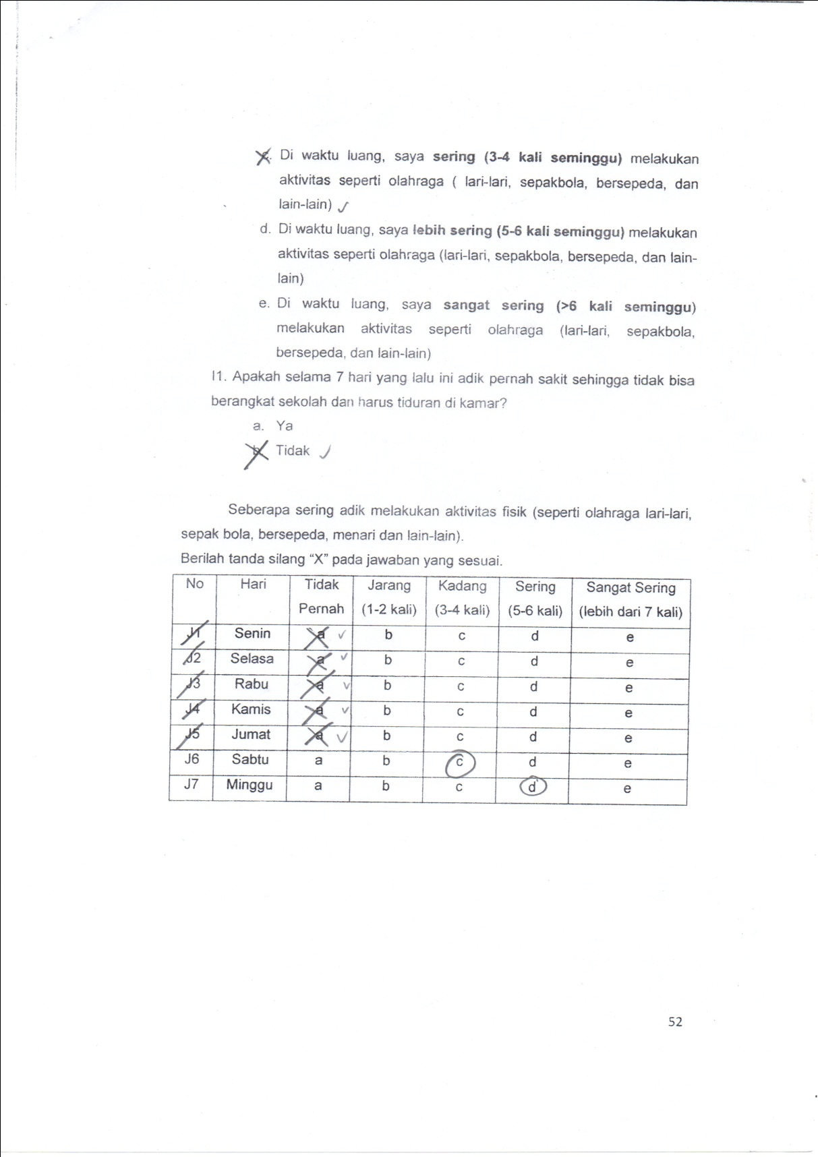

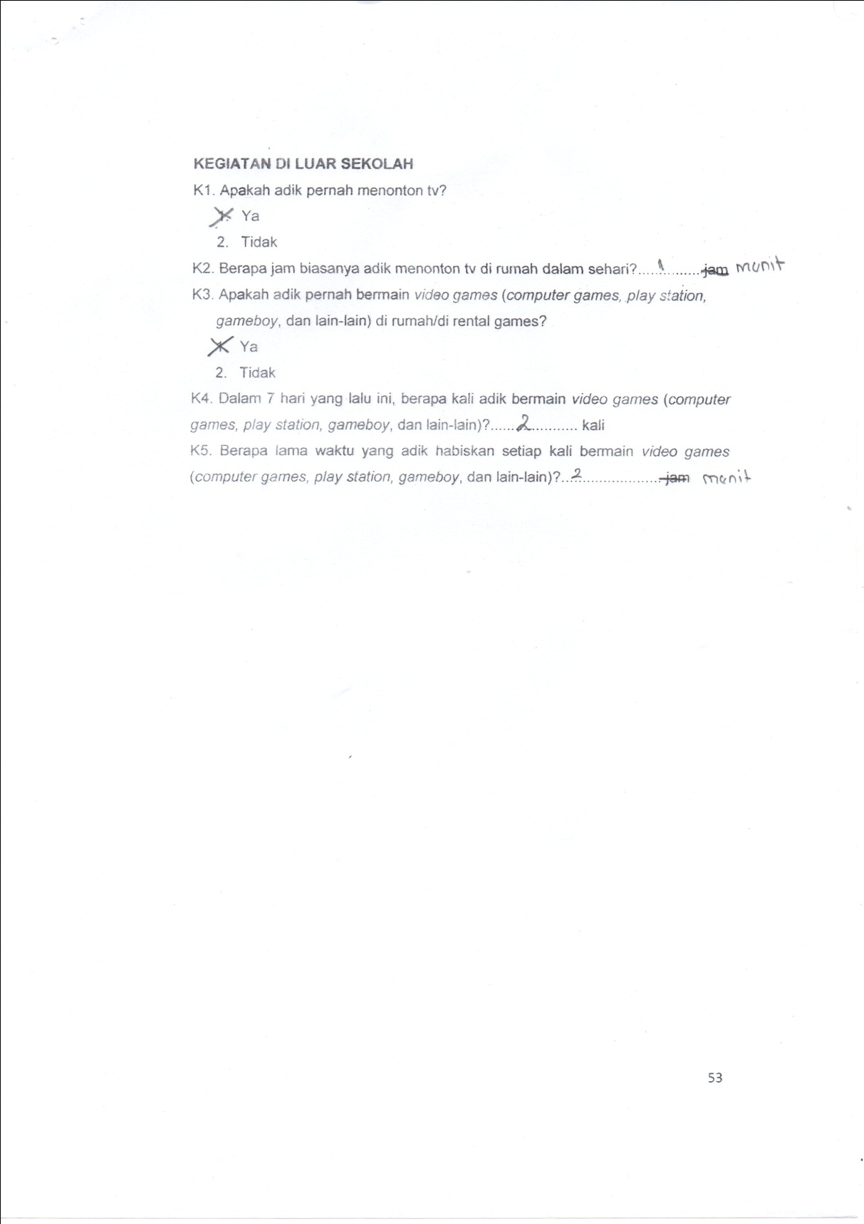

Lampiran 7.

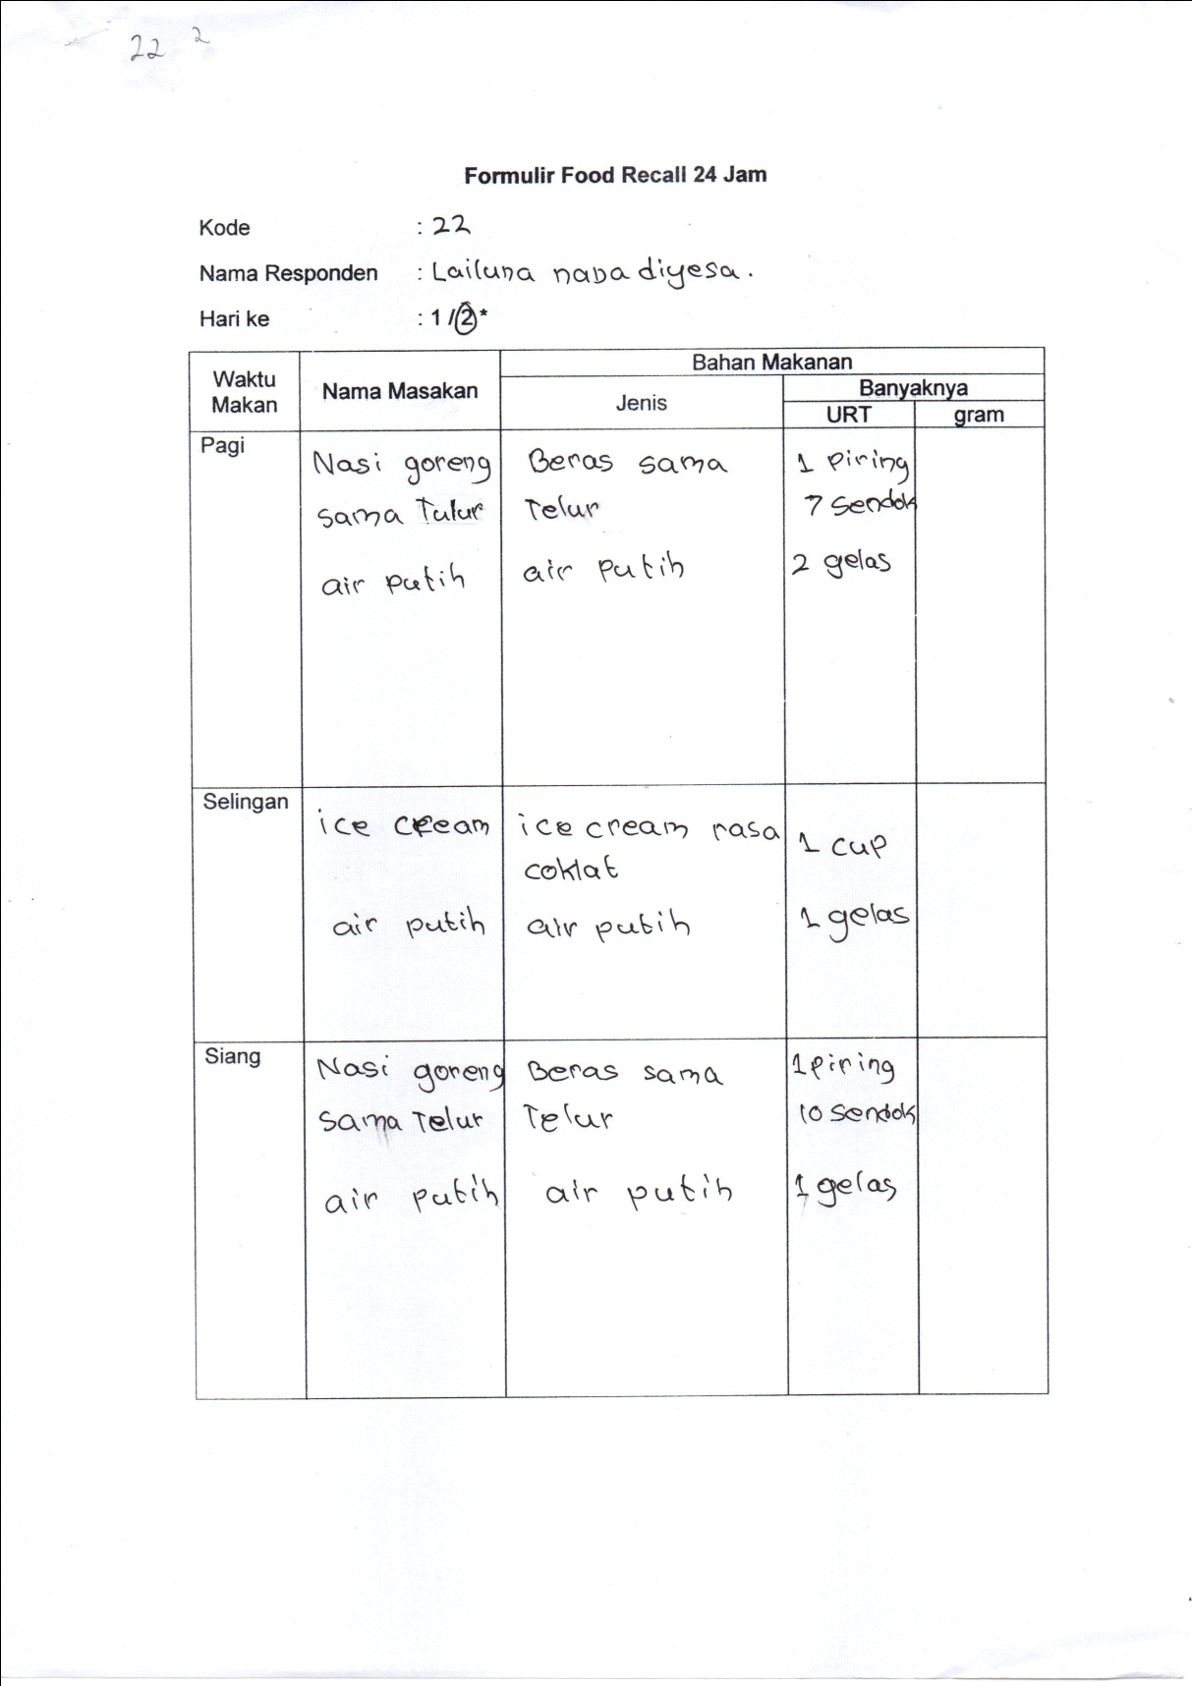

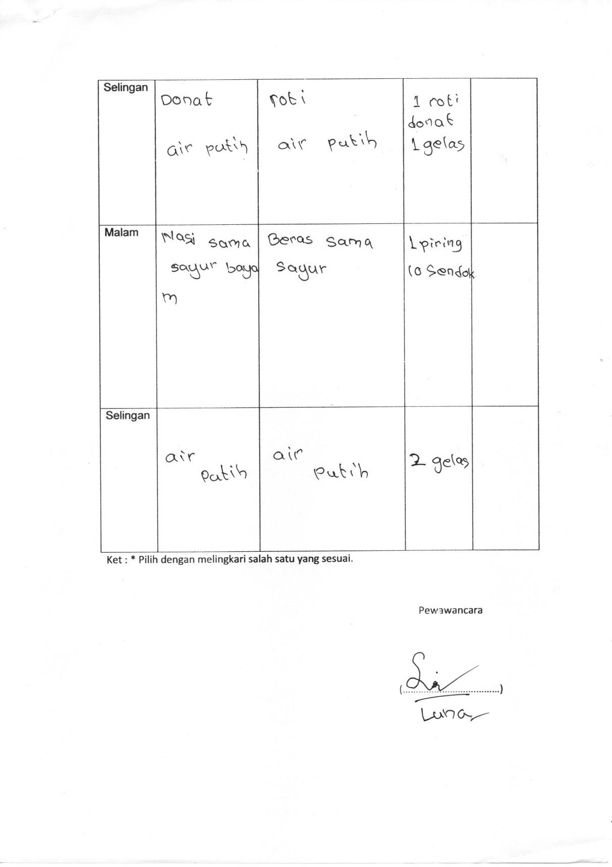

Lampiran 8.

**Data Tingkat Konsumsi Energi dan Protein**

|  |  |  |  |  |  |  |  |  |  |  |
| --- | --- | --- | --- | --- | --- | --- | --- | --- | --- | --- |
| **Responden** | **Tingkat Konsumsi Energi** | | | | | **Tingkat Konsumsi Protein** | | | | |
| **Tingkat Konsumsi** | | **Rata-Rata** | **%** | **Kategori** | **Tingkat Konsumsi** | | **Rata-Rata** | **%** | **Kategori** |
| **Hari 1** | **Hari 2** | **Hari 1** | **Hari 2** |
| 1 | 1084.3 | 1473.1 | 1278.7 | 76.4 | Sedang | 35.4 | 30.5 | 33.0 | 60.4 | Berat |
| 2 | 1320.7 | 1228.2 | 1274.5 | 90.8 | Normal | 57.0 | 81.4 | 69.2 | 110.3 | Normal |
| 3 | 1299.0 | 1376.6 | 1337.8 | 98.2 | Normal | 32.0 | 30.5 | 31.3 | 49.9 | Berat |
| 4 | 1276.9 | 1368.4 | 1322.7 | 95.5 | Normal | 41.8 | 50.1 | 46.0 | 63.3 | Berat |
| 5 | 1183.0 | 1103.9 | 1143.5 | 70.1 | Sedang | 38.5 | 39.3 | 38.9 | 63.6 | Berat |
| 6 | 1097.2 | 1373.0 | 1235.1 | 76.4 | Sedang | 60.0 | 73.5 | 66.8 | 98.2 | Normal |
| 7 | 1110.4 | 1168.3 | 1139.4 | 70.5 | Sedang | 59.2 | 77.8 | 68.5 | 105.0 | Normal |
| 8 | 1165.5 | 1230.9 | 1198.2 | 69.4 | Berat | 43.8 | 40.9 | 42.4 | 65.4 | Berat |
| 9 | 1188.8 | 1205.3 | 1197.1 | 69.3 | Berat | 55.8 | 43.1 | 63.3 | 94.7 | Normal |
| 10 | 1176.9 | 1263.7 | 1220.3 | 74.7 | Sedang | 44.7 | 50.8 | 47.8 | 78.0 | Sedang |
| 11 | 1279.8 | 1354.0 | 1316.9 | 93.0 | Normal | 42.2 | 47.8 | 45.0 | 82.4 | Ringan |
| 12 | 1228.4 | 1347.6 | 1288.0 | 78.2 | Sedang | 31.5 | 45.4 | 38.5 | 62.3 | Berat |
| 13 | 1320.3 | 1200.7 | 1160.5 | 90.5 | Normal | 24.6 | 28.5 | 26.6 | 41.3 | Berat |
| 14 | 1079.7 | 1053.6 | 1066.7 | 93.1 | Normal | 88.1 | 41.6 | 67.8 | 99.5 | Normal |
| 15 | 1068.6 | 1225.3 | 1147.0 | 91.2 | Normal | 66.2 | 36.6 | 61.1 | 91.0 | Normal |
| 16 | 1122.2 | 1261.5 | 1191.9 | 71.3 | Sedang | 54.6 | 32.6 | 43.6 | 69.6 | Sedang |
| 17 | 1274.5 | 1106.6 | 1190.6 | 69.9 | Sedang | 42.6 | 37.7 | 40.2 | 62.8 | Berat |
| 18 | 1261.0 | 1105.1 | 1183.1 | 67.1 | Berat | 75.8 | 40.6 | 62.4 | 93.2 | Normal |
| 19 | 1225.7 | 1136.7 | 1181.2 | 68.9 | Berat | 82.2 | 40.7 | 68.7 | 105.5 | Normal |
| **Responden** | **Tingkat Konsumsi Energi** | | | | | **Tingkat Konsumsi Protein** | | | | |
| **Tingkat Konsumsi** | | **Rata-Rata** | **%** | **Kategori** | **Tingkat Konsumsi** | | **Rata-Rata** | **%** | **Kategori** |
| **Hari 1** | **Hari 2** | **Hari 1** | **Hari 2** |
| 20 | 1308.3 | 1181.8 | 1245.1 | 74.7 | Sedang | 48.8 | 45.6 | 47.2 | 75.5 | Sedang |
| 21 | 1048.6 | 1149.9 | 1099.3 | 64.7 | Berat | 71.1 | 56.1 | 61.7 | 92.4 | Normal |
| 22 | 1184.3 | 1187.0 | 1185.7 | 69.8 | Sedang | 45.6 | 53.8 | 49.7 | 78.1 | Sedang |
| 23 | 1283.5 | 1273.5 | 1278.5 | 58.5 | Berat | 38.8 | 39.9 | 39.4 | 48.0 | Berat |
| 24 | 1218.9 | 1281.5 | 1250.2 | 73.0 | Sedang | 44.5 | 39.3 | 41.9 | 65.2 | Berat |
| 25 | 1185.3 | 1164.4 | 1174.9 | 67.0 | Berat | 62.4 | 47.6 | 55.0 | 83.6 | Ringan |
| 26 | 1205.4 | 1051.8 | 1128.6 | 68.2 | Berat | 45.2 | 33.4 | 39.3 | 63.3 | Berat |
| 27 | 1261.0 | 1105.1 | 1183.1 | 59.1 | Berat | 41.5 | 39.7 | 40.6 | 54.1 | Berat |
| 28 | 1232.7 | 1149.6 | 1191.2 | 71.7 | Sedang | 53.0 | 34.2 | 43.6 | 70.0 | Sedang |
| 29 | 1100.3 | 1233.4 | 1166.9 | 63.4 | Berat | 53.0 | 37.3 | 45.2 | 65.4 | Berat |
| 30 | 1100.2 | 1458.4 | 1279.3 | 76.8 | Sedang | 28.1 | 54.0 | 41.1 | 65.7 | Berat |

Lampiran 9.

**Data Status Gizi**

|  |  |  |  |  |  |  |  |  |
| --- | --- | --- | --- | --- | --- | --- | --- | --- |
| **Responden** | **Karakteristik Responden** | | | | **TB (meter)** | **(TB)2 (meter)** | **Status Gizi** | **Klasifikasi** |
| **Umur** | **Bulan** | **BB** | **TB** |
| 1 | 10 | 0 | 26 | 139.2 | 1.392 | 1.94 | 13.42 | Kurus |
| 2 | 10 | 0 | 24.5 | 127 | 1.27 | 1.61 | 15.19 | Normal |
| 3 | 10 | 4 | 26.5 | 135.2 | 1.352 | 1.83 | 14.50 | Gemuk |
| 4 | 10 | 0 | 44.5 | 138 | 1.38 | 1.90 | 23.37 | Sangat Gemuk |
| 5 | 10 | 0 | 25 | 129.4 | 1.294 | 1.67 | 14.93 | Normal |
| 6 | 10 | 4 | 29 | 136 | 1.36 | 1.85 | 15.68 | Normal |
| 7 | 10 | 10 | 29.5 | 134.6 | 1.346 | 1.81 | 16.28 | Normal |
| 8 | 10 | 0 | 30 | 137.5 | 1.375 | 1.89 | 15.87 | Normal |
| 9 | 10 | 7 | 30 | 138 | 1.38 | 1.90 | 15.75 | Normal |
| 10 | 10 | 0 | 24 | 134.9 | 1.349 | 1.82 | 13.19 | Kurus |
| 11 | 10 | 9 | 27 | 127 | 1.27 | 1.61 | 16.74 | Gemuk |
| 12 | 10 | 8 | 27 | 124.5 | 1.245 | 1.55 | 17.42 | Gemuk |
| 13 | 10 | 0 | 30 | 133.5 | 1.335 | 1.78 | 16.83 | Normal |
| 14 | 10 | 4 | 22 | 126.5 | 1.265 | 1.60 | 13.75 | Normal |
| 15 | 10 | 7 | 32 | 135 | 1.35 | 1.82 | 17.56 | Gemuk |
| 16 | 10 | 2 | 27 | 133 | 1.33 | 1.77 | 15.26 | Normal |
| 17 | 10 | 3 | 34 | 134 | 1.34 | 1.80 | 18.94 | Gemuk |
| 18 | 10 | 7 | 40 | 125.5 | 1.255 | 1.58 | 25.40 | Sangat Gemuk |
| 19 | 10 | 10 | 29 | 138 | 1.38 | 1.90 | 15.23 | Normal |
| 20 | 10 | 7 | 27 | 132 | 1.32 | 1.74 | 15.50 | Normal |
| **Responden** | **Karakteristik Responden** | | | | **TB (meter)** | **(TB)2 (meter)** | **Status Gizi** | **Klasifikasi** |
| **Umur** | **Umur** | **Umur** | **Umur** |
| 21 | 10 | 0 | 30 | 128 | 1.28 | 1.64 | 18.31 | Gemuk |
| 22 | 10 | 9 | 29 | 132.5 | 1.325 | 1.76 | 16.52 | Normal |
| 23 | 10 | 0 | 55 | 140.5 | 1.405 | 1.97 | 27.86 | Sangat Gemuk |
| 24 | 10 | 9 | 32 | 140.7 | 1.407 | 1.98 | 16.16 | Normal |
| 25 | 10 | 6 | 32 | 137.5 | 1.375 | 1.89 | 16.93 | Normal |
| 26 | 10 | 5 | 32 | 133 | 1.33 | 1.77 | 18.09 | Normal |
| 27 | 10 | 7 | 48 | 143.5 | 1.435 | 2.06 | 23.31 | Gemuk |
| 28 | 10 | 7 | 27 | 130 | 1.3 | 1.69 | 15.98 | Normal |
| 29 | 10 | 0 | 38 | 137.7 | 1.377 | 1.90 | 20.04 | Normal |
| 30 | 10 | 2 | 28 | 125.9 | 1.259 | 1.59 | 17.66 | Gemuk |

Lampiran 10.

**Data Aktivitas Fisik dan Kebugaran Jasmani**

|  |  |  |  |  |  |  |  |  |  |  |  |
| --- | --- | --- | --- | --- | --- | --- | --- | --- | --- | --- | --- |
| **RESPONDEN** | **JK** | **SKOR AKTIVITAS FISIK** | | | | | **TOTAL** | **KATEGORI** | **KEBUGARAN** | | |
| **a** | **b** | **c** | **d** | **e** | **WAKTU TEMPUH** | **VO2 MAX** | **HASIL** |
| 1 | P | 19 | 24 | 21 | 11 | 0 | 75 | Kurang | 6.44 | 0 | C |
| 2 | L | 9 | 20 | 27 | 12 | 20 | 88 | Baik | 4.51 | 0 | B |
| 3 | P | 17 | 18 | 12 | 8 | 10 | 65 | Kurang | 6.47 | 0 | C |
| 4 | P | 16 | 26 | 15 | 0 | 5 | 62 | Kurang | 9.1 | 0 | KS |
| 5 | P | 18 | 20 | 18 | 0 | 5 | 61 | Kurang | 9.09 | 0 | KS |
| 6 | L | 12 | 16 | 21 | 24 | 10 | 83 | Baik | 4.52 | 0 | B |
| 7 | L | 20 | 10 | 3 | 16 | 25 | 74 | Kurang | 6.01 | 0 | C |
| 8 | P | 21 | 16 | 3 | 16 | 5 | 61 | Kurang | 7.53 | 0 | K |
| 9 | P | 17 | 16 | 12 | 8 | 20 | 73 | Kurang | 7.43 | 0 | K |
| 10 | P | 18 | 14 | 12 | 20 | 12 | 76 | Kurang | 6.49 | 0 | C |
| 11 | L | 17 | 16 | 12 | 8 | 25 | 78 | Baik | 6.04 | 0 | C |
| 12 | P | 16 | 28 | 9 | 12 | 17 | 82 | Baik | 6.12 | 0 | B |
| 13 | P | 11 | 10 | 12 | 24 | 45 | 102 | Baik | 6.24 | 0 | B |
| 14 | P | 19 | 12 | 6 | 4 | 40 | 81 | Baik | 6.09 | 0 | B |
| 15 | P | 17 | 8 | 21 | 12 | 20 | 78 | Baik | 6.22 | 0 | B |
| 16 | P | 21 | 24 | 6 | 0 | 0 | 51 | Kurang | 8.06 | 0 | K |
| 17 | L | 8 | 18 | 12 | 12 | 25 | 75 | Kurang | 5.53 | 0 | C |
| 18 | L | 12 | 28 | 3 | 8 | 25 | 76 | Kurang | 7.41 | 0 | K |
| 19 | P | 20 | 12 | 21 | 0 | 10 | 63 | Kurang | 7.55 | 0 | K |
| **RESPONDEN** | **JK** | **SKOR AKTIVITAS FISIK** | | | | | **TOTAL** | **KATEGORI** | **KEBUGARAN** | | |
| **a** | **b** | **c** | **d** | **e** | **WAKTU TEMPUH** | **VO2 MAX** | **HASIL** |
| 20 | P | 9 | 24 | 21 | 12 | 14 | 80 | Baik | 6.47 | 0 | C |
| 21 | P | 15 | 14 | 9 | 12 | 31 | 81 | Baik | 7.11 | 0 | C |
| 22 | P | 16 | 8 | 27 | 16 | 10 | 77 | Kurang | 6.4 | 0 | C |
| 23 | L | 16 | 20 | 3 | 8 | 30 | 77 | Kurang | 8.28 | 0 | KS |
| 24 | L | 15 | 18 | 9 | 12 | 25 | 79 | Baik | 5.49 | 0 | B |
| 25 | P | 18 | 20 | 9 | 12 | 17 | 76 | Kurang | 6.08 | 0 | B |
| 26 | L | 20 | 22 | 0 | 16 | 17 | 75 | Kurang | 5.41 | 0 | B |
| 27 | P | 10 | 14 | 12 | 20 | 24 | 80 | Baik | 7.53 | 0 | K |
| 28 | P | 14 | 10 | 18 | 20 | 20 | 82 | Baik | 7.55 | 0 | K |
| 29 | P | 18 | 18 | 3 | 8 | 25 | 72 | Kurang | 6.24 | 0 | B |
| 30 | P | 12 | 24 | 6 | 32 | 5 | 79 | Baik | 7.37 | 0 | C |

Lampiran 11.

**Hasil Uji SPSS *Chi-Square***

Hubungan antara Tingkat Konsumsi Energi dengan Status Gizi

**Crosstab**

|  |  |  |  |  |  |  |
| --- | --- | --- | --- | --- | --- | --- |
| **Case Processing Summary** | | | | | | |
|  | Cases | | | | | |
| Valid | | Missing | | Total | |
| n | Percent | n | Percent | n | Percent |
| Energi * StatusGizi | 30 | 100.0% | 0 | 0.0% | 30 | 100.0% |

|  |  |  |  |  |
| --- | --- | --- | --- | --- |
| **Energi * StatusGizi Crosstabulation** | | | | |
| Count | | | | |
|  | | StatusGizi | | Total |
| Tidak Kurus | Kurus |
| Energi | Normal | 6 | 1 | 7 |
| Kurang | 21 | 2 | 23 |
| Total | | 27 | 3 | 30 |

|  |  |  |  |  |  |
| --- | --- | --- | --- | --- | --- |
| **Chi-Square Tests** | | | | | |
|  | Value | df | Asymp. Sig.  (2-sided) | Exact Sig.  (2-sided) | Exact Sig.  (1-sided) |
| Pearson Chi-Square | .186a | 1 | .666 |  |  |
| Continuity Correctionb | .000 | 1 | 1.000 |  |  |
| Likelihood Ratio | .173 | 1 | .677 |  |  |
| Fisher's Exact Test |  |  |  | 1.000 | .564 |
| Linear-by-Linear Association | .180 | 1 | .671 |  |  |
| N of Valid Cases | 30 |  |  |  |  |

|  |
| --- |
| a. 2 cells (50.0%) have expected count less than 5. The minimum expected count is .70. |
| b. Computed only for a 2x2 table |

Lampiran 12.

Hubungan antara Tingkat Konsumsi Protein dengan Status Gizi

**Crosstabs**

|  |  |  |  |  |  |  |
| --- | --- | --- | --- | --- | --- | --- |
| **Case Processing Summary** | | | | | | |
|  | Cases | | | | | |
| Valid | | Missing | | Total | |
| n | Percent | n | Percent | n | Percent |
| Protein * StatusGizi | 30 | 100.0% | 0 | 0.0% | 30 | 100.0% |

|  |  |  |  |  |
| --- | --- | --- | --- | --- |
| **Protein * StatusGizi Crosstabulation** | | | | |
| Count | | | | |
|  | | StatusGizi | | Total |
| Tidak Kurus | Kurus |
| Protein | Normal | 9 | 0 | 9 |
| Kurang | 18 | 3 | 21 |
| Total | | 27 | 3 | 30 |

|  |  |  |  |  |  |
| --- | --- | --- | --- | --- | --- |
| **Chi-Square Tests** | | | | | |
|  | Value | df | Asymp. Sig.  (2-sided) | Exact Sig.  (2-sided) | Exact Sig.  (1-sided) |
| Pearson Chi-Square | 1.429a | 1 | .232 |  |  |
| Continuity Correctionb | .282 | 1 | .595 |  |  |
| Likelihood Ratio | 2.280 | 1 | .131 |  |  |
| Fisher's Exact Test |  |  |  | .534 | .328 |
| Linear-by-Linear Association | 1.381 | 1 | .240 |  |  |
| N of Valid Cases | 30 |  |  |  |  |

|  |
| --- |
| a. 2 cells (50.0%) have expected count less than 5. The minimum expected count is .90. |
| b. Computed only for a 2x2 table |

Lampiran 13.

Hubungan antara Tingkat Konsumsi Energi dengan Kebugaran Jasmani

**Crosstabs**

|  |  |  |  |  |  |  |
| --- | --- | --- | --- | --- | --- | --- |
| **Case Processing Summary** | | | | | | |
|  | Cases | | | | | |
| Valid | | Missing | | Total | |
| n | Percent | N | Percent | n | Percent |
| Energi * KebugaranJasmani | 30 | 100.0% | 0 | 0.0% | 30 | 100.0% |

|  |  |  |  |  |
| --- | --- | --- | --- | --- |
| **Energi * KebugaranJasmani Crosstabulation** | | | | |
| Count | | | | |
|  | | KebugaranJasmani | | Total |
| Baik | Tidak Baik |
| Energi | Normal | 1 | 0 | 1 |
| Kurang | 12 | 17 | 29 |
| Total | | 13 | 17 | 30 |

|  |  |  |  |  |  |
| --- | --- | --- | --- | --- | --- |
| **Chi-Square Tests** | | | | | |
|  | Value | df | Asymp. Sig.  (2-sided) | Exact Sig.  (2-sided) | Exact Sig.  (1-sided) |
| Pearson Chi-Square | 1.353a | 1 | .245 |  |  |
| Continuity Correctionb | .019 | 1 | .891 |  |  |
| Likelihood Ratio | 1.718 | 1 | .190 |  |  |
| Fisher's Exact Test |  |  |  | .433 | .433 |
| Linear-by-Linear Association | 1.308 | 1 | .253 |  |  |
| N of Valid Cases | 30 |  |  |  |  |

|  |
| --- |
| a. 2 cells (50.0%) have expected count less than 5. The minimum expected count is .43. |
| b. Computed only for a 2x2 table |

Lampiran 14.

Hubungan antara Tingkat Konsumsi Protein dengan Kebugaran Jasmani

**Crosstabs**

|  |  |  |  |  |  |  |
| --- | --- | --- | --- | --- | --- | --- |
| **Case Processing Summary** | | | | | | |
|  | Cases | | | | | |
| Valid | | Missing | | Total | |
| n | Percent | N | Percent | n | Percent |
| Protein * kebugaranJasmani | 30 | 100.0% | 0 | 0.0% | 30 | 100.0% |

|  |  |  |  |  |
| --- | --- | --- | --- | --- |
| **Protein * kebugaranJasmani Crosstabulation** | | | | |
| Count | | | | |
|  | | kebugaranJasmani | | Total |
| Baik | Tidak Baik |
| Protein | Normal | 0 | 1 | 1 |
| Kurang | 13 | 16 | 29 |
| Total | | 13 | 17 | 30 |

|  |  |  |  |  |  |
| --- | --- | --- | --- | --- | --- |
| **Chi-Square Tests** | | | | | |
|  | Value | df | Asymp. Sig.  (2-sided) | Exact Sig.  (2-sided) | Exact Sig.  (1-sided) |
| Pearson Chi-Square | .791a | 1 | .374 |  |  |
| Continuity Correctionb | .000 | 1 | 1.000 |  |  |
| Likelihood Ratio | 1.162 | 1 | .281 |  |  |
| Fisher's Exact Test |  |  |  | 1.000 | .567 |
| Linear-by-Linear Association | .765 | 1 | .382 |  |  |
| N of Valid Cases | 30 |  |  |  |  |

|  |
| --- |
| a. 2 cells (50.0%) have expected count less than 5. The minimum expected count is .43. |
| b. Computed only for a 2x2 table |

Lampiran 15.

Hubungan Status Gizi dengan Kebugaran Jasmani

**Crosstabs**

|  |  |  |  |  |  |  |
| --- | --- | --- | --- | --- | --- | --- |
| **Case Processing Summary** | | | | | | |
|  | Cases | | | | | |
| Valid | | Missing | | Total | |
| n | Percent | N | Percent | n | Percent |
| StatusGizi * KebugaranJasmani | 30 | 100.0% | 0 | 0.0% | 30 | 100.0% |

|  |  |  |  |  |
| --- | --- | --- | --- | --- |
| **StatusGizi * KebugaranJasmani Crosstabulation** | | | | |
| Count | | | | |
|  | | KebugaranJasmani | | Total |
| Baik | Tidak Baik |
| StatusGizi | Tidak Kurus | 13 | 11 | 24 |
| Kurus | 0 | 6 | 6 |
| Total | | 13 | 17 | 30 |

|  |  |  |  |  |  |
| --- | --- | --- | --- | --- | --- |
| **Chi-Square Tests** | | | | | |
|  | Value | df | Asymp. Sig.  (2-sided) | Exact Sig.  (2-sided) | Exact Sig.  (1-sided) |
| Pearson Chi-Square | 5.735a | 1 | .017 |  |  |
| Continuity Correctionb | 3.742 | 1 | .053 |  |  |
| Likelihood Ratio | 7.950 | 1 | .005 |  |  |
| Fisher's Exact Test |  |  |  | .024 | .021 |
| Linear-by-Linear Association | 5.544 | 1 | .019 |  |  |
| N of Valid Cases | 30 |  |  |  |  |

|  |
| --- |
| a. 2 cells (50.0%) have expected count less than 5. The minimum expected count is 2.60. |
| b. Computed only for a 2x2 table |

Lampiran 16.

Hubungan Aktivitas Fisik dengan Kebugaran Jasmani

**Crosstabs**

|  |  |  |  |  |  |  |
| --- | --- | --- | --- | --- | --- | --- |
| **Case Processing Summary** | | | | | | |
|  | Cases | | | | | |
| Valid | | Missing | | Total | |
| n | Percent | N | Percent | n | Percent |
| AktivitasFisik * KebugaranJasmani | 30 | 100.0% | 0 | 0.0% | 30 | 100.0% |

|  |  |  |  |  |
| --- | --- | --- | --- | --- |
| **AktivitasFisik * KebugaranJasmani Crosstabulation** | | | | |
| Count | | | | |
|  | | KebugaranJasmani | | Total |
| Baik | Tidak Baik |
| AktivitasFisik | Baik | 8 | 5 | 13 |
| Tidak Baik | 3 | 14 | 17 |
| Total | | 11 | 19 | 30 |

|  |  |  |  |  |  |
| --- | --- | --- | --- | --- | --- |
| **Chi-Square Tests** | | | | | |
|  | Value | df | Asymp. Sig.  (2-sided) | Exact Sig.  (2-sided) | Exact Sig.  (1-sided) |
| Pearson Chi-Square | 6.111a | 1 | .013 |  |  |
| Continuity Correctionb | 4.367 | 1 | .037 |  |  |
| Likelihood Ratio | 6.262 | 1 | .012 |  |  |
| Fisher's Exact Test |  |  |  | .023 | .018 |
| Linear-by-Linear Association | 5.907 | 1 | .015 |  |  |
| N of Valid Cases | 30 |  |  |  |  |

|  |
| --- |
| a. 1 cells (25.0%) have expected count less than 5. The minimum expected count is 4.77. |
| b. Computed only for a 2x2 table |

Lampiran 17.

Dokumentasi

|  |
| --- |
| D:\Dokumen\IMG20170915073907.jpgPemanasan untuk lari 1000 meter |
| D:\DATA FD NOVEMBER\DATA HP\Isi HP Bulan September 2017\Kebugaran SD\IMG20170828082223.jpg  Persiapan Lari 1000 meter |
| D:\DATA FD NOVEMBER\DATA HP\Isi HP Bulan September 2017\Kebugaran SD\IMG20170828090358.jpgLari 1000 meter |