***Lampiran 1. Ethical Clearance***

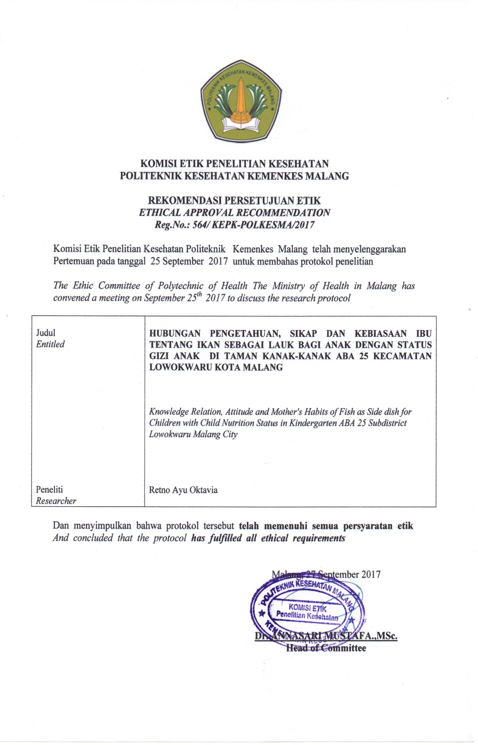

***Lampiran 2. Surat Permohonan Ijin Penelitian***

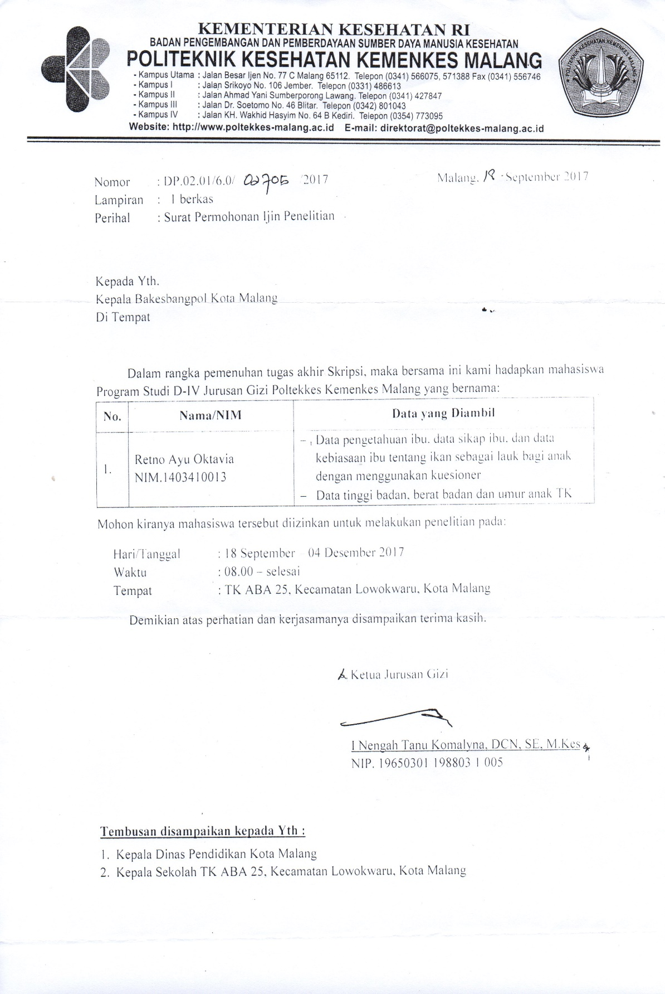

***Lampiran 3. Surat Rekomendasi Pelaksanaan Penelitian Badan Kesatuan Bangsa dan Politik***

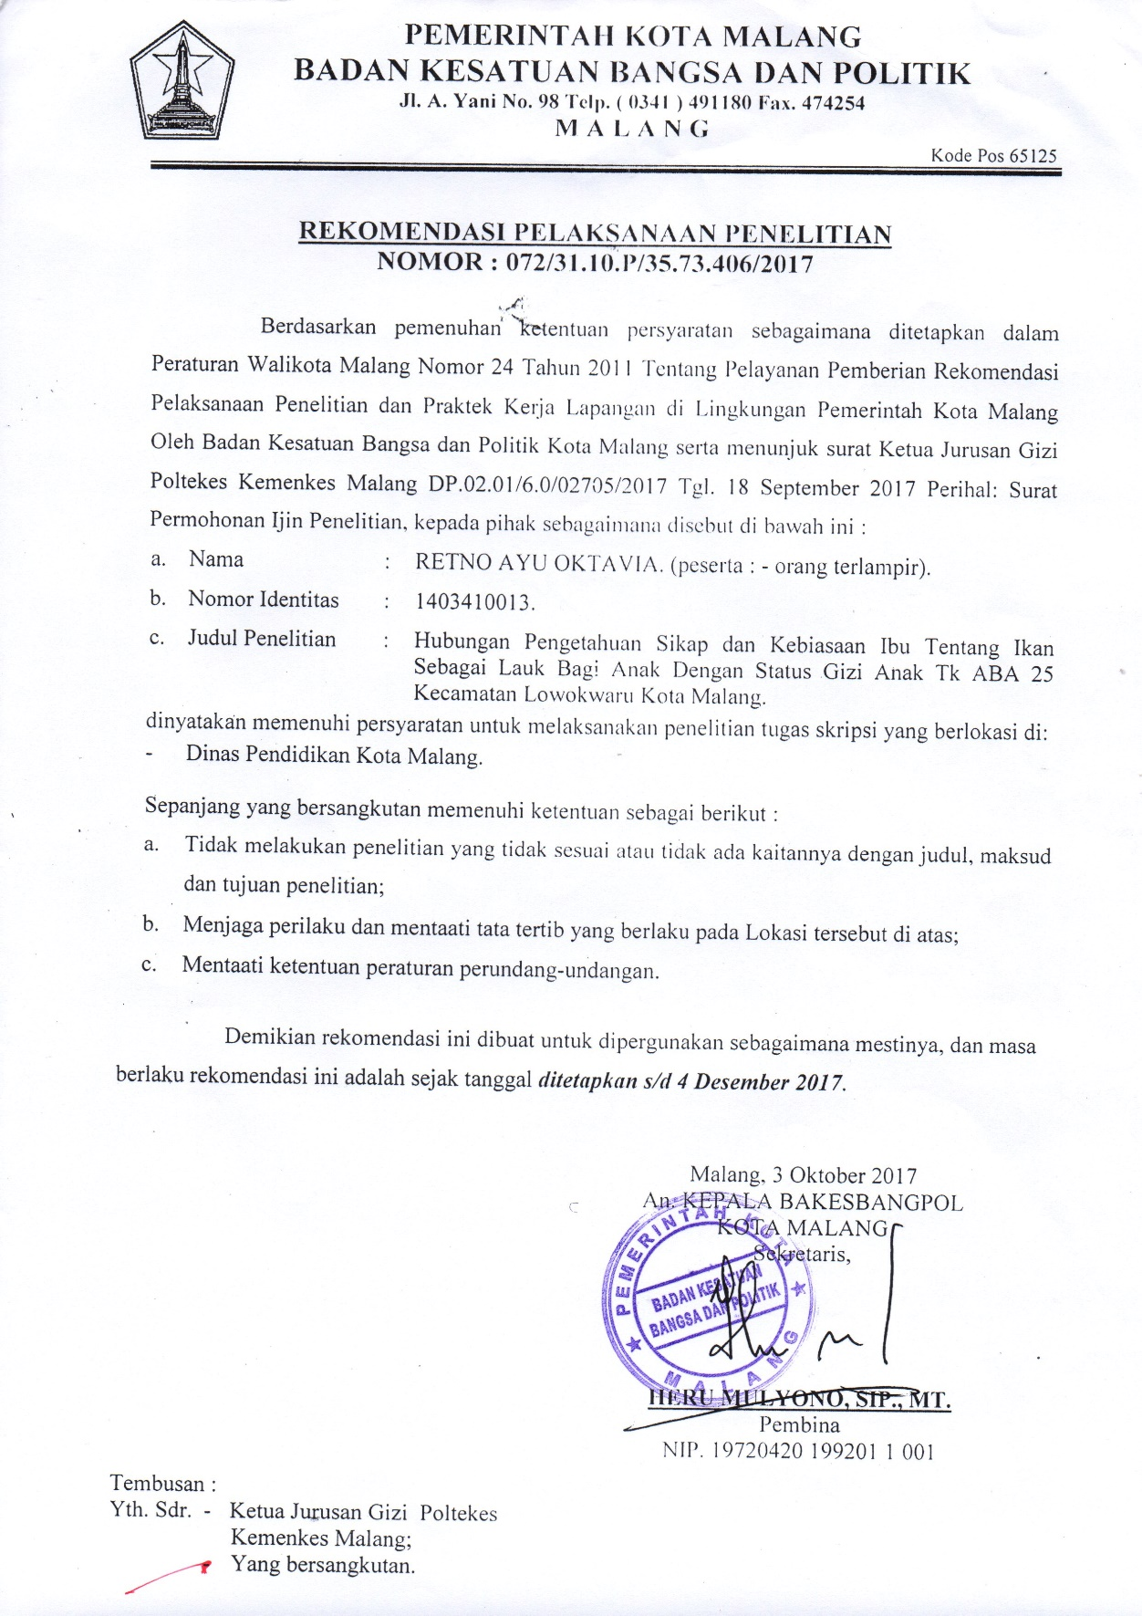

***Lampiran 4. Informed Consent***

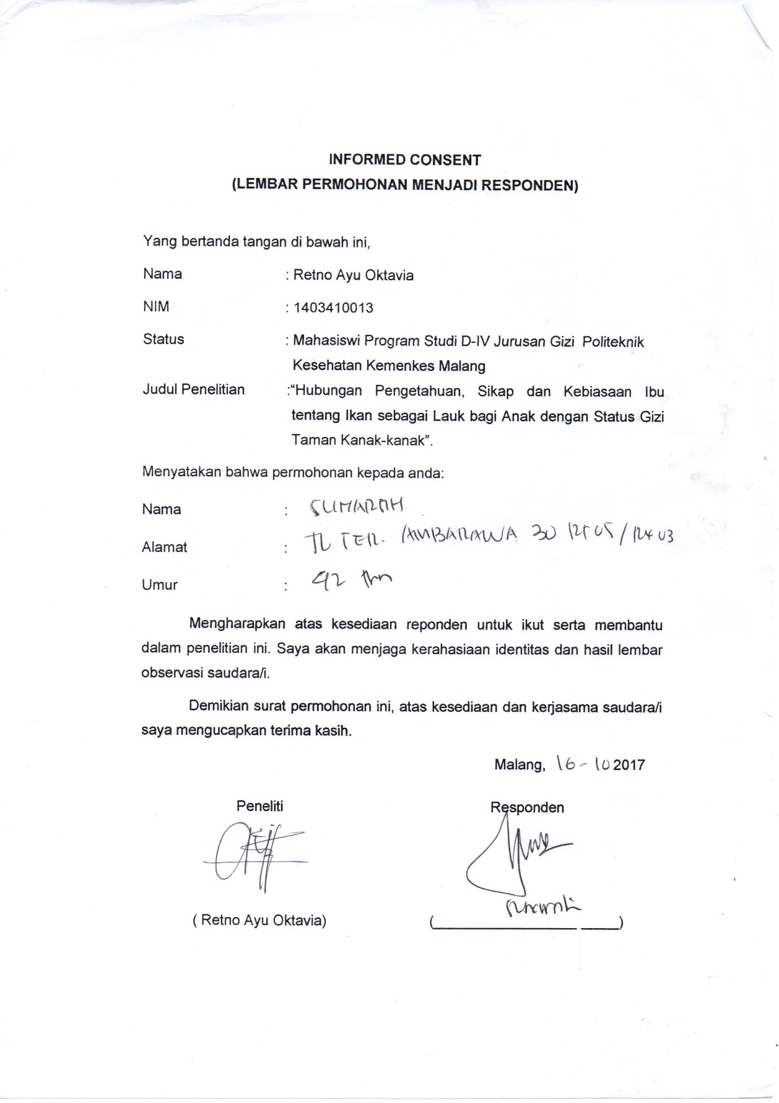

***Lampiran 5. Form Kuisioner Pengetahuan, Sikap dan Kebiasaan Responden***

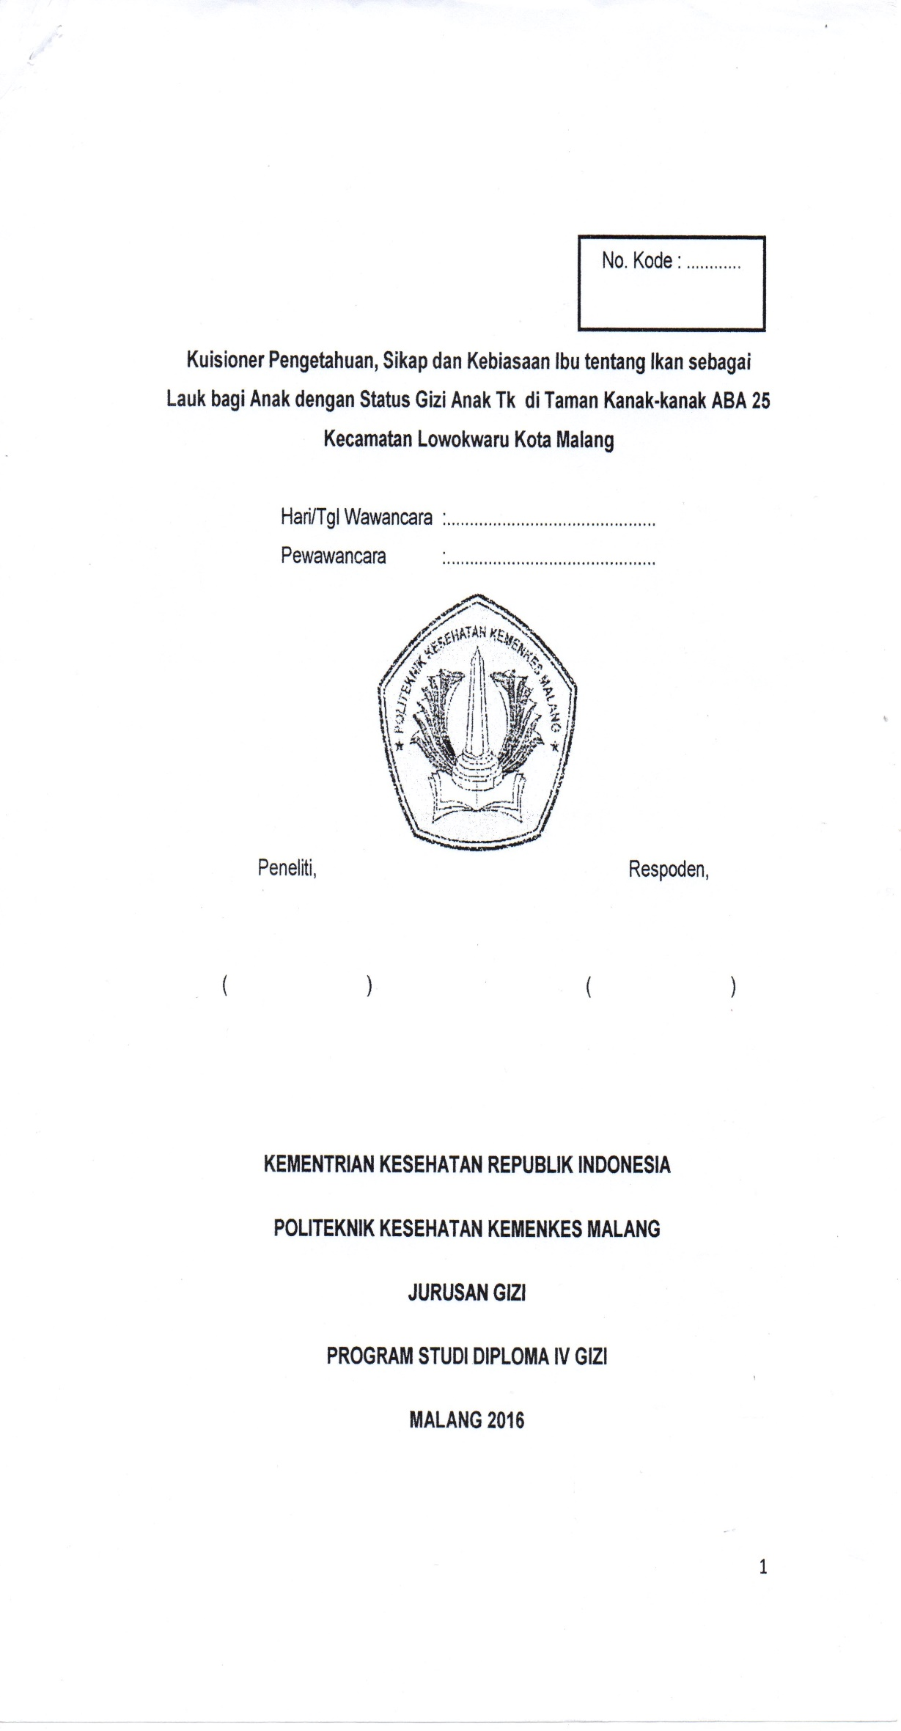

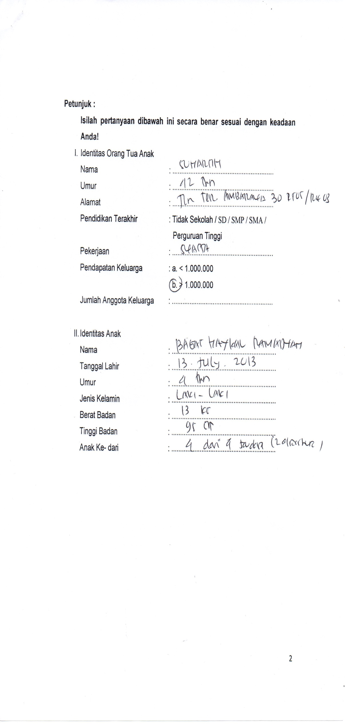

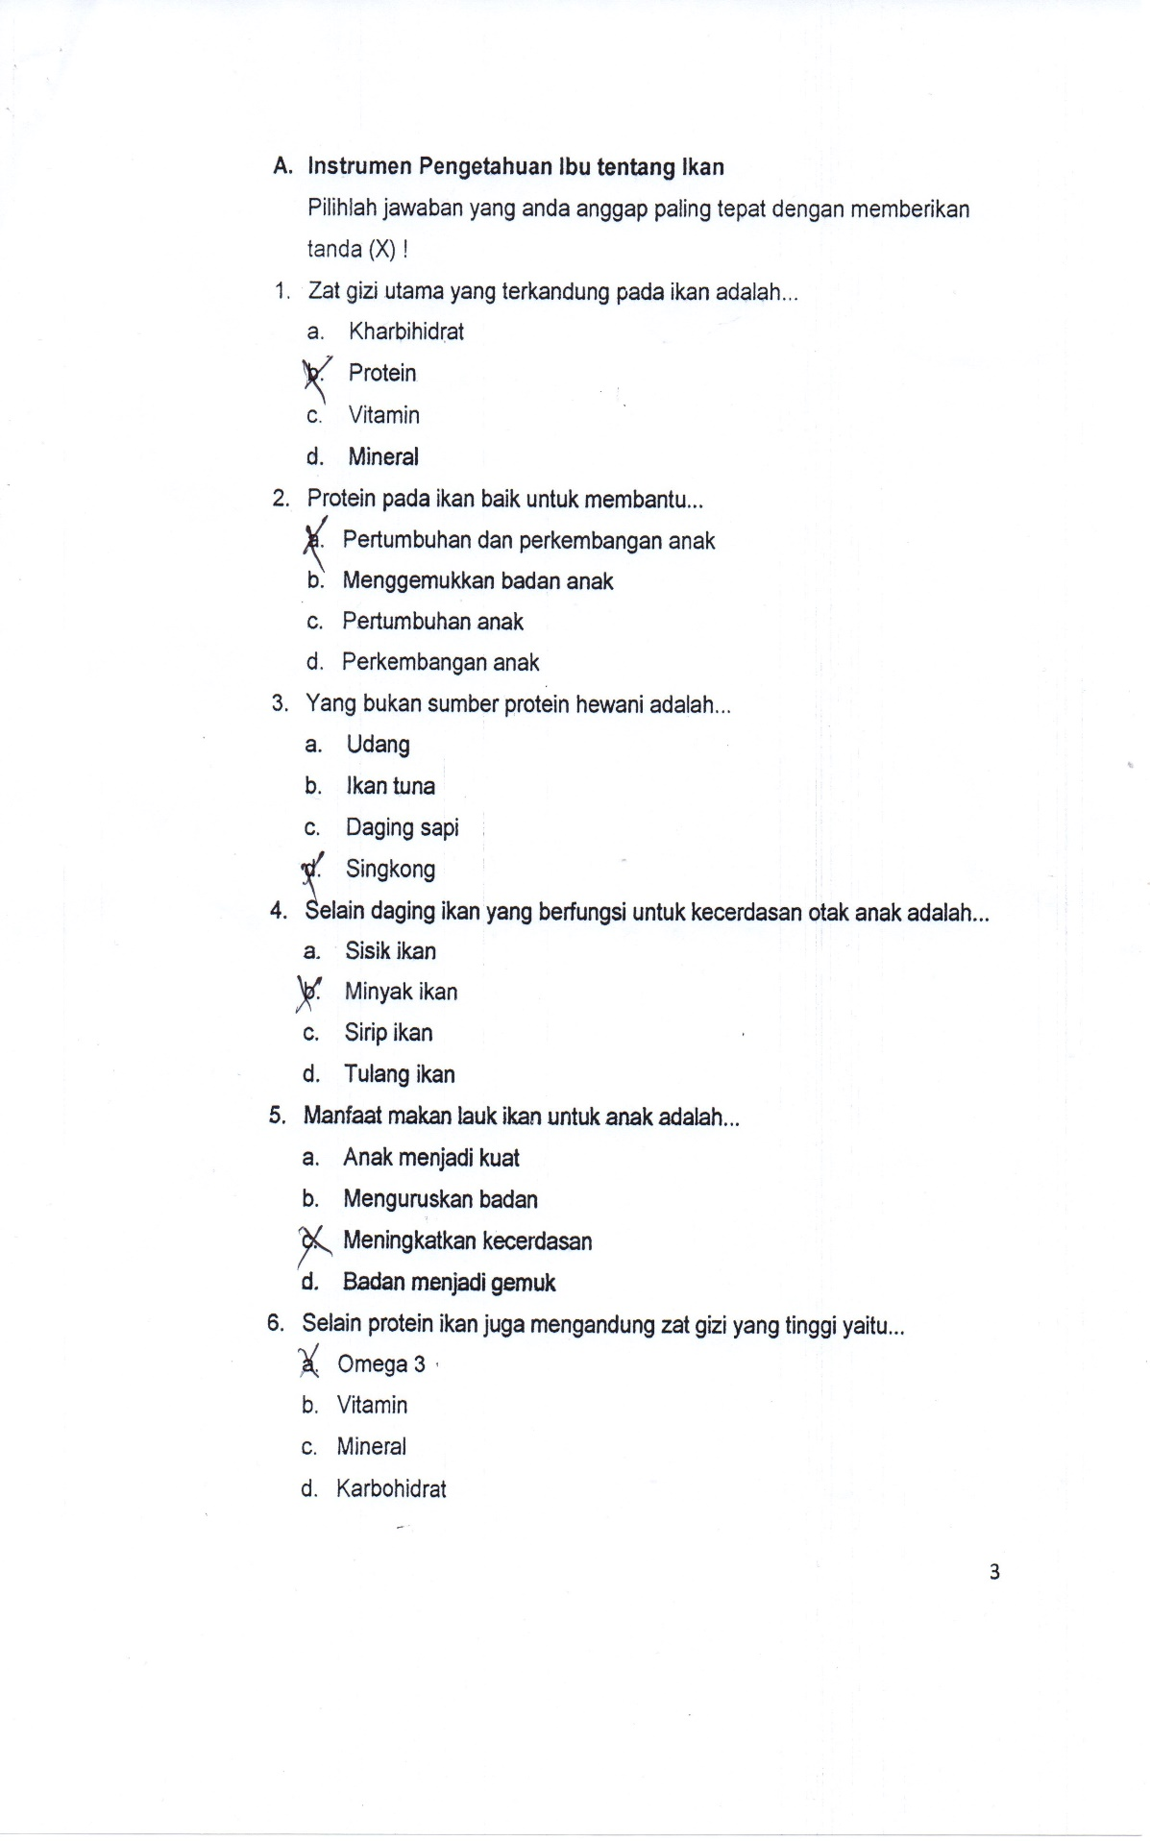

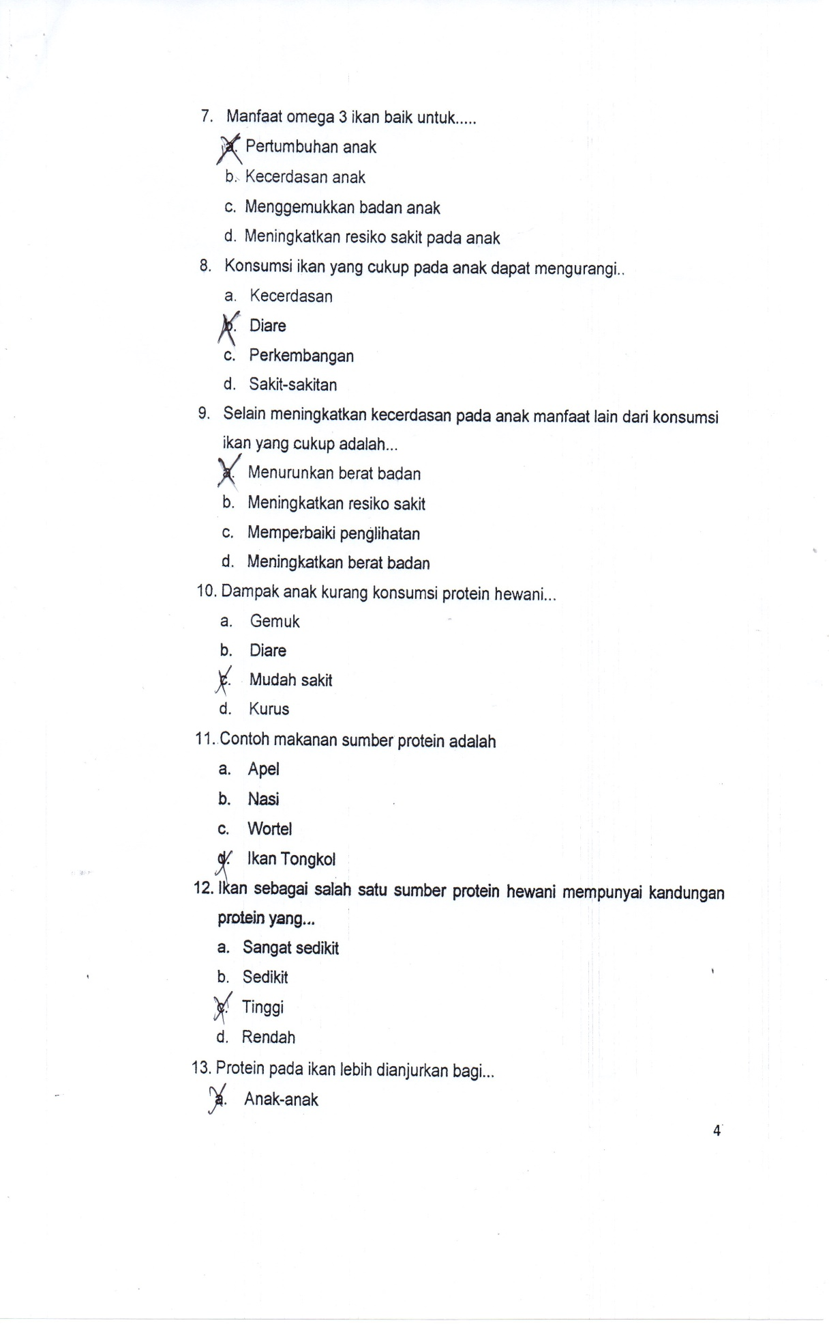

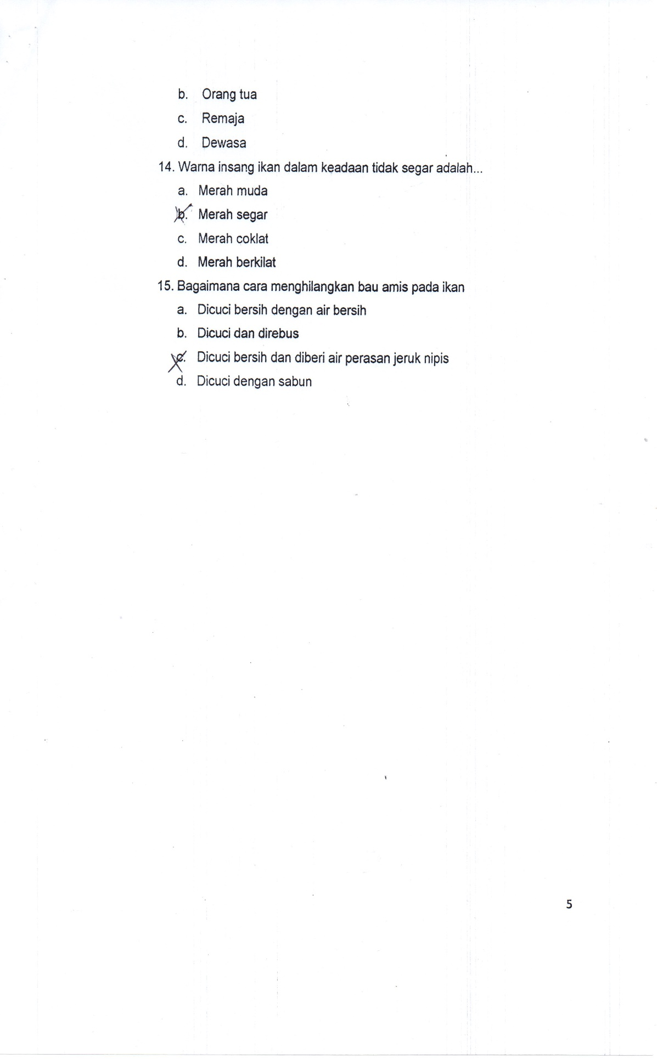

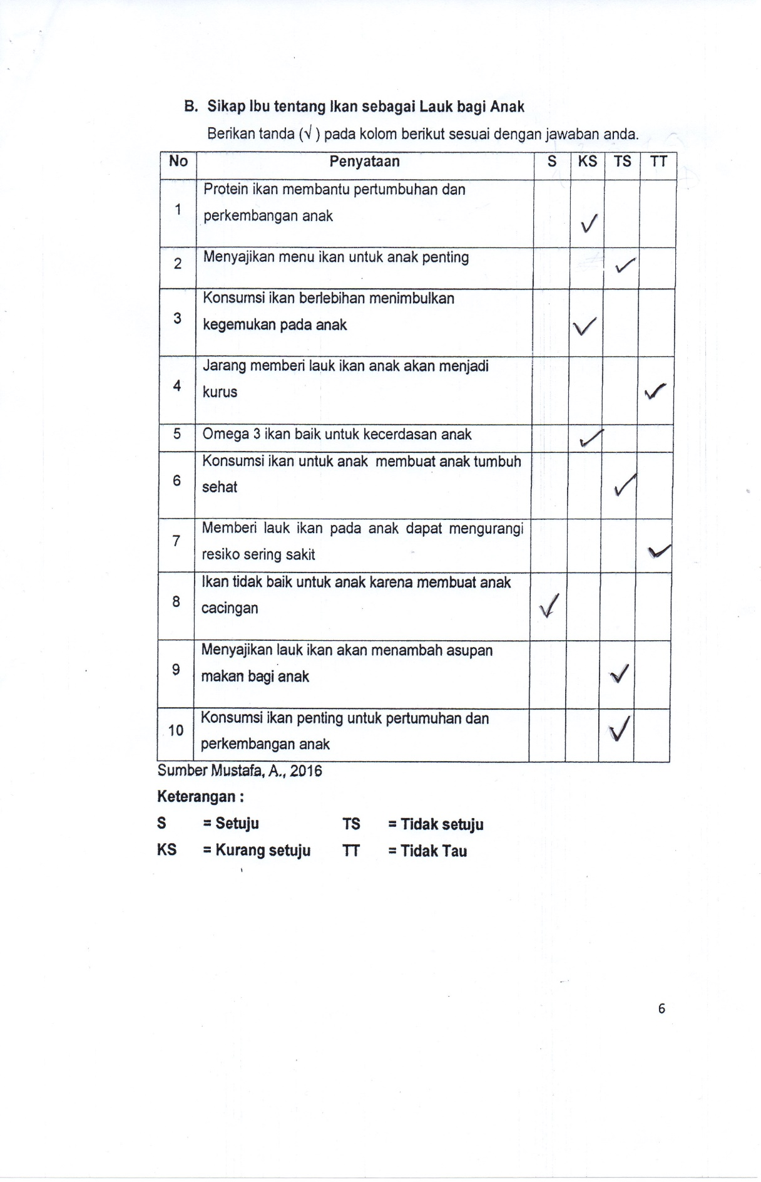

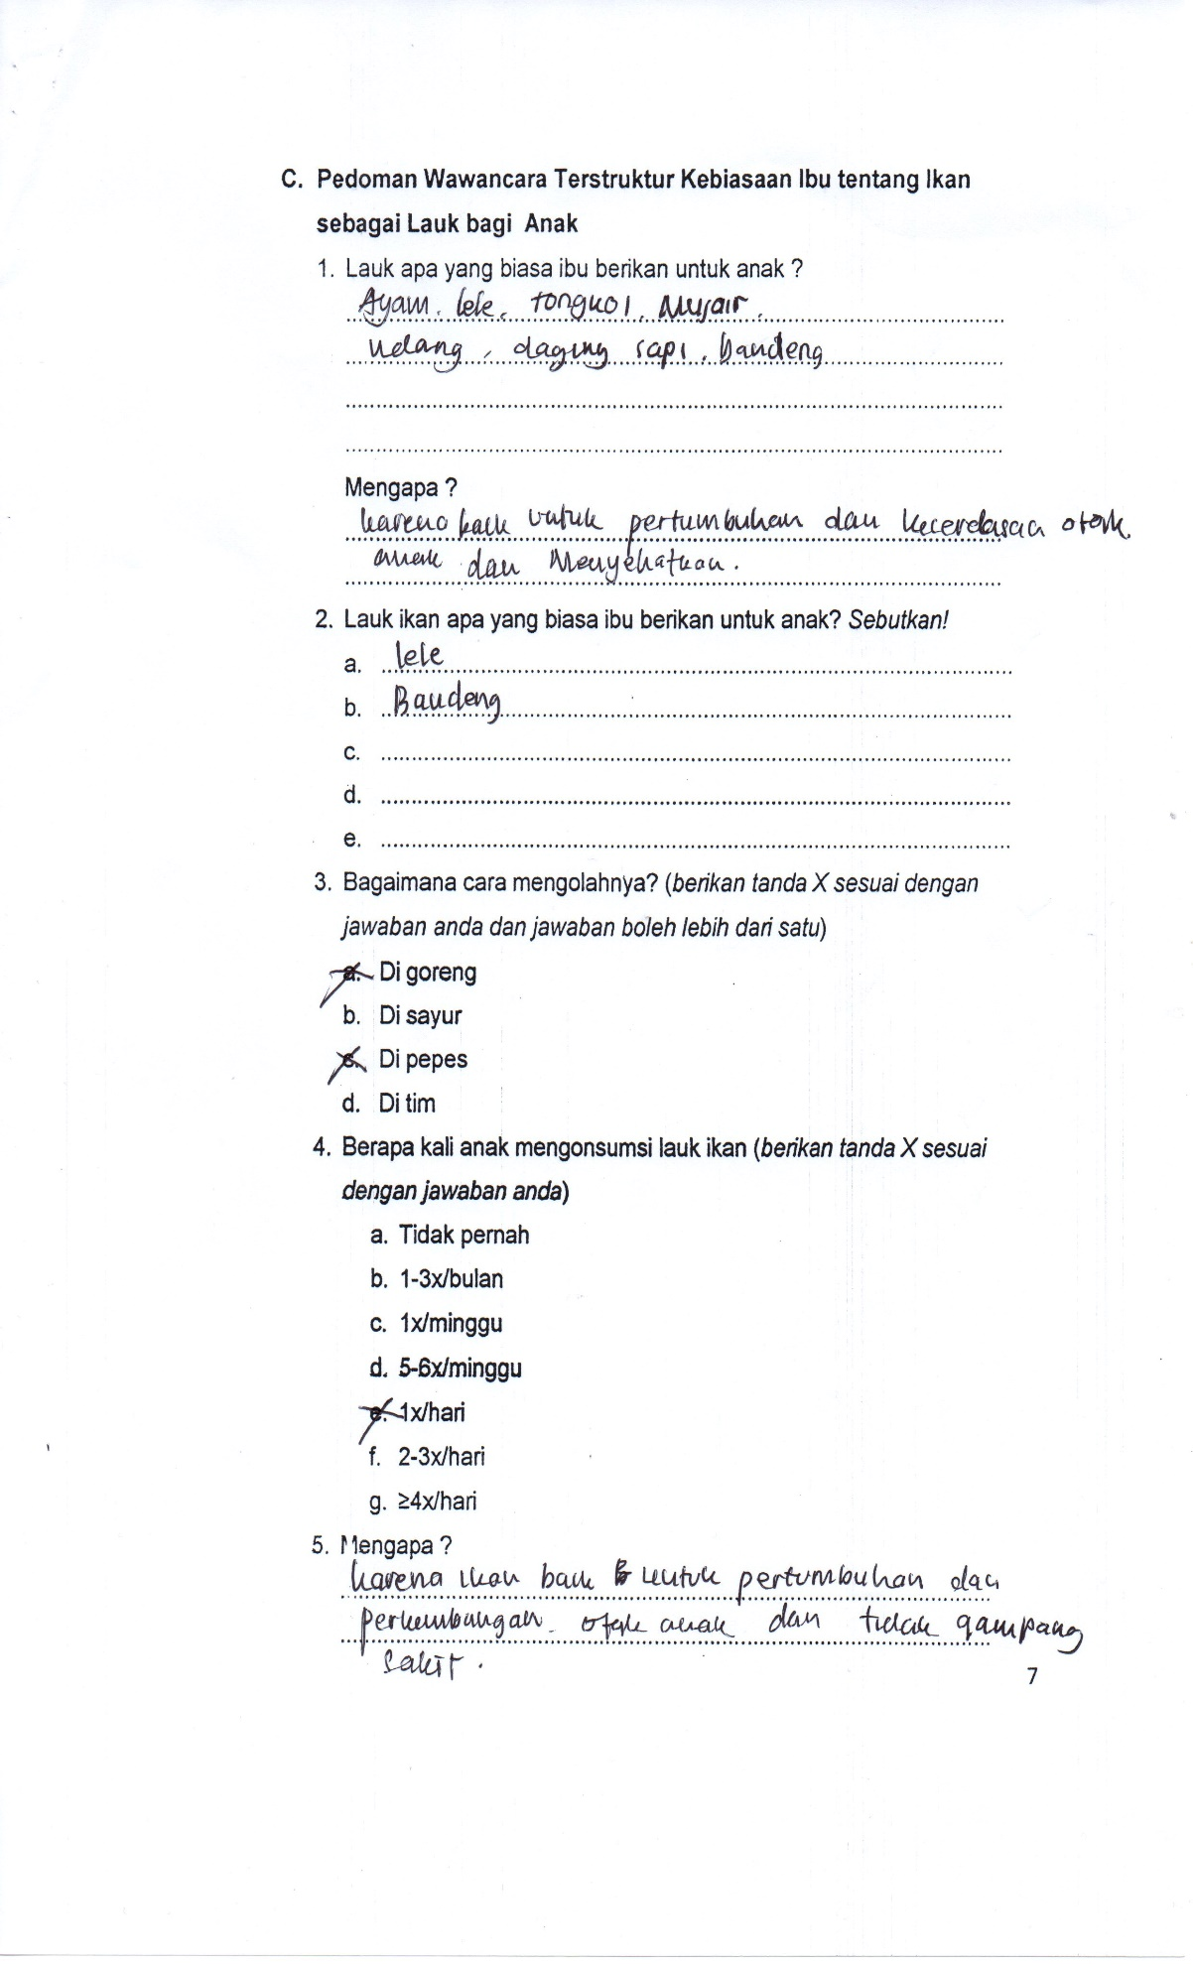

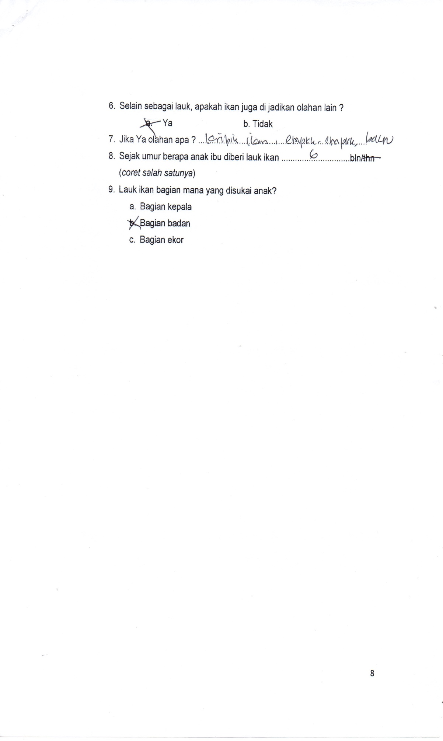

***Lampiran 6. Pengolahan Data***

|  |  |  |  |  |  |  |
| --- | --- | --- | --- | --- | --- | --- |
| **Nomor** | **Nama** | **TB** | **BB** | **Pendapatan** | **Pendidikan** | **Pekerjaan** |
| **(Cm)** | **(Kg)** |
| 1 | A1 | 115 | 32 | > 1.000.000 | SMA | Tidak |
| 2 | A2 | 102 | 14 | > 1.000.000 | Perguruan Tinggi | Bekerja |
| 3 | A3 | 103,5 | 15 | > 1.000.000 | SMA | Tidak |
| 4 | A4 | 97,4 | 12 | > 1.000.000 | SMA | Tidak |
| 5 | A5 | 93 | 12,5 | > 1.000.000 | SMA | Bekerja |
| 6 | A6 | 103,4 | 17 | > 1.000.000 | Perguruan Tinggi | Bekerja |
| 7 | A7 | 103,4 | 17 | > 1.000.000 | SMA | Tidak |
| 8 | A8 | 100,3 | 18 | > 1.000.000 | Perguruan Tinggi | Bekerja |
| 9 | A9 | 103,3 | 20 | > 1.000.000 | SMA | Bekerja |
| 10 | A10 | 93,5 | 13 | > 1.000.000 | SMA | Tidak |
| 11 | A11 | 104,1 | 17 | > 1.000.000 | Perguruan Tinggi | Bekerja |
| 12 | A12 | 97,1 | 13,5 | > 1.000.000 | SMP | Bekerja |
| 13 | A13 | 105,1 | 22 | > 1.000.000 | SMA | Bekerja |
| 14 | A14 | 97,9 | 16 | > 1.000.000 | SMA | Bekerja |
| 15 | A15 | 98 | 13 | > 1.000.000 | SMA | Bekerja |
| 16 | A16 | 108 | 15 | < 1.000.000 | SMA | Tidak |
| 17 | A17 | 97,2 | 16 | > 1.000.000 | Perguruan Tinggi | Bekerja |
| 18 | A18 | 104,1 | 16 | > 1.000.000 | SMA | Tidak |
| 19 | A19 | 107,6 | 22 | > 1.000.000 | SMA | Tidak |
| 20 | A20 | 103,3 | 16 | > 1.000.000 | Perguruan Tinggi | Tidak |
| 21 | A21 | 115 | 20 | < 1.000.000 | SMA | Tidak |
| 22 | A22 | 102 | 15 | > 1.000.000 | SMA | Bekerja |
| 23 | A23 | 106,6 | 19 | > 1.000.000 | SMA | Tidak |
| 24 | A24 | 112 | 19 | > 1.000.000 | Perguruan tinggi | Bekerja |
| 25 | A25 | 116 | 22 | > 1.000.000 | SMA | Tidak |
| 26 | A26 | 107 | 16 | > 1.000.000 | SMA | Tidak |
| 27 | A27 | 117 | 23 | > 1.000.000 | SMA | Tidak |
| 28 | A28 | 124,8 | 30 | > 1.000.000 | SMA | Tidak |
| 29 | A29 | 108,7 | 18 | > 1.000.000 | SMA | Tidak |
| 30 | A30 | 107 | 16 | > 1.000.000 | SMA | Bekerja |
| 31 | A31 | 110,5 | 18 | > 1.000.000 | SMA | Tidak |
| 32 | A32 | 103,1 | 17 | > 1.000.000 | Perguruan Tinggi | Bekerja |
| 33 | A33 | 110,2 | 18 | > 1.000.000 | SMA | Tidak |
| 34 | A34 | 118,2 | 21 | > 1.000.000 | SMA | Tidak |
| 35 | A35 | 106,2 | 19 | > 1.000.000 | SMA | Tidak |
| Rata-rata | | 105,8 | 18,0 | > 1.000.000 | SMA | Tidak bekerja |

**Pengetahuan Responden**

|  |  |  |  |  |  |  |  |  |  |  |  |  |  |  |  |  |  |  |  |
| --- | --- | --- | --- | --- | --- | --- | --- | --- | --- | --- | --- | --- | --- | --- | --- | --- | --- | --- | --- |
| **No** | **Nama** | **Pengetahuan Ibu** | | | | | | | | | | | | | | | Jmlh | Score | KP |
| 1 | 2 | 3 | 4 | 5 | 6 | 7 | 8 | 9 | 10 | 11 | 12 | 13 | 14 | 15 |
| 1 | A1 | 1 | 1 | 1 | 1 | 1 | 1 | 1 | 1 | 1 | 1 | 1 | 1 | 1 | 1 | 1 | 15 | 100 | Baik |
| 2 | A2 | 1 | 1 | 1 | 1 | 1 | 1 | 1 | 1 | 1 | 1 | 1 | 1 | 1 | 1 | 1 | 15 | 100 | Baik |
| 3 | A3 | 1 | 0 | 1 | 1 | 0 | 0 | 1 | 0 | 0 | 1 | 1 | 0 | 1 | 0 | 1 | 8 | 53 | kurang |
| 4 | A4 | 1 | 1 | 1 | 1 | 1 | 1 | 1 | 0 | 0 | 1 | 1 | 1 | 1 | 0 | 1 | 12 | 80 | cukup |
| 5 | A5 | 1 | 1 | 1 | 1 | 1 | 1 | 1 | 0 | 0 | 1 | 1 | 1 | 1 | 0 | 1 | 12 | 80 | Cukup |
| 6 | A6 | 1 | 1 | 1 | 1 | 1 | 1 | 1 | 1 | 1 | 1 | 1 | 1 | 1 | 1 | 1 | 15 | 100 | Baik |
| 7 | A7 | 1 | 0 | 1 | 1 | 0 | 0 | 1 | 0 | 0 | 1 | 1 | 0 | 1 | 0 | 1 | 8 | 53 | kurang |
| 8 | A8 | 1 | 1 | 1 | 1 | 1 | 1 | 0 | 1 | 1 | 1 | 1 | 1 | 1 | 1 | 1 | 14 | 93 | Baik |
| 9 | A9 | 1 | 1 | 1 | 1 | 1 | 1 | 1 | 1 | 1 | 1 | 1 | 1 | 1 | 1 | 1 | 15 | 100 | Baik |
| 10 | A10 | 1 | 0 | 1 | 1 | 0 | 1 | 0 | 0 | 0 | 1 | 1 | 0 | 1 | 0 | 1 | 8 | 53 | kurang |
| 11 | A11 | 1 | 1 | 1 | 1 | 1 | 1 | 1 | 1 | 1 | 1 | 1 | 1 | 1 | 1 | 1 | 15 | 100 | Baik |
| 12 | A12 | 1 | 1 | 1 | 1 | 1 | 1 | 1 | 0 | 0 | 1 | 1 | 1 | 1 | 0 | 1 | 12 | 80 | Cukup |
| 13 | A13 | 1 | 1 | 1 | 1 | 1 | 1 | 1 | 1 | 1 | 1 | 1 | 1 | 1 | 1 | 1 | 15 | 100 | Baik |
| 14 | A14 | 1 | 1 | 1 | 1 | 1 | 1 | 1 | 1 | 1 | 1 | 1 | 1 | 1 | 1 | 1 | 15 | 100 | Baik |
| 15 | A15 | 1 | 1 | 1 | 1 | 1 | 1 | 1 | 1 | 1 | 1 | 1 | 1 | 1 | 1 | 1 | 15 | 100 | Baik |
| 16 | A16 | 1 | 1 | 1 | 1 | 1 | 1 | 0 | 1 | 1 | 1 | 1 | 1 | 1 | 1 | 1 | 14 | 93 | Baik |
| 17 | A17 | 1 | 1 | 1 | 1 | 1 | 1 | 1 | 0 | 0 | 1 | 1 | 1 | 1 | 1 | 1 | 13 | 86 | Baik |
| 18 | A18 | 1 | 1 | 1 | 1 | 1 | 1 | 1 | 1 | 1 | 1 | 1 | 1 | 1 | 1 | 1 | 15 | 100 | Baik |
| 19 | A19 | 1 | 1 | 1 | 1 | 1 | 1 | 1 | 1 | 1 | 1 | 1 | 1 | 1 | 1 | 1 | 15 | 100 | Baik |
| 20 | A20 | 1 | 1 | 1 | 1 | 1 | 1 | 0 | 1 | 0 | 1 | 1 | 1 | 1 | 0 | 1 | 12 | 80 | cukup |
| 21 | A21 | 1 | 0 | 1 | 1 | 0 | 0 | 1 | 0 | 0 | 1 | 1 | 0 | 1 | 0 | 1 | 8 | 53 | kurang |
| 22 | A22 | 1 | 1 | 1 | 1 | 1 | 1 | 1 | 0 | 0 | 1 | 1 | 1 | 1 | 0 | 1 | 12 | 80 | cukup |
| 23 | A23 | 1 | 1 | 1 | 1 | 1 | 1 | 1 | 1 | 1 | 1 | 1 | 1 | 1 | 1 | 1 | 15 | 100 | Baik |
| 24 | A24 | 1 | 1 | 1 | 1 | 1 | 1 | 1 | 1 | 1 | 1 | 1 | 1 | 1 | 1 | 1 | 15 | 100 | Baik |
| 25 | A25 | 1 | 1 | 1 | 1 | 1 | 1 | 1 | 0 | 0 | 1 | 1 | 1 | 1 | 0 | 1 | 12 | 80 | cukup |
| 26 | A26 | 1 | 1 | 1 | 1 | 1 | 1 | 0 | 0 | 1 | 1 | 1 | 1 | 1 | 0 | 1 | 12 | 80 | cukup |
| 27 | A27 | 1 | 0 | 1 | 1 | 0 | 0 | 1 | 0 | 0 | 1 | 1 | 0 | 1 | 0 | 1 | 8 | 53 | kurang |
| 28 | A28 | 1 | 0 | 1 | 1 | 0 | 1 | 0 | 0 | 0 | 1 | 1 | 0 | 1 | 0 | 1 | 8 | 53 | kurang |
| 29 | A29 | 1 | 1 | 1 | 1 | 1 | 1 | 0 | 0 | 1 | 1 | 1 | 1 | 1 | 0 | 1 | 12 | 80 | cukup |
| 30 | A30 | 1 | 0 | 1 | 1 | 0 | 0 | 1 | 0 | 0 | 1 | 1 | 0 | 1 | 0 | 1 | 8 | 53 | kurang |
| 31 | A31 | 1 | 0 | 1 | 1 | 0 | 1 | 0 | 0 | 0 | 1 | 1 | 0 | 1 | 0 | 1 | 8 | 53 | kurang |
| 32 | A32 | 1 | 1 | 1 | 1 | 1 | 1 | 1 | 1 | 1 | 1 | 1 | 1 | 1 | 0 | 1 | 14 | 93 | Baik |
| 33 | A33 | 1 | 1 | 1 | 1 | 1 | 1 | 1 | 1 | 1 | 1 | 1 | 1 | 1 | 1 | 1 | 15 | 100 | Baik |
| 34 | A34 | 1 | 1 | 1 | 1 | 1 | 1 | 1 | 0 | 0 | 1 | 1 | 1 | 1 | 0 | 1 | 12 | 80 | cukup |
| 35 | A35 | 1 | 0 | 1 | 1 | 0 | 1 | 0 | 0 | 0 | 1 | 1 | 0 | 1 | 0 | 1 | 8 | 53 | kurang |
| Jumlah soal benar | | 35 | 26 | 35 | 35 | 26 | 30 | 27 | 17 | 18 | 35 | 35 | 26 | 35 | 17 | 35 | **Rata-rata = 430/35 = 12,3** | | |
| % | | 100 | 74 | 100 | 100 | 74 | 86 | 77 | 49 | 51 | 100 | 100 | 74 | 100 | 49 | 100 | **Rata-rata = 12,3/15 x 100% = 81,7** | | |

**Keterangan**

1. **= Salah**
2. **= Benar**

**Sikap Responden**

|  |  |  |  |  |  |  |  |  |  |  |  |  |  |  |
| --- | --- | --- | --- | --- | --- | --- | --- | --- | --- | --- | --- | --- | --- | --- |
| **Nomor** | **Nama** | **Sikap Ibu** | | | | | | | | | | Score | % | Kategori Sikap |
| 1 | 2 | 3 | 4 | 5 | 6 | 7 | 8 | 9 | 10 |
| (+) | (+) | (-) | (+) | (+) | (+) | (+) | (-) | (+) | (+) |
| 1 | A1 | 4 | 4 | 3 | 3 | 4 | 4 | 4 | 3 | 4 | 4 | 37 | 92,5 | Setuju |
| 2 | A2 | 4 | 4 | 2 | 2 | 4 | 4 | 4 | 3 | 4 | 4 | 35 | 87,5 | Setuju |
| 3 | A3 | 4 | 4 | 4 | 3 | 4 | 4 | 4 | 3 | 4 | 4 | 38 | 95 | Setuju |
| 4 | A4 | 4 | 3 | 2 | 1 | 4 | 2 | 1 | 1 | 2 | 4 | 24 | 60 | Tidak setuju |
| 5 | A5 | 3 | 2 | 2 | 1 | 3 | 2 | 1 | 1 | 2 | 2 | 19 | 47,5 | Tidak tahu |
| 6 | A6 | 4 | 4 | 3 | 3 | 4 | 4 | 4 | 3 | 4 | 4 | 37 | 92,5 | Setuju |
| 7 | A7 | 2 | 2 | 2 | 1 | 3 | 2 | 1 | 1 | 2 | 2 | 18 | 45 | Tidak tahu |
| 8 | A8 | 4 | 4 | 4 | 3 | 4 | 4 | 4 | 3 | 4 | 4 | 38 | 95 | Setuju |
| 9 | A9 | 4 | 4 | 3 | 3 | 4 | 4 | 4 | 3 | 4 | 4 | 37 | 92,5 | Setuju |
| 10 | A10 | 4 | 3 | 2 | 1 | 4 | 2 | 1 | 1 | 2 | 4 | 24 | 60 | Tidak setuju |
| 11 | A11 | 4 | 4 | 4 | 3 | 4 | 4 | 4 | 3 | 4 | 4 | 38 | 95 | Setuju |
| 12 | A12 | 4 | 4 | 3 | 2 | 4 | 3 | 1 | 2 | 3 | 4 | 29 | 72,5 | Kurang setuju |
| 13 | A13 | 4 | 4 | 3 | 3 | 4 | 4 | 4 | 3 | 4 | 4 | 37 | 92,5 | Setuju |
| 14 | A14 | 4 | 4 | 4 | 3 | 4 | 4 | 4 | 3 | 4 | 4 | 38 | 95 | Setuju |
| 15 | A15 | 4 | 4 | 3 | 3 | 4 | 4 | 4 | 3 | 4 | 4 | 37 | 92,5 | Setuju |
| 16 | A16 | 4 | 4 | 2 | 2 | 4 | 4 | 4 | 3 | 4 | 4 | 35 | 87,5 | Setuju |
| 17 | A17 | 4 | 4 | 2 | 2 | 4 | 4 | 4 | 3 | 4 | 4 | 35 | 87,5 | Setuju |
| 18 | A18 | 4 | 4 | 3 | 3 | 4 | 4 | 4 | 3 | 4 | 4 | 37 | 92,5 | Setuju |
| 19 | A19 | 4 | 4 | 4 | 3 | 4 | 4 | 4 | 3 | 4 | 4 | 38 | 95 | Setuju |
| 20 | A20 | 4 | 4 | 3 | 3 | 4 | 4 | 4 | 3 | 4 | 4 | 37 | 92,5 | Setuju |
| 21 | A21 | 4 | 4 | 3 | 2 | 3 | 3 | 1 | 2 | 3 | 4 | 28 | 70 | Kurang setuju |
| 22 | A22 | 3 | 2 | 2 | 1 | 3 | 2 | 1 | 1 | 2 | 2 | 19 | 47,5 | Tidak tahu |
| 23 | A23 | 4 | 4 | 4 | 3 | 4 | 4 | 4 | 3 | 4 | 4 | 38 | 95 | Setuju |
| 24 | A24 | 4 | 4 | 2 | 2 | 4 | 4 | 4 | 3 | 4 | 4 | 35 | 87,5 | Setuju |
| 25 | A25 | 3 | 2 | 2 | 1 | 3 | 2 | 1 | 1 | 2 | 2 | 19 | 47,5 | Tidak tahu |
| 26 | A26 | 3 | 2 | 2 | 1 | 3 | 2 | 1 | 1 | 2 | 2 | 19 | 47,5 | Tidak tahu |
| 27 | A27 | 4 | 4 | 3 | 2 | 3 | 3 | 1 | 2 | 3 | 4 | 28 | 70 | Kurang setuju |
| 28 | A28 | 4 | 4 | 3 | 2 | 4 | 3 | 1 | 2 | 3 | 4 | 29 | 72,5 | Kurang setuju |
| 29 | A29 | 4 | 3 | 2 | 1 | 4 | 2 | 1 | 1 | 2 | 4 | 24 | 60 | Tidak setuju |
| 30 | A30 | 4 | 4 | 3 | 2 | 3 | 3 | 1 | 2 | 3 | 4 | 28 | 70 | Kurang setuju |
| 31 | A31 | 4 | 4 | 3 | 2 | 4 | 3 | 1 | 2 | 3 | 4 | 29 | 72,5 | Kurang setuju |
| 32 | A32 | 4 | 4 | 3 | 2 | 4 | 3 | 1 | 2 | 3 | 4 | 29 | 72,5 | Kurang setuju |
| 33 | A33 | 4 | 4 | 3 | 3 | 4 | 4 | 4 | 3 | 4 | 4 | 37 | 92,5 | Setuju |
| 34 | A34 | 4 | 4 | 3 | 2 | 3 | 3 | 1 | 2 | 3 | 4 | 28 | 70 | Kurang setuju |
| 35 | A35 | 3 | 2 | 2 | 1 | 3 | 2 | 1 | 1 | 2 | 2 | 19 | 47,5 | Tidak tahu |

**Keterangan :**

**Jawaban Positif Jawaban Negatif**

**S ( Setuju) = 4 TT (Tidak tahu) = 4**

**KS (Kurang setuju) = 3 TS (Tidak setuju) = 3**

**TS (Tidak setuju) = 2 KS (Kurang setuju) = 2**

**TT (Tidak tahu) = 1 S (Setuju) = 1**

**Tabel Soal Penyataan Sikap**

|  |  |  |  |
| --- | --- | --- | --- |
| NO | Pernyataan | Skor | % |
| 1 | Protein ikan membantu pertumbuhan dan perkembangan anak | 133 | 95,0 |
| 2 | Menyajikan menu ikan untuk anak penting | 125 | 89,3 |
| 3 | Konsumsi ikan berlebihan menimbulkan kegemukan pada anak | 98 | 70,0 |
| 4 | Jarang memberi lauk ikan anak akan menjadi kurus | 75 | 53,6 |
| 5 | Omega 3 ikan baik untuk kecerdasan anak | 130 | 92,9 |
| 6 | Konsumsi ikan untuk anak membuat anak tumbuh sehat | 114 | 81,4 |
| 7 | Memberi lauk ikan pada anak dapat mengurangi resiko sering sakit | 104 | 74,3 |
| 8 | Ikan tidak baik untuk anak karena membuat anak cacingan | 89 | 63,6 |
| 9 | Menyajikan lauk ikan akan menambah asupan makan bagi anak | 79 | 56,4 |
| 10 | Konsumsi ikan penting untuk pertumuhan dan perkembangan anak | 128 | 91,4 |
| Rata-rata | | 107,5 | 76,79 |

35

70

105

140

TT

TS

S

KS

**Keterangan**

S = Setuju

KS = Kurang Setuju

TS = Tidak Setuju

TT = Tidak Tahu

**Kebiasaan Responden**

1. **Lauk apa yang biasa ibu berikan untuk anak** ?

**Jawaban**

1. Tempe = lllll lllll lllll lllll lllll ll 🡪 27 🡪15,2%
2. Tahu = lllll lllll lllll lllll ll 🡪 22 🡪 12,5%
3. Daging sapi = lllll lllll lllll ll 🡪 17 🡪9,5%
4. Telur = lllll lllll lllll ll 🡪 17 🡪 9,5%
5. Tongkol = lllll lllll lllll l 🡪 16 🡪 9%
6. Lele = lllll lllll lllll 🡪15 🡪 8,4%
7. Ikan laut = lllll lllll lllll 🡪 15 🡪 8,4%
8. Ayam = lllll lllll llll 🡪 14 🡪 7,8%
9. Mujaher = lllll llll 🡪 9 🡪 5%
10. Pindang = lllll 🡪 5 🡪 2,8%
11. Udang = lllll 🡪 5 🡪 2,8%
12. Bandeng = lllll 🡪 5 🡪 2,8%
13. Tuna = llll 🡪4 🡪 2,2%
14. Teri = lll 🡪 3 🡪 1,7%
15. Cumi = ll 🡪 2 🡪 1,1%
16. Salmon = l 🡪 1 🡪 0,5%

**Total = 178**

* 16 jenis lauk yang biasa di buat oleh ibu untuk anaknya
* Lauk hewani = 14 lauk
* Lauk nabati = 2 lauk

**Alasan**

* Karena banyak mengandung protein untuk pertumbuhan dan kecerdasan anak = lllll lllll lllll llll🡪 10
* Karena anak suka = ll 🡪 2
* Karena bergizi = ll 🡪 2
* Karena mengandung vitamin = l 🡪 1
* Karena mencerdaskan anak (baik untuk tumbuh kembang anak) = lllll lllll 🡪 10

1. **Lauk ikan apa yang biasa ibu berikan untuk anak? *Sebutkan!***

**Jawaban**

1. Tongkol = lllll lllll lllll lllll lllll lllll 🡪30 🡪20%
2. Lele = lllll lllll lllll lllll l 🡪 21🡪 14%
3. Mujaher = lllll lllll lllll lllll l 🡪 21 🡪 14%
4. Daging sapi = lllll lllll lllll lll 🡪 18 🡪 12%
5. Bandeng = lllll lllll ll 🡪 12 🡪 8%
6. Pindang = lllll llll 🡪 9 🡪 6%
7. Ayam = lllll lll 🡪 8 🡪5,2%
8. Tuna = lllll lll 🡪 8 🡪 5,2%
9. Udang = lllll ll 🡪 7 🡪 4,6%
10. Telur = lllll 🡪 5 🡪 3,3%
11. Gurame = llll 🡪 4 🡪 2,6%
12. Teri = lll 🡪 3 🡪 2%
13. Cumi = ll 🡪 2 🡪 1,3%
14. Kepiting = l 🡪 1 🡪 1,3%
15. Sea food = l 🡪 1 🡪 1,3%
16. Salmon = l 🡪1 🡪 1,3% **Total = 151**
17. **Bagaimana cara mengolahnya? (*berikan tanda X sesuai dengan jawaban anda dan jawaban boleh lebih dari satu*)**
18. Di goreng = lllll lllll lllll lllll lllll lllll l 🡪 31 = 39,7
19. Di sayur = lllll lllll lllll lllll lllll l 🡪 26 = 33,3
20. Di pepes = lllll lllll 🡪10 = 12,8%
21. Di tim = lllll lllll l 🡪 11 = 14%

**Total = 78**

1. **Berapa kali anak mengonsumsi lauk ikan (*berikan tanda X sesuai dengan jawaban anda*)**
2. Tidak pernah =
3. 1-3x/bulan =
4. 1x/minggu = lllll l 🡪 6
5. 5-6x/minggu = l 🡪 1
6. 1x/hari =
7. 2-3x/hari = lllll lllll lllll lllll lllll lll 🡪 28
8. ≥4x/hari =
9. **Mengapa?**

**Jawaban :**

* Karena banyak mengandung protein untuk pertumbuhan dan kecerdasan anak = lllll lllll l🡪6 = 22,2%
* Asupan zat gizi yang terpenuhi = lllll 🡪5 = 18,5%
* Permintaan anak = lllll l🡪 4 = 14,8%
* Supaya tidak sakit = lll 🡪 3 = 11%
* Karena bosan jika lauk ikan terus = lll 🡪 3 = 11%
* Karena anak tidak suka makanan selain ikan dan telur = ll 🡪 2 = 7,4%
* Karna dibutuhkan untuk anak = ll 🡪 2 = 7,4%
* Untuk menambah protein pada anak = ll 🡪 2 = 7,4%

**Total = 27**

1. **Selain sebagai lauk, apakah ikan juga di jadikan olahan lain ?**
   1. Ya = lllll lllll lllll lllll llll 🡪 25
   2. b. Tidak = lllll lllll 🡪 10
2. **Jika Ya olahan apa ?**

**Jawaban :**

* 1. Nugget ikan = lllll lllll llll 🡪 14 🡪 33,3%
  2. Bakso daging = lllll llll 🡪9 🡪 21,5%
  3. Kripik ikan = llll 🡪4 🡪 9,5%
  4. Rempeyek = lll 🡪 3 🡪 7,1%
  5. Bakso ikan = lll 🡪 3 🡪 7,1%
  6. Empek-empek = ll 🡪 2 🡪 4,8%
  7. Pentol = ll 🡪 2 🡪 4,8%
  8. Abon = ll 🡪 2 🡪 4,8%
  9. Puyam = l 🡪 1 🡪2,4%
  10. Kue = l 🡪 1 🡪 2,4%
  11. Sosis = l 🡪 1 🡪 2,4%

**Total = 42**

1. **Sejak umur berapa anak ibu diberi lauk ikan**

**Jawaban :**

* 1. 1 tahun = lllll lllll 🡪 10
  2. 6 bulan = lllll lllll 🡪 10
  3. 7 bulan = ll 🡪 2
  4. 2 tahun = l 🡪 1
  5. 10 bulan = lllll 🡪 5
  6. 8 bulan = lllll ll 🡪 7

1. **Lauk ikan bagian mana yang disukai anak?**
2. Bagian kepala = l 🡪 1 = 1,75%
3. Bagian badan = lllll lllll lllll lllll lllll lllll llll 🡪34 = 59,6%
4. Bagian ekor = lllll lllll lllll lllll ll 🡪 22 = 38,5

**Total = 57**

Soal Kebiasaan

|  |  |  |  |  |  |  |  |  |  |
| --- | --- | --- | --- | --- | --- | --- | --- | --- | --- |
| Nama | Soal Kebiasaan | | | | | | Jumlah | Score | KT |
| 1 | 2 | 3 | 4 | 6 | 8 |
| A1 | 1 | 1 | 1 | 5 | 1 | 1 | 10 | 90,9 | Baik |
| A2 | 1 | 1 | 1 | 5 | 1 | 1 | 10 | 90,9 | Baik |
| A3 | 1 | 0,6 | 0,75 | 3 | 0 | 1 | 6,35 | 57,7 | Kurang |
| A4 | 1 | 0,8 | 0,75 | 5 | 0 | 0 | 7,55 | 68,6 | Cukup |
| A5 | 1 | 0,2 | 0,5 | 4 | 1 | 1 | 7,7 | 70,0 | Cukup |
| A6 | 1 | 1 | 1 | 5 | 1 | 1 | 10 | 90,9 | Baik |
| A7 | 1 | 0,6 | 0,5 | 5 | 0 | 1 | 8,1 | 73,6 | Cukup |
| A8 | 1 | 1 | 1 | 5 | 1 | 0 | 9 | 81,8 | Baik |
| A9 | 1 | 1 | 1 | 5 | 1 | 1 | 10 | 90,9 | Baik |
| A10 | 1 | 1 | 0,75 | 3 | 0 | 1 | 6,75 | 61,4 | Cukup |
| A11 | 1 | 1 | 1 | 5 | 1 | 1 | 10 | 90,9 | Baik |
| A12 | 1 | 0,6 | 0,25 | 4 | 0 | 0 | 5,75 | 52,3 | Kurang |
| A13 | 1 | 1 | 1 | 5 | 1 | 1 | 10 | 90,9 | Baik |
| A14 | 1 | 1 | 1 | 4 | 1 | 1 | 9 | 81,8 | Baik |
| A15 | 1 | 1 | 1 | 5 | 1 | 1 | 10 | 90,9 | Baik |
| A16 | 1 | 1 | 0,75 | 5 | 1 | 1 | 9,75 | 88,6 | Baik |
| A17 | 1 | 0,6 | 0,75 | 3 | 0 | 1 | 6,35 | 57,7 | Kurang |
| A18 | 1 | 1 | 1 | 5 | 1 | 1 | 10 | 90,9 | Baik |
| A19 | 1 | 1 | 1 | 5 | 1 | 1 | 10 | 90,9 | Baik |
| A20 | 1 | 1 | 0,75 | 5 | 0 | 1 | 8,75 | 79,5 | Cukup |
| A21 | 1 | 0,8 | 0,75 | 3 | 0 | 1 | 6,55 | 59,5 | Kurang |
| A22 | 1 | 1 | 1 | 4 | 0 | 0 | 7 | 63,6 | Cukup |
| A23 | 1 | 1 | 1 | 5 | 1 | 1 | 10 | 90,9 | Baik |
| A24 | 1 | 1 | 1 | 5 | 1 | 1 | 10 | 90,9 | Baik |
| A25 | 1 | 1 | 0,75 | 5 | 1 | 1 | 9,75 | 88,6 | Baik |
| A26 | 1 | 0,6 | 0,5 | 3 | 1 | 1 | 7,1 | 64,5 | Cukup |
| A27 | 1 | 0,6 | 0,5 | 4 | 0 | 0 | 6,1 | 55,5 | Kurang |
| A28 | 1 | 1 | 0,5 | 3 | 1 | 0 | 6,5 | 59,1 | Kurang |
| A29 | 1 | 1 | 0,75 | 5 | 1 | 1 | 9,75 | 88,6 | Baik |
| A30 | 1 | 0,4 | 0,5 | 3 | 1 | 0 | 5,9 | 53,6 | Kurang |
| A31 | 1 | 0,6 | 0,25 | 4 | 0 | 0 | 5,85 | 53,2 | Kurang |
| A32 | 1 | 0,6 | 0,5 | 4 | 0 | 0 | 6,1 | 55,5 | Kurang |
| A33 | 1 | 1 | 1 | 5 | 1 | 1 | 10 | 90,9 | Baik |
| A34 | 1 | 1 | 1 | 3 | 1 | 0 | 7 | 63,6 | Cukup |
| A35 | 1 | 0,2 | 0,5 | 4 | 0 | 0 | 5,7 | 51,8 | Kurang |

***Lampiran 7. Status Gizi***

|  |  |  |  |  |  |  |  |  |  |  |
| --- | --- | --- | --- | --- | --- | --- | --- | --- | --- | --- |
| **Nama Responden** | **Usia (Tahun)** | **TB (cm)** | **BB (kg)** | **Indikator Pertumbuhan** | | | | | | **Masalah Pertumbuhan** |
| **BB/U** | | **TB/U** | | **BB/TB** | |
| **Z-score** | **Kategori** | **Z-score** | **Kategori** | **Z-score** | **Kategori** |
| A1 | 5 tahun 1 bulan | 115 | 32 | 3,87 | Sangat Gemuk | 0,69 | Normal | 4,84 | Sangat Gemuk | Sangat Gemuk |
| A2 | 4 tahun 6 bulan | 102 | 14 | -1,57 | Normal | -0,92 | Normal | -1,59 | Normal | Normal |
| A3 | 5 tahun 5 bulan | 103,5 | 15 | -1,14 | Normal | -0,75 | Normal | -1,06 | Normal | Normal |
| A4 | 5 tahun | 97,4 | 12 | -2,23 | Berat badan kurang | -2,24 | Pendek | -1,24 | Normal | berat badan kurang, pendek |
|
| A5 | 4 tahun | 93 | 12,5 | -2,2 | Berat badan kurang | -2,67 | Pendek | -2,73 | Kurus | Berat badan kurang, Pendek, kurus |
| A6 | 5 tahun 6 bulan | 103,4 | 17 | -0,31 | Normal | -1 | Normal | 0,46 | Normal | Normal |
| A7 | 5 tahun | 103,4 | 17 | -0,56 | Normal | -1,41 | Normal | 0,46 | Normal | Normal |
| A8 | 5 tahun 1 bulan | 100,3 | 18 | 0,41 | Normal | -1,24 | Normal | 1,81 | Normal | Normal |
| A9 | 4 Tahun | 103,3 | 20 | 0,95 | Normal | -0,62 | Normal | 2,19 | Gemuk | Gemuk |
| A10 | 5 tahun 3 bulan | 93,5 | 13 | -2,1 | Berat badan kurang | -2,61 | Pendek | -0,44 | Normal | Pendek |
| A11 | 4 tahun | 104,1 | 17 | 0,04 | Normal | -0,25 | Normal | 0,31 | Normal | Normal |
| A12 | 5 tahun | 97,1 | 13,5 | -2 | Berat badan kurang | -2,07 | Pendek | 0,35 | Normal | Pendek |
| A13 | 5 tahun | 105,1 | 22 | 1,45 | Normal | -0,86 | Normal | 2,98 | Gemuk | Gemuk |
| A14 | 5 tahun | 97,9 | 16 | -0,53 | Normal | -1,85 | Normal | 0,95 | Normal | Normal |
| A15 | 4 tahun 7 bulan | 98 | 13,5 | -2,01 | Berat badan kurang | -0,96 | Normal | -2,27 | Kurus | Berat badan kurang, kurus |
| A16 | 4 tahun 6 bulan | 108 | 15 | -1,03 | Normal | 0,27 | Normal | -1,92 | Normal | Normal |
| A17 | 5 tahun | 97,2 | 16 | -0,81 | Normal | -2,45 | Pendek | 1,1 | Normal | Pendek |
| A18 | 5 tahun 1 bulan | 104,1 | 16 | -0,46 | Normal | -0,31 | Normal | -0,41 | Normal | Normal |
| A19 | 6 tahun 9 bulan | 107,6 | 22 | 1,35 | Normal | -0,48 | Normal | 2,4 | Gemuk | Gemuk |
| A20 | 5 tahun | 103,3 | 16 | -1,44 | Normal | -2,02 | Pendek | -0,15 | Normal | Pendek |
| A21 | 6 tahun 3 bulan | 115 | 20 | -0,32 | Normal | -0,44 | Normal | -0,36 | Normal | Normal |
| A22 | 6 tahun 4 bulan | 102 | 15 | -2 | Berat badan kurang | -2,04 | Pendek | -0,61 | Normal | Pendek |
| A23 | 6 tahun 2 bulan | 106,6 | 19 | -58 | Normal | -1,91 | Normal | 0,97 | Normal | Normal |
| A24 | 6 tahun 6 bulan | 112 | 19 | -0,29 | Normal | -0,4 | Normal | -1,5 | Normal | Normal |
| A25 | 6 tahun 1 bulan | 116 | 22 | 0,48 | Normal | 0,01 | Normal | 0,72 | Normal | Normal |
| A26 | 6 tahun 1 bulan | 107 | 16 | -2,16 | Berat badan kurang | -2,01 | Pendek | -1,13 | Normal | Berat badan kurang, pendek |
| A27 | 6 tahun 1 bulan | 117 | 23 | 0,74 | Normal | 0,07 | Normal | 1,05 | Normal | Normal |
| A28 | 6 tahun 1 bulan | 124,8 | 30 | 2,35 | Gemuk | 1,6 | normal | 2,95 | Gemuk | Gemuk |
| A29 | 6 tahun 5 bulan | 108,7 | 18 | -2,1 | Berat badan kurang | -2 | Pendek | -0,1 | Normal | Pendek |
| A30 | 5 tahun 8 bulan | 107 | 14 | -2,2 | Berat badan kurang | -1,19 | Normal | -1,8 | Normal | Normal |
| A31 | 6 tahun | 110,5 | 18 | -0,82 | Normal | -1,05 | Normal | -0,5 | Normal | Normal |
| A32 | 6 tahun 6 bulan | 103,1 | 15,5 | -1,84 | Normal | -2,28 | Pendek | -2,63 | Kurus | Berat badan kurang, pendek, kurus |
| A33 | 6 tahun 2 bulan | 110,2 | 18 | -0,97 | Normal | -1,24 | Normal | -0,41 | Normal | Normal |
| A34 | 6 tahun 6 bulan | 118,2 | 21 | 0,23 | Normal | 0,49 | Normal | -0,22 | Normal | Normal |
| A35 | 6 tahun 2 bulan | 106,2 | 19 | -0,75 | Normal | -2,19 | Pendek | 1,12 | Normal | Normal |

BB/U = 22,8%

TB/U = 31,43%

BB/TB = 25,72%

**Karakteristik : Kronis dan Akut**

|  |  |  |  |  |  |  |
| --- | --- | --- | --- | --- | --- | --- |
| **Z-score** | TB/U | | BB/U | | BB/TB | |
| n | % | n | % | n | % |
| Diatas 3 | 0 | 0 | 1 | 2,86 | 1 | 2,86 |
| Diatas 2 | 0 | 0 | 1 | 2,86 | 4 | 11,43 |
| Diatas 1 | 1 | 2,86 | 3 | 8,57 | 4 | 11,43 |
| Median | 14 | 40 | 17 | 48,5 | 14 | 40 |
| Dibawah -1 | 9 | 25,7 | 5 | 14,2 | 9 | 25,7 |
| Dibawah -2 | 11 | 31,43 | 8 | 22,8 | 3 | 8,57 |
| Dibawah -3 | 0 | 0 | 0 | 0 | 0 | 0 |

***Lampiran 8. Uji Hubungan Pengetahuan Ibu dengan Status Gizi (BB/U) Anak***

|  |  |  |  |  |  |  |
| --- | --- | --- | --- | --- | --- | --- |
| **Case Processing Summary** | | | | | | |
|  | Cases | | | | | |
| Valid | | Missing | | Total | |
| N | Percent | N | Percent | N | Percent |
| TingkatPengetahuanIbu * StatusGizi | 35 | 100,0% | 0 | 0,0% | 35 | 100,0% |

|  |  |  |  |  |
| --- | --- | --- | --- | --- |
| **TingkatPengetahuanIbu * StatusGizi Crosstabulation** | | | | |
| Count | | | | |
|  | | StatusGizi | | Total |
| Normal | Malnutri |
| TingkatPengetahuanIbu | Baik | 15 | 2 | 17 |
| Kurang | 9 | 9 | 18 |
| Total | | 24 | 11 | 35 |

Keterangan :

Malnutrisi adalah sangat gemuk, gemuk, kurang dan sangat kurang

|  |  |  |  |  |  |
| --- | --- | --- | --- | --- | --- |
| **Chi-Square Tests** | | | | | |
|  | Value | df | Asymp. Sig. (2-sided) | Exact Sig. (2-sided) | Exact Sig. (1-sided) |
| Pearson Chi-Square | 5,931a | 1 | ,015 |  |  |
| Continuity Correctionb | 4,289 | 1 | ,038 |  |  |
| Likelihood Ratio | 6,306 | 1 | ,012 |  |  |
| Fisher's Exact Test |  |  |  | ,027 | ,018 |
| Linear-by-Linear Association | 5,761 | 1 | ,016 |  |  |
| N of Valid Cases | 35 |  |  |  |  |

|  |
| --- |
| a. 0 cells (0,0%) have expected count less than 5. The minimum expected count is 5,34. |
| b. Computed only for a 2x2 table |

***Lampiran 9. Uji Hubungan Pengetahuan Ibu dengan Status Gizi (TB/U) Anak***

|  |  |  |  |  |  |  |
| --- | --- | --- | --- | --- | --- | --- |
| **Case Processing Summary** | | | | | | |
|  | Cases | | | | | |
| Valid | | Missing | | Total | |
| N | Percent | N | Percent | N | Percent |
| TingkatPengetahuanIbu * StatusGizi | 35 | 100,0% | 0 | 0,0% | 35 | 100,0% |

|  |  |  |  |  |
| --- | --- | --- | --- | --- |
| **TingkatPengetahuanIbu * StatusGizi Crosstabulation** | | | | |
| Count | | | | |
|  | | StatusGizi | | Total |
| Normal | Pendek |
| TingkatPengetahuanIbu | baik | 15 | 2 | 17 |
| kurang | 9 | 9 | 18 |
| Total | | 24 | 11 | 35 |

|  |  |  |  |  |  |
| --- | --- | --- | --- | --- | --- |
| **Chi-Square Tests** | | | | | |
|  | Value | df | Asymp. Sig. (2-sided) | Exact Sig. (2-sided) | Exact Sig. (1-sided) |
| Pearson Chi-Square | 5,931a | 1 | ,015 |  |  |
| Continuity Correctionb | 4,289 | 1 | ,038 |  |  |
| Likelihood Ratio | 6,306 | 1 | ,012 |  |  |
| Fisher's Exact Test |  |  |  | ,027 | ,018 |
| Linear-by-Linear Association | 5,761 | 1 | ,016 |  |  |
| N of Valid Cases | 35 |  |  |  |  |

|  |
| --- |
| a. 0 cells (0,0%) have expected count less than 5. The minimum expected count is 5,34. |
| b. Computed only for a 2x2 table |

***Lampiran 10. Uji Hubungan Pengetahuan Ibu dengan Status Gizi (BB/TB) Anak***

|  |  |  |  |  |  |  |
| --- | --- | --- | --- | --- | --- | --- |
| **Case Processing Summary** | | | | | | |
|  | Cases | | | | | |
| Valid | | Missing | | Total | |
| N | Percent | N | Percent | N | Percent |
| TingkatPengetahuanIbu * StatusGizi | 35 | 100,0% | 0 | 0,0% | 35 | 100,0% |

|  |  |  |  |  |
| --- | --- | --- | --- | --- |
| **TingkatPengetahuanIbu * StatusGizi Crosstabulation** | | | | |
| Count | | | | |
|  | | StatusGizi | | Total |
| Baik | Malnutrisi |
| TingkatPengetahuanIbu | Baik | 11 | 6 | 17 |
| Kurang | 16 | 2 | 18 |
| Total | | 27 | 8 | 35 |

Keterangan :

Malnutrisi (sangat gemuk, gemuk, kurus dan sangat kurus)

|  |  |  |  |  |  |
| --- | --- | --- | --- | --- | --- |
| **Chi-Square Tests** | | | | | |
|  | Value | df | Asymp. Sig. (2-sided) | Exact Sig. (2-sided) | Exact Sig. (1-sided) |
| Pearson Chi-Square | 2,900a | 1 | ,089 |  |  |
| Continuity Correctionb | 1,690 | 1 | ,194 |  |  |
| Likelihood Ratio | 2,996 | 1 | ,083 |  |  |
| Fisher's Exact Test |  |  |  | ,121 | ,096 |
| Linear-by-Linear Association | 2,817 | 1 | ,093 |  |  |
| N of Valid Cases | 35 |  |  |  |  |

|  |
| --- |
| a. 2 cells (50,0%) have expected count less than 5. The minimum expected count is 3,89. |
| b. Computed only for a 2x2 table |

***Lampiran 11. Uji Hubungan Sikap Ibu dengan Status Gizi (BB/U) Anak***

|  |  |  |  |  |  |  |
| --- | --- | --- | --- | --- | --- | --- |
| **Case Processing Summary** | | | | | | |
|  | Cases | | | | | |
| Valid | | Missing | | Total | |
| N | Percent | N | Percent | N | Percent |
| SikapIbu * StatusGizi | 35 | 100,0% | 0 | 0,0% | 35 | 100,0% |

|  |  |  |  |  |
| --- | --- | --- | --- | --- |
| **SikapIbu * StatusGizi Crosstabulation** | | | | |
| Count | | | | |
|  | | StatusGizi | | Total |
| Baik | Malnutrisi |
| SikapIbu | Setuju | 15 | 2 | 17 |
| Kurag setuju | 9 | 9 | 18 |
| Total | | 24 | 11 | 35 |

Keterangan :

Malnutrisi adalah sangat gemuk, gemuk, kurang dan sangat kurang

|  |  |  |  |  |  |
| --- | --- | --- | --- | --- | --- |
| **Chi-Square Tests** | | | | | |
|  | Value | df | Asymp. Sig. (2-sided) | Exact Sig. (2-sided) | Exact Sig. (1-sided) |
| Pearson Chi-Square | 5,931a | 1 | ,015 |  |  |
| Continuity Correctionb | 4,289 | 1 | ,038 |  |  |
| Likelihood Ratio | 6,306 | 1 | ,012 |  |  |
| Fisher's Exact Test |  |  |  | ,027 | ,018 |
| Linear-by-Linear Association | 5,761 | 1 | ,016 |  |  |
| N of Valid Cases | 35 |  |  |  |  |

|  |
| --- |
| a. 0 cells (0,0%) have expected count less than 5. The minimum expected count is 5,34. |
| b. Computed only for a 2x2 table |

***Lampiran 12. Uji Hubungan Sikap Ibu dengan Status Gizi (TB/U) Anak***

|  |  |  |  |  |  |  |
| --- | --- | --- | --- | --- | --- | --- |
| **Case Processing Summary** | | | | | | |
|  | Cases | | | | | |
| Valid | | Missing | | Total | |
| N | Percent | N | Percent | N | Percent |
| SikapIbu * StatusGizi | 35 | 100,0% | 0 | 0,0% | 35 | 100,0% |

|  |  |  |  |  |
| --- | --- | --- | --- | --- |
| **SikapIbu * StatusGizi Crosstabulation** | | | | |
| Count | | | | |
|  | | StatusGizi | | Total |
| Normal | Pendek |
| SikapIbu | Setuju | 16 | 1 | 17 |
| Kurang Setuju | 8 | 10 | 18 |
| Total | | 24 | 11 | 35 |

|  |  |  |  |  |  |
| --- | --- | --- | --- | --- | --- |
| **Chi-Square Tests** | | | | | |
|  | Value | df | Asymp. Sig. (2-sided) | Exact Sig. (2-sided) | Exact Sig. (1-sided) |
| Pearson Chi-Square | 10,010a | 1 | ,002 |  |  |
| Continuity Correctionb | 7,838 | 1 | ,005 |  |  |
| Likelihood Ratio | 11,237 | 1 | ,001 |  |  |
| Fisher's Exact Test |  |  |  | ,003 | ,002 |
| Linear-by-Linear Association | 9,724 | 1 | ,002 |  |  |
| N of Valid Cases | 35 |  |  |  |  |

|  |
| --- |
| a. 0 cells (0,0%) have expected count less than 5. The minimum expected count is 5,34. |
| b. Computed only for a 2x2 table |

***Lampiran 13. Uji Hubungan Sikap Ibu dengan Status Gizi (BB/TB) Anak***

|  |  |  |  |  |  |  |
| --- | --- | --- | --- | --- | --- | --- |
| **Case Processing Summary** | | | | | | |
|  | Cases | | | | | |
| Valid | | Missing | | Total | |
| N | Percent | N | Percent | N | Percent |
| SikapIbu * StatusGizi | 35 | 100,0% | 0 | 0,0% | 35 | 100,0% |

|  |  |  |  |  |
| --- | --- | --- | --- | --- |
| **SikapIbu * StatusGizi Crosstabulation** | | | | |
| Count | | | | |
|  | | StatusGizi | | Total |
| Baik | Malnutrisi |
| SikapIbu | Setuju | 13 | 5 | 18 |
| Kurang setuju | 14 | 3 | 17 |
| Total | | 27 | 8 | 35 |

Keterangan :

Malnutrisi adalah sangat gemuk, gemuk, kurang dan sangat kurang

|  |  |  |  |  |  |
| --- | --- | --- | --- | --- | --- |
| **Chi-Square Tests** | | | | | |
|  | Value | df | Asymp. Sig. (2-sided) | Exact Sig. (2-sided) | Exact Sig. (1-sided) |
| Pearson Chi-Square | ,509a | 1 | ,476 |  |  |
| Continuity Correctionb | ,097 | 1 | ,756 |  |  |
| Likelihood Ratio | ,514 | 1 | ,473 |  |  |
| Fisher's Exact Test |  |  |  | ,691 | ,380 |
| Linear-by-Linear Association | ,494 | 1 | ,482 |  |  |
| N of Valid Cases | 35 |  |  |  |  |

|  |
| --- |
| a. 2 cells (50,0%) have expected count less than 5. The minimum expected count is 3,89. |
| b. Computed only for a 2x2 table |

***Lampiran 14. Uji Hubungan Kebiasaan Ibu dengan Status Gizi (BB/U) Anak***

|  |  |  |  |  |  |  |
| --- | --- | --- | --- | --- | --- | --- |
| **Case Processing Summary** | | | | | | |
|  | Cases | | | | | |
| Valid | | Missing | | Total | |
| N | Percent | N | Percent | N | Percent |
| KebiasaanIbu * StatusGizi | 35 | 100,0% | 0 | 0,0% | 35 | 100,0% |

|  |  |  |  |  |
| --- | --- | --- | --- | --- |
| **KebiasaanIbu * StatusGizi Crosstabulation** | | | | |
| Count | | | | |
|  | | StatusGizi | | Total |
| Baik | Malnutrisi |
| KebiasaanIbu | Baik | 15 | 2 | 17 |
| Kurang | 9 | 9 | 18 |
| Total | | 24 | 11 | 35 |

Keterangan :

Malnutrisi adalah sangat gemuk, gemuk, kurang dan sangat kurang

|  |  |  |  |  |  |
| --- | --- | --- | --- | --- | --- |
| **Chi-Square Tests** | | | | | |
|  | Value | df | Asymp. Sig. (2-sided) | Exact Sig. (2-sided) | Exact Sig. (1-sided) |
| Pearson Chi-Square | 5,931a | 1 | ,015 |  |  |
| Continuity Correctionb | 4,289 | 1 | ,038 |  |  |
| Likelihood Ratio | 6,306 | 1 | ,012 |  |  |
| Fisher's Exact Test |  |  |  | ,027 | ,018 |
| Linear-by-Linear Association | 5,761 | 1 | ,016 |  |  |
| N of Valid Cases | 35 |  |  |  |  |

|  |
| --- |
| a. 0 cells (0,0%) have expected count less than 5. The minimum expected count is 5,34. |
| b. Computed only for a 2x2 table |

***Lampiran 15. Uji Hubungan Kebiasaan Ibu dengan Status Gizi (TB/U) Anak***

|  |  |  |  |  |  |  |
| --- | --- | --- | --- | --- | --- | --- |
| **Case Processing Summary** | | | | | | |
|  | Cases | | | | | |
| Valid | | Missing | | Total | |
| N | Percent | N | Percent | N | Percent |
| KebiasaanIbu * StatusGizi | 35 | 100,0% | 0 | 0,0% | 35 | 100,0% |

|  |  |  |  |  |
| --- | --- | --- | --- | --- |
| **KebiasaanIbu * StatusGizi Crosstabulation** | | | | |
| Count | | | | |
|  | | StatusGizi | | Total |
| Normal | Pendek |
| KebiasaanIbu | Baik | 16 | 1 | 17 |
| Kurang | 8 | 10 | 18 |
| Total | | 24 | 11 | 35 |

|  |  |  |  |  |  |
| --- | --- | --- | --- | --- | --- |
| **Chi-Square Tests** | | | | | |
|  | Value | df | Asymp. Sig. (2-sided) | Exact Sig. (2-sided) | Exact Sig. (1-sided) |
| Pearson Chi-Square | 10,010a | 1 | ,002 |  |  |
| Continuity Correctionb | 7,838 | 1 | ,005 |  |  |
| Likelihood Ratio | 11,237 | 1 | ,001 |  |  |
| Fisher's Exact Test |  |  |  | ,003 | ,002 |
| Linear-by-Linear Association | 9,724 | 1 | ,002 |  |  |
| N of Valid Cases | 35 |  |  |  |  |

|  |
| --- |
| a. 0 cells (0,0%) have expected count less than 5. The minimum expected count is 5,34. |
| b. Computed only for a 2x2 table |

***Lampiran 16. Uji Hubungan Kebiasaan Ibu dengan Status Gizi (BB/TB) Anak***

|  |  |  |  |  |  |  |
| --- | --- | --- | --- | --- | --- | --- |
| **Case Processing Summary** | | | | | | |
|  | Cases | | | | | |
| Valid | | Missing | | Total | |
| N | Percent | N | Percent | N | Percent |
| KebiasaanIbu * StatusGizi | 35 | 100,0% | 0 | 0,0% | 35 | 100,0% |

|  |  |  |  |  |
| --- | --- | --- | --- | --- |
| **KebiasaanIbu * StatusGizi Crosstabulation** | | | | |
| Count | | | | |
|  | | StatusGizi | | Total |
| Normal | Malnutrisi |
| KebiasaanIbu | Baik | 12 | 5 | 17 |
| Kurang | 15 | 3 | 18 |
| Total | | 27 | 8 | 35 |

Keterangan :

Malnutrisi adalah sangat gemuk, gemuk, kurang dan sangat kurang

|  |  |  |  |  |  |
| --- | --- | --- | --- | --- | --- |
| **Chi-Square Tests** | | | | | |
|  | Value | Df | Asymp. Sig. (2-sided) | Exact Sig. (2-sided) | Exact Sig. (1-sided) |
| Pearson Chi-Square | ,805a | 1 | ,369 |  |  |
| Continuity Correctionb | ,245 | 1 | ,621 |  |  |
| Likelihood Ratio | ,811 | 1 | ,368 |  |  |
| Fisher's Exact Test |  |  |  | ,443 | ,311 |
| Linear-by-Linear Association | ,782 | 1 | ,376 |  |  |
| N of Valid Cases | 35 |  |  |  |  |

|  |
| --- |
| a. 2 cells (50,0%) have expected count less than 5. The minimum expected count is 3,89. |
| b. Computed only for a 2x2 table |