**LAMPIRAN**

Lampiran 1. Lembar Informed Consent

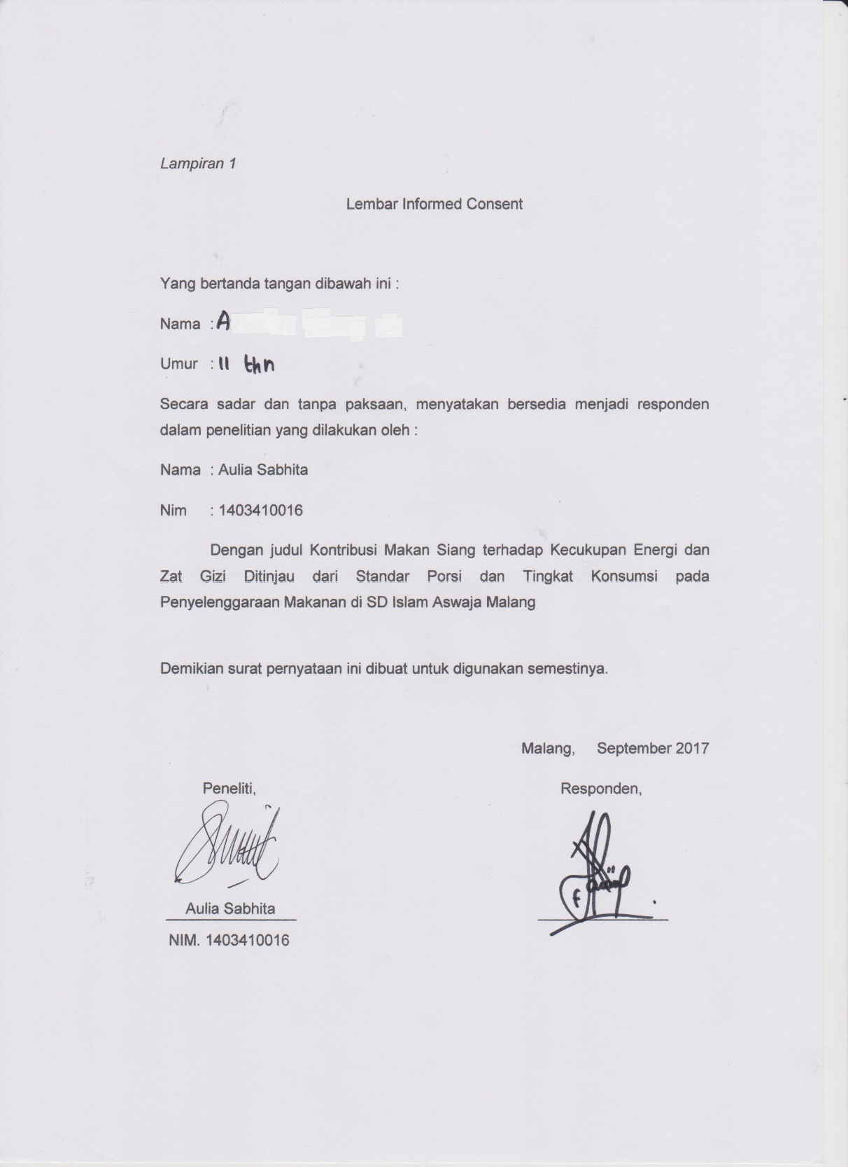

Lampiran 2. Surat Permohonan Ijin Penelitian

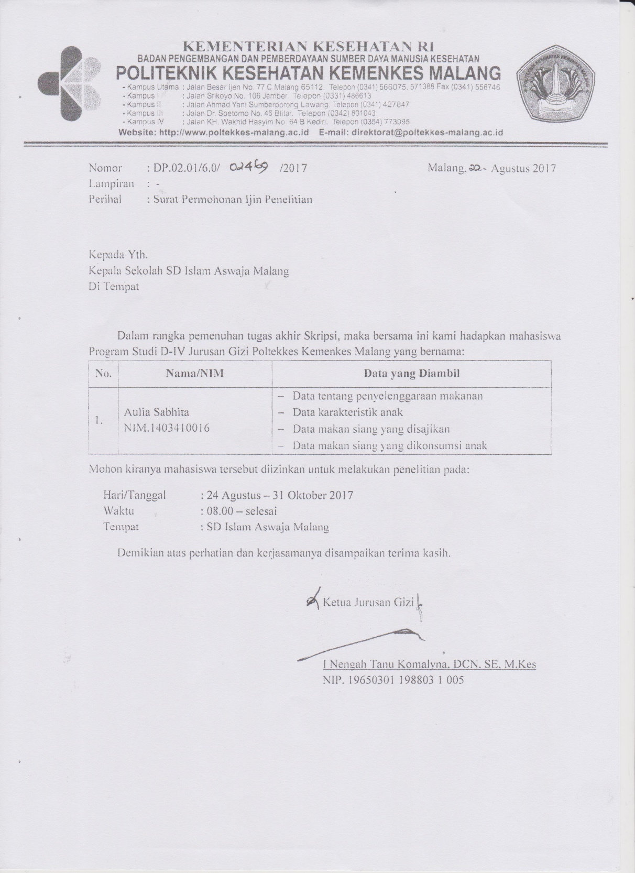

Lampiran 3. Surat Pemberian Ijin Observasi dan Penelitian di SD Islam Aswaja

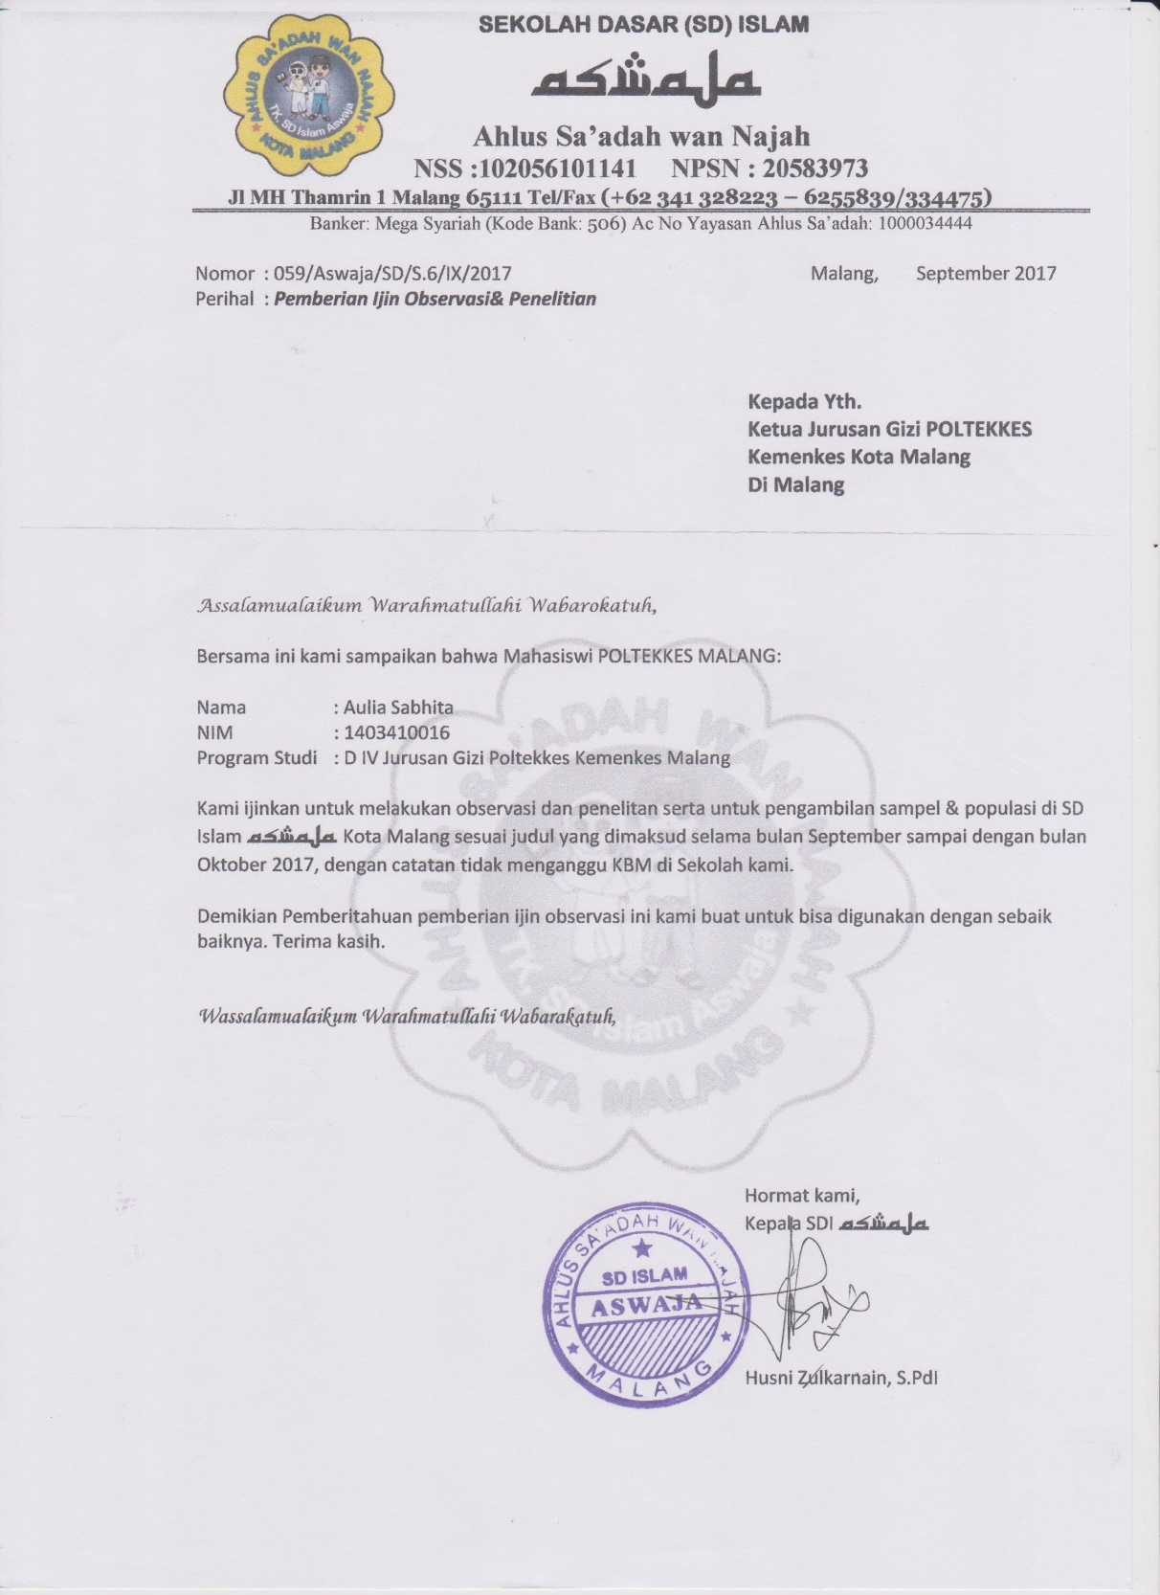

Lampiran 4. Surat Komesi Etik Penelitian

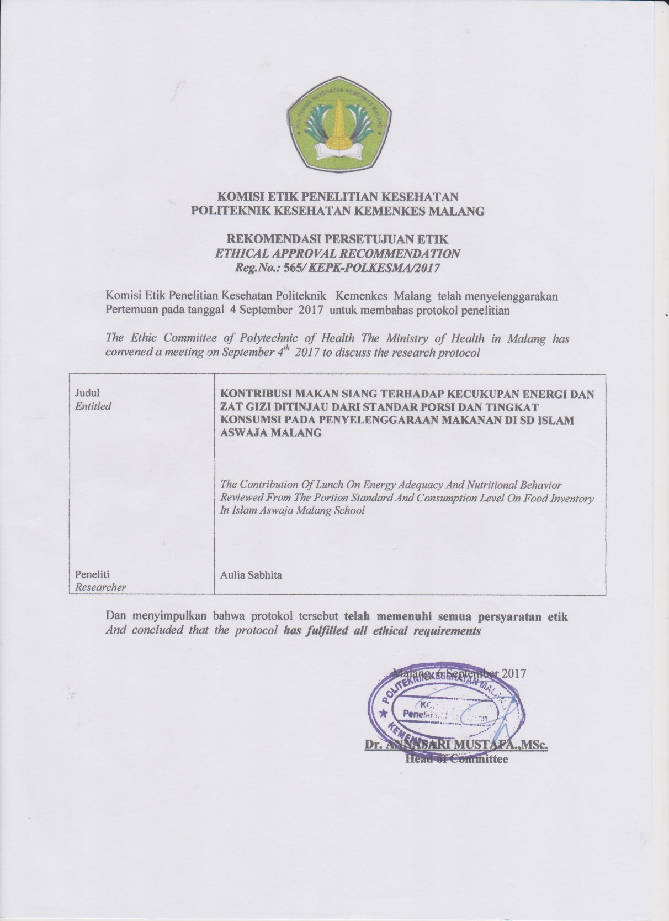

Lampiran 5. Form Identitas Responden

Form Identitas Respoden

Tabel 15. Identitas Responden

|  |  |  |  |  |
| --- | --- | --- | --- | --- |
| No | Kode Nama | Jenis Kelamin | Usia  (tahun) | BB  (kg) |
| 1 | 41 | P | 10 | 29 |
| 2 | 42 | L | 10 | 27 |
| 3 | 43 | P | 10 | 23 |
| 4 | 44 | L | 10 | 25 |
| 5 | 45 | P | 10 | 28 |
| 6 | 46 | L | 10 | 30 |
| 7 | 47 | P | 10 | 30 |
| 8 | 48 | P | 10 | 23 |
| 9 | 49 | P | 10 | 29 |
| 10 | 410 | P | 10 | 22 |
| 11 | 411 | P | 10 | 24 |
| 12 | 412 | L | 10 | 25 |
| 13 | 413 | L | 10 | 31 |
| 14 | 414 | L | 10 | 35 |
| 15 | 515 | P | 10 | 55 |
| 16 | 516 | L | 11 | 51 |
| 17 | 517 | P | 11 | 26 |
| 18 | 518 | P | 11 | 31 |
| 19 | 519 | L | 11 | 30 |
| 20 | 520 | L | 11 | 36 |
| 21 | 521 | L | 10 | 22 |
| 22 | 522 | P | 11 | 28 |
| 23 | 523 | P | 11 | 43 |
| 24 | 524 | L | 11 | 27 |
| 25 | 526 | P | 10 | 30 |
| 26 | 528 | L | 10 | 40 |
| No | Kode Nama | Jenis Kelamin | Usia  (tahun) | BB  (kg) |
| 27 | 529 | L | 11 | 28 |
| 28 | 530 | L | 11 | 27 |
| 29 | 631 | L | 12 | 61 |
| 30 | 632 | P | 12 | 40 |
| 31 | 633 | P | 11 | 33 |
| 32 | 634 | P | 11 | 38 |
| 33 | 635 | P | 12 | 29 |
| 34 | 636 | L | 11 | 33 |
| 35 | 637 | P | 12 | 29 |
| 36 | 638 | L | 11 | 53 |
| 37 | 639 | P | 11 | 31 |
| 38 | 640 | L | 12 | 38 |
| 39 | 641 | P | 12 | 30 |
| 40 | 642 | P | 12 | 37 |

Lampiran 6*.* Menu Makan Siang yang Disajikan Selama 5 Hari di SD Islam Aswaja Malang

|  |  |
| --- | --- |
| Menu ke - | Menu yang disajikan |
| 1 | * Nasi * Mie bihun + sawi * Ayam suwir * Telur dadar * Kerupuk |
| 2 | * Nasi * Tahu telur * Bumbu pecel * Taoge * Kerupuk |
| 3 | * Nasi * Bola-bola tahu * Sayur Sop (wortel + bihun + gambas) * Kerupuk |
| 4 | * Nasi * Soto Ayam (Mie hun + Ayam suwir+gubis) * Tempe goreng * Kerupuk |
| 5 | * Nasi * Telur bali * Tahu bali * Sayur Bening (Bayam + jagung) * Kerupuk |

Lampiran 7.Kecukupan Energi dan Zat Gizi

Tabel 16. Kecukupan Energi dan Zat Gizi Anak Usia 10-12 Tahun

|  |  |  |  |  |
| --- | --- | --- | --- | --- |
| Komposisi Zat Gizi | Usia 10-12 Tahun | | | |
| Laki-laki | | Perempuan | |
| Makan Sehari | Makan siang 30% | Makan Sehari | Makan siang 30% |
| Energi (Kkal) | 2100 | 630 | 2000 | 600 |
| Protein (g) | 56 | 16,8 | 60 | 18 |
| Lemak (g) | 70 | 21 | 67 | 20,1 |
| Karbohidrat (g) | 289 | 86,7 | 275 | 82,5 |
| Vitamin C (mg) | 50 | 15 | 50 | 15 |
| Zat besi (mg) | 13 | 3,9 | 21 | 6 |
| Serat (g) | 30 | 9 | 28 | 8,4 |

Sumber :Angka Kecukupan Gizi (AKG) tahun 2013

Lampiran 8.Standar Porsi Makan Siang Selama 5 Hari di SD Islam Aswaja

Penilaian Standar Porsi Selama 5 Hari di SD Islam Aswaja Malang

|  |  |  |  |  |  |  |  |  |  |  |  |  |  |
| --- | --- | --- | --- | --- | --- | --- | --- | --- | --- | --- | --- | --- | --- |
| No | Menu Makanan | Makanan | Berat per Porsi (gram) Menu Ke- | | | | | Rata – rata (gram) | Standar porsi yang dianjurkan  (gram) | | Presentase penilaian standar porsi (%) | | Kategori |
| 1 | 2 | 3 | 4 | 5 |
| L | P | L | P |
| 1 | Makanan Pokok | Nasi | 71 | 74 | 72 | 70 | 73 | 72 | 180 | 150 | 40 | 48 | Tidak Sesuai |
| 2 | Lauk hewani | Telur | 11 | 9 | - | - | 33 | 14 | 45 | 45 | 31 | 31 | Tidak Sesuai |
| Ayam | 9 | - | - | 7 | - |
| 3 | Lauk nabati | Tahu | - | 13 | 17 | - | 31 | 24 | 45 | 45 | 53 | 53 | Tidak Sesuai |
| Tempe | - | - | - | 33 | - |
| Bihun | 15 | - | 5 | 8 | - |
| 4 | Sayur | Sawi | 7 | - | - | - | - | 13 | 75 | 60 | 17,3 | 21 | Tidak Sesuai |
| Taoge | - | 8 | - | - | - |
| Wortel | - | - | 7 | - | - |
| Gambas | - | - | 18 | - | - |
| Gubis | - | - | - | 4 | - |
| Bayam | - | - | - | - | 16 |
| Jagung | - | - | - | - | 3 |
| 5 | Buah | - | - | - | - | - | - | 0 | 60 | 90 | 0 | 0 | Tidak Sesuai |

Tabel 17 . Rata-Rata Standar Porsi Makan Siang Siswa Perempuan yang disajikan Pada Menu Makan Siang di SD Islam Aswaja Malang

|  |  |  |  |  |  |
| --- | --- | --- | --- | --- | --- |
| Menu ke- | Porsi Makanan | | | | |
| Makanan pokok (g) | Lauk hewani (g) | Lauk nabati (g) | Sayur (g) | Buah (g) |
| 1 | 71 | 20 | 15 | 7 | - |
| 2 | 74 | 9 | 13 | 8 | - |
| 3 | 72 | - | 22 | 25 | - |
| 4 | 70 | 7 | 41 | 4 | - |
| 5 | 73 | 33 | 31 | 19 | - |
| Berat Porsi Rata-rata (g) | 72 | 14 | 24 | 13 | - |
| Standar Porsi  (g) | 150 | 45 | 45 | 60 | 90 |
| %pemenuhan | 48 | 31 | 53 | 21 | 0 |
| Kategori | Tidak sesuai | Tidak sesuai | Tidak Sesuai | Tidak sesuai | Tidak Sesuai |

Tabel 18. Rata-Rata Standar Porsi Makan Siang Siswa Laki-laki yang disajikan Pada Menu Makan Siang di SD Islam Aswaja Malang

|  |  |  |  |  |  |
| --- | --- | --- | --- | --- | --- |
| Menu ke- | Porsi Makanan | | | | |
| Makanan pokok (g) | Lauk hewani (g) | Lauk nabati (g) | Sayur (g) | Buah (g) |
| 1 | 71 | 20 | 15 | 7 | - |
| 2 | 74 | 9 | 13 | 8 | - |
| 3 | 72 | - | 22 | 25 | - |
| 4 | 70 | 7 | 41 | 4 | - |
| 5 | 73 | 33 | 31 | 19 | - |
| Berat Porsi Rata-rata (g) | 72 | 14 | 24 | 13 | - |
| Standar Porsi  (g) | 180 | 45 | 45 | 75 | 60 |
| %pemenuhan | 40 | 31 | 53 | 17 | 0 |
| Kategori | Tidak sesuai | Tidak sesuai | Tidak Sesuai | Tidak sesuai | Tidak Sesuai |

Lampiran 9.Kontribusi Makan Siang Selama 5 hari di SD Islam Aswaja Malang

Penilaian Kontribusi Makan Siang Selama 5 Hari di SD Islam Aswaja Malang

|  |  |  |  |  |  |  |  |  |  |  |
| --- | --- | --- | --- | --- | --- | --- | --- | --- | --- | --- |
| Hari Pengamatan ke- | Menu Makanan | Bahan Makanan | Disajikan (gram) | Zat Gizi | | | | | | |
| E  (kkal) | P  (gram) | KH  (gram) | L  (gram) | Vit. C  (mg) | Fe  (mg) | Serat  (mg) |
| 1 | Nasi | Beras giling masak nasi | 71 | 126,4 | 1,5 | 28,8 | 0,1 | 0 | 0,4 | 0,7 |
| Mie bihun | Bihun | 33 | 118,8 | 1,6 | 27,1 | 0 | 0 | 0,6 | 0 |
| Sawi | 7 | 1,5 | 0,2 | 0,3 | 0 | 7,1 | 0,2 | 0,3 |
| Kecap | 3 | 1,4 | 0,2 | 0,3 | 0 | 0 | 0,2 | 0 |
| Minyak | 2,5 | 22,6 | 0 | 0 | 2,5 | 0 | 0 | 0 |
| Ayam Suwir | Ayam | 9 | 27,2 | 1,6 | 0 | 2,3 | 0 | 0,1 | 0 |
| minyak | 2,5 | 22,6 | 0 | 0 | 2,5 | 0 | 0 | 0 |
| Telur Dadar | Telur | 11 | 17,8 | 1,4 | 0,1 | 1,3 | 0 | 0,3 | 0 |
| Minyak | 2,5 | 22,6 | 0 | 0 | 2,5 | 0 | 0 | 0 |
| Kerupuk | Kerupuk aci | 10 | 35 | 0,1 | 8,6 | 0 | 0 | 0 | 0 |
| Minyak | 2,5 | 22,6 | 0 | 0 | 2,5 | 0 | 0 | 0 |
| 2 | Nasi | Beras giling masak nasi | 74 | 131,7 | 1,6 | 30 | 0,1 | 0 | 0,4 | 0,7 |
| Telur tahu | Telur | 9 | 14,6 | 1,2 | 0,1 | 1 | 0 | 0,2 | 0 |
| Tahu | 13 | 8,8 | 1,0 | 0,2 | 0,6 | 0 | 0,1 | 0,1 |
| minyak | 2,5 | 22,6 | 0 | 0 | 2,5 | 0 | 0 | 0 |
| Taoge | Toge | 8 | 1,8 | 0,2 | 0,3 | 0,1 | 0 | 0,1 | 0 |

|  |  |  |  |  |  |  |  |  |  |  |
| --- | --- | --- | --- | --- | --- | --- | --- | --- | --- | --- |
| Hari Pengamatan ke- | Menu Makanan | Bahan Makanan | Disajikan (gram) | Zat Gizi | | | | | | |
| E  (kkal) | P  (gram) | KH  (gram) | L  (gram) | Vit. C  (mg) | Fe  (mg) | Serat  (mg) |
|  | Bumbu Pecel | Bumbu pecel | 23 | 55,8 | 2,56 | 7,3 | 2,8 | 4,8 | 0,8 | 0,2 |
| Kerupuk | Kerupuk aci | 11 | 38,5 | 0,1 | 9,4 | 0 | 0 | 0 | 0 |
| minyak | 2,5 | 22,6 | 0 | 0 | 2,5 | 0 | 0 | 0 |
| 3 | Nasi | Beras giling masak nasi | 72 | 128,2 | 1,5 | 29,2 | 0,1 | 0 | 0,4 | 0,7 |
| Bola-bola tahu | Tahu | 17 | 11,6 | 1,3 | 0,3 | 0,8 | 0 | 0,1 | 0,1 |
| Minyak | 5 | 45,1 | 0 | 0 | 5 | 0 | 0 | 0 |
| Sayur sop | Wortel | 7 | 2,9 | 0,1 | 0,7 | 0 | 0,4 | 0,1 | 0,4 |
| Bihun | 5 | 18 | 0,2 | 4,1 | 0 | 0 | 0,1 | 0 |
| Gambas | 18 | 3,2 | 0,1 | 0,7 | 0 | 1,4 | 0,2 | 0,5 |
| Kerupuk | Kerupuk aci | 10 | 35 | 0,1 | 8,6 | 0 | 0 | 0 | 0 |
| minyak | 2,5 | 22,6 | 0 | 0 | 2,5 | 0 | 0 | 0 |
| 4 | Nasi | Beras giling masak nasi | 70 | 124,6 | 1,5 | 28,4 | 0,1 | 0 | 0,4 | 0,7 |
| Soto | Bihun | 8 | 28,8 | 0,4 | 6,6 | 0 | 0 | 0,1 | 0 |
| Gubis | 4 | 1 | 0,1 | 0,2 | 0 | 2 | 0 | 0,2 |
| Kuah | 62 | 72,6 | 0,2 | 5,9 | 5,3 | 0,3 | 0,7 | 0 |
| Ayam suwir | Ayam | 7 | 21,1 | 1,3 | 0 | 1,8 | 0 | 0,1 | 0 |
| minyak | 2,5 | 22,6 | 0 | 0 | 2,5 | 0 | 0 | 0 |
| Tempe goreng | Tempe | 33 | 49,2 | 6 | 4,2 | 1,3 | 0 | 3,3 | 2,3 |
| minyak | 2,5 | 22,6 | 0 | 0 | 2,5 | 0 | 0 | 0 |
| Kerupuk | Kerupuk aci | 12 | 42 | 0,1 | 10,3 | 0 | 0 | 0 | 0 |
| Hari Pengamatan ke- | Menu Makanan | Bahan Makanan | Disajikan (gram) | Zat Gizi | | | | | | |
| E  (kkal) | P  (gram) | KH  (gram) | L  (gram) | Vit. C  (mg) | Fe  (mg) | Serat  (mg) |
|  |  | minyak | 2,5 | 22,6 | 0 | 0 | 2,5 | 0 | 0 | 0 |
| 5 | Nasi | Beras giling masak nasi | 73 | 129,9 | 1,5 | 29,6 | 0,1 | 0 | 0,4 | 0,7 |
| Telur bali | Telur | 33 | 53,5 | 4,2 | 0,2 | 3,8 | 0 | 0,9 | 0 |
| Minyak | 2,5 | 22,6 | 0 | 0 | 2,5 | 0 | 0 | 0 |
| Tahu bali | Tahu | 31 | 21,1 | 2,4 | 0,5 | 1,4 | 0 | 0,2 | 0,2 |
| Minyak | 2,5 | 22,6 | 0 | 0 | 2,5 | 0 | 0 | 0 |
| Sayur bening | Bayam | 16 | 5,8 | 0,6 | 1 | 0,1 | 12,8 | 0,6 | 0,6 |
| Jagung | 3 | 4,2 | 0,1 | 1 | 0 | 0,2 | 0 | 0,3 |
| Kerupuk | Kerupuk aci | 12 | 42 | 0,1 | 10,3 | 0 | 0 | 0 | 0 |
| Minyak | 2,5 | 22,6 | 0 | 0 | 2,5 | 0 | 0 | 0 |
| Rata-rata | | | | 342,46 | 7 | 50,8 | 12,1 | 5,86 | 2,17 | 1,72 |

Tabel 19. Rata-Rata Kontribusi Makan Siang Kelas 4 ,5 dan 6 (Perempuan) Selama 5 Hari

|  |  |  |  |  |  |  |  |
| --- | --- | --- | --- | --- | --- | --- | --- |
| Menu ke- | Kontribusi Makan Siang | | | | | | |
| Energi (kkal) | Protein (gram) | Lemak (gram) | Karbohidrat  (gram) | Fe  (mg) | Vit C  (mg) | Serat (mg) |
| 1 | 418,3 | 6,5 | 13,7 | 65,1 | 1,75 | 7,1 | 1 |
| 2 | 296,4 | 6,7 | 9,6 | 47,3 | 1,6 | 4,9 | 1 |
| 3 | 266,6 | 3,4 | 8,4 | 43,6 | 0,8 | 1,9 | 1,7 |
| 4 | 406,9 | 9,5 | 16 | 55,7 | 4,6 | 2,4 | 3,2 |
| 5 | 324,1 | 8,9 | 12,9 | 42,7 | 2,1 | 13 | 1,7 |
| Rata-rata | 342,46 | 7 | 12,1 | 50,8 | 2,17 | 5,86 | 1,72 |
| AKG yang Dianjurkan | 600 | 18 | 20,1 | 82,5 | 6 | 15 | 8,4 |
| %pemenuhan | 57 | 38 | 60,2 | 61,5 | 36,2 | 39,1 | 20,4 |
| Kategori | Kurang | kurang | kurang | kurang | Kurang | Kurang | kurang |

Keterangan:

Baik : 100% dari kebutuhan makan siang

Kurang : <100% dari kebutuhan makan siang

Tabel 20. Rata-Rata Kontribusi Makan Siang Kelas 4 ,5 dan 6 (Laki-laki) Selama 5 Hari

|  |  |  |  |  |  |  |  |
| --- | --- | --- | --- | --- | --- | --- | --- |
| Menu ke- | Kontribusi Makan Siang | | | | | | |
| Energi (kkal) | Protein (gram) | Lemak (gram) | Karbohidrat  (gram) | Fe  (mg) | Vit C  (mg) | Serat (mg) |
| 1 | 418,3 | 6,5 | 13,7 | 65,1 | 1,75 | 7,1 | 1 |
| 2 | 296,4 | 6,7 | 9,6 | 47,3 | 1,6 | 4,9 | 1 |
| 3 | 266,6 | 3,4 | 8,4 | 43,6 | 0,8 | 1,9 | 1,7 |
| 4 | 406,9 | 9,5 | 16 | 55,7 | 4,6 | 2,4 | 3,2 |
| 5 | 324,1 | 8,9 | 12,9 | 42,7 | 2,1 | 13 | 1,7 |
| Rata-rata | 342,46 | 7 | 12,1 | 50,8 | 2,17 | 5,86 | 1,72 |
| AKG yang Dianjurkan | 630 | 16,8 | 21 | 86,7 | 3,9 | 15 | 9 |
| %pemenuhan | 54,3 | 41,6 | 57,6 | 58,6 | 55,6 | 39 | 19,1 |
| Kategori | Kurang | kurang | kurang | Kurang | Kurang | Kurang | kurang |

Keterangan:

Baik : 100% dari kebutuhan makan siang

Kurang : <100% dari kebutuhan makan siang

Lampiran 10. Tingkat Konsumsi Selama 5 Hari di SD Islam Aswaja Malang

Contoh Penilaian Tingkat Konsumsi Selama 5 hari di SD Islam Aswaja Malang

Kode Responden : 633

Nama : An. A

Jenis kelamin : Perempuan

Berat Badan : 29 kg

|  |  |  |  |  |  |  |  |  |  |  |  |  |
| --- | --- | --- | --- | --- | --- | --- | --- | --- | --- | --- | --- | --- |
| Hari Pengamatan ke- | Menu Makanan | Bahan Makanan | Disajikan (gram) | Sisa (gram) | Intake  (gram) | Zat Gizi | | | | | | |
| E  (kkal) | P  (gram) | KH  (gram) | L  (gram) | Vit. C  (mg) | Fe  (mg) | Serat  (mg) | |
| 1 | Nasi | Beras giling masak nasi | 68 | 0 | 68 | 121 | 1,4 | 27,6 | 0,1 | 0 | 0,3 | 0,7 | |
| Mie bihun | Bihun | 31 | 0 | 31 | 111,6 | 1,5 | 25,5 | 0 | 0 | 0,6 | 0 | |
| Sawi | 8 | 0 | 8 | 1,8 | 0,2 | 0,3 | 0 | 8,2 | 0,2 | 0,3 | |
| Kecap | 3 | 0 | 3 | 1,4 | 0,2 | 0,3 | 0 | 0 | 0,2 | 0 | |
| Minyak | 2,5 | 0 | 2,5 | 22,6 | 0 | 0 | 2,5 | 0 | 0 | 0 | |
| Ayam Suwir | Ayam | 12 | 0 | 12 | 36,2 | 2,2 | 0 | 3 | 0 | 0,2 | 0 | |
| minyak | 2,5 | 0 | 2,5 | 22,6 | 0 | 0 | 2,5 | 0 | 0 | 0 | |
| Telur Dadar | Telur | 10 | 0 | 10 | 16,2 | 1,3 | 0,1 | 1,2 | 0 | 0,3 | 0 | |
| Minyak | 2,5 | 0 | 2,5 | 22,6 | 0 | 0 | 2,5 | 0 | 0 | 0 | |
| Kerupuk | Kerupuk aci | 9 | 0 | 9 | 31,5 | 0 | 7,7 | 0 | 0 | 0 | 0 | |
| Minyak | 2,5 | 0 | 2,5 | 22,6 | 0 | 0 | 2,5 | 0 | 0 | 0 | |

|  |  |  |  |  |  |  |  |  |  |  |  |  |
| --- | --- | --- | --- | --- | --- | --- | --- | --- | --- | --- | --- | --- |
| Hari Pengamatan ke- | Menu Makanan | Bahan Makanan | Disajikan (gram) | Sisa (gram) | Intake  (gram) | Zat Gizi | | | | | | |
| E  (kkal) | P  (gram) | KH  (gram) | L  (gram) | Vit. C  (mg) | Fe  (mg) | Serat  (mg) |
| 2 | Nasi | Beras giling masak nasi | 68 | 26 | 42 | 74,8 | 0,9 | 17,1 | 0 | 0 | 0,2 | 0,4 |
| Telur tahu | Telur | 8 | 0 | 8 | 13 | 1 | 0,1 | 0,9 | 0 | 0,2 | 0 |
| Tahu | 12 | 0 | 12 | 8,2 | 0,9 | 0,2 | 0,6 | 0 | 0,1 | 0,1 |
| Minyak | 2,5 | 0 | 2,5 | 22,6 | 0 | 0 | 2,5 | 0 | 0 | 0 |
| Taoge | Toge | 6 | 0 | 6 | 1,4 | 0,2 | 0,2 | 0,1 | 0 | 0,1 | 0 |
| Bumbu Pecel | Bumbu pecel | 26 | 7 | 19 | 46,2 | 2,1 | 6 | 2,3 | 4 | 0,7 | 0,2 |
| Kerupuk | Kerupuk aci | 15 | 0 | 15 | 52,5 | 0,1 | 12,9 | 0 | 0 | 0 | 0 |
| Minyak | 2,5 | 0 | 2,5 | 22,6 | 0 | 0 | 2,5 | 0 | 0 | 0 |
| 3 | Nasi | Beras giling masak nasi | 69 | 9 | 60 | 106,8 | 1,3 | 24,4 | 0,1 | 0 | 0,3 | 0,6 |
| Bola-bola tahu | Tahu | 20 | 0 | 20 | 13,6 | 1,6 | 0,3 | 0,9 | 0 | 0,2 | 0,1 |
| Minyak | 5 | 0 | 5 | 45,1 | 0 | 0 | 5 | 0 | 0 | 0 |
| Sayur sop | Wortel | 8 | 3 | 5 | 2,1 | 0,1 | 0,5 | 0 | 0,3 | 0 | 0,3 |
| Bihun | 5 | 0 | 5 | 18 | 0,2 | 4,1 | 0 | 0 | 0,1 | 0 |
| Gambas | 21 | 11 | 10 | 1,8 | 0,1 | 0,4 | 0 | 0,8 | 0,1 | 0,3 |
| Kerupuk | Kerupuk aci | 11 | 0 | 11 | 38,5 | 0,1 | 9,4 | 0 | 0 | 0 | 0 |
| Minyak | 2,5 | 0 | 2,5 | 22,6 | 0 | 0 | 2,5 | 0 | 0 | 0 |
| 4 | Nasi | Beras giling masak nasi | 126 | 0 | 126 | 224,3 | 2,6 | 51,2 | 0,1 | 0 | 0,6 | 1,3 |
| Soto | Bihun | 8 | 0 | 8 | 28,8 | 0,4 | 6,6 | 0 | 0 | 0,1 | 0 |
| Gubis | 4 | 0 | 4 | 1 | 0,1 | 0,2 | 0 | 2 | 0 | 0,2 |
| Kuah | 62 | 0 | 62 | 72,6 | 0,2 | 5,9 | 5,3 | 0,3 | 0,7 | 0 |
| Ayam suwir | Ayam | 11 | 0 | 11 | 33,2 | 2 | 0 | 2,8 | 0 | 0,2 | 0 |
| Hari Pengamatan ke- | Menu Makanan | Bahan Makanan | Disajikan (gram) | Sisa (gram) | Intake  (gram) | Zat Gizi | | | | | | |
| E  (kkal) | P  (gram) | KH  (gram) | L  (gram) | Vit. C  (mg) | Fe  (mg) | Serat  (mg) |
|  |  | Minyak | 2,5 | 0 | 2,5 | 22,6 | 0 | 0 | 2,5 | 0 | 0 | 0 |
| Tempe goreng | Tempe | 60 | 0 | 60 | 89,4 | 11 | 7,6 | 2,4 | 0 | 6 | 4,2 |
| Minyak | 2,5 | 0 | 2,5 | 22,6 | 0 | 0,0 | 2,5 | 0 | 0 | 0 |
| Kerupuk | Kerupuk aci | 10 | 0 | 10 | 35 | 0,1 | 8,6 | 0 | 0 | 0 | 0 |
| Minyak | 2,5 | 0 | 2,5 | 22,6 | 0 | 0 | 2,5 | 0 | 0 | 0 |
| 5 | Nasi | Beras giling masak nasi | 71 | 0 | 71 | 126,4 | 1,5 | 28,8 | 0,1 | 0 | 0,4 | 0,7 |
| Telur bali | Telur | 35 | 0 | 35 | 56,7 | 4,5 | 0,2 | 4,0 | 0 | 0,9 | 0 |
| Minyak | 2,5 | 0 | 2,5 | 22,6 | 0 | 0 | 2,5 | 0 | 0 | 0 |
| Tahu bali | Tahu | 32 | 0 | 32 | 21,8 | 2,5 | 0,5 | 1,5 | 0 | 0,3 | 0,2 |
| Minyak | 2,5 | 0 | 2,5 | 22,6 | 0 | 0 | 2,5 | 0 | 0 | 0 |
| Sayur bening | Bayam | 15 | 9 | 6 | 2,2 | 0,2 | 0,4 | 0 | 4,8 | 0,2 | 0,2 |
| Jagung | 4 | 0 | 4 | 5,6 | 0,2 | 1,3 | 0,1 | 0,3 | 0 | 0,4 |
| Kerupuk | Kerupuk aci | 7 | 0 | 7 | 24,5 | 0 | 6 | 0 | 0 | 0 | 0 |
| Minyak | 2,5 | 0 | 2,5 | 22,6 | 0 | 0 | 2,5 | 0 | 0 | 0 |
| Rata-rata | | | | | | 361 | 8,5 | 52,2 | 13,1 | 5 | 2,7 | 2,05 |
| AKG Makan siang berdasarkan BBA | | | | | | 483,3 | 14,5 | 66,5 | 16,2 | 12,1 | 4,8 | 6,8 |
| Presentase rata-rata dengan AKG (%) | | | | | | 74,7 | 58,8 | 78,5 | 81,2 | 41,2 | 57,5 | 30,2 |

Rata-Rata Tingkat Konsumsi Energi dan zat gizi Selama 5 Hari

Tabel 21. Rata-Rata Tingkat Konsumsi Energi dan zat gizi Selama 5 Hari

|  |  |  |  |  |  |  |  |  |  |
| --- | --- | --- | --- | --- | --- | --- | --- | --- | --- |
| **Sampel** | **Energi** | | | | **Sampel** | **Protein** | | | |
| **Standar Kecukupan Energi (kkal)** | **Konsumsi Energi (kkal)** | **Tingkat Konsumsi Energi (%)** | **Kategori** | **Standar Kecukupan Protein (gram)** | **Konsumsi Protein (gram)** | **Tingkat Konsumsi Protein (%)** | **Kategori** |
| 41/P | 483,3 | 338,9 | 70,1 | DTS | 41/P | 14,5 | 6,9 | 47,5 | DTB |
| 42/P | 450,0 | 318,4 | 70,8 | DTS | 42/P | 13,5 | 6,4 | 47,1 | DTB |
| 43/P | 383,3 | 386,8 | 100,9 | N | 43/P | 11,5 | 8,3 | 72,3 | DTS |
| 44/L | 463,2 | 375,8 | 81,1 | DTR | 44/L | 12,4 | 7,5 | 60,8 | DTB |
| 45/P | 466,7 | 355,8 | 76,2 | DTS | 45/P | 14,0 | 7,6 | 54,3 | DTB |
| 46/L | 555,9 | 350,9 | 63,1 | DTB | 46/L | 14,8 | 7,2 | 48.5 | DTB |
| 47/P | 500,0 | 333,0 | 66,6 | DTB | 47/P | 15,0 | 7,0 | 46.8 | DTB |
| 48/P | 383,3 | 352,3 | 91,9 | N | 48/P | 11,5 | 7,4 | 64.0 | DTB |
| 49/P | 483,3 | 344,2 | 71,2 | DTS | 49/P | 14,5 | 7,1 | 48.8 | DTB |
| 410/P | 366,7 | 342,2 | 93,3 | N | 410/P | 11,0 | 7,8 | 70.9 | DTS |
| 411/P | 400,0 | 351,7 | 87,9 | DTR | 411/P | 12,0 | 7,5 | 62.2 | DTB |
| 412/L | 463,2 | 337,2 | 72,8 | DTS | 412/L | 12,4 | 6,9 | 56.1 | DTB |
| 413/L | 574,4 | 392,0 | 68,2 | DTB | 413/L | 15,3 | 8,4 | 55.1 | DTB |
| 414/L | 648,5 | 342,7 | 52,8 | DTB | 414/L | 17,3 | 7,5 | 43.6 | DTB |
| 515/P | 916,7 | 438,8 | 47,9 | DTB | 515/P | 27,5 | 9,6 | 34.8 | DTB |
| 516/L | 945,0 | 381,3 | 40,4 | DTB | 516/L | 25,2 | 8,1 | 32.1 | DTB |
| 517/P | 433,3 | 347,8 | 80,3 | DTR | 517/P | 13,0 | 7,6 | 58.3 | DTB |
| 518/P | 516,7 | 343,7 | 66,5 | DTB | 518/P | 15,5 | 7,0 | 44.8 | DTB |
| 519/L | 555,9 | 340,9 | 61,3 | DTB | 519/L | 14,8 | 7,4 | 50.0 | DTB |

|  |  |  |  |  |  |  |  |  |  |
| --- | --- | --- | --- | --- | --- | --- | --- | --- | --- |
| **Sampel** | **Energi** | | | | **Sampel** | **Protein** | | | |
| **Standar Kecukupan Energi (kkal)** | **Konsumsi Energi (kkal)** | **Tingkat Konsumsi Energi (%)** | **Kategori** | **Standar Kecukupan Protein (gram)** | **Konsumsi Protein (gram)** | **Tingkat Konsumsi Protein (%)** | **Kategori** |
| 520/L | 667,1 | 380,5 | 57,0 | DTB | 520/L | 17,8 | 7.9 | 44.7 | DTB |
| 521/L | 407,6 | 290,0 | 71,1 | DTS | 521/L | 10,9 | 5.9 | 54.5 | DTB |
| 522/P | 466,7 | 328,6 | 70,4 | DTS | 522/P | 14,0 | 7.2 | 51.1 | DTB |
| 523/P | 716,7 | 347,5 | 48,5 | DTB | 523/P | 21,5 | 7.0 | 32.7 | DTB |
| 524/L | 500,3 | 345,8 | 69,1 | DTB | 524/L | 13,3 | 7.2 | 53.9 | DTB |
| 526/P | 500,0 | 352,1 | 70,4 | DTS | 526/P | 15,0 | 7.5 | 49.8 | DTB |
| 528/L | 741,2 | 360,8 | 48,7 | DTB | 528/L | 19,8 | 7.6 | 38.4 | DTB |
| 529/L | 518,8 | 369,8 | 71,3 | DTS | 529/L | 13,8 | 9.5 | 71.4 | DTS |
| 530/L | 500,3 | 362,3 | 72,4 | DTS | 530/L | 13,3 | 7.8 | 58.8 | DTB |
| 631/L | 1130,3 | 541,5 | 47,9 | DTB | 631/L | 30,1 | 12.5 | 41.3 | DTB |
| 632/P | 741,2 | 352,0 | 47,5 | DTB | 632/P | 19,8 | 7.3 | 37.1 | DTB |
| 633 | 550,0 | 351,2 | 63,9 | DTB | 633 | 16,5 | 7.3 | 44.0 | DTB |
| 634/P | 633,3 | 351,5 | 55,5 | DTB | 634/P | 19,0 | 7.6 | 40.0 | DTB |
| 635/P | 483,3 | 361,0 | 74,7 | DTS | 635/P | 14,5 | 8.5 | 58.8 | DTB |
| 636/P | 550,0 | 319,9 | 58,2 | DTB | 636/P | 16,5 | 7.1 | 42.9 | DTB |
| 637/L | 537,4 | 351,1 | 65,3 | DTB | 637/L | 14,3 | 7.5 | 52.4 | DTB |
| 638/P | 883,3 | 344,5 | 39,0 | DTB | 638/P | 26,5 | 7.2 | 27.3 | DTB |
| 639/L | 574,4 | 345,3 | 60,1 | DTB | 639/L | 15,3 | 7.3 | 47.4 | DTB |
| 640/P | 633,3 | 320,9 | 50,7 | DTB | 640/P | 19,0 | 7.0 | 36.7 | DTB |
| 641/L | 555,9 | 374,4 | 67,3 | DTB | 641/L | 14,8 | 7.9 | 53.3 | DTB |
| 642/P | 616,7 | 331,9 | 53,8 | DTB | 642/P | 18,5 | 6.9 | 37.4 | DTB |

|  |  |  |  |  |  |  |  |  |  |
| --- | --- | --- | --- | --- | --- | --- | --- | --- | --- |
| **Sampel** | **Lemak** | | | | **Sampel** | **Karbohidrat** | | | |
| **Standar Kecukupan Lemak(gram)** | **Konsumsi Lemak (gram)** | **Tingkat Konsumsi Lemak (%)** | **Kategori** | **Standar Kecukupan KH (gram)** | **Konsumsi KH (gram)** | **Tingkat Konsumsi KH (%)** | **Kategori** |
| 41/P | 16,2 | 12.4 | 76.3 | DTS | 41/P | 66,5 | 50.0 | 75.2 | DTS |
| 42/P | 15,1 | 12.1 | 80.1 | DTR | 42/P | 61,9 | 45.9 | 74.2 | DTS |
| 43/P | 12,8 | 13.4 | 104.5 | N | 43/P | 52,7 | 58.1 | 110.2 | N |
| 44/L | 15,4 | 12.5 | 81.1 | DTR | 44/L | 63,8 | 58.1 | 91.2 | N |
| 45/P | 15,6 | 12.6 | 80.5 | DTR | 45/P | 64,2 | 53.3 | 83.0 | DTR |
| 46/L | 18,5 | 12.5 | 67.3 | DTB | 46/L | 76,5 | 52.4 | 68.5 | DTB |
| 47/P | 16,8 | 12.4 | 73.8 | DTS | 47/P | 68,8 | 48.4 | 70.4 | DTS |
| 48/P | 12,8 | 12.7 | 98.7 | N | 48/P | 52,7 | 52.5 | 99.5 | N |
| 49/P | 16,2 | 12.5 | 77.4 | DTS | 49/P | 66,5 | 50.7 | 76.3 | DTS |
| 410/P | 12,3 | 12.9 | 105.4 | N | 410/P | 50,4 | 49.0 | 97.1 | N |
| 411/P | 13,4 | 12.9 | 96.0 | N | 411/P | 55,0 | 51.6 | 93.9 | N |
| 412/L | 15,4 | 12.4 | 80.2 | DTR | 412/L | 63,8 | 49.4 | 77.5 | DTS |
| 413/L | 19,1 | 13.6 | 70.9 | DTS | 413/L | 79,1 | 59.0 | 74.6 | DTS |
| 414/L | 21,6 | 13.1 | 60.6 | DTB | 414/L | 89,3 | 49.1 | 55.0 | DTB |
| 515/P | 30,7 | 12.9 | 42.0 | DTB | 515/P | 126,0 | 70.3 | 55.8 | DTB |
| 516/L | 31,5 | 13.1 | 41.5 | DTB | 516/L | 130,1 | 57.6 | 44.3 | DTB |
| 517/P | 14,5 | 12.9 | 88.7 | DTR | 517/P | 59,6 | 50.6 | 84.9 | DTR |
| 518/P | 17,3 | 12.4 | 71.7 | DTS | 518/P | 71,0 | 51.1 | 71.9 | DTS |
| 519/L | 18,5 | 12.8 | 69.1 | DTB | 519/L | 76,5 | 49.2 | 64.3 | DTB |
| 520/L | 22,2 | 13.1 | 59.1 | DTB | 520/L | 91,8 | 57.6 | 62.7 | DTB |
| 521/L | 13,6 | 11.7 | 86.0 | DTR | 521/L | 56,1 | 40.3 | 71.9 | DTS |
| 522/P | 15,6 | 12.8 | 81.9 | DTR | 522/P | 64,2 | 46.5 | 72.5 | DTS |
| 523/P | 24,0 | 12.4 | 51.5 | DTB | 523/P | 98,5 | 51.8 | 52.6 | DTB |
| 524/L | 16,7 | 12.5 | 75.0 | DTS | 524/L | 68,9 | 51.1 | 74.3 | DTS |

|  |  |  |  |  |  |  |  |  |  |  |  |  |  |  |  |  |  |  |  |  |  |  |  |  |  |  |  |  |  |  |  |  |  |  |  |  |  |  |  |  |  |  |  |  |  |  |  |  |  |  |  |  |  |  |  |  |  |  |  |  |  |  |  |  |  |  |  |  |  |  |  |  |  |  |  |  |  |  |  |  |  |  |  |  |  |  |  |  |  |  |  |  |  |  |  |  |  |  |  |  |  |  |  |  |  |  |  |  |  |  |  |  |  |  |  |  |  |  |  |  |  |  |  |  |  |  |  |  |  |  |  |  |  |  |  |  |  |  |  |  |  |  |  |  |  |  |  |  |  |  |  |  |  |  |  |  |  |  |  |  |  |  |  |  |  |  |  |  |  |  |  |  |  |  |  |  |  |  |
| --- | --- | --- | --- | --- | --- | --- | --- | --- | --- | --- | --- | --- | --- | --- | --- | --- | --- | --- | --- | --- | --- | --- | --- | --- | --- | --- | --- | --- | --- | --- | --- | --- | --- | --- | --- | --- | --- | --- | --- | --- | --- | --- | --- | --- | --- | --- | --- | --- | --- | --- | --- | --- | --- | --- | --- | --- | --- | --- | --- | --- | --- | --- | --- | --- | --- | --- | --- | --- | --- | --- | --- | --- | --- | --- | --- | --- | --- | --- | --- | --- | --- | --- | --- | --- | --- | --- | --- | --- | --- | --- | --- | --- | --- | --- | --- | --- | --- | --- | --- | --- | --- | --- | --- | --- | --- | --- | --- | --- | --- | --- | --- | --- | --- | --- | --- | --- | --- | --- | --- | --- | --- | --- | --- | --- | --- | --- | --- | --- | --- | --- | --- | --- | --- | --- | --- | --- | --- | --- | --- | --- | --- | --- | --- | --- | --- | --- | --- | --- | --- | --- | --- | --- | --- | --- | --- | --- | --- | --- | --- | --- | --- | --- | --- | --- | --- | --- | --- | --- | --- | --- | --- | --- | --- | --- | --- | --- | --- | --- |
| |  |  |  |  |  |  |  |  |  |  | | --- | --- | --- | --- | --- | --- | --- | --- | --- | --- | | **Sampel** | **Lemak** | | | | **Sampel** | **Karbohidrat** | | | | | **Standar Kecukupan Lemak(gram)** | **Konsumsi Lemak (gram)** | **Tingkat Konsumsi Lemak (%)** | **Kategori** | **Standar Kecukupan KH (gram)** | **Konsumsi KH (gram)** | **Tingkat Konsumsi KH (%)** | **Kategori** | | 526/P | 16,8 | 12.7 | 75.9 | DTS | 526/P | 68,8 | 51.9 | 75.5 | DTS | | 528/L | 24,7 | 12.9 | 52.4 | DTB | 528/L | 102,0 | 53.6 | 52.6 | DTB | | 529/L | 17,3 | 13.0 | 75.4 | DTS | 529/L | 71,4 | 54.6 | 76.5 | DTS | | 530/L | 16,7 | 13.0 | 77.8 | DTS | 530/L | 68,9 | 53.6 | 77.9 | DTS | | 631/L | 37,7 | 14.8 | 39.4 | DTB | 631/L | 155,6 | 88.8 | 57.1 | DTB | | 632/P | 24,7 | 12.6 | 50.9 | DTB | 632/P | 102,0 | 52.2 | 51.2 | DTB | | 633/ | 18,4 | 12.3 | 67.0 | DTB | 633 | 75,6 | 52.6 | 69.6 | DTB | | 634/P | 21,2 | 12.6 | 59.5 | DTB | 634/P | 87,1 | 52.0 | 59.7 | DTB | | 635/P | 16,2 | 13.1 | 81.2 | DTR | 635/P | 66,5 | 52.2 | 78.5 | DTS | | 636/P | 18,4 | 12.8 | 69.3 | DTB | 636/P | 75,6 | 44.5 | 58.8 | DTB | | 637/L | 17,9 | 12.8 | 71.7 | DTS | 637/L | 74,0 | 51.3 | 69.4 | DTB | | 638/P | 29,6 | 12.5 | 42.4 | DTB | 638/P | 121,5 | 50.7 | 41.8 | DTB | | 639/L | 19,1 | 12.7 | 66.1 | DTB | 639/L | 79,1 | 50.6 | 64.0 | DTB | | 640/P | 21,2 | 12.5 | 58.8 | DTB | 640/P | 87,1 | 45.2 | 51.9 | DTB | | 641/L | 18,5 | 12.9 | 69.4 | DTB | 641/L | 76,5 | 56.7 | 74.1 | DTS | | 642/P | 20,7 | 12.5 | 60.3 | DTB | 642/P | 84,8 | 48.2 | 56.9 | DTB | |

|  |  |  |  |  |  |  |  |  |  |
| --- | --- | --- | --- | --- | --- | --- | --- | --- | --- |
| **Sampel** | **Zat Besi (Fe)** | | | | **Sampel** | **Vitamin C** | | | |
| **Standar Kecukupan Fe (mg)** | **Konsumsi Fe (mg)** | **Tingkat Konsumsi Fe (%)** | **Kategori** | **Standar Kecukupan Vitamin C(mg)** | **Konsumsi vitamin C (mg)** | **Tingkat Konsumsi vit C (%)** | **Kategori** |
| 41/P | 4,8 | 2.1 | 43.8 | DTB | 41/P | 12,1 | 4.8 | 40.1 | DTB |
| 42/P | 4,5 | 1.9 | 42.9 | DTB | 42/P | 11,3 | 4.0 | 35.2 | DTB |
| 43/P | 3,8 | 2.4 | 62.9 | DTB | 43/P | 9,6 | 5.3 | 55.3 | DTB |
| 44/L | 2,9 | 2.3 | 80.2 | DTR | 44/L | 11,0 | 5.2 | 46.9 | DTB |
| 45/P | 4,7 | 2.4 | 51.4 | DTB | 45/P | 11,7 | 6.8 | 58.4 | DTB |
| 46/L | 3,4 | 2.2 | 64.1 | DTB | 46/L | 13,2 | 4.9 | 37.2 | DTB |
| 47/P | 5,0 | 2.2 | 43.9 | DTB | 47/P | 12,5 | 5.0 | 39.7 | DTB |
| 48/P | 3,8 | 2.3 | 60.8 | DTB | 48/P | 9,6 | 6.4 | 66.3 | DTB |
| 49/P | 4,8 | 2.1 | 44.1 | DTB | 49/P | 12,1 | 3.6 | 29.6 | DTB |
| 410/P | 3,7 | 2.4 | 64.3 | DTB | 410/P | 9,2 | 5.5 | 59.7 | DTB |
| 411/P | 4,0 | 2.3 | 56.4 | DTB | 411/P | 10,0 | 5.3 | 52.8 | DTB |
| 412/L | 2,9 | 2.1 | 74.5 | DTS | 412/L | 11,0 | 4.7 | 42.7 | DTB |
| 413/L | 3,6 | 2.4 | 68.4 | DTB | 413/L | 13,7 | 5.4 | 39.4 | DTB |
| 414/L | 4,0 | 2.2 | 56.0 | DTB | 414/L | 15,4 | 5.8 | 37.5 | DTB |
| 515/P | 9,2 | 3.1 | 33.4 | DTB | 515/P | 22,9 | 3.0 | 13.1 | DTB |
| 516/L | 5,9 | 2.4 | 40.6 | DTB | 516/L | 22,5 | 5.3 | 23.8 | DTB |
| 517/P | 4,3 | 2.3 | 53.6 | DTB | 517/P | 10,8 | 5.8 | 53.9 | DTB |
| 518/P | 5,2 | 2.2 | 42.0 | DTB | 518/P | 12,9 | 4.6 | 35.9 | DTB |
| 519/L | 3,4 | 2.3 | 66.6 | DTB | 519/L | 13,2 | 6.3 | 47.9 | DTB |
| 520/L | 4,1 | 2.4 | 57.9 | DTB | 520/L | 15,9 | 6.7 | 42.0 | DTB |
| 521/L | 2,5 | 1.8 | 72.4 | DTS | 521/L | 9,7 | 4.0 | 41.2 | DTB |
| 522/P | 4,7 | 2.2 | 46.2 | DTB | 522/P | 11,7 | 4.7 | 40.1 | DTB |
| 523/P | 7,2 | 2.1 | 29.5 | DTB | 523/P | 17,9 | 3.0 | 16.5 | DTB |
| 524/L | 3,1 | 2.2 | 72.1 | DTS | 524/L | 11,9 | 5.2 | 43.6 | DTB |

|  |  |  |  |  |  |  |  |  |  |
| --- | --- | --- | --- | --- | --- | --- | --- | --- | --- |
| **Sampel** | **Zat Besi (Fe)** | | | | **Sampel** | **Vitamin C** | | | |
| **Standar Kecukupan Fe (mg)** | **Konsumsi Fe (mg)** | **Tingkat Konsumsi Fe (%)** | **Kategori** | **Standar Kecukupan Vitamin C(mg)** | **Konsumsi vitamin C (mg)** | **Tingkat Konsumsi vit C (%)** | **Kategori** |
| 526/P | 5,0 | 2.4 | 47.1 | DTB | 526/P | 12,5 | 6.0 | 47.6 | DTB |
| 528/L | 4,6 | 2.4 | 51.3 | DTB | 528/L | 17,6 | 5.8 | 32.6 | DTB |
| 529/L | 3,2 | 3.1 | 95.7 | N | 529/L | 12,4 | 5.9 | 48.1 | DTB |
| 530/L | 3,1 | 2.4 | 77.8 | DTS | 530/L | 11,9 | 6.5 | 54.5 | DTB |
| 631/L | 7,0 | 3.9 | 55.2 | DTB | 631/L | 26,9 | 6.9 | 25.7 | DTB |
| 632/P | 4,6 | 2.3 | 49.3 | DTB | 632/P | 17,6 | 4.8 | 27.1 | DTB |
| 633 | 5,5 | 2.3 | 41.6 | DTB | 633 | 13,8 | 4.4 | 31.8 | DTB |
| 634/P | 6,3 | 2.3 | 36.2 | DTB | 634/P | 15,8 | 5.2 | 33.0 | DTB |
| 635/P | 4,8 | 2.8 | 57.5 | DTB | 635/P | 12,1 | 5.0 | 41.2 | DTB |
| 636/P | 5,5 | 2.1 | 37.4 | DTB | 636/P | 13,8 | 5.1 | 37.1 | DTB |
| 637/L | 3,3 | 2.2 | 66.9 | DTB | 637/L | 12,8 | 5.1 | 40.2 | DTB |
| 638/P | 8,8 | 2.3 | 25.7 | DTB | 638/P | 22,1 | 6.5 | 29.3 | DTB |
| 639/L | 3,6 | 2.3 | 64.0 | DTB | 639/L | 13,7 | 5.5 | 40.2 | DTB |
| 640/P | 6,3 | 2.1 | 32.7 | DTB | 640/P | 15,8 | 4.5 | 28.5 | DTB |
| 641/L | 3,4 | 2.4 | 68.6 | DTB | 641/L | 13,2 | 5.0 | 37.6 | DTB |
| 642/P | 6,2 | 2.1 | 34.8 | DTB | 642/P | 15,4 | 5.4 | 34.7 | DTB |

|  |  |  |  |  |
| --- | --- | --- | --- | --- |
| **Sampel** | **Serat** | | | |
| **Standar Kecukupan Serat (mg)** | **Konsumsi Serat(mg)** | **Tingkat Konsumsi Serat(%)** | **Kategori** |
| 41/P | 6,8 | 1.5 | 22.6 | DTB |
| 42/P | 6,3 | 1.4 | 22.5 | DTB |
| 43/P | 5,4 | 1.8 | 33.0 | DTB |
| 44/L | 6,6 | 1.8 | 27.7 | DTB |
| 45/P | 6,5 | 1.7 | 26.6 | DTB |
| 46/L | 7,9 | 1.6 | 20.7 | DTB |
| 47/P | 7,0 | 1.6 | 23.5 | DTB |
| 48/P | 5,4 | 1.7 | 32.0 | DTB |
| 49/P | 6,8 | 1.5 | 22.0 | DTB |
| 410/P | 5,1 | 1.7 | 33.7 | DTB |
| 411/P | 5,6 | 1.7 | 29.6 | DTB |
| 412/L | 6,6 | 1.6 | 23.9 | DTB |
| 413/L | 8,2 | 1.8 | 22.3 | DTB |
| 414/L | 9,3 | 1.7 | 18.3 | DTB |
| 515/P | 12,8 | 2.6 | 20.2 | DTB |
| 516/L | 13,5 | 1.8 | 13.4 | DTB |
| 517/P | 6,1 | 1.8 | 28.9 | DTB |
| 518/P | 7,2 | 1.6 | 22.4 | DTB |
| 519/L | 7,9 | 1.8 | 22.3 | DTB |
| 520/L | 9,5 | 1.8 | 19.2 | DTB |
| 521/L | 5,8 | 1.2 | 20.8 | DTB |
| 522/P | 6,5 | 1.5 | 22.2 | DTB |
| 523/P | 10,0 | 1.5 | 15.0 | DTB |
| 524/L | 7,1 | 1.7 | 23.2 | DTB |
| 526/P | 7,0 | 1.8 | 25.3 | DTB |
| **Sampel** | **Serat** | | | |
| **Standar Kecukupan Serat (mg)** | **Konsumsi Serat(mg)** | **Tingkat Konsumsi Serat(%)** | **Kategori** |
| 528/L | 10,6 | 1.7 | 16.3 | DTB |
| 529/L | 7,4 | 2.3 | 30.7 | DTB |
| 530/L | 7,1 | 1.8 | 25.4 | DTB |
| 631/L | 16,1 | 3.1 | 18.9 | DTB |
| 632/P | 10,6 | 1.7 | 16.4 | DTB |
| 633 | 7,7 | 1.7 | 22.5 | DTB |
| 634/P | 8,9 | 1.8 | 20.1 | DTB |
| 635/P | 6,8 | 2.0 | 30.2 | DTB |
| 636/P | 7,7 | 1.6 | 20.5 | DTB |
| 637/L | 7,7 | 1.6 | 21.3 | DTB |
| 638/P | 12,4 | 1.7 | 13.7 | DTB |
| 639/L | 8,2 | 1.7 | 21.2 | DTB |
| 640/P | 8,9 | 1.5 | 17.0 | DTB |
| 641/L | 7,9 | 1.9 | 23.7 | DTB |
| 642/P | 8,6 | 1.6 | 19.1 | DTB |

Keterangan :

* Defisit Tingkat Berat = DTB
* Defisit Tingkat Sedang = DTS
* Defisit Tingkat Ringan = DTR
* Normal = N
* Diatas Akg = > Akg

Lampiran 11. Dokumentasi

|  |  |
| --- | --- |
| Standar Porsi | |
| D:\PENELITIAN DI SD ASWAJA\IMG20180427081147.jpg | Gambar 2.  Menu ke 5 sebelum dilakukan penyesuaian porsi   * Nasi :   70 gram   * Telur bumbu bali :   31 gram   * Tahu bumbu bali :   30 gram   * Sayur bening bayam :   19 gram |
| D:\PENELITIAN DI SD ASWAJA\IMG20180427081921.jpg | Gambar 3.  Menu ke 5 yang sesuai standar porsi untuk anak perempuan usia 10-12 tahun   * Nasi :   150 gram   * Telur bumbu bali :   45 gram   * Tahu bumbu bali :   45 gram   * Sayur bening bayam :60 gram |
| D:\PENELITIAN DI SD ASWAJA\IMG20180427082125.jpg | Gambar 4.  Menu ke 5 yang sesuai standar porsi untuk anak laki-laki usia 10-12 tahun   * Nasi :   180 gram   * Telur bumbu bali :   45 gram   * Tahu bumbu bali :   45 gram   * Sayur bening bayam :75 gram |
|  |  |
| Hasil Penimbangan Makanan yang Disajikan di SD Islam Aswaja Malang | |
| D:\PENELITIAN DI SD ASWAJA\IMG-20180426-WA0017.jpg | Gambar 5.  Hasil Penimbangan Nasi |
| D:\PENELITIAN DI SD ASWAJA\IMG20180429104259.jpg | Gambar 6.  Hasil Penimbangan Lauk Hewani |
| D:\PENELITIAN DI SD ASWAJA\IMG20180429103333.jpg | Gambar 7. Hasil Penimbangan Lauk Nabati |
| D:\PENELITIAN DI SD ASWAJA\IMG20180427075915.jpg | Gambar 8. Hasil Penimbangan Sayur |
| I:\skripsi\PENELITIAN DI SD ASWAJA\P_20170914_130016_HDR.jpg | Gambar 9. Contoh Menu ke 2 (Nasi, tahu telur, bumbu pecel, taoge) |
| I:\skripsi\PENELITIAN DI SD ASWAJA\P_20170830_132837_HDR.jpg | Gambar 10. Contoh Menu ke 3 (Nasi, bola-bola tahu, sayur sop) |
| F:\P_20170612_155040_BF.jpg | Gambar 11. Ruang Pengolahan Makanan |
| D:\PENELITIAN DI SD ASWAJA\IMG20180426095526.jpg | Gambar 12. Pendistribusi Makanan |
| F:\P_20170612_155153_BF.jpg | Gambar 13. Ruang Penyajian Makanan |
| D:\PENELITIAN DI SD ASWAJA\IMG20180426103439.jpg | Gambar 14. Foto bersama guru di SD Islam Aswaja Malang |
| I:\skripsi\PENELITIAN DI SD ASWAJA\IMG-20171027-WA0011.jpg | Gambar 15. Foto bersama Kepala Sekolah dan Siswa-siswi kelas 4, 5, dan 6 di SD Islam Aswaja Malang |