Lampiran 1. Taraf Perlakuan

Langkah randomisasi dalam penempatan unit penelitian adalah sebagai berikut:

1. Memberi nomor urut pada semua unit penelitian, yaitu 1 – 9
2. Mengambil bilangan random dari tabel Gomez & Gomez
3. Memberi ranking pada bilangan random

**1 2 3**

799 518 548

7 3 4

**4 5 6**

603 621 428

5 6 2

**7 8 9**

939 911 285

9 8 1

Keterangan:

Baris Pertama : Nomor urut (penempatan unit penelitian sebelum randomisasi)

Baris Kedua : Bilangan random

Baris Ketiga : Ranking (penempatan unit penelitian setelah randomisasi)

Gambar Lampiran 1. Nomor Urut, Bilangan Random, dan Ranking

1. Dengan menggunakan prinsip permutasi sederhana, maka nomor ranking dapat dianggap mewakili nomor urut sesuai dengan jumlah unit penelitian. Dengan demikian taraf perlakuan P1 akan diulang 3 kali dan ditempatkan pada unit penelitian 7, 3, dan 4. Taraf perlakuan P2 akan diulang 3 kali dan ditempatkan pada unit penelitian 5, 6, dan 2. P3 akan diulang 3 kali dan ditempatkan pada unit penelitian 9, 8, dan 1.
2. Memasukkan unit penelitian dalam *lay out*

Urutan 1 ditempati oleh unit penelitian X31, urutan 2 ditempat oleh unit penelitian X13, urutan 3 ditempat oleh unit penelitian X21, urutan 4 ditempat oleh unit penelitian X22, urutan 5 ditempat oleh unit penelitian X23, urutan 6 ditempat oleh unit penelitian X12, urutan 7 ditempat oleh unit penelitian X33, urutan 8 ditempat oleh unit penelitian X32, urutan 9 ditempat oleh unit penelitian X11

|  |  |  |
| --- | --- | --- |
| **1**  X31 | **2**  X13 | **3**  X21 |
| **4**  X22 | **5**  X23 | **6**  X12 |
| **7**  X33 | **8**  X32 | **9**  X11 |

Keterangan:

1 – 9 : Nomor urut (penempatan unit penelitian sebelum randomisasi)

X11 – X33 : Unit penelitian

Gambar Lampiran 1. Lay Out Penelitian dengan Desain RAL

Lampiran 2. *Cookies* Hasil Studi Pendahuluan

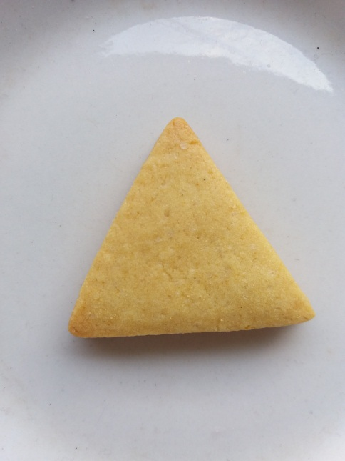

Lampiran 3. Analisis Mutu Kimia

1. Analisis Kadar Air (AOAC, 2005)

Memanaskan wadah/cawan dalam oven pada suhu 100 – 105° C selama 30 menit

↓

Mendinginkan cawan dalam desikator selama 15 menit, kemudian timbang menggunakan neraca analitik (W0)

↓

Menimbang 2 gram sampel ke dalam cawan yang sudah dikeringkan (W1)

↓

Sampel dikeringkan dalam oven pada suhu 100-105° C selama 6 jam

↓

Mendinginkan dalam desikator selama 30 menit

↓

Menimbang (W2) hingga diperoleh bobot konstan

↓

Menghitung kadar air dengan rumus :

|  |
| --- |
| *Kadar air(%) = $\frac{W1- W2}{W1- W0}X 100\%$* |

Keterangan :

W0  = bobot pinggan kosong, dinyatakan dalam gram

W1 = bobot pinggan dan sampel sebelum dikeringkan, dinyatakan dalam gram

W2 = bobot pinggan dan sampel setelah dikeringkan, dinyatakan dalam gram

1. Analisis Kadar Abu (AOAC, 2005)

Mengeringkan cawan dalam oven pada suhu 100 – 105° C selama 30 menit

↓

Mendinginkan cawan selama 15 menit dalam desikator kemudian ditimbang (A)

↓

Menimbang sampelsebanyak 2 gram ke dalam cawan yang sudah dikeringkan (B)

↓

Membakar diatas nyala pembakar sampai tidak berasap dan dilanjutkan dengan pengabuan di dalam tanur bersuhu 550 - 600° C sampai pengabuan sempurna

↓

Mendinginkan sampel yang telah diabukan dalam desikator dan menimbang (C)

↓

Tahap pembakaran dalam tanur diulangi sampai didapat berat yang konstan

↓

Menghitung kadar abu dengan rumus :

|  |
| --- |
| *Kadar abu (%) = $\frac{C-A}{B-A}100\%$* |

Keterangan:

A = Berat cawan kosong dinyatakan dalam gram

B = Berat cawan + sampel awal dinyatakan dalam gram

C = Berat cawan + sampel kering dinyatakan dalam gram

1. Analisis Kadar Protein (Metode Kjeldahl)

Memasukkan 50 mg *cookies* ke dalam labu kjeldahl

↓

Manambahkan 0,5 g tablet kjeldahl dan 2 ml H2SO4 pekat

↓

Melakukan dekstruksi dengan memanaskan selama 3 jam sampai diperoleh larutan jernih dalam tabung, lalu dinginkan

↓

Menambahkan 5 ml aquades ke dalam labu kjeldahl kemudian tetesi dengan 2 tetes indikatorpp dan reagen NaOH-thio sampai suasana menjadi basa (larutan berwarna merah muda)

↓

Menyiapkan 5 ml asam borat 4% yang telah diberikan 4 tetes indikator MR-BCG dalam enlenmeyer 125 ml. Pasang pada mulut destiling tube. Memastikan mulut destiling tube terendam dalam asam borat.

↓

Melakukan destilasi dengan menuang hasil destruksi ke dalam tabung destilasi. Menambahkan 5 ml aquades ke dalam tabung kjeldahl untuk mencuci sisa larutan

↓

Menampung destilat dalam larutan asam borat 3%. Menghentikan destilasi bila destilat sudah bersifat basa

↓

Melakukan titrasi dengan 0,02 N HCl sampai tercapai warna merah muda

↓

Menghitung N total menggunakan rumus :

|  |
| --- |
| *% total nitrogen = $\frac{(ml HCl – ml blanko) x N HCl x 14,007 x 100 mg sampel}{mg cookies}$*  *% protein = % total nitrogen x faktor konversi* |

Keterangan :

Berat atom nitrogen = 14,008

Faktor konversi baahan makanan = 6,25

1. Analisis Kadar Lemak (Metode Ekstraksi)

Menimbang enlenmeyer yang telah dioven, dikeringkan dan dibersihkan yang akan digunakan untuk menampung minyak hasil ekstraksi

↓

Menimbang 5 gram bahan pada kertas saring

↓

Membungkus kertas saring dengan rapi sehingga bahan yang telah ditimbang tidak bocor keluar kertas saring

↓

Mamasukkan dalam soxhlet ekstraktor

↓

Menambahkan pelarut cloroform secukupnya (1,5 x vol ekstraktor)

↓

Mengekstraksi selama 3 jam

↓

Mendestilasi pelarut yang ada dalam labu lemak dan angkat labu lemak

↓

Memanaskan dalam oven suhu 105° C, keringkan sampai beratnya tetap

↓

Mendinginkan dalam desikator kemudian timbang dan catat beratnya

↓

Kadar lemak dihitung dengan menggunakan rumus :

|  |
| --- |
| *Kadar lemak (%) = berat lemak x 100%*  *berat cookies* |

Lampiran 4. Formulir Uji Skala Kesukaan (Hedonic Scale Test)

**UJI SKALA KESUKAAN (HEDONIC SCALE TEST)**

Nama :

Tanggal :

Instruksi :

Di hadapan saudara disajikan produk makanan berupa **“Formulasi *Cookies* Tepung Tempe Kedelai dan Tepung Ikan Gabus *(Channa Striata)* sebagai Pemberian Makanan Tambahan (Pmt) bagi Balita *Stunting”*.** Saudara diminta untuk memberikan penilaian terhadap karakteristik mutu rasa, aroma, warna, dan tekstur dengan menggunakan skala penilaian sebagai berikut:

1 = Sangat tidak suka

2 = Tidak suka

3 = Suka

4 = Sangat suka

Setelah saudara mencicipi salah satu sampel, saudara diminta untuk berkumur dengan air mineral yang sudah disediakan sebelum mencicipi sampel yang lainnya. Selain itu, saudara diminta untuk memberikan kritik dan saran terhadap produk.

|  |  |  |  |  |
| --- | --- | --- | --- | --- |
| Kode Contoh | Skor Penilaian Kesukaan | | | |
| Warna | Aroma | Tekstur | Rasa |
|  |  |  |  |  |
|  |  |  |  |  |
|  |  |  |  |  |

Kritik dan saran :

Lampiran 5. Formulir Penentuan Taraf Perlakuan Terbaik

**PENENTUAN TARAF PERLAKUAN TERBAIK**

Nama :

Tanggal :

Produk : **“Formulasi *Cookies* Tepung Tempe Kedelai dan Tepung Ikan Gabus *(Channa Striata)* sebagai Pemberian Makanan Tambahan (Pmt) bagi Balita *Stunting***

Instruksi:

Saudara diminta untuk mengemukakan pendapat tentang urutan (ranking) pentingnya peranan keempat variabel berikut terhadap mutu *cookies* modifikasi Tempung Tempe Kedelai dan Tepung Ikan Gabus, dengan menggunakan 10 variabel dari tertinggi ke terendah dengan mencantumkan angka 1 – 10. Angka terendah untuk variabel kurang penting dan angka tertinggi untuk variabel terpenting. Pemberian nilai boleh sama apabila dirasa variabel yang dinilai sama pentingnya.

|  |  |
| --- | --- |
| Variabel Mutu | Ranking |
| Nilai Energi |  |
| Kadar Protein |  |
| Kadar Lemak |  |
| Kadar Karbohidrat |  |
| Kadar Air |  |
| Kadar Zink |  |
| Aroma |  |
| Warna |  |
| Rasa |  |
| Tekstur |  |

Atas partisipasi Saudara diucapkan terimakasih.

Lampiran 6. Hasil Analisis Statistik *Oneway Anova* Kadar Air

**Oneway**

|  |  |  |  |  |  |  |  |
| --- | --- | --- | --- | --- | --- | --- | --- |
| **Descriptives** | | | | | | | |
| kadarair | | | | | | | |
|  | N | Mean | Std. Deviation | Std. Error | 95% Confidence Interval for Mean | | Minimum |
| Lower Bound | Upper Bound |
| P1 | 3 | 3.6633 | 1.00749 | .58167 | 1.1606 | 6.1661 | 2.50 |
| P2 | 3 | 1.9667 | .27319 | .15773 | 1.2880 | 2.6453 | 1.74 |
| P3 | 3 | 3.0733 | .72570 | .41898 | 1.2706 | 4.8761 | 2.25 |
| Total | 9 | 2.9011 | .98006 | .32669 | 2.1478 | 3.6544 | 1.74 |

|  |  |
| --- | --- |
| **Descriptives** | |
| kadarair | |
|  | Maximum |
|
| P1 | 4.25 |
| P2 | 2.27 |
| P3 | 3.62 |
| Total | 4.25 |

|  |  |  |  |
| --- | --- | --- | --- |
| **Test of Homogeneity of Variances** | | | |
| kadarair | | | |
| Levene Statistic | df1 | df2 | Sig. |
| 3.737 | 2 | 6 | .088 |

|  |  |  |  |  |  |
| --- | --- | --- | --- | --- | --- |
| **ANOVA** | | | | | |
| kadarair | | | | | |
|  | Sum of Squares | df | Mean Square | F | Sig. |
| Between Groups | 4.451 | 2 | 2.226 | 4.131 | .074 |
| Within Groups | 3.233 | 6 | .539 |  |  |
| Total | 7.684 | 8 |  |  |  |

**Post Hoc Tests**

**Homogeneous Subsets**

|  |  |  |  |
| --- | --- | --- | --- |
| **kadarair** | | | |
| Duncana | | | |
| formulasi | N | Subset for alpha = 0.05 | |
| 1 | 2 |
| P2 | 3 | 1.9667 |  |
| P3 | 3 | 3.0733 | 3.0733 |
| P1 | 3 |  | 3.6633 |
| Sig. |  | .114 | .363 |

|  |
| --- |
| Means for groups in homogeneous subsets are displayed. |
| a. Uses Harmonic Mean Sample Size = 3.000. |

Lampiran 7. Hasil Analisis Statistik *Oneway Anova* Kadar Abu

|  |  |  |  |  |  |  |  |
| --- | --- | --- | --- | --- | --- | --- | --- |
| **Descriptives** | | | | | | | |
| kadarabu | | | | | | | |
|  | N | Mean | Std. Deviation | Std. Error | 95% Confidence Interval for Mean | | Minimum |
| Lower Bound | Upper Bound |
| P1 | 3 | 1.1033 | .08505 | .04910 | .8921 | 1.3146 | 1.04 |
| P2 | 3 | 1.2033 | .04726 | .02728 | 1.0859 | 1.3207 | 1.15 |
| P3 | 3 | 1.1933 | .01155 | .00667 | 1.1646 | 1.2220 | 1.18 |
| Total | 9 | 1.1667 | .06837 | .02279 | 1.1141 | 1.2192 | 1.04 |

|  |  |
| --- | --- |
| **Descriptives** | |
| kadarabu | |
|  | Maximum |
|
| P1 | 1.20 |
| P2 | 1.24 |
| P3 | 1.20 |
| Total | 1.24 |

|  |  |  |  |
| --- | --- | --- | --- |
| **Test of Homogeneity of Variances** | | | |
| kadarabu | | | |
| Levene Statistic | df1 | df2 | Sig. |
| 5.126 | 2 | 6 | .050 |

|  |  |  |  |  |  |
| --- | --- | --- | --- | --- | --- |
| **ANOVA** | | | | | |
| kadarabu | | | | | |
|  | Sum of Squares | df | Mean Square | F | Sig. |
| Between Groups | .018 | 2 | .009 | 2.844 | .135 |
| Within Groups | .019 | 6 | .003 |  |  |
| Total | .037 | 8 |  |  |  |

Lampiran 8. Hasil Analisis Statistik *Oneway Anova* Protein

|  |  |  |  |  |  |  |  |
| --- | --- | --- | --- | --- | --- | --- | --- |
| **Descriptives** | | | | | | | |
| protein | | | | | | | |
|  | N | Mean | Std. Deviation | Std. Error | 95% Confidence Interval for Mean | | Minimum |
| Lower Bound | Upper Bound |
| P1 | 3 | 14.4633 | 2.00809 | 1.15937 | 9.4750 | 19.4517 | 13.22 |
| P2 | 3 | 14.6900 | 1.57038 | .90666 | 10.7890 | 18.5910 | 13.10 |
| P3 | 3 | 15.7867 | 1.91912 | 1.10801 | 11.0193 | 20.5540 | 14.48 |
| Total | 9 | 14.9800 | 1.70911 | .56970 | 13.6663 | 16.2937 | 13.10 |

|  |  |
| --- | --- |
| **Descriptives** | |
| protein | |
|  | Maximum |
|
| P1 | 16.78 |
| P2 | 16.24 |
| P3 | 17.99 |
| Total | 17.99 |

|  |  |  |  |
| --- | --- | --- | --- |
| **Test of Homogeneity of Variances** | | | |
| protein | | | |
| Levene Statistic | df1 | df2 | Sig. |
| .364 | 2 | 6 | .710 |

|  |  |  |  |  |  |
| --- | --- | --- | --- | --- | --- |
| **ANOVA** | | | | | |
| protein | | | | | |
|  | Sum of Squares | df | Mean Square | F | Sig. |
| Between Groups | 3.005 | 2 | 1.503 | .443 | .662 |
| Within Groups | 20.363 | 6 | 3.394 |  |  |
| Total | 23.368 | 8 |  |  |  |

Lampiran 9. Hasil Analisis Statistik *Oneway Anova* Lemak

|  |  |  |  |  |  |  |  |
| --- | --- | --- | --- | --- | --- | --- | --- |
| **Descriptives** | | | | | | | |
| lemak | | | | | | | |
|  | N | Mean | Std. Deviation | Std. Error | 95% Confidence Interval for Mean | | Minimum |
| Lower Bound | Upper Bound |
| P1 | 3 | 20.0100 | .78689 | .45431 | 18.0553 | 21.9647 | 19.29 |
| P2 | 3 | 20.4633 | .73650 | .42522 | 18.6338 | 22.2929 | 19.62 |
| P3 | 3 | 22.6133 | .62644 | .36168 | 21.0572 | 24.1695 | 21.89 |
| Total | 9 | 21.0289 | 1.35617 | .45206 | 19.9864 | 22.0713 | 19.29 |

|  |  |
| --- | --- |
| **Descriptives** | |
| lemak | |
|  | Maximum |
|
| P1 | 20.85 |
| P2 | 20.98 |
| P3 | 22.98 |
| Total | 22.98 |

|  |  |  |  |
| --- | --- | --- | --- |
| **Test of Homogeneity of Variances** | | | |
| lemak | | | |
| Levene Statistic | df1 | df2 | Sig. |
| .072 | 2 | 6 | .932 |

|  |  |  |  |  |  |
| --- | --- | --- | --- | --- | --- |
| **ANOVA** | | | | | |
| lemak | | | | | |
|  | Sum of Squares | df | Mean Square | F | Sig. |
| Between Groups | 11.605 | 2 | 5.803 | 11.202 | .009 |
| Within Groups | 3.108 | 6 | .518 |  |  |
| Total | 14.713 | 8 |  |  |  |

**Post Hoc Tests**

**Homogeneous Subsets**

|  |  |  |  |
| --- | --- | --- | --- |
| **lemak** | | | |
| Duncana | | | |
| Formulasi | N | Subset for alpha = 0.05 | |
| 1 | 2 |
| P1 | 3 | 20.0100 |  |
| P2 | 3 | 20.4633 |  |
| P3 | 3 |  | 22.6133 |
| Sig. |  | .470 | 1.000 |

|  |
| --- |
| Means for groups in homogeneous subsets are displayed. |
| a. Uses Harmonic Mean Sample Size = 3.000. |

Lampiran 10. Hasil Analisis Statistik *Oneway Anova* Karbohidrat

|  |  |  |  |  |  |  |  |
| --- | --- | --- | --- | --- | --- | --- | --- |
| **Descriptives** | | | | | | | |
| karbohidrat | | | | | | | |
|  | N | Mean | Std. Deviation | Std. Error | 95% Confidence Interval for Mean | | Minimum |
| Lower Bound | Upper Bound |
| P1 | 3 | 60.7600 | 3.54920 | 2.04913 | 51.9433 | 69.5767 | 56.92 |
| P2 | 3 | 61.6767 | 2.43806 | 1.40761 | 55.6202 | 67.7331 | 59.67 |
| P3 | 3 | 57.3333 | 1.59249 | .91943 | 53.3774 | 61.2893 | 55.58 |
| Total | 9 | 59.9233 | 3.03317 | 1.01106 | 57.5918 | 62.2548 | 55.58 |

|  |  |
| --- | --- |
| **Descriptives** | |
| karbohidrat | |
|  | Maximum |
|
| P1 | 63.92 |
| P2 | 64.39 |
| P3 | 58.69 |
| Total | 64.39 |

|  |  |  |  |
| --- | --- | --- | --- |
| **Test of Homogeneity of Variances** | | | |
| karbohidrat | | | |
| Levene Statistic | df1 | df2 | Sig. |
| 1.017 | 2 | 6 | .416 |

|  |  |  |  |  |  |
| --- | --- | --- | --- | --- | --- |
| **ANOVA** | | | | | |
| karbohidrat | | | | | |
|  | Sum of Squares | df | Mean Square | F | Sig. |
| Between Groups | 31.447 | 2 | 15.723 | 2.238 | .188 |
| Within Groups | 42.154 | 6 | 7.026 |  |  |
| Total | 73.601 | 8 |  |  |  |

Lampiran 11. Hasil Analisis Statistik *Oneway Anova* Energi

|  |  |  |  |  |  |  |  |
| --- | --- | --- | --- | --- | --- | --- | --- |
| **Descriptives** | | | | | | | |
| energi | | | | | | | |
|  | N | Mean | Std. Deviation | Std. Error | 95% Confidence Interval for Mean | | Minimum |
| Lower Bound | Upper Bound |
| P1 | 3 | 480.9833 | 2.30211 | 1.32913 | 475.2646 | 486.7021 | 478.33 |
| P2 | 3 | 489.6367 | 2.96945 | 1.71441 | 482.2601 | 497.0132 | 486.54 |
| P3 | 3 | 496.0000 | 4.89917 | 2.82854 | 483.8298 | 508.1702 | 491.33 |
| Total | 9 | 488.8733 | 7.22073 | 2.40691 | 483.3230 | 494.4237 | 478.33 |

|  |  |
| --- | --- |
| **Descriptives** | |
| energi | |
|  | Maximum |
|
| P1 | 482.45 |
| P2 | 492.46 |
| P3 | 501.10 |
| Total | 501.10 |

|  |  |  |  |
| --- | --- | --- | --- |
| **Test of Homogeneity of Variances** | | | |
| energi | | | |
| Levene Statistic | df1 | df2 | Sig. |
| .701 | 2 | 6 | .532 |

|  |  |  |  |  |  |
| --- | --- | --- | --- | --- | --- |
| **ANOVA** | | | | | |
| energi | | | | | |
|  | Sum of Squares | df | Mean Square | F | Sig. |
| Between Groups | 340.872 | 2 | 170.436 | 13.413 | .006 |
| Within Groups | 76.239 | 6 | 12.706 |  |  |
| Total | 417.111 | 8 |  |  |  |

**Post Hoc Tests**

**Homogeneous Subsets**

|  |  |  |  |
| --- | --- | --- | --- |
| **energi** | | | |
| Duncana | | | |
| Formulasi | N | Subset for alpha = 0.05 | |
| 1 | 2 |
| P1 | 3 | 480.9833 |  |
| P2 | 3 |  | 489.6367 |
| P3 | 3 |  | 496.0000 |
| Sig. |  | 1.000 | .071 |

|  |
| --- |
| Means for groups in homogeneous subsets are displayed. |
| a. Uses Harmonic Mean Sample Size = 3.000. |

Lampiran 12. Hasil Analisis Statistik *Oneway Anova* Zink

|  |  |  |  |  |  |  |  |
| --- | --- | --- | --- | --- | --- | --- | --- |
| **Descriptives** | | | | | | | |
| zink | | | | | | | |
|  | N | Mean | Std. Deviation | Std. Error | 95% Confidence Interval for Mean | | Minimum |
| Lower Bound | Upper Bound |
| P1 | 3 | 2.4937 | .68600 | .39606 | .7896 | 4.1978 | 1.83 |
| P2 | 3 | 1.9683 | .47285 | .27300 | .7937 | 3.1430 | 1.53 |
| P3 | 3 | 1.5247 | .36421 | .21028 | .6199 | 2.4294 | 1.11 |
| Total | 9 | 1.9956 | .61901 | .20634 | 1.5197 | 2.4714 | 1.11 |

|  |  |
| --- | --- |
| **Descriptives** | |
| zink | |
|  | Maximum |
|
| P1 | 3.20 |
| P2 | 2.47 |
| P3 | 1.81 |
| Total | 3.20 |

|  |  |  |  |
| --- | --- | --- | --- |
| **Test of Homogeneity of Variances** | | | |
| zink | | | |
| Levene Statistic | df1 | df2 | Sig. |
| .425 | 2 | 6 | .672 |

|  |  |  |  |  |  |
| --- | --- | --- | --- | --- | --- |
| **ANOVA** | | | | | |
| zink | | | | | |
|  | Sum of Squares | df | Mean Square | F | Sig. |
| Between Groups | 1.412 | 2 | .706 | 2.561 | .157 |
| Within Groups | 1.654 | 6 | .276 |  |  |
| Total | 3.065 | 8 |  |  |  |

Lampiran 13. Hasil analisis statistik *Kruskal Wallis* Warna

|  |  |  |  |  |  |
| --- | --- | --- | --- | --- | --- |
| **Descriptive Statistics** | | | | | |
|  | N | Mean | Std. Deviation | Minimum | Maximum |
| warna | 60 | 3.3833 | .58488 | 2.00 | 4.00 |
| formulasi | 60 | 2.0000 | .82339 | 1.00 | 3.00 |

**Kruskal-Wallis Test**

|  |  |  |  |
| --- | --- | --- | --- |
| **Ranks** | | | |
|  | formulasi | N | Mean Rank |
| warna | P1 | 20 | 33.25 |
| P2 | 20 | 29.55 |
| P3 | 20 | 28.70 |
| Total | 60 |  |

|  |  |
| --- | --- |
| **Test Statisticsa,b** | |
|  | warna |
| Chi-Square | .983 |
| df | 2 |
| Asymp. Sig. | .612 |

|  |
| --- |
| a. Kruskal Wallis Test |
| b. Grouping Variable: formulasi |

Lampiran 14. Hasil analisis statistik *Kruskal Wallis* Aroma

|  |  |  |  |  |  |
| --- | --- | --- | --- | --- | --- |
| **Descriptive Statistics** | | | | | |
|  | N | Mean | Std. Deviation | Minimum | Maximum |
| aroma | 60 | 3.1333 | .62346 | 2.00 | 4.00 |
| formulasi | 60 | 2.0000 | .82339 | 1.00 | 3.00 |

**Kruskal-Wallis Test**

|  |  |  |  |
| --- | --- | --- | --- |
| **Ranks** | | | |
|  | formulasi | N | Mean Rank |
| aroma | P1 | 20 | 33.20 |
| P2 | 20 | 28.60 |
| P3 | 20 | 29.70 |
| Total | 60 |  |

|  |  |
| --- | --- |
| **Test Statisticsa,b** | |
|  | aroma |
| Chi-Square | .992 |
| df | 2 |
| Asymp. Sig. | .609 |

|  |
| --- |
| a. Kruskal Wallis Test |
| b. Grouping Variable: formulasi |

Lampiran 15. Hasil analisis statistik *Kruskal Wallis* Tekstur

|  |  |  |  |  |  |
| --- | --- | --- | --- | --- | --- |
| **Descriptive Statistics** | | | | | |
|  | N | Mean | Std. Deviation | Minimum | Maximum |
| tekstur | 60 | 3.2500 | .57120 | 2.00 | 4.00 |
| formulasi | 60 | 2.0000 | .82339 | 1.00 | 3.00 |

**Kruskal-Wallis Test**

|  |  |  |  |
| --- | --- | --- | --- |
| **Ranks** | | | |
|  | formulasi | N | Mean Rank |
| tekstur | P1 | 20 | 30.38 |
| P2 | 20 | 33.55 |
| P3 | 20 | 27.58 |
| Total | 60 |  |

|  |  |
| --- | --- |
| **Test Statisticsa,b** | |
|  | tekstur |
| Chi-Square | 1.598 |
| df | 2 |
| Asymp. Sig. | .450 |

|  |
| --- |
| a. Kruskal Wallis Test |
| b. Grouping Variable: formulasi |

Lampiran 16. Hasil analisis statistik *Kruskal Wallis* Rasa

|  |  |  |  |  |  |
| --- | --- | --- | --- | --- | --- |
| **Descriptive Statistics** | | | | | |
|  | N | Mean | Std. Deviation | Minimum | Maximum |
| rasa | 60 | 3.2667 | .60693 | 2.00 | 4.00 |
| formulasi | 60 | 2.0000 | .82339 | 1.00 | 3.00 |

**Kruskal-Wallis Test**

|  |  |  |  |
| --- | --- | --- | --- |
| **Ranks** | | | |
|  | formulasi | N | Mean Rank |
| rasa | P1 | 20 | 30.18 |
| P2 | 20 | 27.43 |
| P3 | 20 | 33.90 |
| Total | 60 |  |

|  |  |
| --- | --- |
| **Test Statisticsa,b** | |
|  | rasa |
| Chi-Square | 1.788 |
| df | 2 |
| Asymp. Sig. | .409 |

|  |
| --- |
| a. Kruskal Wallis Test |
| b. Grouping Variable: formulasi |

Lampiran 17. Hasil uji lab proksimat

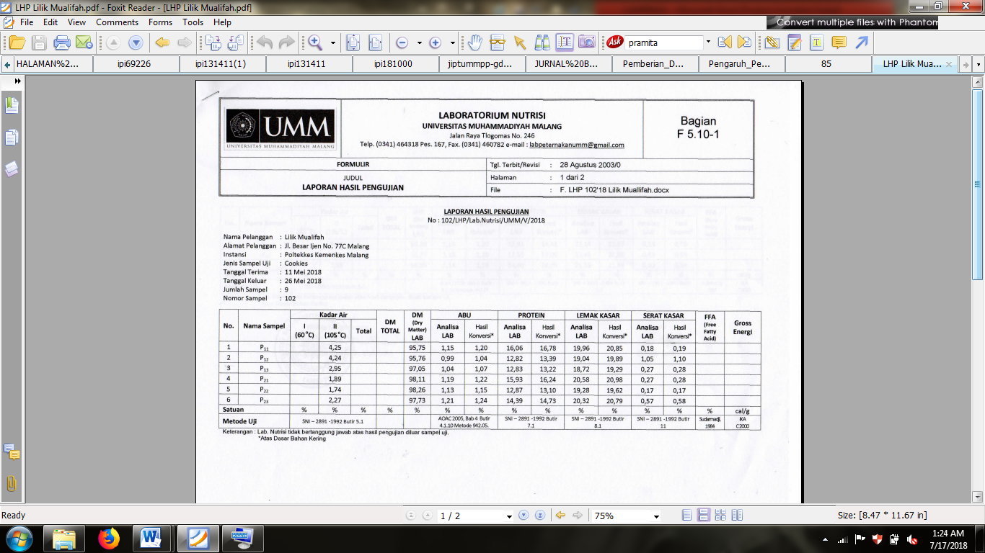

. 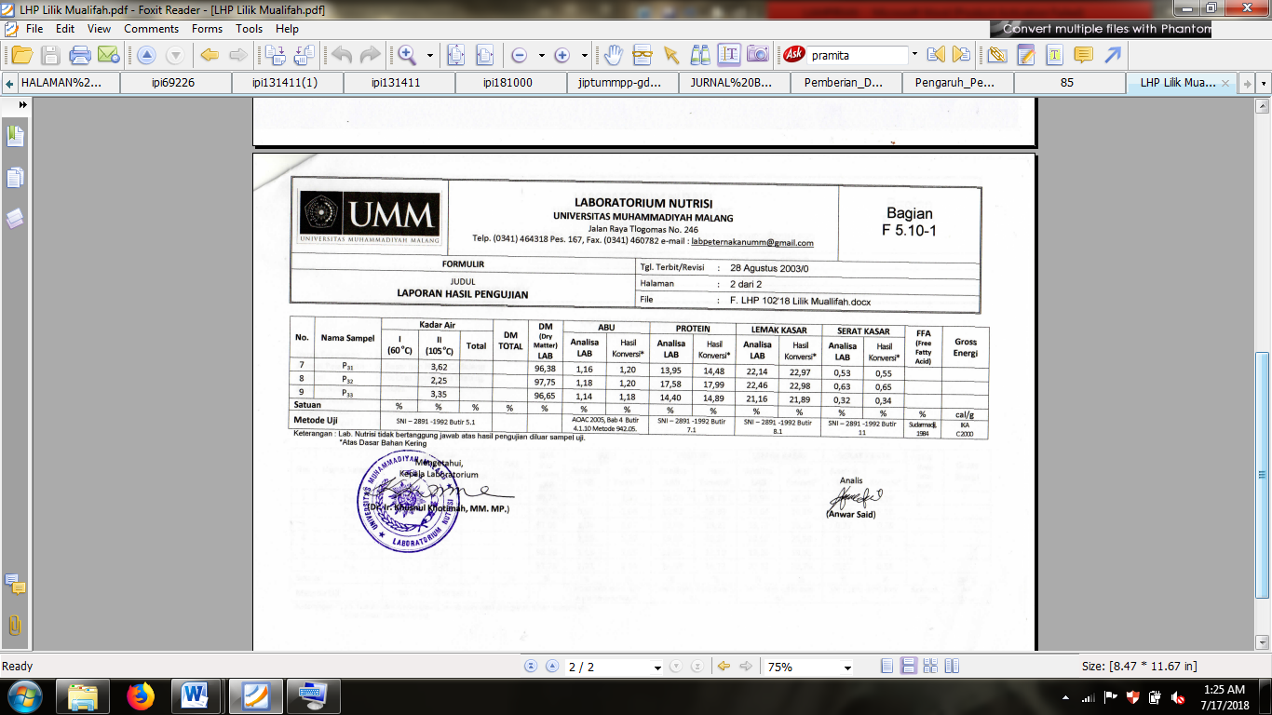

18. Hasil uji zink

Lampiran 19. Dokumentasi pengolahan

|  |  |
| --- | --- |
| Proses Pengolahan Tepung Tempe Kedelai | |
| C:\Users\user lilik\AppData\Local\Microsoft\Windows\Temporary Internet Files\Content.Word\IMG-20180717-WA0012.jpg  Pengovenan | Tepung tempe kedelai |

|  |  |
| --- | --- |
| Proses Pengolahan Tepung Ikan Gabus | |
| Sebelum proses pengukusan | Proses pengukusan |
| Sebelum proses pengovenan | Tepung ikan gabus |

|  |  |
| --- | --- |
| Proses Pengolahan *Cookies* | |
| C:\Users\user lilik\Pictures\DCIM\Camera\20180509_104440.jpgAdonan *cookies* | *Cookies* |

|  |  |
| --- | --- |
| Proses Uji Organoleptik | |
| C:\Users\user lilik\Pictures\DCIM\Camera\20180514_142722.jpg | C:\Users\user lilik\Pictures\DCIM\Camera\20180514_142129.jpg |