LAMPIRAN

Lampiran 1. Surat Izin Penelitian

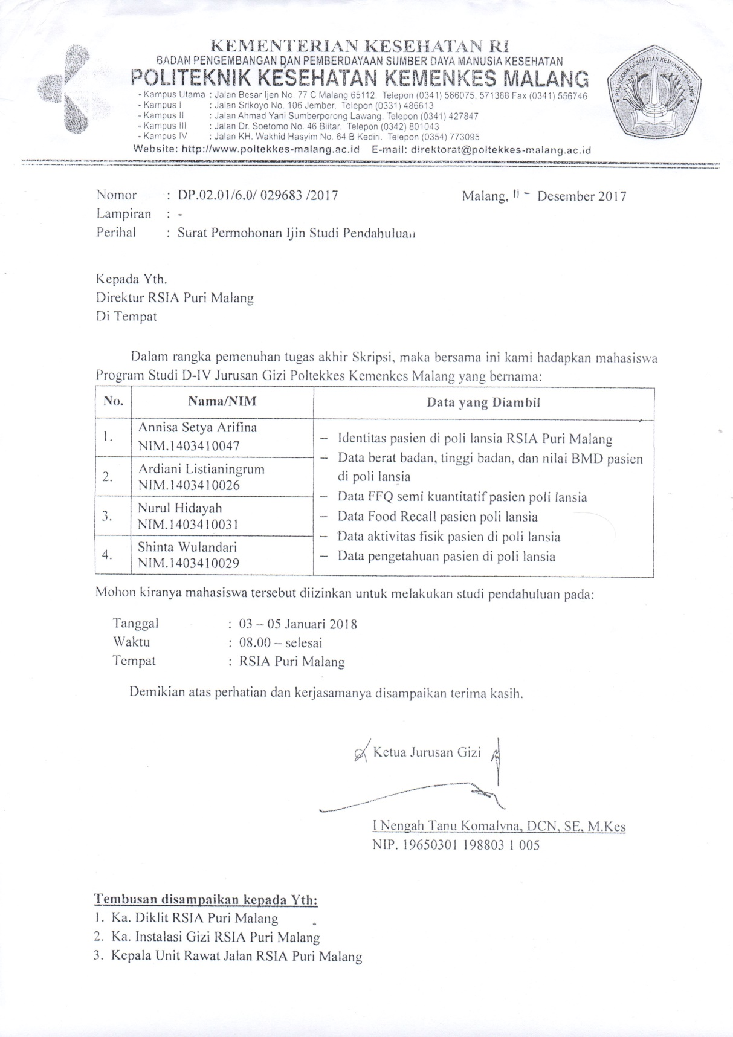

Lampiran 2. *Ethical Clearane*

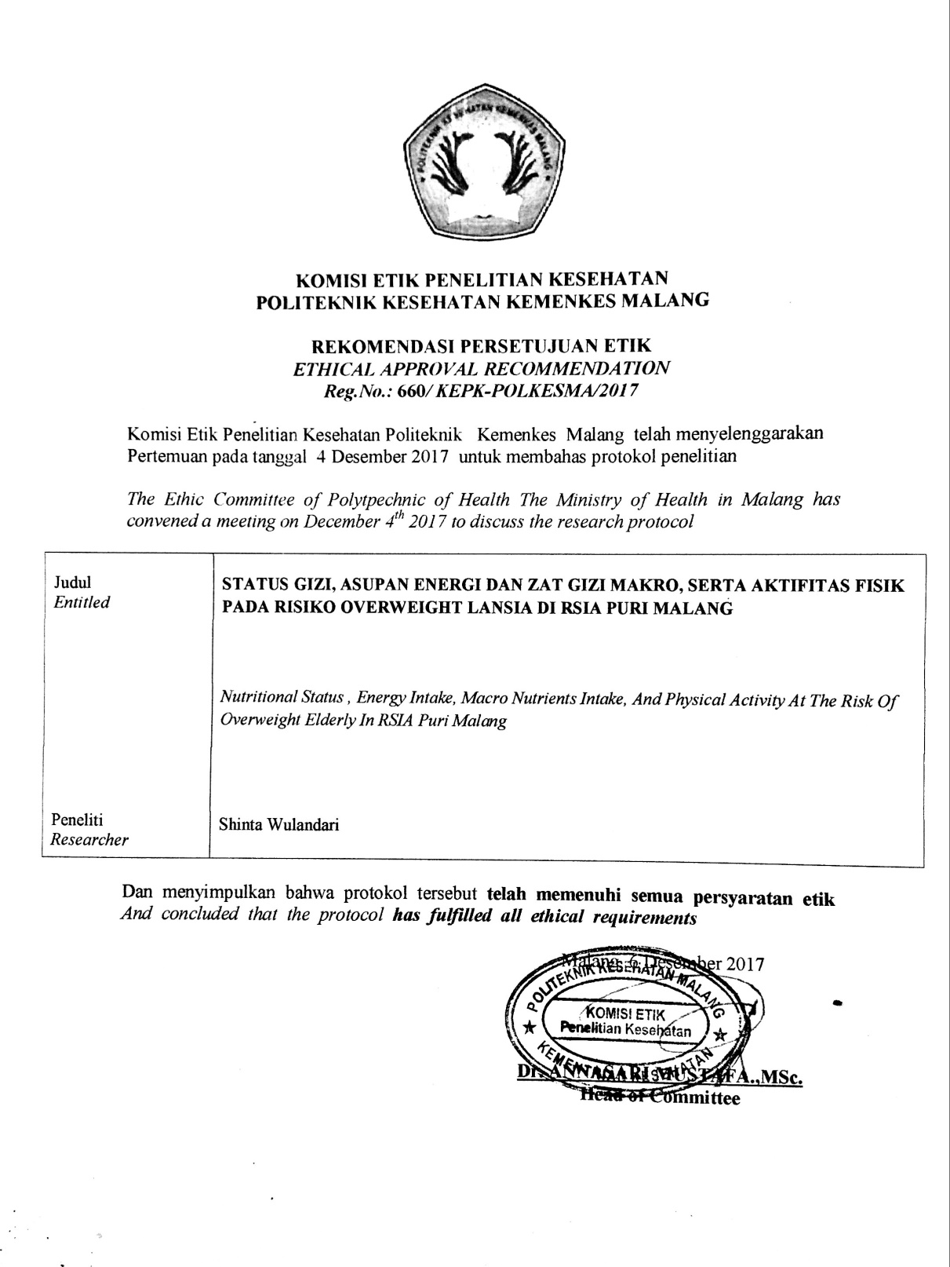

Lampiran 3. Penjelasan Sebelum Penelitian (PSP)

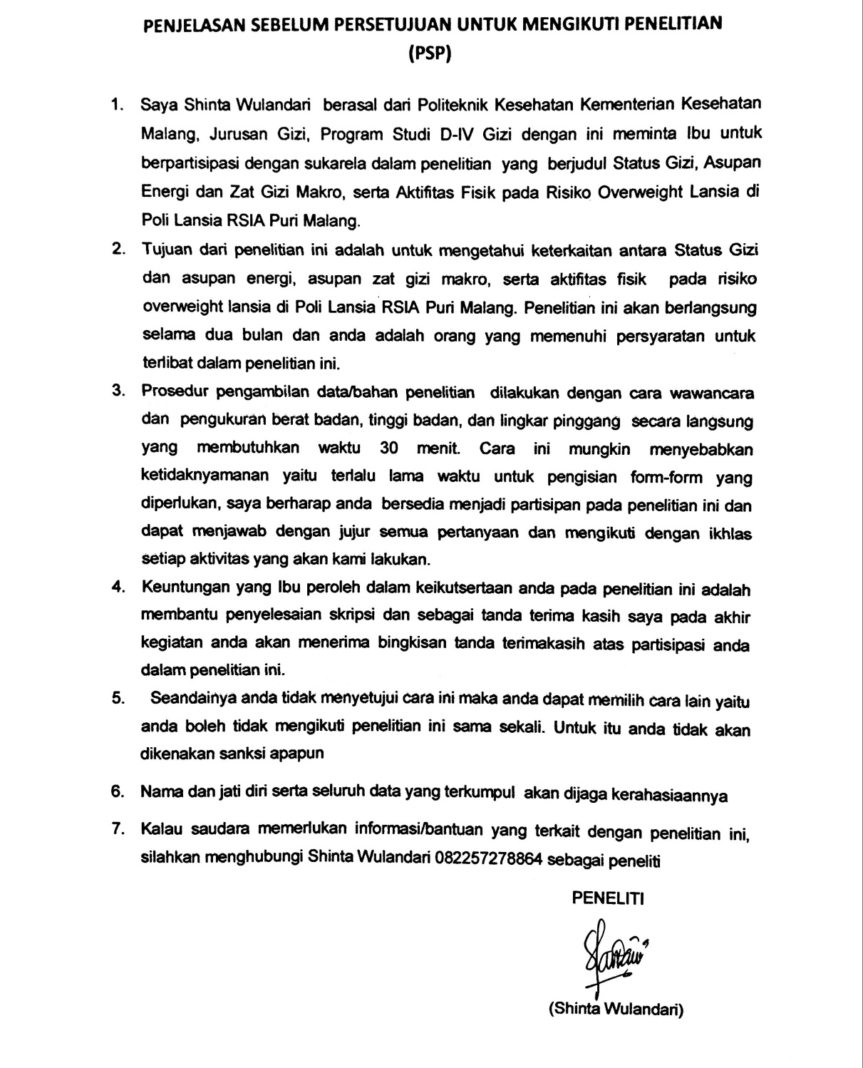

Lampiran 4. *Informed Consent*

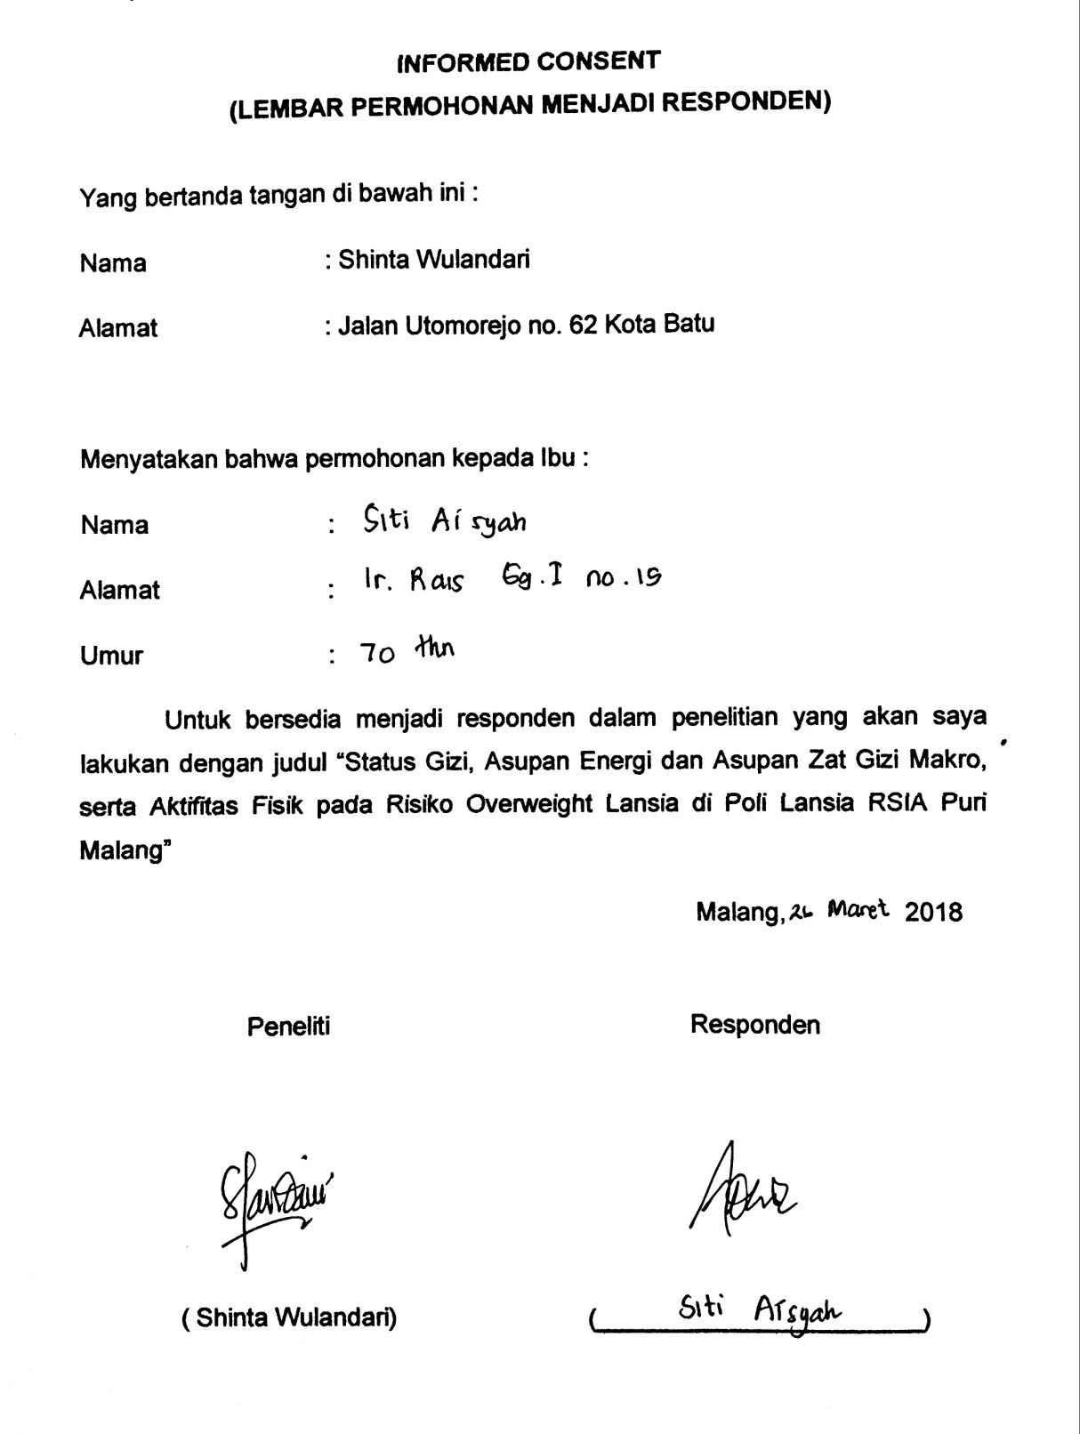

Lampiran 5. Form Identitas Responden

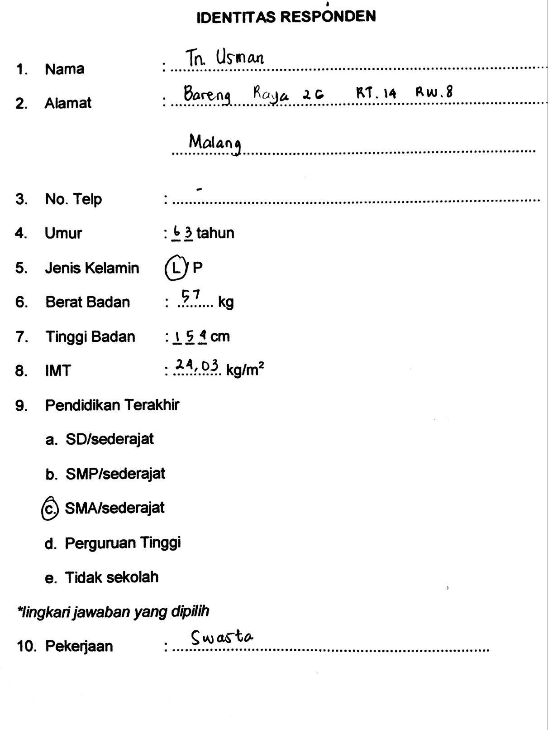

Lampiran 6. Formulir FFQ Semi Kuantitatif

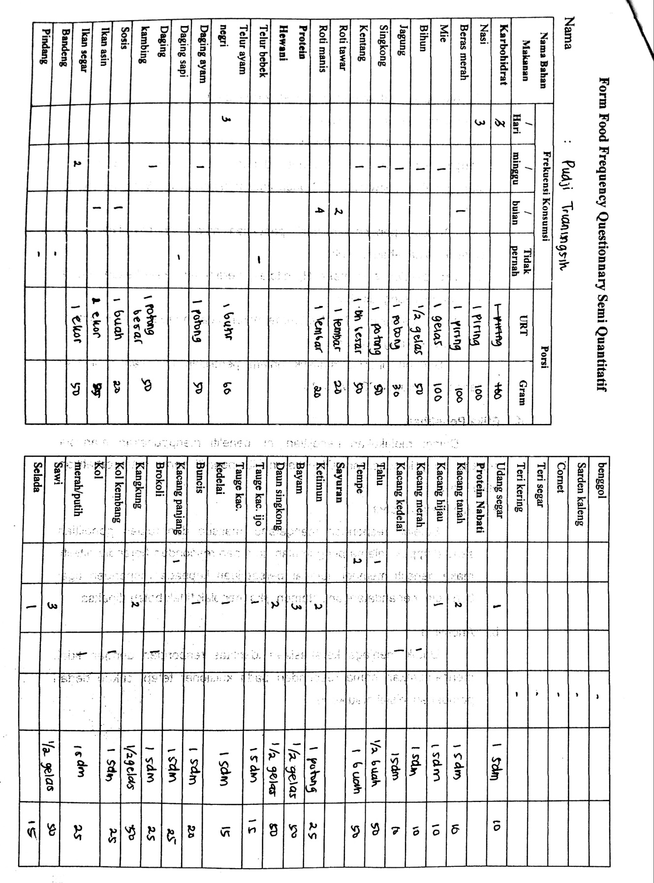

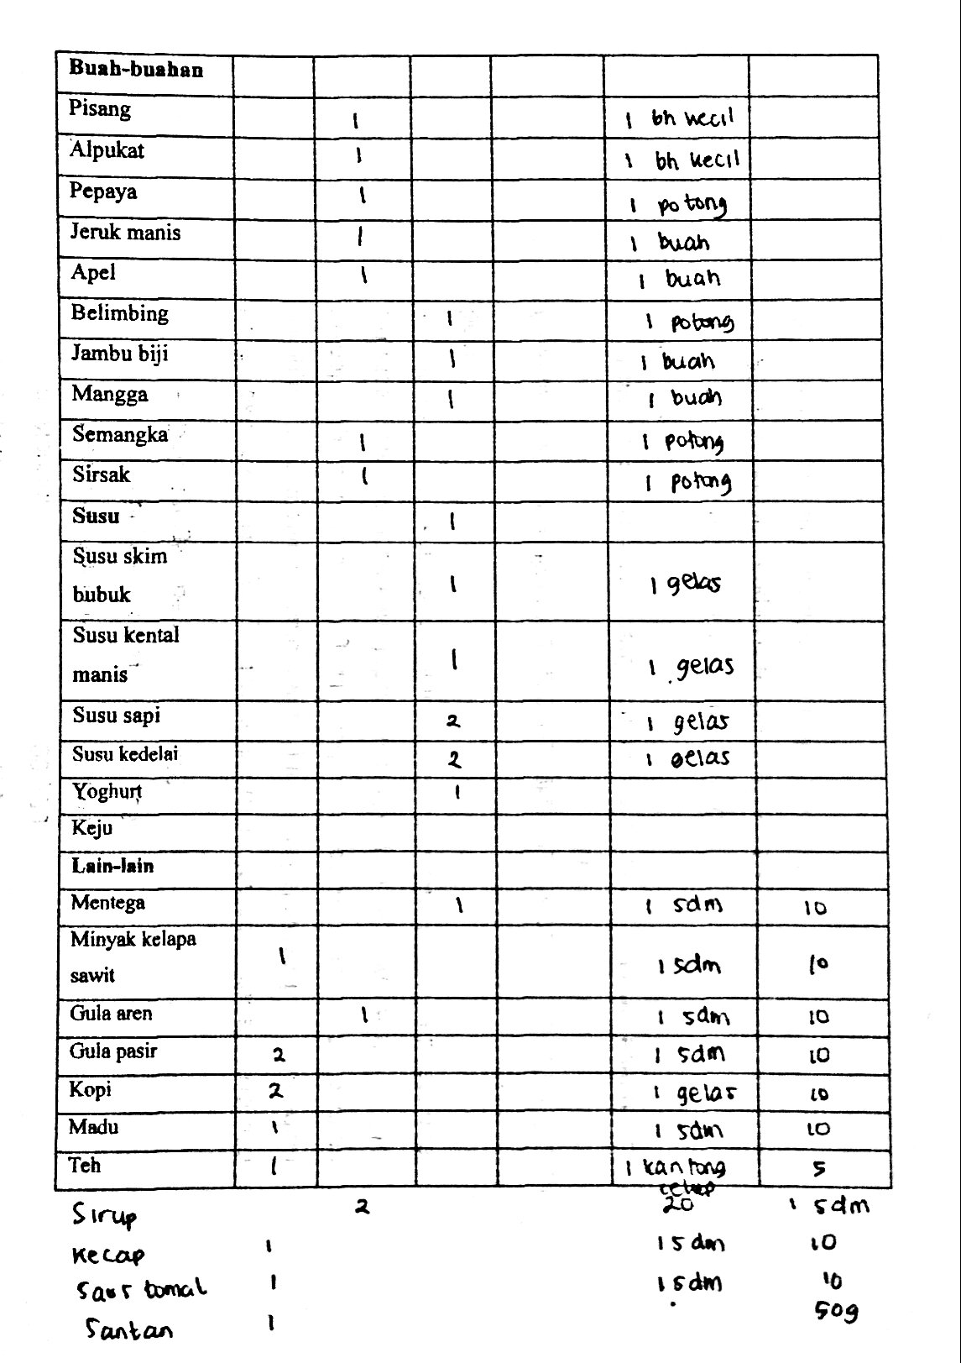

Lampiran 7. Formulir Recall Aktivitas Fisik 24 Jam

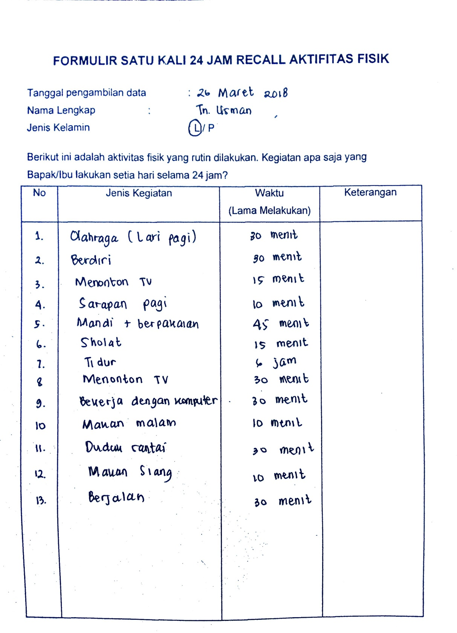

Lampiran 8. Tabel Physical Activity Ratio (PAR) berbagai Aktivitas Fisik

**TABEL PHYSICAL ACTIVITY RATIO (PAR) BERBAGAI AKTIVITAS FISIK**

|  |  |
| --- | --- |
| **Aktivitas** | **Physical Activity Ratio / satuan waktu** |
| Tidur | 1,0 |
| Berkendaraan dalam bus/mobil | 1,2 |
| Aktivitas santai (nonton TV dan mengobrol) | 1,4 |
| Makan | 1,5 |
| Duduk (bekerja kantor, menjaga toko) | 1,5 |
| Mengendarai mobil/berjalan | 2,0 |
| Memasak | 2,1 |
| Berdiri, membawa barang yang ringan | 2,2 |
| Mandi dan berpakaian | 2,3 |
| Menyapu, mencuci baju dan piring tanpa mesin | 2,3 |
| Mengerjakan pekerjaan rumah tangga | 2,8 |
| Berjalan | 3,2 |
| Berkebun | 4,1 |
| Olahraga ringan (jalan kaki) | 4,2 |
| Kegiatan yang dilakukan dengan duduk | 1,5 |
| Transportasi dengan bus | 1,2 |
| Kegiatan ringan | 1,4 |

Sumber : FAO/WHO/UNU. Human Energy Requirements. WHO Technical Report Series, no. 724. Geneva: World Helath Organization; 2001.

Lampiran 9. Master Data Karakteristik Responden

|  |  |  |  |  |
| --- | --- | --- | --- | --- |
| No Resp | Jenis Kelamin | Usia | Pekerjaan | Pendidikan |
|  | P | 63 | IRT | S1 |
|  | P | 66 | Dosen | S2 |
|  | P | 74 | Pedagang | SD |
|  | P | 67 | IRT | SD |
|  | L | 67 | Pedagang | SMA |
|  | P | 79 | Notaris | S2 |
|  | P | 67 | IRT | SMP |
|  | P | 62 | Swasta | SD |
|  | P | 70 | Pensiun | SD |
|  | P | 67 | Instruktur Senam | SMA |
|  | P | 70 | Babysitter | SD |
|  | P | 65 | IRT | S1 |
|  | P | 68 | Swasta | SD |
|  | P | 83 | Swasta | S1 |
|  | L | 67 | Pensiun | SMA |
|  | P | 66 | IRT | SMA |
|  | P | 68 | IRT | SMA |
|  | P | 65 | IRT | SMP |
|  | L | 80 | Swasta | S1 |
|  | P | 60 | Notaris | S2 |
|  | P | 60 | Kontraktor | S1 |
|  | P | 67 | Swasta | S1 |
|  | P | 63 | IRT | SMA |
|  | L | 67 | Swasta | SD |
|  | P | 63 | Pedagang | SMA |
|  | P | 64 | Swasta | SMA |
|  | P | 63 | IRT | SD |
|  | L | 60 | Swasta | SMA |
|  | P | 65 | IRT | SD |
|  | P | 62 | Pensiunan PNS | S1 |
|  | L | 63 | Swasta | SMA |
|  | L | 64 | Swasta | SMP |
|  | P | 67 | IRT | SMA |
|  | L | 64 | Swasta | S1 |
|  | P | 74 | IRT | S1 |
|  | L | 60 | Swasta | S1 |
|  | L | 77 | Swasta | SMA |
|  | L | 72 | Swasta | S1 |
|  | L | 61 | Swasta | S1 |
|  | L | 63 | Swasta | SMA |
|  | L | 60 | Pedagang | SMA |
|  | L | 64 | Swasta | SD |
|  | L | 60 | Swasta | SD |
|  | L | 61 | Pensiunan | S1 |
|  | L | 63 | Swasta | SMA |
|  | L | 60 | Pedagang | SMA |

Lampiran 10. Master Data Status Gizi Responden

|  |  |  |  |  |
| --- | --- | --- | --- | --- |
| No  Responden | Berat Badan | Tinggi Badan | IMT | Keterangan |
|  | 51 | 1,45 | 24,26 | OVERWEIGHT |
|  | 53 | 1,48 | 24,20 | OVERWEIGHT |
|  | 50 | 1,46 | 23,46 | OVERWEIGHT |
|  | 57 | 1,57 | 23,12 | OVERWEIGHT |
|  | 54 | 1,53 | 23,07 | OVERWEIGHT |
|  | 50 | 1,47 | 23,14 | OVERWEIGHT |
|  | 55 | 1,54 | 23,19 | OVERWEIGHT |
|  | 47 | 1,4 | 23,98 | OVERWEIGHT |
|  | 56 | 1,5 | 24,89 | OVERWEIGHT |
|  | 56 | 1,52 | 24,24 | OVERWEIGHT |
|  | 53 | 1,51 | 23,24 | OVERWEIGHT |
|  | 65 | 1,64 | 24,17 | OVERWEIGHT |
|  | 56 | 1,55 | 23,31 | OVERWEIGHT |
|  | 56 | 1,52 | 24,24 | OVERWEIGHT |
|  | 59 | 1,6 | 23,05 | OVERWEIGHT |
|  | 58 | 1,54 | 24,46 | OVERWEIGHT |
|  | 56 | 1,55 | 23,31 | OVERWEIGHT |
|  | 57 | 1,56 | 23,42 | OVERWEIGHT |
|  | 64 | 1,65 | 23,51 | OVERWEIGHT |
|  | 56 | 1,54 | 23,61 | OVERWEIGHT |
|  | 68 | 1,69 | 23,81 | OVERWEIGHT |
|  | 59 | 1,56 | 24,24 | OVERWEIGHT |
|  | 55 | 1,52 | 23,81 | OVERWEIGHT |
|  | 53 | 1,47 | 24,53 | OVERWEIGHT |
|  | 52 | 1,5 | 23,11 | OVERWEIGHT |
|  | 55 | 1,54 | 23,19 | OVERWEIGHT |
|  | 55 | 1,5 | 24,44 | OVERWEIGHT |
|  | 54 | 1,52 | 23,37 | OVERWEIGHT |
|  | 68 | 1,7 | 23,53 | OVERWEIGHT |
|  | 52 | 1,49 | 23,42 | OVERWEIGHT |
|  | 57 | 1,54 | 24,03 | OVERWEIGHT |
|  | 48 | 1,395 | 24,67 | OVERWEIGHT |
|  | 63 | 1,63 | 23,71 | OVERWEIGHT |
|  | 50 | 1,45 | 23,78 | OVERWEIGHT |
|  | 54 | 1,52 | 23,37 | OVERWEIGHT |
|  | 65 | 1,62 | 24,77 | OVERWEIGHT |
|  | 54 | 1,5 | 24,00 | OVERWEIGHT |
|  | 60 | 1,57 | 24,34 | OVERWEIGHT |
|  | 71 | 1,71 | 24,28 | OVERWEIGHT |
|  | 68 | 1,69 | 23,81 | OVERWEIGHT |
|  | 54 | 1,52 | 23,37 | OVERWEIGHT |
|  | 66 | 1,63 | 24,84 | OVERWEIGHT |
|  | 70 | 1,73 | 23,39 | OVERWEIGHT |
|  | 76 | 1,77 | 24,26 | OVERWEIGHT |
|  | 62 | 1,58 | 24,84 | OVERWEIGHT |
|  | 55 | 1,5 | 24,44 | OVERWEIGHT |

Lampiran 11. Master Data IMT, Aktifitas Fisik, dan Asupan Energi serta Zat Gizi Makro Responden

|  |  |  |  |  |  |  |  |
| --- | --- | --- | --- | --- | --- | --- | --- |
| No  Resp | IMT | | AKTIFITAS FISIK | ASUPAN | | | |
| ENERGI | KH | PROTEIN | LEMAK |
|  | 24,26 | Sedang | | NORMAL | NORMAL | LEBIH | NORMAL |
|  | 24,20 | Sedang | | NORMAL | NORMAL | NORMAL | LEBIH |
|  | 23,46 | Sedang | | NORMAL | NORMAL | NORMAL | NORMAL |
|  | 23,12 | Sedang | | DEFISIT SEDANG | DEFISIT SEDANG | NORMAL | DEFISIT SEDANG |
|  | 23,07 | Sedang | | DEFISIT BERAT | DEFISIT BERAT | DEFISIT BERAT | DEFISIT BERAT |
|  | 23,14 | Ringan | | NORMAL | DEFISIT RINGAN | NORMAL | DEFISIT RINGAN |
|  | 23,19 | Sedang | | DEFISIT RINGAN | DEFISIT SEDANG | LEBIH | DEFISIT SEDANG |
|  | 23,98 | Ringan | | NORMAL | NORMAL | LEBIH | NORMAL |
|  | 24,89 | Sedang | | NORMAL | NORMAL | LEBIH | LEBIH |
|  | 24,24 | Sedang | | NORMAL | DEFISIT RINGAN | DEFISIT BERAT | LEBIH |
|  | 23,24 | Sedang | | DEFISIT RINGAN | DEFISIT RINGAN | NORMAL | NORMAL |
|  | 24,17 | Sedang | | DEFISIT RINGAN | DEFISIT BERAT | NORMAL | NORMAL |
|  | 23,31 | Sedang | | DEFISIT RINGAN | DEFISIT SEDANG | NORMAL | NORMAL |
|  | 24,24 | Ringan | | NORMAL | DEFISIT RINGAN | LEBIH | DEFISIT BERAT |
|  | 23,05 | Sedang | | DEFISIT BERAT | DEFISIT BERAT | DEFISIT BERAT | DEFISIT BERAT |
|  | 24,46 | Ringan | | NORMAL | NORMAL | NORMAL | NORMAL |
|  | 23,31 | Ringan | | DEFISIT RINGAN | NORMAL | NORMAL | DEFISIT SEDANG |
|  | 23,42 | Ringan | | DEFISIT RINGAN | DEFISIT BERAT | NORMAL | LEBIH |
|  | 23,51 | Sedang | | DEFISIT SEDANG | DEFISIT BERAT | NORMAL | NORMAL |
|  | 23,61 | Ringan | | DEFISIT SEDANG | DEFISIT SEDANG | NORMAL | DEFISIT RINGAN |
|  | 23,81 | Sedang | | DEFISIT BERAT | DEFISIT BERAT | NORMAL | DEFISIT BERAT |
|  | 24,24 | Sedang | | NORMAL | DEFISIT RINGAN | LEBIH | LEBIH |
|  | 23,81 | Sedang | | DEFISIT RINGAN | DEFISIT RINGAN | LEBIH | NORMAL |
|  | 24,53 | Sedang | | NORMAL | LEBIH | LEBIH | NORMAL |
|  | 23,11 | Sedang | | DEFISIT BERAT | DEFISIT BERAT | DEFISIT BERAT | NORMAL |
|  | 23,19 | Ringan | | DEFISIT SEDANG | DEFISIT BERAT | NORMAL | DEFISIT RINGAN |
|  | 24,44 | Sedang | | DEFISIT RINGAN | DEFISIT RINGAN | LEBIH | NORMAL |
|  | 23,37 | Ringan | | DEFISIT BERAT | DEFISIT BERAT | NORMAL | DEFISIT BERAT |
|  | 23,53 | Ringan | | DEFISIT SEDANG | NORMAL | DEFISIT RINGAN | DEFISIT BERAT |
|  | 23,42 | Sedang | | DEFISIT RINGAN | DEFISIT SEDANG | NORMAL | NORMAL |
|  | 24,03 | Ringan | | DEFISIT SEDANG | DEFISIT BERAT | NORMAL | DEFISIT RINGAN |
|  | 24,67 | Ringan | | NORMAL | NORMAL | LEBIH | LEBIH |
|  | 23,71 | Ringan | | DEFISIT RINGAN | DEFISIT SEDANG | NORMAL | DEFISIT BERAT |
|  | 23,78 | Sedang | | DEFISIT SEDANG | DEFISIT SEDANG | LEBIH | LEBIH |
|  | 23,37 | Ringan | | NORMAL | DEFISIT BERAT | NORMAL | DEFISIT BERAT |
|  | 24,77 | Ringan | | DEFISIT SEDANG | DEFISIT SEDANG | LEBIH | DEFISIT RINGAN |
|  | 24,00 | Ringan | | NORMAL | DEFISIT SEDANG | LEBIH | DEFISIT RINGAN |
|  | 24,34 | Ringan | | DEFISIT RINGAN | DEFISIT SEDANG | NORMAL | DEFISIT RINGAN |
|  | 24,28 | Sedang | | DEFISIT BERAT | DEFISIT BERAT | DEFISIT RINGAN | DEFISIT SEDANG |
|  | 23,81 | Sedang | | DEFISIT BERAT | DEFISIT BERAT | NORMAL | DEFISIT BERAT |
|  | 23,37 | Sedang | | DEFISIT BERAT | DEFISIT SEDANG | NORMAL | DEFISIT SEDANG |
|  | 24,84 | Ringan | | DEFISIT SEDANG | DEFISIT BERAT | NORMAL | NORMAL |
|  | 23,39 | Ringan | | DEFISIT BERAT | DEFISIT BERAT | NORMAL | DEFISIT BERAT |
|  | 24,26 | Ringan | | DEFISIT BERAT | DEFISIT BERAT | NORMAL | DEFISIT RINGAN |
|  | 24,84 | Ringan | | DEFISIT RINGAN | NORMAL | NORMAL | DEFISIT BERAT |
|  | 24,44 | Sedang | | DEFISIT RINGAN | DEFISIT SEDANG | LEBIH | NORMAL |

Lampiran 12. Master Data Aktifitas Fisik Responden

|  |  |  |  |  |
| --- | --- | --- | --- | --- |
| No Resp | Jenis Kelamin | Umur | Aktifitas Fisik | |
| Nilai | Kategori |
|  | P | 63 | 1,71 | Sedang |
|  | P | 66 | 1,72 | Sedang |
|  | P | 74 | 1,71 | Sedang |
|  | P | 67 | 1,72 | Sedang |
|  | L | 67 | 1,81 | Sedang |
|  | P | 79 | 1,61 | Ringan |
|  | P | 67 | 1,82 | Sedang |
|  | P | 62 | 1,5 | Ringan |
|  | P | 70 | 1,73 | Sedang |
|  | P | 67 | 1,76 | Sedang |
|  | P | 70 | 1,78 | Sedang |
|  | P | 65 | 1,81 | Sedang |
|  | P | 68 | 1,81 | Sedang |
|  | P | 83 | 1,57 | Ringan |
|  | L | 67 | 1,83 | Sedang |
|  | P | 66 | 1,59 | Ringan |
|  | P | 68 | 1,69 | Ringan |
|  | P | 65 | 1,67 | Ringan |
|  | L | 80 | 1,82 | Sedang |
|  | P | 60 | 1,68 | Ringan |
|  | P | 60 | 1,86 | Sedang |
|  | P | 67 | 1,73 | Sedang |
|  | P | 63 | 1,8 | Sedang |
|  | L | 67 | 1,87 | Sedang |
|  | P | 63 | 1,71 | Sedang |
|  | P | 64 | 1,59 | Ringan |
|  | P | 63 | 1,73 | Sedang |
|  | L | 60 | 1,58 | Ringan |
|  | P | 65 | 1,55 | Ringan |
|  | P | 62 | 1,81 | Sedang |
|  | L | 63 | 1,49 | Ringan |
|  | L | 64 | 1,44 | Ringan |
|  | P | 67 | 1,65 | Ringan |
|  | L | 64 | 1,72 | Sedang |
|  | P | 74 | 1,65 | Ringan |
|  | L | 60 | 1,54 | Ringan |
|  | L | 77 | 1,46 | Ringan |
|  | L | 72 | 1,5 | Ringan |
|  | L | 61 | 1,84 | Sedang |
|  | L | 63 | 1,8 | Sedang |
|  | L | 60 | 1,77 | Sedang |
|  | L | 64 | 1,61 | Ringan |
|  | L | 60 | 1,59 | Ringan |
|  | L | 61 | 1,55 | Ringan |
|  | L | 63 | 1,56 | Ringan |
|  | L | 60 | 1,81 | Sedang |

Lampiran 13. Master Data Asupan Energi, Karbohidrat, Protein, dan Lemak

|  |  |  |  |  |  |  |  |
| --- | --- | --- | --- | --- | --- | --- | --- |
| No Res | Asupan Energi | | | | | | |
| BB aktual | BB AKG | Standar AKG | Standar Individu | Recall | Pemenuhan (%) | Kategori |
|  | 51 | 55 | 1900 | 1761,82 | 1653,1 | 93,83 | NORMAL |
|  | 53 | 54 | 1550 | 1521,30 | 1617,4 | 106,32 | NORMAL |
|  | 50 | 54 | 1550 | 1435,19 | 1457,66 | 101,57 | NORMAL |
|  | 57 | 54 | 1550 | 1636,11 | 1287,64 | 78,70 | DEFISIT SEDANG |
|  | 54 | 60 | 1900 | 1710,00 | 1146,98 | 67,07 | DEFISIT BERAT |
|  | 50 | 54 | 1550 | 1435,19 | 1302,72 | 90,77 | NORMAL |
|  | 55 | 54 | 1550 | 1578,70 | 1335,3 | 84,58 | DEFISIT RINGAN |
|  | 47 | 55 | 1900 | 1623,64 | 1553,5 | 95,68 | NORMAL |
|  | 56 | 54 | 1550 | 1607,41 | 1887,32 | 117,41 | NORMAL |
|  | 56 | 54 | 1550 | 1607,41 | 1618 | 100,66 | NORMAL |
|  | 53 | 54 | 1550 | 1521,30 | 1364,2 | 89,67 | DEFISIT RINGAN |
|  | 65 | 54 | 1550 | 1865,74 | 1586,71 | 85,04 | DEFISIT RINGAN |
|  | 56 | 54 | 1550 | 1607,41 | 1370,2 | 85,24 | DEFISIT RINGAN |
|  | 56 | 54 | 1550 | 1607,41 | 1645,31 | 102,36 | NORMAL |
|  | 59 | 60 | 1900 | 1868,33 | 837,35 | 44,82 | DEFISIT BERAT |
|  | 58 | 54 | 1550 | 1664,81 | 1988 | 119,41 | NORMAL |
|  | 56 | 54 | 1550 | 1607,41 | 1392,9 | 86,66 | DEFISIT RINGAN |
|  | 57 | 54 | 1550 | 1636,11 | 1418,1 | 86,68 | DEFISIT RINGAN |
|  | 64 | 60 | 1900 | 2026,67 | 1458,8 | 71,98 | DEFISIT SEDANG |
|  | 56 | 55 | 1900 | 1934,55 | 1489,2 | 76,98 | DEFISIT SEDANG |
|  | 68 | 55 | 1900 | 2349,09 | 1501,5 | 63,92 | DEFISIT BERAT |
|  | 59 | 54 | 1550 | 1693,52 | 1649,69 | 97,41 | NORMAL |
|  | 55 | 55 | 1900 | 1900,00 | 1526,8 | 80,36 | DEFISIT RINGAN |
|  | 53 | 60 | 1900 | 1678,33 | 1748,37 | 104,17 | NORMAL |
|  | 52 | 55 | 1900 | 1796,36 | 1192,92 | 66,41 | DEFISIT BERAT |
|  | 55 | 55 | 1900 | 1900,00 | 1362,3 | 71,70 | DEFISIT SEDANG |
|  | 55 | 55 | 1900 | 1900,00 | 1699,8 | 89,46 | DEFISIT RINGAN |
|  | 54 | 62 | 2325 | 2025,00 | 1407 | 69,48 | DEFISIT BERAT |
|  | 68 | 54 | 1550 | 1951,85 | 1488,3 | 76,25 | DEFISIT SEDANG |
|  | 52 | 55 | 1900 | 1796,36 | 1451,87 | 80,82 | DEFISIT RINGAN |
|  | 57 | 62 | 2325 | 2137,50 | 1558,6 | 72,92 | DEFISIT SEDANG |
|  | 48 | 62 | 2325 | 1800,00 | 1782,11 | 99,01 | NORMAL |
|  | 63 | 54 | 1550 | 1808,33 | 1489,73 | 82,38 | DEFISIT RINGAN |
|  | 50 | 62 | 2325 | 1875,00 | 1490,3 | 79,48 | DEFISIT SEDANG |
|  | 54 | 54 | 1550 | 1550,00 | 1407 | 90,77 | NORMAL |
|  | 65 | 62 | 2325 | 2437,50 | 1813,01 | 74,38 | DEFISIT SEDANG |
|  | 54 | 60 | 1550 | 1395,00 | 1554,37 | 111,42 | NORMAL |
|  | 60 | 60 | 1900 | 1900,00 | 1658,71 | 87,30 | DEFISIT RINGAN |
|  | 71 | 62 | 2325 | 2662,50 | 1658,05 | 62,27 | DEFISIT BERAT |
|  | 68 | 62 | 2325 | 2550,00 | 1540,3 | 60,40 | DEFISIT BERAT |
|  | 54 | 62 | 2325 | 2025,00 | 1408 | 69,53 | DEFISIT BERAT |
|  | 66 | 62 | 2325 | 2475,00 | 1840,68 | 74,37 | DEFISIT SEDANG |
|  | 70 | 62 | 2325 | 2625,00 | 1409,2 | 53,68 | DEFISIT BERAT |
|  | 76 | 62 | 2325 | 2850,00 | 1654,99 | 58,07 | DEFISIT BERAT |
|  | 62 | 62 | 2325 | 2325,00 | 1879,88 | 80,86 | DEFISIT RINGAN |
|  | 55 | 62 | 2325 | 2062,50 | 1733,3 | 84,04 | DEFISIT RINGAN |

|  |  |  |  |  |  |  |  |
| --- | --- | --- | --- | --- | --- | --- | --- |
| No Res | Asupan Karbohidrat | | | | | | |
| BB aktual | BB AKG | Standar AKG | Standar Individu | Recall | Pemenuhan (%) | Kategori |
|  | 51 | 55 | 285 | 264,27 | 248,2 | 93,92 | NORMAL |
|  | 53 | 54 | 252 | 247,33 | 224,91 | 90,93 | NORMAL |
|  | 50 | 54 | 252 | 233,33 | 233,51 | 100,08 | NORMAL |
|  | 57 | 54 | 252 | 266,00 | 203,73 | 76,59 | DEFISIT SEDANG |
|  | 54 | 60 | 309 | 278,10 | 191,48 | 68,85 | DEFISIT BERAT |
|  | 50 | 54 | 252 | 233,33 | 203,54 | 87,23 | DEFISIT RINGAN |
|  | 55 | 54 | 252 | 256,67 | 196,81 | 76,68 | DEFISIT SEDANG |
|  | 47 | 55 | 285 | 243,55 | 240,58 | 98,78 | NORMAL |
|  | 56 | 54 | 252 | 261,33 | 288,52 | 110,40 | NORMAL |
|  | 56 | 54 | 252 | 261,33 | 220,39 | 84,33 | DEFISIT RINGAN |
|  | 53 | 54 | 252 | 247,33 | 198,9 | 80,42 | DEFISIT RINGAN |
|  | 65 | 54 | 252 | 303,33 | 203,94 | 67,23 | DEFISIT BERAT |
|  | 56 | 54 | 252 | 261,33 | 185,31 | 70,91 | DEFISIT SEDANG |
|  | 56 | 54 | 252 | 261,33 | 213,39 | 84,68 | DEFISIT RINGAN |
|  | 59 | 60 | 252 | 247,80 | 158,54 | 63,98 | DEFISIT BERAT |
|  | 58 | 54 | 252 | 270,67 | 293,98 | 108,61 | NORMAL |
|  | 56 | 54 | 252 | 261,33 | 249,22 | 95,36 | NORMAL |
|  | 57 | 54 | 252 | 266,00 | 179,96 | 67,65 | DEFISIT BERAT |
|  | 64 | 60 | 309 | 329,60 | 197,59 | 59,95 | DEFISIT BERAT |
|  | 56 | 55 | 285 | 290,18 | 207,09 | 71,37 | DEFISIT SEDANG |
|  | 68 | 55 | 285 | 352,36 | 236,83 | 67,21 | DEFISIT BERAT |
|  | 59 | 54 | 252 | 275,33 | 231,36 | 84,03 | DEFISIT RINGAN |
|  | 55 | 55 | 285 | 285,00 | 243,31 | 85,37 | DEFISIT RINGAN |
|  | 53 | 60 | 309 | 272,95 | 450,35 | 164,99 | LEBIH |
|  | 52 | 55 | 285 | 269,45 | 182,65 | 67,79 | DEFISIT BERAT |
|  | 55 | 55 | 285 | 285,00 | 184,73 | 64,82 | DEFISIT BERAT |
|  | 55 | 55 | 285 | 285,00 | 244,36 | 85,74 | DEFISIT RINGAN |
|  | 54 | 62 | 349 | 303,97 | 209,05 | 68,77 | DEFISIT BERAT |
|  | 68 | 54 | 252 | 317,33 | 331,66 | 104,51 | NORMAL |
|  | 52 | 55 | 285 | 269,45 | 195,52 | 72,56 | DEFISIT SEDANG |
|  | 57 | 62 | 349 | 320,85 | 213,14 | 66,43 | DEFISIT BERAT |
|  | 48 | 62 | 349 | 270,19 | 244,23 | 90,39 | NORMAL |
|  | 63 | 54 | 252 | 294,00 | 226,68 | 77,10 | DEFISIT SEDANG |
|  | 50 | 62 | 349 | 281,45 | 219,96 | 78,15 | DEFISIT SEDANG |
|  | 54 | 54 | 309 | 309,00 | 209,05 | 67,65 | DEFISIT BERAT |
|  | 65 | 62 | 349 | 365,89 | 281,07 | 76,82 | DEFISIT SEDANG |
|  | 54 | 60 | 309 | 278,10 | 213,23 | 76,67 | DEFISIT SEDANG |
|  | 60 | 60 | 309 | 309,00 | 230,12 | 74,47 | DEFISIT SEDANG |
|  | 71 | 62 | 349 | 399,66 | 225,64 | 56,46 | DEFISIT BERAT |
|  | 68 | 62 | 349 | 382,77 | 220,3 | 57,55 | DEFISIT BERAT |
|  | 54 | 62 | 349 | 303,97 | 215,85 | 71,01 | DEFISIT SEDANG |
|  | 66 | 62 | 349 | 371,52 | 198,14 | 53,33 | DEFISIT BERAT |
|  | 70 | 62 | 349 | 394,03 | 200,84 | 50,97 | DEFISIT BERAT |
|  | 76 | 62 | 349 | 427,81 | 195,58 | 45,72 | DEFISIT BERAT |
|  | 62 | 62 | 349 | 349,00 | 314,52 | 90,12 | NORMAL |
|  | 55 | 62 | 349 | 309,60 | 221,11 | 71,42 | DEFISIT SEDANG |

|  |  |  |  |  |  |  |  |
| --- | --- | --- | --- | --- | --- | --- | --- |
| No Res | Asupan Protein | | | | | | |
| BB aktual | BB AKG | Standar AKG | Standar Individu | Recall | Pemenuhan (%) | Kategori |
|  | 51 | 55 | 57 | 52,85 | 65,46 | 123,85 | LEBIH |
|  | 53 | 54 | 56 | 54,96 | 64,32 | 117,02 | NORMAL |
|  | 50 | 54 | 56 | 51,85 | 58,93 | 113,65 | NORMAL |
|  | 57 | 54 | 56 | 59,11 | 56,98 | 96,39 | NORMAL |
|  | 54 | 60 | 62 | 55,80 | 32,5 | 58,24 | DEFISIT BERAT |
|  | 50 | 54 | 56 | 51,85 | 56,27 | 108,52 | NORMAL |
|  | 55 | 54 | 56 | 57,04 | 73,31 | 128,53 | LEBIH |
|  | 47 | 55 | 56 | 47,85 | 66,6 | 139,17 | LEBIH |
|  | 56 | 54 | 56 | 58,07 | 75,06 | 129,25 | LEBIH |
|  | 56 | 54 | 56 | 58,07 | 32,15 | 55,36 | DEFISIT BERAT |
|  | 53 | 54 | 56 | 54,96 | 52,4 | 95,34 | NORMAL |
|  | 65 | 54 | 56 | 67,41 | 74,38 | 110,34 | NORMAL |
|  | 56 | 54 | 56 | 58,07 | 62,29 | 107,26 | NORMAL |
|  | 56 | 54 | 56 | 58,07 | 77,01 | 132,61 | LEBIH |
|  | 59 | 60 | 62 | 60,97 | 18,91 | 31,02 | DEFISIT BERAT |
|  | 58 | 54 | 56 | 60,15 | 71,92 | 119,57 | NORMAL |
|  | 56 | 54 | 56 | 58,07 | 67,95 | 117,01 | NORMAL |
|  | 57 | 54 | 56 | 59,11 | 60,05 | 101,59 | NORMAL |
|  | 64 | 60 | 62 | 66,13 | 60,98 | 92,21 | NORMAL |
|  | 56 | 55 | 57 | 58,04 | 68,2 | 117,51 | NORMAL |
|  | 68 | 55 | 57 | 70,47 | 67,97 | 96,45 | NORMAL |
|  | 59 | 54 | 56 | 61,19 | 76,01 | 124,23 | LEBIH |
|  | 55 | 55 | 57 | 57,00 | 82,3 | 144,39 | LEBIH |
|  | 53 | 60 | 56 | 49,47 | 81,75 | 165,26 | LEBIH |
|  | 52 | 55 | 57 | 53,89 | 19,08 | 35,40 | DEFISIT BERAT |
|  | 55 | 55 | 57 | 57,00 | 60,39 | 105,95 | NORMAL |
|  | 55 | 55 | 57 | 57,00 | 76,01 | 133,35 | LEBIH |
|  | 54 | 62 | 65 | 56,61 | 63,32 | 111,85 | NORMAL |
|  | 68 | 54 | 57 | 71,78 | 60,34 | 84,07 | DEFISIT RINGAN |
|  | 52 | 55 | 65 | 61,45 | 65,57 | 106,70 | NORMAL |
|  | 57 | 62 | 65 | 59,76 | 67,96 | 113,73 | NORMAL |
|  | 48 | 62 | 56 | 43,35 | 72,79 | 167,89 | LEBIH |
|  | 63 | 54 | 54 | 63,00 | 59,8 | 94,92 | NORMAL |
|  | 50 | 62 | 56 | 45,16 | 74,07 | 164,01 | LEBIH |
|  | 54 | 54 | 65 | 65,00 | 63,32 | 97,42 | NORMAL |
|  | 65 | 62 | 62 | 65,00 | 80,67 | 124,11 | LEBIH |
|  | 54 | 60 | 65 | 58,50 | 76,36 | 130,53 | LEBIH |
|  | 60 | 60 | 65 | 65,00 | 68,84 | 105,91 | NORMAL |
|  | 71 | 62 | 65 | 74,44 | 65,5 | 88,00 | DEFISIT RINGAN |
|  | 68 | 62 | 65 | 71,29 | 79,81 | 111,95 | NORMAL |
|  | 54 | 62 | 65 | 56,61 | 55,92 | 98,78 | NORMAL |
|  | 66 | 62 | 65 | 69,19 | 67,95 | 98,20 | NORMAL |
|  | 70 | 62 | 65 | 73,39 | 68,24 | 92,99 | NORMAL |
|  | 76 | 62 | 65 | 79,68 | 77,68 | 97,49 | NORMAL |
|  | 62 | 62 | 65 | 65,00 | 59,23 | 91,12 | NORMAL |
|  | 55 | 62 | 65 | 57,66 | 77,4 | 134,23 | LEBIH |

|  |  |  |  |  |  |  |  |
| --- | --- | --- | --- | --- | --- | --- | --- |
| No Res | Asupan Lemak | | | | | | |
| BB aktual | BB AKG | Standar AKG | Standar Individu | Recall | Pemenuhan (%) | Kategori |
|  | 51 | 55 | 53 | 49,15 | 48,43 | 98,54 | NORMAL |
|  | 53 | 54 | 43 | 42,20 | 54,48 | 129,09 | LEBIH |
|  | 50 | 54 | 43 | 39,81 | 42,22 | 106,04 | NORMAL |
|  | 57 | 54 | 43 | 45,39 | 34,02 | 74,95 | DEFISIT SEDANG |
|  | 54 | 60 | 53 | 47,70 | 29,41 | 61,66 | DEFISIT BERAT |
|  | 50 | 54 | 43 | 39,81 | 32,93 | 82,71 | DEFISIT RINGAN |
|  | 55 | 54 | 43 | 43,80 | 34,55 | 78,89 | DEFISIT SEDANG |
|  | 47 | 55 | 53 | 45,29 | 45,59 | 100,66 | NORMAL |
|  | 56 | 54 | 43 | 44,59 | 55,89 | 125,33 | LEBIH |
|  | 56 | 54 | 43 | 44,59 | 58 | 130,07 | LEBIH |
|  | 53 | 54 | 43 | 42,20 | 44,38 | 105,16 | NORMAL |
|  | 65 | 54 | 43 | 51,76 | 58,81 | 113,62 | NORMAL |
|  | 56 | 54 | 43 | 44,59 | 45,48 | 101,99 | NORMAL |
|  | 56 | 54 | 43 | 44,59 | 31,01 | 69,54 | DEFISIT BERAT |
|  | 59 | 60 | 53 | 52,12 | 14,67 | 28,15 | DEFISIT BERAT |
|  | 58 | 54 | 53 | 56,93 | 63,79 | 112,06 | NORMAL |
|  | 56 | 54 | 53 | 54,96 | 40,73 | 74,10 | DEFISIT SEDANG |
|  | 57 | 54 | 53 | 55,94 | 67,59 | 120,82 | LEBIH |
|  | 64 | 60 | 53 | 56,53 | 52,2 | 92,33 | NORMAL |
|  | 56 | 55 | 53 | 53,96 | 47,61 | 88,23 | DEFISIT RINGAN |
|  | 68 | 55 | 53 | 65,53 | 40,43 | 61,70 | DEFISIT BERAT |
|  | 59 | 54 | 43 | 46,98 | 61,07 | 129,99 | LEBIH |
|  | 55 | 55 | 53 | 53,00 | 62,99 | 118,85 | NORMAL |
|  | 53 | 60 | 53 | 46,82 | 42,46 | 90,69 | NORMAL |
|  | 52 | 55 | 53 | 50,11 | 45,17 | 90,14 | NORMAL |
|  | 55 | 55 | 53 | 53,00 | 46,15 | 87,08 | DEFISIT RINGAN |
|  | 55 | 55 | 53 | 53,00 | 50,57 | 95,42 | NORMAL |
|  | 54 | 62 | 65 | 56,61 | 37,67 | 66,54 | DEFISIT BERAT |
|  | 68 | 54 | 53 | 66,74 | 38,21 | 57,25 | DEFISIT BERAT |
|  | 52 | 55 | 65 | 61,45 | 68,42 | 111,33 | NORMAL |
|  | 57 | 62 | 65 | 59,76 | 51,65 | 86,43 | DEFISIT RINGAN |
|  | 48 | 62 | 43 | 33,29 | 66,1 | 198,56 | LEBIH |
|  | 63 | 54 | 65 | 75,83 | 44,15 | 58,22 | DEFISIT BERAT |
|  | 50 | 62 | 43 | 34,68 | 43,94 | 126,71 | LEBIH |
|  | 54 | 54 | 65 | 65,00 | 37,67 | 57,95 | DEFISIT BERAT |
|  | 65 | 62 | 53 | 55,56 | 48,65 | 87,56 | DEFISIT RINGAN |
|  | 54 | 60 | 65 | 58,50 | 48,94 | 83,66 | DEFISIT RINGAN |
|  | 60 | 60 | 65 | 65,00 | 57,89 | 89,06 | DEFISIT RINGAN |
|  | 71 | 62 | 65 | 74,44 | 58,32 | 78,35 | DEFISIT SEDANG |
|  | 68 | 62 | 65 | 71,29 | 41,91 | 58,79 | DEFISIT BERAT |
|  | 54 | 62 | 65 | 56,61 | 39,76 | 70,23 | DEFISIT SEDANG |
|  | 66 | 62 | 65 | 69,19 | 65,77 | 95,05 | NORMAL |
|  | 70 | 62 | 65 | 73,39 | 43,05 | 58,66 | DEFISIT BERAT |
|  | 76 | 62 | 65 | 79,68 | 65,36 | 82,03 | DEFISIT RINGAN |
|  | 62 | 62 | 65 | 65,00 | 45,24 | 69,60 | DEFISIT BERAT |
|  | 55 | 62 | 65 | 57,66 | 67,59 | 117,22 | NORMAL |

Lampiran 14. Hubungan Status Gizi Lansia berdasarkan IMT dengan Aktifitas Fisik

|  |  |  | IMT | Aktifitas Fisik |
| --- | --- | --- | --- | --- |
| Spearman's rho | IMT | Correlation Coefficient | 1,000 | ,224 |
| Sig. (2-tailed) | . | ,135 |
| N | 46 | 46 |
| Aktifitas Fisik | Correlation Coefficient | ,224 | 1,000 |
| Sig. (2-tailed) | ,135 | . |
| N | 46 | 46 |

Lampiran 15. Hubungan Status Gizi Lansia berdasarkan IMT dengan Asupan Energi

|  |  |  | Status Gizi berdasarkan IMT | Asupan Energi |
| --- | --- | --- | --- | --- |
| Spearman's rho | Status Gizi berdasarkan IMT | Correlation Coefficient | 1,000 | -,406** |
| Sig. (2-tailed) | . | ,005 |
| N | 46 | 46 |
| Asupan Energi | Correlation Coefficient | -,406** | 1,000 |
| Sig. (2-tailed) | ,005 | . |
| N | 46 | 46 |

Lampiran 16. Hubungan Status Gizi Lansia berdasarkan IMT dengan Asupan Karbohidrat

|  |  |  | Status Gizi berdasarkan IMT | Asupan Karbohidrat |
| --- | --- | --- | --- | --- |
| Spearman's rho | Status Gizi berdasarkan IMT | Correlation Coefficient | 1,000 | ,360* |
| Sig. (2-tailed) | . | ,014 |
| N | 46 | 46 |
| Asupan Karbohidrat | Correlation Coefficient | ,360* | 1,000 |
| Sig. (2-tailed) | ,014 | . |
| N | 46 | 46 |

Lampiran 17. Hubungan Status Gizi Lansia berdasarkan IMT dengan Asupan Protein

|  |  |  | Status Gizi berdasarkan IMT | Asupan Protein |
| --- | --- | --- | --- | --- |
| Spearman's rho | Status Gizi berdasarkan IMT | Correlation Coefficient | 1,000 | ,461** |
| Sig. (2-tailed) | . | ,001 |
| N | 46 | 46 |
| Asupan Protein | Correlation Coefficient | ,461** | 1,000 |
| Sig. (2-tailed) | ,001 | . |
| N | 46 | 46 |

Lampiran 18. Hubungan Status Gizi Lansia berdasarkan IMT dengan Asupan Lemak

|  |  |  | Status Gizi berdasarkan IMT | Asupan Lemak |
| --- | --- | --- | --- | --- |
| Spearman's rho | Status Gizi berdasarkan IMT | Correlation Coefficient | 1,000 | ,346* |
| Sig. (2-tailed) | . | ,018 |
| N | 46 | 46 |
| Asupan Lemak | Correlation Coefficient | ,346* | 1,000 |
| Sig. (2-tailed) | ,018 | . |
| N | 46 | 46 |