**Lampiran 1**

Kategori dan Ambang Batas Status Gizi Anak berdasarkan Indeks

|  |  |  |
| --- | --- | --- |
| **Indeks** | **Kategori Status Gizi** | **Ambang Batas (Z-Score)** |
| Berat Badan menurut Umur (BB/U) Anak Umur 0-60 Bulan | Gizi Buruk | <-3 SD |
| Gizi Kurang | -3 SD sampai dengan <-2 SD |
| Gizi Baik | -2 SD sampai dengan 2 SD |
| Gizi Lebih | >2 SD |
| Panjang Badan menurut Umur (PB/U) atau Tinggi Badan menurut Umur (TB/U) Anak Umur 0-60 Bulan | Sangat Pendek | <-3 SD |
| Pendek | -3 SD sampai dengan <-2 SD |
| Normal | -2 SD sampai dengan 2 SD |
| Tinggi | >2 SD |
| Berat Badan menurut Panjang Badan (BB/PB) atau Berat Badan menurut Tinggi Badan (BB/TB) Anak Umur 0-60 bulan | Sangat Kurus | <-3 SD |
| Kurus | -3 SD sampai dengan <-2 SD |
| Normal | -2 SD sampai dengan 2 SD |
| Gemuk | >2 SD |
| Indeks Massa Tubuh menurut Umur (IMT/U)  Anak Umur 0-60 Bulan | Sangat Kurus | <-3 SD |
| Kurus | -3 SD sampai dengan <-2 SD |
| Normal | -2 SD sampai dengan 2 SD |
| Gemuk | >2 SD |
| Indeks Massa Tubuh menurut Umur (IMT/U)  Anak Umur 5-18 Tahun | Sangat Kurus | <-3 SD |
| Kurus | -3 SD sampai dengan <-2 SD |
| Normal | -2 SD sampai dengan 1 SD |
| Gemuk | >1 SD sampai dengan 2 SD |
| Obesitas | >2 SD |

Sumber : Keputusan Menteri Kesehatan Republik Indonesia Nomor 1995/MENKES/SK/XII/2010 tentang Standar Antropometri Penilaian Status Gizi Anak.

**Lampiran 2**

Pertumbuhan Menurut Z-Score

|  |  |  |  |  |
| --- | --- | --- | --- | --- |
| **Z-Score** | **Indikator Pertumbuhan** | | | |
| **PB/U atau TB/U** | **BB/U** | **BB/PB atau BB/TB** | **IMT/U** |
| >3 SD | Sangat Tinggi (lihat catatan 1 ) | Masalah pertumbuhan (lihat catatan 2) | Obes | Obes |
| >2 SD | Normal | BB lebih | BB lebih |
| >1 SD | Normal | Kemungkinan potensi BB lebih (lihat catatan 3) | Kemungkinan potensi BB lebih (lihat catatan 3) |
| 0 (Angka Median) | **Normal** | | | |
| -1SD | Normal | Normal | Normal | Normal |
| <2 SD | Pendek/stunted (lihat catatan 4) | BB kurang | Kurus (Kurang Gizi) | Kurus |
| <-3 SD | Sangat pendek/stunted (lihat catatan 4) | BB sangat kurang (lihat catatan 5) | Sangat Kurus (Gizi Buruk)* | Sangat Kurus |

Keterangan: *Gizi buruk Jika ada edema jikateral, BB/TB bisa >-3 SD

Catatan :

1. Seorang balita pada kategori ini termasuk sangat tinggi. Balita yang sangat tinggi dapat mengalami gangguan kelenjar endokrin seperti adanya tumor yang memproduksi hormon pertumbuhan. Rujuklah balita jika diduga mengalami gangguan kelenjar endokrin. (misalnya anak yang tinggi sekali menurut umurnya, sedangkan tinggi orang tuanya normal)
2. Seorang anak berdasarkan BB/U pada kategori ini memiliki masalah pertumbuhan, tetapi lebih baik jika dinilai berdasarkan indikator BB/PB atau BB/TB atau IMT/U
3. Hasil ploting >1 adalah kemungkinan resiko. Bila kecenderungannya menuju garis z-score 2 berarti resiko lebih pasti.
4. Anak yang pendek atau sangat pendek, kemungkinan akan menjadi gemuk bila mendapat intervensi yang salah.

**Lampiran 3**Tinggi Badan Rata-rata Umur 0-5 tahun

|  |  |  |
| --- | --- | --- |
| **Umur** | **Tinggi badan** | |
| **Standar** | **80% standar** |
| Lahir | 50.5 | 40.5 |
| 0-1 bulan | 55.0 | 43.5 |
| 2 bulan | 58.0 | 46.0 |
| 3 | 60.0 | 48.0 |
| 4 | 62.5 | 49.5 |
| 5 | 64.5 | 51.0 |
| 6 | 66.0 | 52.5 |
| 7 | 67.5 | 54.0 |
| 8 | 69.0 | 55.5 |
| 9 | 70.5 | 56.5 |
| 10 | 72.0 | 57.5 |
| 11 | 73.5 | 58.5 |
| 12 | 74.5 | 60.0 |
| 1 tahun 3 bulan | 78.0 | 62.5 |
| 6 | 81.5 | 65.0 |
| 9 | 84.5 | 67.5 |
| 2 tahun 0 bulan | 87.0 | 69.5 |
| 3 | 89.5 | 71.5 |
| 6 | 92.0 | 73.5 |
| 9 | 94.0 | 75.0 |
| 3 tahun 0 bulan | 96.0 | 77.0 |
| 3 | 98.0 | 78.5 |
| 6 | 99.5 | 79.5 |
| 9 | 101.5 | 81.5 |
| 4 tahun 0 bulan | 103.5 | 82.5 |
| 3 | 105.0 | 86.5 |
| 6 | 107.0 | - |
| 9 | 108.0 | - |
| 5 tahun 0 bulan | 109.0 | 87.0 |

Sumber : Direktorat Gizi, Departemen Kesehatan RI

**Lampiran 4**

**Penyebab Masalah Gizi**

STATUS GIZI

PENYEBAB LANGSUNG

ASUPAN GIZI

INFEKSI/PENYAKIT

PENYEBAB TAK LANGSUNG

KEMISKINAN, PENDIDIKAN RENDAH, KETERSEDIAAN PANGAN, KESEMPATAN KERJA

MASALAH UTAMA

MASALAH DASAR

KRISIS POLITIK DAN EKONOMI

**Lampiran 5**

**Alur Penelitian**

Pengambilan data secara *Total Sampling* dan memenuhi kriteria inklusi (Data diambil dari Puskesmas Lawang, Kabupaten Malang dan pengambilan data dasar di Kelurahan Kalirejo Puskesmas Lawang, Kabupaten Malang)

**Alur Penelitian**

Kelompok kontrol

Kelompok perlakuan

Kunjungan kerumah warga yang memenuhi kriteria inklusi

Pengisian kuisioner untuk mengetahui karakteristik subjek dan responden serta pengisiankuisioner tingkat pengetahuan responden. (Pre-Test)

Pelaksanann konseling gizi 1x setiap minggu selama 3 minggu

Pengisian kuisioner untuk mengetahui tingkat pengetahuan responden setelah dilakukan perlakuan (Post- Test)

Analisis Data

**Lampiran 6**

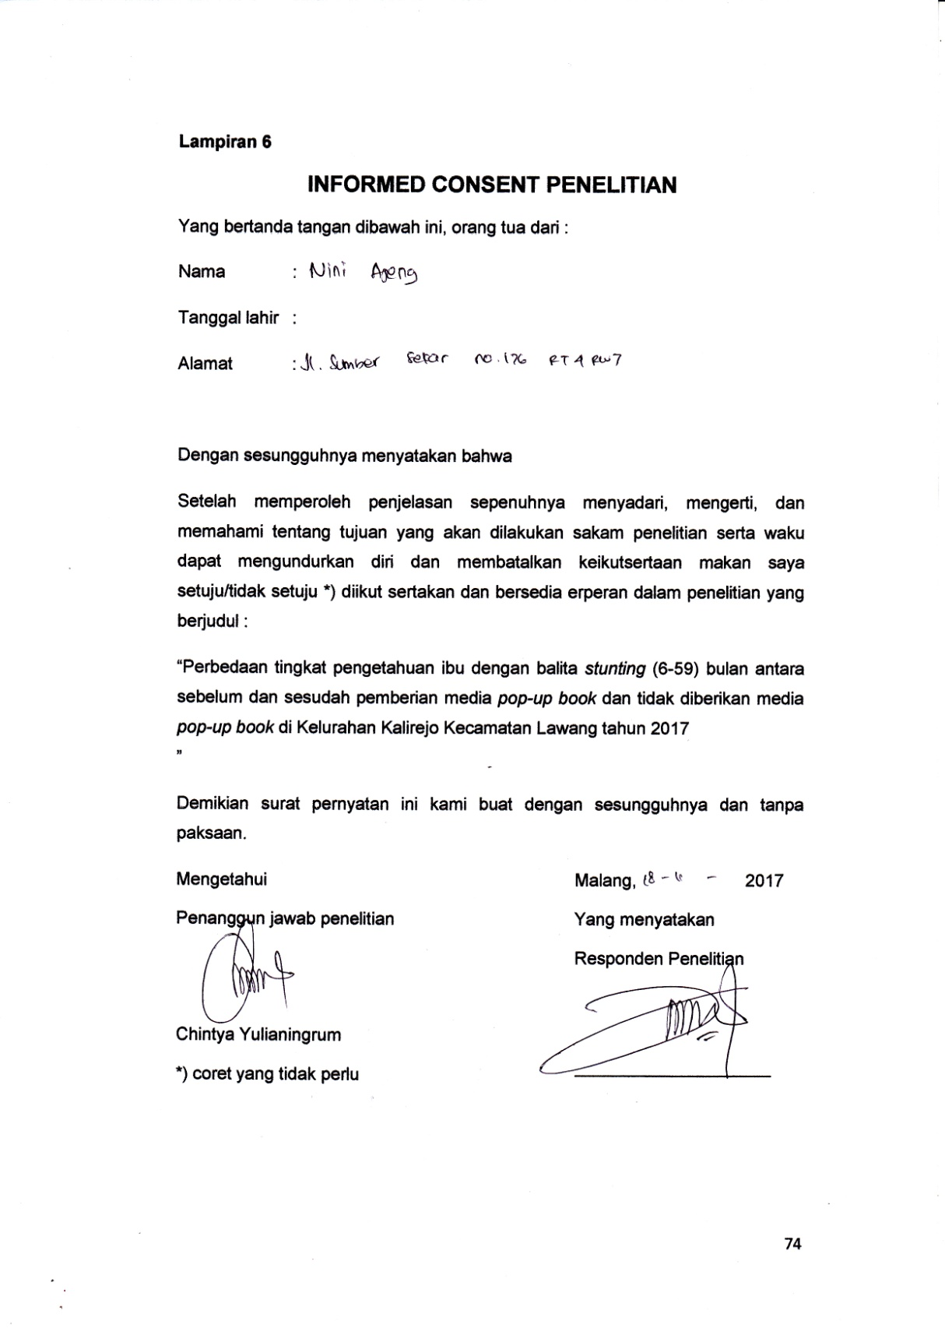

**Lampiran 7**

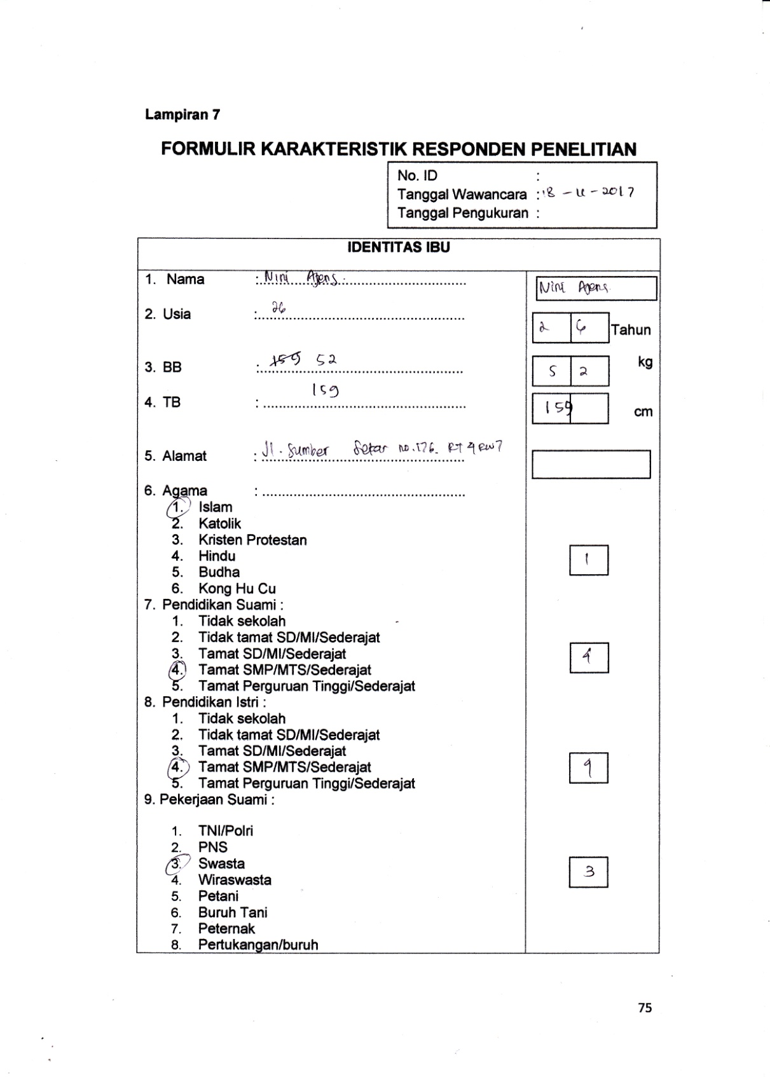

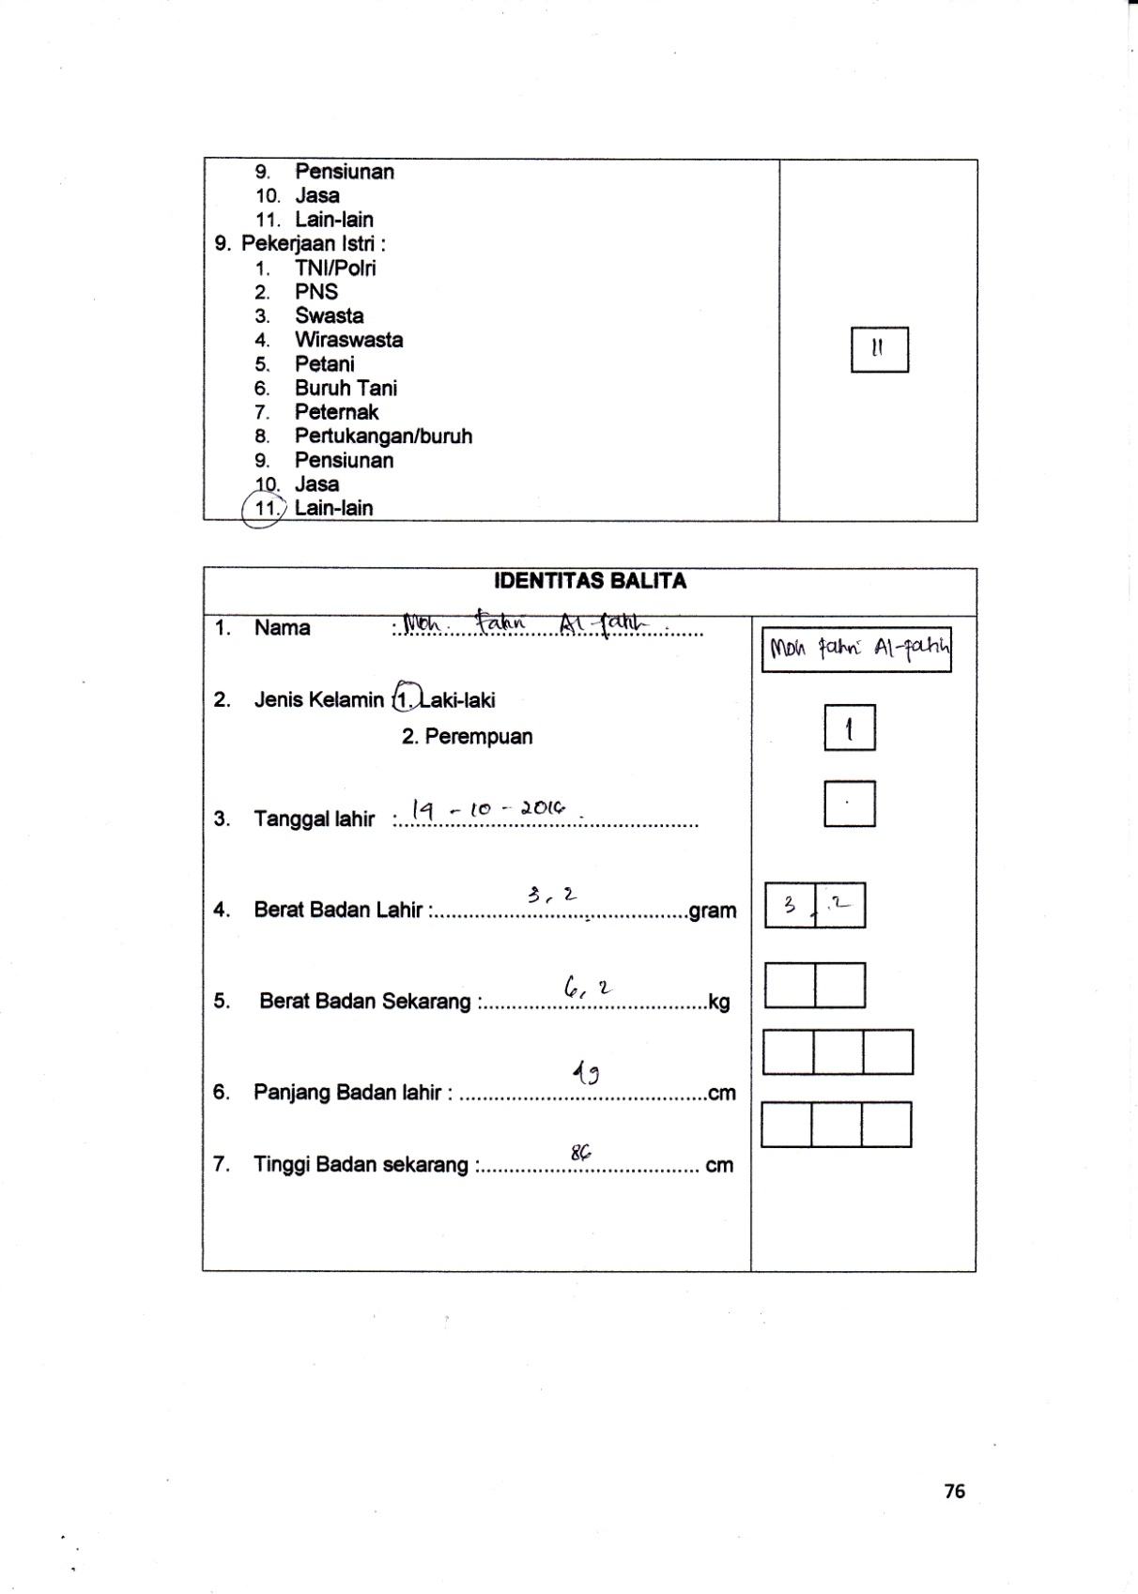

**Lampiran 8**

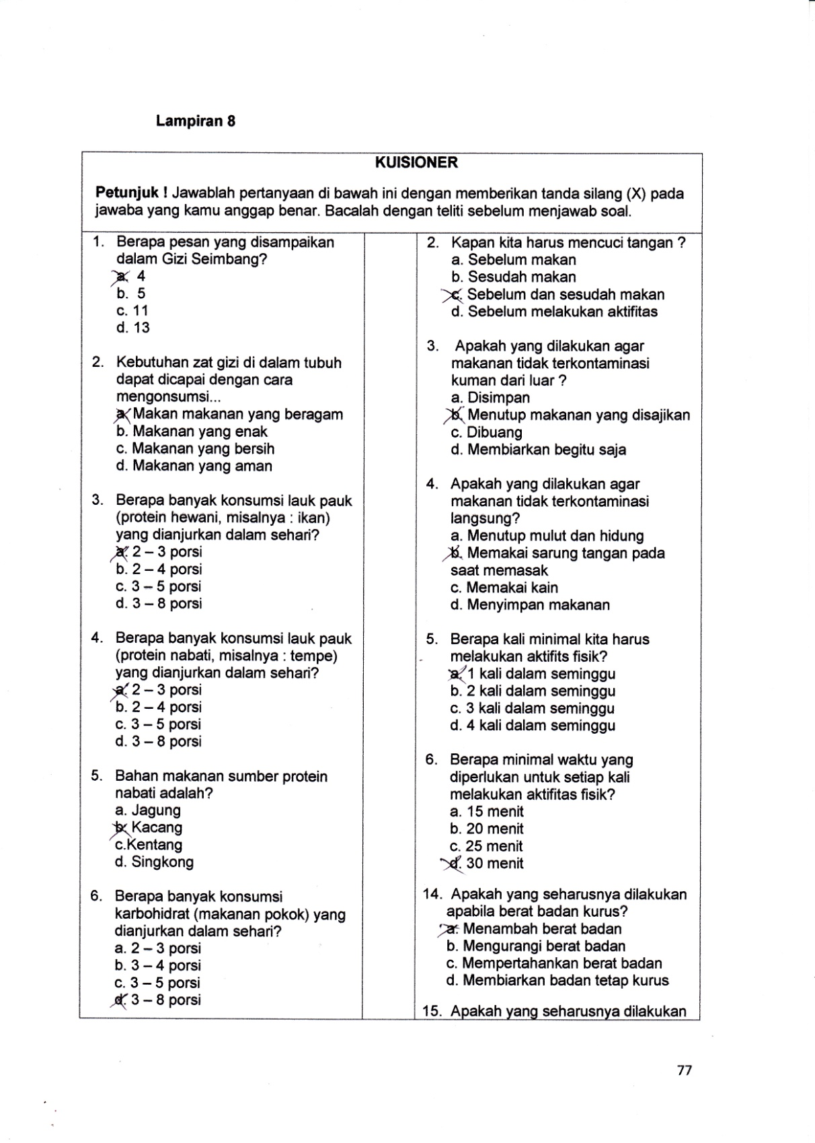

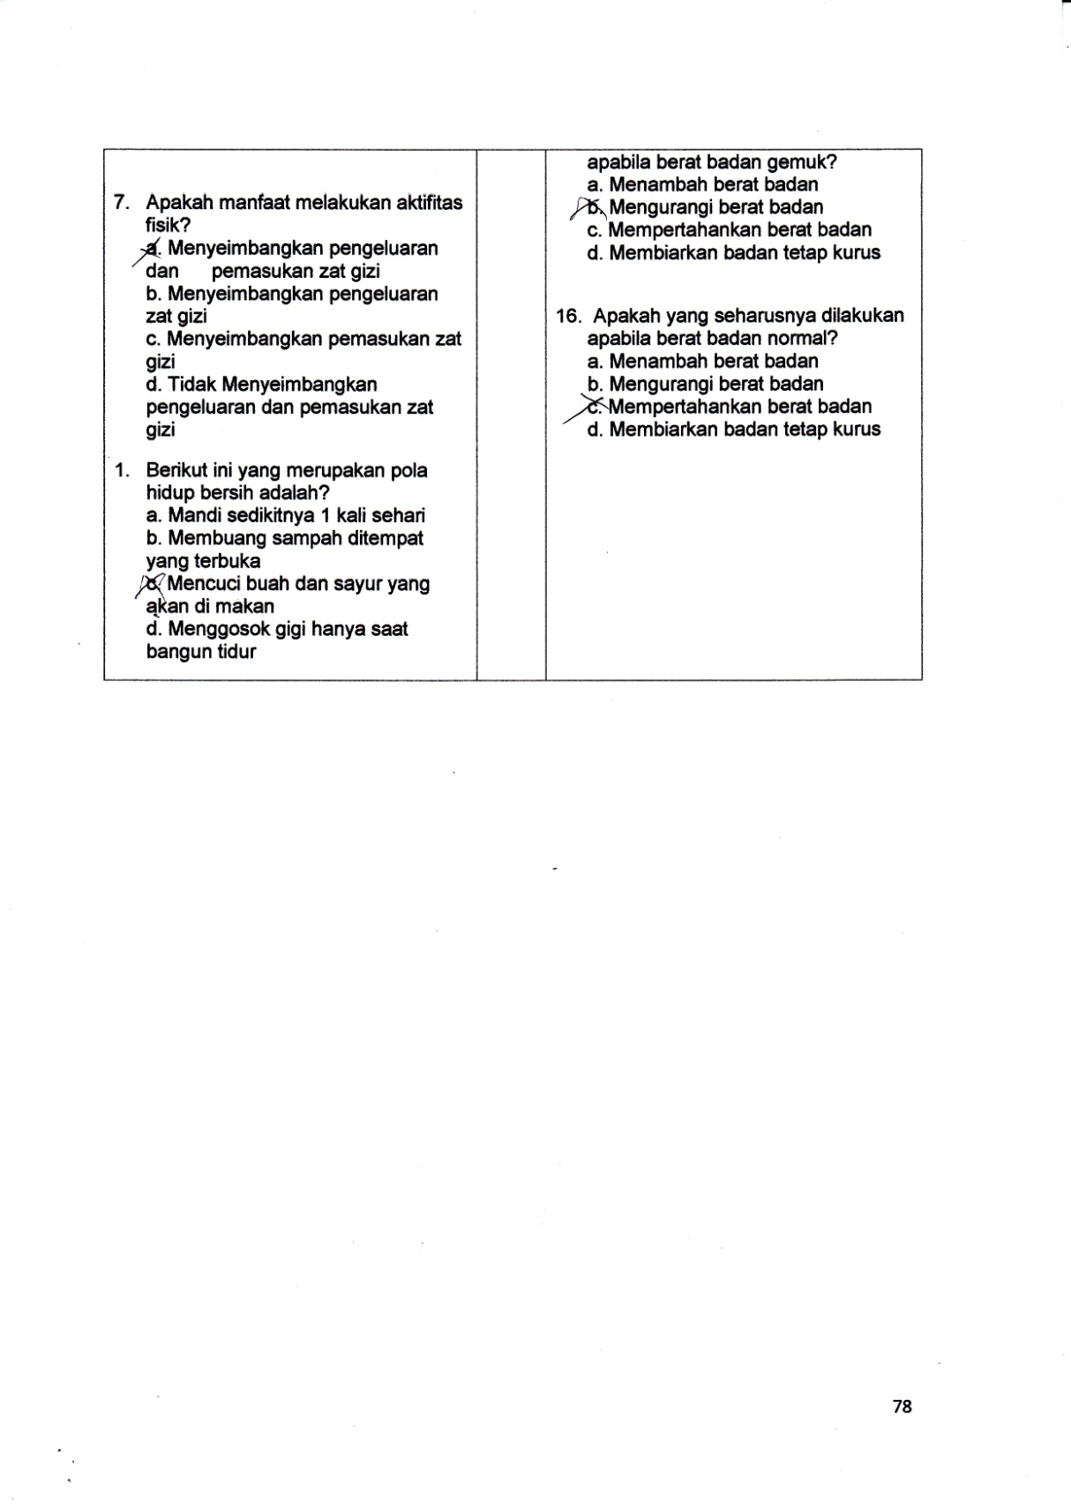

**Lampiran 10.** **Komisi Etik Penelitian Poltekkes Kemenkes Malang**

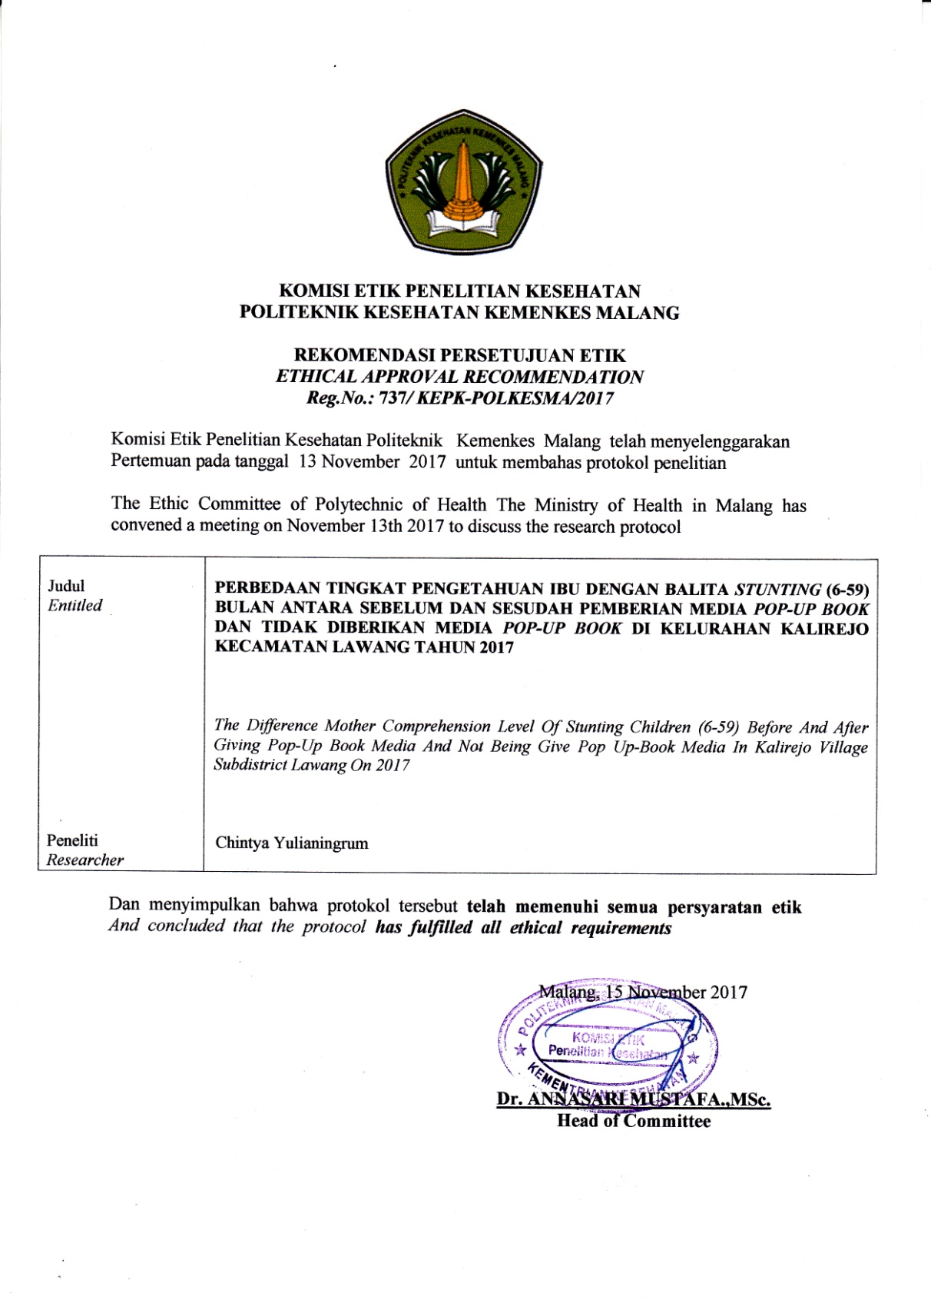

**Lampiran 11. Permohonan Surat Ijin Penelitian Poltekkes Kemenkes Malang**

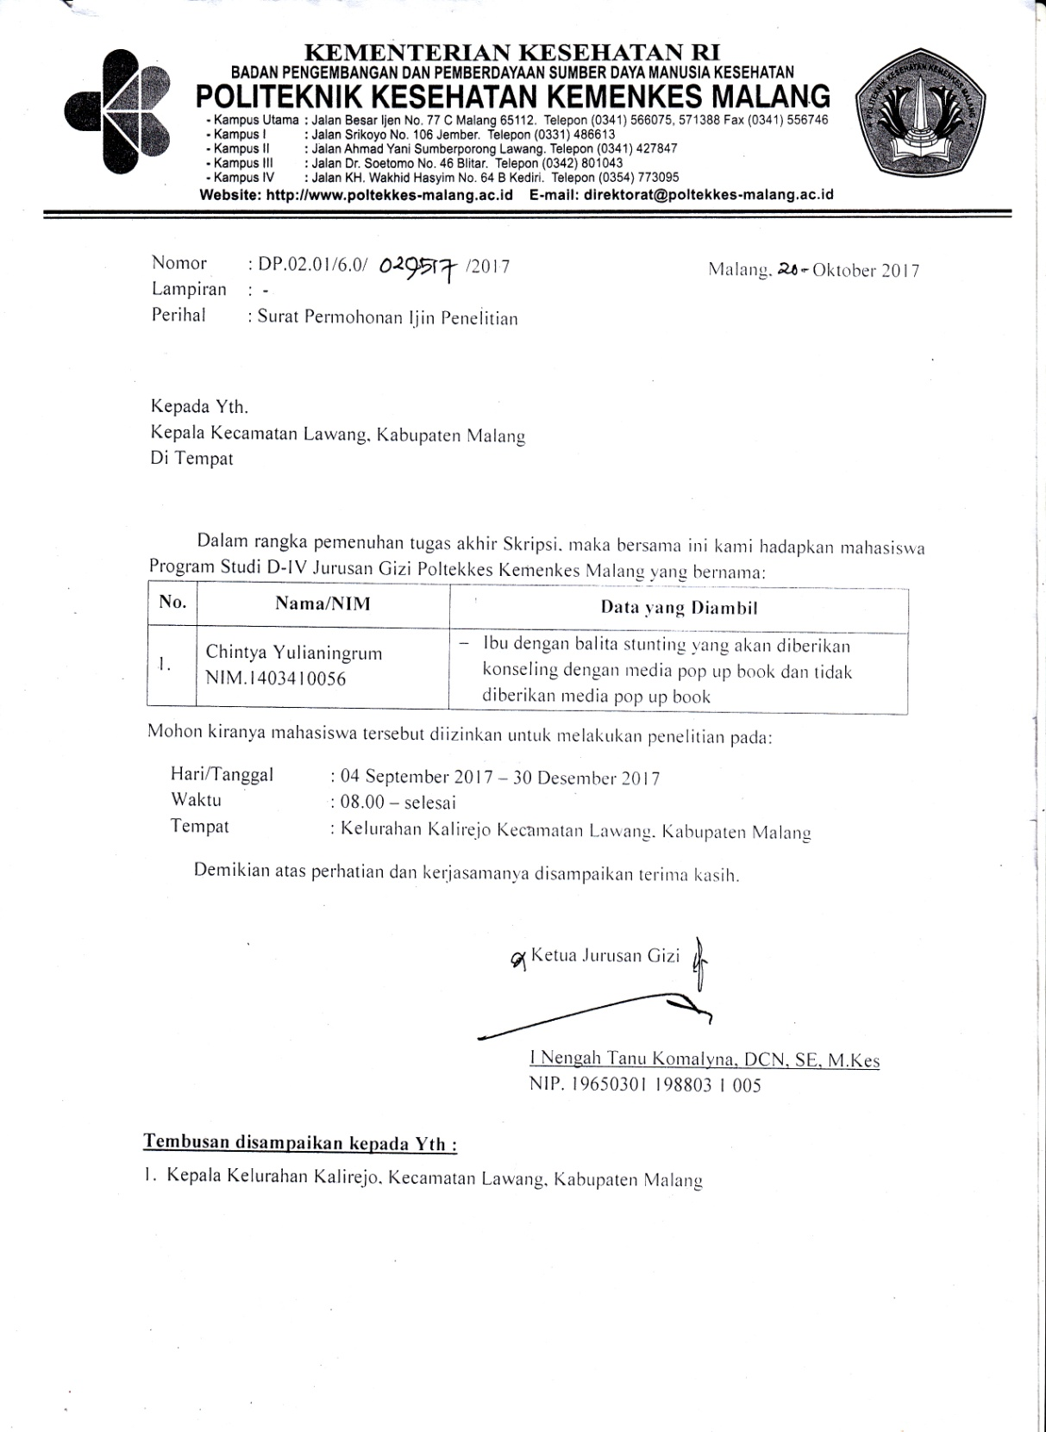

**Lampiran 12.** **Permohonan Surat Ijin Penelitian Badan Kesatuan Bangsa dan Politik**

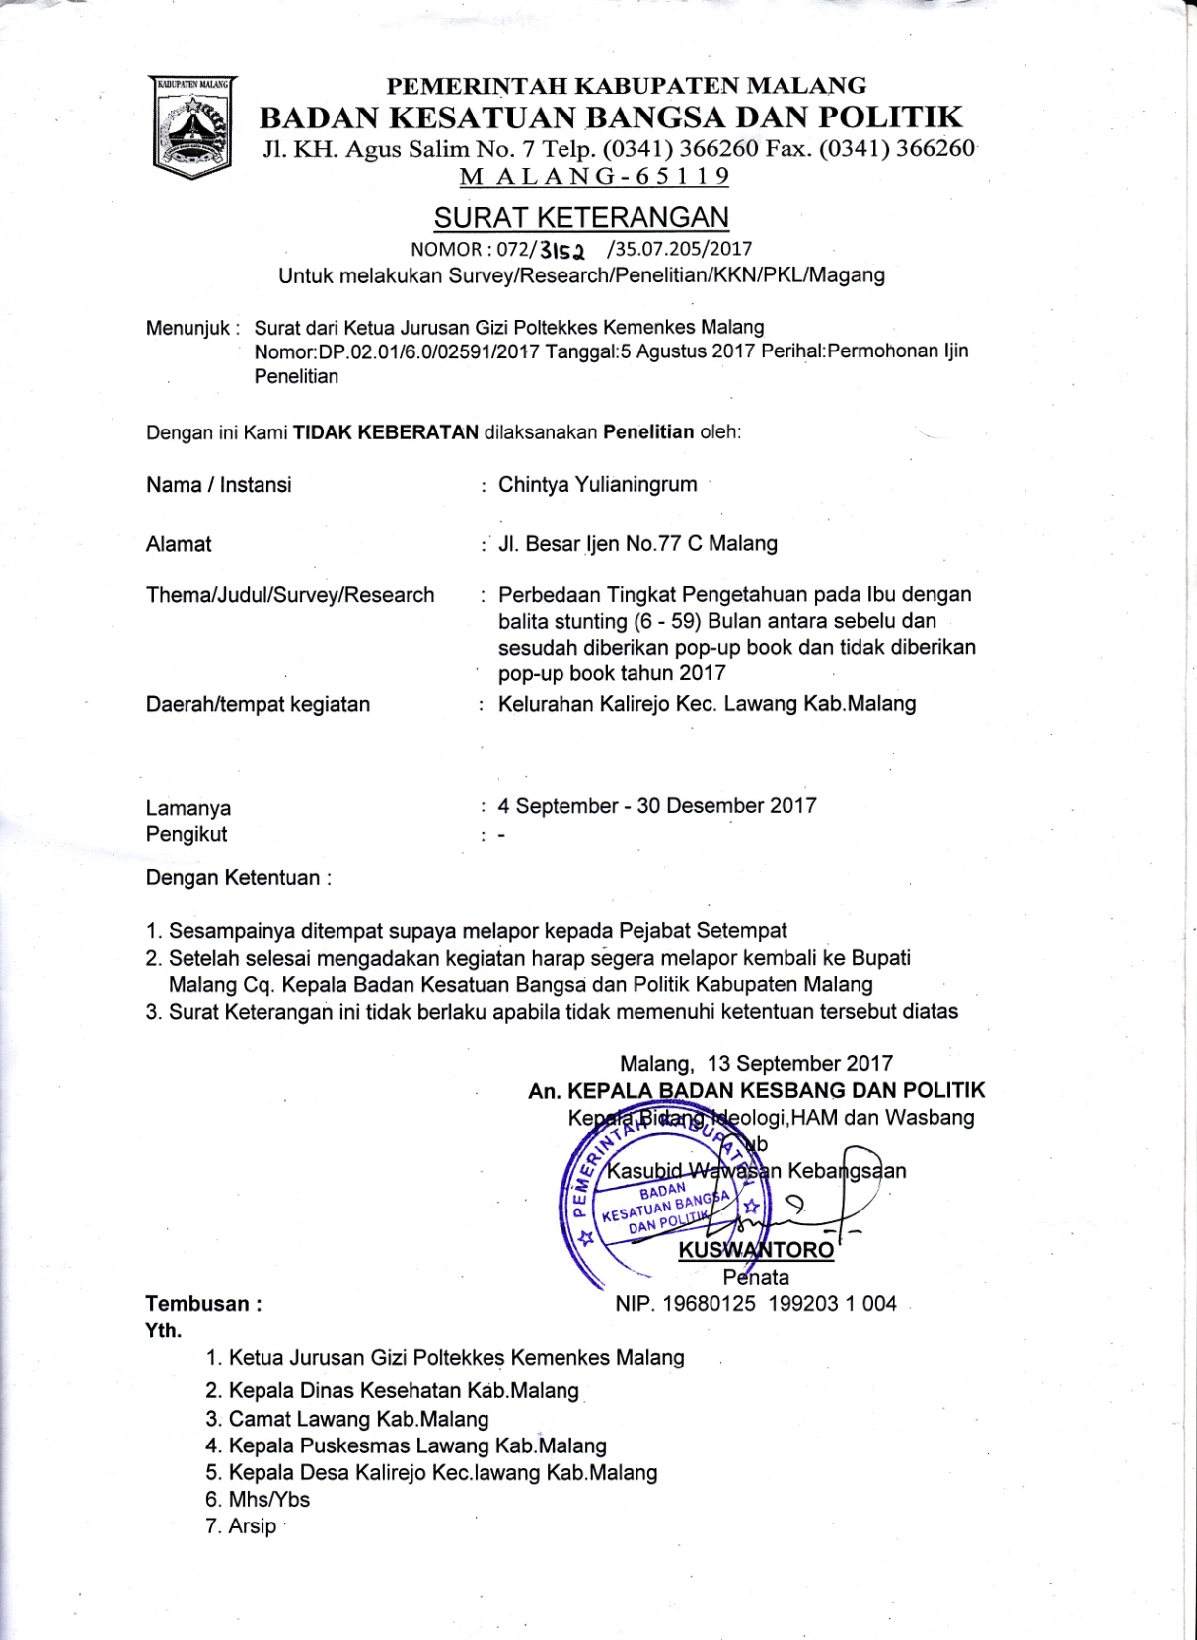

**Lampiran 13. Surat Balasan Puskesmas Lawang**

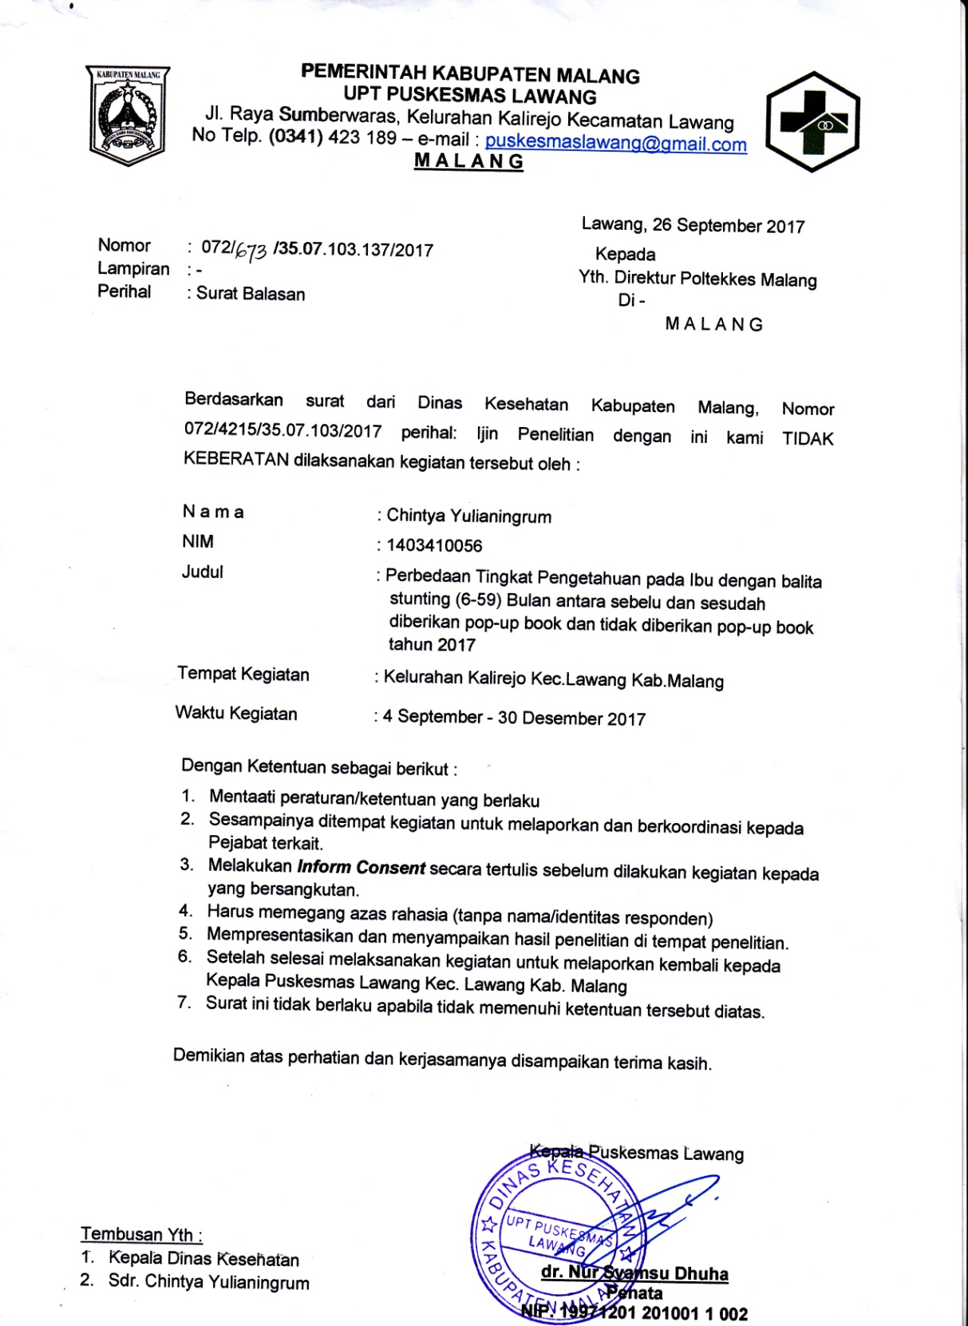

**Lampiran 14. Pengolahan Data pada Kelompok Kontrol dan Kelompok Perlakuan**

|  |  |  |  |  |  |  |  |
| --- | --- | --- | --- | --- | --- | --- | --- |
| KONTROL | | | | PERLAKUAN | | | |
| KODE | PRETEST | POSTEST | SELISIH | KODE | PRETEST | POSTEST | SELISIH |
| A1 | 68.75 | 93.75 | 25 | B1 | 56.25 | 93.75 | 37.5 |
| A2 | 25 | 81.25 | 56.25 | B2 | 68.75 | 81.25 | 12.5 |
| A3 | 75 | 75 | 0 | B3 | 50 | 87.5 | 37.5 |
| A4 | 50 | 87.5 | 37.5 | B4 | 62.5 | 93.75 | 31.25 |
| A5 | 50 | 81.25 | 31.25 | B5 | 62.5 | 87.5 | 25 |
| A6 | 81.25 | 100 | 18.75 | B6 | 62.5 | 100 | 37.5 |
| A7 | 75 | 81.25 | 6.25 | B7 | 62.5 | 81.25 | 18.75 |
| A8 | 42.85 | 100 | 57.15 | B8 | 50 | 100 | 50 |
| A9 | 62.5 | 62.5 | 0 | B9 | 81.25 | 100 | 18.75 |
| A10 | 68.75 | 81.25 | 12.5 | B10 | 62.5 | 62.5 | 0 |
| A11 | 68.75 | 81.25 | 12.5 | B11 | 62.5 | 100 | 37.5 |
| A12 | 62.5 | 62.5 | 0 | B12 | 50 | 75 | 25 |
| A13 | 50 | 62.5 | 12.5 | B13 | 75 | 81.25 | 6.25 |
| A14 | 50 | 81.25 | 31.25 | B14 | 68.75 | 87.5 | 18.75 |
| A15 | 43.75 | 87.5 | 43.75 | B15 | 56.25 | 93.75 | 37.5 |
| MEAN | 58.27333 | 81.25 | 22.9766 | MEAN | 62.0833 | 88.3333 | 26.25 |
| STDV | 15.31156 | 10.79 | 19.4000 | STDV | 8.9849 | 12.04 | 13.8147 |

**Lampiran 15.** **Rincian pengolahan data pada Kelompok Kontrol dan Kelompok Perlakuan**

|  |  |  |  |  |  |  |
| --- | --- | --- | --- | --- | --- | --- |
| **Responden** | **KONTROL** | | | **PERLAKUAN** | | |
| ***Pretest*** | ***Posttest*** | **Selisih** | ***Pretest*** | ***Posttest*** | **Selisih** |
| 1 | 68.75 | 93.75 | 25 | 56.25 | 93.75 | 37.5 |
| 2 | 25 | 81.25 | 56.25 | 68.75 | 81.25 | 12.5 |
| 3 | 75 | 75 | 0 | 50 | 87.5 | 37.5 |
| 4 | 50 | 87.5 | 37.5 | 62.5 | 93.75 | 31.25 |
| 5 | 50 | 81.25 | 31.25 | 62.5 | 87.5 | 25 |
| 6 | 81.25 | 100 | 18.75 | 62.5 | 100 | 37.5 |
| 7 | 75 | 81.25 | 6.25 | 62.5 | 81.25 | 18.75 |
| 8 | 42.85 | 100 | 57.15 | 50 | 100 | 50 |
| 9 | 62.5 | 62.5 | 0 | 81.25 | 100 | 18.75 |
| 10 | 68.75 | 81.25 | 12.5 | 62.5 | 62.5 | 0 |
| 11 | 68.75 | 81.25 | 12.5 | 62.5 | 100 | 37.5 |
| 12 | 62.5 | 62.5 | 0 | 50 | 75 | 25 |
| 13 | 50 | 62.5 | 12.5 | 75 | 81.25 | 6.25 |
| 14 | 50 | 81.25 | 31.25 | 68.75 | 87.5 | 18.75 |
| 15 | 43.75 | 87.5 | 43.75 | 56.25 | 93.75 | 37.5 |
| Rata-rata | 58.27 | 81.25 | 22.97 | 62 | 88.3 | 26.25 |

Sumber: Data Primer 2017

**Lampiran 16. Uji Statistik**

* + - * 1. **Normalitas pada Kelompok Kontrol**

|  |  |  |  |  |  |  |
| --- | --- | --- | --- | --- | --- | --- |
| **Case Processing Summary** | | | | | | |
|  | Cases | | | | | |
| Valid | | Missing | | Total | |
| N | Percent | N | Percent | N | Percent |
| pretest | 15 | 100.0% | 0 | 0.0% | 15 | 100.0% |
| posttest | 15 | 100.0% | 0 | 0.0% | 15 | 100.0% |

|  |  |  |  |  |
| --- | --- | --- | --- | --- |
| **Descriptives** | | | | |
|  | | | Statistic | Std. Error |
| pretest | Mean | | 58.2733 | 3.95343 |
| 95% Confidence Interval for Mean | Lower Bound | 49.7941 |  |
| Upper Bound | 66.7526 |  |
| 5% Trimmed Mean | | 58.8454 |  |
| Median | | 62.5000 |  |
| Variance | | 234.444 |  |
| Std. Deviation | | 15.31156 |  |
| Minimum | | 25.00 |  |
| Maximum | | 81.25 |  |
| Range | | 56.25 |  |
| Interquartile Range | | 18.75 |  |
| Skewness | | -.476 | .580 |
| Kurtosis | | -.135 | 1.121 |
| posttest | Mean | | 81.2500 | 3.11008 |
| 95% Confidence Interval for Mean | Lower Bound | 74.5795 |  |
| Upper Bound | 87.9205 |  |
| 5% Trimmed Mean | | 81.2500 |  |
| Median | | 81.2500 |  |
| Variance | | 145.089 |  |
| Std. Deviation | | 12.04530 |  |
| Minimum | | 62.50 |  |
| Maximum | | 100.00 |  |
| Range | | 37.50 |  |
| Interquartile Range | | 12.50 |  |
| Skewness | | -.207 | .580 |
| Kurtosis | | -.392 | 1.121 |

|  |  |  |  |  |  |  |
| --- | --- | --- | --- | --- | --- | --- |
| **Tests of Normality** | | | | | | |
|  | Kolmogorov-Smirnova | | | Shapiro-Wilk | | |
| Statistic | df | Sig. | Statistic | Df | Sig. |
| pretest | .172 | 15 | .200* | .943 | 15 | .427 |
| posttest | .233 | 15 | .027 | .897 | 15 | .087 |

**B.Paired Sampel T-test pada Kelompok Kontrol**

|  |  |  |  |  |  |
| --- | --- | --- | --- | --- | --- |
| **Paired Samples Statistics** | | | | | |
|  | | Mean | N | Std. Deviation | Std. Error Mean |
| Pair 1 | posttest | 81.2500 | 15 | 12.04530 | 3.11008 |
| pretest | 58.2733 | 15 | 15.31156 | 3.95343 |

|  |  |  |  |  |
| --- | --- | --- | --- | --- |
| **Paired Samples Correlations** | | | | |
|  | | N | Correlation | Sig. |
| Pair 1 | posttest & pretest | 15 | .009 | .976 |

|  |  |  |  |  |  |  |  |
| --- | --- | --- | --- | --- | --- | --- | --- |
| **Paired Samples Test** | | | | | | | |
|  | | Paired Differences | | | | |
| Mean | Std. Deviation | Std. Error Mean | 95% Confidence Interval of the Difference | |
| Lower | Upper |
| Pair 1 | posttest – pretest | 22.97667 | 19.40009 | 5.00908 | 12.23325 | 33.72008 |

|  |  |  |  |  |
| --- | --- | --- | --- | --- |
| **Paired Samples Test** | | | | |
|  | | t | Df | Sig. (2-tailed) |
|
|
| Pair 1 | posttest - pretest | 4.587 | 14 | .000 |

1. **Normalitas pada Kelompok Perlakuan**

|  |  |  |  |  |  |  |
| --- | --- | --- | --- | --- | --- | --- |
| **Case Processing Summary** | | | | | | |
|  | Cases | | | | | |
| Valid | | Missing | | Total | |
| N | Percent | N | Percent | N | Percent |
| pretest | 15 | 100.0% | 0 | 0.0% | 15 | 100.0% |
| posttest | 15 | 100.0% | 0 | 0.0% | 15 | 100.0% |

|  |  |  |  |  |
| --- | --- | --- | --- | --- |
| **Descriptives** | | | | |
|  | | | Statistic | Std. Error |
| pretest | Mean | | 62.0833 | 2.31990 |
| 95% Confidence Interval for Mean | Lower Bound | 57.1076 |  |
| Upper Bound | 67.0590 |  |
| 5% Trimmed Mean | | 61.6898 |  |
| Median | | 62.5000 |  |
| Variance | | 80.729 |  |
| Std. Deviation | | 8.98494 |  |
| Minimum | | 50.00 |  |
| Maximum | | 81.25 |  |
| Range | | 31.25 |  |
| Interquartile Range | | 12.50 |  |
| Skewness | | .466 | .580 |
| Kurtosis | | .160 | 1.121 |
| posttest | Mean | | 88.3333 | 2.78620 |
| 95% Confidence Interval for Mean | Lower Bound | 82.3575 |  |
| Upper Bound | 94.3091 |  |
| 5% Trimmed Mean | | 89.1204 |  |
| Median | | 87.5000 |  |
| Variance | | 116.443 |  |
| Std. Deviation | | 10.79090 |  |
| Minimum | | 62.50 |  |
| Maximum | | 100.00 |  |
| Range | | 37.50 |  |
| Interquartile Range | | 18.75 |  |
| Skewness | | -.908 | .580 |
| Kurtosis | | .779 | 1.121 |

|  |  |  |  |  |  |  |
| --- | --- | --- | --- | --- | --- | --- |
| **Tests of Normality** | | | | | | |
|  | Kolmogorov-Smirnova | | | Shapiro-Wilk | | |
| Statistic | Df | Sig. | Statistic | Df | Sig. |
| pretest | .215 | 15 | .061 | .919 | 15 | .186 |
| posttest | .159 | 15 | .200* | .899 | 15 | .093 |

1. **Paired Sample T-Test pada Kelompok Perlakuan**

|  |  |  |  |  |  |
| --- | --- | --- | --- | --- | --- |
| 1. **Paired Samples Statistics** | | | | | |
|  | | Mean | N | Std. Deviation | Std. Error Mean |
| Pair 1 | posttest | 88.3333 | 15 | 10.79090 | 2.78620 |
| pretest | 62.0833 | 15 | 8.98494 | 2.31990 |

|  |  |  |  |  |
| --- | --- | --- | --- | --- |
| **Paired Samples Correlations** | | | | |
|  | | N | Correlation | Sig. |
| Pair 1 | posttest & pretest | 15 | .033 | .908 |

|  |  |  |  |  |  |  |  |
| --- | --- | --- | --- | --- | --- | --- | --- |
| **Paired Samples Test** | | | | | | | |
|  | | Paired Differences | | | | |
| Mean | Std. Deviation | Std. Error Mean | 95% Confidence Interval of the Difference | |
| Lower | Upper |
| Pair 1 | posttest – pretest | 26.25000 | 13.81478 | 3.56696 | 18.59963 | 33.90037 |

|  |  |  |  |  |
| --- | --- | --- | --- | --- |
| **Paired Samples Test** | | | | |
|  | | t | df | Sig. (2-tailed) |
|
|
| Pair 1 | posttest - pretest | 7.359 | 14 | .000 |

**E.Independent Sample T-Test**

|  |  |  |  |  |  |
| --- | --- | --- | --- | --- | --- |
| **Group Statistics** | | | | | |
|  | responden | N | Mean | Std. Deviation | Std. Error Mean |
| Groupposttest | kelompok intervensi | 15 | 88.33 | 10.791 | 2.786 |
| kelompok kontrol | 15 | 81.25 | 12.045 | 3.110 |

|  |  |  |  |  |  |  |
| --- | --- | --- | --- | --- | --- | --- |
| **Independent Samples Test** | | | | | | |
|  | | Levene's Test for Equality of Variances | | t-test for Equality of Means | |
| F | Sig. | t | df |
|
| groupposttest | Equal variances assumed | .000 | .984 | 1.696 | 28 |
| Equal variances not assumed |  |  | 1.696 | 27.668 |

|  |  |  |  |  |  |
| --- | --- | --- | --- | --- | --- |
| **Independent Samples Test** | | | | | |
|  | | t-test for Equality of Means | | |
| Sig. (2-tailed) | Mean Difference | Std. Error Difference |
|
| groupposttest | Equal variances assumed | .101 | 7.083 | 4.176 |
| Equal variances not assumed | .101 | 7.083 | 4.176 |

|  |  |  |  |
| --- | --- | --- | --- |
| **Independent Samples Test** | | | |
|  | | t-test for Equality of Means | |
| 95% Confidence Interval of the Difference | |
| Lower | Upper |
| Groupposttest | Equal variances assumed | -1.470 | 15.637 |
| Equal variances not assumed | -1.475 | 15.641 |

**Lampiran 17. Satuan Penyuluhan Pedoman Gizi Seimbang**

**SATUAN PENYULUHAN**

**Judul Kegiatan :** Konseling Gizi

**Pokok Bahasan :** Pedoman Gizi Seimbang

**Jenis :** Penyuluhan

**Metode :** Ceramah, diskusi, tanya jawab

**Sasaran :** ibu dengan anak balita stunting

**Waktu :** 60 menit

**Tempat :** Rumah Responden

* + - * 1. **TUJUAN**
    1. **Tujuan Instruksional Umum (TIU)**

Setelah dilaksanakan konseling, peserta dapat mengerti dan memahami tentang pedoman gizi seimbang pada anak balita stunting.

* + 1. **Tujuan Instruksional Khusus (TIK)** 
       - 1. Responden dapat menjelaskan tentang pilar gizi seimbang
         2. Responden dapat menjelaskan tentang point pertama dalam gizi seimbang yaitu keanekaragaman makanan
         3. Responden dapat menjelaskan tentang point pertama dalam gizi seimbang yaitu membiasakan perilaku bersh dan sehat
         4. Responden dapat menjelaskan tentang point pertama dalam gizi seimbang yaitu melakukan aktifitas fisik
         5. Responden dapat menjelaskan tentang point pertama dalam gizi seimbang yaitu memperhatikan dan memantau berat badan normal

1. **MATERI**

Pedoman gizi seimbang yang terdiri dari:

* + - * 1. keanekaragaman makanan
        2. membiasakan perilaku bersh dan sehat
        3. melakukan aktifitas fisik
        4. memperhatikan dan memantau berat badan normal

1. **PROSES PENYULUHAN**

|  |  |  |  |  |
| --- | --- | --- | --- | --- |
| **Tahapan** | **Waktu (menit)** | **Kegiatan penyuluhan** | **Kegiatan audience** | **Keterampilan** |
| Pembukaan | 5 menit | * + 1. Salam     2. Perkenalan diri sebagai konselor     3. Perkenalan dengan ubu balita | Menjawab salam  memperhatikan | Membuka |
| Pelaksanaan | 15 menit | Penyampaian materi :  Pedoman gizi seimbang yang terdiri dari:   * + - * 1. keanekaragaman makanan         2. membiasakan perilaku bersh dan sehat         3. melakukan aktifitas fisik         4. memperhatikan dan memantau berat badan normal | Mendengarkan  Memperhatikan konselor dengan baik | Menjelaskan, memberi penguatan dan mengelola situasi pada saat konseling berlangsung |
| Tanya jawab | 5 menit | Konselor memberikan kesempatan kepada para audience untuk bertanya | Audience menanyakan tentang materi yang kurang dipahami oleh responden | Menjawab |
| Penutup | 5 menit | * + 1. menyimpulkan hasil konseling     2. salam penutup | Audience memperhatikan konselor dan menjaawab salam | menutup |

1. **METODE**

Ceramah, diskusi, dan tanya jawab

1. **ALAT PERAGA**

Pop-up book

1. **ALAT EVALUASI**

Kuisioner Pretest dan posttest

**Lampiran 18. Desain *Pop-up book***

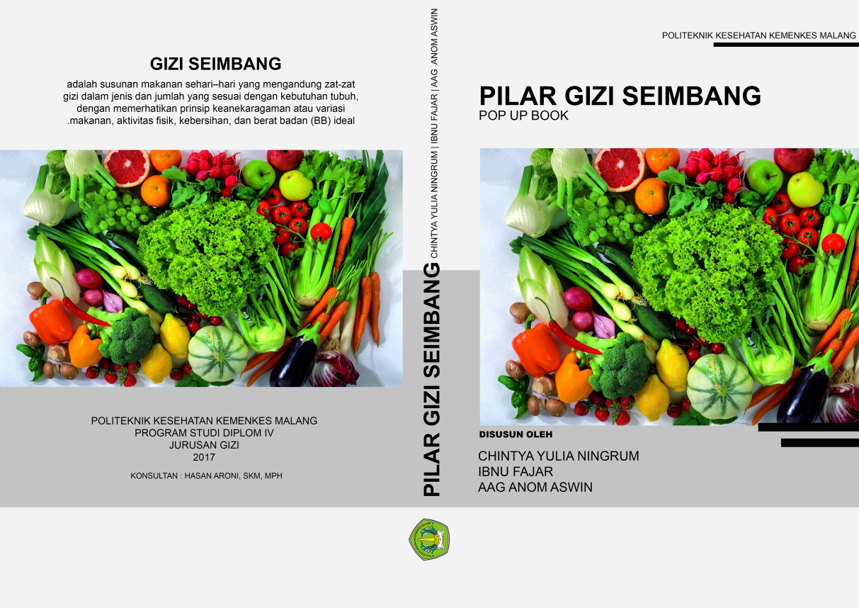

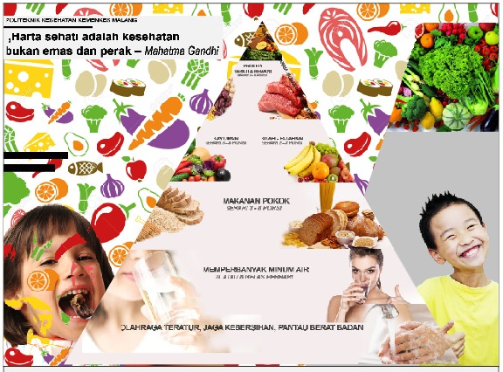

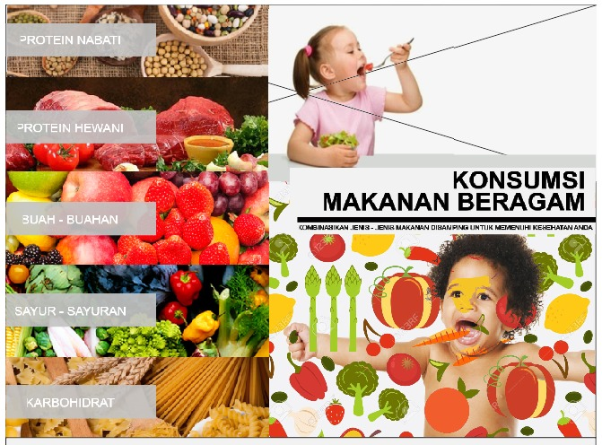





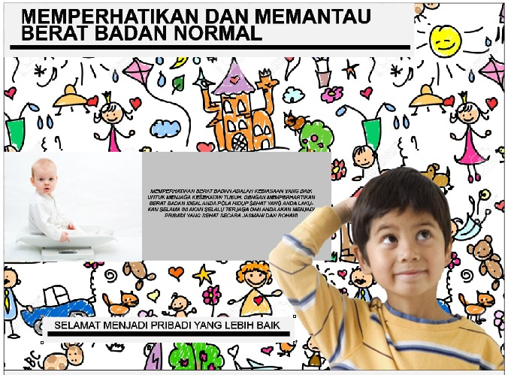

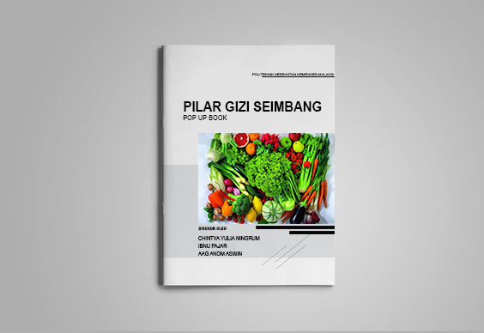

Lampiran 19. Dokumentasi Penelitian

