Lampiran 1

**LEMBAR JADWAL PENYUSUNAN SKRIPSI TAHUN 2018/2019**

|  |  |  |  |  |  |  |  |  |  |  |  |  |
| --- | --- | --- | --- | --- | --- | --- | --- | --- | --- | --- | --- | --- |
| **No** | **Kegiatan** | **Agust 2018** | **Sept 2018** | **Okt 2018** | **Nov 2018** | **Des 2018** | **Jan 2019** | **Feb 2019** | **Mar 2019** | **April 2019** | **Mei 2019** | **Juni 2019** |
| 1 | Informasi pembimbing |  |  |  |  |  |  |  |  |  |  |  |
| 2 | Proses bimbingan dan penyusunan proposal |  |  |  |  |  |  |  |  |  |  |  |
| 3 | Pengumpulan proposal ke panitia/pendaftaran seminar proposal |  |  |  |  |  |  |  |  |  |  |  |
| 4 | Seminar proposal |  |  |  |  |  |  |  |  |  |  |  |
| 5 | Revisi dan persetujuan proposal oleh penguji |  |  |  |  |  |  |  |  |  |  |  |
| 6 | Mengambil data/penelitian |  |  |  |  |  |  |  |  |  |  |  |
| 7 | Pendaftaran ujian |  |  |  |  |  |  |  |  |  |  |  |
| 8 | Pelaksanaan ujian |  |  |  |  |  |  |  |  |  |  |  |
| 9 | Revisi laporan |  |  |  |  |  |  |  |  |  |  |  |
| 10 | Penyerahan laporan |  |  |  |  |  |  |  |  |  |  |  |

Lampiran 2

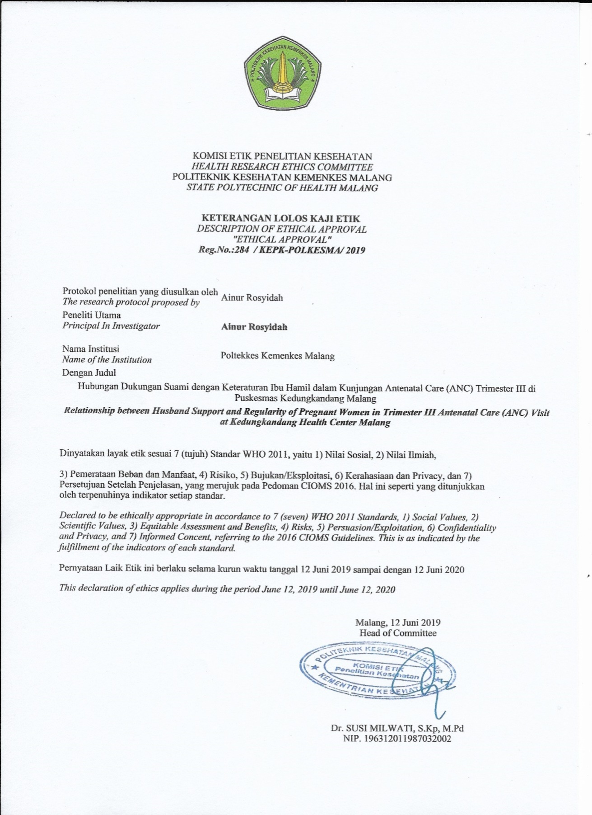

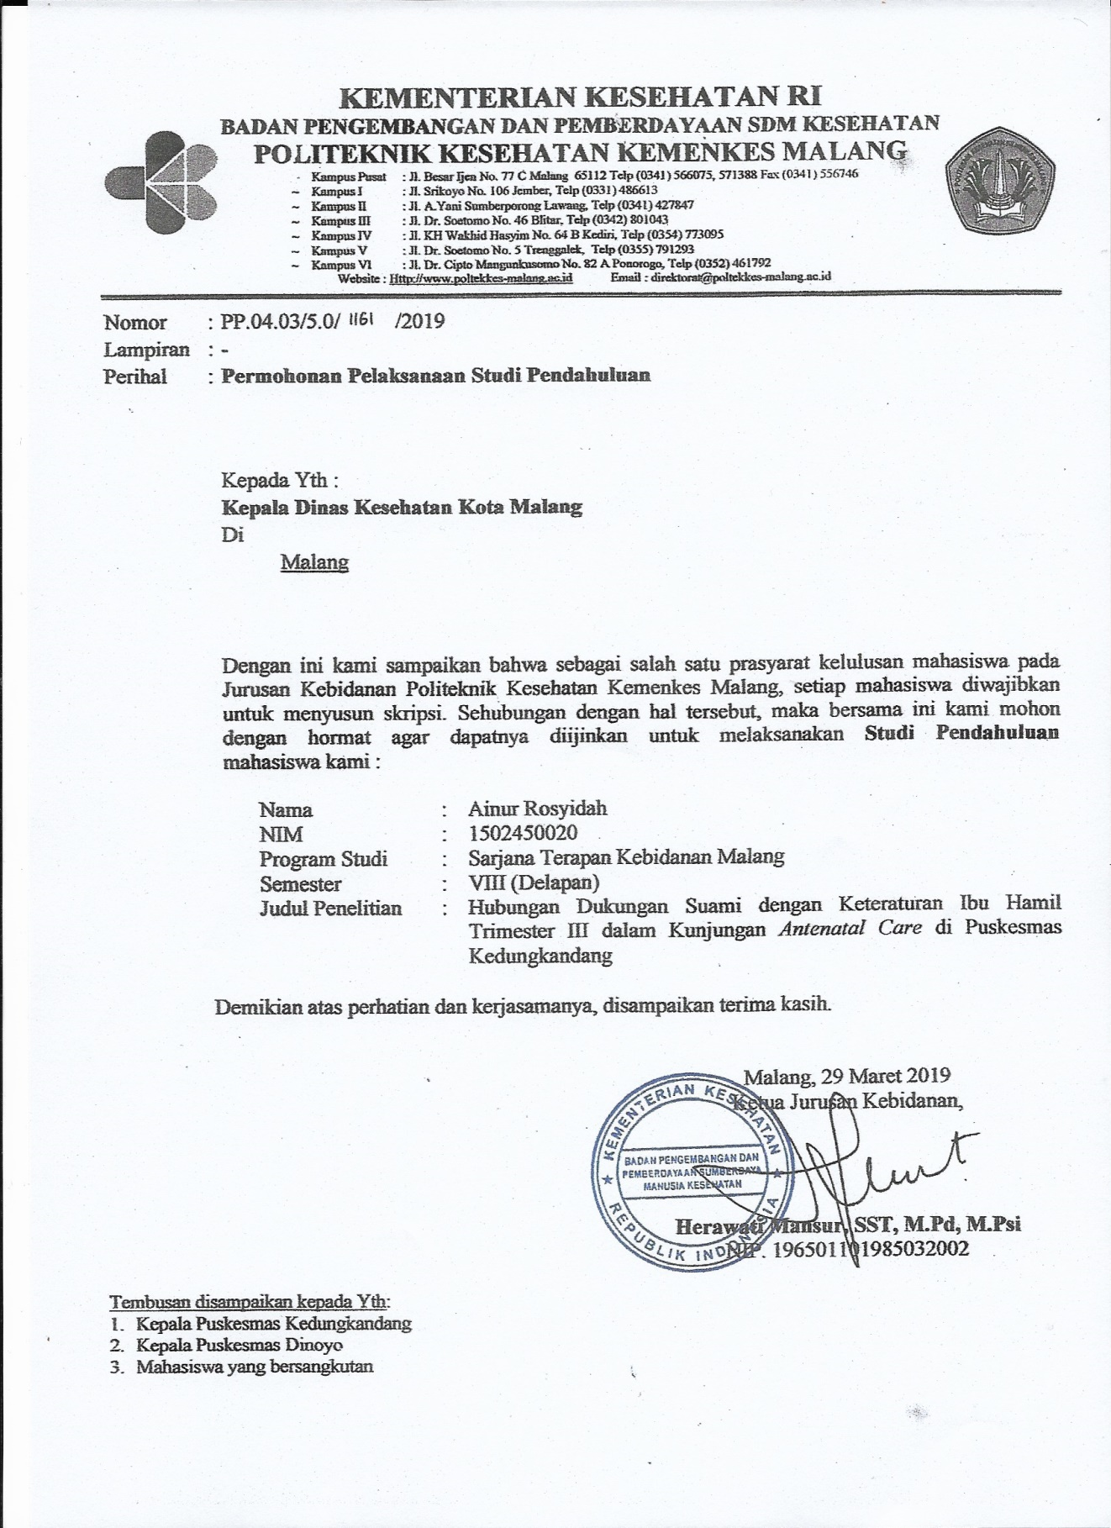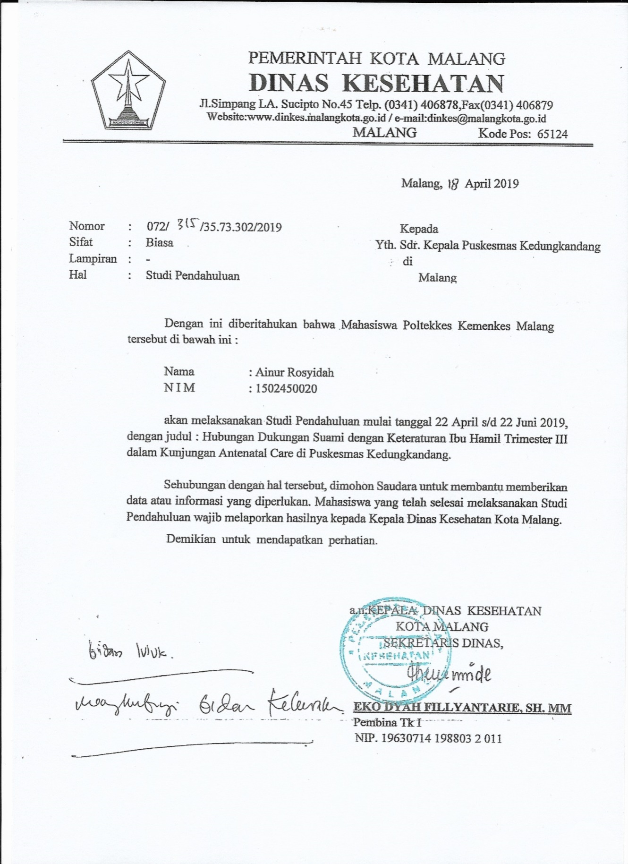

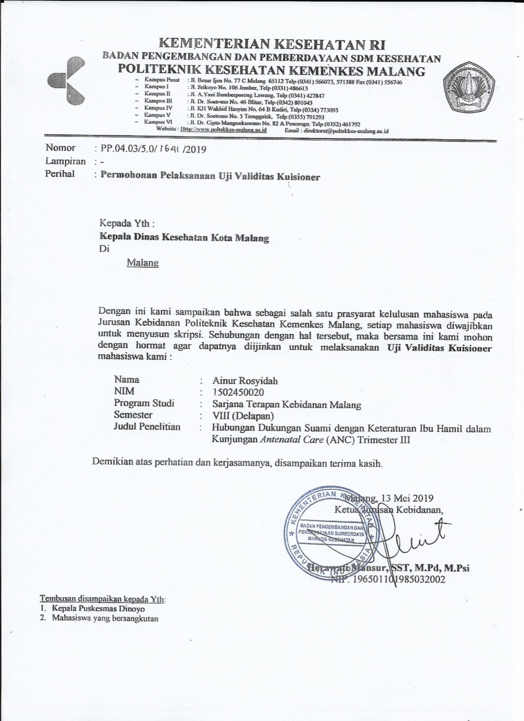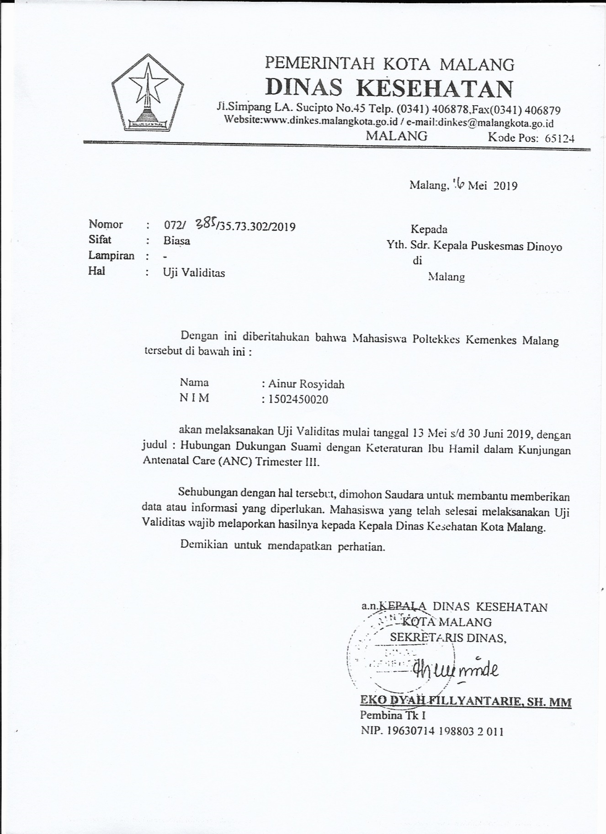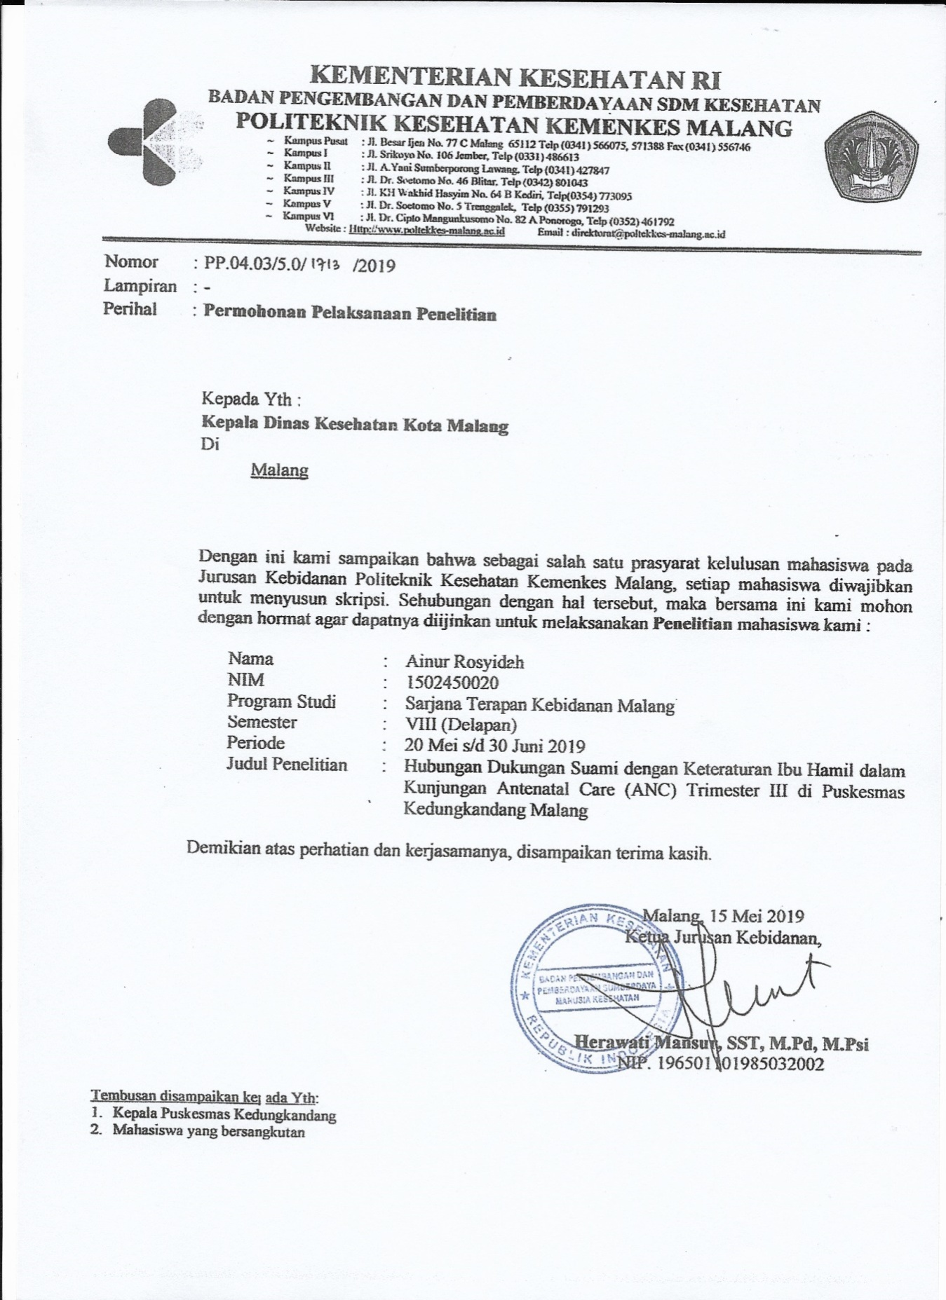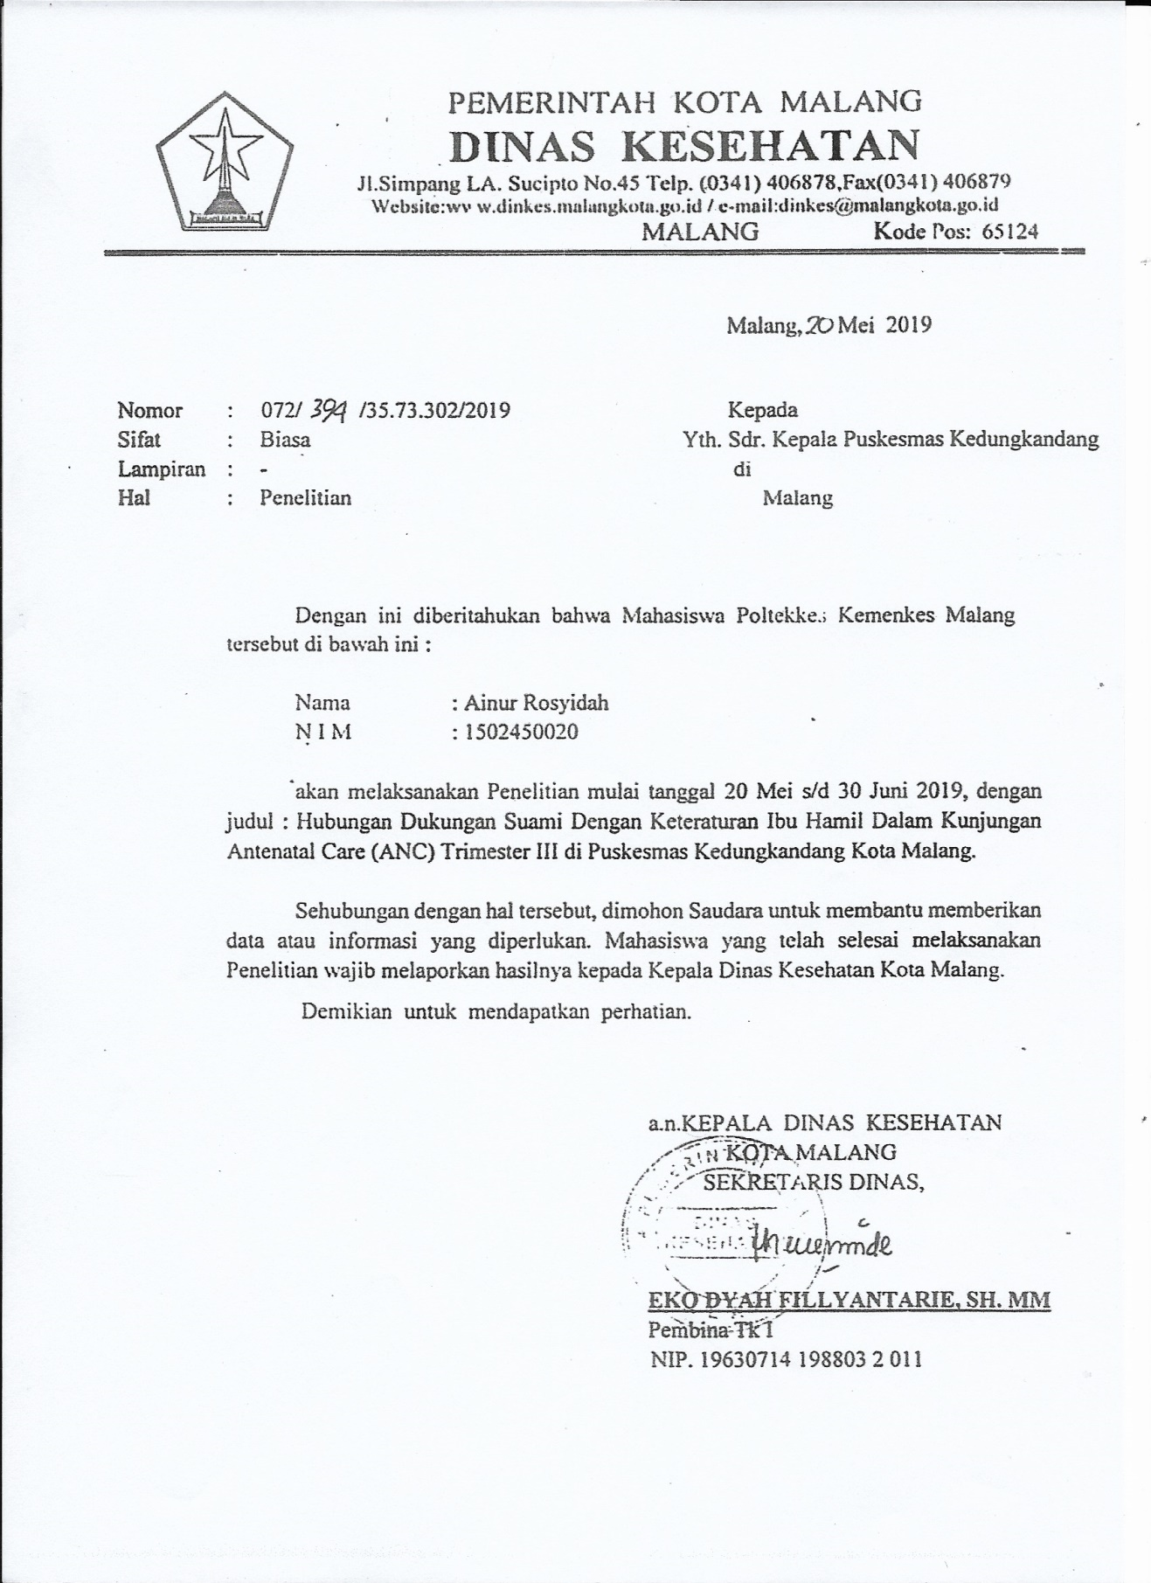

Lampiran 3

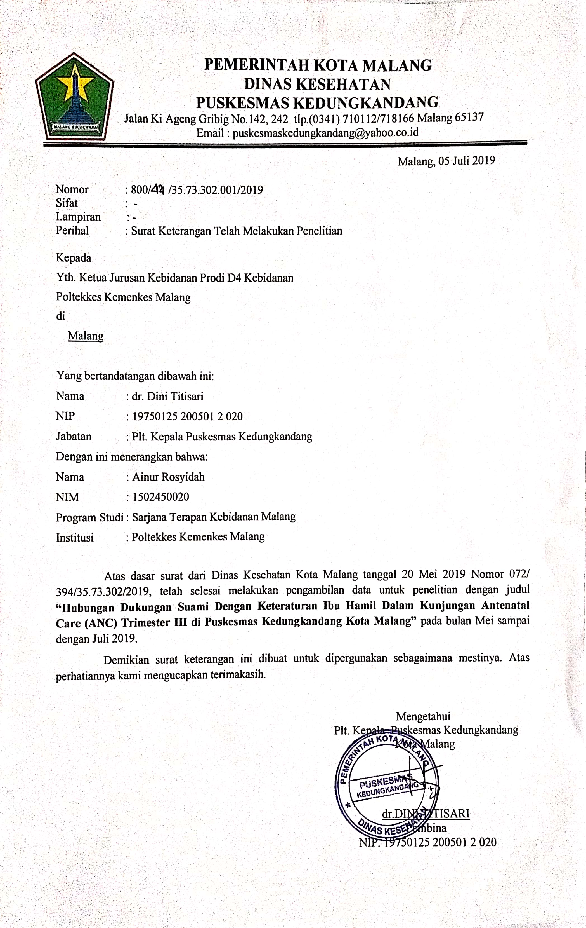Lampiran 6

Lampiran 5

**LEMBAR PERMOHONAN MENJADI RESPONDEN**

Saya yang bertandatangan di bawah ini :

Nama : Ainur Rosyidah

NIM : 1502450020

Program Studi : Sarjana Terapan dan Profesi Kebidanan Malang

Jurusan : Kebidanan Poltekkes Kemenkes Malang

Menyatakan bahwa saat ini sedang melakukan penelitian tentang berjudul “Hubungan Dukungan Suami dengan Keteraturan Ibu Hamil dalam Kunjungan *Antenatal Care* (ANC) Trimester III di Puskesmas Kedungkandang Malang”. Penelitian ini disusun sebagai salah satu syarat menyelesaikan Pendidikan Sarjana Terapan dan Profesi Kebidanan pada Program Studi Sarjana Terapan Kebidanan Malang Politeknik Kesehatan Kementerian Kesehatan Malang.

Untuk keperluan tersebut, saya memohon kesediaan saudara sebagai responden dalam penelitian ini. Selanjutnya saya memohon kesediaan saudara dalam melakukan pelaksanaan tentang tujuan penelitian tersebut. Jika saudara bersedia silahkan menandatangani lembar persetujuan ini sebagai bukti kesediaan menjadi responden.

Partisipasi saudara dalam penelitian ini bersifat sukarela, sehingga bebas untuk mengundurkan diri setiap saat tanpa ada sanksi apapun, identitas pribadi saudara dan informasi yang diberikan kami rahasiakan serta hanya akan digunakan untuk keperluan penelitian ini.

Terimakasih atas partisipasi saudara dalam penelitian ini.

Malang, …………………2019

Wali responden

(……………………….)

Peneliti

(Ainur Rosyidah)

Lampiran 7

**LEMBAR INFORMED CONSENT**

Saya yang bertandatangan dibawah ini menyatakan bahwa saya telah mendapatkan penjelasan secara rinci dan telah mengerti penelitian yang akan dilakukan oleh Ainur Rosyidah, mahasiswi Sarjana Terapan dan Profesi Kebidanan Malang dari Jurusan Kebidanan Politeknik Kesehatan Kemenkes Malang yang berjudul “Hubungan Dukungan Suami dengan Keteraturan Ibu Hamil dalam Kunjungan *Antenatal Care* (ANC) Trimester III di Puskesmas Kedungkandang Malang”.

Saya yakin bahwa penelitian ini tidak menimbulkan kerugian apapun pada saya dan keluarga. Dan saya telah mempertimbangkan serta memutuskan untuk berpartisipasi dalam penelitian.

Malang, Januari 2019

Saksi

(………………………)

Yang Membuat Persetujuan

(……………………….)

Mengetahui,

Peneliti

(Ainur Rosyidah)

Lampiran 8

Kisi-Kisi Dukungan Suami

|  |  |  |
| --- | --- | --- |
| Indikator | No item | |
| *Favorable* | *Unfavorable* |
| Dukungan Emotional | 1,3,5,6,7 | 2,4 |
| Dukungan Informational | - | 8,9 |
| Dukungan Penilaian | 11,13 | 10,12 |
| Dukungan Instrumental | 14,16 | 15,17 |

**IDENTITAS RESPONDEN**

Isilah identitas anda secara lengkap dan benar dengan tanda ( X )

1. Kode Responden :
2. Nama (Inisial) :
3. Umur :
4. Pendidikan Terakhir :

Ibu Hamil Suami

1. SD
2. SMP
3. SMA
4. Perguruan Tinggi
5. Pekerjaan :

Ibu Hamil Suami

1. IRT
2. Petani
3. Swasta
4. PNS
5. Lain-lain ……….
6. Paritas :
7. paritas 0
8. Paritas 1
9. Paritas 2-4
10. Paritas > 5
11. Tinggal Bersama Suami :
12. Ya
13. Tidak

**INSTRUMEN PENELITIAN**

**Kuesioner Dukungan Suami**

**Petunjuk Pengisian :**

1. Bacalah dengan teliti pertanyaan kemudian jawablah sesuai dengan keadaan anda yang sesungguhnya. Apabila terdapat pertanyaan yang tidak dimengerti dapat menanyakannya kepada pihak peneliti.
2. Berilah tanda centang (√) pada pilihan jawaban yang sesuai dengan pendapat anda

SL : Selalu dilakukan 4

SR : Sering dilakukan 3

KK : Kadang-kadang dilakukan 2

TP : Tidak Pernah dilakukan 1

|  |  |  |  |  |  |
| --- | --- | --- | --- | --- | --- |
| No | Pertanyaan | SL | SR | KK | TP |
| 1 | Apakah suami ibu menunjukkan wajah yang menyenangkan saat membantu atau melayani ibu? |  |  |  |  |
| 2 | Apakah suami ibu sering sibuk bekerja pada saat ibu hamil? |  |  |  |  |
| 3 | Apakah suami ibu selalu memberikan pujian saat ada perkembangan kehamilan ibu? |  |  |  |  |
| 4 | Apakah suami ibu tidak membelikan apa yang diinginkan ibu? |  |  |  |  |
| 5 | Apakah suami ibu memarahi ibu saat ibu tidak melakukan pemeriksaan kehamilan? |  |  |  |  |
| 6 | Apakah suami perduli kepada ibu saat ibu mengeluhkan tentang kehamilan? |  |  |  |  |
| 7 | Apakah suami ibu mengingatkan ibu untuk tidak melakukan aktivitas yang berlebihan |  |  |  |  |
| 8 | Apakah suami ibu tidak menyarankan kepada ibu untuk melakukan kunjungan pemeriksaan kehamilan secara rutin? |  |  |  |  |
| 9 | Apakah suami ibu tidak mengetahui jadwal pemeriksaan hamil ibu? |  |  |  |  |
| 10 | Apakah suami ibu melarang untuk menentukan tempat pemeriksaan kehamilan sesuai keinginan ibu? |  |  |  |  |
| 11 | Apakah suami ibu melibatkan ibu dalam pengambilan keputusan keluarga? |  |  |  |  |
| 12 | Apakah suami ibu tidak mendengarkan saran atau pendapat yang diberikan oleh ibu? |  |  |  |  |
| 13 | Apakah suami ibu menerima ibu apa adanya dengan segala keterbatasan ibu? |  |  |  |  |
| 14 | Apakah suami ibu mengantar ibu untuk memeriksakan kehamilan ibu? |  |  |  |  |
| 15 | Apakah suami ibu tidak menyediakan kebutuhan ibu dan bayi saat hamil? |  |  |  |  |
| 16 | Apakah suami ibu membelikan buku-buku tentang kehamilan? |  |  |  |  |
| 17 | Apakah suami ibu tidak menemani ibu saat melakukan senam hamil saat tidak sibuk bekerja |  |  |  |  |

**Keteraturan *Antenatal Care* (diisi oleh peneliti)**

|  |  |
| --- | --- |
| **Trimester** | **Frekuensi *Antenatal Care*** |
| **I (UK < 16 minggu)** |  |
| **II (UK antara 24-28 minggu)** |  |
| **III (UK antara 30-32 minggu)** |  |
| **III (UK > 36 minggu)** |  |

**Kesimpulan : Teratur/Tidak teratur\***

1. Teratur melakukan *antenatal care* apabila kunjungan *antenatal* minimal dilakukan 4 kali selama kehamilan. Satu kali dalam trimester I (UK < 16 minggu), satu kali dalam trimester II (UK 24-28 minggu), dua kali dalam trimester III antara (UK 30-32 minggu) dan antara (UK > 36 minggu).
2. Tidak teratur melakukan *antenatal care* apabila kunjungan tidak sesuai dengan standar minimal kunjungan *antenatal care*, yaitu tidak melakukan kunjungan Satu kali dalam trimester I (UK < 16 minggu), satu kali dalam trimester II (UK 24-28 minggu), dua kali dalam trimester III antara (UK 30-32 minggu) dan antara (UK > 36 minggu).

Lampiran 9

***MASTER SHEET* DUKUNGAN SUAMI**

|  |  |  |  |  |  |  |  |  |  |  |  |  |  |  |  |  |  |  |  |  |  |  |  |  |  |  |  |
| --- | --- | --- | --- | --- | --- | --- | --- | --- | --- | --- | --- | --- | --- | --- | --- | --- | --- | --- | --- | --- | --- | --- | --- | --- | --- | --- | --- |
| **Kode Responden** | **Umur (Tahun)** | **Pendidikan** | | **pekerjaan** | | **jumlah kelahiran hidup** | **tinggal bersama suami** | **NOMOR SOAL** | | | | | | | | | | | | | | | | | **TOTAL SKOR** | **KATEGORI** | **Dukungan Suami** |
| **ibu** | **suami** | **ibu** | **suami** | **1** | **2** | **3** | **4** | **5** | **6** | **7** | **8** | **9** | **10** | **11** | **12** | **13** | **14** | **15** | **16** | **17** |
| R1 | 2 | 2 | 2 | 2 | 1 | 1 | 1 | 4 | 1 | 4 | 4 | 2 | 4 | 1 | 4 | 3 | 4 | 2 | 3 | 4 | 4 | 4 | 1 | 3 | 52 | Sedang | 2 |
| R2 | 2 | 2 | 2 | 2 | 1 | 1 | 1 | 4 | 2 | 4 | 4 | 2 | 4 | 1 | 1 | 3 | 4 | 4 | 1 | 4 | 4 | 1 | 1 | 4 | 48 | Sedang | 2 |
| R3 | 2 | 1 | 1 | 2 | 1 | 2 | 1 | 4 | 3 | 2 | 3 | 1 | 1 | 3 | 3 | 3 | 4 | 4 | 3 | 2 | 4 | 4 | 1 | 4 | 49 | Sedang | 2 |
| R4 | 3 | 1 | 1 | 1 | 1 | 1 | 1 | 4 | 1 | 4 | 4 | 4 | 4 | 1 | 4 | 1 | 4 | 4 | 4 | 4 | 4 | 4 | 4 | 4 | 59 | Sedang | 2 |
| R5 | 3 | 1 | 2 | 2 | 1 | 2 | 1 | 4 | 1 | 4 | 3 | 4 | 4 | 1 | 4 | 4 | 4 | 2 | 2 | 4 | 2 | 4 | 1 | 1 | 49 | Sedang | 2 |
| R6 | 2 | 1 | 1 | 1 | 1 | 1 | 1 | 4 | 2 | 4 | 1 | 4 | 4 | 3 | 4 | 3 | 4 | 2 | 4 | 4 | 4 | 1 | 1 | 1 | 50 | Sedang | 2 |
| R7 | 2 | 2 | 2 | 2 | 1 | 1 | 1 | 4 | 3 | 4 | 1 | 3 | 4 | 1 | 4 | 1 | 4 | 1 | 3 | 4 | 2 | 1 | 1 | 4 | 45 | Sedang | 2 |
| R8 | 2 | 3 | 4 | 1 | 1 | 1 | 1 | 3 | 3 | 3 | 3 | 2 | 3 | 1 | 3 | 3 | 4 | 3 | 2 | 4 | 3 | 2 | 2 | 3 | 47 | Sedang | 2 |
| R9 | 2 | 3 | 1 | 1 | 1 | 1 | 1 | 4 | 1 | 4 | 4 | 2 | 4 | 1 | 1 | 1 | 4 | 4 | 4 | 4 | 4 | 4 | 4 | 4 | 54 | Sedang | 2 |
| R10 | 2 | 2 | 1 | 2 | 1 | 1 | 1 | 4 | 3 | 4 | 4 | 4 | 4 | 1 | 4 | 4 | 4 | 4 | 4 | 4 | 4 | 4 | 1 | 4 | 61 | Tinggi | 3 |
| R11 | 3 | 3 | 3 | 1 | 1 | 1 | 1 | 4 | 1 | 4 | 2 | 1 | 4 | 1 | 1 | 1 | 4 | 3 | 4 | 4 | 4 | 4 | 2 | 4 | 48 | Sedang | 2 |
| **Kode Responden** | **Umur (Tahun)** | **Pendidikan** | | **pekerjaan** | | **jumlah kelahiran hidup** | **tinggal bersama suami** | **NOMOR SOAL** | | | | | | | | | | | | | | | | | **TOTAL SKOR** | **KATEGORI** | **Dukungan Suami** |
| **ibu** | **suami** | **ibu** | **suami** | **1** | **2** | **3** | **4** | **5** | **6** | **7** | **8** | **9** | **10** | **11** | **12** | **13** | **14** | **15** | **16** | **17** |
| R12 | 2 | 3 | 3 | 2 | 1 | 2 | 1 | 4 | 3 | 3 | 4 | 3 | 4 | 1 | 4 | 1 | 4 | 4 | 4 | 4 | 4 | 4 | 4 | 4 | 59 | Sedang | 2 |
| R13 | 2 | 2 | 3 | 2 | 1 | 1 | 1 | 4 | 3 | 3 | 1 | 1 | 3 | 1 | 2 | 2 | 4 | 4 | 2 | 4 | 4 | 1 | 4 | 4 | 47 | Sedang | 2 |
| R14 | 2 | 2 | 2 | 2 | 1 | 2 | 1 | 2 | 2 | 4 | 3 | 1 | 4 | 1 | 4 | 4 | 4 | 1 | 1 | 4 | 2 | 4 | 1 | 4 | 46 | Sedang | 2 |
| R15 | 2 | 3 | 2 | 1 | 1 | 1 | 1 | 4 | 3 | 4 | 4 | 4 | 4 | 1 | 4 | 4 | 4 | 4 | 2 | 4 | 4 | 1 | 3 | 2 | 56 | Sedang | 2 |
| R16 | 2 | 3 | 3 | 1 | 1 | 2 | 1 | 4 | 2 | 2 | 3 | 1 | 4 | 2 | 3 | 4 | 4 | 2 | 4 | 4 | 4 | 3 | 1 | 3 | 50 | Sedang | 2 |
| R17 | 2 | 1 | 2 | 2 | 1 | 1 | 1 | 3 | 4 | 3 | 4 | 3 | 3 | 1 | 4 | 4 | 4 | 3 | 4 | 3 | 2 | 4 | 1 | 4 | 54 | Sedang | 2 |
| R18 | 3 | 3 | 3 | 2 | 1 | 3 | 1 | 4 | 3 | 4 | 4 | 1 | 4 | 2 | 4 | 4 | 4 | 2 | 4 | 4 | 4 | 4 | 1 | 4 | 57 | Sedang | 2 |
| R19 | 2 | 3 | 3 | 1 | 1 | 1 | 1 | 4 | 2 | 4 | 4 | 2 | 4 | 1 | 2 | 2 | 4 | 3 | 4 | 4 | 4 | 2 | 2 | 4 | 52 | Sedang | 2 |
| R20 | 2 | 3 | 2 | 2 | 1 | 2 | 1 | 3 | 1 | 2 | 3 | 4 | 3 | 2 | 1 | 3 | 4 | 4 | 4 | 4 | 4 | 4 | 1 | 4 | 51 | Sedang | 2 |
| R21 | 2 | 4 | 3 | 2 | 1 | 1 | 1 | 4 | 4 | 4 | 4 | 2 | 4 | 1 | 4 | 3 | 4 | 4 | 4 | 4 | 4 | 4 | 3 | 3 | 60 | Tinggi | 3 |
| R22 | 2 | 3 | 3 | 2 | 1 | 1 | 1 | 4 | 2 | 4 | 4 | 2 | 4 | 1 | 4 | 4 | 4 | 4 | 2 | 4 | 4 | 4 | 2 | 3 | 56 | Sedang | 2 |
| R23 | 2 | 2 | 3 | 2 | 1 | 1 | 1 | 4 | 1 | 4 | 2 | 1 | 4 | 1 | 4 | 4 | 4 | 3 | 4 | 4 | 4 | 4 | 2 | 2 | 52 | Sedang | 2 |
| R24 | 2 | 3 | 3 | 1 | 1 | 1 | 1 | 4 | 1 | 3 | 2 | 2 | 4 | 2 | 4 | 3 | 4 | 2 | 4 | 3 | 3 | 2 | 1 | 4 | 48 | Sedang | 2 |
| R25 | 2 | 4 | 4 | 2 | 1 | 1 | 1 | 4 | 2 | 4 | 3 | 4 | 4 | 2 | 4 | 4 | 4 | 3 | 3 | 4 | 4 | 4 | 1 | 4 | 58 | Sedang | 2 |
| R26 | 2 | 3 | 1 | 2 | 1 | 1 | 2 | 3 | 3 | 3 | 4 | 2 | 4 | 1 | 2 | 3 | 4 | 4 | 4 | 4 | 3 | 1 | 2 | 3 | 50 | Sedang | 2 |
| R27 | 2 | 2 | 1 | 2 | 1 | 1 | 1 | 4 | 3 | 4 | 4 | 4 | 4 | 1 | 4 | 4 | 4 | 4 | 4 | 4 | 4 | 4 | 2 | 4 | 62 | Tinggi | 3 |
| R28 | 2 | 3 | 3 | 2 | 1 | 1 | 1 | 4 | 3 | 4 | 4 | 4 | 4 | 1 | 4 | 4 | 4 | 4 | 4 | 4 | 4 | 4 | 2 | 4 | 62 | Tinggi | 3 |

|  |  |  |  |  |  |  |  |  |  |  |  |  |  |  |  |  |  |  |  |  |  |  |  |  |  |  |  |
| --- | --- | --- | --- | --- | --- | --- | --- | --- | --- | --- | --- | --- | --- | --- | --- | --- | --- | --- | --- | --- | --- | --- | --- | --- | --- | --- | --- |
| **Kode Responden** | **Umur (Tahun)** | **Pendidikan** | | **pekerjaan** | | **jumlah kelahiran hidup** | **tinggal bersama suami** | **NOMOR SOAL** | | | | | | | | | | | | | | | | | **TOTAL SKOR** | **KATEGORI** | **Dukungan Suami** |
| **ibu** | **suami** | **ibu** | **suami** | **1** | **2** | **3** | **4** | **5** | **6** | **7** | **8** | **9** | **10** | **11** | **12** | **13** | **14** | **15** | **16** | **17** |
| R29 | 2 | 3 | 3 | 2 | 1 | 1 | 1 | 4 | 4 | 4 | 4 | 4 | 4 | 1 | 4 | 4 | 4 | 4 | 1 | 4 | 4 | 4 | 3 | 4 | 61 | Tinggi | 3 |
| R30 | 3 | 1 | 1 | 2 | 1 | 2 | 1 | 4 | 3 | 4 | 1 | 1 | 4 | 1 | 4 | 1 | 4 | 4 | 1 | 4 | 4 | 1 | 1 | 4 | 46 | Sedang | 2 |
| R31 | 3 | 2 | 2 | 2 | 1 | 2 | 1 | 4 | 1 | 4 | 3 | 4 | 1 | 2 | 1 | 1 | 1 | 4 | 1 | 4 | 3 | 1 | 2 | 4 | 41 | Rendah | 1 |
| R32 | 2 | 2 | 2 | 2 | 1 | 2 | 1 | 4 | 1 | 1 | 2 | 2 | 3 | 2 | 2 | 1 | 1 | 4 | 4 | 4 | 4 | 1 | 1 | 3 | 40 | Rendah | 1 |
| R33 | 2 | 1 | 3 | 2 | 1 | 2 | 1 | 4 | 2 | 4 | 3 | 3 | 4 | 3 | 2 | 3 | 4 | 4 | 3 | 4 | 4 | 2 | 1 | 3 | 53 | Sedang | 2 |
| R34 | 2 | 2 | 2 | 2 | 1 | 1 | 1 | 4 | 1 | 4 | 3 | 1 | 4 | 1 | 1 | 1 | 1 | 3 | 1 | 3 | 4 | 2 | 3 | 2 | 39 | Rendah | 1 |
| R35 | 2 | 2 | 2 | 1 | 1 | 1 | 1 | 4 | 1 | 3 | 1 | 2 | 4 | 1 | 3 | 1 | 4 | 1 | 2 | 4 | 4 | 2 | 1 | 4 | 42 | Rendah | 1 |
| R36 | 2 | 3 | 2 | 2 | 1 | 2 | 1 | 4 | 3 | 4 | 1 | 4 | 4 | 1 | 1 | 1 | 1 | 4 | 1 | 4 | 4 | 1 | 4 | 1 | 43 | Sedang | 2 |
| R37 | 2 | 1 | 3 | 1 | 1 | 2 | 1 | 4 | 1 | 1 | 4 | 1 | 4 | 1 | 4 | 4 | 1 | 4 | 1 | 4 | 4 | 1 | 1 | 4 | 44 | Sedang | 2 |
| R38 | 3 | 3 | 1 | 2 | 1 | 2 | 1 | 4 | 1 | 4 | 4 | 1 | 4 | 1 | 4 | 4 | 4 | 4 | 4 | 4 | 4 | 1 | 4 | 4 | 56 | Sedang | 2 |
| R39 | 2 | 4 | 4 | 1 | 1 | 1 | 1 | 4 | 1 | 4 | 4 | 4 | 4 | 1 | 4 | 4 | 4 | 4 | 4 | 4 | 4 | 4 | 2 | 4 | 60 | Tinggi | 3 |
| R40 | 2 | 4 | 4 | 1 | 1 | 1 | 1 | 4 | 4 | 4 | 4 | 1 | 4 | 1 | 4 | 4 | 4 | 4 | 4 | 4 | 4 | 4 | 1 | 2 | 57 | Sedang | 2 |
| R41 | 2 | 2 | 2 | 2 | 1 | 1 | 1 | 4 | 1 | 4 | 4 | 1 | 4 | 3 | 1 | 1 | 4 | 4 | 1 | 4 | 4 | 4 | 1 | 4 | 49 | Sedang | 2 |
| R42 | 3 | 1 | 1 | 1 | 1 | 2 | 1 | 4 | 1 | 3 | 4 | 4 | 3 | 2 | 4 | 4 | 4 | 4 | 3 | 4 | 4 | 3 | 1 | 4 | 56 | Sedang | 2 |
| R43 | 2 | 3 | 3 | 1 | 1 | 1 | 1 | 4 | 4 | 4 | 1 | 4 | 4 | 3 | 4 | 2 | 4 | 4 | 2 | 4 | 4 | 4 | 1 | 4 | 57 | Sedang | 2 |

Lampiran 10

***MASTER SHEET* KETERATURAN IBU HAMIL DALAM KUNJUNGAN *ANTEATAL CARE***

|  |  |  |  |  |  |  |  |  |  |  |  |  |  |
| --- | --- | --- | --- | --- | --- | --- | --- | --- | --- | --- | --- | --- | --- |
| **Kode Responden** | **Umur (Tahun)** | **Pendidikan** | | **pekerjaan** | | **jumlah kelahiran hidup** | **tinggal bersama suami** | **TRIMESTER 1** | **TRIMESTER 2** | **TRIMESTER 3** | **TRIMESTER 3** | **Keteraturan** | **Kategori** |
| **ibu** | **suami** | **ibu** | **suami** |
| R1 | 2 | 2 | 2 | 2 | 1 | 1 | 1 | 3 | 2 | 2 | 0 | 1 | Tidak teratur |
| R2 | 2 | 2 | 2 | 2 | 1 | 1 | 1 | 4 | 3 | 2 | 1 | 2 | Teratur |
| R3 | 2 | 1 | 1 | 2 | 1 | 2 | 1 | 3 | 1 | 1 | 1 | 2 | Teratur |
| R4 | 3 | 1 | 1 | 1 | 1 | 1 | 1 | 3 | 3 | 3 | 1 | 2 | Teratur |
| R5 | 3 | 1 | 2 | 2 | 1 | 2 | 1 | 2 | 4 | 1 | 1 | 2 | Teratur |
| R6 | 2 | 1 | 1 | 1 | 1 | 1 | 1 | 2 | 3 | 2 | 1 | 2 | Teratur |
| R7 | 2 | 2 | 2 | 2 | 1 | 1 | 1 | 1 | 2 | 2 | 1 | 2 | Teratur |
| R8 | 2 | 3 | 4 | 1 | 1 | 1 | 1 | 1 | 1 | 2 | 2 | 1 | Teratur |
| R9 | 2 | 3 | 1 | 1 | 1 | 1 | 1 | 1 | 1 | 0 | 2 | 1 | Tidak teratur |
| R10 | 2 | 2 | 1 | 2 | 1 | 1 | 1 | 1 | 1 | 1 | 1 | 2 | Teratur |

|  |  |  |  |  |  |  |  |  |  |  |  |  |  |
| --- | --- | --- | --- | --- | --- | --- | --- | --- | --- | --- | --- | --- | --- |
| **Kode Responden** | **Umur (Tahun)** | **Pendidikan** | | **pekerjaan** | | **jumlah kelahiran hidup** | **tinggal bersama suami** | **TRIMESTER 1** | **TRIMESTER 2** | **TRIMESTER 3** | **TRIMESTER 3** | **Keteraturan** | **Kategori** |
| **ibu** | **suami** | **ibu** | **suami** |
| R11 | 3 | 3 | 3 | 1 | 1 | 1 | 1 | 1 | 1 | 1 | 4 | 2 | Teratur |
| R12 | 2 | 3 | 3 | 2 | 1 | 2 | 1 | 2 | 1 | 1 | 1 | 2 | Teratur |
| R13 | 2 | 2 | 3 | 2 | 1 | 1 | 1 | 2 | 2 | 1 | 4 | 2 | Teratur |
| R14 | 2 | 2 | 2 | 2 | 1 | 2 | 1 | 1 | 1 | 2 | 2 | 2 | Teratur |
| R15 | 2 | 3 | 2 | 1 | 1 | 1 | 1 | 1 | 0 | 1 | 1 | 1 | Tidak teratur |
| R16 | 2 | 3 | 3 | 1 | 1 | 2 | 1 | 1 | 1 | 1 | 1 | 2 | Teratur |
| R17 | 2 | 1 | 2 | 2 | 1 | 1 | 1 | 1 | 1 | 2 | 2 | 2 | Teratur |
| R18 | 3 | 3 | 3 | 2 | 1 | 3 | 1 | 1 | 2 | 0 | 1 | 1 | Tidak teratur |
| R19 | 2 | 3 | 3 | 1 | 1 | 1 | 1 | 4 | 3 | 1 | 1 | 2 | Teratur |
| R20 | 2 | 3 | 2 | 2 | 1 | 2 | 1 | 0 | 2 | 1 | 1 | 1 | Tidak teratur |
| R21 | 2 | 4 | 3 | 2 | 1 | 1 | 1 | 2 | 3 | 1 | 1 | 2 | Teratur |

|  |  |  |  |  |  |  |  |  |  |  |  |  |  |
| --- | --- | --- | --- | --- | --- | --- | --- | --- | --- | --- | --- | --- | --- |
| **Kode Responden** | **Umur (Tahun)** | **Pendidikan** | | **pekerjaan** | | **jumlah kelahiran hidup** | **tinggal bersama suami** | **TRIMESTER 1** | **TRIMESTER 2** | **TRIMESTER 3** | **TRIMESTER 3** | **Keteraturan** | **Kategori** |
| **ibu** | **suami** | **ibu** | **suami** |
| R22 | 2 | 3 | 3 | 2 | 1 | 1 | 1 | 5 | 2 | 2 | 1 | 2 | Teratur |
| R23 | 2 | 2 | 3 | 2 | 1 | 1 | 1 | 3 | 1 | 2 | 1 | 2 | Teratur |
| R24 | 2 | 3 | 3 | 1 | 1 | 1 | 1 | 0 | 2 | 1 | 0 | 1 | Tidak teratur |
| R25 | 2 | 4 | 4 | 2 | 1 | 1 | 1 | 4 | 1 | 1 | 3 | 2 | Teratur |
| R26 | 2 | 3 | 1 | 2 | 1 | 1 | 2 | 2 | 1 | 2 | 1 | 2 | Teratur |
| R27 | 2 | 2 | 1 | 2 | 1 | 1 | 1 | 1 | 2 | 2 | 1 | 2 | Teratur |
| R28 | 2 | 3 | 3 | 2 | 1 | 1 | 1 | 1 | 2 | 1 | 1 | 2 | Teratur |
| R29 | 2 | 3 | 3 | 2 | 1 | 1 | 1 | 4 | 2 | 1 | 1 | 2 | Teratur |
| R30 | 3 | 1 | 1 | 2 | 1 | 2 | 1 | 2 | 2 | 1 | 1 | 2 | Teratur |
| R31 | 3 | 2 | 2 | 2 | 1 | 2 | 1 | 2 | 2 | 1 | 2 | 2 | Teratur |
| R32 | 2 | 2 | 2 | 2 | 1 | 2 | 1 | 3 | 3 | 2 | 1 | 2 | Teratur |

|  |  |  |  |  |  |  |  |  |  |  |  |  |  |
| --- | --- | --- | --- | --- | --- | --- | --- | --- | --- | --- | --- | --- | --- |
| **Kode Responden** | **Umur (Tahun)** | **Pendidikan** | | **pekerjaan** | | **jumlah kelahiran hidup** | **tinggal bersama suami** | **TRIMESTER 1** | **TRIMESTER 2** | **TRIMESTER 3** | **TRIMESTER 3** | **Keteraturan** | **Kategori** |
| **ibu** | **suami** | **ibu** | **suami** |
| R33 | 2 | 1 | 3 | 2 | 1 | 2 | 1 | 3 | 3 | 1 | 1 | 1 | Teratur |
| R34 | 2 | 2 | 2 | 2 | 1 | 1 | 1 | 2 | 2 | 1 | 1 | 2 | Teratur |
| R35 | 2 | 2 | 2 | 1 | 1 | 1 | 1 | 4 | 1 | 1 | 3 | 2 | Teratur |
| R36 | 2 | 3 | 2 | 2 | 1 | 2 | 1 | 3 | 3 | 5 | 2 | 2 | Teratur |
| R37 | 2 | 1 | 3 | 1 | 1 | 2 | 1 | 1 | 0 | 1 | 1 | 1 | Tidak teratur |
| R38 | 3 | 3 | 1 | 2 | 1 | 2 | 1 | 1 | 2 | 1 | 1 | 2 | Teratur |
| R39 | 2 | 4 | 4 | 1 | 1 | 1 | 1 | 3 | 1 | 2 | 1 | 2 | Teratur |
| R40 | 2 | 4 | 4 | 1 | 1 | 1 | 1 | 3 | 3 | 2 | 2 | 2 | Teratur |
| R41 | 2 | 2 | 2 | 2 | 1 | 1 | 1 | 2 | 1 | 2 | 1 | 2 | Teratur |
| R42 | 3 | 1 | 1 | 1 | 1 | 2 | 1 | 2 | 2 | 1 | 1 | 2 | Teratur |
| R43 | 2 | 3 | 3 | 1 | 1 | 1 | 1 | 2 | 2 | 2 | 1 | 2 | Teratur |

Keterangan:

1. Kode Responden

Responden pertama : R1

Responden kedua : R2

Responden ketiga : R3, dst

1. Dukungan Suami

Rendah : 1

Sedang : 2

Tinggi : 3

1. Keteraturan Ibu Hamil dalam Kunjungan *Antenatal Care*

Tidak teratur : 1

Teratur : 2

1. Umur Ibu Hamil

< 20 tahun : 1

20-35 tahun : 2

> 35 tahun : 3

1. Tingkat Pendidikan Ibu Hamil dan Suami

SD : 1

SMP : 2

SMA : 3

PT : 4

1. Pekerjaan Ibu Hamil dan Suami

Bekerja : 1

Tidak bekerja : 2

1. Paritas

Paritas 0 : 1

Paritas 1 : 2

Paritas 2-4 : 3

Paritas > 5 : 4

1. Tinggal Bersama Suami

Ya : 1

Tidak : 2

Lampiran 11

| **Correlations** | | | | |
| --- | --- | --- | --- | --- |
|  | | | dukungan suami | keteraturan ANC |
| Spearman's rho | dukungan suami | Correlation Coefficient | 1,000 | ,557** |
| Sig. (2-tailed) | . | ,000 |
| N | 43 | 43 |
| keteraturan ANC | Correlation Coefficient | ,557** | 1,000 |
| Sig. (2-tailed) | ,000 | . |
| N | 43 | 43 |
| **. Correlation is significant at the 0.01 level (2-tailed). | | | | |

Lampiran 12

| **Case Processing Summary** | | | | | | |
| --- | --- | --- | --- | --- | --- | --- |
|  | Cases | | | | | |
| Valid | | Missing | | Total | |
| N | Percent | N | Percent | N | Percent |
| dukungan suami * umur ibu hamil | 43 | 100,0% | 0 | ,0% | 43 | 100,0% |
| dukungan suami * pendidikan ibu hamil | 43 | 100,0% | 0 | ,0% | 43 | 100,0% |
| dukungan suami * pendidikan suami | 43 | 100,0% | 0 | ,0% | 43 | 100,0% |
| dukungan suami * pekerjaan ibu hamil | 43 | 100,0% | 0 | ,0% | 43 | 100,0% |
| dukungan suami * pekerjaan suami | 43 | 100,0% | 0 | ,0% | 43 | 100,0% |
| dukungan suami * jumlah kelahiran hidup | 43 | 100,0% | 0 | ,0% | 43 | 100,0% |

| **dukungan suami * umur ibu hamil Crosstabulation** | | | | | |
| --- | --- | --- | --- | --- | --- |
|  | | | umur ibu hamil | | Total |
| 20-35 tahun | > 35 tahun |
| dukungan suami | rendah | Count | 3 | 1 | 4 |
| % within dukungan suami | 75,0% | 25,0% | 100,0% |
| % within umur ibu hamil | 8,6% | 12,5% | 9,3% |
| % of Total | 7,0% | 2,3% | 9,3% |
| sedang | Count | 26 | 7 | 33 |
| % within dukungan suami | 78,8% | 21,2% | 100,0% |
| % within umur ibu hamil | 74,3% | 87,5% | 76,7% |
| % of Total | 60,5% | 16,3% | 76,7% |
| tinggi | Count | 6 | 0 | 6 |
| % within dukungan suami | 100,0% | ,0% | 100,0% |
| % within umur ibu hamil | 17,1% | ,0% | 14,0% |
| % of Total | 14,0% | ,0% | 14,0% |
| Total | | Count | 35 | 8 | 43 |
| % within dukungan suami | 81,4% | 18,6% | 100,0% |
| % within umur ibu hamil | 100,0% | 100,0% | 100,0% |
| % of Total | 81,4% | 18,6% | 100,0% |

| **Case Processing Summary** | | | | | | |
| --- | --- | --- | --- | --- | --- | --- |
|  | Cases | | | | | |
| Valid | | Missing | | Total | |
| N | Percent | N | Percent | N | Percent |
| keteraturan ANC * umur ibu hamil | 43 | 100,0% | 0 | ,0% | 43 | 100,0% |
| keteraturan ANC * pendidikan ibu hamil | 43 | 100,0% | 0 | ,0% | 43 | 100,0% |
| keteraturan ANC * pendidikan suami | 43 | 100,0% | 0 | ,0% | 43 | 100,0% |
| keteraturan ANC * pekerjaan ibu hamil | 43 | 100,0% | 0 | ,0% | 43 | 100,0% |
| keteraturan ANC * pekerjaan suami | 43 | 100,0% | 0 | ,0% | 43 | 100,0% |
| keteraturan ANC * jumlah kelahiran hidup | 43 | 100,0% | 0 | ,0% | 43 | 100,0% |

| **keteraturan ANC * umur ibu hamil Crosstabulation** | | | | | |
| --- | --- | --- | --- | --- | --- |
|  | | | umur ibu hamil | | Total |
| 20-35 tahun | > 35 tahun |
| keteraturan ANC | tidak teratur | Count | 6 | 1 | 7 |
| % within keteraturan ANC | 85,7% | 14,3% | 100,0% |
| % within umur ibu hamil | 17,1% | 12,5% | 16,3% |
| % of Total | 14,0% | 2,3% | 16,3% |
| teratur | Count | 29 | 7 | 36 |
| % within keteraturan ANC | 80,6% | 19,4% | 100,0% |
| % within umur ibu hamil | 82,9% | 87,5% | 83,7% |
| % of Total | 67,4% | 16,3% | 83,7% |
| Total | | Count | 35 | 8 | 43 |
| % within keteraturan ANC | 81,4% | 18,6% | 100,0% |
| % within umur ibu hamil | 100,0% | 100,0% | 100,0% |
| % of Total | 81,4% | 18,6% | 100,0% |

| **keteraturan ANC * pendidikan ibu hamil Crosstabulation** | | | | | | | |
| --- | --- | --- | --- | --- | --- | --- | --- |
|  | | | pendidikan ibu hamil | | | | Total |
| SD | SMP | SMA | PT |
| keteraturan ANC | tidak teratur | Count | 2 | 5 | 0 | 0 | 7 |
| % within keteraturan ANC | 28,6% | 71,4% | ,0% | ,0% | 100,0% |
| % within pendidikan ibu hamil | 22,2% | 38,5% | ,0% | ,0% | 16,3% |
| % of Total | 4,7% | 11,6% | ,0% | ,0% | 16,3% |
| teratur | Count | 7 | 8 | 17 | 4 | 36 |
| % within keteraturan ANC | 19,4% | 22,2% | 47,2% | 11,1% | 100,0% |
| % within pendidikan ibu hamil | 77,8% | 61,5% | 100,0% | 100,0% | 83,7% |
| % of Total | 16,3% | 18,6% | 39,5% | 9,3% | 83,7% |
| Total | | Count | 9 | 13 | 17 | 4 | 43 |
| % within keteraturan ANC | 20,9% | 30,2% | 39,5% | 9,3% | 100,0% |
| % within pendidikan ibu hamil | 100,0% | 100,0% | 100,0% | 100,0% | 100,0% |
| % of Total | 20,9% | 30,2% | 39,5% | 9,3% | 100,0% |

| **keteraturan ANC * jumlah kelahiran hidup Crosstabulation** | | | | | | |
| --- | --- | --- | --- | --- | --- | --- |
|  | | | jumlah kelahiran hidup | | | Total |
| jumlah kelahiran 1 | jumlah kelahiran > 2 | jumlah kelahiran > 5 |
| keteraturan ANC | tidak teratur | Count | 3 | 4 | 0 | 7 |
| % within keteraturan ANC | 42,9% | 57,1% | ,0% | 100,0% |
| % within jumlah kelahiran hidup | 10,7% | 28,6% | ,0% | 16,3% |
| % of Total | 7,0% | 9,3% | ,0% | 16,3% |
| teratur | Count | 25 | 10 | 1 | 36 |
| % within keteraturan ANC | 69,4% | 27,8% | 2,8% | 100,0% |
| % within jumlah kelahiran hidup | 89,3% | 71,4% | 100,0% | 83,7% |
| % of Total | 58,1% | 23,3% | 2,3% | 83,7% |
| Total | | Count | 28 | 14 | 1 | 43 |
| % within keteraturan ANC | 65,1% | 32,6% | 2,3% | 100,0% |
| % within jumlah kelahiran hidup | 100,0% | 100,0% | 100,0% | 100,0% |
| % of Total | 65,1% | 32,6% | 2,3% | 100,0% |

| **Case Processing Summary** | | | | | | |
| --- | --- | --- | --- | --- | --- | --- |
|  | Cases | | | | | |
| Valid | | Missing | | Total | |
| N | Percent | N | Percent | N | Percent |
| Dukungan Suami * Keteraturan ANC | 43 | 100,0% | 0 | ,0% | 43 | 100,0% |

| **Dukungan Suami * Keteraturan ANC Crosstabulation** | | | | | |
| --- | --- | --- | --- | --- | --- |
|  | | | Keteraturan ANC | | Total |
| 1,00 | 2,00 |
| Dukungan Suami | Rendah | Count | 4 | 0 | 4 |
| % within Dukungan Suami | 100,0% | ,0% | 100,0% |
| % within Keteraturan ANC | 57,1% | ,0% | 9,3% |
| % of Total | 9,3% | ,0% | 9,3% |
| Sedang | Count | 3 | 30 | 33 |
| % within Dukungan Suami | 9,1% | 90,9% | 100,0% |
| % within Keteraturan ANC | 42,9% | 83,3% | 76,7% |
| % of Total | 7,0% | 69,8% | 76,7% |
| Tinggi | Count | 0 | 6 | 6 |
| % within Dukungan Suami | ,0% | 100,0% | 100,0% |
| % within Keteraturan ANC | ,0% | 16,7% | 14,0% |
| % of Total | ,0% | 14,0% | 14,0% |
| Total | | Count | 7 | 36 | 43 |
| % within Dukungan Suami | 16,3% | 83,7% | 100,0% |
| % within Keteraturan ANC | 100,0% | 100,0% | 100,0% |
| % of Total | 16,3% | 83,7% | 100,0% |

| **Statistics** | | | |
| --- | --- | --- | --- |
|  | | Dukungan Suami | Keteraturan ANC |
| N | Valid | 43 | 43 |
| Missing | 0 | 0 |

| **Dukungan Suami** | | | | | |
| --- | --- | --- | --- | --- | --- |
|  | | Frequency | Percent | Valid Percent | Cumulative Percent |
| Valid | Rendah | 4 | 9,3 | 9,3 | 9,3 |
| Sedang | 33 | 76,7 | 76,7 | 86,0 |
| Tinggi | 6 | 14,0 | 14,0 | 100,0 |
| Total | 43 | 100,0 | 100,0 |  |

| **Keteraturan ANC** | | | | | |
| --- | --- | --- | --- | --- | --- |
|  | | Frequency | Percent | Valid Percent | Cumulative Percent |
| Valid | 1,00 | 7 | 16,3 | 16,3 | 16,3 |
| 2,00 | 36 | 83,7 | 83,7 | 100,0 |
| Total | 43 | 100,0 | 100,0 |  |

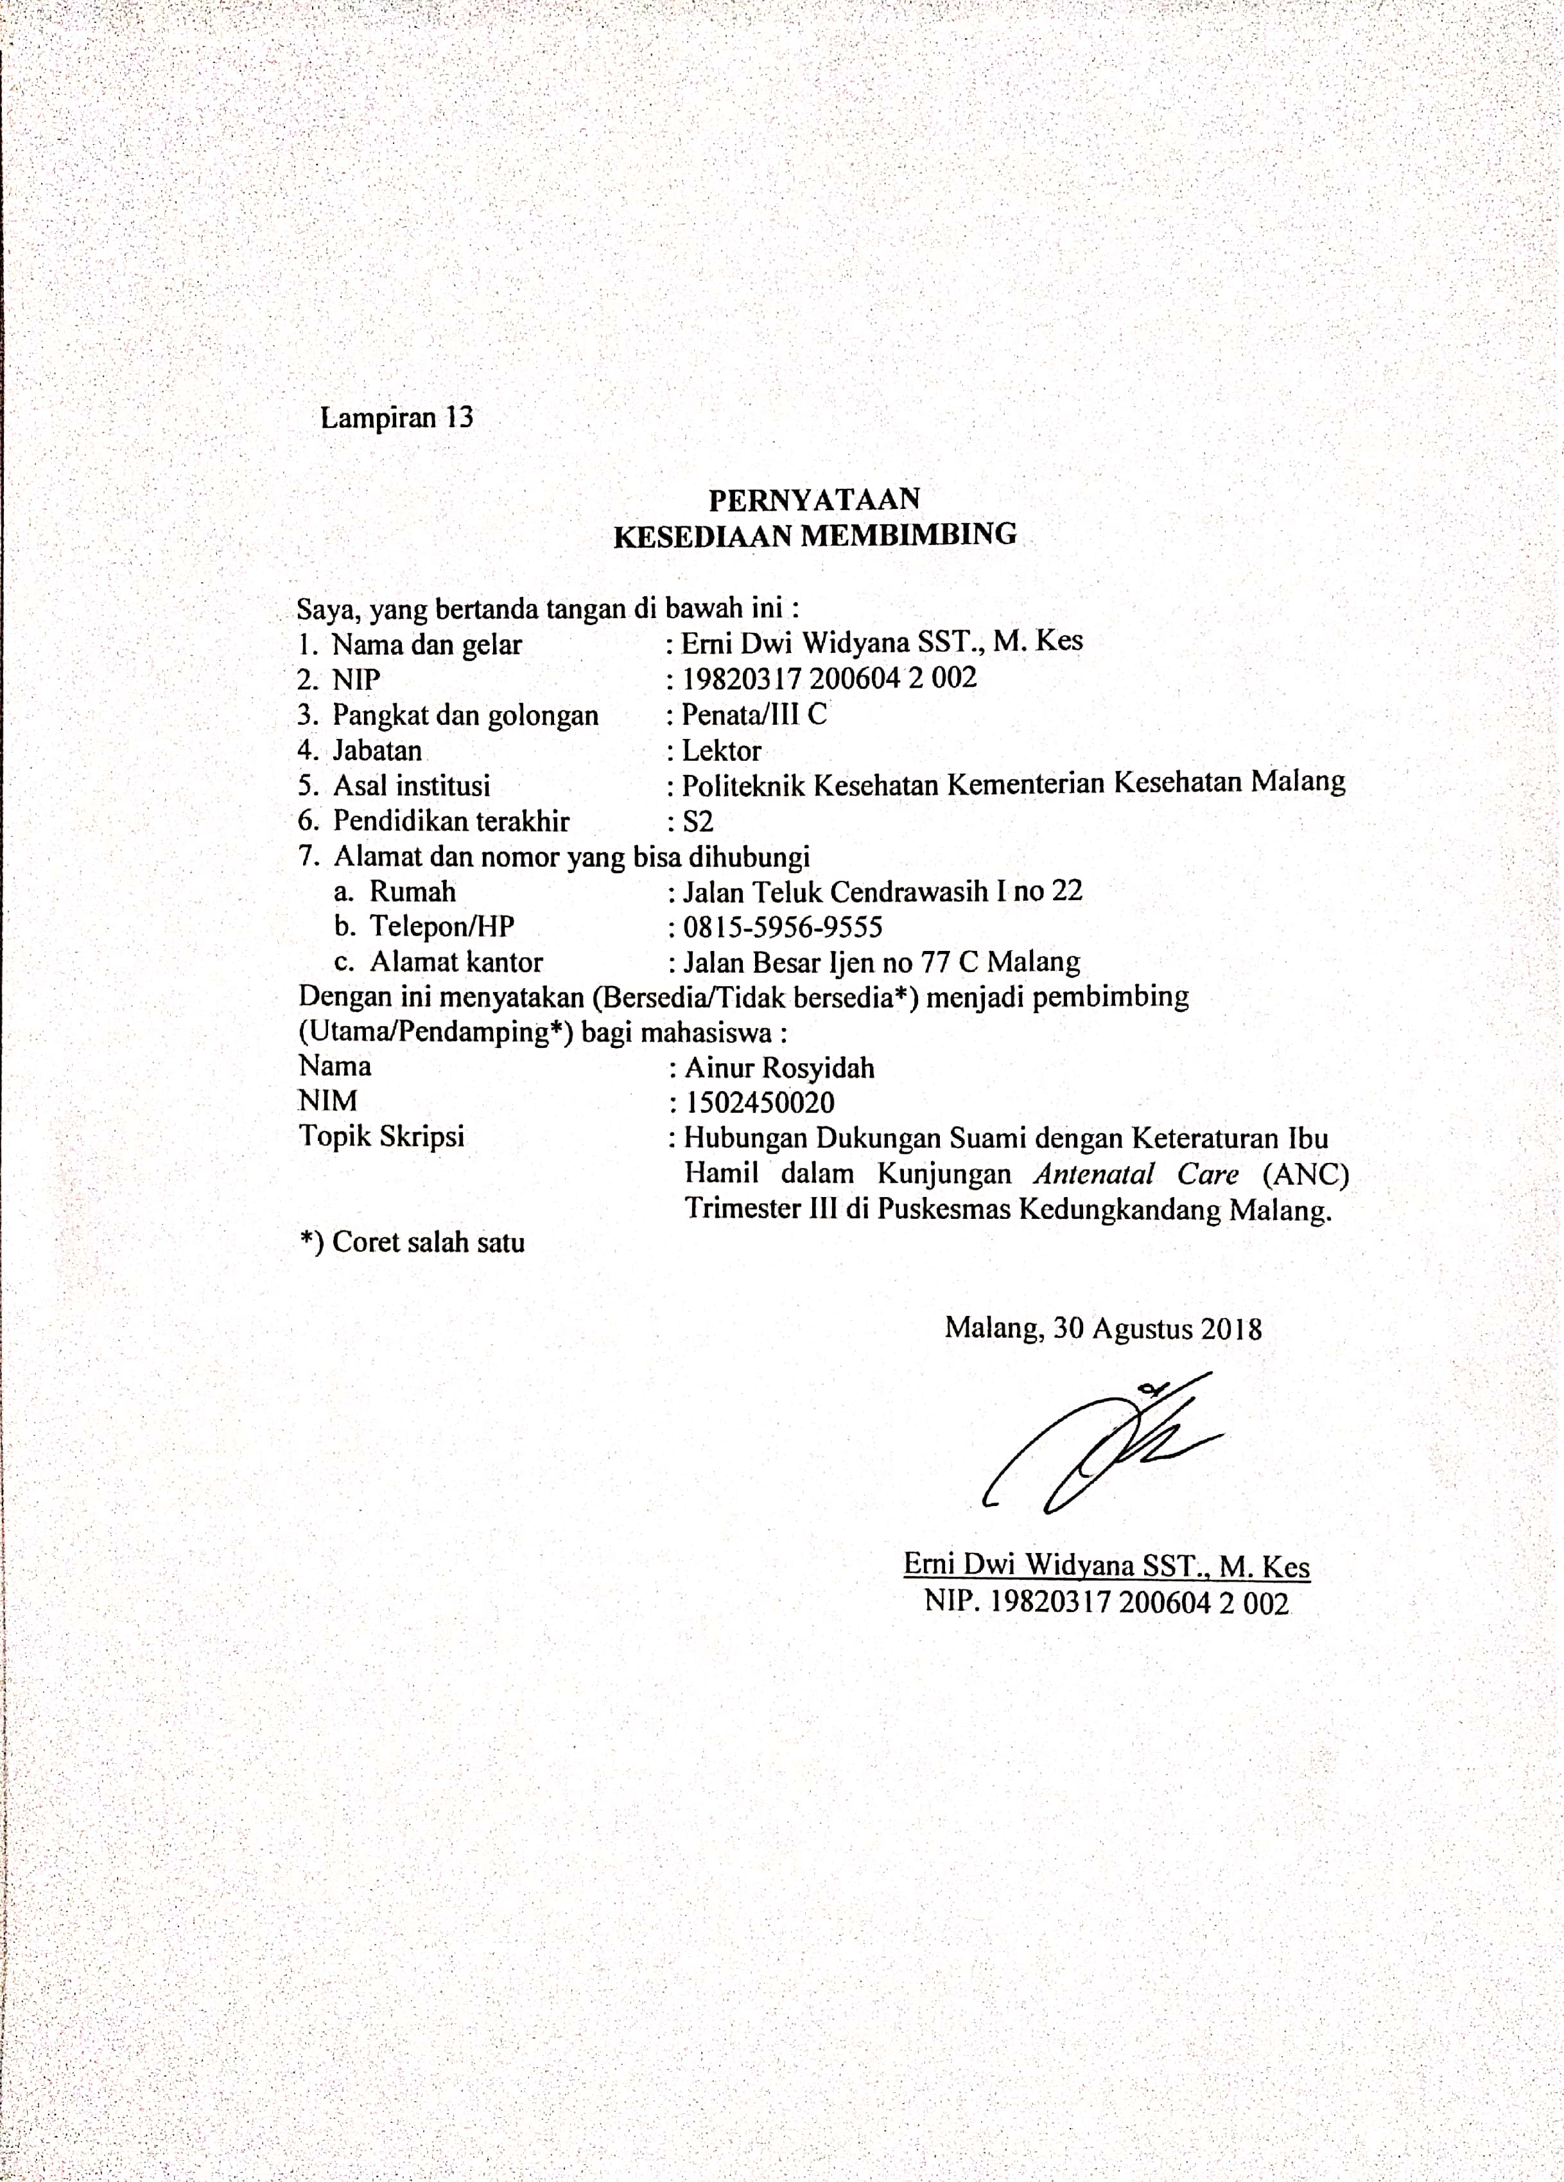

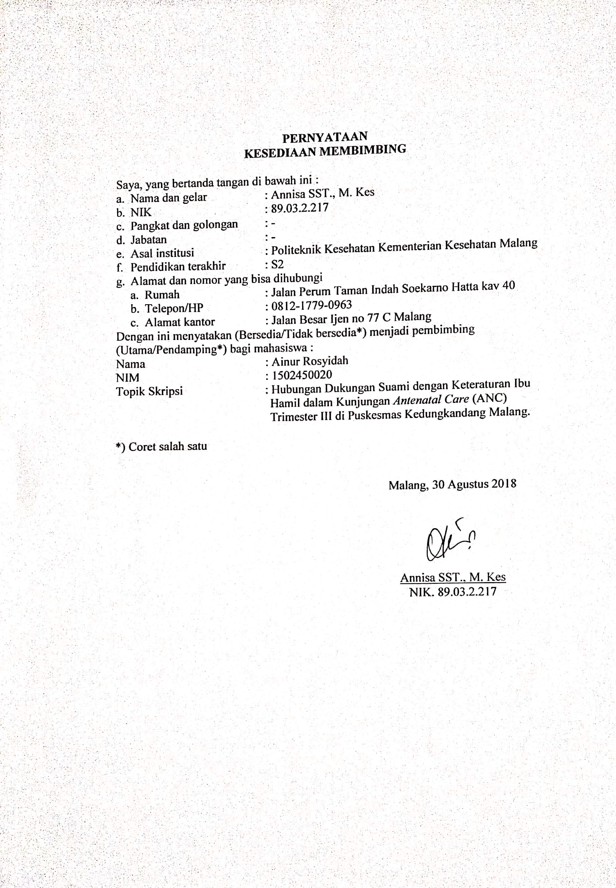 **LEMBAR PENJELASAN UNTUK MENGIKUTI PENELITIAN (PSP)**

Lampiran 14

1. Saya adalah Ainur Rosyidah, mahasiswi Sarjana Terapan dan Profesi Kebidanan Malang dari Jurusan Kebidanan Politeknik Kesehatan Kementerian Kesehatan Malang dengan ini meminta anda untuk berpartisipasi dengan sukarela dalam penelitian yang berjudul “Hubungan Dukungan Suami dengan Keteraturan Ibu Hamil dalam Kunjungan *Antenatal Care* (ANC) Trimester III di Puskesmas Kedungkandang Malang”.
2. Tujuan dari penelitian ini adalah : untuk mengetahui dukungan suami dengan keteraturan ibu hamil dalam kunjungan *antenatal care* (ANC) trimester III di Puskesmas Kedungkandang Malang, yang memberikan manfaat sebagai bahan informasi mengenai hubungan dukungan suami dengan keteraturan ibu hamil dalam kunjungan *antenatal care* trimester III. Penelitian ini akan berlangsung selama kurang lebih 30 menit dan responden yang terpilih dalam penelitian ini akan diberikan kuesioner dukungan suami untuk diisi. Besar sampel berjumlah 43 responden.
3. Keuntungan yang diperoleh responden dalam keikutsertaan pada penelitian ini adalah ikut menyumbangkan dan memberikan manfaat bagi pengembangan ilmu khususnya di bidang kesehatan.
4. Seandainya responden tidak menyetujui cara ini, maka responden boleh tidak mengikuti penelitian ini sama sekali. Untuk itu responden tidak akan dikenakan sanksi apapun.
5. Semua data/informasi yang kami peroleh akan tetap dirahasiakan.
6. Kalau responden memerlukan informasi/bantuan yang terkait dengan penelitian ini, silahkan menghubungi (Ainur Rosyidah) dengan nomor telepon 085336164788 sebagai peneliti utama.

Malang, ………….2019

Peneliti

Ainur Rosyidah

NIM. 1502450020

Lampiran 15

*MASTER SHEET* UJI VALIDITAS KUESIONER DUKUNGAN SUAMI

|  |  |  |  |  |  |  |  |  |  |  |  |  |  |  |  |  |  |  |  |  |  |  |  |  |  |  |
| --- | --- | --- | --- | --- | --- | --- | --- | --- | --- | --- | --- | --- | --- | --- | --- | --- | --- | --- | --- | --- | --- | --- | --- | --- | --- | --- |
| **Kode Responden** | **PERNYATAAN** | | | | | | | | | | | | | | | | | | | | | | | | | **TOTAL** |
| **S1** | **S2** | **S3** | **S4** | **S5** | **S6** | **S7** | **S8** | **S9** | **S10** | **S11** | **S12** | **S13** | **S14** | **S15** | **S16** | **S17** | **S18** | **S19** | **S20** | **S21** | **S22** | **S23** | **S24** | **S25** |
| R1 | 4 | 4 | 3 | 4 | 4 | 4 | 4 | 4 | 4 | 3 | 3 | 4 | 4 | 3 | 3 | 4 | 3 | 4 | 3 | 4 | 4 | 4 | 3 | 3 | 4 | 91 |
| R2 | 2 | 2 | 3 | 2 | 2 | 2 | 2 | 1 | 3 | 4 | 4 | 2 | 3 | 1 | 1 | 2 | 2 | 2 | 2 | 2 | 2 | 2 | 3 | 4 | 2 | 57 |
| R3 | 3 | 3 | 4 | 3 | 3 | 3 | 3 | 1 | 4 | 3 | 3 | 3 | 4 | 4 | 4 | 3 | 3 | 3 | 3 | 3 | 3 | 3 | 4 | 3 | 3 | 79 |
| R4 | 4 | 4 | 3 | 4 | 4 | 4 | 4 | 4 | 4 | 4 | 4 | 4 | 3 | 4 | 4 | 4 | 3 | 4 | 3 | 4 | 4 | 4 | 4 | 3 | 4 | 95 |
| R5 | 3 | 3 | 4 | 3 | 3 | 3 | 3 | 3 | 3 | 3 | 3 | 3 | 4 | 3 | 3 | 3 | 3 | 3 | 3 | 3 | 3 | 3 | 3 | 4 | 3 | 78 |
| R6 | 4 | 3 | 3 | 3 | 3 | 3 | 4 | 4 | 4 | 4 | 4 | 4 | 3 | 3 | 4 | 3 | 3 | 4 | 3 | 4 | 4 | 3 | 4 | 3 | 3 | 87 |
| R7 | 3 | 4 | 4 | 4 | 4 | 4 | 3 | 4 | 4 | 4 | 4 | 3 | 4 | 4 | 4 | 4 | 3 | 3 | 3 | 3 | 3 | 4 | 3 | 4 | 4 | 91 |
| R8 | 4 | 4 | 4 | 4 | 4 | 4 | 4 | 4 | 4 | 3 | 4 | 4 | 3 | 4 | 4 | 4 | 3 | 4 | 3 | 4 | 4 | 4 | 4 | 3 | 4 | 95 |
| R9 | 3 | 2 | 1 | 2 | 2 | 2 | 3 | 2 | 4 | 4 | 1 | 3 | 4 | 4 | 4 | 2 | 3 | 3 | 3 | 3 | 3 | 2 | 1 | 4 | 2 | 67 |
| R10 | 3 | 3 | 3 | 3 | 3 | 3 | 3 | 4 | 4 | 3 | 4 | 3 | 3 | 3 | 3 | 3 | 3 | 3 | 3 | 3 | 3 | 3 | 3 | 3 | 3 | 78 |

Lampiran 16

**Hasil Uji Validitas Dukungan Suami**

| **Correlations** | | | | | | | | | | | | | | | | | | | | | | | | | | | |
| --- | --- | --- | --- | --- | --- | --- | --- | --- | --- | --- | --- | --- | --- | --- | --- | --- | --- | --- | --- | --- | --- | --- | --- | --- | --- | --- | --- |
|  |  | R1 | R2 | R3 | R4 | R5 | R6 | R7 | R8 | R9 | R10 | R11 | R12 | R13 | R14 | R15 | R16 | R17 | R18 | R19 | R20 | R21 | R22 | R23 | R24 | R25 | DUKUNGAN |
| R1 | Pearson Correlation | 1 | .710* | .072 | .710* | .710* | .710* | 1.000** | .729* | .625 | -.156 | .136 | 1.000** | -.156 | .538 | .648* | .710* | .677* | 1.000** | .677* | 1.000** | 1.000** | .710* | .430 | -.701* | .710* | .861** |
| Sig. (2-tailed) |  | .022 | .844 | .022 | .022 | .022 | .000 | .017 | .053 | .667 | .707 | .000 | .667 | .109 | .043 | .022 | .032 | .000 | .032 | .000 | .000 | .022 | .215 | .024 | .022 | .001 |
| N | 10 | 10 | 10 | 10 | 10 | 10 | 10 | 10 | 10 | 10 | 10 | 10 | 10 | 10 | 10 | 10 | 10 | 10 | 10 | 10 | 10 | 10 | 10 | 10 | 10 | 10 |
| R2 | Pearson Correlation | .710* | 1 | .552 | 1.000** | 1.000** | 1.000** | .710* | .744* | .468 | -.267 | .467 | .710* | .000 | .505 | .467 | 1.000** | .535 | .710* | .535 | .710* | .710* | 1.000** | .552 | -.491 | 1.000** | .948** |
| Sig. (2-tailed) | .022 |  | .098 | .000 | .000 | .000 | .022 | .014 | .173 | .455 | .174 | .022 | 1.000 | .137 | .174 | .000 | .111 | .022 | .111 | .022 | .022 | .000 | .098 | .150 | .000 | .000 |
| N | 10 | 10 | 10 | 10 | 10 | 10 | 10 | 10 | 10 | 10 | 10 | 10 | 10 | 10 | 10 | 10 | 10 | 10 | 10 | 10 | 10 | 10 | 10 | 10 | 10 | 10 |
| R3 | Pearson Correlation | .072 | .552 | 1 | .552 | .552 | .552 | .072 | .169 | -.172 | -.459 | .651* | .072 | .000 | .051 | .025 | .552 | .076 | .072 | .076 | .072 | .072 | .552 | .737* | -.187 | .552 | .438 |
| Sig. (2-tailed) | .844 | .098 |  | .098 | .098 | .098 | .844 | .640 | .635 | .182 | .042 | .844 | 1.000 | .889 | .945 | .098 | .834 | .844 | .834 | .844 | .844 | .098 | .015 | .604 | .098 | .206 |
| N | 10 | 10 | 10 | 10 | 10 | 10 | 10 | 10 | 10 | 10 | 10 | 10 | 10 | 10 | 10 | 10 | 10 | 10 | 10 | 10 | 10 | 10 | 10 | 10 | 10 | 10 |
| R4 | Pearson Correlation | .710* | 1.000** | .552 | 1 | 1.000** | 1.000** | .710* | .744* | .468 | -.267 | .467 | .710* | .000 | .505 | .467 | 1.000** | .535 | .710* | .535 | .710* | .710* | 1.000** | .552 | -.491 | 1.000** | .948** |
| Sig. (2-tailed) | .022 | .000 | .098 |  | .000 | .000 | .022 | .014 | .173 | .455 | .174 | .022 | 1.000 | .137 | .174 | .000 | .111 | .022 | .111 | .022 | .022 | .000 | .098 | .150 | .000 | .000 |
| N | 10 | 10 | 10 | 10 | 10 | 10 | 10 | 10 | 10 | 10 | 10 | 10 | 10 | 10 | 10 | 10 | 10 | 10 | 10 | 10 | 10 | 10 | 10 | 10 | 10 | 10 |
| R5 | Pearson Correlation | .710* | 1.000** | .552 | 1.000** | 1 | 1.000** | .710* | .744* | .468 | -.267 | .467 | .710* | .000 | .505 | .467 | 1.000** | .535 | .710* | .535 | .710* | .710* | 1.000** | .552 | -.491 | 1.000** | .948** |
| Sig. (2-tailed) | .022 | .000 | .098 | .000 |  | .000 | .022 | .014 | .173 | .455 | .174 | .022 | 1.000 | .137 | .174 | .000 | .111 | .022 | .111 | .022 | .022 | .000 | .098 | .150 | .000 | .000 |
| N | 10 | 10 | 10 | 10 | 10 | 10 | 10 | 10 | 10 | 10 | 10 | 10 | 10 | 10 | 10 | 10 | 10 | 10 | 10 | 10 | 10 | 10 | 10 | 10 | 10 | 10 |
| R6 | Pearson Correlation | .710* | 1.000** | .552 | 1.000** | 1.000** | 1 | .710* | .744* | .468 | -.267 | .467 | .710* | .000 | .505 | .467 | 1.000** | .535 | .710* | .535 | .710* | .710* | 1.000** | .552 | -.491 | 1.000** | .948** |
| Sig. (2-tailed) | .022 | .000 | .098 | .000 | .000 |  | .022 | .014 | .173 | .455 | .174 | .022 | 1.000 | .137 | .174 | .000 | .111 | .022 | .111 | .022 | .022 | .000 | .098 | .150 | .000 | .000 |
| N | 10 | 10 | 10 | 10 | 10 | 10 | 10 | 10 | 10 | 10 | 10 | 10 | 10 | 10 | 10 | 10 | 10 | 10 | 10 | 10 | 10 | 10 | 10 | 10 | 10 | 10 |
| R7 | Pearson Correlation | 1.000** | .710* | .072 | .710* | .710* | .710* | 1 | .729* | .625 | -.156 | .136 | 1.000** | -.156 | .538 | .648* | .710* | .677* | 1.000** | .677* | 1.000** | 1.000** | .710* | .430 | -.701* | .710* | .861** |
| Sig. (2-tailed) | .000 | .022 | .844 | .022 | .022 | .022 |  | .017 | .053 | .667 | .707 | .000 | .667 | .109 | .043 | .022 | .032 | .000 | .032 | .000 | .000 | .022 | .215 | .024 | .022 | .001 |
| N | 10 | 10 | 10 | 10 | 10 | 10 | 10 | 10 | 10 | 10 | 10 | 10 | 10 | 10 | 10 | 10 | 10 | 10 | 10 | 10 | 10 | 10 | 10 | 10 | 10 | 10 |
| R8 | Pearson Correlation | .729* | .744* | .169 | .744* | .744* | .744* | .729* | 1 | .451 | -.082 | .411 | .729* | -.246 | .337 | .411 | .744* | .573 | .729* | .573 | .729* | .729* | .744* | .263 | -.401 | .744* | .800** |
| Sig. (2-tailed) | .017 | .014 | .640 | .014 | .014 | .014 | .017 |  | .191 | .822 | .238 | .017 | .494 | .341 | .238 | .014 | .083 | .017 | .083 | .017 | .017 | .014 | .463 | .250 | .014 | .005 |
| N | 10 | 10 | 10 | 10 | 10 | 10 | 10 | 10 | 10 | 10 | 10 | 10 | 10 | 10 | 10 | 10 | 10 | 10 | 10 | 10 | 10 | 10 | 10 | 10 | 10 | 10 |
| R9 | Pearson Correlation | .625 | .468 | -.172 | .468 | .468 | .468 | .625 | .451 | 1 | .000 | -.055 | .625 | .000 | .722* | .764* | .468 | .667* | .625 | .667* | .625 | .625 | .468 | .115 | -.612 | .468 | .601 |
| Sig. (2-tailed) | .053 | .173 | .635 | .173 | .173 | .173 | .053 | .191 |  | 1.000 | .881 | .053 | 1.000 | .018 | .010 | .173 | .035 | .053 | .035 | .053 | .053 | .173 | .752 | .060 | .173 | .066 |
| N | 10 | 10 | 10 | 10 | 10 | 10 | 10 | 10 | 10 | 10 | 10 | 10 | 10 | 10 | 10 | 10 | 10 | 10 | 10 | 10 | 10 | 10 | 10 | 10 | 10 | 10 |
| R10 | Pearson Correlation | -.156 | -.267 | -.459 | -.267 | -.267 | -.267 | -.156 | -.082 | .000 | 1 | .000 | -.156 | -.200 | -.111 | .000 | -.267 | -.333 | -.156 | -.333 | -.156 | -.156 | -.267 | -.229 | .408 | -.267 | -.202 |
| Sig. (2-tailed) | .667 | .455 | .182 | .455 | .455 | .455 | .667 | .822 | 1.000 |  | 1.000 | .667 | .580 | .760 | 1.000 | .455 | .347 | .667 | .347 | .667 | .667 | .455 | .524 | .242 | .455 | .576 |
| N | 10 | 10 | 10 | 10 | 10 | 10 | 10 | 10 | 10 | 10 | 10 | 10 | 10 | 10 | 10 | 10 | 10 | 10 | 10 | 10 | 10 | 10 | 10 | 10 | 10 | 10 |
| R11 | Pearson Correlation | .136 | .467 | .651* | .467 | .467 | .467 | .136 | .411 | -.055 | .000 | 1 | .136 | -.655* | -.267 | -.190 | .467 | -.218 | .136 | -.218 | .136 | .136 | .467 | .776** | -.356 | .467 | .383 |
| Sig. (2-tailed) | .707 | .174 | .042 | .174 | .174 | .174 | .707 | .238 | .881 | 1.000 |  | .707 | .040 | .456 | .598 | .174 | .545 | .707 | .545 | .707 | .707 | .174 | .008 | .312 | .174 | .274 |
| N | 10 | 10 | 10 | 10 | 10 | 10 | 10 | 10 | 10 | 10 | 10 | 10 | 10 | 10 | 10 | 10 | 10 | 10 | 10 | 10 | 10 | 10 | 10 | 10 | 10 | 10 |
| R12 | Pearson Correlation | 1.000** | .710* | .072 | .710* | .710* | .710* | 1.000** | .729* | .625 | -.156 | .136 | 1 | -.156 | .538 | .648* | .710* | .677* | 1.000** | .677* | 1.000** | 1.000** | .710* | .430 | -.701* | .710* | .861** |
| Sig. (2-tailed) | .000 | .022 | .844 | .022 | .022 | .022 | .000 | .017 | .053 | .667 | .707 |  | .667 | .109 | .043 | .022 | .032 | .000 | .032 | .000 | .000 | .022 | .215 | .024 | .022 | .001 |
| N | 10 | 10 | 10 | 10 | 10 | 10 | 10 | 10 | 10 | 10 | 10 | 10 | 10 | 10 | 10 | 10 | 10 | 10 | 10 | 10 | 10 | 10 | 10 | 10 | 10 | 10 |
| R13 | Pearson Correlation | -.156 | .000 | .000 | .000 | .000 | .000 | -.156 | -.246 | .000 | -.200 | -.655* | -.156 | 1 | .333 | .218 | .000 | .333 | -.156 | .333 | -.156 | -.156 | .000 | -.459 | .408 | .000 | -.050 |
| Sig. (2-tailed) | .667 | 1.000 | 1.000 | 1.000 | 1.000 | 1.000 | .667 | .494 | 1.000 | .580 | .040 | .667 |  | .347 | .545 | 1.000 | .347 | .667 | .347 | .667 | .667 | 1.000 | .182 | .242 | 1.000 | .890 |
| N | 10 | 10 | 10 | 10 | 10 | 10 | 10 | 10 | 10 | 10 | 10 | 10 | 10 | 10 | 10 | 10 | 10 | 10 | 10 | 10 | 10 | 10 | 10 | 10 | 10 | 10 |
| R14 | Pearson Correlation | .538 | .505 | .051 | .505 | .505 | .505 | .538 | .337 | .722* | -.111 | -.267 | .538 | .333 | 1 | .946** | .505 | .852** | .538 | .852** | .538 | .538 | .505 | .051 | -.272 | .505 | .631 |
| Sig. (2-tailed) | .109 | .137 | .889 | .137 | .137 | .137 | .109 | .341 | .018 | .760 | .456 | .109 | .347 |  | .000 | .137 | .002 | .109 | .002 | .109 | .109 | .137 | .889 | .447 | .137 | .050 |
| N | 10 | 10 | 10 | 10 | 10 | 10 | 10 | 10 | 10 | 10 | 10 | 10 | 10 | 10 | 10 | 10 | 10 | 10 | 10 | 10 | 10 | 10 | 10 | 10 | 10 | 10 |
| R15 | Pearson Correlation | .648* | .467 | .025 | .467 | .467 | .467 | .648* | .411 | .764* | .000 | -.190 | .648* | .218 | .946** | 1 | .467 | .873** | .648* | .873** | .648* | .648* | .467 | .150 | -.356 | .467 | .668* |
| Sig. (2-tailed) | .043 | .174 | .945 | .174 | .174 | .174 | .043 | .238 | .010 | 1.000 | .598 | .043 | .545 | .000 |  | .174 | .001 | .043 | .001 | .043 | .043 | .174 | .679 | .312 | .174 | .035 |
| N | 10 | 10 | 10 | 10 | 10 | 10 | 10 | 10 | 10 | 10 | 10 | 10 | 10 | 10 | 10 | 10 | 10 | 10 | 10 | 10 | 10 | 10 | 10 | 10 | 10 | 10 |
| R16 | Pearson Correlation | .710* | 1.000** | .552 | 1.000** | 1.000** | 1.000** | .710* | .744* | .468 | -.267 | .467 | .710* | .000 | .505 | .467 | 1 | .535 | .710* | .535 | .710* | .710* | 1.000** | .552 | -.491 | 1.000** | .948** |
| Sig. (2-tailed) | .022 | .000 | .098 | .000 | .000 | .000 | .022 | .014 | .173 | .455 | .174 | .022 | 1.000 | .137 | .174 |  | .111 | .022 | .111 | .022 | .022 | .000 | .098 | .150 | .000 | .000 |
| N | 10 | 10 | 10 | 10 | 10 | 10 | 10 | 10 | 10 | 10 | 10 | 10 | 10 | 10 | 10 | 10 | 10 | 10 | 10 | 10 | 10 | 10 | 10 | 10 | 10 | 10 |
| R17 | Pearson Correlation | .677* | .535 | .076 | .535 | .535 | .535 | .677* | .573 | .667* | -.333 | -.218 | .677* | .333 | .852** | .873** | .535 | 1 | .677* | 1.000** | .677* | .677* | .535 | .076 | -.408 | .535 | .695* |
| Sig. (2-tailed) | .032 | .111 | .834 | .111 | .111 | .111 | .032 | .083 | .035 | .347 | .545 | .032 | .347 | .002 | .001 | .111 |  | .032 | .000 | .032 | .032 | .111 | .834 | .242 | .111 | .026 |
| N | 10 | 10 | 10 | 10 | 10 | 10 | 10 | 10 | 10 | 10 | 10 | 10 | 10 | 10 | 10 | 10 | 10 | 10 | 10 | 10 | 10 | 10 | 10 | 10 | 10 | 10 |
| R18 | Pearson Correlation | 1.000** | .710* | .072 | .710* | .710* | .710* | 1.000** | .729* | .625 | -.156 | .136 | 1.000** | -.156 | .538 | .648* | .710* | .677* | 1 | .677* | 1.000** | 1.000** | .710* | .430 | -.701* | .710* | .861** |
| Sig. (2-tailed) | .000 | .022 | .844 | .022 | .022 | .022 | .000 | .017 | .053 | .667 | .707 | .000 | .667 | .109 | .043 | .022 | .032 |  | .032 | .000 | .000 | .022 | .215 | .024 | .022 | .001 |
| N | 10 | 10 | 10 | 10 | 10 | 10 | 10 | 10 | 10 | 10 | 10 | 10 | 10 | 10 | 10 | 10 | 10 | 10 | 10 | 10 | 10 | 10 | 10 | 10 | 10 | 10 |
| R19 | Pearson Correlation | .677* | .535 | .076 | .535 | .535 | .535 | .677* | .573 | .667* | -.333 | -.218 | .677* | .333 | .852** | .873** | .535 | 1.000** | .677* | 1 | .677* | .677* | .535 | .076 | -.408 | .535 | .695* |
| Sig. (2-tailed) | .032 | .111 | .834 | .111 | .111 | .111 | .032 | .083 | .035 | .347 | .545 | .032 | .347 | .002 | .001 | .111 | .000 | .032 |  | .032 | .032 | .111 | .834 | .242 | .111 | .026 |
| N | 10 | 10 | 10 | 10 | 10 | 10 | 10 | 10 | 10 | 10 | 10 | 10 | 10 | 10 | 10 | 10 | 10 | 10 | 10 | 10 | 10 | 10 | 10 | 10 | 10 | 10 |
| R20 | Pearson Correlation | 1.000** | .710* | .072 | .710* | .710* | .710* | 1.000** | .729* | .625 | -.156 | .136 | 1.000** | -.156 | .538 | .648* | .710* | .677* | 1.000** | .677* | 1 | 1.000** | .710* | .430 | -.701* | .710* | .861** |
| Sig. (2-tailed) | .000 | .022 | .844 | .022 | .022 | .022 | .000 | .017 | .053 | .667 | .707 | .000 | .667 | .109 | .043 | .022 | .032 | .000 | .032 |  | .000 | .022 | .215 | .024 | .022 | .001 |
| N | 10 | 10 | 10 | 10 | 10 | 10 | 10 | 10 | 10 | 10 | 10 | 10 | 10 | 10 | 10 | 10 | 10 | 10 | 10 | 10 | 10 | 10 | 10 | 10 | 10 | 10 |
| R21 | Pearson Correlation | 1.000** | .710* | .072 | .710* | .710* | .710* | 1.000** | .729* | .625 | -.156 | .136 | 1.000** | -.156 | .538 | .648* | .710* | .677* | 1.000** | .677* | 1.000** | 1 | .710* | .430 | -.701* | .710* | .861** |
| Sig. (2-tailed) | .000 | .022 | .844 | .022 | .022 | .022 | .000 | .017 | .053 | .667 | .707 | .000 | .667 | .109 | .043 | .022 | .032 | .000 | .032 | .000 |  | .022 | .215 | .024 | .022 | .001 |
| N | 10 | 10 | 10 | 10 | 10 | 10 | 10 | 10 | 10 | 10 | 10 | 10 | 10 | 10 | 10 | 10 | 10 | 10 | 10 | 10 | 10 | 10 | 10 | 10 | 10 | 10 |
| R22 | Pearson Correlation | .710* | 1.000** | .552 | 1.000** | 1.000** | 1.000** | .710* | .744* | .468 | -.267 | .467 | .710* | .000 | .505 | .467 | 1.000** | .535 | .710* | .535 | .710* | .710* | 1 | .552 | -.491 | 1.000** | .948** |
| Sig. (2-tailed) | .022 | .000 | .098 | .000 | .000 | .000 | .022 | .014 | .173 | .455 | .174 | .022 | 1.000 | .137 | .174 | .000 | .111 | .022 | .111 | .022 | .022 |  | .098 | .150 | .000 | .000 |
| N | 10 | 10 | 10 | 10 | 10 | 10 | 10 | 10 | 10 | 10 | 10 | 10 | 10 | 10 | 10 | 10 | 10 | 10 | 10 | 10 | 10 | 10 | 10 | 10 | 10 | 10 |
| R23 | Pearson Correlation | .430 | .552 | .737* | .552 | .552 | .552 | .430 | .263 | .115 | -.229 | .776** | .430 | -.459 | .051 | .150 | .552 | .076 | .430 | .076 | .430 | .430 | .552 | 1 | -.656* | .552 | .563 |
| Sig. (2-tailed) | .215 | .098 | .015 | .098 | .098 | .098 | .215 | .463 | .752 | .524 | .008 | .215 | .182 | .889 | .679 | .098 | .834 | .215 | .834 | .215 | .215 | .098 |  | .040 | .098 | .090 |
| N | 10 | 10 | 10 | 10 | 10 | 10 | 10 | 10 | 10 | 10 | 10 | 10 | 10 | 10 | 10 | 10 | 10 | 10 | 10 | 10 | 10 | 10 | 10 | 10 | 10 | 10 |
| R24 | Pearson Correlation | -.701* | -.491 | -.187 | -.491 | -.491 | -.491 | -.701* | -.401 | -.612 | .408 | -.356 | -.701* | .408 | -.272 | -.356 | -.491 | -.408 | -.701* | -.408 | -.701* | -.701* | -.491 | -.656* | 1 | -.491 | -.587 |
| Sig. (2-tailed) | .024 | .150 | .604 | .150 | .150 | .150 | .024 | .250 | .060 | .242 | .312 | .024 | .242 | .447 | .312 | .150 | .242 | .024 | .242 | .024 | .024 | .150 | .040 |  | .150 | .075 |
| N | 10 | 10 | 10 | 10 | 10 | 10 | 10 | 10 | 10 | 10 | 10 | 10 | 10 | 10 | 10 | 10 | 10 | 10 | 10 | 10 | 10 | 10 | 10 | 10 | 10 | 10 |
| R25 | Pearson Correlation | .710* | 1.000** | .552 | 1.000** | 1.000** | 1.000** | .710* | .744* | .468 | -.267 | .467 | .710* | .000 | .505 | .467 | 1.000** | .535 | .710* | .535 | .710* | .710* | 1.000** | .552 | -.491 | 1 | .948** |
| Sig. (2-tailed) | .022 | .000 | .098 | .000 | .000 | .000 | .022 | .014 | .173 | .455 | .174 | .022 | 1.000 | .137 | .174 | .000 | .111 | .022 | .111 | .022 | .022 | .000 | .098 | .150 |  | .000 |
| N | 10 | 10 | 10 | 10 | 10 | 10 | 10 | 10 | 10 | 10 | 10 | 10 | 10 | 10 | 10 | 10 | 10 | 10 | 10 | 10 | 10 | 10 | 10 | 10 | 10 | 10 |
| DUKUNGAN | Pearson Correlation | .861** | .948** | .438 | .948** | .948** | .948** | .861** | .800** | .601 | -.202 | .383 | .861** | -.050 | .631 | .668* | .948** | .695* | .861** | .695* | .861** | .861** | .948** | .563 | -.587 | .948** | 1 |
| Sig. (2-tailed) | .001 | .000 | .206 | .000 | .000 | .000 | .001 | .005 | .066 | .576 | .274 | .001 | .890 | .050 | .035 | .000 | .026 | .001 | .026 | .001 | .001 | .000 | .090 | .075 | .000 |  |
| N | 10 | 10 | 10 | 10 | 10 | 10 | 10 | 10 | 10 | 10 | 10 | 10 | 10 | 10 | 10 | 10 | 10 | 10 | 10 | 10 | 10 | 10 | 10 | 10 | 10 | 10 |
| *. Correlation is significant at the 0.05 level (2-tailed). | | | | | | | | | | | | | | | | | | | | | | | | | | | |
| **. Correlation is significant at the 0.01 level (2-tailed). | | | | | | | | | | | | | | | | | | | | | | | | | | | |

**Reliability**

| **Case Processing Summary** | | | |
| --- | --- | --- | --- |
|  |  | N | % |
| Cases | Valid | 10 | 100.0 |
| Excludeda | 0 | .0 |
| Total | 10 | 100.0 |
| a. Listwise deletion based on all variables in the procedure. | | | |

| **Reliability Statistics** | |
| --- | --- |
| Cronbach's Alpha | N of Items |
| .756 | 26 |

| **Item-Total Statistics** | | | | |
| --- | --- | --- | --- | --- |
|  | Scale Mean if Item Deleted | Scale Variance if Item Deleted | Corrected Item-Total Correlation | Cronbach's Alpha if Item Deleted |
| R1 | 160.30 | 600.456 | .854 | .745 |
| R2 | 160.40 | 592.267 | .945 | .741 |
| R3 | 160.40 | 609.822 | .407 | .750 |
| R4 | 160.40 | 592.267 | .945 | .741 |
| R5 | 160.40 | 592.267 | .945 | .741 |
| R6 | 160.40 | 592.267 | .945 | .741 |
| R7 | 160.30 | 600.456 | .854 | .745 |
| R8 | 160.50 | 579.167 | .780 | .736 |
| R9 | 159.80 | 616.622 | .590 | .752 |
| R10 | 160.10 | 634.767 | -.222 | .760 |
| R11 | 160.20 | 611.511 | .350 | .751 |
| R12 | 160.30 | 600.456 | .854 | .745 |
| R13 | 160.10 | 630.767 | -.071 | .759 |
| R14 | 160.30 | 600.011 | .608 | .745 |
| R15 | 160.20 | 597.733 | .645 | .744 |
| R16 | 160.40 | 592.267 | .945 | .741 |
| R17 | 160.70 | 618.233 | .688 | .753 |
| R18 | 160.30 | 600.456 | .854 | .745 |
| R19 | 160.70 | 618.233 | .688 | .753 |
| R20 | 160.30 | 600.456 | .854 | .745 |
| R21 | 160.30 | 600.456 | .854 | .745 |
| R22 | 160.40 | 592.267 | .945 | .741 |
| R23 | 160.40 | 604.044 | .537 | .747 |
| R24 | 160.20 | 644.622 | -.600 | .765 |
| R25 | 160.40 | 592.267 | .945 | .741 |
| DUKUNGAN | 81.80 | 157.289 | 1.000 | .946 |

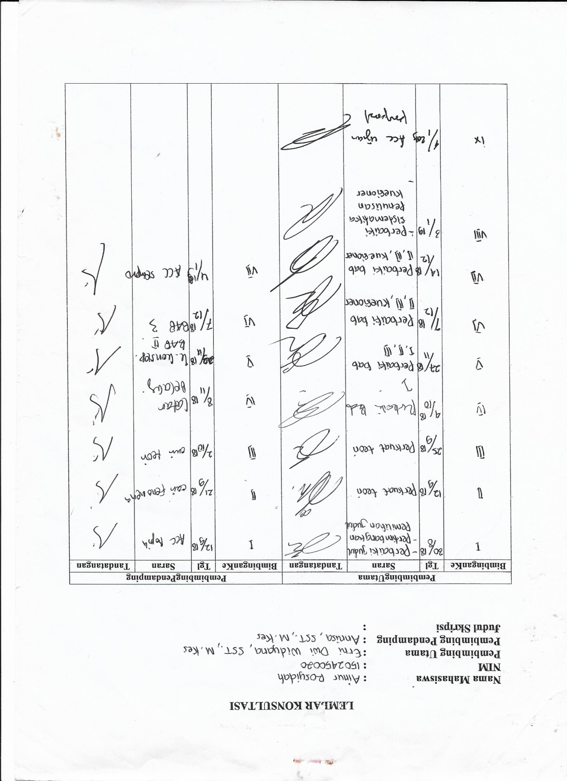lampiran 17

