**LAMPIRAN**

Lampiran 1. Karakteristik Subyek dan Responden

|  |  |  |  |  |  |  |  |  |  |  |  |  |  |
| --- | --- | --- | --- | --- | --- | --- | --- | --- | --- | --- | --- | --- | --- |
| No | Identitas Balita | | | | | Identitas Orang Tua | | | | | | | |
| Kode | Tanggal Lahir | Usia | Jenis Kelamin | BB (kg) | Usia (tahun) | | Pendidikan | | Pekerjaan | | Pendapatan | |
| Ayah | Ibu | Ayah | Ibu | Ayah | Ibu | Ayah | Ibu |
| 1. | A1 | 30/01/2014 | 4 tahun 1 bulan | L | 11,9 | 41 | 31 | SMP | SMP | Swasta | IRT | $≥$ UMR | $≥$ UMR |
| 2. | A2 | 15/07/2015 | 2 tahun 6 bulan | P | 10 | 30 | 27 | SD | SMP | Seniman | IRT | ≤ UMR | - |
| 3. | A3 | 05/08/2015 | 2 tahun 6 bulan | L | 10 | 25 | 20 | SD | SMP | Kuli | IRT | ≤ UMR | - |
| 4. | A4 | 12/03/2015 | 2 tahun 11 bulan | L | 10,5 | 30 | 23 | SMA | SMA | Petani | Swasta | $≥$ UMR | $≥$ UMR |
| 5. | A5 | 09/05/2015 | 2 tahun 9 bulan | P | 10,5 | 24 | 23 | SD | SD | Petani | Swasta | $≥$ UMR | $≥$ UMR |
| 6. | A6 | 19/05/2013 | 4 tahun 9 bulan | P | 12,9 | 26 | 26 | SMP | SMP | Swasta | Swasta | $≥$ UMR | $≥$ UMR |
| 7. | A7 | 16/08/2014 | 3 tahun 6 bulan | L | 11 | 33 | 32 | SMA | SMA | Swasta | Swasta | $≥$ UMR | $≥$ UMR |
| 8. | A8 | 25/07/2015 | 2 tahun 7 bulan | L | 10,1 | 29 | 30 | SMA | SMA | Swasta | Swasta | $≥$ UMR | $≥$ UMR |
| 9. | A9 | 06/03/2013 | 4 tahun 11 bulan | L | 14 | 37 | 36 | SMP | SD | Swasta | Swasta | $≥$ UMR | $≥$ UMR |
| 10. | A10 | 16/06/2015 | 2 tahun 8 bulan | P | 10 | 30 | 47 | SMA | SMA | Wiraswasta | IRT | ≤ UMR | - |
| 11. | A11 | 30/07/2013 | 4 tahun 7 hulan | L | 13 | 43 | 33 | SMP | SMP | Swasta | Swasta | $≥$ UMR | $≥$ UMR |
| 12. | A12 | 31/05/2014 | 3 tahun 9 bulan | P | 14 | 33 | 31 | SMP | SMP | Wiraswasta | IRT | ≤ UMR | - |

Lampiran 2. Distribusi Responden Berdasarkan Tingkat Pengetahuan

|  |  |  |  |  |
| --- | --- | --- | --- | --- |
| Kode | Tingkat Pengetahuan Gizi | | | |
| Sebelum Konseling | | Setelah Konseling | |
| Skor (%) | Kategori | Skor (%) | Kategori |
| A1 | 60 | Cukup | 85 | Baik |
| A2 | 75 | Cukup | 90 | Baik |
| A3 | 50 | Kurang | 75 | Cukup |
| A4 | 80 | Cukup | 90 | Baik |
| A5 | 65 | Cukup | 85 | Baik |
| A6 | 75 | Cukup | 95 | Baik |
| A7 | 65 | Cukup | 90 | Baik |
| A8 | 60 | Cukup | 85 | Baik |
| A9 | 55 | Kurang | 70 | Cukup |
| A10 | 80 | Cukup | 95 | Baik |
| A11 | 90 | Baik | 100 | Baik |
| A12 | 75 | Cukup | 90 | Baik |
| Rata – Rata | 69,1 | Cukup | 87,5 | Baik |

Lampiran 3. Distribusi Responden berdasarkan Sikap Ibu

|  |  |  |  |  |
| --- | --- | --- | --- | --- |
| Kode | Sikap | | | |
| Sebelum Konseling | | Setelah Konseling | |
| Skor (%) | Kategori | Skor (%) | Kategori |
| A1 | 90 | Baik | 90 | Baik |
| A2 | 60 | Cukup | 80 | Cukup |
| A3 | 70 | Cukup | 70 | Cukup |
| A4 | 100 | Baik | 100 | Baik |
| A5 | 95 | Baik | 100 | Baik |
| A6 | 100 | Baik | 90 | Baik |
| A7 | 90 | Baik | 95 | Baik |
| A8 | 60 | Cukup | 90 | Baik |
| A9 | 40 | Kurang | 60 | Cukup |
| A10 | 100 | Baik | 100 | Baik |
| A11 | 100 | Baik | 95 | Baik |
| A12 | 60 | Cukup | 70 | Cukup |
| Rata – rata | 80,4 | Baik | 86,6 | Baik |

Lampiran 4. Distribusi Pola Makan Sumber Energi

|  |  |  |  |  |  |  |  |  |
| --- | --- | --- | --- | --- | --- | --- | --- | --- |
| Kode | BB  Aktual  (kg) | Kebutuhan Energi  Per Individu  (kkal) | Sebelum Konseling | | | Sesudah Konseling | | |
| Rata – Rata Konsumsi Energi (kkal) | Pola Makan Sumber Energi (%) | Kategori | Rata – Rata Konsumsi Energi (kkal) | Pola Makan Sumber Energi (%) | Kategori |
| A1 | 11,9 | 1485 | 633,6 | 42,6 | Tidak Seimbang | 1226,6 | 82,5 | Seimbang |
| A2 | 10 | 1377 | 562,7 | 40,8 | Tidak Seimbang | 640,9 | 46,5 | Tidak Seimbang |
| A3 | 10 | 1377 | 808,6 | 58,7 | Tidak Seimbang | 565,6 | 41 | Tidak Seimbang |
| A4 | 10,5 | 1244 | 905,6 | 72,7 | Tidak Seimbang | 1153,0 | 92,6 | Seimbang |
| A5 | 10,5 | 1244 | 778,1 | 62,5 | Tidak Seimbang | 755,6 | 60,7 | Tidak Seimbang |
| A6 | 12,9 | 1611 | 799,5 | 49,6 | Tidak Seimbang | 1009,4 | 62,6 | Tidak Seimbang |
| A7 | 11 | 1581 | 461,8 | 29,2 | Tidak Seimbang | 1051,8 | 66,5 | Tidak Seimbang |
| A8 | 10,1 | 1377 | 846,6 | 61,4 | Tidak Seimbang | 794,6 | 57,7 | Tidak Seimbang |
| A9 | 14 | 1611 | 779,5 | 48,3 | Tidak Seimbang | 1300,5 | 80,7 | Seimbang |
| A10 | 10 | 1377 | 891,0 | 64,7 | Tidak Seimbang | 1079,5 | 78,3 | Tidak Seimbang |
| A11 | 13 | 1560 | 1064,7 | 68,2 | Tidak Seimbang | 1555,4 | 99,7 | Seimbang |
| A12 | 11 | 1632 | 570,5 | 34,9 | Tidak Seimbang | 664,7 | 40,7 | Tidak Seimbang |
| Rata – Rata | | | | 52,8 | Tidak Seimbang | 67,4 | | Tidak Seimbang |

Lampiran 5. Distribusi Pola Makan Sumber Protein

|  |  |  |  |  |  |  |  |  |
| --- | --- | --- | --- | --- | --- | --- | --- | --- |
| Kode | BB  Aktual  (kg) | Kebutuhan Protein  Per Individu  (g) | Sebelum Konseling | | | Sesudah Konseling | | |
| Rata – Rata Konsumsi Protein (g) | Pola Makan Sumber Protein (%) | Kategori | Rata – Rata Konsumsi Protein (g) | Pola Makan Sumber Energi (%) | Kategori |
| A1 | 11,9 | 55,6 | 26,1 | 46,9 | Tidak Seimbang | 67,3 | 121 | Seimbang |
| A2 | 10 | 51,6 | 22,3 | 43,2 | Tidak Seimbang | 29,2 | 56,5 | Tidak Seimbang |
| A3 | 10 | 51,6 | 28,5 | 55,2 | Tidak Seimbang | 18,7 | 36,2 | Tidak Seimbang |
| A4 | 10,5 | 45,9 | 45,9 | 100 | Seimbang | 50,9 | 110,8 | Seimbang |
| A5 | 10,5 | 45,9 | 31,5 | 68,6 | Tidak Seimbang | 31,8 | 69,2 | Tidak Seimbang |
| A6 | 12,9 | 60,4 | 48,0 | 79,4 | Tidak Seimbang | 31,9 | 52,8 | Tidak Seimbang |
| A7 | 11 | 59,2 | 20,1 | 33,9 | Tidak Seimbang | 34,0 | 57,4 | Tidak Seimbang |
| A8 | 10,1 | 51,6 | 54,5 | 105,6 | Seimbang | 52,4 | 101,5 | Seimbang |
| A9 | 14 | 60,4 | 44,2 | 69,8 | Tidak Seimbang | 54,0 | 89,4 | Seimbang |
| A10 | 10 | 51,6 | 33,7 | 65,3 | Tidak Seimbang | 50,9 | 98,6 | Seimbang |
| A11 | 13 | 58,5 | 48,9 | 83,5 | Seimbang | 71,3 | 121,8 | Seimbang |
| A12 | 11 | 61,2 | 20,3 | 33,1 | Tidak Seimbang | 26,5 | 43,3 | Tidak Seimbang |
| Rata – Rata | | | | 65,3 | Tidak Seimbang | 79,8 | | Tidak Seimbang |

Lampiran 6. Distribusi Pola Makan Sumber Lemak

|  |  |  |  |  |  |  |  |  |
| --- | --- | --- | --- | --- | --- | --- | --- | --- |
| Kode | BB  Aktual  (kg) | Kebutuhan Lemak  Per Individu  (g) | Sebelum Konseling | | | Sesudah Konseling | | |
| Rata – Rata Konsumsi lemak (g) | Pola Makan Sumber Lemak (%) | Kategori | Rata – Rata Konsumsi Lemak (g) | Pola Makan Sumber Lemak (%) | Kategori |
| A1 | 11,9 | 41,25 | 16,3 | 39,5 | Tidak Seimbang | 36,7 | 88,9 | Seimbang |
| A2 | 10 | 38,2 | 7,6 | 19,8 | Tidak Seimbang | 11,9 | 31,5 | Tidak Seimbang |
| A3 | 10 | 38,2 | 7,5 | 19,6 | Tidak Seimbang | 5,2 | 13,6 | Tidak Seimbang |
| A4 | 10,5 | 34 | 26,0 | 76,4 | Tidak Seimbang | 26,8 | 78,8 | Tidak Seimbang |
| A5 | 10,5 | 34 | 13,8 | 40,5 | Tidak Seimbang | 13,5 | 39,7 | Tidak Seimbang |
| A6 | 12,9 | 44,7 | 23,1 | 51,6 | Tidak Seimbang | 27,4 | 61,2 | Tidak Seimbang |
| A7 | 11 | 43,9 | 11,2 | 25,5 | Tidak Seimbang | 31,7 | 72,2 | Tidak Seimbang |
| A8 | 10,1 | 38,2 | 29,7 | 77,7 | Seimbang | 27,8 | 60 | Tidak Seimbang |
| A9 | 14 | 44,7 | 21,9 | 48,9 | Tidak Seimbang | 23,7 | 53 | Tidak Seimbang |
| A10 | 10 | 38,2 | 15,7 | 41 | Tidak Seimbang | 24,7 | 64,6 | Tidak Seimbang |
| A11 | 13 | 43,3 | 23,1 | 53,3 | Tidak Seimbang | 61,3 | 141,5 | Seimbang |
| A12 | 11 | 45,3 | 13,8 | 30,4 | Tidak Seimbang | 16,3 | 35,9 | Tidak Seimbang |
| Rata – Rata | | | | 43,6 | Tidak Seimbang |  | 61,7 | Tidak Seimbang |

Lampiran 7. Distribusi Pola Makan Sumber Karbohidrat

|  |  |  |  |  |  |  |  |  |
| --- | --- | --- | --- | --- | --- | --- | --- | --- |
| Kode | BB  Aktual  (kg) | Kebutuhan Karbohidrat  Per Individu  (g) | Sebelum Konseling | | | Sesudah Konseling | | |
| Rata – Rata Konsumsi Karbohidrat (g) | Pola Makan Sumber Karbohidrat (%) | Kategori | Rata – Rata Konsumsi Karbohidrat  (g) | Pola Makan Sumber Karbohidrat (%) | Kategori |
| A1 | 11,9 | 222 | 94,6 | 42,6 | Tidak Seimbang | 162,5 | 73 | Tidak Seimbang |
| A2 | 10 | 206,5 | 104,3 | 50,5 | Tidak Seimbang | 107,7 | 52,1 | Tidak Seimbang |
| A3 | 10 | 206,5 | 157,5 | 76,2 | Tidak Seimbang | 112,1 | 54,2 | Tidak Seimbang |
| A4 | 10,5 | 183,6 | 122,3 | 66,6 | Tidak Seimbang | 178,0 | 96,9 | Seimbang |
| A5 | 10,5 | 183,6 | 137,4 | 74,8 | Tidak Seimbang | 131,0 | 71,3 | Tidak Seimbang |
| A6 | 12,9 | 241 | 108,7 | 45 | Tidak Seimbang | 160,4 | 66,5 | Tidak Seimbang |
| A7 | 11 | 237 | 69,7 | 29,4 | Tidak Seimbang | 159,3 | 67,2 | Tidak Seimbang |
| A8 | 10,1 | 206,5 | 96,1 | 46,5 | Seimbang | 88.6 | 42,9 | Seimbang |
| A9 | 14 | 241 | 108,9 | 45,1 | Tidak Seimbang | 226,9 | 94 | Seimbang |
| A10 | 10 | 214,2 | 157,1 | 73,3 | Tidak Seimbang | 166,0 | 77,4 | Tidak Seimbang |
| A11 | 13 | 234 | 169,2 | 72,3 | Tidak Seimbang | 183,2 | 78,2 | Tidak Seimbang |
| A12 | 11 | 244,8 | 93,1 | 38 | Tidak Seimbang | 102,1 | 41,7 | Tidak Seimbang |
| Rata – Rata | | | | 55 | Tidak Seimbang | 67,9 | | Tidak Seimbang |

Lampiran 8. Distribusi Penambahan Berat Badan Balita

|  |  |  |  |  |  |  |  |  |  |
| --- | --- | --- | --- | --- | --- | --- | --- | --- | --- |
| Kode | BBI  (kg) | Peningkatan Berat Badan | | | | | | |  |
| Minggu 1 | Peningkatan | Minggu 2 | Peningkatan | Minggu 3 | Peningkatan | Minggu 4 | Peningkatan |
| A1 | 16,5 | 11,9 | 595 | 12 | 600 | 12,2 | 610 | 13 | 650 |
| A2 | 13,5 | 10 | 500 | 10,1 | 505 | 10,3 | 515 | 10,2 | 510 |
| A3 | 13,5 | 10 | 500 | 10,1 | 505 | 10,4 | 520 | 8 | 400 |
| A4 | 12 | 10,5 | 525 | 11 | 550 | 12 | 6000 | 14 | 700 |
| A5 | 12 | 10,5 | 525 | 10,7 | 535 | 11 | 550 | 10 | 500 |
| A6 | 17,9 | 12,9 | 595 | 13 | 650 | 13,3 | 665 | 14 | 700 |
| A7 | 15,5 | 11 | 550 | 11,3 | 565 | 11,8 | 590 | 12,5 | 625 |
| A8 | 13,5 | 10,1 | 505 | 10,4 | 520 | 10,6 | 530 | 10 | 500 |
| A9 | 17,9 | 14 | 700 | 14,1 | 705 | 14,4 | 720 | 15 | 745 |
| A10 | 13,5 | 10 | 500 | 10,5 | 525 | 11,2 | 560 | 12,1 | 605 |
| A11 | 17,4 | 13 | 650 | 13,2 | 660 | 13,7 | 685 | 14,5 | 725 |
| A12 | 14 | 11 | 550 | 11,1 | 555 | 11,4 | 570 | 12 | 550 |
| Rata – rata | | 558 | | 573 | | 593 | | 601 | |

Lampiran 9. Uji statistik *Paired Sampel T –Test* Pengetahuan Responden

**T-Test**

|  |  |  |  |  |  |
| --- | --- | --- | --- | --- | --- |
| **Paired Samples Statistics** | | | | | |
|  | | Mean | N | Std. Deviation | Std. Error Mean |
| Pair 1 | sebelum konseling | 69,1667 | 12 | 11,83856 | 3,41750 |
| sesudah konseling | 87,5000 | 12 | 8,39372 | 2,42306 |

|  |  |  |  |  |
| --- | --- | --- | --- | --- |
| **Paired Samples Correlations** | | | | |
|  | | N | Correlation | Sig. |
| Pair 1 | sebelum konseling & sesudah konseling | 12 | ,892 | ,000 |

|  |  |  |  |  |  |
| --- | --- | --- | --- | --- | --- |
| **Paired Samples Test** | | | | | |
|  | | Paired Differences | | | |
| Mean | Std. Deviation | Std. Error Mean | 95% Confidence Interval of the Difference |
| Lower |
| Pair 1 | sebelum konseling - sesudah konseling | -18,33333 | 5,77350 | 1,66667 | -22,00164 |

|  |  |  |  |  |  |
| --- | --- | --- | --- | --- | --- |
| **Paired Samples Test** | | | | | |
|  | | Paired Differences | t | Df | Sig. (2-tailed) |
| 95% Confidence Interval of the Difference |
| Upper |
| Pair 1 | sebelum konseling - sesudah konseling | -14,66502 | -11,000 | 11 | ,000 |

Lampiran 10. Uji statistik *Paired Sampel T –Test* Sikap Responden

|  |  |  |  |  |  |
| --- | --- | --- | --- | --- | --- |
| **Paired Samples Statistics** | | | | | |
|  | | Mean | N | Std. Deviation | Std. Error Mean |
| Pair 1 | SEBELUM | 80,0000 | 12 | 20,33805 | 5,87109 |
| SESUDAH | 86,2500 | 12 | 11,89442 | 3,43362 |

|  |  |  |  |  |
| --- | --- | --- | --- | --- |
| **Paired Samples Correlations** | | | | |
|  | | N | Correlation | Sig. |
| Pair 1 | SEBELUM & SESUDAH | 12 | ,770 | ,003 |

|  |  |  |  |  |  |
| --- | --- | --- | --- | --- | --- |
| **Paired Samples Test** | | | | | |
|  | | Paired Differences | | | |
| Mean | Std. Deviation | Std. Error Mean | 95% Confidence Interval of the Difference |
| Lower |
| Pair 1 | SEBELUM - SESUDAH | -6,25000 | 13,50505 | 3,89857 | -14,83070 |

|  |  |  |  |  |  |
| --- | --- | --- | --- | --- | --- |
| **Paired Samples Test** | | | | | |
|  | | Paired Differences | t | df | Sig. (2-tailed) |
| 95% Confidence Interval of the Difference |
| Upper |
| Pair 1 | SEBELUM - SESUDAH | 2,33070 | -1,603 | 11 | ,137 |

Lampiran 11. Uji statistik *Paired Sampel T –Test* Berat Badan Subjek

|  |  |  |  |  |  |
| --- | --- | --- | --- | --- | --- |
| **Paired Samples Statistics** | | | | | |
|  | | Mean | N | Std. Deviation | Std. Error Mean |
| Pair 1 | beratbadansebelum | 11,2417 | 12 | 1,38266 | ,39914 |
| beratbadansesudah | 12,0250 | 12 | 2,18970 | ,63211 |

|  |  |  |  |  |
| --- | --- | --- | --- | --- |
| **Paired Samples Correlations** | | | | |
|  | | N | Correlation | Sig. |
| Pair 1 | beratbadansebelum & beratbadansesudah | 12 | ,785 | ,003 |

|  |  |  |  |  |  |
| --- | --- | --- | --- | --- | --- |
| **Paired Samples Test** | | | | | |
|  | | Paired Differences | | | |
| Mean | Std. Deviation | Std. Error Mean | 95% Confidence Interval of the Difference |
| Lower |
| Pair 1 | beratbadansebelum - beratbadansesudah | -,78333 | 1,39859 | ,40374 | -1,67196 |

|  |  |  |  |  |  |
| --- | --- | --- | --- | --- | --- |
| **Paired Samples Test** | | | | | |
|  | | Paired Differences | t | df | Sig. (2-tailed) |
| 95% Confidence Interval of the Difference |
| Upper |
| Pair 1 | beratbadansebelum - beratbadansesudah | ,10529 | -1,940 | 11 | ,078 |

Lampiran 12. Uji statistik *Paired Sampel T –Test* Pola Makan Sumber Energi

|  |  |  |  |  |  |
| --- | --- | --- | --- | --- | --- |
| **Paired Samples Statistics** | | | | | |
|  | | Mean | N | Std. Deviation | Std. Error Mean |
| Pair 1 | sebelum | 52,8000 | 12 | 13,92689 | 4,02035 |
| sesudah | 67,4583 | 12 | 19,56688 | 5,64847 |

|  |  |  |  |  |
| --- | --- | --- | --- | --- |
| **Paired Samples Correlations** | | | | |
|  | | N | Correlation | Sig. |
| Pair 1 | sebelum & sesudah | 12 | ,459 | ,133 |

|  |  |  |  |  |  |
| --- | --- | --- | --- | --- | --- |
| **Paired Samples Test** | | | | | |
|  | | Paired Differences | | | |
| Mean | Std. Deviation | Std. Error Mean | 95% Confidence Interval of the Difference |
| Lower |
| Pair 1 | sebelum - sesudah | -14,65833 | 18,07366 | 5,21742 | -26,14179 |

|  |  |  |  |  |  |
| --- | --- | --- | --- | --- | --- |
| **Paired Samples Test** | | | | | |
|  | | Paired Differences | t | df | Sig. (2-tailed) |
| 95% Confidence Interval of the Difference |
| Upper |
| Pair 1 | sebelum - sesudah | -3,17488 | -2,810 | 11 | ,017 |

Lampiran 13. Uji statistik *Paired Sampel T –Test* Pola Makan Sumber Protein

|  |  |  |  |  |  |
| --- | --- | --- | --- | --- | --- |
|  | | Mean | N | Std. Deviation | Std. Error Mean |
| Pair 1 | sebelum | 65,3750 | 12 | 24,00962 | 6,93098 |
| sesudah | 79,8750 | 12 | 30,83399 | 8,90101 |

|  |  |  |  |  |
| --- | --- | --- | --- | --- |
| **Paired Samples Correlations** | | | | |
|  | | N | Correlation | Sig. |
| Pair 1 | sebelum & sesudah | 12 | ,543 | ,068 |

|  |  |  |  |  |  |
| --- | --- | --- | --- | --- | --- |
| **Paired Samples Test** | | | | | |
|  | | Paired Differences | | | |
| Mean | Std. Deviation | Std. Error Mean | 95% Confidence Interval of the Difference |
| Lower |
| Pair 1 | sebelum - sesudah | -14,50000 | 26,90607 | 7,76711 | -31,59530 |

|  |  |  |  |  |  |
| --- | --- | --- | --- | --- | --- |
| **Paired Samples Test** | | | | | |
|  | | Paired Differences | t | df | Sig. (2-tailed) |
| 95% Confidence Interval of the Difference |
| Upper |
| Pair 1 | sebelum - sesudah | 2,59530 | -1,867 | 11 | ,089 |

Lampiran 14. Uji statistik *Paired Sampel T –Test* Pola Makan Sumber Lemak

|  |  |  |  |  |  |
| --- | --- | --- | --- | --- | --- |
| **Paired Samples Statistics** | | | | | |
|  | | Mean | N | Std. Deviation | Std. Error Mean |
| Pair 1 | sebelum | 43,6833 | 12 | 19,31136 | 5,57471 |
| sesudah | 61,742 | 12 | 32,9918 | 9,5239 |

|  |  |  |  |  |
| --- | --- | --- | --- | --- |
| **Paired Samples Correlations** | | | | |
|  | | N | Correlation | Sig. |
| Pair 1 | sebelum & sesudah | 12 | ,457 | ,136 |

|  |  |  |  |  |  |
| --- | --- | --- | --- | --- | --- |
| **Paired Samples Test** | | | | | |
|  | | Paired Differences | | | |
| Mean | Std. Deviation | Std. Error Mean | 95% Confidence Interval of the Difference |
| Lower |
| Pair 1 | sebelum - sesudah | -18,05833 | 29,65868 | 8,56172 | -36,90256 |

|  |  |  |  |  |  |
| --- | --- | --- | --- | --- | --- |
| **Paired Samples Test** | | | | | |
|  | | Paired Differences | t | df | Sig. (2-tailed) |
| 95% Confidence Interval of the Difference |
| Upper |
| Pair 1 | sebelum - sesudah | ,78589 | -2,109 | 11 | ,059 |

Lampiran 15. Uji statistik *Paired Sampel T –Test* Pola Makan Sumber Karbohidrat

|  |  |  |  |  |  |
| --- | --- | --- | --- | --- | --- |
| **Paired Samples Statistics** | | | | | |
|  | | Mean | N | Std. Deviation | Std. Error Mean |
| Pair 1 | sebelum | 55,0250 | 12 | 16,51127 | 4,76639 |
| sesudah | 67,950 | 12 | 17,8563 | 5,1547 |

|  |  |  |  |  |
| --- | --- | --- | --- | --- |
| **Paired Samples Correlations** | | | | |
|  | | N | Correlation | Sig. |
| Pair 1 | sebelum & sesudah | 12 | ,279 | ,380 |

|  |  |  |  |  |  |
| --- | --- | --- | --- | --- | --- |
| **Paired Samples Test** | | | | | |
|  | | Paired Differences | | | |
| Mean | Std. Deviation | Std. Error Mean | 95% Confidence Interval of the Difference |
| Lower |
| Pair 1 | sebelum – sesudah | -12,92500 | 20,66390 | 5,96515 | -26,05421 |

|  |  |  |  |  |  |
| --- | --- | --- | --- | --- | --- |
| **Paired Samples Test** | | | | | |
|  | | Paired Differences | t | df | Sig. (2-tailed) |
| 95% Confidence Interval of the Difference |
| Upper |
| Pair 1 | sebelum – sesudah | ,20421 | -2,167 | 11 | ,053 |

Lampiran 16. Pernyataan Persetujuan

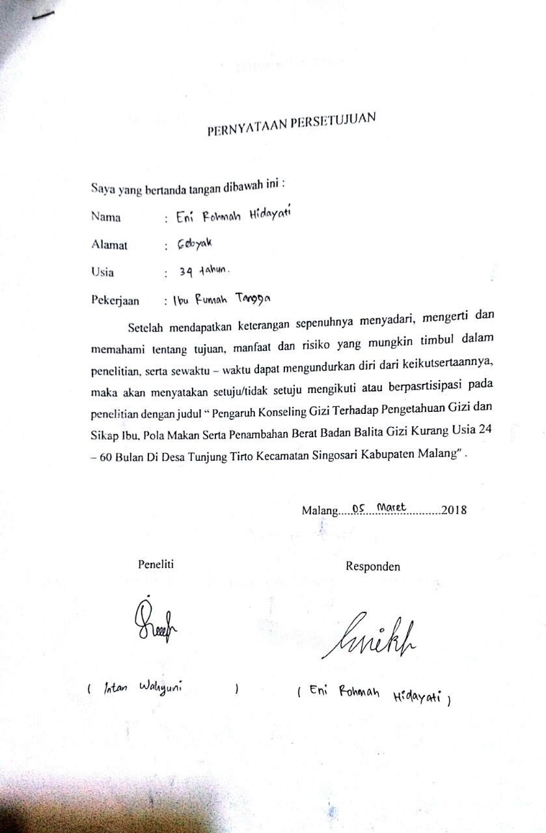

Lampiran 17. Formulir Identitas

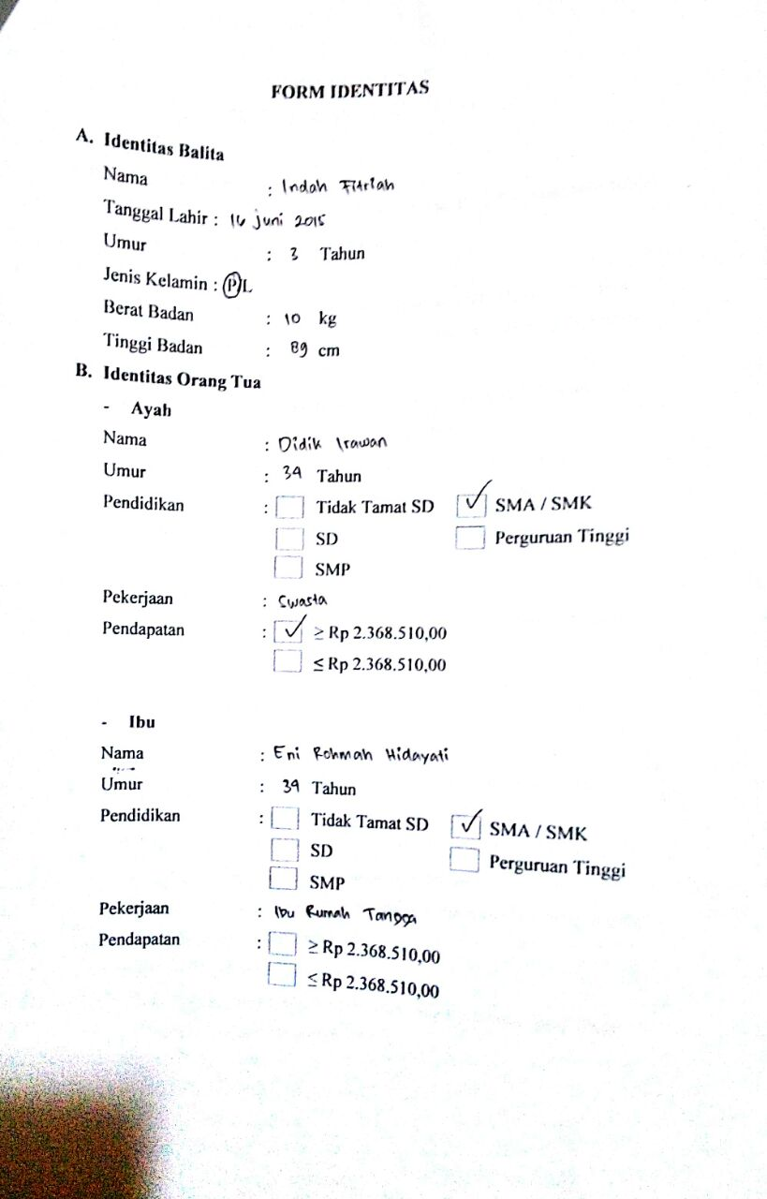

Lampiran 18. Kuesioner Pengetahuan

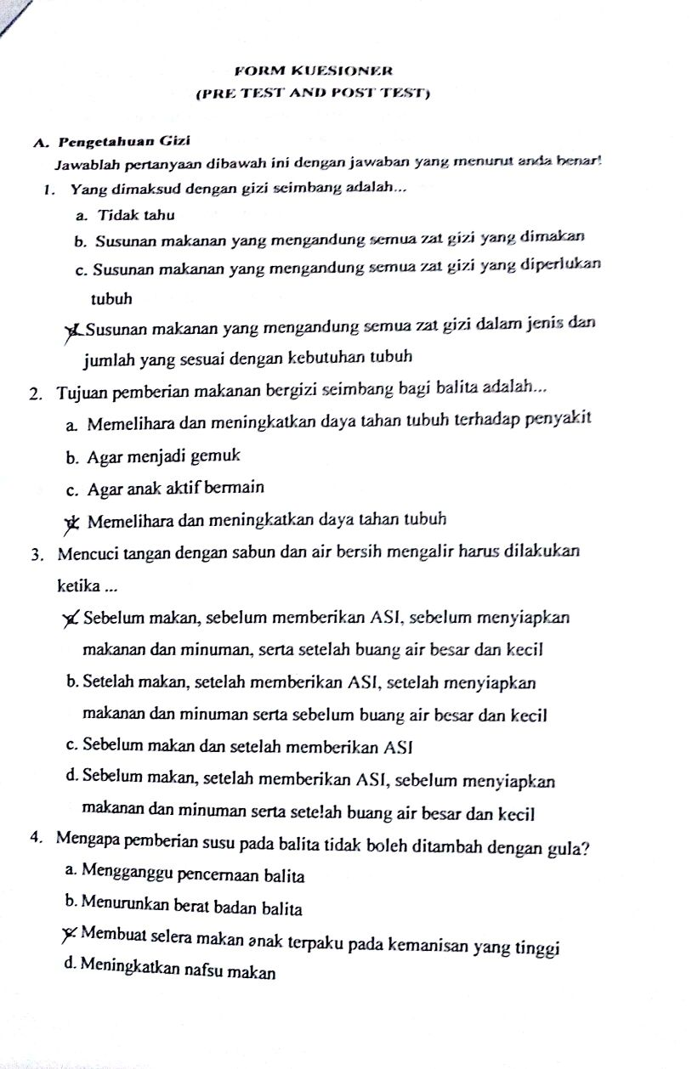

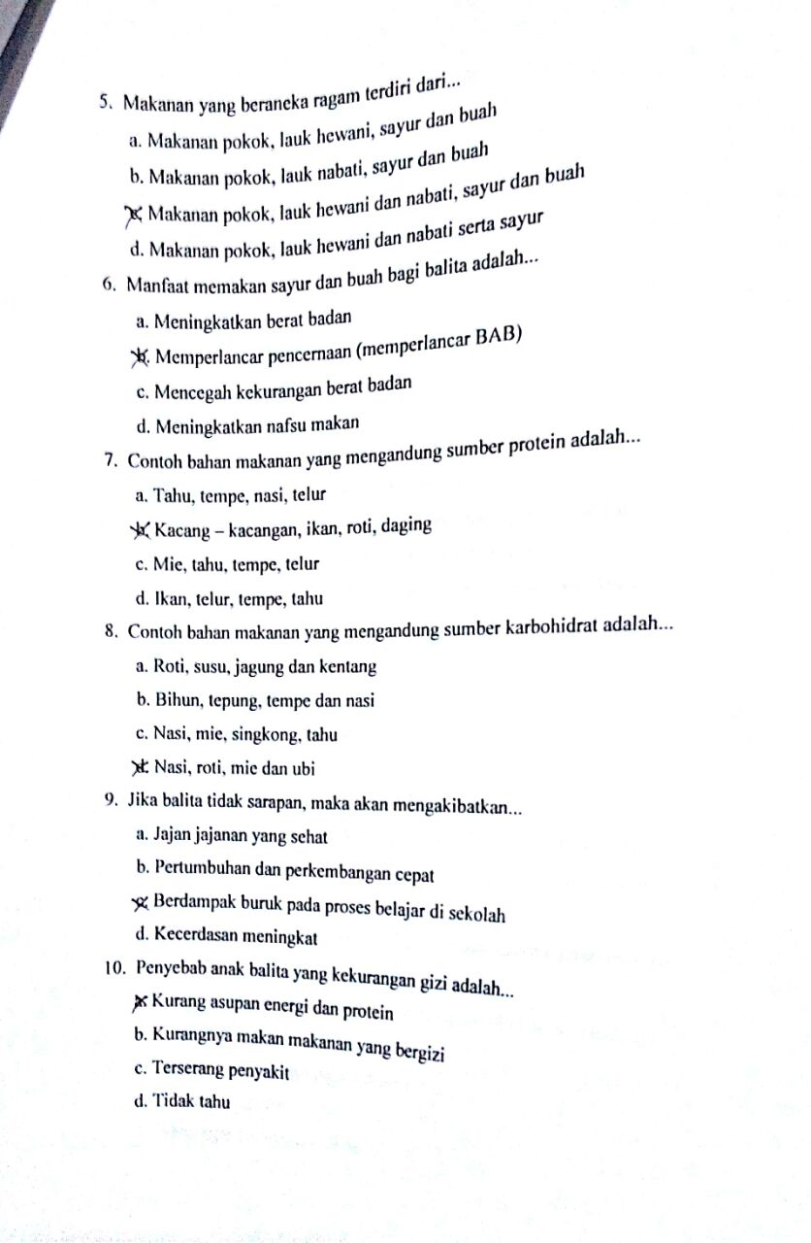

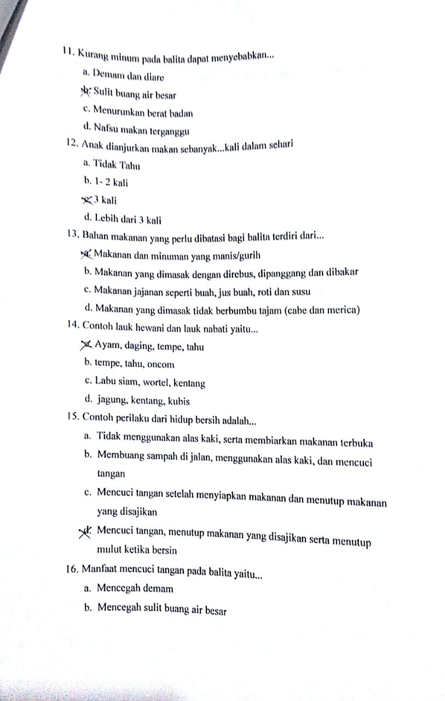

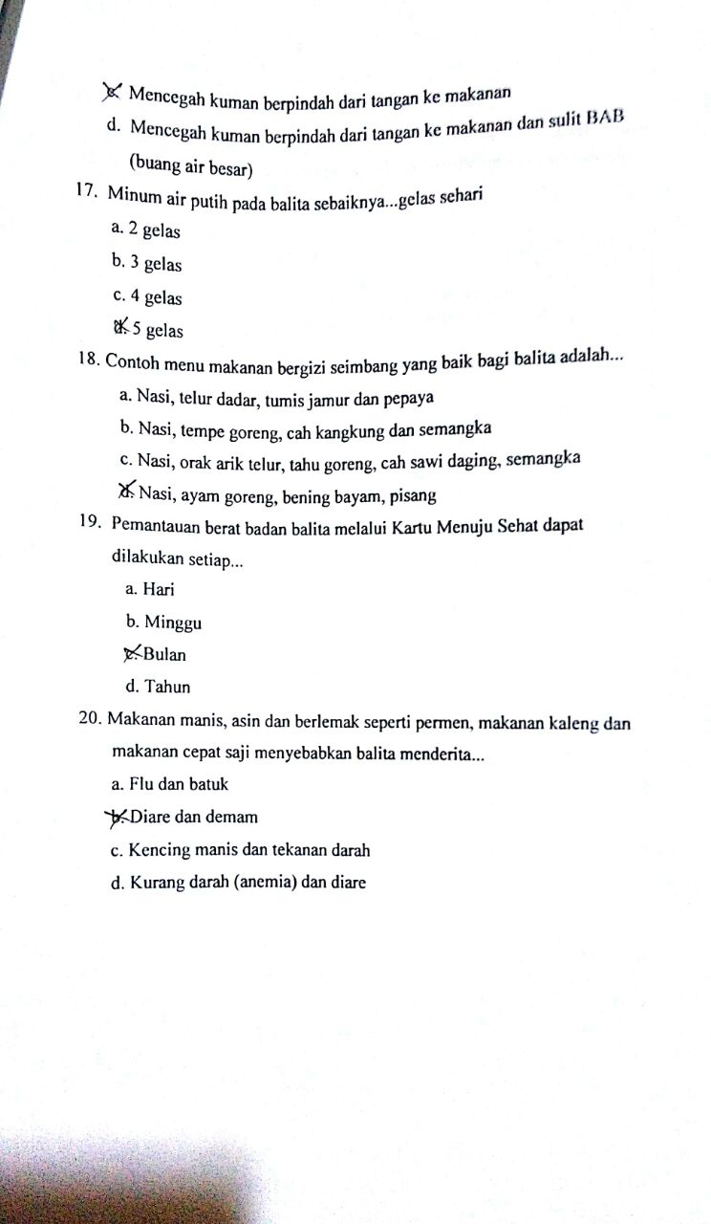

Lampiran 19. Kuesioner Sikap

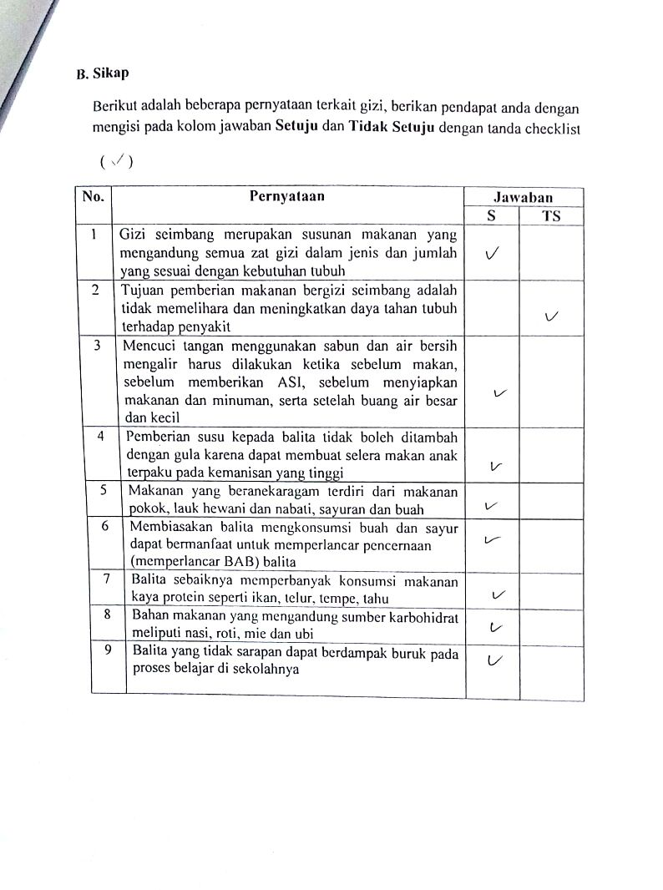

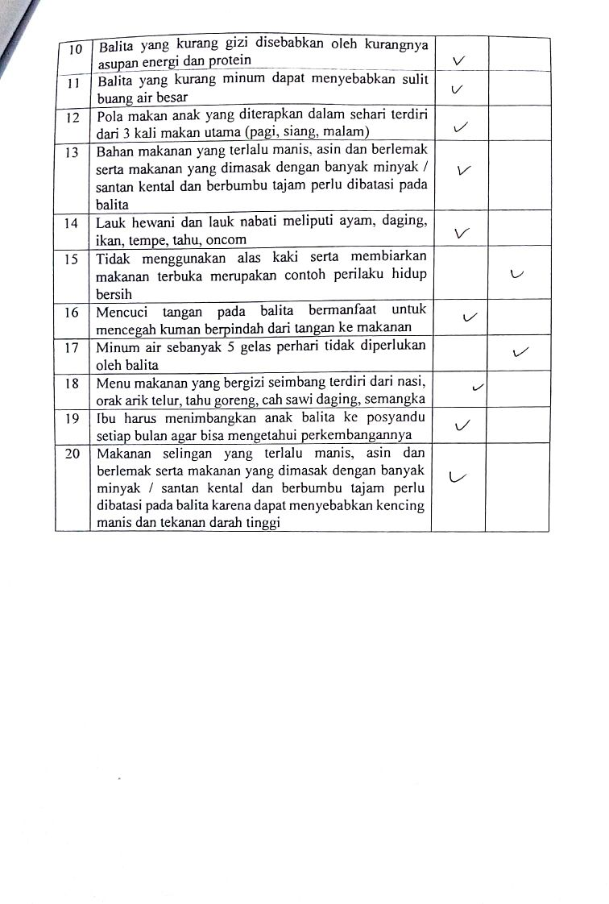

Lampiran 20. Formulir Frekuensi Makanan

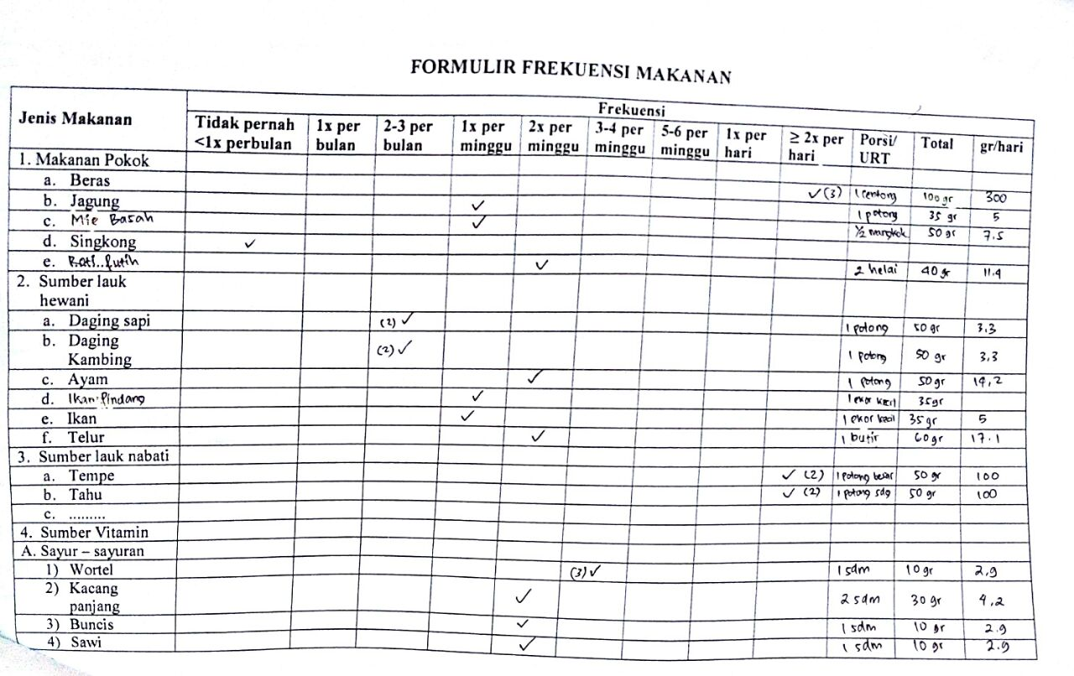

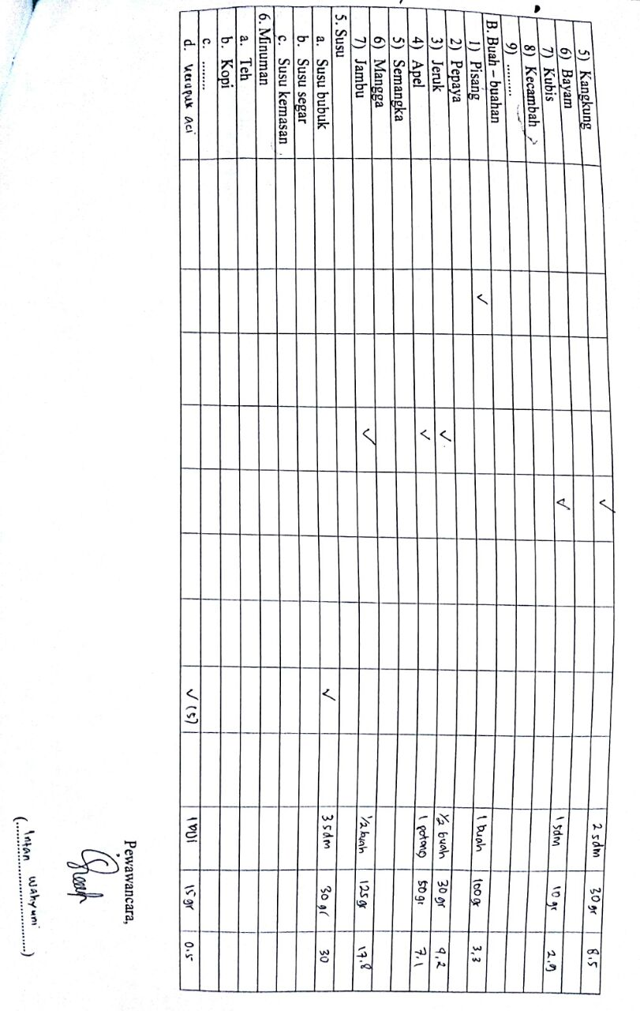

Lampiran 21. Booklet Pedoman Gizi Seimbang Balita



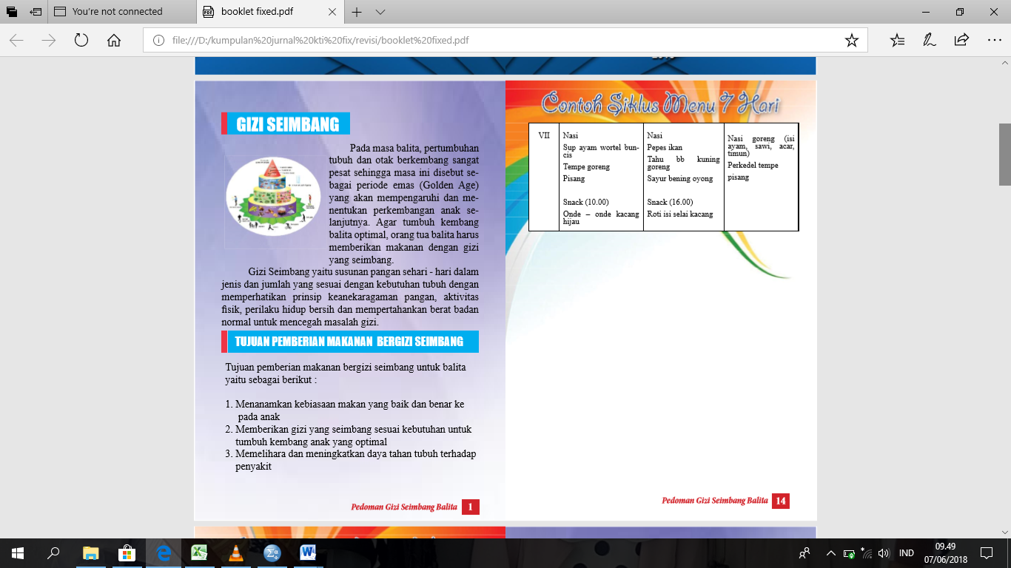

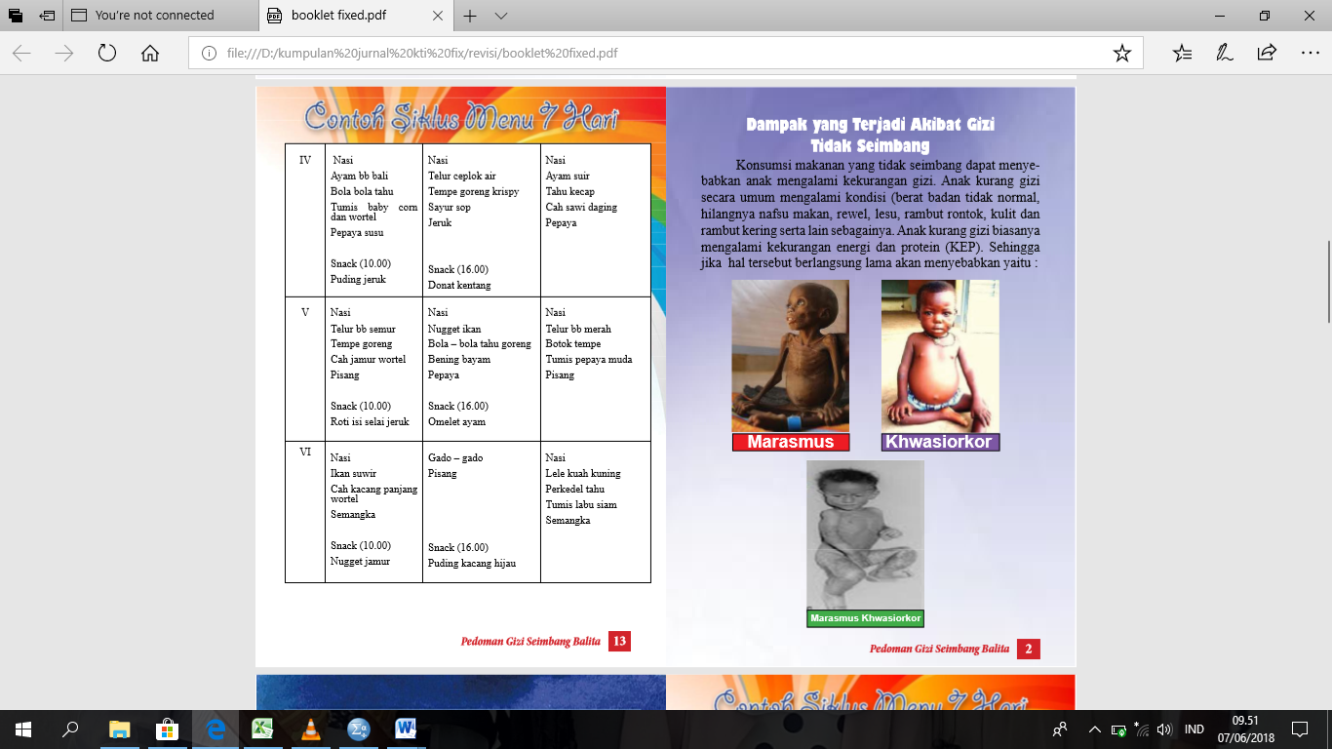



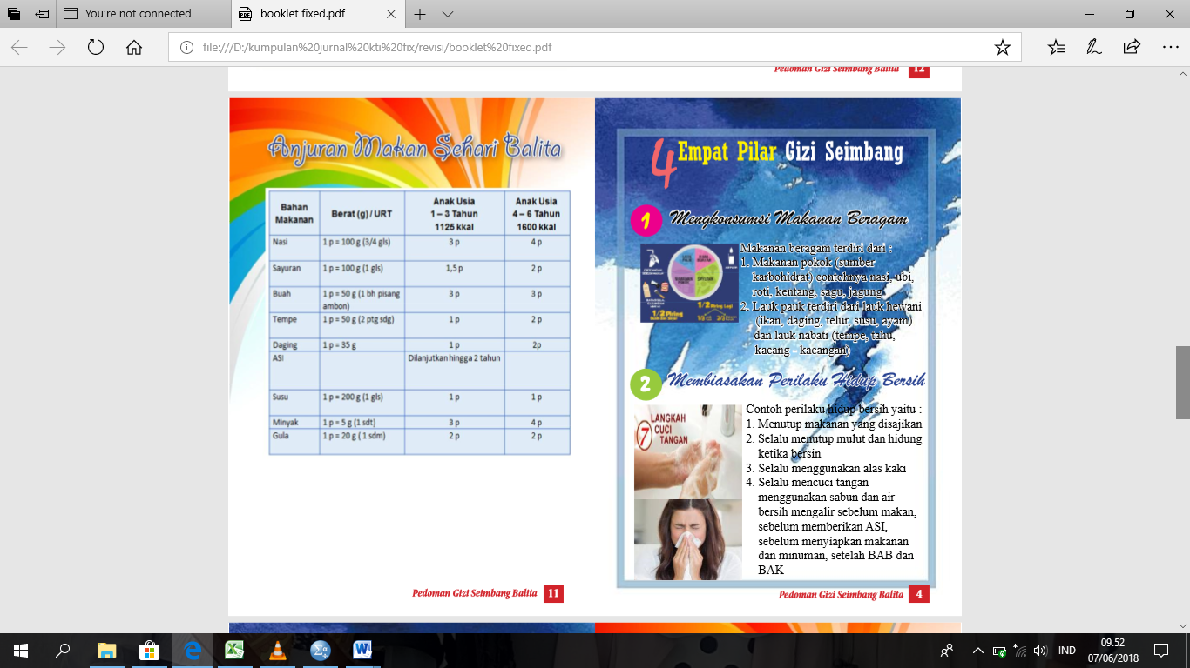

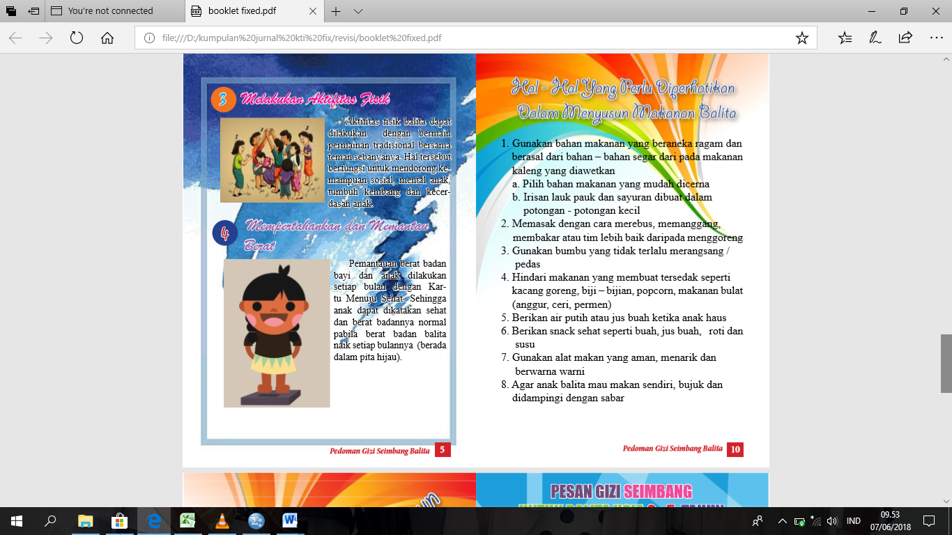

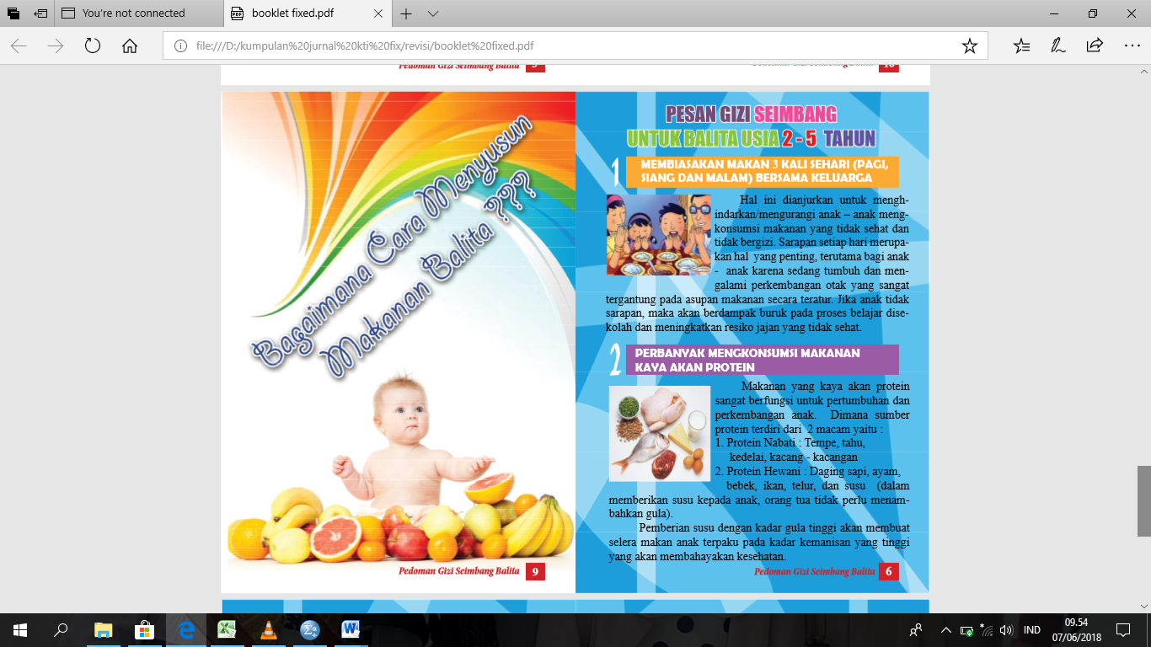

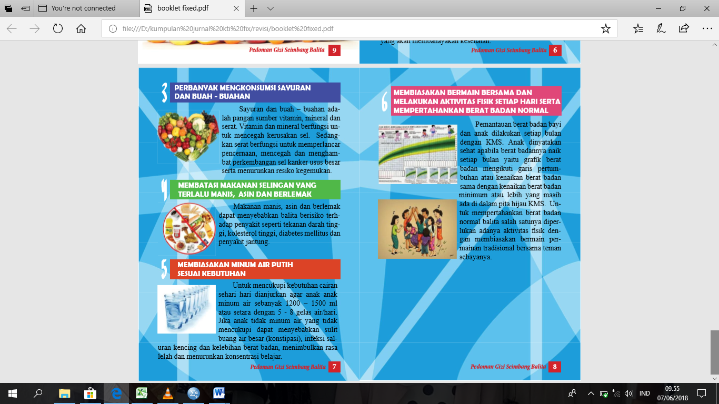

Lampiran 22. Dokumentasi

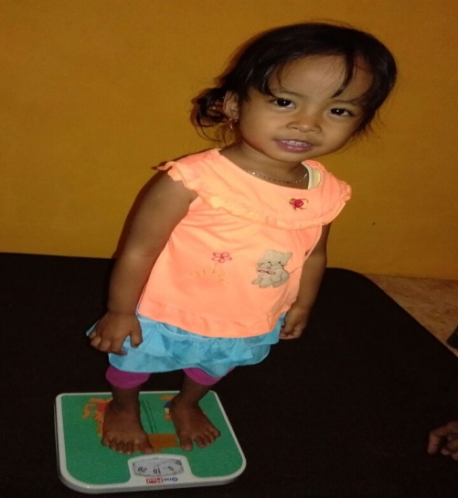 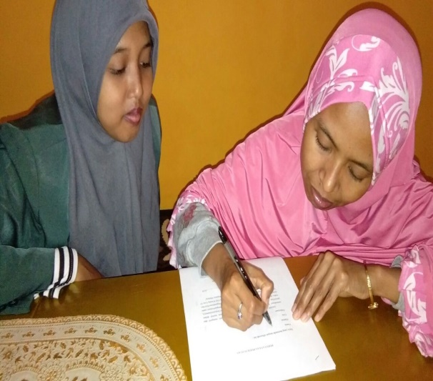 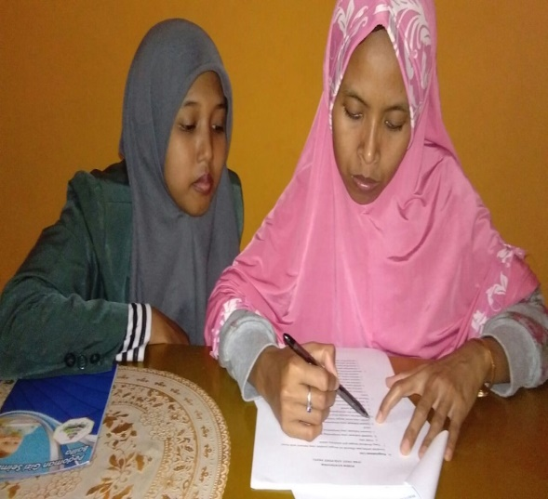

Penimbangan Berat Badan Balita Pengisian Lembar Persetujuan Pengisian Kuesioner Pengetahuan

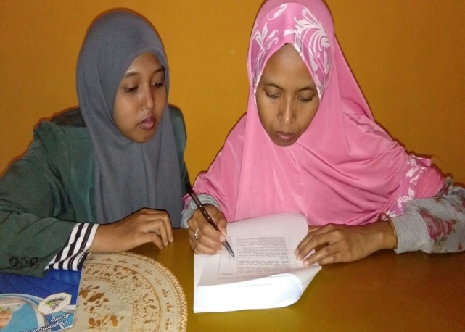 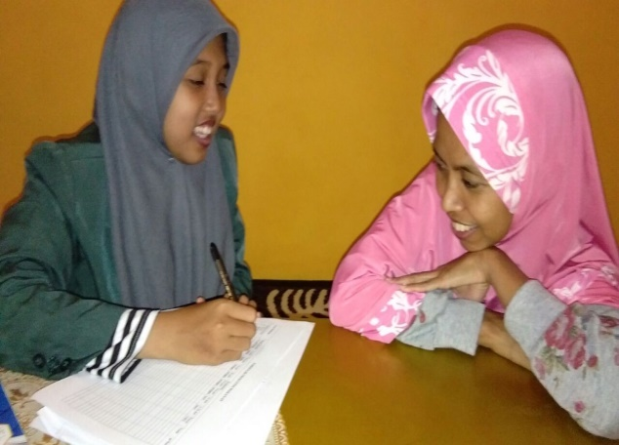 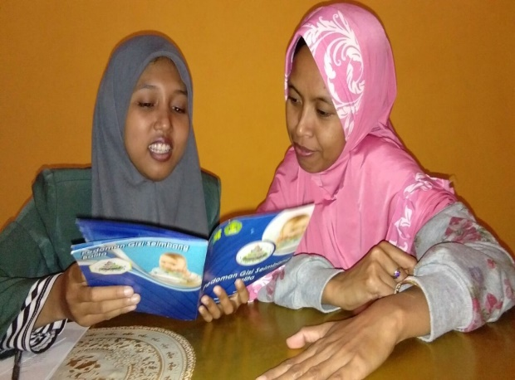

Konseling Gizi Menggunakan Media Booklet

Pengisian Kuesioner Sikap

Wawancara Pola Makan Balita