LAMPIRAN-LAMPIRAN
Lampiran 1. Perhitungan Nilai Energi dan Nilai Gizi per Resep Crackers Substitusi Tepung Ikan Gabus.
P0
BAHAN | jumlah | energi | protein | KH | lemak
tepung terigu | 500 | 1665 | 45 | 386 | 5
tepung ikan gabus | 0 | 0 | 0 | 0 | 0
gula halus | 5 | 19.7 | 0 | 4.7 | 0
margarin | 96 | 691.2 | 0.576 | 0.384 | 77.76
mentega | 64 | 474.88 | 0.32 | 0.896 | 52.224
susu skim | 20 | 71.8 | 7.12 | 10.4 | 0.2
jumlah |  | 2922.58 | 53.016 | 402.38 | 135.184

P1
BAHAN | jumlah | energi | protein | KH | lemak
tepung terigu | 475 | 1581.75 | 42.75 | 366.7 | 4.75
tepung ikan gabus | 25 | 92.655 | 19.8375 | 0.2325 | 1.375
gula halus | 5 | 19.7 | 0 | 4.7 | 0
margarin | 96 | 691.2 | 0.576 | 0.384 | 77.76
mentega | 64 | 474.88 | 0.32 | 0.896 | 52.224
susu skim | 20 | 71.8 | 7.12 | 10.4 | 0.2
jumlah |  | 2931.985 | 70.6035 | 383.3125 | 136.309

P2
BAHAN | jumlah | energi | protein | KH | lemak
tepung terigu | 450 | 1498.5 | 40.5 | 347.4 | 4.5
tepung ikan gabus | 50 | 185.31 | 39.675 | 0.465 | 2.75
gula halus | 5 | 19.7 | 0 | 4.7 | 0
margarin | 96 | 691.2 | 0.576 | 0.384 | 77.76
mentega | 64 | 474.88 | 0.32 | 0.896 | 52.224
susu skim | 20 | 71.8 | 7.12 | 10.4 | 0.2
jumlah |  | 2941.39 | 88.191 | 364.245 | 137.434

P3
BAHAN | jumlah | energi | protein | KH | lemak
tepung terigu | 425 | 1415.25 | 38.25 | 328.1 | 4.25
tepung ikan gabus | 75 | 277.965 | 59.5125 | 0.6975 | 4.125
gula halus | 5 | 19.7 | 0 | 4.7 | 0
margarin | 96 | 691.2 | 0.576 | 0.384 | 77.76
mentega | 64 | 474.88 | 0.32 | 0.896 | 52.224
susu skim | 20 | 71.8 | 7.12 | 10.4 | 0.2
jumlah |  | 2950.795 | 105.7785 | 345.1775 | 138.559

Daftar komposisi Bahan Makanan
BAHAN | energi | protein | KH | lemak
tepung terigu | 333 | 9 | 77.2 | 1
tepung ikan gabus | 370.62 | 79.35 | 0.93 | 5.5
gula halus | 394 | 0 | 94 | 0
margarin | 720 | 0.6 | 0.4 | 81
mentega | 742 | 0.5 | 1.4 | 81.6
susu skim | 359 | 35.6 | 52 | 1
Sumber : Tabel Komposisi Pangan Indonesia (TKPI) PERSAGI, 2009

Crackers per 100 gram
taraf perlakuan | energi | protein | kadar lemak | KH
P0 | 521.88 | 9,46 | 24.14 | 71.85
p1 | 523.56 | 12.60 | 24.34 | 68.44
p2 | 525.24 | 15.74 | 24.54 | 65.04
p3 | 526.92 | 18.88 | 24.74 | 61.63

Lampiran 2. Komposisi Bahan Penyusun Crackers per Unit Penelitian (Gram)

Bahan | Taraf Perlakuan  (Tepung Terigu : Tepung Ikan gabus)
Bahan | P₀  (100:0) | P₁  (95:5) | P₂  (90:10) | P₃  (85:15)
Tepung terigu | 500 | 475 | 450 | 425
Tepung ikan gabus | 0 | 25 | 50 | 75
Gula halus | 5 | 5 | 5 | 5
Margarin | 96 | 96 | 96 | 96
Mentega | 64 | 64 | 64 | 64
Susu bubuk (skim) | 20 | 20 | 20 | 20
Garam halus | 1 | 1 | 1 | 1
Ragi | 5 | 5 | 5 | 5
Baking powder | 1 | 1 | 1 | 1
Air | 250 | 250 | 250 | 250
Dust filling :  - Tepung terigu  - Garam  - Baking powder | 50  0,5  0,5 | 50  0,5  0,5 | 50  0,5  0,5 | 50  0,5  0,5
Lampiran 3 : Langkah Randomisasi dalam Penempatan Unit Penelitian

Langkah Randomisasi dalam Penempatan Unit Penelitian adalah sebagai berikut
- Memberi nomor urut pada semua unit penelitian, yaitu 1 – 12
- Mengambil bilangan random dari kalkulator menggunakan digit sebanyak jumlah unit penelitian sebagaimana disajikan pada Gambar 1.
- Memberi ranking pada bilangan random yang diperoleh (Gambar 1).
1  232  4 | 2  694  10 | 3  508  7
4  521  8 | 5  933  12 | 6  104  1
7  455  6 | 8  528  9 | 9  282  5
10  113  2 | 11  178  3 | 12  702  11
Keterangan :
Baris pertama : Nomor urut (Penempatan Unit Penelitian sebelum Randomisasi)
Baris kedua : Bilangan Random
Baris Ketiga : Ranking (Penempatan Unit Penelitian setelah Randomisasi)

Gambar x Nomor urut, Bilangan Random, dan Ranking

- Dengan menggunakan prinsip permutasi sederhana, maka nomor ranking dapat dianggap mewakili nomor urut sesuai dengan jumlah unit penelitian. Dengan demikian taraf perlakuan P0 akan diulang 3 kali dan ditempatkan pada unit penelitian nomor 4, 10, dan 7. Taraf perlakuan P₁ akan diulang 3 kali dan ditempatkan pada unit penelitian nomor 8, 12, dan 1. Taraf perlakuan P₂ akan diulang 3 kali dan ditempatkan pada unit penelitian 6, 9, dan 5. Taraf perlakuan P₃ akan diulang 3 kali dan ditempatkan pada unit penelitian 2, 3, dan 11.
- Memasukkan unit penelitian dalam lay out.
Urutan 1 ditempati oleh unit penelitian X₂₃, urutan 2 ditempati oleh unit penelitian X₄₁, urutan 3 ditempati oleh unit penelitian X₄₂, dan seterusnya sampai urutan 12 ditempati unit penelitian X₂₂ seperti yang disajikan pada Gambar Lampiran 1.

1  X₂₃ | 2  X₄₁ | 3  X₄₂
4  X₁₁ | 5  X₃₃ | 6  X₃₁
7  X₁₃ | 8  X₂₁ | 9  X₃₂
10  X₂₁ | 11  X₄₃ | 12  X₂₂
Keterangan:
1 – 12 : Nomor Urut (Penempatan Unit Penelitian setelah Randomisasi)
X₁₁ - X₄₃ : Unit Penelitian

Gambar x Lay Out Penelitian dengan Desain RAL (Kristianto, Y.,2005)

Lampiran 4. Formulir Uji Skala Kesukaan Crackers
Formulir Uji Skala Kesukaan (Hedonic Scale Test)
Nama Panelis :
Tanggal :
Contoh : “Crackers”
Instruksi : Dihadapan Saudara disajikan 4 macam buah “Crackers”. Saudara diminta untuk memberikan penilaian terhadap tekstur, aroma, warna,dan rasa dengan menggunakan skala penilaian sebagai berikut :
4 = Sangat Suka
3 = Suka
2 = Tidak Suka
1 = Sangat Tidak Suka
Setelah saudara mencicipi salah satu sampel saudara diminta berkumur dengan air putih yang telah disediakan sebelum mencicipi sampel yang lain. Selain itu saudara juga diminta memberikan kritik dan saran.
Kode Sampel | Kriteria Penilaian
Kode Sampel | Warna | Aroma | Rasa | Tekstur
Kritik dan Saran:
…………………………………………………………………………………………………………………………………………

Terima Kasih Atas Partisipasinya
Lampiran 5. Formulir Penentuan Taraf Perlakuan Terbaik Crackers
PENENTUAN TARAF PERLAKUAN TERBAIK

Nama :
Produk : Substitusi Tepung Ikan Gabus Terhadap Kadar dan Mutu Gizi serta Mutu Organoleptik Crackers Bagi Balita Gizi Kurang
Petunjuk :
Bapak/Ibu/Saudara dimohon untuk mengemukakan pendapat tentang urutan (ranking) pentingnya variabel berikut terhadap mutu produk Crackers subtitusi tepung ikan gabus, dengan mengurutkan 12 variabel dari tertinggi ke terendah dengan mencantumkan angka 1 – 12. Angka terendah untuk variabel kurang penting dan angka tertinggi untuk variabel terpenting. Pemberian nilai boleh sama apabila dirasa variabel yang dinilai sama pentingnya.
Variabel | Ranking
Nilai Energi
Kadar Karbohidrat
Kadar Protein
Kadar Lemak
Kadar Air
Kadar Abu
Daya Patah
Daya Serap Air
Aroma
Warna
Rasa
Tekstur

Terimakasih atas partisipanya ☺
Lampiran 6. Hasil Uji Statistik Oneway Anova Nilai Energi Crackers
Tabel Lampiran 6. Rata-rata Nilai Energi Crackers tiap Taraf Perlakuan
taraf perlakuan | 1 | 2 | 3 | total | rata-rata
P0 | 378.85 | 378.9 | 379.58 | 1137.33 | 379.11
p1 | 399.42 | 397.33 | 396.52 | 1193.27 | 397.7567
p2 | 401.42 | 399.8 | 400.88 | 1202.1 | 400.7
p3 | 389.32 | 389.13 | 385.1 | 1163.55 | 387.85

Tabel Lampiran 6. Deskripsi Nilai Energi Crackers tiap Taraf Perlakuan
Taraf Perlakuan | N | Mean | Std. Deviation | Std. Error | 95% Confidence Interval for Mean |  | Minimum | Maximum
 |  |  |  |  | Lower Bound | Upper Bound | Minimum | Maximum
P0 | 3 | 3.7911E2 | .40780 | .23544 | 378.0970 | 380.1230 | 378.85 | 379.58
p1 | 3 | 3.9776E2 | 1.49634 | .86391 | 394.0396 | 401.4738 | 396.52 | 399.42
p2 | 3 | 4.0070E2 | .82486 | .47624 | 398.6509 | 402.7491 | 399.80 | 401.42
p3 | 2 | 3.8922E2 | .13435 | .09500 | 388.0179 | 390.4321 | 389.13 | 389.32
Total | 11 | 3.9192E2 | 9.20038 | 2.77402 | 385.7418 | 398.1036 | 378.85 | 401.42

Tabel Lampiran 6. Hasil Analisis Nilai Energi Crackers tiap Taraf Perlakuan dengan OnewayAnova pada tingkat kepercayaan 95%
 | Sum of Squares | df | Mean Square | F | Sig.
Between Groups | 840.280 | 3 | 280.093 | 316.770 | .000
Within Groups | 6.190 | 7 | .884
Total | 846.469 | 10

Hasil Analisis Duncan
taraf_perlakuan | N | Subset for alpha = 0.05
taraf_perlakuan | N | 1 | 2 | 3 | 4
P0 | 3 | 3.7911E2
p3 | 2 |  | 3.8922E2
p1 | 3 |  |  | 3.9776E2
p2 | 3 |  |  |  | 4.0070E2
Sig. |  | 1.000 | 1.000 | 1.000 | 1.000
Means for groups in homogeneous subsets are displayed.

Lampiran 7. Hasil Uji Statistik Oneway Anova Kadar Air Crackers
Tabel Lampiran 7. Rata-rata Kadar Air Crackers tiap Taraf Perlakuan
taraf perlakuan | 1 | 2 | 3 | total | rata-rata
P0 | 4.32 | 4.25 | 4.2 | 12.77 | 4.256667
p1 | 2.68 | 2.7 | 2.81 | 8.19 | 2.73
p2 | 3.52 | 3.71 | 3.08 | 10.31 | 3.436667
p3 | 3.6 | 3.65 | 3.48 | 10.73 | 3.576667

Tabel Lampiran 7. Deskripsi Kadar Air Crackers tiap Taraf Perlakuan
Taraf perlakuan | N | Mean | Std. Deviation | Std. Error | 95% Confidence Interval for Mean |  | Minimum | Maximum
 |  |  |  |  | Lower Bound | Upper Bound | Minimum | Maximum
P0 | 3 | 4.2567 | .06028 | .03480 | 4.1069 | 4.4064 | 4.20 | 4.32
p1 | 3 | 2.7300 | .07000 | .04041 | 2.5561 | 2.9039 | 2.68 | 2.81
p2 | 3 | 3.4367 | .32316 | .18658 | 2.6339 | 4.2394 | 3.08 | 3.71
p3 | 3 | 3.5767 | .08737 | .05044 | 3.3596 | 3.7937 | 3.48 | 3.65
Total | 12 | 3.5000 | .58521 | .16894 | 3.1282 | 3.8718 | 2.68 | 4.32

Tabel Lampiran 7. Hasil Analisis Kadar Air Crackers tiap Taraf Perlakuan dengan Oneway Anova pada tingkat kepercayaan 95%
 | Sum of Squares | df | Mean Square | F | Sig.
Between Groups | 3.526 | 3 | 1.175 | 38.983 | .000
Within Groups | .241 | 8 | .030
Total | 3.767 | 11

HasilAnalisis Duncan
taraf_perlakuan | N | Subset for alpha = 0.05
taraf_perlakuan | N | 1 | 2 | 3
p1 | 3 | 2.7300
p2 | 3 |  | 3.4367
p3 | 3 |  | 3.5767
P0 | 3 |  |  | 4.2567
Sig. |  | 1.000 | .352 | 1.000
Means for groups in homogeneous subsets are displayed.
Lampiran 8. Hasil Uji Statistik Oneway Anova Kadar Abu Crackers
Tabel Lampiran 8. Rata-rata Kadar Abu Crackers tiap Taraf Perlakuan
taraf perlakuan | 1 | 2 | 3 | total | rata-rata
P0 | 2.98 | 2.9 | 3.05 | 8.93 | 2.976667
p1 | 3.12 | 3.02 | 3.15 | 9.29 | 3.096667
p2 | 3.1 | 3.08 | 3.13 | 9.31 | 3.103333
p3 | 3.09 | 3.15 | 3.2 | 9.44 | 3.146667

Tabel Lampiran 8. Deskripsi Kadar Abu Crackers tiap Taraf Perlakuan
Taraf perlakuan | N | Mean | Std. Deviation | Std. Error | 95% Confidence Interval for Mean |  | Minimum | Maximum
 |  |  |  |  | Lower Bound | Upper Bound | Minimum | Maximum
P0 | 3 | 2.9767 | .07506 | .04333 | 2.7902 | 3.1631 | 2.90 | 3.05
p1 | 3 | 3.0967 | .06807 | .03930 | 2.9276 | 3.2658 | 3.02 | 3.15
p2 | 3 | 3.1033 | .02517 | .01453 | 3.0408 | 3.1658 | 3.08 | 3.13
p3 | 3 | 3.1467 | .05508 | .03180 | 3.0099 | 3.2835 | 3.09 | 3.20
Total | 12 | 3.0808 | .08295 | .02395 | 3.0281 | 3.1335 | 2.90 | 3.20

Tabel Lampiran 8. Hasil Analisis Kadar Abu Crackers tiap Taraf Perlakuan dengan Oneway Anova pada tingkat kepercayaan 95%
 | Sum of Squares | df | Mean Square | F | Sig.
Between Groups | .048 | 3 | .016 | 4.577 | .038
Within Groups | .028 | 8 | .003
Total | .076 | 11

Hasil Analisis Duncan
taraf_perlakuan | N | Subset for alpha = 0.05
taraf_perlakuan | N | 1 | 2
P0 | 3 | 2.9767
p1 | 3 |  | 3.0967
p2 | 3 |  | 3.1033
p3 | 3 |  | 3.1467
Sig. |  | 1.000 | .349
Means for groups in homogeneous subsets are displayed.
Lampiran 9. Hasil Uji Statistik Oneway Anova Kadar Protein Crackers
Tabel Lampiran 9. Rata-rata Kadar Protein Crackers tiap Taraf Perlakuan
taraf perlakuan | 1 | 2 | 3 | total | rata-rata
P0 | 5.08 | 5.14 | 5.13 | 15.35 | 5.116667
p1 | 8.05 | 8.18 | 8.09 | 24.32 | 8.106667
p2 | 11.34 | 11.58 | 11.29 | 34.21 | 11.40333
p3 | 12.61 | 12.82 | 13.01 | 38.44 | 12.81333

Tabel Lampiran 9. Deskripsi Kadar Protein Crackers tiap Taraf Perlakuan
Taraf Perlakuan | N | Mean | Std. Deviation | Std. Error | 95% Confidence Interval for Mean |  | Minimum | Maximum
 |  |  |  |  | Lower Bound | Upper Bound | Minimum | Maximum
P0 | 3 | 5.1167 | .03215 | .01856 | 5.0368 | 5.1965 | 5.08 | 5.14
p1 | 3 | 8.1067 | .06658 | .03844 | 7.9413 | 8.2721 | 8.05 | 8.18
p2 | 3 | 11.4033 | .15503 | .08950 | 11.0182 | 11.7884 | 11.29 | 11.58
p3 | 3 | 12.8133 | .20008 | .11552 | 12.3163 | 13.3104 | 12.61 | 13.01
Total | 12 | 9.3600 | 3.12135 | .90106 | 7.3768 | 11.3432 | 5.08 | 13.01

Tabel Lampiran 9. Hasil Analisis Kadar Protein Crackers tiap Taraf Perlakuan dengan Oneway Anova pada tingkat kepercayaan 95%
 | Sum of Squares | df | Mean Square | F | Sig.
Between Groups | 107.032 | 3 | 35.677 | 2.052E3 | .000
Within Groups | .139 | 8 | .017
Total | 107.171 | 11

Hasil Analisis Duncan
taraf_perlakuan | N | Subset for alpha = 0.05
taraf_perlakuan | N | 1 | 2 | 3 | 4
P0 | 3 | 5.1167
p1 | 3 |  | 8.1067
p2 | 3 |  |  | 11.4033
p3 | 3 |  |  |  | 12.8133
Sig. |  | 1.000 | 1.000 | 1.000 | 1.000
Means for groups in homogeneous subsets are displayed.

Lampiran 10. Hasil Uji Statistik Oneway Anova Kadar Lemak Crackers
Tabel Lampiran 10. Rata-rata Kadar Lemak Crackers tiap Taraf Perlakuan
taraf perlakuan | 1 | 2 | 3 | total | rata-rata
P0 | 3.81 | 3.78 | 3.9 | 11.49 | 3.83
p1 | 4.98 | 5.01 | 4.88 | 14.87 | 4.956667
p2 | 5.74 | 5.36 | 5.28 | 16.38 | 5.46
p3 | 5.88 | 5.69 | 5.62 | 17.19 | 5.73

Tabel Lampiran 10. Deskripsi Kadar Lemak Crackers tiap Taraf Perlakuan
Taraf Perlakuan | N | Mean | Std. Deviation | Std. Error | 95% Confidence Interval for Mean |  | Minimum | Maximum
 |  |  |  |  | Lower Bound | Upper Bound | Minimum | Maximum
P0 | 3 | 3.8300 | .06245 | .03606 | 3.6749 | 3.9851 | 3.78 | 3.90
p1 | 3 | 4.9567 | .06807 | .03930 | 4.7876 | 5.1258 | 4.88 | 5.01
p2 | 3 | 5.4600 | .24576 | .14189 | 4.8495 | 6.0705 | 5.28 | 5.74
p3 | 3 | 8.1933 | 4.17244 | 2.40896 | -2.1716 | 18.5582 | 5.69 | 13.01
Total | 12 | 5.6100 | 2.44634 | .70620 | 4.0557 | 7.1643 | 3.78 | 13.01

Tabel Lampiran 10. Hasil Analisis Kadar Lemak Crackers tiap Taraf Perlakuan dengan Oneway Anova pada tingkat kepercayaan 95%
 | Sum of Squares | df | Mean Square | F | Sig.
Between Groups | 30.874 | 3 | 10.291 | 2.355 | .148
Within Groups | 34.956 | 8 | 4.370
Total | 65.830 | 11

Hasil analisis Duncan
taraf_perlakuan | N | Subset for alpha = 0.05
taraf_perlakuan | N | 1 | 2
P0 | 3 | 3.8300
p1 | 3 | 4.9567 | 4.9567
p2 | 3 | 5.4600 | 5.4600
p3 | 3 |  | 8.1933
Sig. |  | .386 | .106
Means for groups in homogeneous subsets are displayed.
Lampiran 11. Hasil Uji Statistik Oneway Anova Karbohidrat Crackers
Tabel Lampiran 11. Rata-rata Kadar karbohidrat Crackers tiap Taraf Perlakuan
taraf perlakuan | 1 | 2 | 3 | total | rata-rata
P0 | 81.06 | 81.08 | 80.99 | 243.13 | 81.04333
p1 | 80.6 | 79.88 | 80.06 | 240.54 | 80.18
p2 | 76.1 | 76.31 | 77.05 | 229.46 | 76.48667
p3 | 71.49 | 71.66 | 70.62 | 213.77 | 71.25667

Tabel Lampiran 11. Deskripsi Kadar Karbohidrat Crackers tiap Taraf Perlakuan
Taraf perlakuan | N | Mean | Std. Deviation | Std. Error | 95% Confidence Interval for Mean |  | Minimum | Maximum
 |  |  |  |  | Lower Bound | Upper Bound | Minimum | Maximum
P0 | 3 | 81.0433 | .04726 | .02728 | 80.9259 | 81.1607 | 80.99 | 81.08
p1 | 3 | 80.1800 | .37470 | .21633 | 79.2492 | 81.1108 | 79.88 | 80.60
p2 | 3 | 76.4867 | .49903 | .28812 | 75.2470 | 77.7263 | 76.10 | 77.05
p3 | 2 | 71.5750 | .12021 | .08500 | 70.4950 | 72.6550 | 71.49 | 71.66
Total | 11 | 77.8436 | 3.63323 | 1.09546 | 75.4028 | 80.2845 | 71.49 | 81.08

Tabel Lampiran 11. Hasil Analisis Kadar Karbohidrat Crackers tiap Taraf Perlakuan dengan Oneway Anova pada tingkat kepercayaan 95%
 | Sum of Squares | df | Mean Square | F | Sig.
Between Groups | 131.206 | 3 | 43.735 | 383.747 | .000
Within Groups | .798 | 7 | .114
Total | 132.003 | 10

Hasil Analisis Duncan
taraf_perlakuan | N | Subset for alpha = 0.05
taraf_perlakuan | N | 1 | 2 | 3 | 4
p3 | 2 | 71.5750
p2 | 3 |  | 76.4867
p1 | 3 |  |  | 80.1800
P0 | 3 |  |  |  | 81.0433
Sig. |  | 1.000 | 1.000 | 1.000 | 1.000
Means for groups in homogeneous subsets are displayed.

Lampiran 12. Hasil Uji Statistik Oneway Anova Daya Patah Crackers
Tabel Lampiran 12. Rata-rata Daya Patah Crackers tiap Taraf Perlakuan
taraf perlakuan | 1 | 2 | 3 | total | rata-rata
p0 | 18.65 | 18.2 | 17.9 | 54.75 | 18.25
p1 | 16.08 | 16.11 | 16.15 | 48.34 | 16.11333
p2 | 15.4 | 15.81 | 15.36 | 46.57 | 15.52333
p3 | 14.98 | 15.22 | 15.08 | 45.28 | 15.09333

Tabel Lampiran 12. Deskripsi Daya Patah Crackers tiap Taraf Perlakuan
Taraf Perlakuan | N | Mean | Std. Deviation | Std. Error | 95% Confidence Interval for Mean |  | Minimum | Maximum
 |  |  |  |  | Lower Bound | Upper Bound | Minimum | Maximum
p0 | 3 | 18.2500 | .37749 | .21794 | 17.3123 | 19.1877 | 17.90 | 18.65
p1 | 3 | 16.1133 | .03512 | .02028 | 16.0261 | 16.2006 | 16.08 | 16.15
p2 | 3 | 15.5233 | .24906 | .14380 | 14.9046 | 16.1420 | 15.36 | 15.81
p3 | 3 | 15.0933 | .12055 | .06960 | 14.7939 | 15.3928 | 14.98 | 15.22
Total | 12 | 16.2450 | 1.28254 | .37024 | 15.4301 | 17.0599 | 14.98 | 18.65

Tabel Lampiran 12. Hasil Analisis Daya Patah Crackers tiap Taraf Perlakuan dengan Oneway Anova pada tingkat kepercayaan 95%
 | Sum of Squares | df | Mean Square | F | Sig.
Between Groups | 17.653 | 3 | 5.884 | 106.845 | .000
Within Groups | .441 | 8 | .055
Total | 18.094 | 11

Hasil Analisis Duncan
taraf_perlakuan | N | Subset for alpha = 0.05
taraf_perlakuan | N | 1 | 2 | 3
p3 | 3 | 15.0933
p2 | 3 | 15.5233
p1 | 3 |  | 16.1133
p0 | 3 |  |  | 18.2500
Sig. |  | .055 | 1.000 | 1.000
Means for groups in homogeneous subsets are displayed.
Lampiran 13. Hasil Uji Statistik Oneway Anova Daya Serap Air Crackers
Tabel Lampiran 13. Rata-rata Daya Serap Air Crackers tiap Taraf Perlakuan
taraf perlakuan | 1 | 2 | 3 | total | rata-rata
p0 | 38.6 | 38.82 | 39.14 | 116.56 | 38.85333
p1 | 26.2 | 25.9 | 24.99 | 77.09 | 25.69667
p2 | 21.42 | 22.05 | 21.56 | 65.03 | 21.67667
p3 | 19.22 | 20.05 | 20.21 | 59.48 | 19.82667

Tabel Lampiran 13. Deskripsi Daya Serap Air Crackers tiap Taraf Perlakuan
Taraf Perlakuan | N | Mean | Std. Deviation | Std. Error | 95% Confidence Interval for Mean |  | Minimum | Maximum
 |  |  |  |  | Lower Bound | Upper Bound | Minimum | Maximum
p0 | 3 | 38.8533 | .27154 | .15677 | 38.1788 | 39.5279 | 38.60 | 39.14
p1 | 3 | 25.6967 | .63011 | .36379 | 24.1314 | 27.2619 | 24.99 | 26.20
p2 | 3 | 21.6767 | .33081 | .19099 | 20.8549 | 22.4984 | 21.42 | 22.05
p3 | 2 | 19.6350 | .58690 | .41500 | 14.3619 | 24.9081 | 19.22 | 20.05
Total | 11 | 27.0864 | 7.88368 | 2.37702 | 21.7900 | 32.3827 | 19.22 | 39.14

Tabel Lampiran 13. Hasil Analisis Daya Serap Air Crackers tiap Taraf Perlakuan dengan Oneway Anova pada tingkat kepercayaan 95%
 | Sum of Squares | df | Mean Square | F | Sig.
Between Groups | 620.019 | 3 | 206.673 | 961.365 | .000
Within Groups | 1.505 | 7 | .215
Total | 621.523 | 10
Hasil Analisis Duncan
taraf_perlakuan | N | Subset for alpha = 0.05
taraf_perlakuan | N | 1 | 2 | 3 | 4
p3 | 2 | 19.6350
p2 | 3 |  | 21.6767
p1 | 3 |  |  | 25.6967
p0 | 3 |  |  |  | 38.8533
Sig. |  | 1.000 | 1.000 | 1.000 | 1.000
Means for groups in homogeneous subsets are displayed.

Lampiran 14. Hasil Skor Tingkat Kesukaan Crackers
panelis | taraf perlakuan tekstur |  |  |  | taraf perlakuan aroma |  |  |  | taraf perlakuan warna |  |  |  | taraf perlakuan rasa
panelis | p0 | p1 | p2 | p3 | p0 | p1 | p2 | p3 | p0 | p1 | p2 | p3 | p0 | p1 | p2 | p3
1 | 3 | 4 | 2 | 2 | 3 | 3 | 3 | 3 | 3 | 3 | 3 | 2 | 2 | 4 | 2 | 2
2 | 3 | 3 | 3 | 2 | 4 | 3 | 3 | 2 | 4 | 4 | 3 | 2 | 3 | 3 | 3 | 2
3 | 3 | 2 | 2 | 2 | 3 | 3 | 3 | 2 | 3 | 3 | 4 | 3 | 3 | 3 | 2 | 2
4 | 4 | 3 | 3 | 3 | 3 | 3 | 3 | 3 | 3 | 3 | 3 | 2 | 3 | 3 | 2 | 1
5 | 4 | 4 | 4 | 4 | 4 | 4 | 4 | 3 | 4 | 4 | 3 | 3 | 4 | 2 | 3 | 4
6 | 3 | 4 | 4 | 4 | 3 | 3 | 2 | 3 | 4 | 4 | 4 | 4 | 3 | 4 | 2 | 4
7 | 2 | 3 | 4 | 3 | 2 | 3 | 4 | 3 | 4 | 3 | 3 | 2 | 3 | 2 | 3 | 3
8 | 3 | 3 | 2 | 4 | 3 | 3 | 2 | 4 | 4 | 4 | 3 | 4 | 4 | 3 | 2 | 4
9 | 4 | 3 | 3 | 3 | 4 | 4 | 3 | 2 | 4 | 4 | 3 | 3 | 4 | 2 | 3 | 2
10 | 4 | 4 | 3 | 3 | 4 | 4 | 3 | 2 | 4 | 4 | 3 | 3 | 4 | 3 | 3 | 2
11 | 3 | 2 | 4 | 4 | 4 | 3 | 3 | 3 | 4 | 3 | 4 | 3 | 3 | 3 | 4 | 4
12 | 3 | 3 | 3 | 3 | 4 | 2 | 2 | 3 | 4 | 3 | 3 | 3 | 3 | 3 | 2 | 2
13 | 4 | 3 | 2 | 2 | 4 | 3 | 3 | 3 | 3 | 3 | 3 | 3 | 4 | 3 | 2 | 2
14 | 3 | 3 | 3 | 4 | 3 | 2 | 3 | 2 | 2 | 3 | 3 | 2 | 3 | 3 | 3 | 3
15 | 4 | 2 | 3 | 3 | 3 | 3 | 2 | 2 | 3 | 4 | 2 | 1 | 2 | 3 | 3 | 2
16 | 4 | 2 | 3 | 3 | 3 | 2 | 3 | 1 | 3 | 4 | 2 | 1 | 2 | 3 | 2 | 3
17 | 3 | 3 | 2 | 2 | 3 | 3 | 2 | 2 | 3 | 2 | 3 | 2 | 3 | 3 | 2 | 2
18 | 4 | 2 | 3 | 4 | 3 | 3 | 3 | 3 | 3 | 3 | 3 | 3 | 3 | 2 | 2 | 3
19 | 4 | 2 | 2 | 3 | 3 | 3 | 3 | 3 | 3 | 3 | 4 | 2 | 2 | 3 | 3 | 3
20 | 4 | 3 | 2 | 3 | 2 | 3 | 3 | 3 | 4 | 4 | 4 | 3 | 2 | 2 | 2 | 3
modus | 4 | 3 | 3 | 3 | 3 | 3 | 3 | 3 | 4 | 3 | 3 | 3 | 3 | 3 | 2 | 2

Lampiran 15. Hasil Uji Statistik Organoleptik Warna Crackers
panelis | Taraf Perlakuan
panelis | P0 | p1 | p2 | p3
1 | 3 | 3 | 3 | 2
2 | 4 | 4 | 3 | 2
3 | 3 | 3 | 4 | 3
4 | 3 | 3 | 3 | 2
5 | 4 | 4 | 3 | 3
6 | 4 | 4 | 4 | 4
7 | 4 | 3 | 3 | 2
8 | 4 | 4 | 3 | 4
9 | 4 | 4 | 3 | 3
10 | 4 | 4 | 3 | 3
11 | 4 | 3 | 4 | 3
12 | 4 | 3 | 3 | 3
13 | 3 | 3 | 3 | 3
14 | 2 | 3 | 3 | 2
15 | 3 | 4 | 2 | 1
16 | 3 | 4 | 2 | 1
17 | 3 | 2 | 3 | 2
18 | 3 | 3 | 3 | 3
19 | 3 | 3 | 4 | 2
20 | 4 | 4 | 4 | 3
modus | 4 | 3 | 3 | 3

Deskriptif Hasil Uji Warna Crackers
 | N | Mean | Std. Deviation | Minimum | Maximum
warna | 80 | 3.1375 | .74194 | 1.00 | 4.00
taraf_perlakuan | 80 | 2.5000 | 1.12509 | 1.00 | 4.00

 | taraf_perlakuan | N | Mean Rank
warna | p0 | 20 | 49.45
warna | p1 | 20 | 47.78
warna | p2 | 20 | 39.78
warna | p3 | 20 | 25.00
warna | Total | 80

Test Statistics^{a,b}
 | warna
Chi-Square | 16.709
df | 3
Asymp. Sig. | .001

P0-P1
Mann – Whitney Test
Ranks
 | taraf_perlakuan | N | Mean Rank | Sum of Ranks
warna | p0 | 20 | 20.98 | 419.50
warna | p1 | 20 | 20.02 | 400.50
warna | Total | 40

Test Statistics^{b}
 |  |  |  | warna
Mann-Whitney U |  |  |  | 190.500
Wilcoxon W |  |  |  | 400.500
Z |  |  |  | -.290
Asymp. Sig. (2-tailed) |  |  |  | .772
Exact Sig. [2*(1-tailed Sig.)] |  |  |  | .799ª
P0-P2
Mann – Whitney Test
Ranks
 | taraf_perlakuan | N | Mean Rank |  | Sum of Ranks
warna | p0 | 20 | 23.12 |  | 462.50
warna | p2 | 20 | 17.88 |  | 357.50
warna | Total | 40

Test Statistics^{b}
 | warna
Mann-Whitney U | 147.500
Wilcoxon W | 357.500
Z | -1.607
Asymp. Sig. (2-tailed) | .108
Exact Sig. [2*(1-tailed Sig.)] | .157ª

P0-P3
Mann – Whitney Test
Ranks
 | taraf_perlakuan | N | Mean Rank | Sum of Ranks
warna | p0 | 20 | 26.35 | 527.00
warna | p3 | 20 | 14.65 | 293.00
warna | Total | 40

Test Statistics^{b}
 | warna
Mann-Whitney U | 83.000
Wilcoxon W | 293.000
Z | -3.385
Asymp. Sig. (2-tailed) | .001
Exact Sig. [2*(1-tailed Sig.)] | .001ª

P1-P2
Mann – Whitney Test
Ranks
 | taraf_perlakuan | N | Mean Rank | Sum of Ranks
warna | p1 | 20 | 22.68 | 453.50
warna | p2 | 20 | 18.32 | 366.50
warna | Total | 40

Test Statistics^{b}
 | warna
Mann-Whitney U | 156.500
Wilcoxon W | 366.500
Z | -1.344
Asymp. Sig. (2-tailed) | .179
Exact Sig. [2*(1-tailed Sig.)] | .242ª
P1-P3
Mann – Whitney Test
Ranks
 | taraf_perlakuan | N | Mean Rank | Sum of Ranks
warna | p1 | 20 | 26.08 | 521.50
warna | p3 | 20 | 14.92 | 298.50
warna | Total | 40

Test Statistics^{b}
 | warna
Mann-Whitney U | 88.500
Wilcoxon W | 298.500
Z | -3.244
Asymp. Sig. (2-tailed) | .001
Exact Sig. [2*(1-tailed Sig.)] | .002ª

P2-P3
Mann – Whitney Test
Ranks
 | taraf_perlakuan | N | Mean Rank | Sum of Ranks
warna | p2 | 20 | 24.58 | 491.50
warna | p3 | 20 | 16.42 | 328.50
warna | Total | 40

Test Statistics^{b}
 | warna
Mann-Whitney U | 118.500
Wilcoxon W | 328.500
Z | -2.439
Asymp. Sig. (2-tailed) | .015
Exact Sig. [2*(1-tailed Sig.)] | .026ª

Lampiran 16. Hasil Uji Statistik Organoleptik Aroma Crackers
panelis | Taraf Perlakuan
panelis | P0 | p1 | p2 | p3
1 | 3 | 3 | 3 | 3
2 | 4 | 3 | 3 | 2
3 | 3 | 3 | 3 | 2
4 | 3 | 3 | 3 | 3
5 | 4 | 4 | 4 | 3
6 | 3 | 3 | 2 | 3
7 | 2 | 3 | 4 | 3
8 | 3 | 3 | 2 | 4
9 | 4 | 4 | 3 | 2
10 | 4 | 4 | 3 | 2
11 | 4 | 3 | 3 | 3
12 | 4 | 2 | 2 | 3
13 | 4 | 3 | 3 | 3
14 | 3 | 2 | 3 | 2
15 | 3 | 3 | 2 | 2
16 | 3 | 2 | 3 | 1
17 | 3 | 3 | 2 | 2
18 | 3 | 3 | 3 | 3
19 | 3 | 3 | 3 | 3
20 | 2 | 3 | 3 | 3
modus | 3 | 3 | 3 | 3

Deskriptif Uji Organoleptik Aroma Crackers
 | N | Mean | Std. Deviation | Minimum | Maximum
aroma | 80 | 2.9250 | .65168 | 1.00 | 4.00
taraf_perlakuan | 80 | 2.5000 | 1.12509 | 1.00 | 4.00

Ranks
 | taraf_perlakuan | N | Mean Rank
aroma | p0 | 20 | 50.55
aroma | p1 | 20 | 42.70
aroma | p2 | 20 | 37.85
aroma | p3 | 20 | 30.90
aroma | Total | 80
Test Statistics^{a,b}
 | aroma
Chi-Square | 10.038
df | 3
Asymp. Sig. | .018

P0-P1
Mann – Whitney Test
Ranks
 | taraf_perlakuan | N | Mean Rank | Sum of Ranks
aroma | p0 | 20 | 22.62 | 452.50
aroma | p1 | 20 | 18.38 | 367.50
aroma | Total | 40

Test Statistics^{b}
 | aroma
Mann-Whitney U | 157.500
Wilcoxon W | 367.500
Z | -1.338
Asymp. Sig. (2-tailed) | .181
Exact Sig. [2*(1-tailed Sig.)] | .253ª

P0-P2
Mann – Whitney Test
Ranks
 | taraf_perlakuan | N | Mean Rank | Sum of Ranks
aroma | p0 | 20 | 23.72 | 474.50
aroma | p2 | 20 | 17.28 | 345.50
aroma | Total | 40

Test Statistics^{b}
 | aroma
Mann-Whitney U | 135.500
Wilcoxon W | 345.500
Z | -1.991
Asymp. Sig. (2-tailed) | .046
Exact Sig. [2*(1-tailed Sig.)] | .081ª

P0-P3
Mann – Whitney Test
Ranks
 | taraf_perlakuan | N | Mean Rank | Sum of Ranks
aroma | p0 | 20 | 25.20 | 504.00
aroma | p3 | 20 | 15.80 | 316.00
aroma | Total | 40

Test Statistics^{b}
 | aroma
Mann-Whitney U | 106.000
Wilcoxon W | 316.000
Z | -2.817
Asymp. Sig. (2-tailed) | .005
Exact Sig. [2*(1-tailed Sig.)] | .010ª

P1-P2
Mann – Whitney Test
Ranks
 | taraf_perlakuan | N | Mean Rank | Sum of Ranks
aroma | p1 | 20 | 21.78 | 435.50
aroma | p2 | 20 | 19.22 | 384.50
aroma | Total | 40

Test Statistics^{b}
 | aroma
Mann-Whitney U | 174.500
Wilcoxon W | 384.500
Z | -.835
Asymp. Sig. (2-tailed) | .404
Exact Sig. [2*(1-tailed Sig.)] | .495ª

P1-P3
Mann – Whitney Test
Ranks
 | taraf_perlakuan | N | Mean Rank | Sum of Ranks
aroma | p1 | 20 | 23.55 | 471.00
aroma | p3 | 20 | 17.45 | 349.00
aroma | Total | 40

Test Statistics^{b}
 | aroma
Mann-Whitney U | 139.000
Wilcoxon W | 349.000
Z | -1.919
Asymp. Sig. (2-tailed) | .055
Exact Sig. [2*(1-tailed Sig.)] | .102ª

P2-P3
Mann – Whitney Test
 | taraf_perlakuan | N | Mean Rank | Sum of Ranks
aroma | p2 | 20 | 22.35 | 447.00
aroma | p3 | 20 | 18.65 | 373.00
aroma | Total | 40

Test Statistics^{b}
 | aroma
Mann-Whitney U | 163.000
Wilcoxon W | 373.000
Z | -1.150
Asymp. Sig. (2-tailed) | .250
Exact Sig. [2*(1-tailed Sig.)] | .327ª

Lampiran 17. Hasil Uji Statistik Organoleptik Rasa Crackers
panelis | Taraf perlakuan
panelis | P0 | p1 | p2 | p3
1 | 2 | 4 | 2 | 2
2 | 3 | 3 | 3 | 2
3 | 3 | 3 | 2 | 2
4 | 3 | 3 | 2 | 1
5 | 4 | 2 | 3 | 4
6 | 3 | 4 | 2 | 4
7 | 3 | 2 | 3 | 3
8 | 4 | 3 | 2 | 4
9 | 4 | 2 | 3 | 2
10 | 4 | 3 | 3 | 2
11 | 3 | 3 | 4 | 4
12 | 3 | 3 | 2 | 2
13 | 4 | 3 | 2 | 2
14 | 3 | 3 | 3 | 3
15 | 2 | 3 | 3 | 2
16 | 2 | 3 | 2 | 3
17 | 3 | 3 | 2 | 2
18 | 3 | 2 | 2 | 3
19 | 2 | 3 | 3 | 3
20 | 2 | 2 | 2 | 3
modus | 3 | 3 | 2 | 2

Deskriptif Hasil Uji Rasa Crackers
 | N | Mean | Std. Deviation | Minimum | Maximum
rasa | 80 | 2.7500 | .72041 | 1.00 | 4.00
taraf_perlakuan | 80 | 2.5000 | 1.12509 | 1.00 | 4.00

Ranks
 | taraf_perlakuan | N | Mean Rank
rasa | p0 | 20 | 47.75
rasa | p1 | 20 | 44.08
rasa | p2 | 20 | 32.80
rasa | p3 | 20 | 37.38
rasa | Total | 80

Test Statistics^{a,b}
 | rasa
Chi-Square | 5.890
df | 3
Asymp. Sig. | .117

Lampiran 18. Hasil Uji Statistik Organoleptik Tekstur Crackers
panelis | Taraf Perlakuan
panelis | P0 | p1 | p2 | p3
1 | 3 | 4 | 2 | 2
2 | 3 | 3 | 3 | 2
3 | 3 | 2 | 2 | 2
4 | 4 | 3 | 3 | 3
5 | 4 | 4 | 4 | 4
6 | 3 | 4 | 4 | 4
7 | 2 | 3 | 4 | 3
8 | 3 | 3 | 2 | 4
9 | 4 | 3 | 3 | 3
10 | 4 | 4 | 3 | 3
11 | 3 | 2 | 4 | 4
12 | 3 | 3 | 3 | 3
13 | 4 | 3 | 2 | 2
14 | 3 | 3 | 3 | 4
15 | 4 | 2 | 3 | 3
16 | 4 | 2 | 3 | 3
17 | 3 | 3 | 2 | 2
18 | 4 | 2 | 3 | 4
19 | 4 | 2 | 2 | 3
20 | 4 | 3 | 2 | 3
modus | 4 | 3 | 3 | 3

Deskriptif Uji Organoleptik Tekstur Crackers
 | N | Mean | Std. Deviation | Minimum | Maximum
tekstur | 80 | 3.0625 | .73508 | 2.00 | 4.00
taraf_perlakuan | 80 | 2.5000 | 1.12509 | 1.00 | 4.00

 | taraf_perlakuan | N | Mean Rank
tekstur | p0 | 20 | 51.85
tekstur | p1 | 20 | 35.70
tekstur | p2 | 20 | 34.30
tekstur | p3 | 20 | 40.15
tekstur | Total | 80
Test Statistics^{a,b}
 | tekstur
Chi-Square | 8.193
df | 3
Asymp. Sig. | .042
a. Kruskal Wallis Test
b. Grouping Variable: taraf_perlakuan

P0-P1
Mann – Whitney Test
Ranks
 | taraf_perlakuan | N | Mean Rank | Sum of Ranks
tekstur | p0 | 20 | 24.60 | 492.00
tekstur | p1 | 20 | 16.40 | 328.00
tekstur | Total | 40

Test Statistics^{b}
 | tekstur
Mann-Whitney U | 118.000
Wilcoxon W | 328.000
Z | -2.413
Asymp. Sig. (2-tailed) | .016
Exact Sig. [2*(1-tailed Sig.)] | .026ª

P0-P2
Mann – Whitney Test
Ranks
 | taraf_perlakuan | N | Mean Rank | Sum of Ranks
tekstur | p0 | 20 | 24.85 | 497.00
tekstur | p2 | 20 | 16.15 | 323.00
tekstur | Total | 40

Test Statistics^{b}
 | tekstur
Mann-Whitney U | 113.000
Wilcoxon W | 323.000
Z | -2.540
Asymp. Sig. (2-tailed) | .011
Exact Sig. [2*(1-tailed Sig.)] | .018ª

P0-P3
Mann – Whitney Test
Ranks
 | taraf_perlakuan | N | Mean Rank | Sum of Ranks
tekstur | p0 | 20 | 23.40 | 468.00
tekstur | p3 | 20 | 17.60 | 352.00
tekstur | Total | 40

Test Statistics^{b}
 | tekstur
Mann-Whitney U | 142.000
Wilcoxon W | 352.000
Z | -1.710
Asymp. Sig. (2-tailed) | .087
Exact Sig. [2*(1-tailed Sig.)] | .121ª

P1-P2
Mann – Whitney Test
Ranks
 | taraf_perlakuan | N | Mean Rank | Sum of Ranks
tekstur | p1 | 20 | 20.90 | 418.00
tekstur | p2 | 20 | 20.10 | 402.00
tekstur | Total | 40

Test Statistics^{b}
 | tekstur
Mann-Whitney U | 192.000
Wilcoxon W | 402.000
Z | -.235
Asymp. Sig. (2-tailed) | .815
Exact Sig. [2*(1-tailed Sig.)] | .841ª
a. Not corrected for ties.
b. Grouping Variable: taraf_perlakuan

P1-P3
Mann – Whitney Test
 | taraf_perlakuan | N | Mean Rank |  | Sum of Ranks
tekstur | p1 | 20 | 19.40 |  | 388.00
tekstur | p3 | 20 | 21.60 |  | 432.00
tekstur | Total | 40
Test Statistics^{b}
 |  |  |  | tekstur
Mann-Whitney U |  |  |  | 178.000
Wilcoxon W |  |  |  | 388.000
Z |  |  |  | -.643
Asymp. Sig. (2-tailed) |  |  |  | .520
Exact Sig. [2*(1-tailed Sig.)] |  |  |  | .565ª
a. Not corrected for ties.
b. Grouping Variable: taraf_perlakuan

P2 – P3
Mann – Whitney Test Ranks
 | taraf_perlakuan | N | Mean Rank | Sum of Ranks
tekstur | p2 | 20 | 19.05 | 381.00
tekstur | p3 | 20 | 21.95 | 439.00
tekstur | Total | 40

Test Statistics^{b}
 | tekstur
Mann-Whitney U | 171.000
Wilcoxon W | 381.000
Z | -.843
Asymp. Sig. (2-tailed) | .399
Exact Sig. [2*(1-tailed Sig.)] | .445ª

Lampiran 19. Hasil Rangking Perlakuan Terbaik Crackers
no | variabel | Panelis |  |  |  |  |  |  |  |  |  | jumlah | rata-rata | rangking | bobot variabel
no | variabel | 1 | 2 | 3 | 4 | 5 | 6 | 7 | 8 | 9 | 10
1 | nilai energi | 11 | 11 | 10 | 11 | 12 | 11 | 12 | 11 | 12 | 2 | 103 | 10.3 | 2 | 0.97
2 | kadar karbohidrat | 10 | 6 | 5 | 10 | 9 | 10 | 11 | 11 | 10 | 5 | 87 | 8.7 | 6 | 0.82
3 | kadar protein | 11 | 7 | 5 | 10 | 11 | 12 | 12 | 11 | 11 | 8 | 98 | 9.8 | 3 | 0.92
4 | kadar lemak | 10 | 3 | 5 | 10 | 8 | 9 | 10 | 10 | 9 | 6 | 80 | 8 | 8 | 0.75
5 | kadar air | 10 | 5 | 4 | 8 | 3 | 3 | 5 | 10 | 2 | 7 | 57 | 5.7 | 10 | 0.53
6 | kadar abu | 9 | 4 | 1 | 8 | 2 | 4 | 4 | 10 | 1 | 4 | 47 | 4.7 | 12 | 0.44
7 | daya patah | 12 | 2 | 7 | 9 | 4 | 5 | 6 | 10 | 6 | 9 | 70 | 7 | 9 | 0.66
8 | daya serap air | 9 | 1 | 6 | 9 | 5 | 2 | 6 | 10 | 5 | 3 | 56 | 5.6 | 11 | 0.52
9 | aroma | 12 | 8 | 11 | 12 | 10 | 7 | 9 | 11 | 7 | 10 | 97 | 9.7 | 4 | 0.91
10 | warna | 9 | 9 | 8 | 12 | 7 | 8 | 7 | 10 | 4 | 12 | 86 | 8.6 | 7 | 0.81
11 | rasa | 12 | 12 | 12 | 12 | 12 | 6 | 9 | 12 | 8 | 11 | 106 | 10.6 | 1 | 1
12 | tekstur | 12 | 10 | 9 | 12 | 6 | 6 | 8 | 12 | 3 | 11 | 89 | 8.9 | 5 | 0.83

Hasil Perlakuan Terbaik Crackers
perlakuan | rasa | nilai energi | protein | aroma | tekstur | Karbohidrat | warna | lemak | daya patah | air | daya serap air | abu
0 | 3 | 379.11 | 5.11 | 3.25 | 3.45 | 81.04 | 3.45 | 3.83 | 18.25 | 4.2 | 38.85 | 2.97
1 | 2.85 | 397.75 | 8.1 | 3 | 2.9 | 80.18 | 3.4 | 4.95 | 16.11 | 2.73 | 25.69 | 3.09
2 | 2.5 | 400.7 | 11.4 | 2.85 | 2.85 | 76.48 | 3.15 | 5.46 | 15.52 | 3.43 | 21.67 | 3.1
3 | 2.65 | 387.85 | 12.81 | 2.6 | 3.05 | 71.25 | 2.6 | 5.73 | 15.09 | 3.57 | 19.82 | 3.14

variabel | rata-rata | BV | BN | Taraf Perlakuan
 |  |  |  | p0 |  | p1 |  | p2 |  | p3
 |  |  |  | Ne | Nh | Ne | Nh | Ne | Nh | Ne | Nh
rasa | 10.6 | 1 | 0.10917 | 1 | 0.10917 | 0.7 | 0.076419 | 0 | 0 | 0.3 | 0.032751
nilai energi | 10.3 | 0.97 | 0.105895 | 0 | 0 | 0.863363 | 0.091426 | 1 | 0.105895 | 0.404817 | 0.042868
protein | 9.8 | 0.92 | 0.100437 | 0 | 0 | 0.388312 | 0.039001 | 0.816883 | 0.082045 | 1 | 0.100437
aroma | 9.7 | 0.91 | 0.099345 | 1 | 0.099345 | 0.615385 | 0.061135 | 0.384615 | 0.03821 | 0 | 0
tekstur | 8.9 | 0.83 | 0.090611 | 1 | 0.090611 | 0.083333 | 0.007551 | 0 | 0 | 0.333333 | 0.030204
Karbohidrat | 8.7 | 0.82 | 0.08952 | 1 | 0.08952 | 0.912155 | 0.081656 | 0.534219 | 0.047823 | 0 | 0
warna | 8.6 | 0.81 | 0.088428 | 1 | 0.088428 | 0.941176 | 0.083226 | 0.647059 | 0.057218 | 0 | 0
lemak | 8 | 0.75 | 0.081878 | 0 | 0 | 0.589474 | 0.048265 | 0.857895 | 0.070242 | 1 | 0.081878
daya patah | 7 | 0.66 | 0.072052 | 1 | 0.072052 | 0.322785 | 0.023257 | 0.136076 | 0.009805 | 0 | 0
air | 5.7 | 0.53 | 0.05786 | 1 | 0.05786 | 0 | 0 | 0.47619 | 0.027553 | 0.571429 | 0.033063
daya serap air | 5.6 | 0.52 | 0.056769 | 1 | 0.056769 | 0.30846 | 0.017511 | 0.097215 | 0.005519 | 0 | 0
abu | 4.7 | 0.44 | 0.048035 | 0 | 0 | 0.705882 | 0.033907 | 0.764706 | 0.036733 | 1 | 0.048035
total |  | 9.16 |  |  | 0.663755 |  | 0.563354 |  | 0.481042 |  | 0.369235

no | variabel | Panelis |  |  |  |  |  | jumlah | rata-rata | rangking | bobot variabel
no | variabel | 1 | 2 | 3 | 4 | 5 | 6
1 | nilai energi | 11 | 11 | 12 | 11 | 12 | 11 | 68 | 11.33333 | 1 | 1
2 | kadar karbohidrat | 10 | 10 | 9 | 10 | 11 | 11 | 61 | 10.16667 | 4.5 | 0.89380531
3 | kadar protein | 11 | 10 | 11 | 12 | 12 | 11 | 67 | 11.16667 | 2 | 0.982300885
4 | kadar lemak | 10 | 10 | 8 | 9 | 10 | 10 | 57 | 9.5 | 6 | 0.840707965
5 | kadar air | 10 | 8 | 3 | 3 | 5 | 10 | 39 | 6.5 | 11 | 0.575221239
6 | kadar abu | 9 | 8 | 2 | 4 | 4 | 10 | 37 | 6.166667 | 12 | 0.539823009
7 | daya patah | 12 | 9 | 4 | 5 | 6 | 10 | 46 | 7.666667 | 9 | 0.672566372
8 | daya serap air | 9 | 9 | 5 | 2 | 6 | 10 | 41 | 6.833333 | 10 | 0.601769912
9 | aroma | 12 | 12 | 10 | 7 | 9 | 11 | 61 | 10.16667 | 4.5 | 0.89380531
10 | warna | 9 | 12 | 7 | 8 | 7 | 10 | 53 | 8.833333 | 8 | 0.778761062
11 | rasa | 12 | 12 | 12 | 6 | 9 | 12 | 63 | 10.5 | 3 | 0.92920354
12 | tekstur | 12 | 12 | 6 | 6 | 8 | 12 | 56 | 9.333333 | 7 | 0.82300885

perlakuan | nilai energi | protein | rasa | kh | aroma | lemak | tekstur | warna | daya patah | daya serap air | air | abu
0 | 379.11 | 5.11 | 3 | 81.04 | 3.25 | 3.83 | 3.45 | 3.45 | 18.25 | 38.85 | 4.2 | 2.97
1 | 397.75 | 8.1 | 2.85 | 80.18 | 3 | 4.95 | 2.9 | 3.4 | 16.11 | 25.69 | 2.73 | 3.09
2 | 400.7 | 11.4 | 2.5 | 76.48 | 2.85 | 5.46 | 2.85 | 3.15 | 15.52 | 21.67 | 3.43 | 3.1
3 | 387.85 | 12.81 | 2.65 | 71.25 | 2.6 | 5.73 | 3.05 | 2.6 | 15.09 | 19.82 | 3.57 | 3.14

variabel | rata-rata | BV | BN | taraf Perlakuan
 |  |  |  | p0 |  | p1 |  | p2 |  | p3
 |  |  |  | Ne | Nh | Ne | Nh | Ne | Nh | Ne | Nh
nilai energi | 6.8 | 1 | 0.105485 | 0 | 0 | 0.863363 | 0.091072 | 1 | 0.105485 | 0.404817 | 0.042702
protein | 6.7 | 0.98 | 0.103376 | 0 | 0 | 0.388312 | 0.040142 | 0.816883 | 0.084446 | 1 | 0.103376
rasa | 6.3 | 0.92 | 0.097046 | 1 | 0.097046 | 0.7 | 0.067932 | 0 | 0 | 0.3 | 0.029114
kh | 6.1 | 0.89 | 0.093882 | 1 | 0.093882 | 0.912155 | 0.085635 | 0.534219 | 0.050153 | 0 | 0
aroma | 6.1 | 0.89 | 0.093882 | 0.615385 | 0.057773 | 0.615385 | 0.057773 | 0.384615 | 0.036108 | 0 | 0
lemak | 5.7 | 0.84 | 0.088608 | 0 | 0 | 0.589474 | 0.052232 | 0.857895 | 0.076016 | 1 | 0.088608
tekstur | 5.6 | 0.82 | 0.086498 | 1 | 0.086498 | 0.083333 | 0.007208 | 0 | 0 | 1 | 0.086498
warna | 5.3 | 0.77 | 0.081224 | 1 | 0.081224 | 0.941176 | 0.076446 | 0.647059 | 0.052556 | 0 | 0
daya patah | 4.6 | 0.67 | 0.070675 | 1 | 0.070675 | 0.322785 | 0.022813 | 0.136076 | 0.009617 | 0 | 0
daya serap air | 4.1 | 0.6 | 0.063291 | 1 | 0.063291 | 0.30846 | 0.019523 | 0.097215 | 0.006153 | 0 | 0
air | 3.9 | 0.57 | 0.060127 | 1 | 0.060127 | 0 | 0 | 0.47619 | 0.028632 | 0.571429 | 0.034358
abu | 3.7 | 0.53 | 0.055907 | 0.705882 | 0.039464 | 0.705882 | 0.039464 | 0.764706 | 0.042753 | 1 | 0.055907
total |  | 9.48 |  |  | 0.64998 |  | 0.56024 |  | 0.49192 |  | 0.440562

Lampiran 20. Hasil Uji Kimia, Daya Patah, Daya Serap Air Crackers
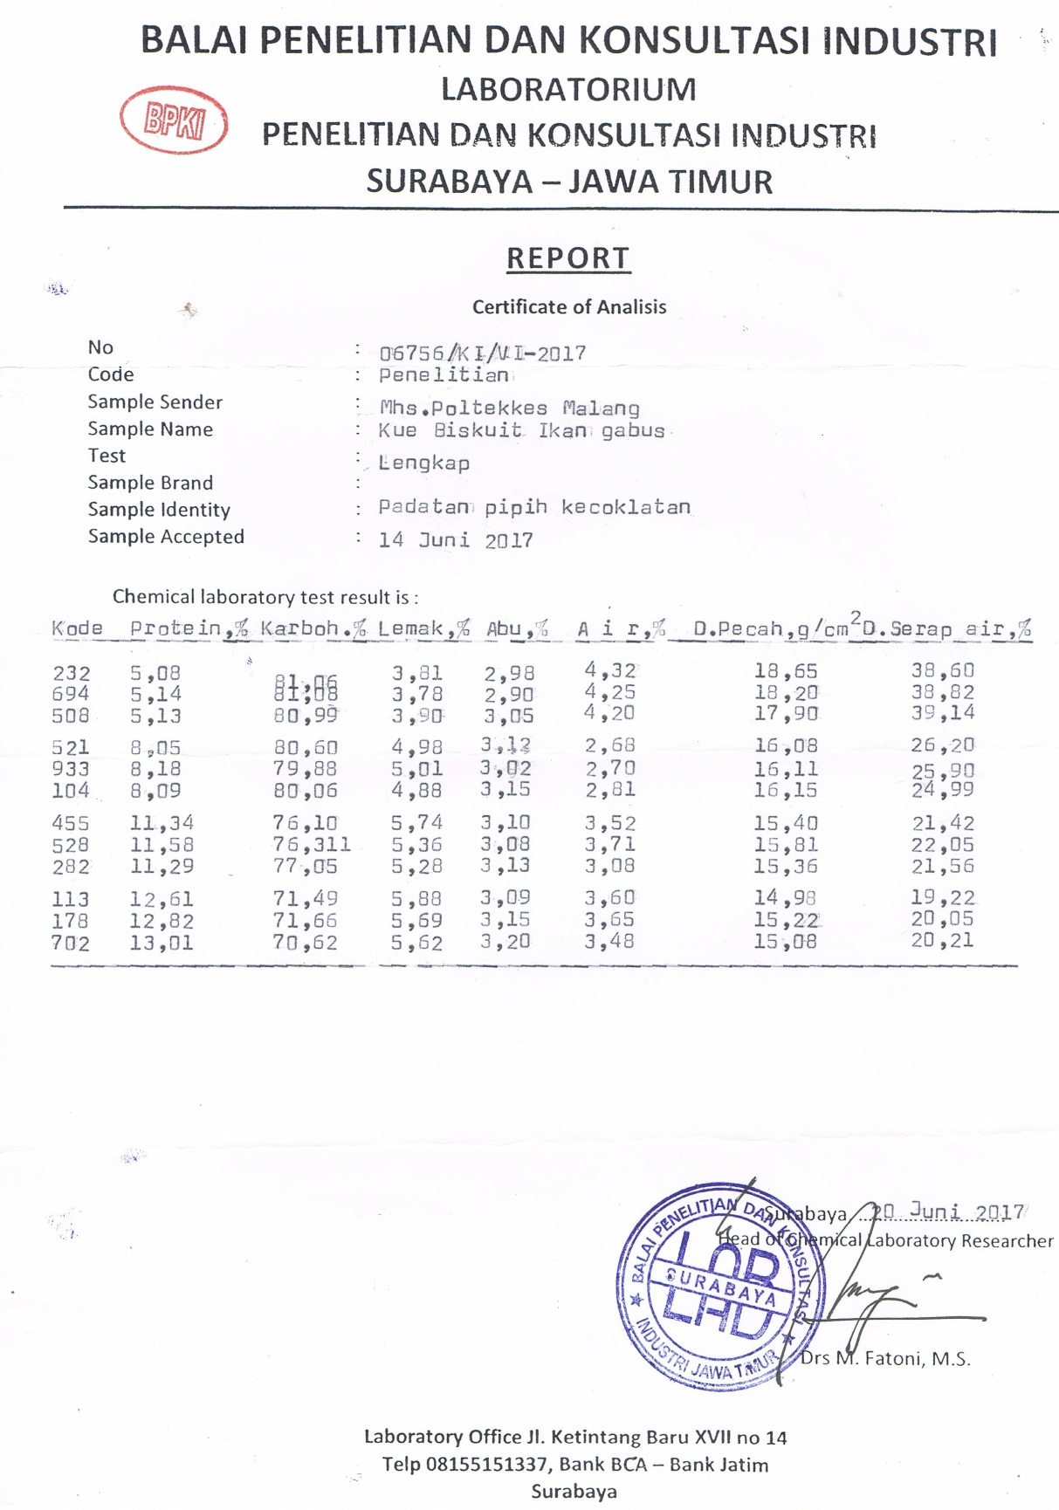
Lampiran 21. Hasil Uji Daya Patah Biskuit PMT
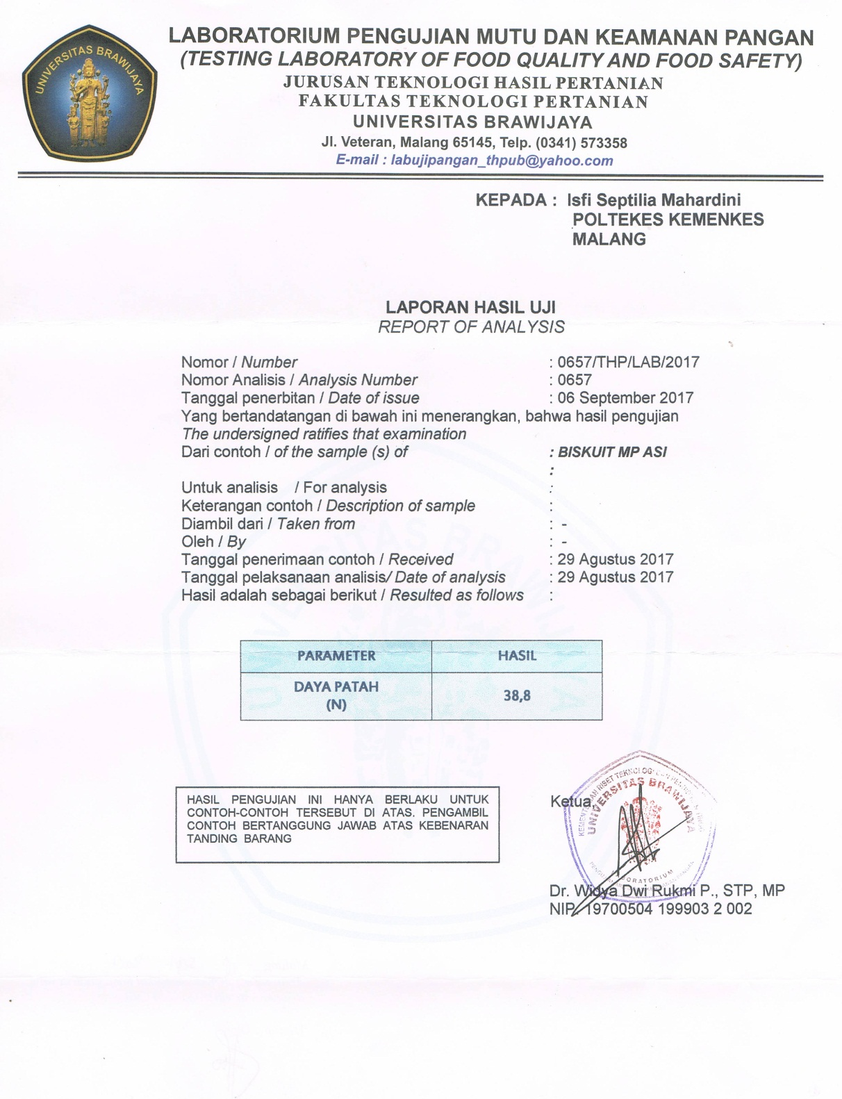
Lampiran 22. Hasil Uji Daya Serap Air Biskuit PMT
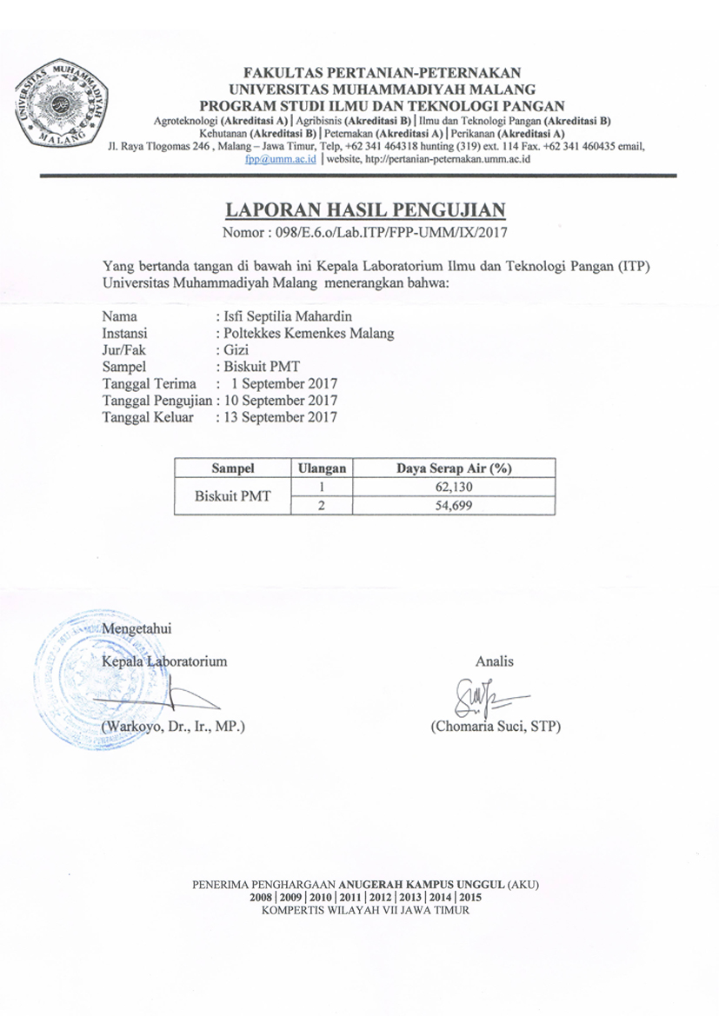
Lampiran 23. Surat peminjaman Laboratorium ITP
