**LAMPIRAN**

**Lampiran 1.** Lembar Persetujuan untuk Responden

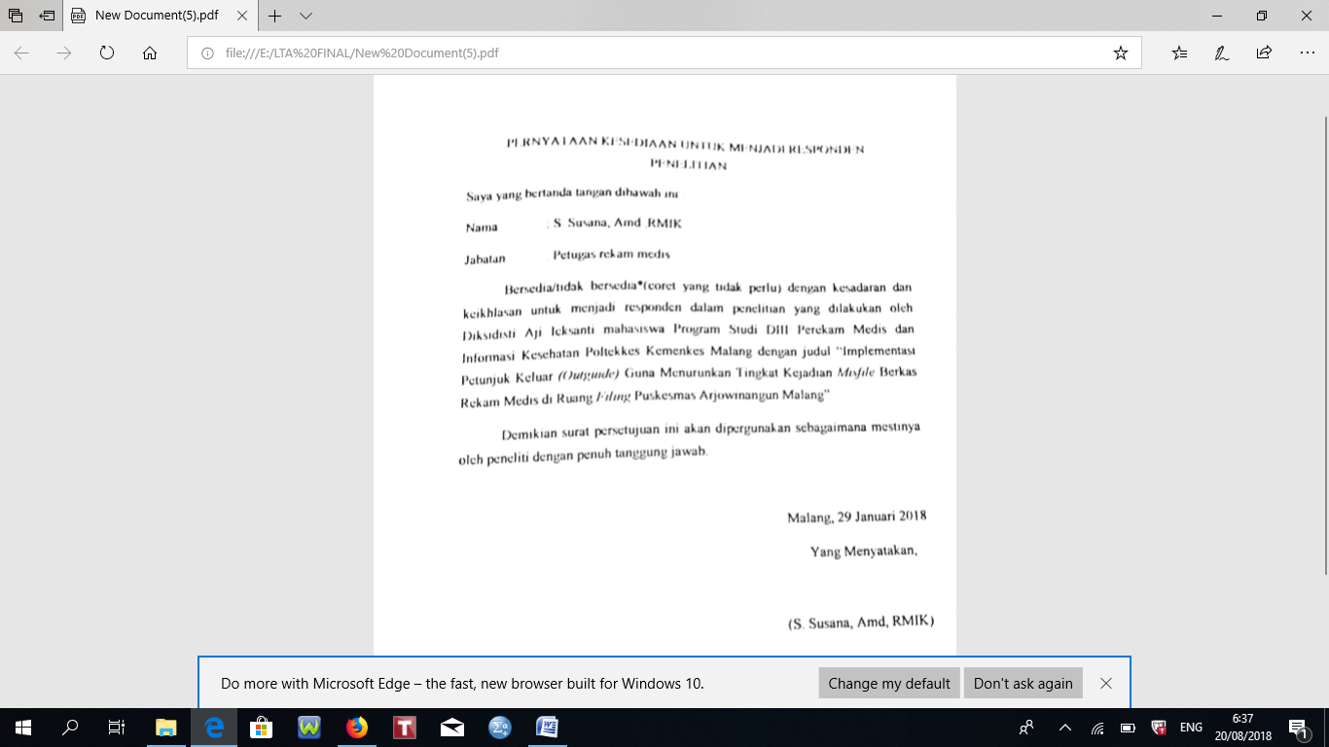

**Lampiran 2.** Undangan Sosialisasi Implementasi *Outguide*

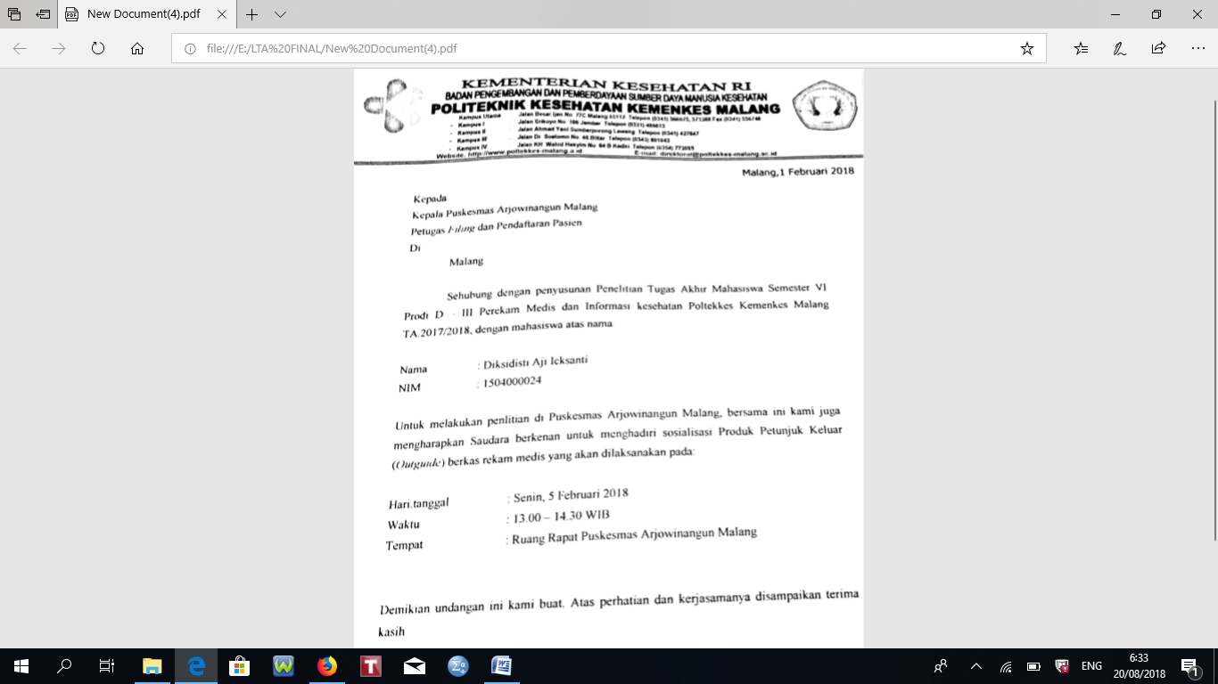

**Lampiran 3.** Berita Acara Sosialisasi Implementasi *Outguide*

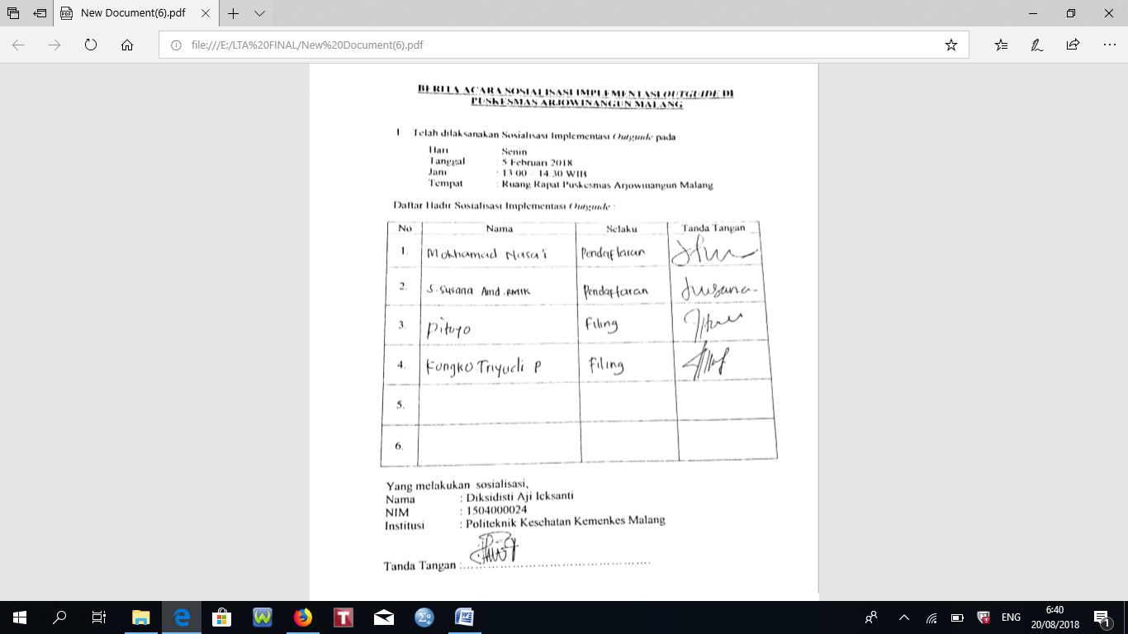

**Lampiran 4.** *Checklist* Berkas Rekam Medis **S**ebelum Implementasi *Outguide*

HARI KE-1 (Tanggal: 29 Januari 2018)

|  |  |  |  |  |
| --- | --- | --- | --- | --- |
| No. | No. Berkas Rekam Medis | Berkas Kunjungan Lama | | Keterangan |
| *Misfie* | Tidak *Misfile* |
|  | A 001764 |  | 🗸 |  |
|  | A 000440 |  | 🗸 |  |
|  | B 002524 | 🗸 |  | SALAH LETAK |
|  | B 000459 |  | 🗸 |  |
|  | B 002022 | 🗸 |  | SALAH LETAK |
|  | A 001764 |  | 🗸 |  |
|  | B 001772 |  | 🗸 |  |
|  | B 001000 |  | 🗸 |  |
|  | A 001052 |  | 🗸 |  |
|  | T 000192 |  | 🗸 |  |
|  | B 001877 |  | 🗸 |  |
|  | A 000302 |  | 🗸 |  |
|  | A 000870 |  | 🗸 |  |
|  | B 002255 |  | 🗸 |  |
|  | B 000016 |  | 🗸 |  |
|  | B 000525 |  | 🗸 |  |
|  | B 001661 |  | 🗸 |  |
|  | T 000538 |  | 🗸 |  |
|  | T 000054 |  | 🗸 |  |
|  | T 001015 | 🗸 |  | HILANG |
|  | A 000614 |  | 🗸 |  |
|  | A 000652 |  | 🗸 |  |
|  | T 002223 |  | 🗸 |  |
|  | A 002538 |  | 🗸 |  |
|  | AS 000032 |  | 🗸 |  |
|  | A 000697 |  | 🗸 |  |
|  | B 001293 |  | 🗸 |  |
|  | A 002025 |  | 🗸 |  |
|  | T 000315 |  | 🗸 |  |
|  | AS 000082 |  | 🗸 |  |
|  | A 000981 |  | 🗸 |  |
|  | A 000779 |  | 🗸 |  |
|  | A 000773 | 🗸 |  | SALAH LETAK |
|  | B 002503 |  | 🗸 |  |
|  | B 001204 |  | 🗸 |  |
|  | T 000186 |  | 🗸 |  |
|  | T 000239 |  | 🗸 |  |
|  | A 002283 |  | 🗸 |  |
|  | WK 001716 |  | 🗸 |  |
|  | B 000530 |  | 🗸 |  |
|  | A 002295 |  | 🗸 |  |
|  | A 000825 |  | 🗸 |  |
|  | A 000006 |  | 🗸 |  |
|  | T 000379 |  | 🗸 |  |
|  | A 000662 |  | 🗸 |  |
|  | A 001742 |  | 🗸 |  |
|  | A 001633 |  | 🗸 |  |
|  | B 002133 |  | 🗸 |  |
|  | A 000083 |  | 🗸 |  |
|  | A 000652 |  | 🗸 |  |
|  | L 001490 |  | 🗸 |  |
|  | A 000901 |  | 🗸 |  |
|  | T 000456 |  | 🗸 |  |
|  | T 001383 |  | 🗸 |  |
|  | A 001383 |  | 🗸 |  |
|  | A 001131 |  | 🗸 |  |
|  | AS 000288 |  | 🗸 |  |
|  | AS 000446 |  | 🗸 |  |
|  | A 002322 |  | 🗸 |  |
|  | B 001608 |  | 🗸 |  |
|  | B 001607 |  | 🗸 |  |
|  | B 000875 | 🗸 |  | HILANG |
|  | B 001235 | 🗸 |  | HILANG |
|  | T 000693 |  | 🗸 |  |
|  | A 002283 |  | 🗸 |  |
|  | A 002186 |  | 🗸 |  |
|  | B 001320 |  | 🗸 |  |
|  | SP 001340 |  | 🗸 |  |
|  | A 000222 |  | 🗸 |  |
|  | A 001980 |  | 🗸 |  |
|  | B 000666 |  | 🗸 |  |
|  | A 002695 |  | 🗸 |  |
|  | A 001888 |  | 🗸 |  |
|  | M 000052 |  | 🗸 |  |
|  | T 000726 |  | 🗸 |  |
|  | T 000112 |  | 🗸 |  |
|  | B 002131 |  | 🗸 |  |
|  | A 001576 |  | 🗸 |  |
|  | B 000223 |  | 🗸 |  |
|  | M 000884 |  | 🗸 |  |
|  | A 000265 |  | 🗸 |  |
|  | B 00707 |  | 🗸 |  |
|  | A 001112 |  | 🗸 |  |
|  | B 000960 |  | 🗸 |  |
|  | A 002057 |  | 🗸 |  |
|  | T 000743 |  | 🗸 |  |
|  | T 008384 |  | 🗸 |  |
|  | TL 000931 |  | 🗸 |  |
|  | B 001131 |  | 🗸 |  |
|  | A 000503 |  | 🗸 |  |
|  | A 000834 |  | 🗸 |  |
|  | A 002114 | 🗸 |  | SALAH LETAK |
|  | TL 000328 |  | 🗸 |  |
|  | A 000867 |  | 🗸 |  |
|  | TL 000059 |  | 🗸 |  |
| **TOTAL = 95 BERKAS** | | 7 BERKAS | 88 BERKAS |  |

HARI KE-2 (Tanggal: 30 Januari 2018)

|  |  |  |  |  |
| --- | --- | --- | --- | --- |
| No. | No. Berkas Rekam Medis | Berkas Kunjungan Lama | | Keterangan |
| *Misfile* | Tidak *Misfile* |
|  | B 000065 |  | 🗸 |  |
|  | M 000052 |  | 🗸 |  |
|  | AS 000004 |  | 🗸 |  |
|  | B 000770 |  | 🗸 |  |
|  | A 002254 |  | 🗸 |  |
|  | A 000004 |  | 🗸 |  |
|  | B 002341 |  | 🗸 |  |
|  | B 001721 |  | 🗸 |  |
|  | B 000817 |  | 🗸 |  |
|  | B 000485 |  | 🗸 |  |
|  | A 000505 |  | 🗸 |  |
|  | T 000713 |  | 🗸 |  |
|  | A 000175 | 🗸 |  | SALAH LETAK |
|  | B 001806 |  | 🗸 |  |
|  | L 001410 |  | 🗸 |  |
|  | A 000100 |  | 🗸 |  |
|  | A 001617 |  | 🗸 |  |
|  | A 001617 |  | 🗸 |  |
|  | A 002433 |  | 🗸 |  |
|  | A 000892 |  | 🗸 |  |
|  | B 002342 |  | 🗸 |  |
|  | A 000200 |  | 🗸 |  |
|  | B 002298 |  | 🗸 |  |
|  | B 000777 |  | 🗸 |  |
|  | A 000825 |  | 🗸 |  |
|  | A 001569 |  | 🗸 |  |
|  | TL 000328 |  | 🗸 |  |
|  | A 000132 |  | 🗸 |  |
|  | M 001189 |  | 🗸 |  |
|  | A 000517 |  | 🗸 |  |
|  | B 000198 |  | 🗸 |  |
|  | B 000723 |  | 🗸 |  |
|  | A 000417 |  | 🗸 |  |
|  | A 002321 |  | 🗸 |  |
|  | B 000454 |  | 🗸 |  |
|  | TL 000633 |  | 🗸 |  |
|  | A 001098 |  | 🗸 |  |
|  | A 000223 | 🗸 |  | SALAH LETAK |
|  | L 000384 |  | 🗸 |  |
|  | M 002343 |  | 🗸 |  |
|  | AS 000244 | 🗸 |  | SALAH LETAK |
|  | M 002605 |  | 🗸 |  |
|  | A 000055 |  | 🗸 |  |
|  | A 002671 |  | 🗸 |  |
|  | TL 001558 |  | 🗸 |  |
|  | A 000428 | 🗸 |  | SALAH LETAK |
|  | A 000953 |  | 🗸 |  |
|  | TL 000813 |  | 🗸 |  |
|  | AS 000191 |  | 🗸 |  |
|  | M 002022 |  | 🗸 |  |
|  | A 000742 |  | 🗸 |  |
|  | A 000849 |  | 🗸 |  |
|  | B 000027 | 🗸 |  | HILANG |
|  | A 001636 |  | 🗸 |  |
|  | A 000308 |  | 🗸 |  |
|  | A 000463 |  | 🗸 |  |
|  | A 001067 |  | 🗸 |  |
| **TOTAL = 57 BERKAS** | | 5 BERKAS | 52 BERKAS |  |

HARI KE-3 (Tanggal: 31 Januari 2018)

|  |  |  |  |  |
| --- | --- | --- | --- | --- |
| No. | No. Berkas Rekam Medis | Berkas Kunjungan Lama | | Keterangan |
| *Misfile* | Tidak *Misfile* |
|  | A 001969 | 🗸 |  | SALAH LETAK |
|  | B 001983 |  | 🗸 |  |
|  | TL 001059 |  | 🗸 |  |
|  | A 000487 |  | 🗸 |  |
|  | A 000228 |  | 🗸 |  |
|  | T 000042 |  | 🗸 |  |
|  | B 001853 |  | 🗸 |  |
|  | B 001441 |  | 🗸 |  |
|  | B 002348 |  | 🗸 |  |
|  | A 000275 |  | 🗸 |  |
|  | A 002348 |  | 🗸 |  |
|  | B 000195 |  | 🗸 |  |
|  | M 002349 |  | 🗸 |  |
|  | A 002211 |  | 🗸 |  |
|  | A 000392 |  | 🗸 |  |
|  | T 002350 |  | 🗸 |  |
|  | B 000086 |  | 🗸 |  |
|  | A 001994 |  | 🗸 |  |
|  | B 002351 |  | 🗸 |  |
|  | A 000529 |  | 🗸 |  |
|  | B 001065 |  | 🗸 |  |
|  | A 000829 |  | 🗸 |  |
|  | T 000829 |  | 🗸 |  |
|  | B 001530 |  | 🗸 |  |
|  | B 002554 | 🗸 |  | HILANG |
|  | B 000056 |  | 🗸 |  |
|  | A 000508 |  | 🗸 |  |
|  | B 002356 |  | 🗸 |  |
|  | A 000368 |  | 🗸 |  |
|  | B 000701 |  | 🗸 |  |
|  | B 002024 |  | 🗸 |  |
|  | B 001221 | 🗸 |  | SALAH LETAK |
|  | B 000553 |  | 🗸 |  |
|  | A 000739 |  | 🗸 |  |
|  | A 001075 |  | 🗸 |  |
|  | A 002002 |  | 🗸 |  |
|  | B 000173 |  | 🗸 |  |
|  | A 001298 | 🗸 |  | SALAH LETAK |
|  | A 000209 |  | 🗸 |  |
|  | A 000691 | 🗸 |  | HILANG |
|  | AS 000277 |  | 🗸 |  |
|  | A 000475 |  | 🗸 |  |
|  | A 000053 |  | 🗸 |  |
|  | B 000333 |  | 🗸 |  |
| **TOTAL = 44 BERKAS** | | 5 BERKAS | 39 BERKAS |  |

HARI KE-4 (Tanggal: 1 Februari 2018)

|  |  |  |  |  |
| --- | --- | --- | --- | --- |
| No. | No. Berkas Rekam Medis | Berkas Kunjungan Lama | | Keterangan |
| *Misfile* | Tidak *Misfile* |
|  | A 000242 |  | 🗸 |  |
|  | T 002631 |  | 🗸 |  |
|  | B 000072 |  | 🗸 |  |
|  | B 000898 |  | 🗸 |  |
|  | TJ 000309 |  | 🗸 |  |
|  | B 000628 | 🗸 |  | SALAH LETAK |
|  | B 000627 |  | 🗸 |  |
|  | T 000114 |  | 🗸 |  |
|  | A 002371 |  | 🗸 |  |
|  | T 002372 | 🗸 |  | SALAH LETAK |
|  | A 000276 |  | 🗸 |  |
|  | T 000931 |  | 🗸 |  |
|  | A 002374 |  | 🗸 |  |
|  | T 000929 |  | 🗸 |  |
|  | T 000399 |  | 🗸 |  |
|  | A 001820 | 🗸 |  | HILANG |
|  | B 001850 |  | 🗸 |  |
|  | A 001074 |  | 🗸 |  |
|  | M 000443 |  | 🗸 |  |
|  | A 001107 |  | 🗸 |  |
|  | A 002117 |  | 🗸 |  |
|  | B 002383 |  | 🗸 |  |
|  | A 001739 |  | 🗸 |  |
|  | A 000780 |  | 🗸 |  |
|  | AS 000378 | 🗸 |  | HILANG |
|  | A 000230 |  | 🗸 |  |
|  | B 000114 |  | 🗸 |  |
|  | AS 000266 |  | 🗸 |  |
|  | M 000660 |  | 🗸 |  |
|  | A 001985 |  | 🗸 |  |
|  | A 000833 |  | 🗸 |  |
|  | T 000558 | 🗸 |  | SALAH LETAK |
|  | M 00157 |  | 🗸 |  |
|  | T 000018 |  | 🗸 |  |
|  | AS 000295 |  | 🗸 |  |
|  | M 000385 |  | 🗸 |  |
|  | A 002520 |  | 🗸 |  |
|  | A 001525 | 🗸 |  | SALAH LETAK |
|  | A 000645 |  | 🗸 |  |
| **TOTAL = 39 BERKAS** | | 6 BERKAS | 33 BERKAS |

HARI KE-5 (Tanggal: 2 Februari 2018)

|  |  |  |  |  |
| --- | --- | --- | --- | --- |
| No. | No. Berkas Rekam Medis | Berkas Kunjungan Lama | | Keterangan |
| *Misfile* | Tidak *Misfile* |
|  | A 000070 |  | 🗸 |  |
|  | A 000069 |  | 🗸 |  |
|  | M 000067 |  | 🗸 |  |
|  | T 000789 |  | 🗸 |  |
|  | A 000808 |  | 🗸 |  |
|  | SP 000952 |  | 🗸 |  |
|  | SP 000633 |  | 🗸 |  |
|  | A 000374 |  | 🗸 |  |
|  | B 000633 |  | 🗸 |  |
|  | A 000229 |  | 🗸 |  |
|  | A 001480 |  | 🗸 |  |
|  | A 000467 |  | 🗸 |  |
|  | B 001237 |  | 🗸 |  |
|  | B 002429 |  | 🗸 |  |
|  | A 002364 |  | 🗸 |  |
|  | TL 000779 |  | 🗸 |  |
|  | A 001139 |  | 🗸 |  |
|  | TL 000074 |  | 🗸 |  |
|  | B 000325 |  | 🗸 |  |
|  | TL 000371 |  | 🗸 |  |
|  | SP 001340 |  | 🗸 |  |
|  | SP 001340 |  | 🗸 |  |
|  | M 002390 |  | 🗸 |  |
|  | A 002272 |  | 🗸 |  |
|  | A 000277 |  | 🗸 |  |
|  | A 001129 |  | 🗸 |  |
|  | B 001400 |  | 🗸 |  |
|  | B 002417 |  | 🗸 |  |
|  | A 002096 |  | 🗸 |  |
|  | A 002423 |  | 🗸 |  |
|  | SP 000813 |  | 🗸 |  |
|  | A 000311 | 🗸 |  | SALAH LETAK |
|  | A 001963 |  | 🗸 |  |
|  | A 000904 |  | 🗸 |  |
|  | A 002061 |  | 🗸 |  |
|  | B 000096 |  | 🗸 |  |
|  | B 001317 |  | 🗸 |  |
|  | L 002242 | 🗸 |  | SALAH LETAK |
|  | B 000485 |  | 🗸 |  |
|  | B 001035 |  |  |  |
|  | A 002061 |  |  |  |
|  | TL 000196 |  | 🗸 |  |
|  | A 000015 |  | 🗸 |  |
|  | A 000451 |  | 🗸 |  |
|  | A 001992 | 🗸 |  | HILANG |
|  | B 001223 | 🗸 |  | SALAH LETAK |
|  | B 001224 |  | 🗸 |  |
|  | B 001024 |  | 🗸 |  |
|  | AS 000385 | 🗸 |  | HILANG |
|  | B 001351 |  | 🗸 |  |
| **TOTAL = 50 BERKAS** | | 5 BERKAS | 45 BERKAS |

HARI KE-6 (Tanggal: 3 Februari 2018)

|  |  |  |  |  |
| --- | --- | --- | --- | --- |
| No. | No. Berkas Rekam Medis | Berkas Kunjungan Lama | | Keterangan |
| *Misfie* | Tidak *Misfile* |
|  | M 000522 |  | 🗸 |  |
|  | A 002305 |  | 🗸 |  |
|  | B 002424 |  | 🗸 |  |
|  | T 000138 |  | 🗸 |  |
|  | A 000066 |  | 🗸 |  |
|  | B 001441 |  | 🗸 |  |
|  | B 000418 |  | 🗸 |  |
|  | A 000472 |  | 🗸 |  |
|  | B 001542 |  | 🗸 |  |
|  | T 002350 |  | 🗸 |  |
|  | M 000146 |  | 🗸 |  |
|  | A 002210 |  | 🗸 |  |
|  | A 000694 |  | 🗸 |  |
|  | M 002343 |  | 🗸 |  |
|  | A 000041 | 🗸 |  | HILANG |
|  | SP 000952 |  | 🗸 |  |
|  | B 000365 |  | 🗸 |  |
|  | SP 000386 |  | 🗸 |  |
|  | A 002109 |  | 🗸 |  |
|  | AS 000266 | 🗸 |  | SALAH LETAK |
|  | T 000082 |  | 🗸 |  |
|  | A 000201 |  | 🗸 |  |
|  | B 002102 |  | 🗸 |  |
|  | T 000340 |  | 🗸 |  |
|  | M 001942 |  | 🗸 |  |
|  | T 000339 |  | 🗸 |  |
|  | B 002169 |  | 🗸 |  |
|  | A 000200 |  | 🗸 |  |
|  | A 000492 |  | 🗸 |  |
|  | A 000130 |  | 🗸 |  |
|  | T 000586 |  | 🗸 |  |
|  | A 000223 |  | 🗸 |  |
|  | B 000319 |  | 🗸 |  |
|  | A 000398 |  | 🗸 |  |
|  | B 000268 |  | 🗸 |  |
|  | B 001244 |  | 🗸 |  |
|  | A 002563 |  | 🗸 |  |
|  | B 001014 | 🗸 |  | SALAH LETAK |
|  | B 002376 |  | 🗸 |  |
|  | A 000034 |  | 🗸 |  |
|  | T 002000 |  | 🗸 |  |
|  | B 001615 |  | 🗸 |  |
|  | T 002357 |  | 🗸 |  |
|  | A 000581 |  | 🗸 |  |
|  | T 000977 |  | 🗸 |  |
|  | A 001880 |  | 🗸 |  |
|  | T 000922 |  | 🗸 |  |
|  | TL 002397 |  | 🗸 |  |
|  | T 002397 |  | 🗸 |  |
|  | B 002515 |  | 🗸 |  |
|  | A 001383 | 🗸 |  | HILANG |
|  | A 002605 |  | 🗸 |  |
|  | T 001441 |  | 🗸 |  |
|  | A 001178 |  | 🗸 |  |
|  | B 000016 |  | 🗸 |  |
|  | B 000015 | 🗸 |  | HILANG |
|  | SP 000915 |  | 🗸 |  |
|  | A 000773 |  | 🗸 |  |
|  | AS 000380 |  | 🗸 |  |
|  | B 000249 |  | 🗸 |  |
|  | A 002273 | 🗸 |  | SALAH LETAK |
|  | B 001387 |  | 🗸 |  |
|  | B 002049 |  | 🗸 |  |
|  | A 000036 |  | 🗸 |  |
|  | A 001957 |  | 🗸 |  |
|  | A 000308 |  | 🗸 |  |
|  | A 001150 |  | 🗸 |  |
| **TOTAL = 67 BERKAS** | | 6 BERKAS | 61 BERKAS |  |

**Lampiran 5.** *Checklist* Berkas Rekam Medis Sesudah Implementasi *Outguide*

HARI KE-1 (Tanggal: 10 Februari 2018)

|  |  |  |  |  |
| --- | --- | --- | --- | --- |
| No. | No. Berkas Rekam Medis | Berkas Kunjungan Lama | | Keterangan |
| *Misfie* | Tidak *Misfile* |
|  | A 002458 |  | 🗸 |  |
|  | B 001441 |  | 🗸 |  |
|  | B 000358 |  | 🗸 |  |
|  | AS 000347 |  | 🗸 |  |
|  | A 002323 |  | 🗸 |  |
|  | A 001633 |  | 🗸 |  |
|  | A 002190 |  | 🗸 |  |
|  | A 000116 |  | 🗸 |  |
|  | B 001550 |  | 🗸 |  |
|  | B 000902 |  | 🗸 |  |
|  | B 002456 |  | 🗸 |  |
|  | B 002399 |  | 🗸 |  |
|  | B 001233 |  | 🗸 |  |
|  | B 002462 |  | 🗸 |  |
|  | A 000555 |  | 🗸 |  |
|  | A 000325 |  | 🗸 |  |
|  | B 000029 |  | 🗸 |  |
|  | M 002427 |  | 🗸 |  |
|  | B 000416 |  | 🗸 |  |
|  | A 000197 |  | 🗸 |  |
|  | TL 000050 |  | 🗸 |  |
|  | TL 002419 |  | 🗸 |  |
|  | TL 000456 |  | 🗸 |  |
|  | A 002460 |  | 🗸 |  |
|  | SP 001100 |  | 🗸 |  |
|  | A 001393 |  | 🗸 |  |
|  | TL 000719 |  | 🗸 |  |
|  | TL 000465 |  | 🗸 |  |
|  | B 000178 |  | 🗸 |  |
|  | B 001322 |  | 🗸 |  |
|  | A 000382 |  | 🗸 |  |
|  | A 000724 |  | 🗸 |  |
|  | TL 000462 |  | 🗸 |  |
|  | B 001542 |  | 🗸 |  |
|  | B 001235 |  | 🗸 |  |
|  | A 002468 |  | 🗸 |  |
|  | AS 000482 |  | 🗸 |  |
|  | TL 000581 |  | 🗸 |  |
|  | A 000373 |  | 🗸 |  |
|  | A 000735 |  | 🗸 |  |
|  | AS 000127 |  | 🗸 |  |
|  | A 001098 |  | 🗸 |  |
|  | T 001476 |  | 🗸 |  |
|  | B 001075 |  | 🗸 |  |
| **TOTAL = 44 BERKAS** | | 0 BERKAS | 44 BERKAS |  |

HARI KE-2 (Tanggal: 12 Februari 2018)

|  |  |  |  |  |
| --- | --- | --- | --- | --- |
| No. | No. Berkas Rekam Medis | Berkas Kunjungan Lama | | Keterangan |
| *Misfie* | Tidak *Misfile* |
|  | B 000416 |  | 🗸 |  |
|  | M 000267 |  | 🗸 |  |
|  | SP 000921 |  | 🗸 |  |
|  | A 000568 |  | 🗸 |  |
|  | A 001138 |  | 🗸 |  |
|  | SP 002532 |  | 🗸 |  |
|  | B 001387 |  | 🗸 |  |
|  | B 000390 |  | 🗸 |  |
|  | A 001395 |  | 🗸 |  |
|  | TL 000934 |  | 🗸 |  |
|  | A 001536 |  | 🗸 |  |
|  | A 001166 |  | 🗸 |  |
|  | A 001820 |  | 🗸 |  |
|  | A 002231 |  | 🗸 |  |
|  | A 000299 |  | 🗸 |  |
|  | B 000011 | 🗸 |  | HILANG |
|  | A 000125 |  | 🗸 |  |
|  | B 000917 |  | 🗸 |  |
|  | A 000698 |  | 🗸 |  |
|  | A 001527 |  | 🗸 |  |
|  | AS 000316 |  | 🗸 |  |
|  | AS 000167 |  | 🗸 |  |
|  | TL 000844 |  | 🗸 |  |
|  | AS 000167 |  | 🗸 |  |
|  | TL 000844 |  | 🗸 |  |
|  | AS 000162 |  | 🗸 |  |
|  | TL 000043 |  | 🗸 |  |
|  | A 001258 |  | 🗸 |  |
|  | B 000426 |  | 🗸 |  |
|  | B 000427 |  | 🗸 |  |
|  | A 002305 |  | 🗸 |  |
|  | A 002307 |  | 🗸 |  |
|  | B 001098 |  | 🗸 |  |
|  | B 000595 |  | 🗸 |  |
|  | B 001866 |  | 🗸 |  |
|  | B 000466 |  | 🗸 |  |
|  | TL 000918 | 🗸 |  | HILANG |
|  | AS 000085 |  | 🗸 |  |
|  | A 000303 |  | 🗸 |  |
|  | B 002457 |  | 🗸 |  |
|  | B 001113 |  | 🗸 |  |
|  | B 000800 |  | 🗸 |  |
|  | A 001969 |  | 🗸 |  |
|  | M 001804 |  | 🗸 |  |
|  | B 002205 |  | 🗸 |  |
|  | A 001907 |  | 🗸 |  |
|  | B 000306 |  | 🗸 |  |
|  | A 000556 |  | 🗸 |  |
|  | B 002036 |  | 🗸 |  |
|  | AS 000470 |  | 🗸 |  |
|  | A 000967 |  | 🗸 |  |
|  | A 000696 |  | 🗸 |  |
|  | A 002227 |  | 🗸 |  |
|  | A 000051 |  | 🗸 |  |
|  | A 000107 |  | 🗸 |  |
|  | B 001666 |  | 🗸 |  |
|  | AS 000169 | 🗸 |  | SALAH LETAK |
|  | A 000428 |  | 🗸 |  |
|  | B 002465 |  | 🗸 |  |
|  | A 000462 |  | 🗸 |  |
|  | T 000045 |  | 🗸 |  |
|  | M 000191 |  | 🗸 |  |
|  | T 000654 |  | 🗸 |  |
|  | B 001808 |  | 🗸 |  |
|  | B 002525 |  | 🗸 |  |
|  | A 001710 |  | 🗸 |  |
|  | B 000961 |  | 🗸 |  |
|  | T 000356 |  | 🗸 |  |
|  | B 000816 |  | 🗸 |  |
|  | A 001492 |  | 🗸 |  |
|  | T 000356 |  | 🗸 |  |
|  | A 001554 |  | 🗸 |  |
|  | AS 000172 |  | 🗸 |  |
|  | A 002347 |  | 🗸 |  |
|  | SP 000215 |  | 🗸 |  |
|  | B 001594 |  | 🗸 |  |
|  | B 000718 |  | 🗸 |  |
|  | B 001350 |  | 🗸 |  |
|  | B 000292 |  | 🗸 |  |
|  | A 001478 |  | 🗸 |  |
|  | A 000680 |  | 🗸 |  |
|  | A 000330 |  | 🗸 |  |
|  | A 002381 |  | 🗸 |  |
|  | A 002637 |  | 🗸 |  |
|  | B 002469 |  | 🗸 |  |
|  | T 000229 |  | 🗸 |  |
|  | A 000079 |  | 🗸 |  |
|  | AS 000120 |  | 🗸 |  |
|  | B 001922 |  | 🗸 |  |
| **TOTAL = 89 BERKAS** | | 3 BERKAS | 86 BERKAS |  |

HARI KE-3 (Tanggal: 13 Februari 2018)

|  |  |  |  |  |
| --- | --- | --- | --- | --- |
| No. | No. Berkas Rekam Medis | Berkas Kunjungan Lama | | Keterangan |
| *Misfie* | Tidak *Misfile* |
|  | TL 000309 |  | 🗸 |  |
|  | M 000053 |  | 🗸 |  |
|  | WK 000504 |  | 🗸 |  |
|  | B 000528 |  | 🗸 |  |
|  | AS 000127 |  | 🗸 |  |
|  | B 000528 |  | 🗸 |  |
|  | B 000605 |  | 🗸 |  |
|  | SP 002082 |  | 🗸 |  |
|  | B 000422 |  | 🗸 |  |
|  | B 000166 |  | 🗸 |  |
|  | B 001187 |  | 🗸 |  |
|  | TL 001339 |  | 🗸 |  |
|  | AS 000083 |  | 🗸 |  |
|  | A 000132 |  | 🗸 |  |
|  | A 002441 |  | 🗸 |  |
|  | A 000924 |  | 🗸 |  |
|  | A 000607 | 🗸 |  | HILANG |
|  | TL 001846 |  | 🗸 |  |
|  | L 000012 |  | 🗸 |  |
|  | B 000268 |  | 🗸 |  |
|  | A 001493 |  | 🗸 |  |
|  | B 002207 |  | 🗸 |  |
|  | B 000491 |  | 🗸 |  |
|  | B 000430 |  | 🗸 |  |
|  | A 000349 |  | 🗸 |  |
|  | TL 000579 |  | 🗸 |  |
|  | A 002258 |  | 🗸 |  |
|  | A 000508 |  | 🗸 |  |
|  | B 000952 |  | 🗸 |  |
|  | SP 001007 |  | 🗸 |  |
|  | SP 001008 |  | 🗸 |  |
|  | TL 000393 |  | 🗸 |  |
|  | A 000291 |  | 🗸 |  |
|  | B 000703 |  | 🗸 |  |
|  | A 002388 |  | 🗸 |  |
|  | A 000660 |  | 🗸 |  |
|  | TL 000001 |  | 🗸 |  |
|  | TL 000582 |  | 🗸 |  |
|  | B 000636 |  | 🗸 |  |
|  | A 000904 |  | 🗸 |  |
|  | B 000312 |  | 🗸 |  |
|  | TL 000307 |  | 🗸 |  |
|  | A 000013 |  | 🗸 |  |
|  | T 002238 |  | 🗸 |  |
|  | AS 000172 |  | 🗸 |  |
|  | B 001350 |  | 🗸 |  |
|  | A 002321 |  | 🗸 |  |
|  | WK 002601 |  | 🗸 |  |
|  | B 002329 |  | 🗸 |  |
|  | M 002090 |  | 🗸 |  |
|  | B 000081 |  | 🗸 |  |
|  | A 000169 |  | 🗸 |  |
|  | A 001809 |  | 🗸 |  |
|  | TL 000159 |  | 🗸 |  |
| **TOTAL = 54 BERKAS** | | 1 BERKAS | 53 BERKAS |  |

HARI KE-4 (Tanggal: 14 Februari 2018)

|  |  |  |  |  |
| --- | --- | --- | --- | --- |
| No. | No. Berkas Rekam Medis | Berkas Kunjungan Lama | | Keterangan |
| *Misfie* | Tidak *Misfile* |
|  | M 000522 |  | 🗸 |  |
|  | M 000383 |  | 🗸 |  |
|  | TL 000248 |  | 🗸 |  |
|  | TL 000173 |  | 🗸 |  |
|  | AS 000524 |  | 🗸 |  |
|  | AS 000017 |  | 🗸 |  |
|  | B 000836 |  | 🗸 |  |
|  | B 000258 |  | 🗸 |  |
|  | B 000589 |  | 🗸 |  |
|  | AS 000256 |  | 🗸 |  |
|  | A 000096 |  | 🗸 |  |
|  | B 001639 |  | 🗸 |  |
|  | B 000140 | 🗸 |  | SALAH LETAK |
|  | A 001782 |  | 🗸 |  |
|  | A 002478 |  | 🗸 |  |
|  | A 001486 |  | 🗸 |  |
|  | B 002482 |  | 🗸 |  |
|  | M 000385 | 🗸 |  | SALAH LETAK |
|  | B 000177 |  | 🗸 |  |
|  | A 001907 |  | 🗸 |  |
|  | B 001180 |  | 🗸 |  |
|  | B 001400 |  | 🗸 |  |
|  | M 000524 |  | 🗸 |  |
|  | T 002287 |  | 🗸 |  |
|  | L 002507 |  | 🗸 |  |
|  | A 000827 |  | 🗸 |  |
|  | AS 000008 |  | 🗸 |  |
|  | SP 001472 |  | 🗸 |  |
|  | B 002551 |  | 🗸 |  |
|  | AS 000078 |  | 🗸 |  |
|  | B 001853 |  | 🗸 |  |
|  | A 000095 |  | 🗸 |  |
|  | AS 000143 |  | 🗸 |  |
|  | B 000902 |  | 🗸 |  |
|  | A 000667 |  | 🗸 |  |
|  | A 001126 |  | 🗸 |  |
|  | A 002115 |  | 🗸 |  |
|  | TL 000586 |  | 🗸 |  |
|  | A 000088 |  | 🗸 |  |
|  | B 002005 |  | 🗸 |  |
|  | M 002512 |  | 🗸 |  |
|  | B 000814 |  | 🗸 |  |
|  | A 001733 |  | 🗸 |  |
|  | B 000318 |  | 🗸 |  |
|  | A 002459 |  | 🗸 |  |
|  | TL 000773 |  | 🗸 |  |
|  | TL 000278 |  | 🗸 |  |
|  | TL 002308 |  | 🗸 |  |
|  | B 000269 |  | 🗸 |  |
|  | B 001756 |  | 🗸 |  |
|  | A 002538 |  | 🗸 |  |
|  | A 002272 |  | 🗸 |  |
| **TOTAL = 52 BERKAS** | | 2 BERKAS | 50 BERKAS |  |

HARI KE-5 (Tanggal: 15 Februari 2018)

|  |  |  |  |  |
| --- | --- | --- | --- | --- |
| No. | No. Berkas Rekam Medis | Berkas Kunjungan Lama | | Keterangan |
| *Misfie* | Tidak *Misfile* |
|  | A 000034 |  | 🗸 |  |
|  | A 001858 |  | 🗸 |  |
|  | B 000285 |  | 🗸 |  |
|  | T 000332 |  | 🗸 |  |
|  | T 002502 |  | 🗸 |  |
|  | A 002703 |  | 🗸 |  |
|  | B 002192 |  | 🗸 |  |
|  | A 001764 |  | 🗸 |  |
|  | A 002194 |  | 🗸 |  |
|  | SP 001110 |  | 🗸 |  |
|  | A 001305 |  | 🗸 |  |
|  | B 002169 |  | 🗸 |  |
|  | B 002646 |  | 🗸 |  |
|  | A 002637 |  | 🗸 |  |
|  | B 001772 |  | 🗸 |  |
|  | A 002691 |  | 🗸 |  |
|  | A 001796 |  | 🗸 |  |
|  | B 002014 |  | 🗸 |  |
|  | A 002685 |  | 🗸 |  |
|  | B 001892 |  | 🗸 |  |
|  | A 002210 |  | 🗸 |  |
|  | B 000330 |  | 🗸 |  |
|  | B 001839 |  | 🗸 |  |
|  | A 001997 | 🗸 |  | HILANG |
|  | A 000384 |  | 🗸 |  |
|  | TL 000394 |  | 🗸 |  |
|  | A 002468 |  | 🗸 |  |
|  | B 001542 |  | 🗸 |  |
|  | TL 000701 |  | 🗸 |  |
|  | A 000944 |  | 🗸 |  |
|  | A 002321 |  | 🗸 |  |
|  | AS 000406 |  | 🗸 |  |
|  | A 000289 |  | 🗸 |  |
|  | B 002158 |  | 🗸 |  |
|  | A 000083 |  | 🗸 |  |
|  | AS 000127 |  | 🗸 |  |
|  | A 000778 |  | 🗸 |  |
|  | B 002492 |  | 🗸 |  |
|  | A 000798 |  | 🗸 |  |
|  | B 000110 |  | 🗸 |  |
|  | TL 000801 |  | 🗸 |  |
|  | A 000211 |  | 🗸 |  |
|  | B 002596 |  | 🗸 |  |
|  | A 001957 |  | 🗸 |  |
|  | A 002373 |  | 🗸 |  |
|  | B 002556 |  | 🗸 |  |
|  | B 001530 |  | 🗸 |  |
|  | B 001899 |  | 🗸 |  |
|  | W 002242 |  | 🗸 |  |
|  | A 001296 |  | 🗸 |  |
|  | W 001455 |  | 🗸 |  |
|  | B 001607 |  | 🗸 |  |
|  | TL 000265 |  | 🗸 |  |
|  | A 000259 |  | 🗸 |  |
|  | A 000462 |  | 🗸 |  |
|  | A 001077 |  | 🗸 |  |
|  | B 000173 |  | 🗸 |  |
|  | AS 000071 |  | 🗸 |  |
|  | L 000124 |  | 🗸 |  |
| **TOTAL = 59 BERKAS** | | 1 BERKAS | 58 BERKAS |  |

HARI KE-6 (Tanggal: 17 Februari 2018)

|  |  |  |  |  |
| --- | --- | --- | --- | --- |
| No. | No. Berkas Rekam Medis | Berkas Kunjungan Lama | | Keterangan |
| *Misfie* | Tidak *Misfile* |
|  | B 002529 |  | 🗸 |  |
|  | B 002207 |  | 🗸 |  |
|  | SP 000248 |  | 🗸 |  |
|  | A 001880 |  | 🗸 |  |
|  | AS 000496 |  | 🗸 |  |
|  | T 002641 |  | 🗸 |  |
|  | B 001474 |  | 🗸 |  |
|  | B 002520 |  | 🗸 |  |
|  | AS 000009 |  | 🗸 |  |
|  | A 000515 |  | 🗸 |  |
|  | AS 000496 |  | 🗸 |  |
|  | T 000158 |  | 🗸 |  |
|  | A 000551 |  | 🗸 |  |
|  | B 000448 |  | 🗸 |  |
|  | B 000607 |  | 🗸 |  |
|  | B 002108 |  | 🗸 |  |
|  | B 001208 |  | 🗸 |  |
|  | A 002116 |  | 🗸 |  |
|  | B 000808 | 🗸 |  | HILANG |
|  | B 001447 |  | 🗸 |  |
|  | B 002433 |  | 🗸 |  |
|  | B 001815 |  | 🗸 |  |
|  | A 001627 |  | 🗸 |  |
|  | T 001339 |  | 🗸 |  |
|  | A 000235 |  | 🗸 |  |
|  | B 002564 |  | 🗸 |  |
|  | A 000979 |  | 🗸 |  |
|  | B 000433 |  | 🗸 |  |
|  | B 000675 |  | 🗸 |  |
|  | B 001927 |  | 🗸 |  |
|  | B 001322 |  | 🗸 |  |
|  | M 000482 |  | 🗸 |  |
|  | T 000250 | 🗸 |  | HILANG |
|  | B 002545 |  | 🗸 |  |
|  | B 002546 |  | 🗸 |  |
|  | B 000777 |  | 🗸 |  |
|  | A 002119 |  | 🗸 |  |
|  | A 000257 |  | 🗸 |  |
|  | B 001092 |  | 🗸 |  |
|  | T 000016 |  | 🗸 |  |
|  | A 000535 |  | 🗸 |  |
|  | A 000245 |  | 🗸 |  |
|  | B 000372 |  | 🗸 |  |
|  | M 000510 |  | 🗸 |  |
|  | M 002414 | 🗸 |  | SALAH LETAK |
|  | B 001553 |  | 🗸 |  |
|  | A 000895 |  | 🗸 |  |
|  | A 000349 |  | 🗸 |  |
| **TOTAL = 48 BERKAS** | | 3 BERKAS | 45 BERKAS |  |

**Lampiran 6a.** Lembar Rekapitulasi *Pretest*

|  |  |  |  |
| --- | --- | --- | --- |
| Hari ke- | Total Sampel | *Pretest* | |
| *Misfile* | Tidak *Misfile* |
| 1 | 95 berkas | 7 berkas | 88 berkas |
| 2 | 57 berkas | 5 berkas | 52 berkas |
| 3 | 44 berkas | 5 berkas | 39 berkas |
| 4 | 39 berkas | 6 berkas | 33 berkas |
| 5 | 50 berkas | 5 berkas | 45 berkas |
| 6 | 67 berkas | 6 berkas | 61 berkas |
| **TOTAL** | 352 berkas | 34 berkas | 318 berkas |

**Lampiran 6b.** Lembar Rekapitulasi *Posttest*

|  |  |  |  |
| --- | --- | --- | --- |
| Hari ke- | Total Sampel | *Posttest* | |
| *Misfile* | Tidak *Misfile* |
| 1 | 44 berkas | 0 berkas | 44 berkas |
| 2 | 89 berkas | 3 berkas | 86 berkas |
| 3 | 54 berkas | 1 berkas | 53 berkas |
| 4 | 52 berkas | 2 berkas | 50 berkas |
| 5 | 59 berkas | 1 berkas | 58 berkas |
| 6 | 48 berkas | 3 berkas | 45 berkas |
| **TOTAL** | 346 berkas | 10 berkas | 336 berkas |

**Lampiran 7.** Desan *Outguide* Berkas Rekam Medis

BAGIAN DEPAN

32 cm

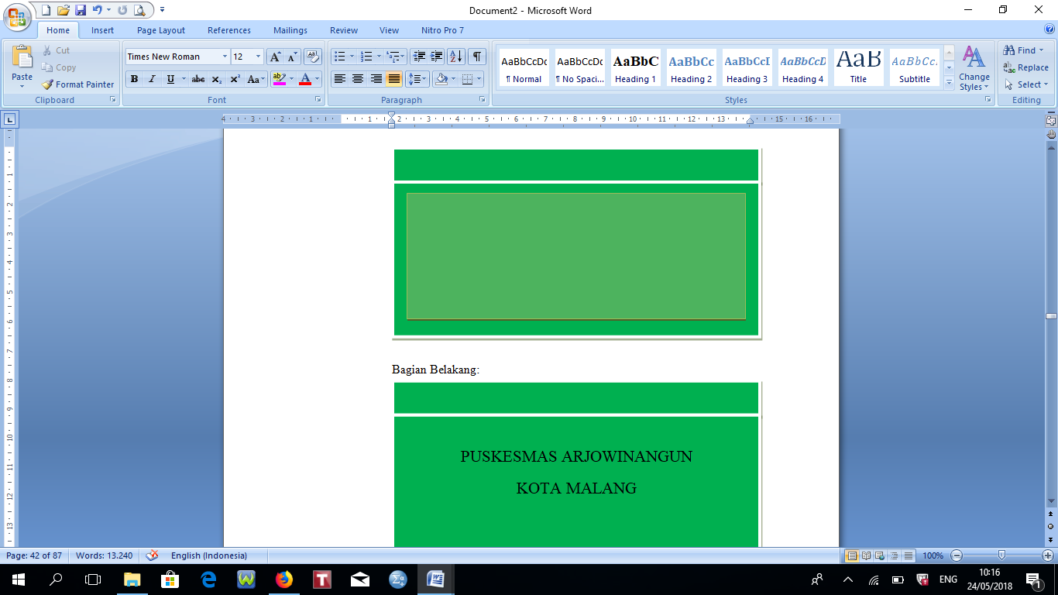

31 cm

11 cm

13 cm

BAGIAN BELAKANG

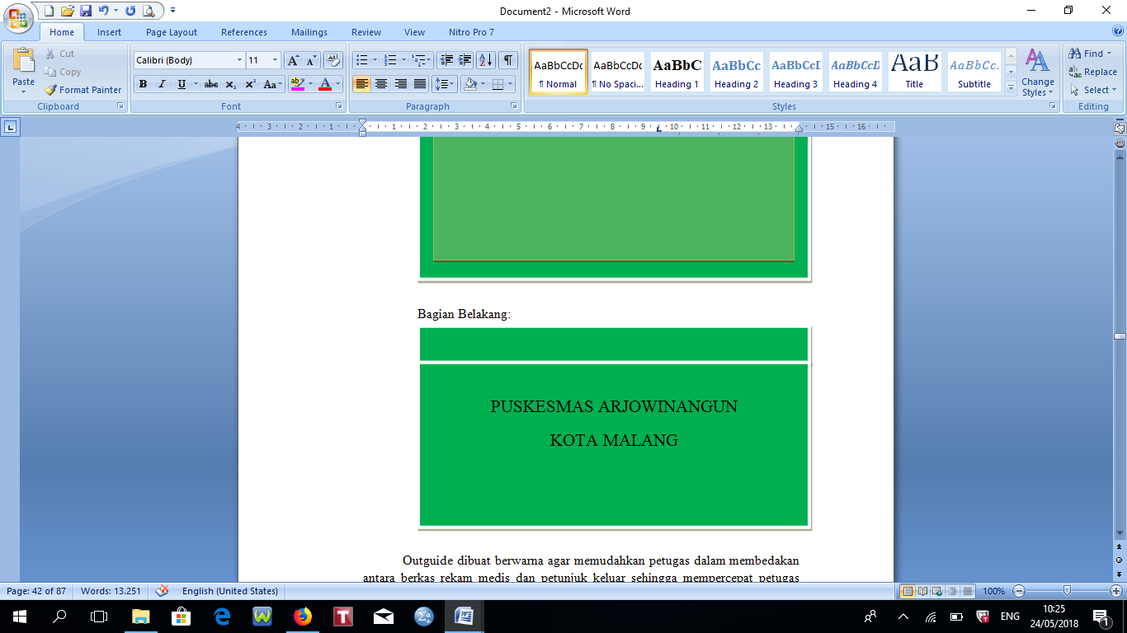

32 cm

13 cm

**Lampiran 8.** Desain Lembar *Tracer*

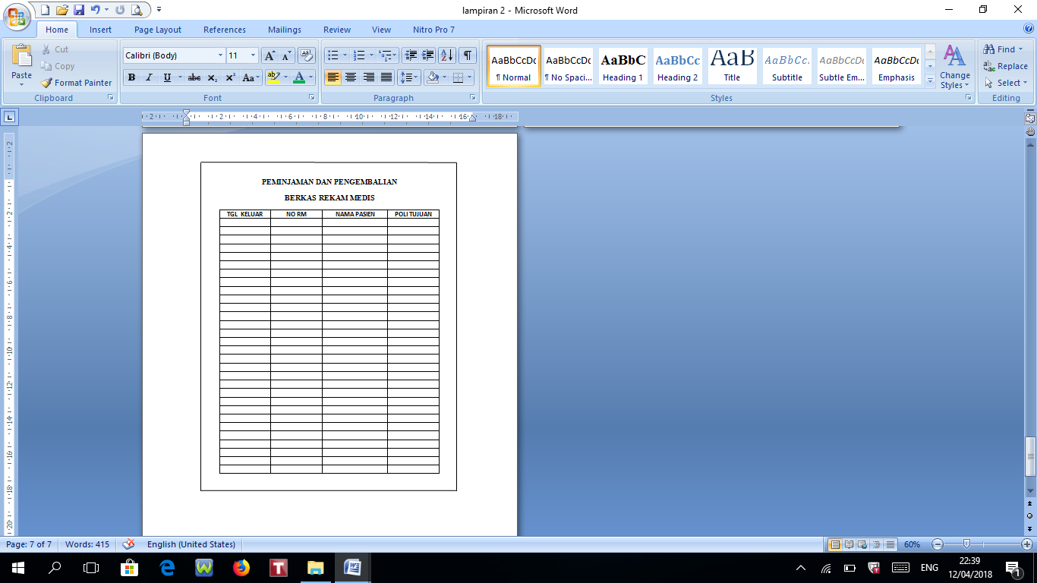

**Lampiran 9.** SOP AKSES TERHADAP REKAM MEDIS PUSKESMAS ARJOWINANGUN MALANG

|  |  |  |  |  |
| --- | --- | --- | --- | --- |
| + | **AKSES TERHADAP REKAM MEDIS** | | | E:\Logo Puskesmas Terbaru (1).png |
| SOP | No. Dokumen | : 440/85/BAB VIII/2017 |
| No. Revisi | : |
| Tanggal Terbit | : |
| Halaman | : |
| PUSKESMAS ARJOWINANGUN |  | | | drg.Camelia Finda A.  NIP.19750113 200312 2 007 |
| 1. **Pengertian** | Rekam Medis adalah catatan kondisi kesehatan pasien, pengobatan, rencana tindakan dan terapi pasien yang harus terjamin kerahasiaannya. Akses petugas terhadap Rekam Medis adalah Petugas yang diberi kewenangan untuk mengakses Rekam Medis. | | | |
| 1. **Tujuan** | 1. Untuk mendapatkan hasil secaran maksimal dalam proses pelayanan. 2. Sebagai pedoman dalam akses terhadap rekam medis | | | |
| 1. **Kebijakan** | FSK kepala puskesmas tentang akses terhadap rekam medis NO440/086/SK/35.37.302.03/2017 | | | |
| 1. **Referensi** | 1. 1. Berpedoman pada kebijakan rekam medis. 2. PERMENKES RI NO 269/MENKES PER/III/2008 tentang rekam medis. | | | |
| 1. **Prosedur / Langkah-langkah** | Pihak internal :   1. Peminjam menghubungi petugas RM untuk meminjam status RM, 2. Petugas menulis pada buku peminjaman status RM, 3. Waktu peminjaman 1 x 24 jam, 4. Berkas RM tidak boleh keluar puskesmas.   Pihak Eksternal :   1. Pihak Eksternal yang boleh mengakses berkas RM dalam hal untuk : 2. Kepentingan kesehatan pasien, 3. Memenuhi permintaan penegak hukum, 4. Permintaan/persetujuan pasien sendiri, 5. Permintaan institusi berdasarkan perundang undangan dan 6. Untuk kepentingan tidak menyebutkan identitas pasien. 7. Petugas RM menulis RM pada buku peminjaman rekam medis 8. Peminjaman hanya pada lingkungan Puskesmas tidak boleh dibawa keluar Puskesmas 9. Peminjaman pada jam kerja.   Peminjaman RM oleh Pihak Eksternal HARUS dengan Persetujuan Kepala Puskesmas. | | | |
| 1. **Bagan Alir (Jika Dibutuh-kan)** |  | | | |
| 1. **Unit Terkait** | Petugas RM, dokter, tenaga kesehatan tertentu yang diberi wewenang. | | | |

**Lampiran 10.** SPO PENYIMPANAN BERKAS REKAM MEDIS PUSKESMAS ARJOWINANGUN MALANG

|  |  |  |  |  |
| --- | --- | --- | --- | --- |
|  | PENYIMPANAN REKAM MEDIS | | | E:\Logo Puskesmas Terbaru (1).png |
| SOP | No. Dokumen | : 440/86/BAB VIII/2017 |
| No. Revisi | :- |
| Tanggal Terbit | : |
| Halaman | : |
| PUSKESMAS ARJOWINANGUN |  | | | drg.Camelia Finda A.  NIP.19750113 200312 2 007 |
| 1. **Pengertian** | Penyimpanan rekam medis adalah kegiatan menyimpan berkas rekam medis pasien kedalam rak yang disediakan sesuai dengan sistem yang ditetapkan setelahmelalui proses pengolahan berkas rekam medis. | | | |
| 1. **Tujuan** | 1. Untuk mendapatkan hasil secaran maksimal dalam proses pelayanan. 2. Sebagai pedoman dalam penyimpananrekammedis | | | |
| 1. **Kebijakan** | SK Kepala Puskesmas Arjowinangun tentang | | | |
| 1. **Referensi** | 1. Berpedoman pada kebijakan rekam medis. 2. PERMENKES RI NO 269/MENKES PER/III/2008 tentang rekam medis. | | | |
| 1. **Prosedur / Langkah-langkah** | * 1. Petugas menerima dokumen rekam medis dari unit layanan.   2. Petugas mengecek kelengkapan dokumen rekam medis.   3. Petugas unit layanan mengembalikan dokumen rekam medis kepada petugas yang mempunyai kompetensi mengisi dokumen rekam medis jika dokumen tidak lengkap.   4. Urutkan dokumen rekam medis dari yang terkecil hingga yang terbesar.   5. Petugas menyimpan dokumen rekam medis pada rak penyimpanan. | | | |
| 1. **Unit Terkait** | Petugas rekam medis dan seluruh petugas puskesmas | | | |

**Lampiran 11.** Hasil Output *Independet Sample t Test*

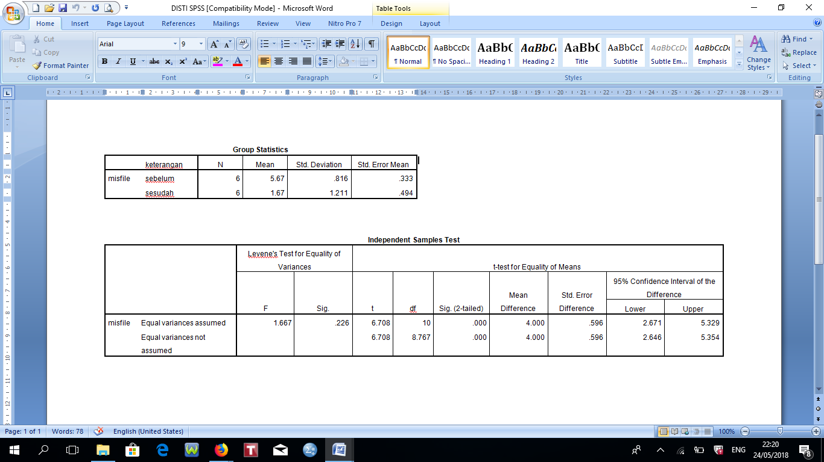

**Lampiran 12.** Berkas Rekam Medis Puskesmas Arjowinangun Malang

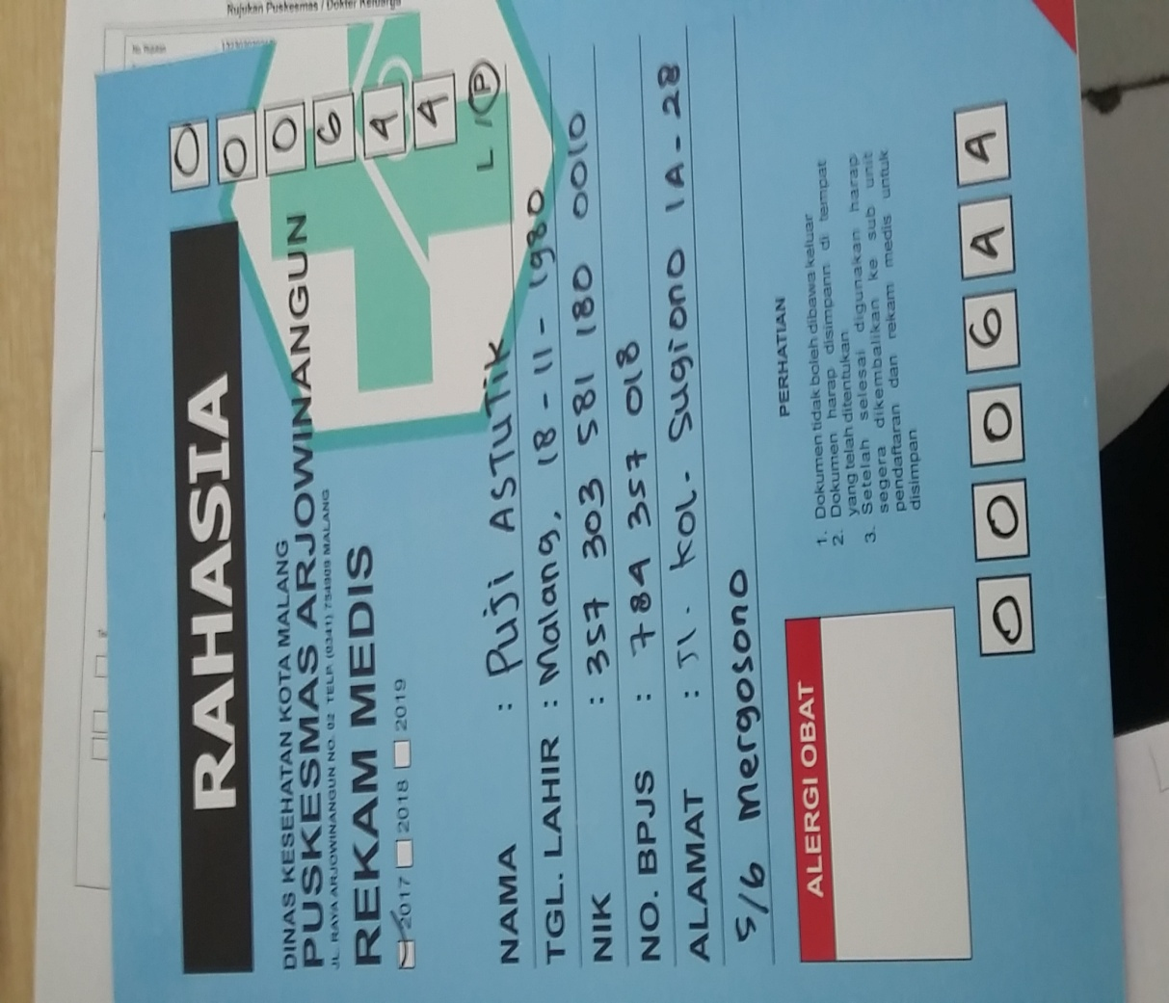

**Lampiran 13.** Petugas *Filing* Mengimplementasikan *Outguide*

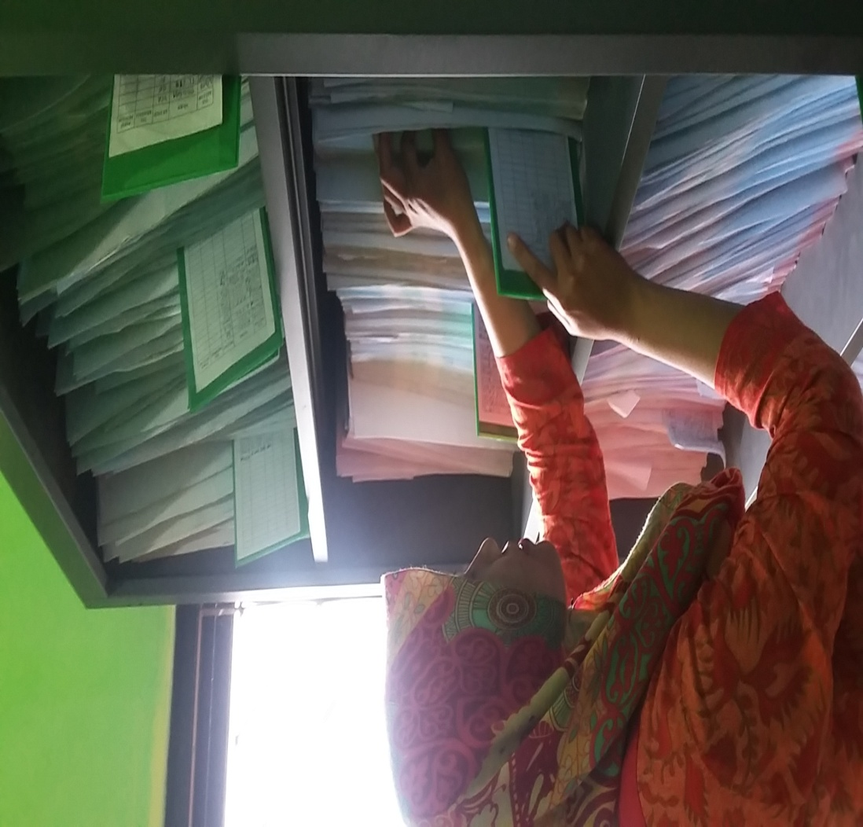

**Lampiran 14.** Surat Ijin Penelitian

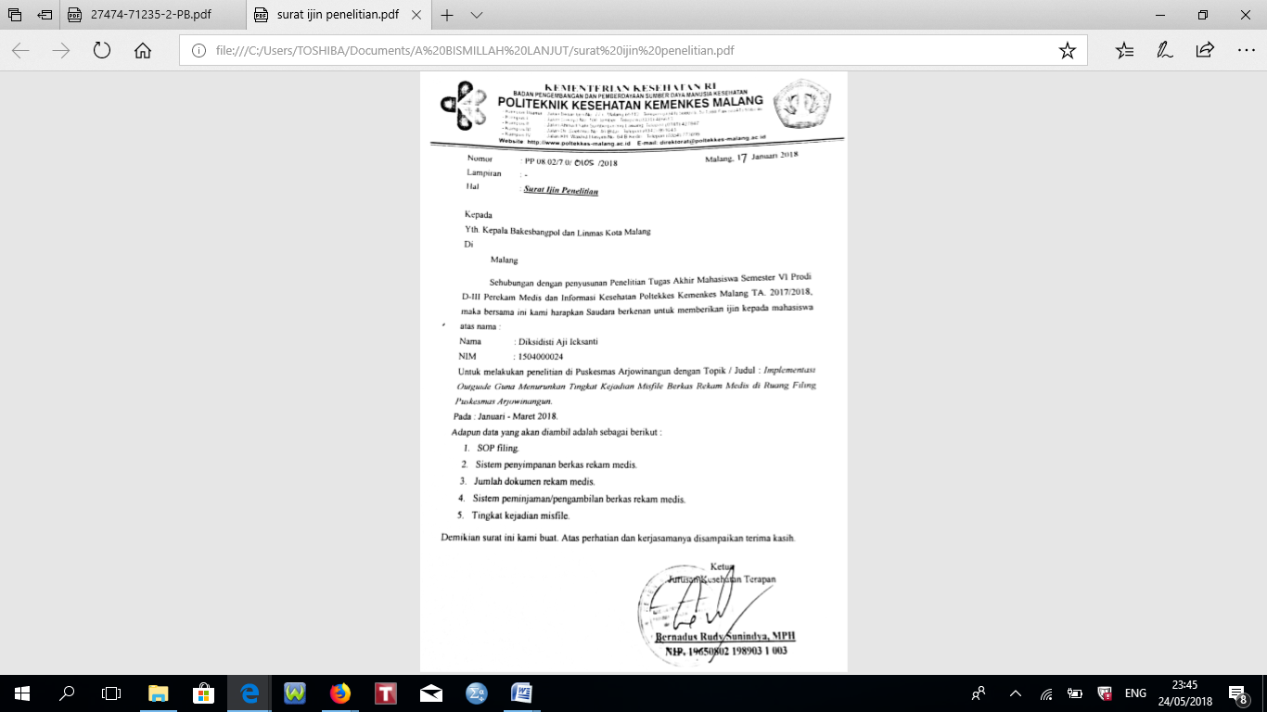

**Lampiran 15.** Surat Bangkes Bangpol Kota Malang

