**LAMPIRAN**

***Lampiran 1***

**Surat Ijin Penelitian**

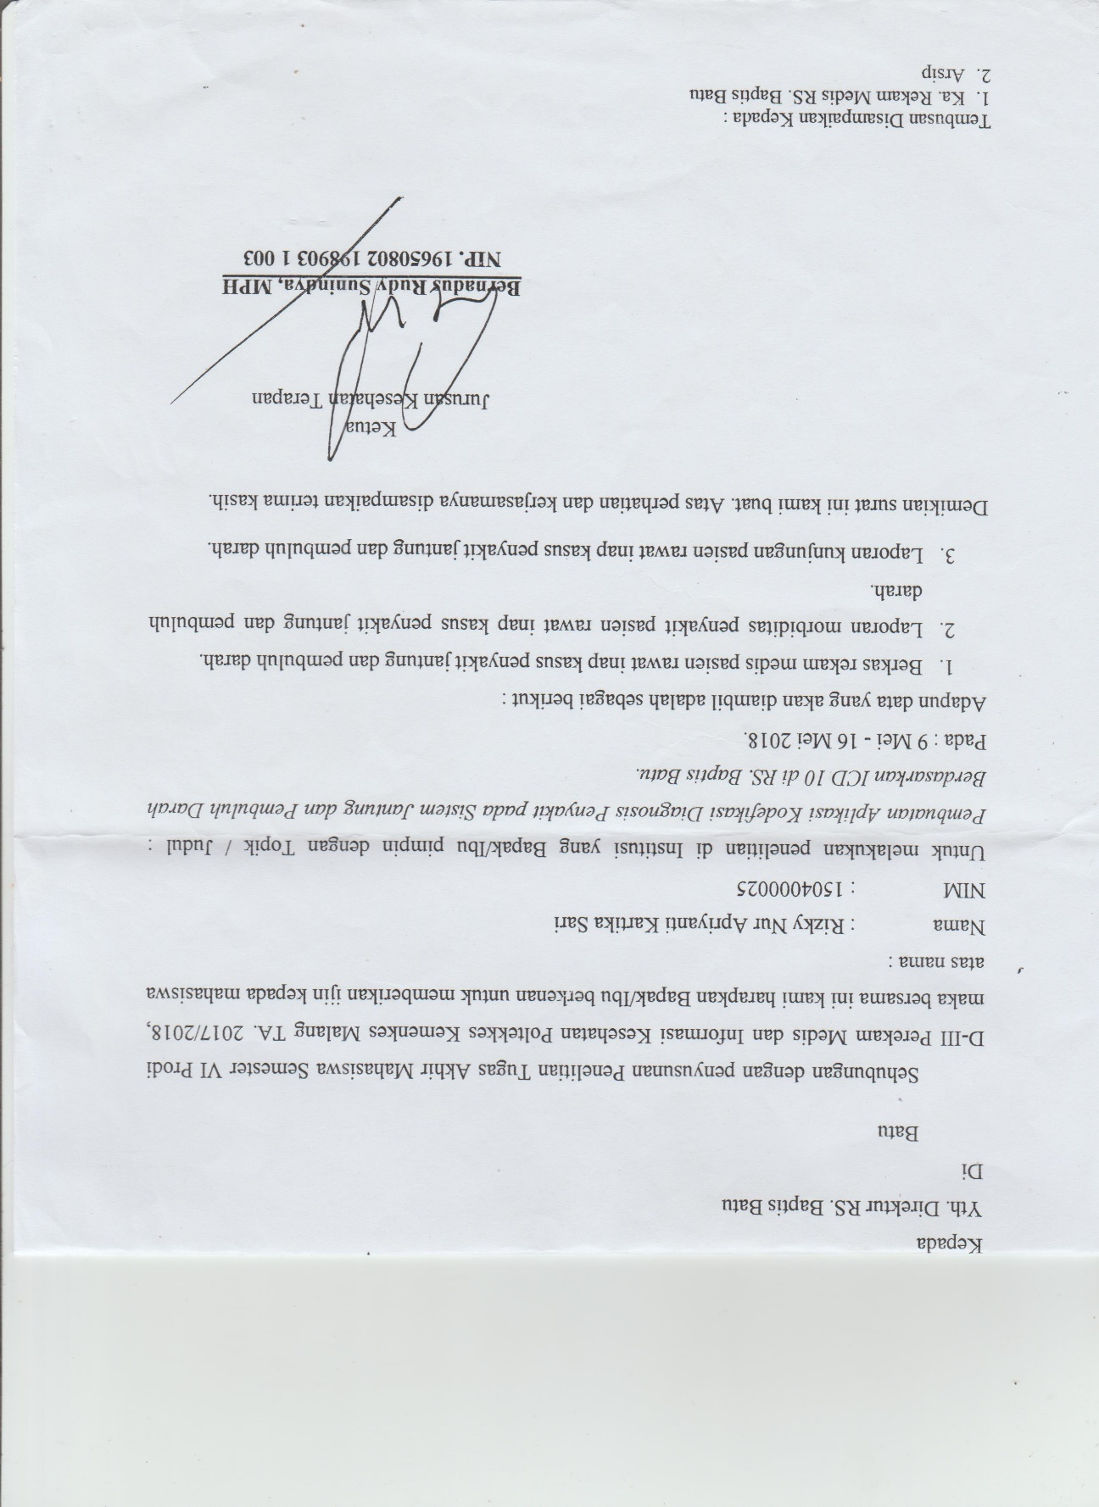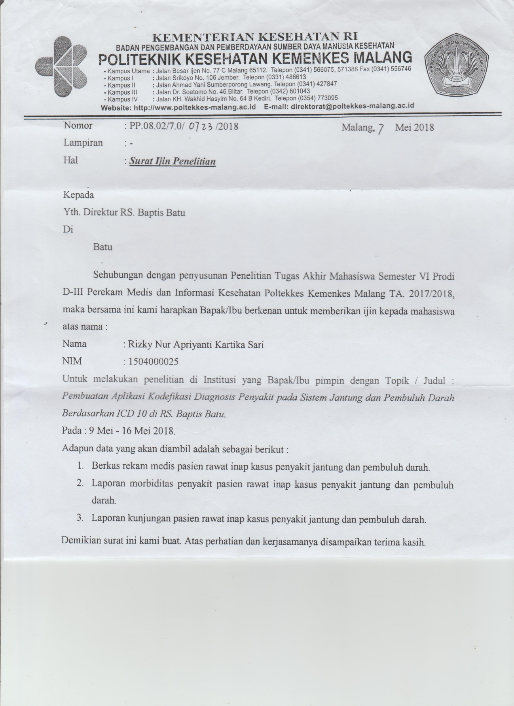

***Lampiran 2***

**Surat Balasan dari Rumah Sakit Baptis Batu**

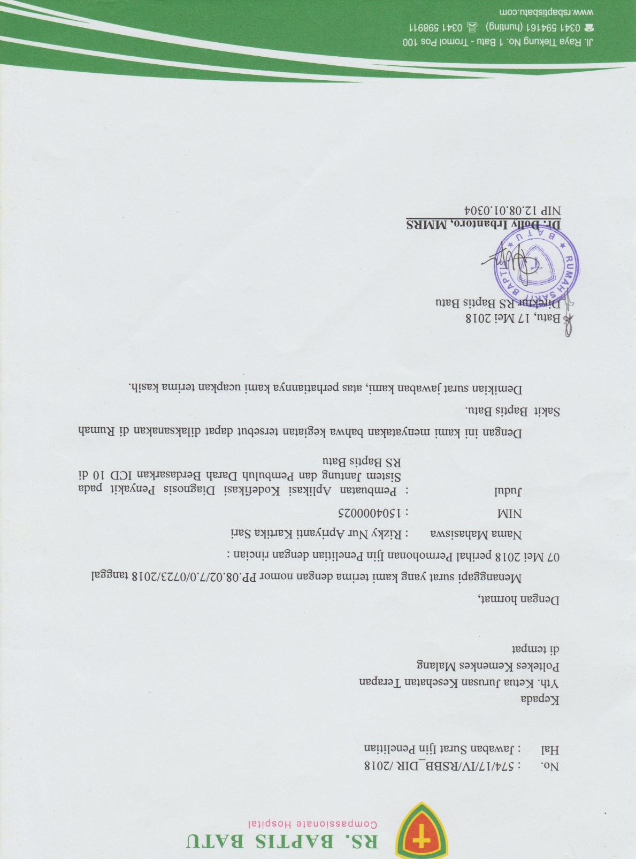

***Lampiran 6***

**Surat Pernyataan Validasi oleh Ahli Koding**

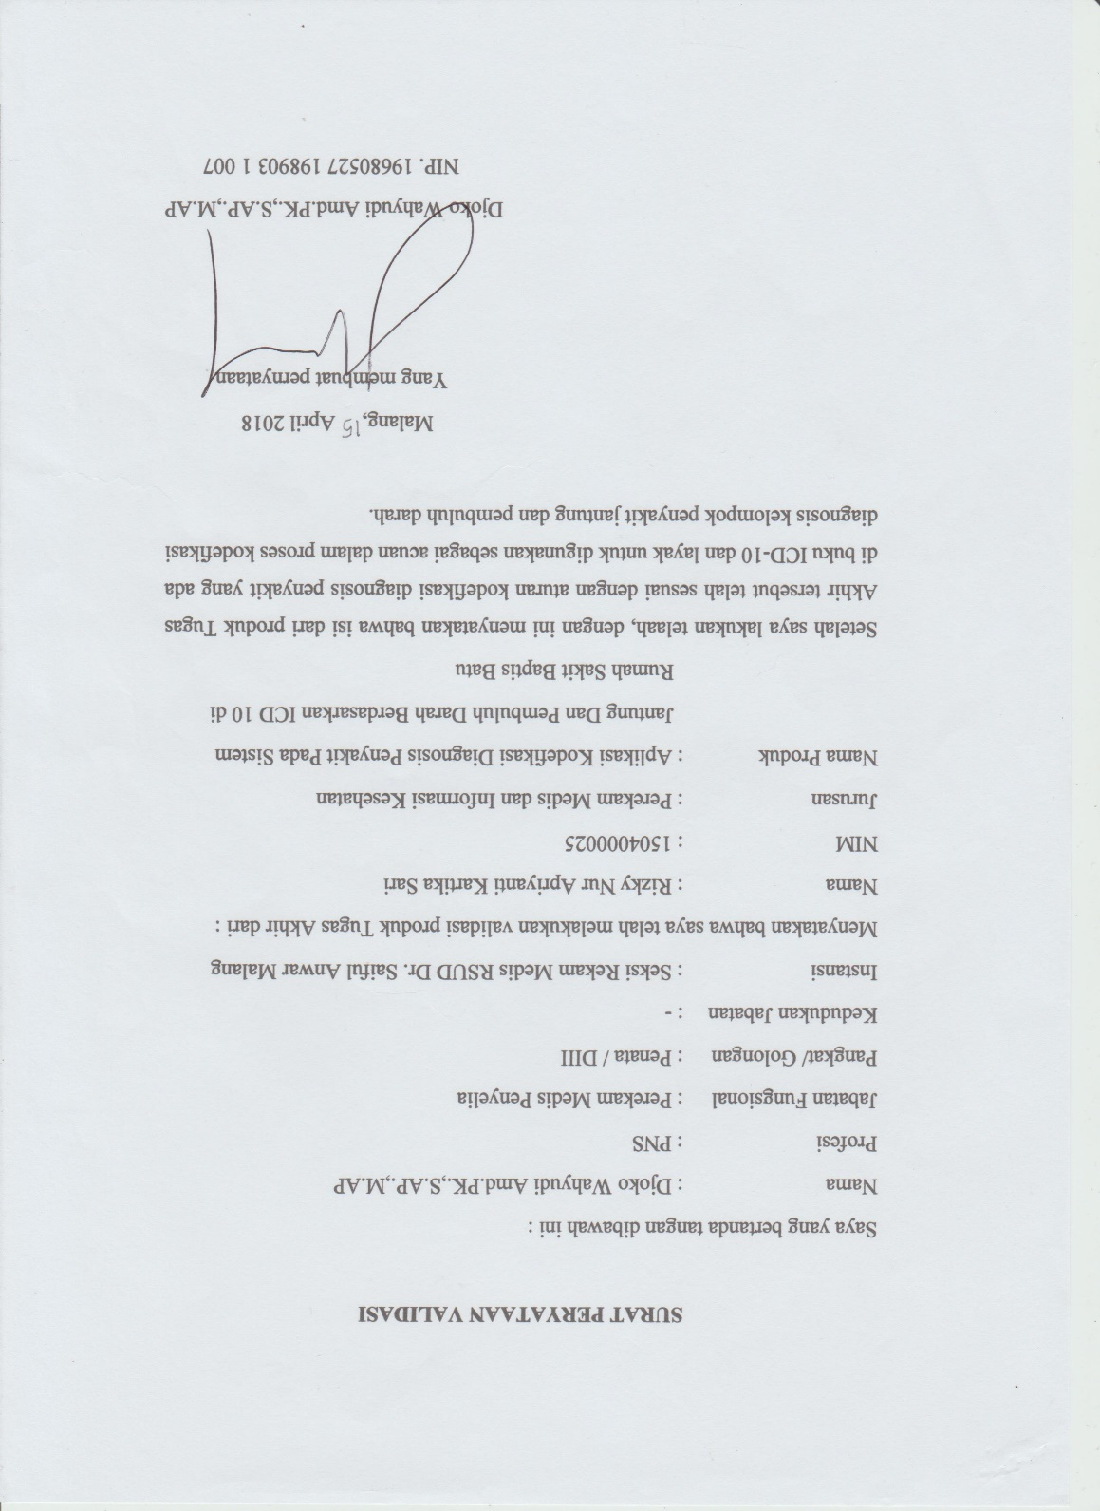

***Lampiran 7***

**Surat KeteranganValidasi Uji Black Box**

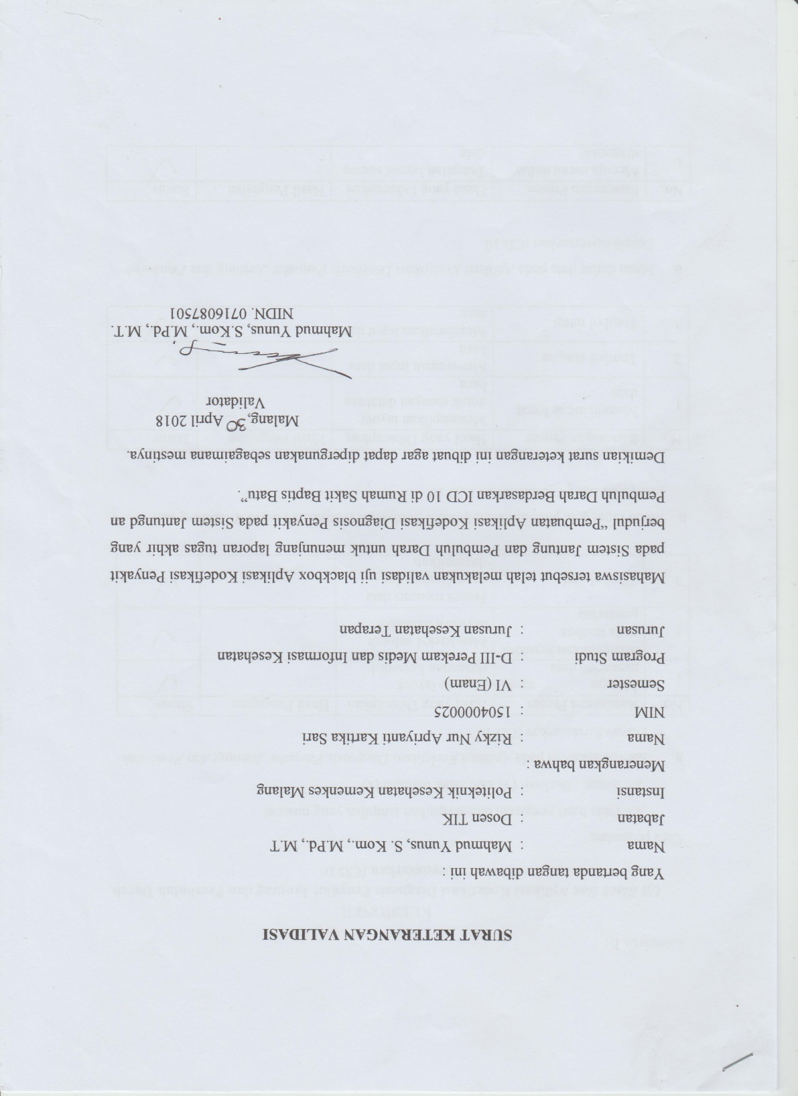

***Lampiran 8***

### **KUESIONER**

***Uji Black Box* Aplikasi Kodefikasi Diagnosis Penyakit Jantung dan Pembuluh Darah berdasarkan ICD 10**

Cara pengisian:

Pada hasil pengujian dituliskan “diterima” bila hasil yang muncul sesuai dengan yang diharapkan.

Status : Berhasil (√) atau tidak berhasil (x)

|  |  |  |  |  |
| --- | --- | --- | --- | --- |
| No | Rancangan Proses | Hasil yang Diharapkan | Hasil Pengujian | Status |
| 1 | Menu Log in | Login | Diterima | √ |
| 2 | Menuju menu pencarian data | Menuju layout pencarian keyword | Diterima | √ |
| 3 | Mengetikkan *keyword* pada textbox pencarian | Mendeteksi seluruh *keyword* database | Diterima | √ |
| 4 | Tombol cari | Proses mencari data yang diminta dan ditampilkan | Diterima | √ |
| 5 | Detail diagnosis | Menampilkan detail dari diagnosis yang dipilih | Diterima | √ |
| 6 | Daftar Diagnosis | Tampilan layout semua data | Diterima | √ |
| Jumlah | | | | 6 |
| Prosentase | | | | 100% |

***Lampiran 9***

### **LEMBAR CHEKLIST**

**HASIL OBSERVASI KETAKURATAN KODE DIAGNOSIS SEBELUM PENGGUNAAN APLIKASI**

Petunjuk Pengisian

* Pada kolom No Rekam Medis tulislah nomor sampel ( tiga digit dari belakang)
* Berilah tanda centang (🗸) pada kolom Akurat bila kode diagnosis penyakit akurat dan Tidak Akurat bila kode diagnosis penyakit tidak akurat.
* Pada kolom nilai keakuratan isi dengan nilai 1 jika akurat dan isi dengan nilai 0 bila tidak akurat
* Kolom keterangan digunakan untuk menulis kode diagnosa yang benar bila kode salah

|  |  |  |  |  |  |  |  |
| --- | --- | --- | --- | --- | --- | --- | --- |
| NO | No Rekam Medis | Diagnosa | Kode | keakuratan | | nilai keakuratan | keterangan |
| akurat | tidak akurat |
| 1 | xxx602 | Congestive Heart Failure | I50 |  | V | 0 | I50.0 |
| 2 | xx733 | Angina Pectoris | I20 |  | V | 0 | I20.9 |
| 3 | xxx514 | Cerebral Infraction | I63 |  | V | 0 | I63.9 |
| 4 | xxx416 | Cerebrovascular Accident Trombosis | I64 |  | V | 0 | I63.3 |
| 5 | xxx472 | Angina Pectoris | I20 |  | V | 0 | I20.9 |
| 6 | x292 | Hypertension | I10 | V |  | 1 |  |
| 7 | xxx979 | Nontransmural myocardial infraction, NOS | I21.9 |  | V | 0 | I21.4 |
| 8 | xx452 | Coronary Artery Disease | I25.9 |  | V | 0 | I25.1 |
| 9 | xxx746 | Heart Failure | I50.9 | V |  | 1 |  |
| 10 | xx842 | Atrial Fibrillation | I48 | V |  | 1 |  |
| 11 | xxx306 | Cerebrovascular Accident | I64 | V |  | 1 |  |
| 12 | x756 | Nontransmural myocardial infraction, NOS | I21 |  | V | 0 | I21.4 |
| 13 | xxx731 | Unstable Angina Pectoris | I20.9 |  | V | 0 | I20.0 |
| 14 | xx314 | Atrial Fibrillation | I50 |  | V | 0 | I48 |
| 15 | xx944 | Congestive Heart Failure | I50.9 |  | V | 0 | I50.0 |
| 16 | xx786 | Angina Pectoris | I20.9 | V |  | 1 |  |
| 17 | xxx738 | Cerebrovascular Accident | I64 | V |  | 1 |  |
| 18 | xxx187 | Rheumatic Heart Disease | I09.9 | V |  | 1 |  |
| 19 | xx863 | CHF+CKD | I50.9 |  | V | 0 | I13.0 |
| 20 | xx88 | Nontransmural myocardial infraction, NOS | I21.9 |  | V | 0 | I21.4 |
| 21 | xx116 | Cerebral Infraction | I63 |  | V | 0 | I63.9 |
| 22 | xxx817 | Hypertensive Heart Disease | I11.9 | V |  | 1 |  |
| 23 | x536 | Coronary Artery Disease | I25.9 |  | V | 0 | I25.1 |
| 24 | xx534 | Hypertension | I10 | V |  | 1 |  |
| 25 | xx949 | Angina Pectoris | I20.9 | V |  | 1 |  |
| 26 | xxx880 | Congestive Heart Failure | I50.9 |  | V | 0 | I50.0 |
| 27 | xxx607 | Congestive Heart Failure | I50.9 |  | V | 0 | I50.0 |
| 28 | xx267 | CVA thrombosis | I64 |  | V | 0 | I63.3 |
| 29 | xx516 | Cerebrovascular Accident | I64 | V |  | 1 |  |
| 30 | xxx672 | Unstable Angina Pectoris | I20.9 |  | V | 0 | I20.0 |
| Total | | | | 11 | 19 | Prosentase Keakuratan | |
| 37% | |

### **LEMBAR CHEKLIST**

**HASIL OBSERVASI KETAKURATAN KODE DIAGNOSIS MENGGUNAKAN APLIKASI**

Petunjuk Pengisian

* Pada kolom No Rekam Medis tulislah nomor sampel ( tiga digit dari belakang)
* Berilah tanda centang (🗸) pada kolom Akurat bila kode diagnosis penyakit akurat dan Tidak Akurat bila kode diagnosis penyakit tidak akurat.
* Pada kolom nilai keakuratan isi dengan nilai 1 jika akurat dan isi dengan nilai 0 bila tidak akurat
* Kolom keterangan digunakan untuk menulis kode diagnosa yang benar bila kode salah

|  |  |  |  |  |  |  |  |
| --- | --- | --- | --- | --- | --- | --- | --- |
| NO | No Rekam Medis | Diagnosa | Kode | keakuratan | | nilai keakuratan | Keterangan |
| akurat | tidak akurat |
| 1 | XXX664 | Cerebrovascular Accident | I64 | V |  | 1 |  |
| 2 | XXX665 | Hypertension | I10 | V |  | 1 |  |
| 3 | XXX666 | Hypertension | I10 | V |  | 1 |  |
| 4 | XXX947 | Hypertensive Heart Disease | I11.9 | V |  | 1 |  |
| 5 | XXX010 | Cerebrovascular Accident | I64 | V |  | 1 |  |
| 6 | XX519 | Cerebrovascular Accident | I64 | V |  | 1 |  |
| 7 | XXX156 | Atrial Fibrillation | I48 | V |  | 1 |  |
| 8 | XXX456 | Congestive Heart Failure | I50.0 | V |  | 1 |  |
| 9 | XXX985 | Coronary Artery Disease | I25.1 | V |  | 1 |  |
| 10 | XXX422 | Atrial Fibrillation | I10 |  | V | 0 | I48 |
| 11 | XX760 | Coronary Artery Disease | I50.0 |  | V | 0 | I25.1 |
| 12 | XXX156 | Cerebral Infraction | I63.9 | V |  | 1 |  |
| 13 | XX104 | Cerebrovascular Accident | I64 | V |  | 1 |  |
| 14 | XX412 | Hypertensive Heart Disease | I11.9 | V |  | 1 |  |
| 15 | XX093 | Hypertension | I10 | V |  | 1 |  |
| 16 | XX883 | Cerebral Infractio | I63.9 | V |  | 1 |  |
| 17 | XX663 | Angina Pectoris | I20 |  | V | 0 | I20.9 |
| 18 | XXX147 | Cerebrovascular Accident trombosis | I63.9 | V |  | 1 |  |
| 19 | XX469 | Angina Pectoris | I20 |  | V | 0 | I20.9 |
| 20 | XXX210 | Cerebral Infraction | I63.9 | V |  | 1 |  |
| 21 | XXX284 | Rheumatic Heart Disease | 109.9 | V |  | 1 |  |
| 22 | XX083 | Congestive Heart Failure | I50.0 | V |  | 1 |  |
| 23 | XX216 | Cerebrovascular Accident | I64 | V |  | 1 |  |
| 24 | XXX904 | Hypertensive Heart Disease | I11 |  | V | 0 | I11.9 |
| 25 | X1615 | Nontransmural myocardial infraction, NOS | I21.4 | V |  | 1 |  |
| 26 | XXX015 | Hypertension | I10 | V |  | 1 |  |
| 27 | XX221 | Nontransmural myocardial infraction, NOS | I21.4 | V |  | 1 |  |
| 28 | XX469 | Rheumatic Heart Disease | I09.0 | V |  | 1 |  |
| 29 | XXX885 | Hypertensive Heart Disease | I11.9 | V |  | 1 |  |
| 30 | XX556 | Congestive Heart Failure | I50.0 | V |  | 1 |  |
| Total | | | | 25 | 5 | Prosentase Keakuratan | |
| 83% | |

***Lampiran 5***

**Surat Validasi Dokter Terkait**

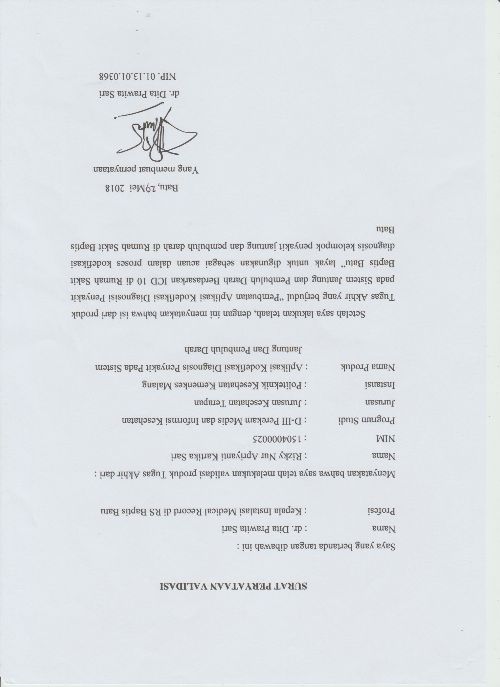

***Lampiran 4***

**Informed Consent**

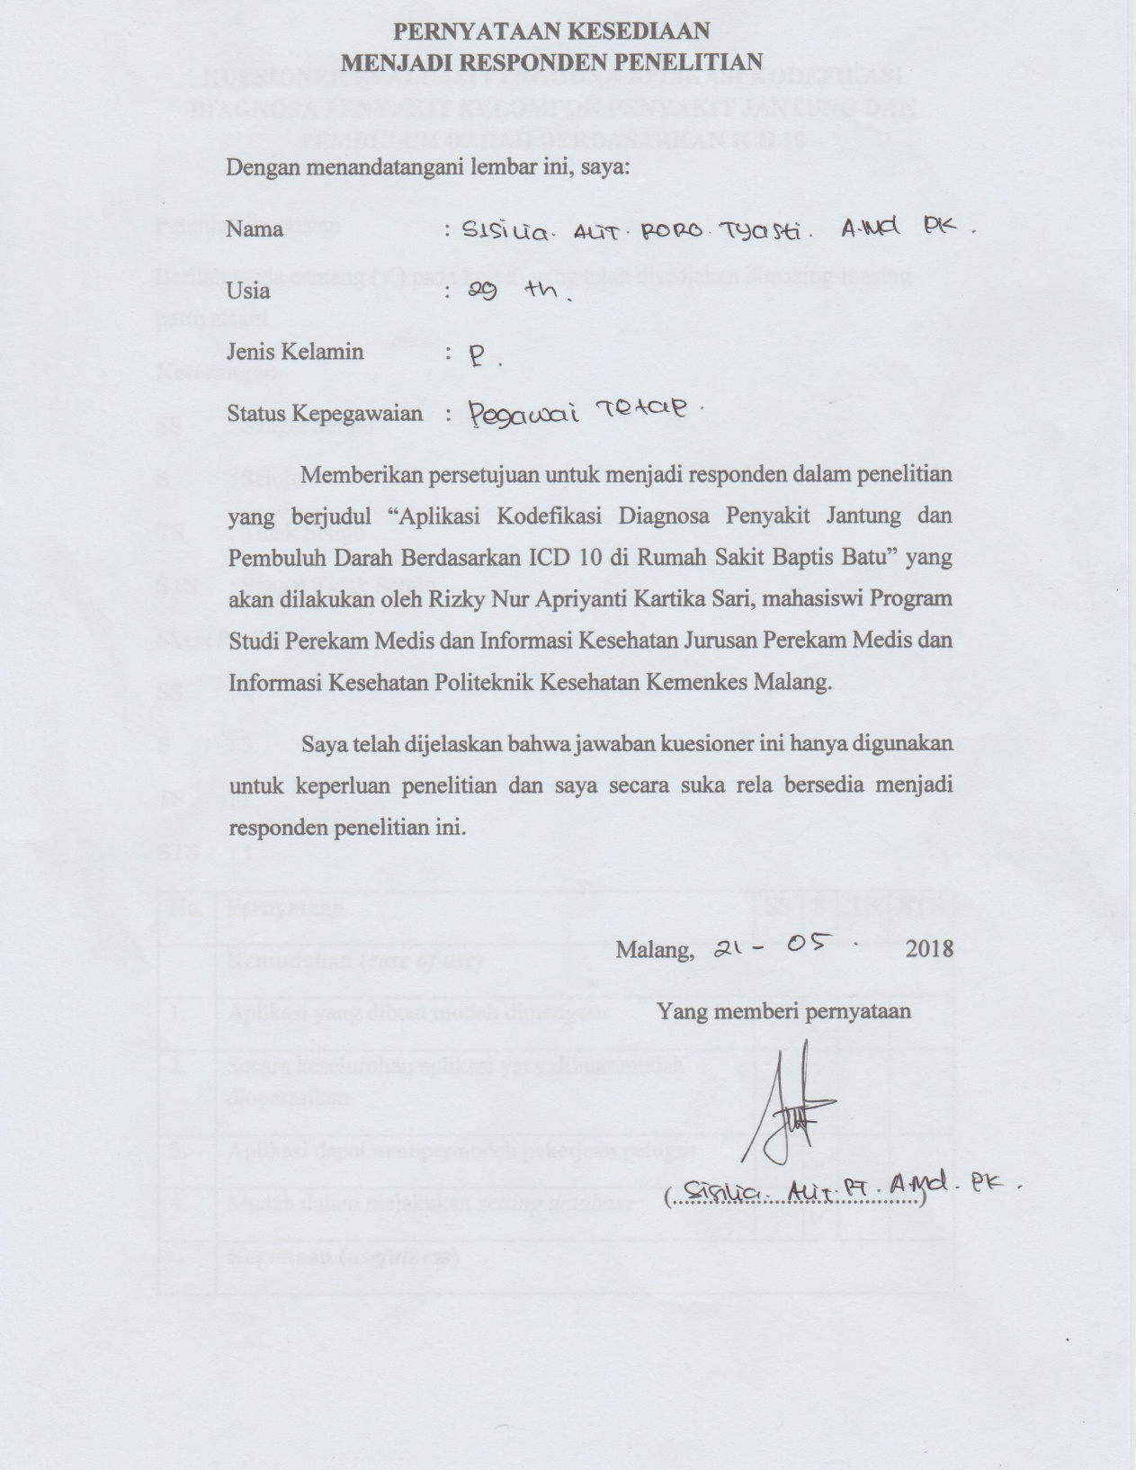

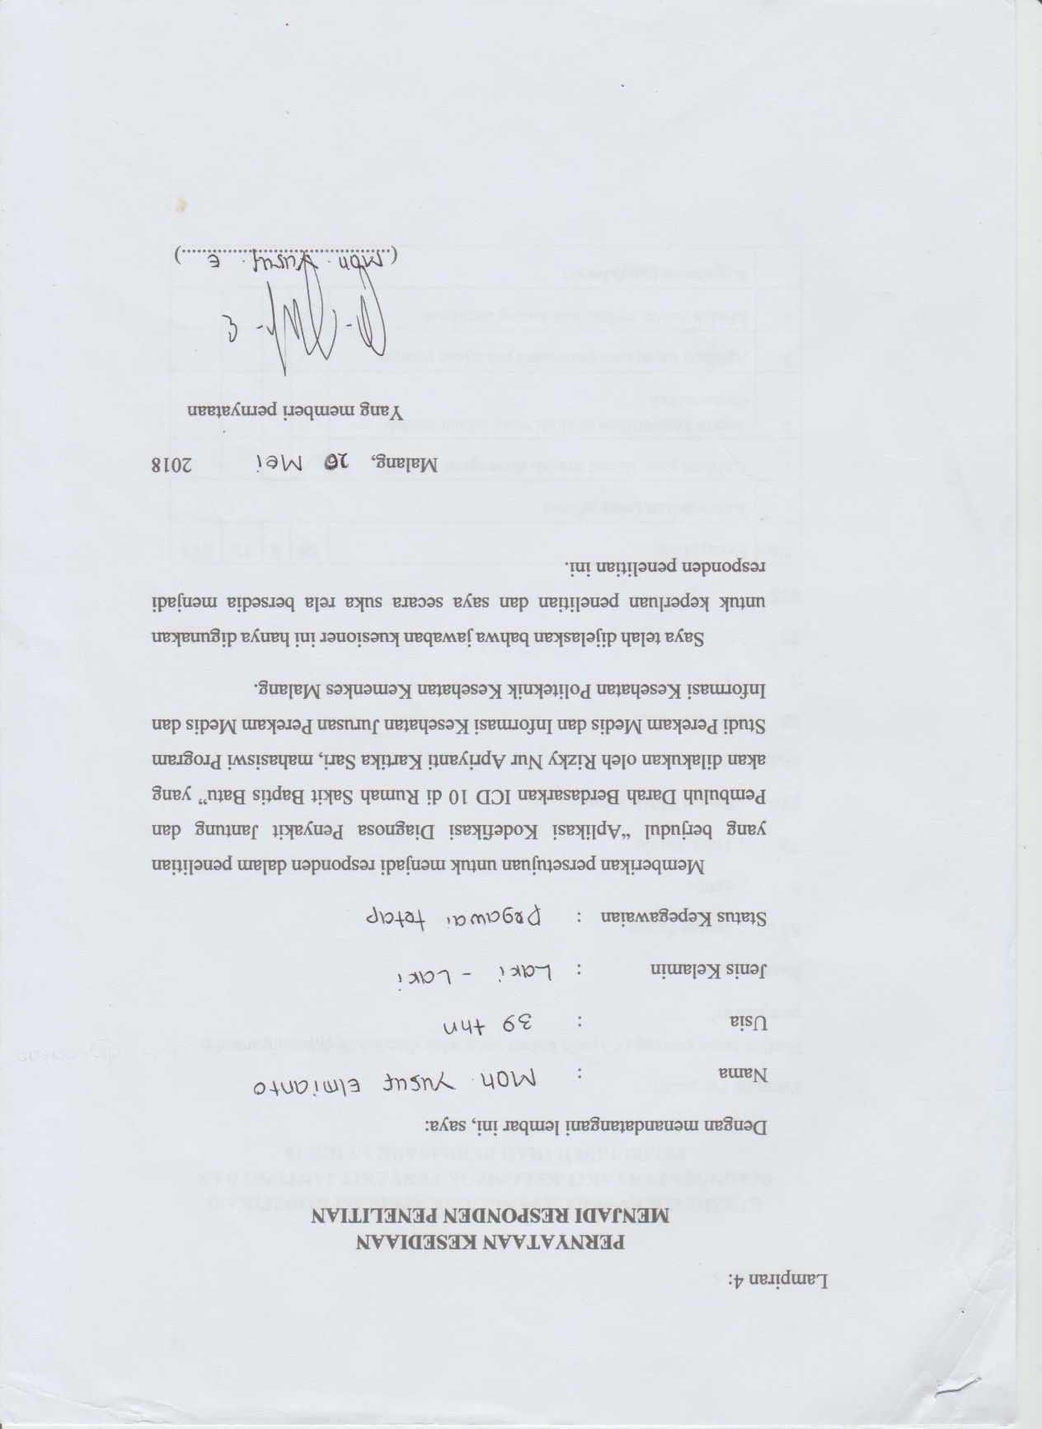

***Lampiran 10***



