**LAMPIRAN**

**LAMPIRAN 1 Surat Permohonan**

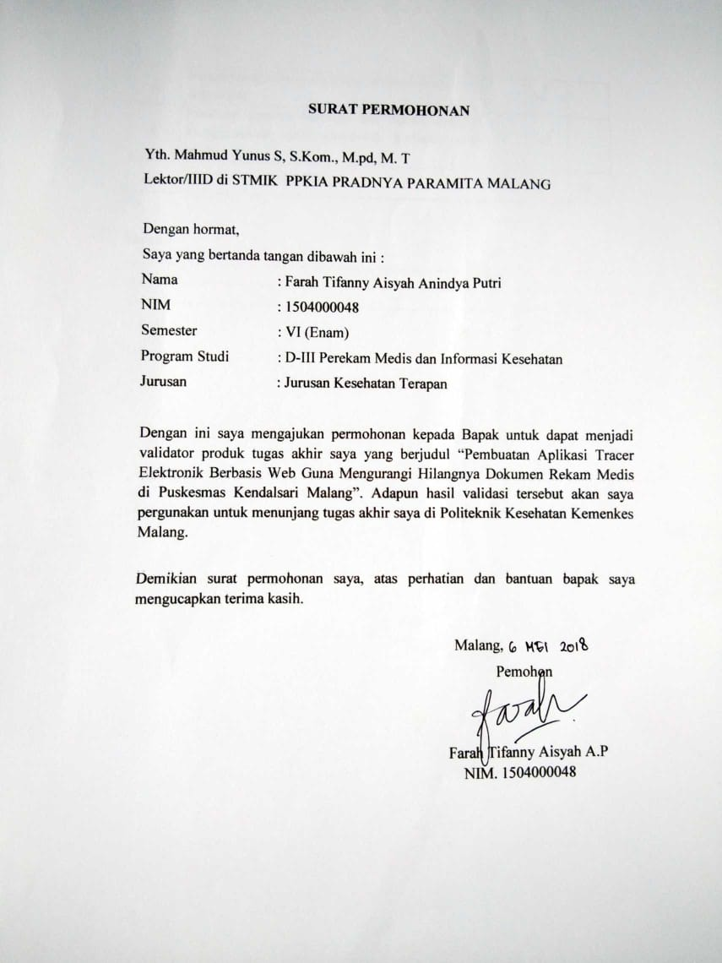

**LAMPIRAN 2 Surat Pernyataan Validasi**

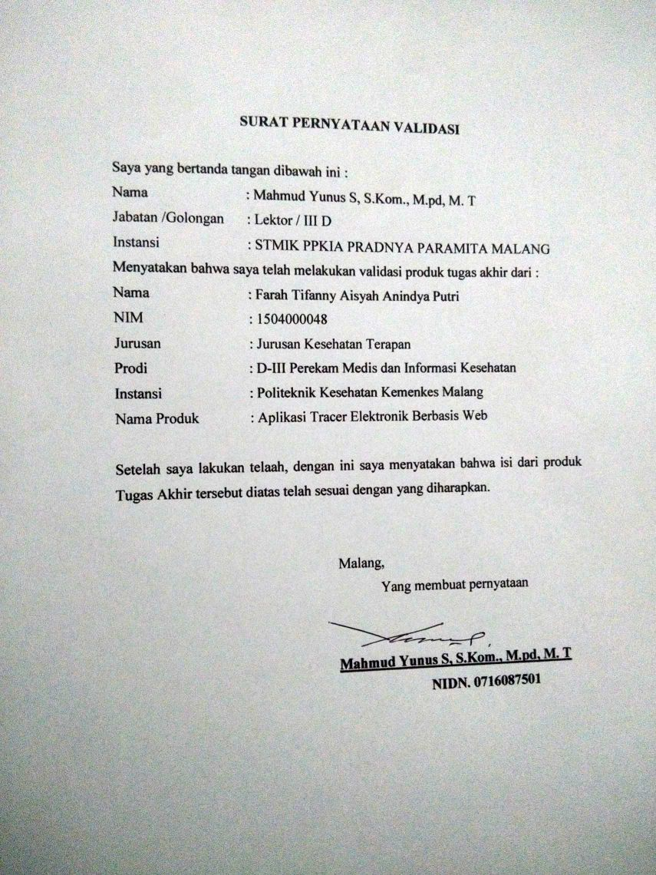

**LAMPIRAN 3 Surat Izin Penelitian**

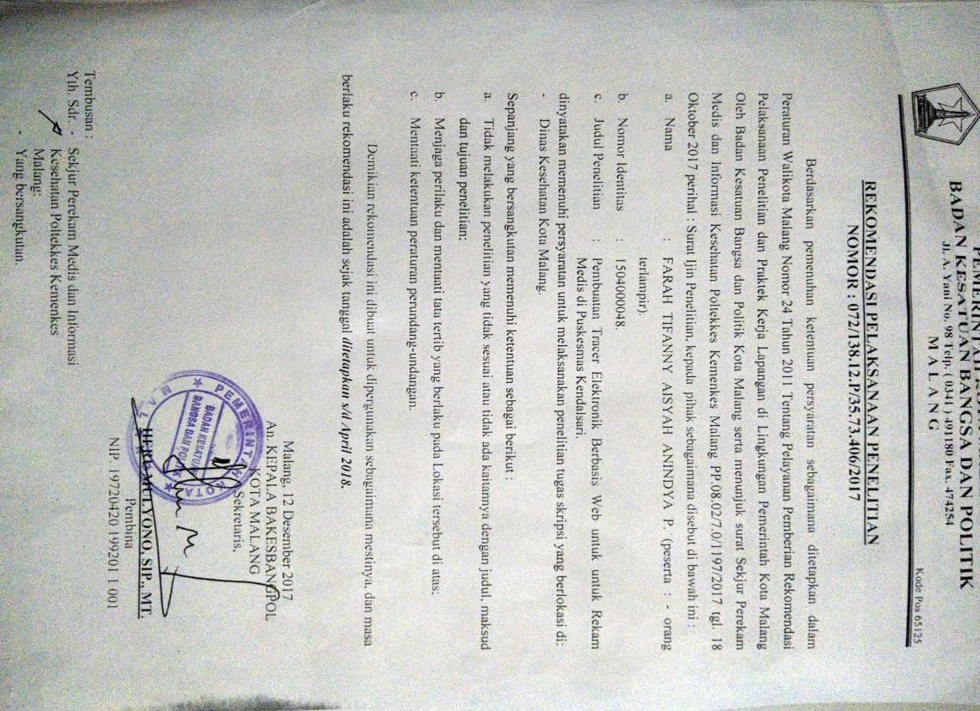

**LAMPIRAN 4 Surat Pernyataan Kesanggupan Validator**

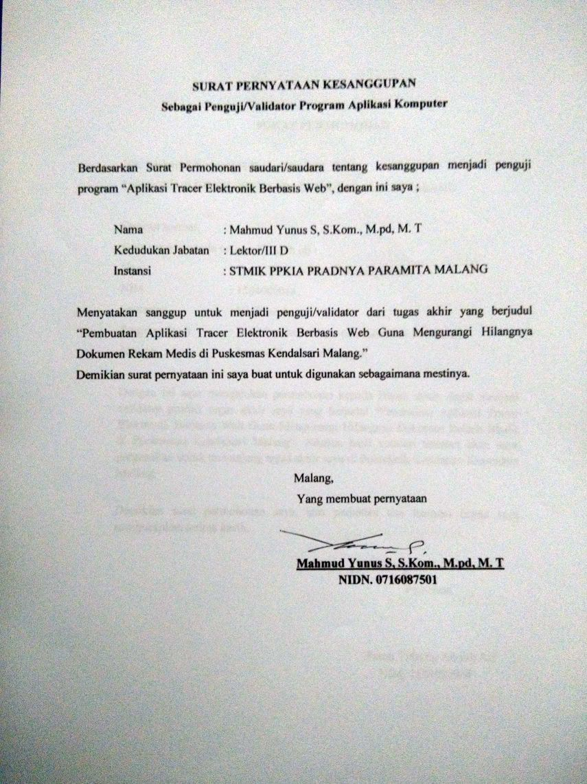

**LAMPIRAN 5 Lembar Uji Blackbox**

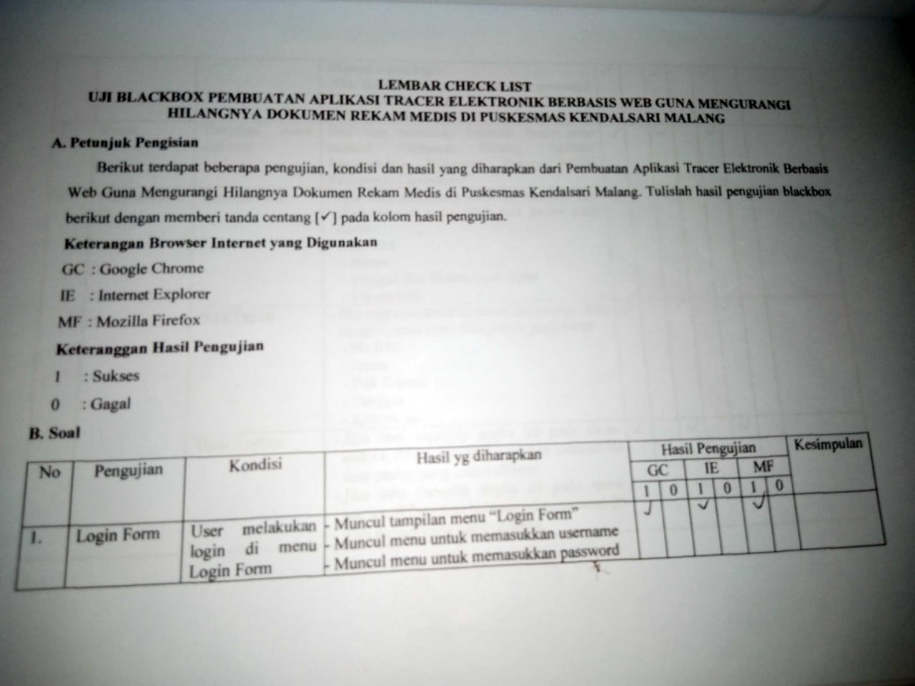

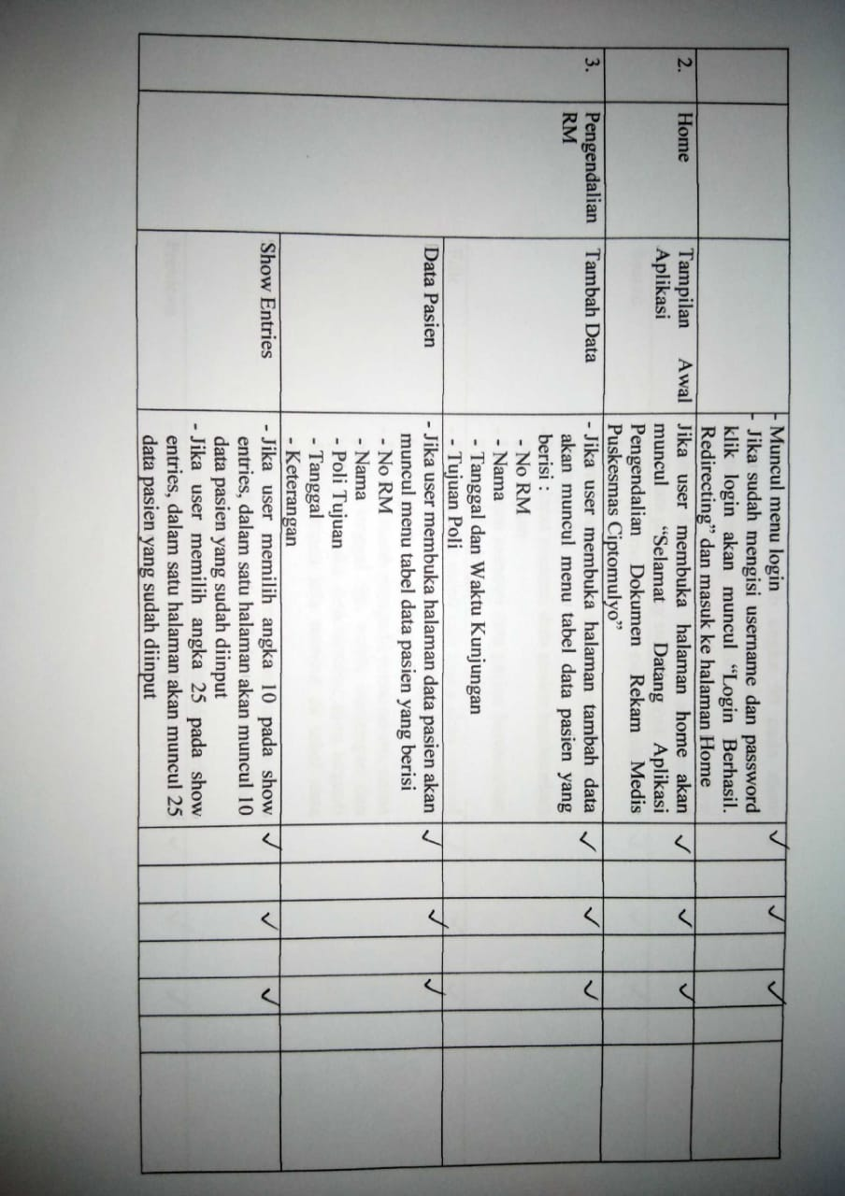

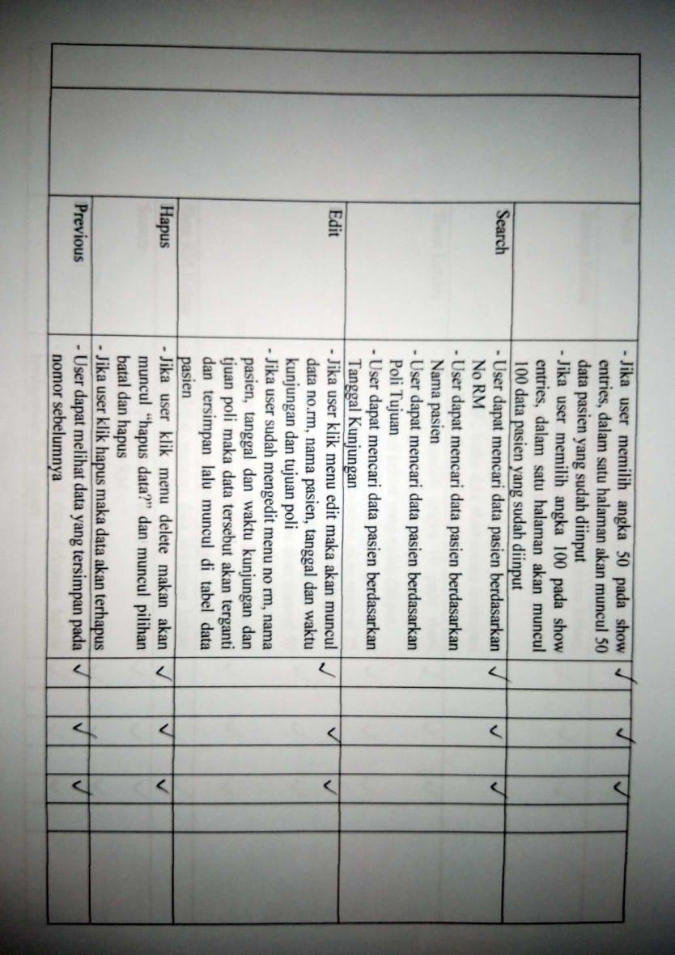

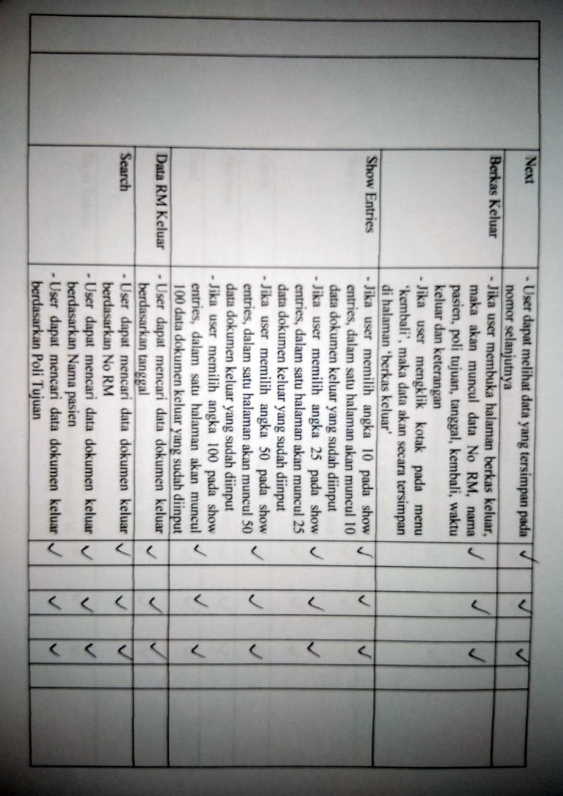

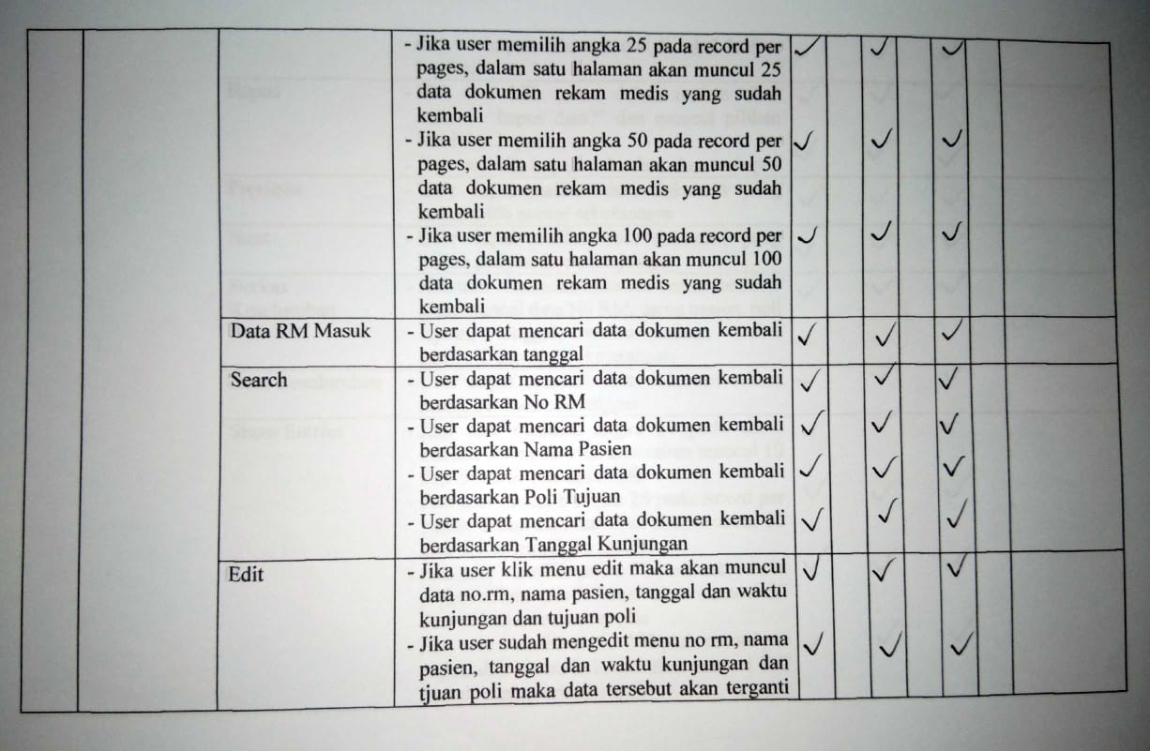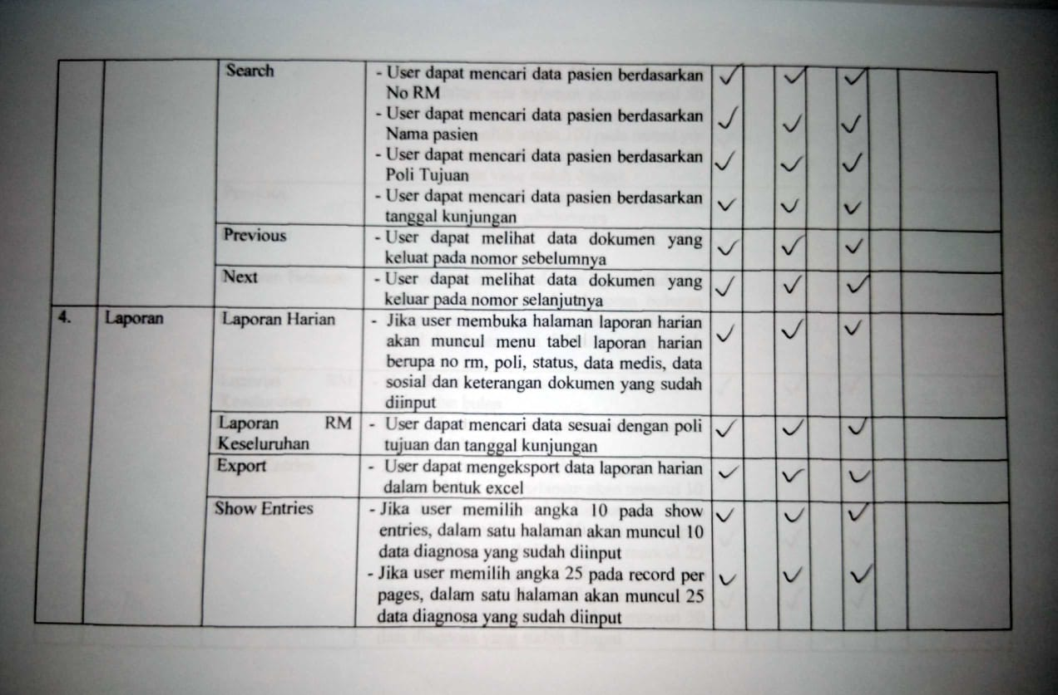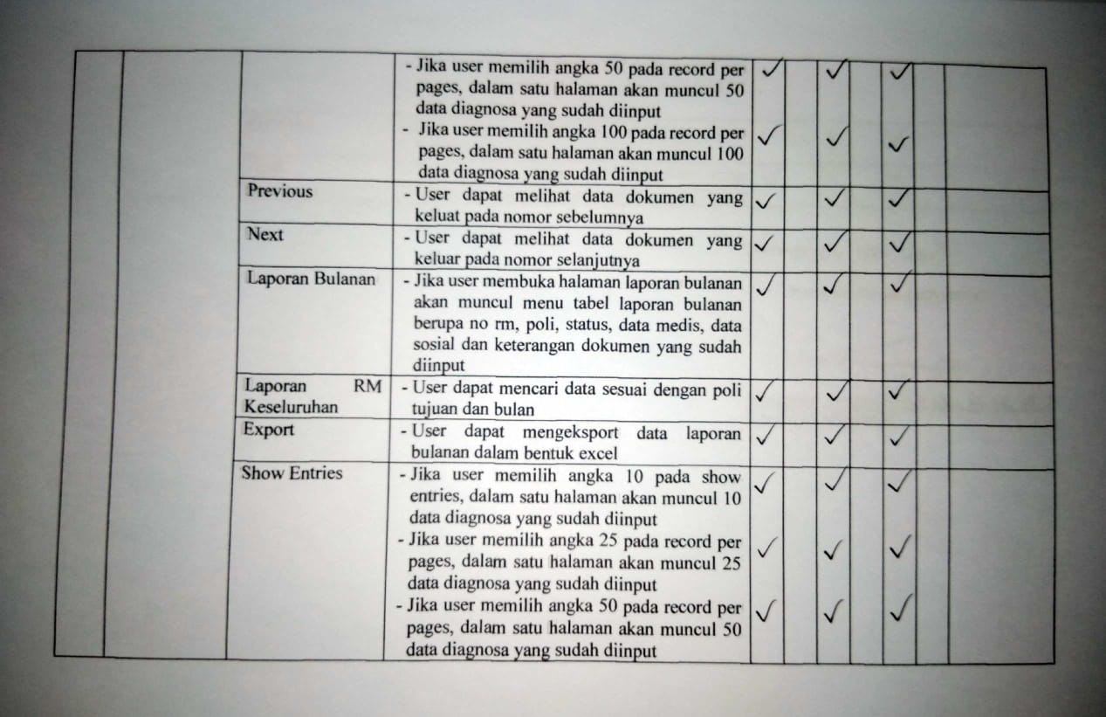

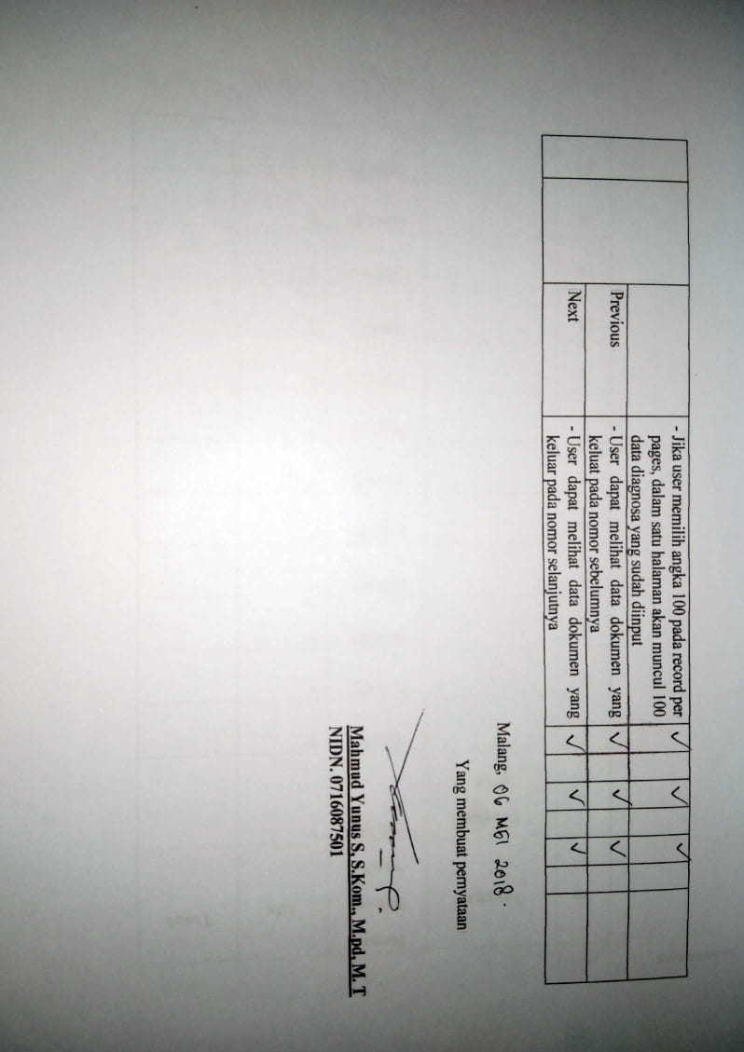

**Lampiran 6 Lembar Kuesioner Penelitian** 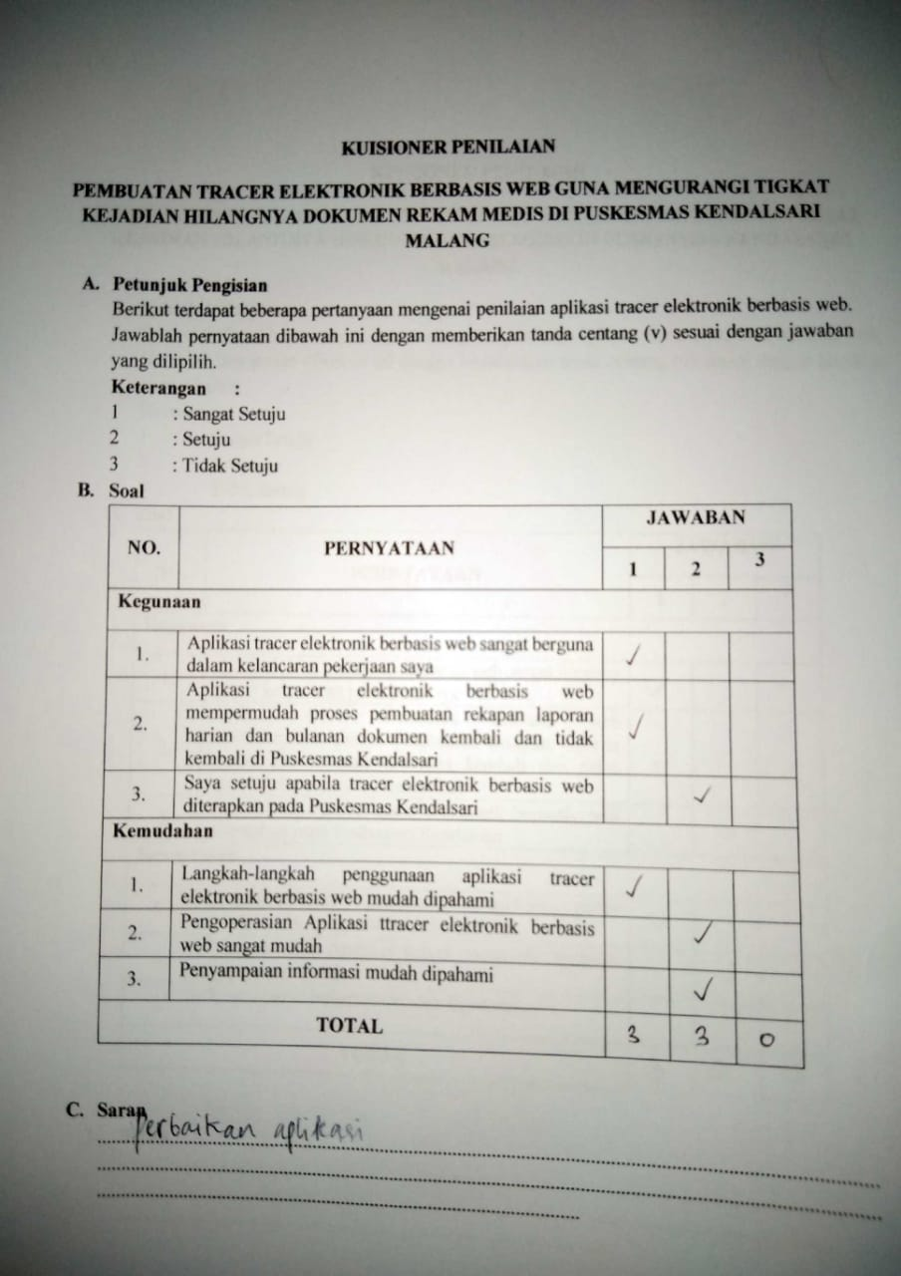

**Lembar Kuesioner Penelitian 2**

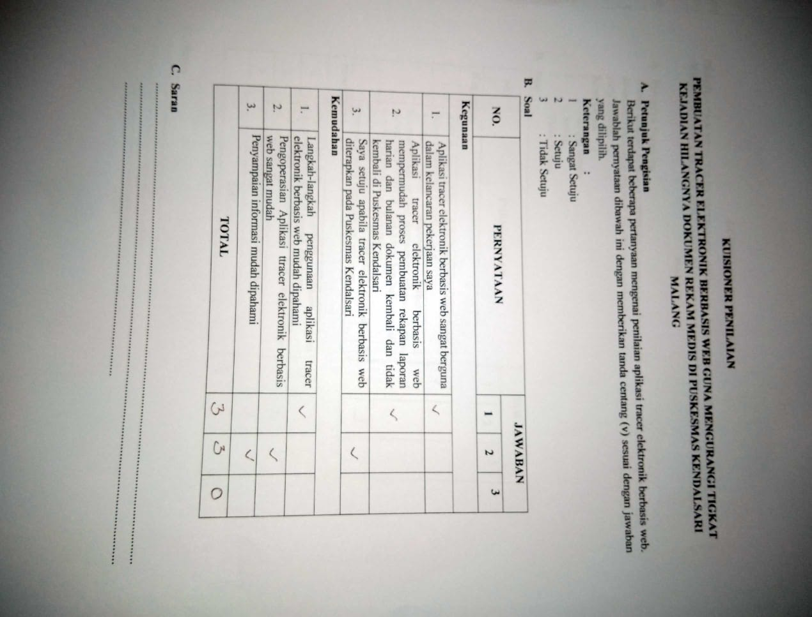

**Lembar Kuesioner Penelitian 3**

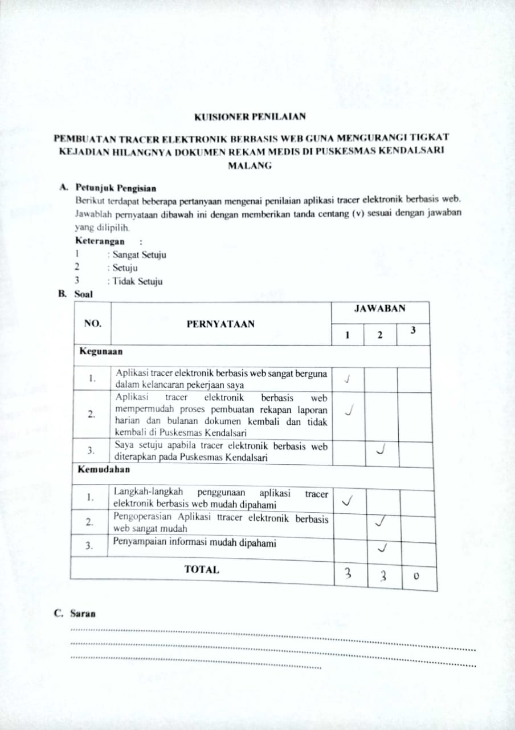

**Lampiran 7 Data Identifikasi Dokumen**

**Sebelum menggunakan Aplikasi**

|  |  |  |  |  |
| --- | --- | --- | --- | --- |
| **No** | **Tanggal** | **Nomor Rekam Medis** | **Ada** | **Tidak** |
| **1.** | **07/02/18** | **020383** | **V** |  |
| **2.** |  | **020389** | **V** |  |
| **3.** |  | **020392** | **V** |  |
| **4.** |  | **020407** | **V** |  |
| **5.** |  | **020397** | **V** |  |
| **6.** |  | **020400** | **V** |  |
| **7.** |  | **020119** | **V** |  |
| **8.** |  | **020130** | **V** |  |
| **9.** |  | **020122** | **V** |  |
| **10.** |  | **020157** | **V** |  |
| **11.** |  | **020162** | **V** |  |
| **12.** |  | **020153** | **V** |  |
| **13.** |  | **020151** | **V** |  |
| **14.** |  | **020168** | **V** |  |
| **15.** |  | **020160** | **V** |  |
| **16.** |  | **020163** | **V** |  |
| **17.** |  | **020185** | **V** |  |
| **18.** |  | **020176** | **V** |  |
| **19.** |  | **020186** | **V** |  |
| **20.** |  | **020196** |  | **V** |
| **21.** |  | **020198** | **V** |  |
| **22.** |  | **020188** | **V** |  |
| **23.** |  | **020201** | **V** |  |
| **24.** |  | **020205** | **V** |  |
| **25.** |  | **020208** | **V** |  |
| **26.** |  | **020210** | **V** |  |
| **27.** |  | **020219** | **V** |  |
| **28.** |  | **020223** | **V** |  |
| **29.** |  | **020232** | **V** |  |
| **30.** |  | **020235** | **V** |  |
| **31.** |  | **020237** | **V** |  |
| **32.** |  | **020239** | **V** |  |
| **33.** |  | **020246** | **V** |  |
| **34.** |  | **020250** | **V** |  |
| **35.** |  | **020247** | **V** |  |
| **36.** |  | **020252** | **V** |  |
| **37.** |  | **020255** | **V** |  |
| **38.** |  | **020260** |  | **V** |
| **39.** |  | **020261** | **V** |  |
| **40.** |  | **020266** | **V** |  |
| **41.** |  | **020268** | **V** |  |
| **42.** |  | **020269** | **V** |  |
| **43.** |  | **020270** | **V** |  |
| **44.** |  | **020276** | **V** |  |
| **45.** |  | **020278** | **V** |  |
| **46.** |  | **020277** | **V** |  |
| **47.** |  | **020279** | **V** |  |
| **48.** |  | **020280** | **V** |  |
| **49.** |  | **030579** | **V** |  |
| **50.** |  | **031353** | **V** |  |
| **51.** |  | **031139** | **V** |  |
| **52.** |  | **031625** | **V** |  |
| **53.** |  | **030146** | **V** |  |
| **54.** |  | **030929** | **V** |  |
| **55.** |  | **041294** | **V** |  |
| **56.** |  | **041563** | **V** |  |
| **57.** |  | **040554** | **V** |  |
| **58.** |  | **040822** | **V** |  |
| **59.** |  | **040988** | **V** |  |
| **60.** |  | **041049** | **V** |  |
| **61.** |  | **040494** | **V** |  |
| **62.** |  | **041215** | **V** |  |
| **63.** |  | **040038** | **V** |  |
| **64.** |  | **040917** | **V** |  |
| **65.** |  | **041266** | **V** |  |
| **66.** |  | **020394** | **V** |  |
| **67.** |  | **020384** | **V** |  |
| **68.** |  | **020388** | **V** |  |
| **69.** |  | **010388** |  | **V** |
| **70.** |  | **020453** | **V** |  |
| **71.** |  | **020455** | **V** |  |
| **72.** |  | **020463** | **V** |  |
| **73.** |  | **020457** | **V** |  |
| **74.** |  | **024075** | **V** |  |
| **75.** |  | **020459** | **V** |  |
| **76.** |  | **020461** | **V** |  |
| **77.** |  | **024016** | **V** |  |
| **78.** |  | **020464** | **V** |  |
| **79.** |  | **0200446** | **V** |  |
| **80.** |  | **020466** | **V** |  |
| **81.** |  | **020468** | **V** |  |
| **82.** |  | **020469** | **V** |  |
| **83.** |  | **020473** | **V** |  |
| **84.** |  | **020478** | **V** |  |
| **85.** |  | **020480** | **V** |  |
| **86.** |  | **020482** | **V** |  |
| **87.** |  | **020475** | **V** |  |
| **88.** |  | **020472** | **V** |  |
| **89.** |  | **020471** | **V** |  |
| **90.** |  | **020479** | **V** |  |
| **91.** |  | **020481** | **V** |  |
| **92.** |  | **020527** | **V** |  |
| **93.** |  | **020523** | **V** |  |
| **94.** |  | **020519** | **V** |  |
| **95.** |  | **020526** | **V** |  |
| **96.** |  | **020549** |  | **V** |
| **97.** |  | **020542** | **V** |  |
| **98.** |  | **020545** | **V** |  |
| **99.** |  | **020572** | **V** |  |
| **100.** |  | **020569** | **V** |  |
| **101.** |  | **020562** | **V** |  |
| **102.** |  | **020567** | **V** |  |
| **103.** |  | **020564** | **V** |  |
| **104.** |  | **020571** | **V** |  |
| **105.** |  | **020578** | **V** |  |
| **106.** |  | **020586** | **V** |  |
| **107.** |  | **020581** | **V** |  |
| **108.** |  | **020587** | **V** |  |
| **109.** |  | **020590** | **V** |  |
| **110.** |  | **020597** | **V** |  |
| **111.** |  | **020614** | **V** |  |
| **112.** |  | **020608** | **V** |  |
| **113.** |  | **020655** | **V** |  |
| **114.** |  | **020650** | **V** |  |
| **115.** |  | **020646** | **V** |  |
| **116.** |  | **020652** |  | **V** |
| **117.** |  | **020688** | **V** |  |
| **118.** |  | **020680** | **V** |  |
| **119.** |  | **020683** | **V** |  |
| **120.** |  | **020714** | **V** |  |
| **121.** |  | **020707** |  | **V** |
| **122.** |  | **020712** | **V** |  |
| **1.** | **8 Februari 2018** | **020704** | **V** |  |
| **2.** |  | **020711** | **V** |  |
| **3.** |  | **020735** | **V** |  |
| **4.** |  | **020728** | **V** |  |
| **5.** |  | **020732** | **V** |  |
| **6.** |  | **020768** | **V** |  |
| **7.** |  | **020762** | **V** |  |
| **8.** |  | **020794** | **V** |  |
| **9.** |  | **020790** | **V** |  |
| **10.** |  | **020786** | **V** |  |
| **11.** |  | **020789** |  | **V** |
| **12.** |  | **020807** | **V** |  |
| **13.** |  | **020799** | **V** |  |
| **14.** |  | **020813** | **V** |  |
| **15.** |  | **020810** | **V** |  |
| **16.** |  | **020826** | **V** |  |
| **17.** |  | **020818** | **V** |  |
| **18.** |  | **020820** | **V** |  |
| **19.** |  | **020823** | **V** |  |
| **20.** |  | **020834** | **V** |  |
| **21.** |  | **020837** |  | **V** |
| **22.** |  | **020842** | **V** |  |
| **23.** |  | **020845** | **V** |  |
| **24.** |  | **020783** | **V** |  |
| **25.** |  | **020788** | **V** |  |
| **26.** |  | **020791** | **V** |  |
| **27.** |  | **020764** | **V** |  |
| **28.** |  | **020759** | **V** |  |
| **29.** |  | **010556** | **V** |  |
| **30.** |  | **010560** | **V** |  |
| **31.** |  | **020401** |  | **V** |
| **32.** |  | **030407** | **V** |  |
| **33.** |  | **030411** | **V** |  |
| **34.** |  | **030413** | **V** |  |
| **35.** |  | **040013** | **V** |  |
| **36.** |  | **040006** | **V** |  |
| **37.** |  | **010652** | **V** |  |
| **38.** |  | **010657** | **V** |  |
| **39.** |  | **030410** | **V** |  |
| **40.** |  | **030428** |  | **V** |
| **41.** |  | **030420** | **V** |  |
| **42.** |  | **030449** | **V** |  |
| **43.** |  | **030440** | **V** |  |
| **44.** |  | **030482** | **V** |  |
| **45.** |  | **020474** | **V** |  |
| **46.** |  | **030477** | **V** |  |
| **47.** |  | **030481** | **V** |  |
| **48.** |  | **030509** | **V** |  |
| **49.** |  | **020721** | **V** |  |
| **50.** |  | **020661** | **V** |  |
| **51.** |  | **020623** | **V** |  |
| **52.** |  | **020626** | **V** |  |
| **53.** |  | **020631** | **V** |  |
| **54.** |  | **010567** | **V** |  |
| **55.** |  | **010562** | **V** |  |
| **56.** |  | **010568** |  | **V** |
| **57.** |  | **020466** | **V** |  |
| **58.** |  | **030456** | **V** |  |
| **59.** |  | **030460** | **V** |  |
| **60.** |  | **030461** | **V** |  |
| **61.** |  | **040009** | **V** |  |
| **62.** |  | **010656** | **V** |  |
| **63.** |  | **010565** | **V** |  |
| **64.** |  | **010564** |  | **V** |
| **65.** |  | **020629** | **V** |  |
| **66.** |  | **020681** | **V** |  |
| **67.** |  | **030397** | **V** |  |
| **68.** |  | **010628** | **V** |  |
| **69.** |  | **010638** | **V** |  |
| **70.** |  | **030304** | **V** |  |
| **71.** |  | **030312** | **V** |  |
| **72.** |  | **020601** | **V** |  |
| **73.** |  | **020560** | **V** |  |
| **74.** |  | **020503** | **V** |  |
| **75.** |  | **030306** | **V** |  |
| **76.** |  | **040050** | **V** |  |
| **77.** |  | **040080** | **V** |  |
| **78.** |  | **010632** | **V** |  |
| **79.** |  | **010508** | **V** |  |
| **80.** |  | **010423** | **V** |  |
| **81.** |  | **020468** | **V** |  |
| **82.** |  | **020492** | **V** |  |
| **83.** |  | **020360** | **V** |  |
| **84.** |  | **020370** | **V** |  |
| **85.** |  | **020365** | **V** |  |
| **86.** |  | **030251** | **V** |  |
| **87.** |  | **010430** | **V** |  |
| **88.** |  | **020377** | **V** |  |
| **89.** |  | **020374** | **V** |  |
| **90.** |  | **030257** | **V** |  |
| **91.** |  | **030313** |  | **V** |
| **92.** |  | **030357** | **V** |  |
| **93.** |  | **030377** | **V** |  |
| **94.** |  | **030249** | **V** |  |
| **95.** |  | **030247** | **V** |  |
| **96.** |  | **030126** | **V** |  |
| **97.** |  | **020366** | **V** |  |
| **98.** |  | **020398** | **V** |  |
| **99.** |  | **020395** | **V** |  |
| **100.** |  | **010427** | **V** |  |
| **101.** |  | **010433** | **V** |  |
| **102.** |  | **020394** | **V** |  |
| **103.** |  | **020364** | **V** |  |
| **104.** |  | **020369** | **V** |  |
| **105.** |  | **010434** | **V** |  |
| **106.** |  | **010439** | **V** |  |
| **107.** |  | **030174** | **V** |  |
| **108.** |  | **030113** | **V** |  |
| **109.** |  | **020401** | **V** |  |
| **110.** |  | **010451** | **V** |  |
| **111.** |  | **020320** | **V** |  |
| **112.** |  | **020330** | **V** |  |
| **113.** |  | **010459** | **V** |  |
| **114.** |  | **020326** | **V** |  |
| **115.** |  | **030125** | **V** |  |
| **116.** |  | **030013** | **V** |  |
| **117.** |  | **020353** | **V** |  |
| **118.** |  | **020281** | **V** |  |
| **119.** |  | **020181** | **V** |  |
| **1.** | **9 Februari 2018** | **020190** | **V** |  |
| **2.** |  | **020175** | **V** |  |
| **3.** |  | **030005** | **V** |  |
| **4.** |  | **040032** | **V** |  |
| **5.** |  | **010444** | **V** |  |
| **6.** |  | **010002** | **V** |  |
| **7.** |  | **010010** | **V** |  |
| **8.** |  | **020002** | **V** |  |
| **9.** |  | **020010** | **V** |  |
| **10.** |  | **020017** | **V** |  |
| **11.** |  | **020023** | **V** |  |
| **12.** |  | **030109** |  | **V** |
| **13.** |  | **030340** | **V** |  |
| **14.** |  | **030334** | **V** |  |
| **15.** |  | **030540** | **V** |  |
| **16.** |  | **040350** | **V** |  |
| **17.** |  | **010633** | **V** |  |
| **18.** |  | **010678** | **V** |  |
| **19.** |  | **040606** | **V** |  |
| **20.** |  | **040236** | **V** |  |
| **21.** |  | **040242** | **V** |  |
| **22.** |  | **030544** | **V** |  |
| **23.** |  | **020019** | **V** |  |
| **24.** |  | **010143** | **V** |  |
| **25.** |  | **010291** | **V** |  |
| **26.** |  | **010295** | **V** |  |
| **27.** |  | **010354** |  | **V** |
| **28.** |  | **010359** | **V** |  |
| **29.** |  | **020210** | **V** |  |
| **30.** |  | **020215** | **V** |  |
| **31.** |  | **010351** | **V** |  |
| **32.** |  | **020207** | **V** |  |
| **33.** |  | **030690** | **V** |  |
| **34.** |  | **020220** | **V** |  |
| **35.** |  | **030701** | **V** |  |
| **36.** |  | **030694** |  | **V** |
| **37.** |  | **040246** | **V** |  |
| **38.** |  | **010683** | **V** |  |
| **39.** |  | **010330** | **V** |  |
| **40.** |  | **010325** | **V** |  |
| **41.** |  | **010327** | **V** |  |
| **42.** |  | **040001** | **V** |  |
| **43.** |  | **030020** | **V** |  |
| **44.** |  | **030244** | **V** |  |
| **45.** |  | **020213** | **V** |  |
| **46.** |  | **020635** |  | **V** |
| **47.** |  | **020671** | **V** |  |
| **48.** |  | **010004** | **V** |  |
| **49.** |  | **020007** | **V** |  |
| **50.** |  | **021436** | **V** |  |
| **51.** |  | **030800** | **V** |  |
| **52.** |  | **040577** | **V** |  |
| **53.** |  | **010378** | **V** |  |
| **54.** |  | **041004** | **V** |  |
| **55.** |  | **041490** | **V** |  |
| **56.** |  | **042269** | **V** |  |
| **57.** |  | **030406** | **V** |  |
| **58.** |  | **020195** | **V** |  |
| **59.** |  | **020863** | **V** |  |
| **60.** |  | **010245** | **V** |  |
| **61.** |  | **010008** | **V** |  |
| **62.** |  | **020857** | **V** |  |
| **63.** |  | **021090** | **V** |  |
| **64.** |  | **020733** |  | **V** |
| **65.** |  | **020258** | **V** |  |
| **66.** |  | **020157** | **V** |  |
| **67.** |  | **020160** | **V** |  |
| **68.** |  | **030261** | **V** |  |
| **69.** |  | **030329** | **V** |  |
| **70.** |  | **030373** | **V** |  |
| **71.** |  | **040522** | **V** |  |
| **72.** |  | **040857** | **V** |  |
| **73.** |  | **041051** | **V** |  |
| **74.** |  | **010372** | **V** |  |
| **75.** |  | **010607** | **V** |  |
| **76.** |  | **010005** |  | **V** |
| **77.** |  | **010088** | **V** |  |
| **78.** |  | **041046** | **V** |  |
| **1.** | **10 Februari 2018** | **030369** | **V** |  |
| **2.** |  | **020154** | **V** |  |
| **3.** |  | **020163** | **V** |  |
| **4.** |  | **020340** | **V** |  |
| **5.** |  | **010255** | **V** |  |
| **6.** |  | **020565** | **V** |  |
| **7.** |  | **020686** | **V** |  |
| **8.** |  | **020296** | **V** |  |
| **9.** |  | **020304** | **V** |  |
| **10.** |  | **020415** |  | **V** |
| **11.** |  | **020452** | **V** |  |
| **12.** |  | **020445** | **V** |  |
| **13.** |  | **020991** | **V** |  |
| **14.** |  | **021220** | **V** |  |
| **15.** |  | **021220** | **V** |  |
| **16.** |  | **010676** |  | **V** |
| **17.** |  | **010658** | **V** |  |
| **18.** |  | **010887** | **V** |  |
| **19.** |  | **010932** | **V** |  |
| **20.** |  | **011134** | **V** |  |
| **21.** |  | **011283** | **V** |  |
| **22.** |  | **011465** | **V** |  |
| **23.** |  | **022409** | **V** |  |
| **24.** |  | **022428** | **V** |  |
| **25.** |  | **022906** |  | **V** |
| **26.** |  | **041481** | **V** |  |
| **27.** |  | **041647** | **V** |  |
| **28.** |  | **041712** | **V** |  |
| **29.** |  | **041704** | **V** |  |
| **30.** |  | **030376** | **V** |  |
| **31.** |  | **030432** | **V** |  |
| **32.** |  | **030487** | **V** |  |
| **33.** |  | **030604** | **V** |  |
| **34.** |  | **030857** |  | **V** |
| **35.** |  | **022971** | **V** |  |
| **36.** |  | **022965** | **V** |  |
| **37.** |  | **022712** | **V** |  |
| **38.** |  | **011084** | **V** |  |
| **39.** |  | **011092** | **V** |  |
| **40.** |  | **022719** | **V** |  |
| **41.** |  | **022969** | **V** |  |
| **42.** |  | **030972** | **V** |  |
| **43.** |  | **041710** | **V** |  |
| **44.** |  | **010158** | **V** |  |
| **45.** |  | **010254** | **V** |  |
| **46.** |  | **010246** | **V** |  |
| **47.** |  | **010418** | **V** |  |
| **48.** |  | **042006** |  | **V** |
| **49.** |  | **031284** | **V** |  |
| **50.** |  | **030371** | **V** |  |
| **51.** |  | **030697** | **V** |  |
| **52.** |  | **031865** | **V** |  |
| **53.** |  | **021207** | **V** |  |
| **54.** |  | **011392** | **V** |  |
| **55.** |  | **010902** | **V** |  |
| **56.** |  | **010501** | **V** |  |
| **57.** |  | **010262** | **V** |  |
| **58.** |  | **011534** | **V** |  |
| **59.** |  | **021476** | **V** |  |
| **60.** |  | **021821** | **V** |  |
| **61.** |  | **021816** | **V** |  |
| **62.** |  | **022257** | **V** |  |
| **63.** |  | **022251** | **V** |  |
| **64.** |  | **022419** |  | **V** |
| **65.** |  | **022691** | **V** |  |
| **66.** |  | **011713** | **V** |  |
| **67.** |  | **011596** | **V** |  |
| **68.** |  | **031856** | **V** |  |
| **69.** |  | **032038** | **V** |  |
| **70.** |  | **041997** | **V** |  |
| **71.** |  | **042287** | **V** |  |
| **72.** |  | **031873** | **V** |  |
| **73.** |  | **031869** | **V** |  |
| **74.** |  | **031712** | **V** |  |
| **75.** |  | **031707** | **V** |  |
| **76.** |  | **031778** | **V** |  |
| **77.** |  | **031677** | **V** |  |
| **78.** |  | **031670** | **V** |  |
| **79.** |  | **031943** | **V** |  |
| **80.** |  | **031937** | **V** |  |
| **81.** |  | **022684** | **V** |  |
| **82.** |  | **022256** | **V** |  |
| **83.** |  | **011603** | **V** |  |
| **84.** |  | **011707** | **V** |  |
| **85.** |  | **011902** | **V** |  |
| **86.** |  | **012032** | **V** |  |
| **87.** |  | **011935** | **V** |  |
| **1.** | **12 Februari 2018** | **011943** | **V** |  |
| **2.** |  | **011937** | **V** |  |
| **3.** |  | **022575** | **V** |  |
| **4.** |  | **022569** | **V** |  |
| **5.** |  | **022881** | **V** |  |
| **6.** |  | **022874** | **V** |  |
| **7.** |  | **022875** | **V** |  |
| **8.** |  | **022876** | **V** |  |
| **9.** |  | **022877** | **V** |  |
| **10.** |  | **022878** | **V** |  |
| **11.** |  | **012127** | **V** |  |
| **12.** |  | **012128** | **V** |  |
| **13.** |  | **012129** | **V** |  |
| **14.** |  | **012130** |  | **V** |
| **15.** |  | **012131** | **V** |  |
| **16.** |  | **012132** | **V** |  |
| **17.** |  | **012133** | **V** |  |
| **18.** |  | **012134** | **V** |  |
| **19.** |  | **012135** | **V** |  |
| **20.** |  | **022865** | **V** |  |
| **21.** |  | **022870** | **V** |  |
| **22.** |  | **022559** | **V** |  |
| **23.** |  | **022564** | **V** |  |
| **24.** |  | **031934** |  | **V** |
| **25.** |  | **032033** | **V** |  |
| **26.** |  | **042281** | **V** |  |
| **27.** |  | **041496** | **V** |  |
| **28.** |  | **031623** | **V** |  |
| **29.** |  | **031527** | **V** |  |
| **30.** |  | **031534** | **V** |  |
| **31.** |  | **031727** | **V** |  |
| **32.** |  | **031734** | **V** |  |
| **33.** |  | **031735** | **V** |  |
| **34.** |  | **031736** | **V** |  |
| **35.** |  | **031737** | **V** |  |
| **36.** |  | **031738** | **V** |  |
| **37.** |  | **022777** | **V** |  |
| **38.** |  | **022778** | **V** |  |
| **39.** |  | **022779** |  | **V** |
| **40.** |  | **022780** | **V** |  |
| **41.** |  | **022781** | **V** |  |
| **42.** |  | **010700** | **V** |  |
| **43.** |  | **010705** | **V** |  |
| **44.** |  | **010696** | **V** |  |
| **45.** |  | **010417** | **V** |  |
| **46.** |  | **010413** | **V** |  |
| **47.** |  | **010278** | **V** |  |
| **48.** |  | **010283** | **V** |  |
| **49.** |  | **010284** | **V** |  |
| **50.** |  | **010285** | **V** |  |
| **51.** |  | **010286** | **V** |  |
| **52.** |  | **010287** | **V** |  |
| **53.** |  | **010288** | **V** |  |
| **54.** |  | **010007** | **V** |  |
| **55.** |  | **010099** | **V** |  |
| **56.** |  | **010129** | **V** |  |
| **57.** |  | **010124** |  | **V** |
| **58.** |  | **020069** | **V** |  |
| **59.** |  | **020075** | **V** |  |
| **60.** |  | **020004** | **V** |  |
| **61.** |  | **020138** | **V** |  |
| **62.** |  | **020143** | **V** |  |
| **63.** |  | **020143** | **V** |  |
| **64.** |  | **020324** | **V** |  |
| **65.** |  | **020458** | **V** |  |
| **66.** |  | **020454** | **V** |  |
| **67.** |  | **010210** |  | **V** |
| **68.** |  | **010213** | **V** |  |
| **69.** |  | **010311** | **V** |  |
| **70.** |  | **010315** | **V** |  |
| **71.** |  | **010305** | **V** |  |
| **72.** |  | **010383** | **V** |  |
| **73.** |  | **010387** | **V** |  |
| **74.** |  | **010378** | **V** |  |
| **75.** |  | **010494** | **V** |  |
| **76.** |  | **010488** |  | **V** |
| **77.** |  | **010498** | **V** |  |
| **78.** |  | **010409** | **V** |  |
| **79.** |  | **010387** | **V** |  |
| **80.** |  | **041432** | **V** |  |
| **81.** |  | **041437** | **V** |  |
| **82.** |  | **041550** | **V** |  |
| **83.** |  | **041543** | **V** |  |
| **84.** |  | **041874** | **V** |  |
| **85.** |  | **041867** | **V** |  |
| **86.** |  | **041776** | **V** |  |
| **87.** |  | **041781** | **V** |  |
| **88.** |  | **040007** | **V** |  |
| **89.** |  | **040485** | **V** |  |
| **90.** |  | **040482** | **V** |  |
| **91.** |  | **040483** | **V** |  |
| **92.** |  | **040484** | **V** |  |
| **93.** |  | **040485** | **V** |  |
| **94.** |  | **040486** | **V** |  |
| **95.** |  | **040487** | **V** |  |
| **96.** |  | **040488** | **V** |  |
| **97.** |  | **040489** | **V** |  |
| **98.** |  | **040490** | **V** |  |
| **99.** |  | **040491** | **V** |  |
| **100.** |  | **010382** | **V** |  |
| **101.** |  | **010364** | **V** |  |
| **102.** |  | **010456** |  | **V** |
| **103.** |  | **010451** | **V** |  |
| **104.** |  | **010449** | **V** |  |
| **105.** |  | **010421** | **V** |  |
| **106.** |  | **010426** | **V** |  |
| **107.** |  | **010494** | **V** |  |
| **108.** |  | **010488** | **V** |  |
| **109.** |  | **010485** | **V** |  |
| **110.** |  | **010375** | **V** |  |
| **111.** |  | **010315** | **V** |  |
| **112.** |  | **010320** | **V** |  |
| **113.** |  | **010321** | **V** |  |
| **114.** |  | **010322** | **V** |  |
| **115.** |  | **010323** | **V** |  |
| **116.** |  | **040337** | **V** |  |
| **117.** |  | **040342** | **V** |  |
| **118.** |  | **031561** | **V** |  |
| **119.** |  | **031493** | **V** |  |
| **120.** |  | **031499** | **V** |  |
| **121.** |  | **031495** | **V** |  |
| **122.** |  | **031554** | **V** |  |
| **123.** |  | **031550** | **V** |  |
| **124.** |  | **031546** | **V** |  |
| **125.** |  | **020322** | **V** |  |
| **126.** |  | **020328** | **V** |  |
| **127.** |  | **020532** | **V** |  |
| **128.** |  | **020594** | **V** |  |
| **129.** |  | **020886** | **V** |  |
| **130.** |  | **020887** | **V** |  |
| **131.** |  | **020888** | **V** |  |
| **132.** |  | **020889** | **V** |  |
| **133.** |  | **020890** | **V** |  |
| **134.** |  | **020891** | **V** |  |
| **135.** |  | **010648** | **V** |  |
| **136.** |  | **010833** | **V** |  |
| **137.** |  | **011988** | **V** |  |
| **138.** |  | **011988** | **V** |  |
| **139.** |  | **011994** | **V** |  |
| **140.** |  | **011889** | **V** |  |
| **141.** |  | **011897** | **V** |  |
| **142.** |  | **011893** | **V** |  |
| **143.** |  | **011886** | **V** |  |
| **144.** |  | **020883** | **V** |  |
| **1.** | **13 Februari 2018** | **010782** | **V** |  |
| **2.** |  | **010987** | **V** |  |
| **3.** |  | **010981** | **V** |  |
| **4.** |  | **011087** | **V** |  |
| **5.** |  | **011291** | **V** |  |
| **6.** |  | **011287** | **V** |  |
| **7.** |  | **011420** | **V** |  |
| **8.** |  | **011413** | **V** |  |
| **9.** |  | **011417** | **V** |  |
| **10.** |  | **021234** | **V** |  |
| **11.** |  | **021348** | **V** |  |
| **12.** |  | **021349** | **V** |  |
| **13.** |  | **021350** | **V** |  |
| **14.** |  | **021351** | **V** |  |
| **15.** |  | **021352** | **V** |  |
| **16.** |  | **021348** | **V** |  |
| **17.** |  | **011499** | **V** |  |
| **18.** |  | **011500** |  | **V** |
| **19.** |  | **011501** | **V** |  |
| **20.** |  | **011502** | **V** |  |
| **21.** |  | **011503** | **V** |  |
| **22.** |  | **011504** | **V** |  |
| **23.** |  | **011499** | **V** |  |
| **24.** |  | **021371** | **V** |  |
| **25.** |  | **021372** | **V** |  |
| **26.** |  | **021373** | **V** |  |
| **27.** |  | **021374** | **V** |  |
| **28.** |  | **021375** | **V** |  |
| **29.** |  | **021385** | **V** |  |
| **30.** |  | **021386** |  | **V** |
| **31.** |  | **021387** | **V** |  |
| **32.** |  | **021388** | **V** |  |
| **33.** |  | **021389** | **V** |  |
| **34.** |  | **011520** | **V** |  |
| **35.** |  | **011521** | **V** |  |
| **36.** |  | **011522** | **V** |  |
| **37.** |  | **011523** | **V** |  |
| **38.** |  | **011524** | **V** |  |
| **39.** |  | **011525** | **V** |  |
| **40.** |  | **011526** | **V** |  |
| **41.** |  | **011527** | **V** |  |
| **42.** |  | **011528** | **V** |  |
| **43.** |  | **011529** | **V** |  |
| **44.** |  | **011530** | **V** |  |
| **45.** |  | **011531** | **V** |  |
| **46.** |  | **011532** | **V** |  |
| **47.** |  | **011533** | **V** |  |
| **48.** |  | **011520** | **V** |  |
| **50.** |  | **021414** | **V** |  |
| **51.** |  | **021415** | **V** |  |
| **52.** |  | **021416** | **V** |  |
| **53.** |  | **021417** | **V** |  |
| **54.** |  | **021418** | **V** |  |
| **55.** |  | **021419** | **V** |  |
| **56.** |  | **021414** | **V** |  |
| **57.** |  | **031656** |  | **V** |
| **58.** |  | **031657** | **V** |  |
| **59.** |  | **031658** | **V** |  |
| **60.** |  | **031659** | **V** |  |
| **61.** |  | **031660** | **V** |  |
| **62.** |  | **031661** | **V** |  |
| **63.** |  | **031662** | **V** |  |
| **64.** |  | **031663** | **V** |  |
| **65.** |  | **031656** | **V** |  |
| **66.** |  | **040369** | **V** |  |
| **67.** |  | **040370** | **V** |  |
| **68.** |  | **040371** | **V** |  |
| **69.** |  | **040372** | **V** |  |
| **70.** |  | **040373** | **V** |  |
| **71.** |  | **040374** | **V** |  |
| **72.** |  | **040375** | **V** |  |
| **73.** |  | **040376** | **V** |  |
| **74.** |  | **040377** | **V** |  |
| **75.** |  | **040378** | **V** |  |
| **76.** |  | **040369** | **V** |  |
| **77.** |  | **010350** | **V** |  |
| **78.** |  | **010351** | **V** |  |
| **79.** |  | **010352** | **V** |  |
| **80.** |  | **010353** | **V** |  |
| **81.** |  | **010354** | **V** |  |
| **82.** |  | **010355** | **V** |  |
| **83.** |  | **010356** | **V** |  |
| **84.** |  | **010357** | **V** |  |
| **85.** |  | **010358** | **V** |  |
| **86.** |  | **010359** | **V** |  |
| **87.** |  | **010350** | **V** |  |
| **88.** |  | **011581** | **V** |  |
| **90.** |  | **011582** | **V** |  |
| **91.** |  | **011583** | **V** |  |
| **92.** |  | **011584** | **V** |  |
| **93.** |  | **011585** | **V** |  |
| **94.** |  | **011586** | **V** |  |
| **95.** |  | **011587** | **V** |  |
| **96.** |  | **011588** | **V** |  |
| **97.** |  | **011589** | **V** |  |
| **98.** |  | **011590** | **V** |  |
| **99.** |  | **021446** | **V** |  |
| **100.** |  | **021447** |  | **V** |
| **101.** |  | **021448** | **V** |  |
| **102.** |  | **021449** | **V** |  |
| **103.** |  | **021450** | **V** |  |
| **104.** |  | **021451** | **V** |  |
| **105.** |  | **021452** | **V** |  |
| **106.** |  | **021453** | **V** |  |
| **107.** |  | **021454** | **V** |  |
| **108.** |  | **021455** | **V** |  |
| **109.** |  | **021446** | **V** |  |
| **110.** |  | **031695** | **V** |  |
| **111.** |  | **031696** | **V** |  |
| **112.** |  | **031697** | **V** |  |
| **113.** |  | **031698** | **V** |  |
| **114.** |  | **031699** | **V** |  |
| **115.** |  | **031700** | **V** |  |
| **116.** |  | **031701** | **V** |  |
| **117.** |  | **031702** | **V** |  |
| **118.** |  | **031703** | **V** |  |
| **119.** |  | **031704** | **V** |  |
| **120.** |  | **031695** | **V** |  |
| **121.** |  | **010530** | **V** |  |
| **122.** |  | **021492** | **V** |  |
| **123.** |  | **010532** | **V** |  |
| **124.** |  | **021498** | **V** |  |
| **125.** |  | **010534** | **V** |  |
| **126.** |  | **010535** | **V** |  |
| **127.** |  | **021528** | **V** |  |
| **128.** |  | **010537** |  | **V** |
| **129.** |  | **021575** | **V** |  |
| **130.** |  | **010539** | **V** |  |
| **131.** |  | **010530** | **V** |  |
| **132.** |  | **021520** | **V** |  |

***Sesudah menggunakan Aplikasi***

|  |  |  |  |  |
| --- | --- | --- | --- | --- |
| **NO** | **Tanggal** | **Nomor Rekam Medis** | **Ada** | **Tidak** |
| **1.** | **4 April 2018** | **020392** | **V** |  |
| **2.** |  | **020389** | **V** |  |
| **3.** |  | **020383** | **V** |  |
| **4.** |  | **020407** | **V** |  |
| **5.** |  | **020397** | **V** |  |
| **6.** |  | **020400** | **V** |  |
| **7.** |  | **020130** | **V** |  |
| **8.** |  | **020119** | **V** |  |
| **9.** |  | **020122** | **V** |  |
| **10.** |  | **020157** | **V** |  |
| **11.** |  | **020162** |  | **V** |
| **12.** |  | **020153** | **V** |  |
| **13.** |  | **020151** | **V** |  |
| **14.** |  | **020185** | **V** |  |
| **15.** |  | **020176** | **V** |  |
| **16.** |  | **020168** | **V** |  |
| **17.** |  | **020196** | **V** |  |
| **18.** |  | **020186** | **V** |  |
| **19.** |  | **020198** | **V** |  |
| **20.** |  | **020188** | **V** |  |
| **21.** |  | **020205** | **V** |  |
| **22.** |  | **020201** |  | **V** |
| **23.** |  | **020163** | **V** |  |
| **24.** |  | **020219** | **V** |  |
| **25.** |  | **020210** | **V** |  |
| **26.** |  | **020232** | **V** |  |
| **27.** |  | **020223** | **V** |  |
| **28.** |  | **020208** | **V** |  |
| **29.** |  | **020160** | **V** |  |
| **30.** |  | **020250** | **V** |  |
| **31.** |  | **020247** | **V** |  |
| **32.** |  | **020246** | **V** |  |
| **33.** |  | **020235** | **V** |  |
| **34.** |  | **020237** | **V** |  |
| **35.** |  | **020239** | **V** |  |
| **36.** |  | **020261** | **V** |  |
| **37.** |  | **020260** | **V** |  |
| **38.** |  | **020255** | **V** |  |
| **39.** |  | **020252** | **V** |  |
| **40.** |  | **020270** |  | **V** |
| **41.** |  | **020269** | **V** |  |
| **42.** |  | **020278** | **V** |  |
| **43.** |  | **020276** | **V** |  |
| **44.** |  | **020279** | **V** |  |
| **45.** |  | **020277** | **V** |  |
| **46.** |  | **030579** | **V** |  |
| **47.** |  | **020280** | **V** |  |
| **48.** |  | **031625** | **V** |  |
| **49.** |  | **031353** | **V** |  |
| **50.** |  | **031139** | **V** |  |
| **51.** |  | **041294** | **V** |  |
| **52.** |  | **030929** | **V** |  |
| **53.** |  | **041563** | **V** |  |
| **54.** |  | **040822** | **V** |  |
| **55.** |  | **040554** | **V** |  |
| **56.** |  | **041049** | **V** |  |
| **57.** |  | **040988** | **V** |  |
| **58.** |  | **030146** | **V** |  |
| **59.** |  | **041266** | **V** |  |
| **60.** |  | **041215** | **V** |  |
| **61.** |  | **040917** | **V** |  |
| **62.** |  | **040494** | **V** |  |
| **63.** |  | **040038** | **V** |  |
| **64.** |  | **020394** | **V** |  |
| **65.** |  | **020388** | **V** |  |
| **66.** |  | **020384** | **V** |  |
| **67.** |  | **010388** | **V** |  |
| **68.** |  | **020266** | **V** |  |
| **69.** |  | **020463** | **V** |  |
| **70.** |  | **020457** | **V** |  |
| **71.** |  | **024075** | **V** |  |
| **72.** |  | **024016** | **V** |  |
| **73.** |  | **020461** | **V** |  |
| **74.** |  | **020459** | **V** |  |
| **75.** |  | **020455** | **V** |  |
| **76.** |  | **0200446** |  | **V** |
| **77.** |  | **020478** | **V** |  |
| **78.** |  | **020473** | **V** |  |
| **79.** |  | **020469** | **V** |  |
| **80.** |  | **020468** | **V** |  |
| **81.** |  | **020482** | **V** |  |
| **82.** |  | **020480** | **V** |  |
| **83.** |  | **020466** | **V** |  |
| **84.** |  | **020475** | **V** |  |
| **85.** |  | **020472** | **V** |  |
| **86.** |  | **020464** | **V** |  |
| **87.** |  | **020479** | **V** |  |
| **88.** |  | **020471** | **V** |  |
| **89.** |  | **020527** | **V** |  |
| **90.** |  | **020481** | **V** |  |
| **91.** |  | **020453** | **V** |  |
| **92.** |  | **020268** | **V** |  |
| **93.** |  | **020523** | **V** |  |
| **94.** |  | **020519** | **V** |  |
| **95.** |  | **020526** | **V** |  |
| **96.** |  | **020549** | **V** |  |
| **97.** |  | **020542** | **V** |  |
| **98.** |  | **020545** | **V** |  |
| **99.** |  | **020590** | **V** |  |
| **100.** |  | **020587** | **V** |  |
| **101.** |  | **020586** | **V** |  |
| **102.** |  | **020581** | **V** |  |
| **103.** |  | **020578** | **V** |  |
| **104.** |  | **020572** | **V** |  |
| **105.** |  | **020571** | **V** |  |
| **106.** |  | **020569** | **V** |  |
| **107.** |  | **020614** | **V** |  |
| **108.** |  | **020608** | **V** |  |
| **109.** |  | **020597** | **V** |  |
| **110.** |  | **020567** | **V** |  |
| **111** |  | **020655** | **V** |  |
| **112.** |  | **020650** | **V** |  |
| **113.** |  | **020646** | **V** |  |
| **114.** |  | **020688** | **V** |  |
| **115.** |  | **020562** | **V** |  |
| **116.** |  | **020714** | **V** |  |
| **117.** |  | **020712** | **V** |  |
| **118.** |  | **020652** | **V** |  |
| **119.** |  | **020707** | **V** |  |
| **120.** |  | **020683** | **V** |  |
| **121.** |  | **020564** | **V** |  |
| **122.** |  | **020680** | **V** |  |
| **1.** | **5 april 2018** | **020704** | **V** |  |
| **2.** |  | **020768** | **V** |  |
| **3.** |  | **020762** | **V** |  |
| **4.** |  | **020735** | **V** |  |
| **5.** |  | **020728** | **V** |  |
| **6.** |  | **020732** | **V** |  |
| **7.** |  | **020790** | **V** |  |
| **8.** |  | **020711** | **V** |  |
| **9.** |  | **020786** | **V** |  |
| **10.** |  | **020789** | **V** |  |
| **11.** |  | **020807** | **V** |  |
| **12.** |  | **020799** | **V** |  |
| **13.** |  | **020813** | **V** |  |
| **14.** |  | **020810** | **V** |  |
| **15.** |  | **020826** | **V** |  |
| **16.** |  | **020818** | **V** |  |
| **17.** |  | **020794** | **V** |  |
| **18.** |  | **020837** | **V** |  |
| **19.** |  | **020834** | **V** |  |
| **20.** |  | **020845** | **V** |  |
| **21.** |  | **020842** |  | **V** |
| **22.** |  | **020823** | **V** |  |
| **23.** |  | **020820** | **V** |  |
| **24.** |  | **020791** | **V** |  |
| **25.** |  | **020788** | **V** |  |
| **26.** |  | **020783** | **V** |  |
| **27.** |  | **020764** | **V** |  |
| **28.** |  | **020759** | **V** |  |
| **29.** |  | **030407** | **V** |  |
| **30.** |  | **020401** | **V** |  |
| **31.** |  | **030413** | **V** |  |
| **32.** |  | **030411** | **V** |  |
| **33.** |  | **040013** |  | **V** |
| **34.** |  | **040006** | **V** |  |
| **35.** |  | **010657** | **V** |  |
| **36.** |  | **010652** | **V** |  |
| **37.** |  | **030428** | **V** |  |
| **38.** |  | **030410** | **V** |  |
| **39.** |  | **030449** | **V** |  |
| **40.** |  | **030420** | **V** |  |
| **41.** |  | **010560** | **V** |  |
| **42.** |  | **030482** | **V** |  |
| **43.** |  | **030440** | **V** |  |
| **44.** |  | **030509** | **V** |  |
| **45.** |  | **030481** | **V** |  |
| **46.** |  | **030477** | **V** |  |
| **47.** |  | **020721** | **V** |  |
| **48.** |  | **020661** | **V** |  |
| **49.** |  | **020631** | **V** |  |
| **50.** |  | **020626** | **V** |  |
| **51.** |  | **020623** | **V** |  |
| **52.** |  | **020474** |  | **V** |
| **53.** |  | **010568** | **V** |  |
| **54.** |  | **010567** | **V** |  |
| **55.** |  | **040009** | **V** |  |
| **56.** |  | **030461** | **V** |  |
| **57.** |  | **030460** | **V** |  |
| **58.** |  | **030456** | **V** |  |
| **59.** |  | **020466** | **V** |  |
| **60.** |  | **010656** | **V** |  |
| **61.** |  | **010565** | **V** |  |
| **62.** |  | **030397** | **V** |  |
| **63.** |  | **020681** | **V** |  |
| **64.** |  | **020629** | **V** |  |
| **65.** |  | **010638** | **V** |  |
| **66.** |  | **010628** | **V** |  |
| **67.** |  | **010564** | **V** |  |
| **68.** |  | **010562** | **V** |  |
| **69.** |  | **010556** | **V** |  |
| **70.** |  | **030304** | **V** |  |
| **71.** |  | **030312** | **V** |  |
| **72.** |  | **020601** | **V** |  |
| **73.** |  | **040080** | **V** |  |
| **74.** |  | **040050** | **V** |  |
| **75.** |  | **030306** | **V** |  |
| **76.** |  | **020560** | **V** |  |
| **77.** |  | **020503** | **V** |  |
| **78.** |  | **010423** | **V** |  |
| **79.** |  | **010508** | **V** |  |
| **80.** |  | **010632** | **V** |  |
| **81.** |  | **020360** |  | **V** |
| **82.** |  | **010430** | **V** |  |
| **83.** |  | **020365** | **V** |  |
| **84.** |  | **020370** | **V** |  |
| **85.** |  | **030251** | **V** |  |
| **86.** |  | **020492** | **V** |  |
| **87.** |  | **020468** | **V** |  |
| **88.** |  | **030313** | **V** |  |
| **89.** |  | **030377** | **V** |  |
| **90.** |  | **030357** | **V** |  |
| **91.** |  | **030257** | **V** |  |
| **92.** |  | **030249** | **V** |  |
| **93.** |  | **030247** | **V** |  |
| **94.** |  | **030126** | **V** |  |
| **95.** |  | **020398** | **V** |  |
| **96.** |  | **020395** | **V** |  |
| **97.** |  | **020394** |  | **V** |
| **98.** |  | **020377** | **V** |  |
| **99.** |  | **020374** | **V** |  |
| **100.** |  | **020369** | **V** |  |
| **101.** |  | **020366** | **V** |  |
| **102.** |  | **020364** | **V** |  |
| **103.** |  | **010427** | **V** |  |
| **104.** |  | **010433** | **V** |  |
| **105.** |  | **010434** | **V** |  |
| **106.** |  | **030174** | **V** |  |
| **107.** |  | **030113** | **V** |  |
| **108.** |  | **010439** | **V** |  |
| **109.** |  | **020330** | **V** |  |
| **110.** |  | **010451** | **V** |  |
| **111.** |  | **020320** | **V** |  |
| **112.** |  | **020401** | **V** |  |
| **113.** |  | **020326** | **V** |  |
| **114.** |  | **030125** | **V** |  |
| **115.** |  | **020181** | **V** |  |
| **116.** |  | **010459** | **V** |  |
| **117.** |  | **020190** | **V** |  |
| **118.** |  | **020281** | **V** |  |
| **119.** |  | **020353** | **V** |  |
| **1.** | **6 April 2018** | **040032** | **V** |  |
| **2.** |  | **030013** | **V** |  |
| **3.** |  | **030005** | **V** |  |
| **4.** |  | **020175** |  | **V** |
| **5.** |  | **010002** | **V** |  |
| **6.** |  | **010010** | **V** |  |
| **7.** |  | **030340** | **V** |  |
| **8.** |  | **030334** | **V** |  |
| **9.** |  | **030109** | **V** |  |
| **10.** |  | **020023** | **V** |  |
| **11.** |  | **020017** | **V** |  |
| **12.** |  | **020010** | **V** |  |
| **13.** |  | **020002** | **V** |  |
| **14.** |  | **010444** | **V** |  |
| **15.** |  | **040606** | **V** |  |
| **16.** |  | **040350** | **V** |  |
| **17.** |  | **030540** | **V** |  |
| **18.** |  | **010678** | **V** |  |
| **19.** |  | **040242** | **V** |  |
| **20.** |  | **040236** | **V** |  |
| **21.** |  | **010633** | **V** |  |
| **22.** |  | **030544** | **V** |  |
| **23.** |  | **020019** | **V** |  |
| **24.** |  | **010143** | **V** |  |
| **25.** |  | **010291** | **V** |  |
| **26.** |  | **010295** | **V** |  |
| **27.** |  | **010354** | **V** |  |
| **28.** |  | **010359** | **V** |  |
| **29.** |  | **042269** | **V** |  |
| **30.** |  | **041490** |  | **V** |
| **31.** |  | **041004** | **V** |  |
| **32.** |  | **040577** | **V** |  |
| **33.** |  | **040246** | **V** |  |
| **34.** |  | **040001** | **V** |  |
| **35.** |  | **030800** | **V** |  |
| **36.** |  | **030701** | **V** |  |
| **37.** |  | **030694** | **V** |  |
| **38.** |  | **030690** | **V** |  |
| **39.** |  | **030406** | **V** |  |
| **40.** |  | **030329** | **V** |  |
| **41.** |  | **030261** | **V** |  |
| **42.** |  | **030244** | **V** |  |
| **43.** |  | **030020** | **V** |  |
| **44.** |  | **021436** | **V** |  |
| **45.** |  | **021090** | **V** |  |
| **46.** |  | **020863** | **V** |  |
| **47.** |  | **020857** | **V** |  |
| **48.** |  | **020733** | **V** |  |
| **49.** |  | **020671** | **V** |  |
| **50.** |  | **020635** | **V** |  |
| **51.** |  | **020258** | **V** |  |
| **52.** |  | **020220** | **V** |  |
| **53.** |  | **020215** |  | **V** |
| **54.** |  | **020213** | **V** |  |
| **55.** |  | **020210** | **V** |  |
| **56.** |  | **020207** | **V** |  |
| **57.** |  | **020195** | **V** |  |
| **58.** |  | **020160** | **V** |  |
| **59.** |  | **020157** | **V** |  |
| **60.** |  | **020007** | **V** |  |
| **61.** |  | **010683** | **V** |  |
| **62.** |  | **010378** | **V** |  |
| **63.** |  | **010351** | **V** |  |
| **64.** |  | **010330** | **V** |  |
| **65.** |  | **010327** | **V** |  |
| **66.** |  | **010325** | **V** |  |
| **67.** |  | **010245** | **V** |  |
| **68.** |  | **010008** | **V** |  |
| **69.** |  | **010004** | **V** |  |
| **70.** |  | **030373** | **V** |  |
| **71.** |  | **040522** | **V** |  |
| **72.** |  | **040857** | **V** |  |
| **73.** |  | **041051** |  | **V** |
| **74.** |  | **010372** | **V** |  |
| **75.** |  | **010607** | **V** |  |
| **76.** |  | **010005** | **V** |  |
| **77.** |  | **010088** | **V** |  |
| **78.** |  | **041046** | **V** |  |
| **1.** | **7 April 2018** | **030369** | **V** |  |
| **2.** |  | **020340** | **V** |  |
| **3.** |  | **020163** | **V** |  |
| **4.** |  | **020686** | **V** |  |
| **5.** |  | **020565** | **V** |  |
| **6.** |  | **020154** | **V** |  |
| **7.** |  | **010255** | **V** |  |
| **8.** |  | **020452** | **V** |  |
| **9.** |  | **020445** | **V** |  |
| **10.** |  | **020415** | **V** |  |
| **11.** |  | **021220** | **V** |  |
| **12.** |  | **020991** | **V** |  |
| **13.** |  | **020304** | **V** |  |
| **14.** |  | **020296** | **V** |  |
| **15.** |  | **021220** | **V** |  |
| **16.** |  | **010676** | **V** |  |
| **17.** |  | **011283** | **V** |  |
| **18.** |  | **011134** | **V** |  |
| **19.** |  | **010932** | **V** |  |
| **20.** |  | **011465** | **V** |  |
| **21.** |  | **022409** | **V** |  |
| **22.** |  | **022906** | **V** |  |
| **23.** |  | **041481** | **V** |  |
| **24.** |  | **022428** | **V** |  |
| **25.** |  | **010887** | **V** |  |
| **26.** |  | **041712** |  | **V** |
| **27.** |  | **030376** | **V** |  |
| **28.** |  | **041647** | **V** |  |
| **29.** |  | **041704** | **V** |  |
| **30.** |  | **030857** | **V** |  |
| **31.** |  | **030604** | **V** |  |
| **32.** |  | **030487** | **V** |  |
| **33.** |  | **030432** | **V** |  |
| **34.** |  | **022971** | **V** |  |
| **35.** |  | **022965** | **V** |  |
| **36.** |  | **022719** | **V** |  |
| **37.** |  | **022712** | **V** |  |
| **38.** |  | **011092** | **V** |  |
| **39.** |  | **030972** | **V** |  |
| **40.** |  | **022969** | **V** |  |
| **41.** |  | **011084** | **V** |  |
| **42.** |  | **010158** | **V** |  |
| **43.** |  | **010246** | **V** |  |
| **44.** |  | **010254** | **V** |  |
| **45.** |  | **010658** | **V** |  |
| **46.** |  | **041710** | **V** |  |
| **47.** |  | **010418** | **V** |  |
| **48.** |  | **011392** |  | **V** |
| **49.** |  | **021207** | **V** |  |
| **50.** |  | **031284** | **V** |  |
| **51.** |  | **030697** | **V** |  |
| **52.** |  | **042006** | **V** |  |
| **53.** |  | **031865** | **V** |  |
| **54.** |  | **010501** | **V** |  |
| **55.** |  | **010902** | **V** |  |
| **56.** |  | **010262** | **V** |  |
| **57.** |  | **011534** | **V** |  |
| **58.** |  | **021476** | **V** |  |
| **59.** |  | **021816** | **V** |  |
| **60.** |  | **021821** | **V** |  |
| **61.** |  | **022251** | **V** |  |
| **62.** |  | **022257** | **V** |  |
| **63.** |  | **042287** | **V** |  |
| **64.** |  | **041997** | **V** |  |
| **65.** |  | **032038** | **V** |  |
| **66.** |  | **031873** | **V** |  |
| **67.** |  | **031869** | **V** |  |
| **68.** |  | **031856** | **V** |  |
| **69.** |  | **031778** | **V** |  |
| **70.** |  | **031712** | **V** |  |
| **71.** |  | **031707** | **V** |  |
| **72.** |  | **031677** |  | **V** |
| **73.** |  | **031670** | **V** |  |
| **74.** |  | **030371** | **V** |  |
| **75.** |  | **022691** | **V** |  |
| **76.** |  | **031943** | **V** |  |
| **77.** |  | **031937** | **V** |  |
| **78.** |  | **022684** | **V** |  |
| **79.** |  | **022419** | **V** |  |
| **80.** |  | **022256** | **V** |  |
| **81.** |  | **011713** | **V** |  |
| **82.** |  | **011596** | **V** |  |
| **83.** |  | **011603** | **V** |  |
| **84.** |  | **011707** | **V** |  |
| **85.** |  | **012032** | **V** |  |
| **86.** |  | **011935** | **V** |  |
| **87.** |  | **011902** | **V** |  |
| **1.** | **9 April 2018** | **022881** | **V** |  |
| **2.** |  | **022878** | **V** |  |
| **3.** |  | **022877** | **V** |  |
| **4.** |  | **022876** | **V** |  |
| **5.** |  | **022875** | **V** |  |
| **6.** |  | **022874** | **V** |  |
| **7.** |  | **022575** | **V** |  |
| **8.** |  | **022569** | **V** |  |
| **9.** |  | **012128** | **V** |  |
| **10.** |  | **012127** | **V** |  |
| **11.** |  | **012132** | **V** |  |
| **12.** |  | **012131** | **V** |  |
| **13.** |  | **012130** | **V** |  |
| **14.** |  | **012129** | **V** |  |
| **15.** |  | **042281** | **V** |  |
| **16.** |  | **032033** | **V** |  |
| **17.** |  | **031934** | **V** |  |
| **18.** |  | **022870** | **V** |  |
| **19.** |  | **022865** | **V** |  |
| **20.** |  | **022564** | **V** |  |
| **21.** |  | **022559** | **V** |  |
| **22.** |  | **012135** | **V** |  |
| **23.** |  | **012134** | **V** |  |
| **24.** |  | **012133** | **V** |  |
| **25.** |  | **041496** | **V** |  |
| **26.** |  | **031734** | **V** |  |
| **27.** |  | **031727** | **V** |  |
| **28.** |  | **031623** | **V** |  |
| **29.** |  | **031534** | **V** |  |
| **30.** |  | **031527** | **V** |  |
| **31.** |  | **011943** | **V** |  |
| **32.** |  | **031738** | **V** |  |
| **33.** |  | **031737** | **V** |  |
| **34.** |  | **031736** | **V** |  |
| **35.** |  | **031735** |  | **V** |
| **36.** |  | **022779** | **V** |  |
| **37.** |  | **022781** | **V** |  |
| **38.** |  | **022780** | **V** |  |
| **39.** |  | **022778** | **V** |  |
| **40.** |  | **022777** | **V** |  |
| **41.** |  | **011937** | **V** |  |
| **42.** |  | **010705** | **V** |  |
| **43.** |  | **010278** | **V** |  |
| **44.** |  | **010413** | **V** |  |
| **45.** |  | **010417** | **V** |  |
| **46.** |  | **020458** | **V** |  |
| **47.** |  | **020454** | **V** |  |
| **48.** |  | **020324** | **V** |  |
| **49.** |  | **020143** | **V** |  |
| **50.** |  | **020143** | **V** |  |
| **51.** |  | **020138** | **V** |  |
| **52.** |  | **020075** | **V** |  |
| **53.** |  | **020069** | **V** |  |
| **54.** |  | **020004** | **V** |  |
| **55.** |  | **010700** | **V** |  |
| **56.** |  | **010696** | **V** |  |
| **57.** |  | **010383** | **V** |  |
| **58.** |  | **010315** | **V** |  |
| **59.** |  | **010311** | **V** |  |
| **60.** |  | **010305** | **V** |  |
| **61.** |  | **010288** | **V** |  |
| **62.** |  | **010287** | **V** |  |
| **63.** |  | **010286** | **V** |  |
| **64.** |  | **010285** | **V** |  |
| **65.** |  | **010284** | **V** |  |
| **66.** |  | **010283** | **V** |  |
| **67.** |  | **010213** | **V** |  |
| **68.** |  | **010210** | **V** |  |
| **69.** |  | **010129** | **V** |  |
| **70.** |  | **010124** | **V** |  |
| **71.** |  | **010099** | **V** |  |
| **72.** |  | **041874** | **V** |  |
| **73.** |  | **041867** | **V** |  |
| **74.** |  | **041781** | **V** |  |
| **75.** |  | **041776** | **V** |  |
| **76.** |  | **041550** | **V** |  |
| **77.** |  | **041543** | **V** |  |
| **78.** |  | **041437** | **V** |  |
| **79.** |  | **041432** | **V** |  |
| **80.** |  | **040007** | **V** |  |
| **81.** |  | **010498** |  | **V** |
| **82.** |  | **010494** | **V** |  |
| **83.** |  | **010488** | **V** |  |
| **84.** |  | **010409** | **V** |  |
| **85.** |  | **010387** | **V** |  |
| **86.** |  | **010387** | **V** |  |
| **87.** |  | **010378** | **V** |  |
| **88.** |  | **010007** | **V** |  |
| **89.** |  | **040491** | **V** |  |
| **90.** |  | **040490** | **V** |  |
| **91.** |  | **040489** | **V** |  |
| **92.** |  | **040488** | **V** |  |
| **93.** |  | **040487** | **V** |  |
| **94.** |  | **040486** | **V** |  |
| **95.** |  | **040485** | **V** |  |
| **96.** |  | **040485** | **V** |  |
| **97.** |  | **040484** | **V** |  |
| **98.** |  | **040483** | **V** |  |
| **99.** |  | **040482** | **V** |  |
| **100.** |  | **010456** | **V** |  |
| **101.** |  | **010451** | **V** |  |
| **102.** |  | **010382** | **V** |  |
| **103.** |  | **010494** | **V** |  |
| **104.** |  | **010488** | **V** |  |
| **105.** |  | **010485** | **V** |  |
| **106.** |  | **010449** | **V** |  |
| **107.** |  | **010426** | **V** |  |
| **108.** |  | **010421** | **V** |  |
| **109.** |  | **010375** | **V** |  |
| **110.** |  | **010364** | **V** |  |
| **111.** |  | **010323** | **V** |  |
| **112.** |  | **010322** | **V** |  |
| **113.** |  | **010321** | **V** |  |
| **114.** |  | **040342** | **V** |  |
| **115.** |  | **040337** | **V** |  |
| **116.** |  | **031561** | **V** |  |
| **117.** |  | **031554** | **V** |  |
| **118.** |  | **031550** | **V** |  |
| **119.** |  | **031499** | **V** |  |
| **120.** |  | **031495** | **V** |  |
| **121.** |  | **031493** | **V** |  |
| **122.** |  | **010320** | **V** |  |
| **123.** |  | **031546** | **V** |  |
| **124.** |  | **020891** | **V** |  |
| **125.** |  | **020890** | **V** |  |
| **126.** |  | **020889** | **V** |  |
| **127.** |  | **020888** | **V** |  |
| **128.** |  | **020887** | **V** |  |
| **129.** |  | **020886** | **V** |  |
| **130.** |  | **020594** | **V** |  |
| **131.** |  | **020532** | **V** |  |
| **132.** |  | **020328** | **V** |  |
| **133.** |  | **020322** | **V** |  |
| **134.** |  | **020883** | **V** |  |
| **135.** |  | **011994** | **V** |  |
| **136.** |  | **011988** | **V** |  |
| **137.** |  | **011988** | **V** |  |
| **138.** |  | **011897** | **V** |  |
| **139.** |  | **011893** | **V** |  |
| **140.** |  | **011889** | **V** |  |
| **141.** |  | **011886** | **V** |  |
| **142.** |  | **011420** | **V** |  |
| **143.** |  | **011291** | **V** |  |
| **144.** |  | **011287** | **V** |  |
| **1.** | **10 April 2018** | **011087** | **V** |  |
| **2.** |  | **010987** | **V** |  |
| **3.** |  | **010981** | **V** |  |
| **4.** |  | **010833** | **V** |  |
| **5.** |  | **010782** | **V** |  |
| **6.** |  | **021349** | **V** |  |
| **7.** |  | **021348** | **V** |  |
| **8.** |  | **021234** | **V** |  |
| **9.** |  | **011417** | **V** |  |
| **10.** |  | **011413** | **V** |  |
| **11.** |  | **021352** | **V** |  |
| **12.** |  | **021351** | **V** |  |
| **13.** |  | **021350** | **V** |  |
| **14.** |  | **010648** | **V** |  |
| **15.** |  | **010315** | **V** |  |
| **16.** |  | **021348** | **V** |  |
| **17.** |  | **011504** | **V** |  |
| **18.** |  | **011503** | **V** |  |
| **19.** |  | **011502** | **V** |  |
| **20.** |  | **011501** | **V** |  |
| **21.** |  | **011500** | **V** |  |
| **22.** |  | **011499** | **V** |  |
| **23.** |  | **011497** | **V** |  |
| **24.** |  | **021389** | **V** |  |
| **25.** |  | **021388** | **V** |  |
| **26.** |  | **021387** | **V** |  |
| **27.** |  | **021386** | **V** |  |
| **28.** |  | **021385** | **V** |  |
| **29.** |  | **021375** | **V** |  |
| **30.** |  | **021374** | **V** |  |
| **31.** |  | **021373** | **V** |  |
| **32.** |  | **021372** | **V** |  |
| **33.** |  | **021371** | **V** |  |
| **34.** |  | **011526** | **V** |  |
| **35.** |  | **011525** | **V** |  |
| **36.** |  | **011524** | **V** |  |
| **37.** |  | **011523** | **V** |  |
| **38.** |  | **011522** | **V** |  |
| **39.** |  | **011521** | **V** |  |
| **40.** |  | **021419** | **V** |  |
| **41.** |  | **021418** | **V** |  |
| **42.** |  | **021417** | **V** |  |
| **43.** |  | **021416** | **V** |  |
| **44.** |  | **021415** | **V** |  |
| **45.** |  | **021414** | **V** |  |
| **46.** |  | **011533** | **V** |  |
| **47.** |  | **011532** | **V** |  |
| **48.** |  | **011531** | **V** |  |
| **50.** |  | **011530** | **V** |  |
| **51.** |  | **011529** | **V** |  |
| **52.** |  | **011528** | **V** |  |
| **53.** |  | **011527** | **V** |  |
| **54.** |  | **011520** | **V** |  |
| **55.** |  | **031661** | **V** |  |
| **56.** |  | **031660** | **V** |  |
| **57.** |  | **031659** | **V** |  |
| **58.** |  | **031658** | **V** |  |
| **59.** |  | **031657** | **V** |  |
| **60.** |  | **031656** | **V** |  |
| **61.** |  | **040378** | **V** |  |
| **62.** |  | **040377** | **V** |  |
| **63.** |  | **040376** | **V** |  |
| **64.** |  | **040375** | **V** |  |
| **65.** |  | **040374** | **V** |  |
| **66.** |  | **040373** | **V** |  |
| **67.** |  | **040372** | **V** |  |
| **68.** |  | **040371** | **V** |  |
| **69.** |  | **040370** | **V** |  |
| **70.** |  | **040369** | **V** |  |
| **71.** |  | **040369** | **V** |  |
| **72.** |  | **031663** | **V** |  |
| **73.** |  | **031662** | **V** |  |
| **74.** |  | **031656** | **V** |  |
| **75.** |  | **021414** | **V** |  |
| **76.** |  | **011521** | **V** |  |
| **77.** |  | **010357** | **V** |  |
| **78.** |  | **010356** | **V** |  |
| **79.** |  | **010355** | **V** |  |
| **80.** |  | **010354** | **V** |  |
| **81.** |  | **010353** | **V** |  |
| **82.** |  | **010352** | **V** |  |
| **83.** |  | **011585** | **V** |  |
| **84.** |  | **011584** | **V** |  |
| **85.** |  | **011583** | **V** |  |
| **86.** |  | **011582** | **V** |  |
| **87.** |  | **011581** | **V** |  |
| **88.** |  | **010359** | **V** |  |
| **90.** |  | **010358** | **V** |  |
| **91.** |  | **010351** | **V** |  |
| **92.** |  | **021452** | **V** |  |
| **93.** |  | **021451** | **V** |  |
| **94.** |  | **021450** | **V** |  |
| **95.** |  | **021449** | **V** |  |
| **96.** |  | **021448** | **V** |  |
| **97.** |  | **021447** | **V** |  |
| **98.** |  | **021446** | **V** |  |
| **99.** |  | **011590** | **V** |  |
| **100.** |  | **011589** | **V** |  |
| **101.** |  | **011588** | **V** |  |
| **102.** |  | **011587** | **V** |  |
| **103.** |  | **011586** | **V** |  |
| **104.** |  | **021455** | **V** |  |
| **105.** |  | **021454** | **V** |  |
| **106.** |  | **021453** | **V** |  |
| **107.** |  | **021446** | **V** |  |
| **108.** |  | **031704** | **V** |  |
| **109.** |  | **031703** | **V** |  |
| **110.** |  | **031702** | **V** |  |
| **111.** |  | **031701** | **V** |  |
| **112.** |  | **031700** | **V** |  |
| **113.** |  | **031699** | **V** |  |
| **114.** |  | **031698** | **V** |  |
| **115.** |  | **031697** | **V** |  |
| **116.** |  | **031696** | **V** |  |
| **117.** |  | **031695** | **V** |  |
| **118.** |  | **031695** | **V** |  |
| **119.** |  | **021528** | **V** |  |
| **120.** |  | **021498** | **V** |  |
| **121.** |  | **021492** | **V** |  |
| **122.** |  | **010537** | **V** |  |
| **123.** |  | **010535** | **V** |  |
| **124.** |  | **010534** | **V** |  |
| **125.** |  | **010532** | **V** |  |
| **126.** |  | **010530** | **V** |  |
| **127.** |  | **010350** | **V** |  |
| **128.** |  | **010340** | **V** |  |
| **129.** |  | **021575** | **V** |  |
| **130.** |  | **010539** | **V** |  |
| **131.** |  | **010590** | **V** |  |
| **132.** |  | **021520** | **V** |  |

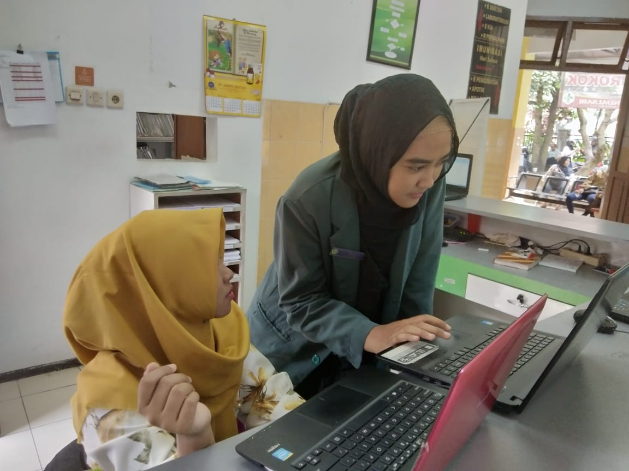

Lampiraan 8 Buku Pedoman Penggunaan Aplikasi

**PEDOMAN PENGGUNAAN APLIKASI TRACER ELEKTRONIK BERBASIS WEB DI PUSKESMAS KENDALSARI MALANG**



**Oleh**

FARAH TIFANNY AISYAH ANINDYA PUTRI

1504000048

**JURUSAN KESEHATAN TERAPAN**

**PRODI D-III PEREKAM MEDIS DAN INFORMASI KESEHATAN**

**POLITEKNIK KESEHATAN KEMENKES MALANG**

**TAHUN 2018**

**MENGGUNAKAN APLIKASI**

Jalankan aplikasi dengan membuka file Aplikasi . Setelah itu akan muncul tampilan login. Inputkan username beserta password lalu log in untuk menjalankan aplikasi.

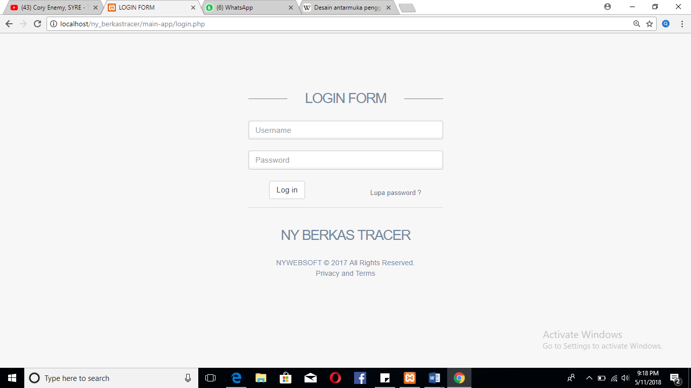

A. FUNGSI TOMBOL

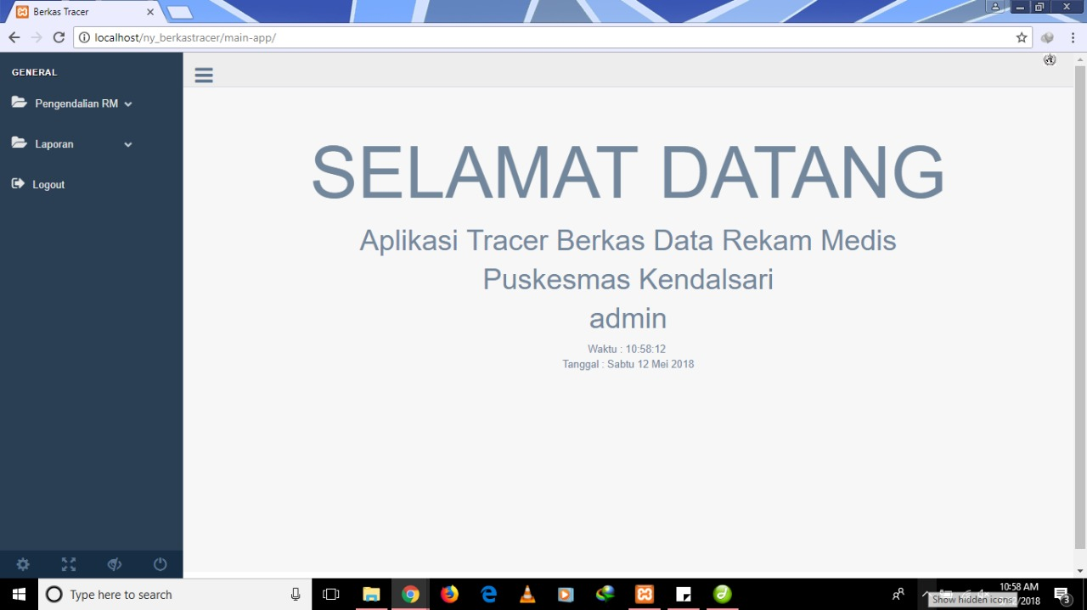

a. **Search** : untuk mencari pasien berdasarkan nomor rekam medis

b. **Tambah Pasien :** untuk menambahkan registrasi ulang atau baru pada pasien yang berobat

c**. Simpan** : untuk menyimpan data yang telah ditambahkan

d**. Hapus** : untuk menghapus data pasien yang telah ditambahkan

e. **Edit** : untuk merubah data yang telah ditambahkan

f**. Batal** : untuk membatalkan data yang akan ditambahkan

g. **Data Pasien** : untuk melihat, mengubah, dan menghapus data yang telah ditambahkan

h. **Berkas Keluar** : untuk pengendalian dokumen rekam medis yang keluar

i. **Berkas Kembali** : untuk melihat data dokumen rekam medis yang telah kembali

j. **Berkas Keseluruhan** : untuk melihat data dokumen rekam medis yang keluar dan sudah kembali

k. **Laporan** : untuk melihat rekapan jumlah data dokumen rekam medis yang keluar dan belum kembali dalam harian dan bulanan

B. TAMBAH DATA PASIEN

Untuk proses tambah data pasien maka klik menu tambah data dan akan muncul tampilan seperti dibawah ini:

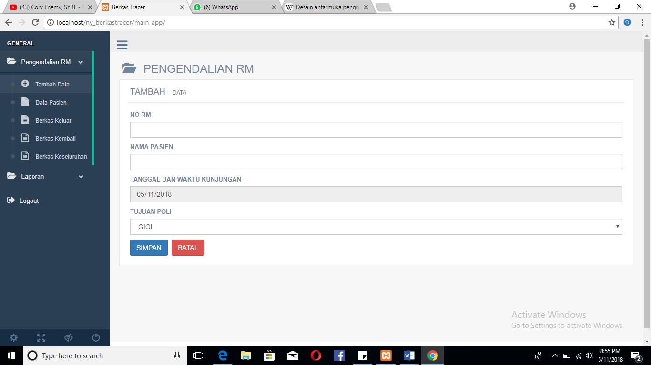

Isikan sesuai dengan data nomor rekam medis, nama pasien, dan tujuan poli, jika sudah semua terisi klik tombol SIMPAN untuk menyimpan dan klik tombol BATAL jika ingin membatalkan data yang belum ditambahkan

C. EDIT DAN HAPUS DATA PASIEN

Klik menu data pasien dan pilih kolom yang akan di edit data, lalu klik ikon edit pada sisi kanan kolom, setelah itu ubah data yang ingin diedit. Jika ingin menghapus data yang telah ditambahkan, klik ikon hapus yang berada di sisi kanan kolom, secara otomatis data akan terhapus. Berikut tampilan data pasien:

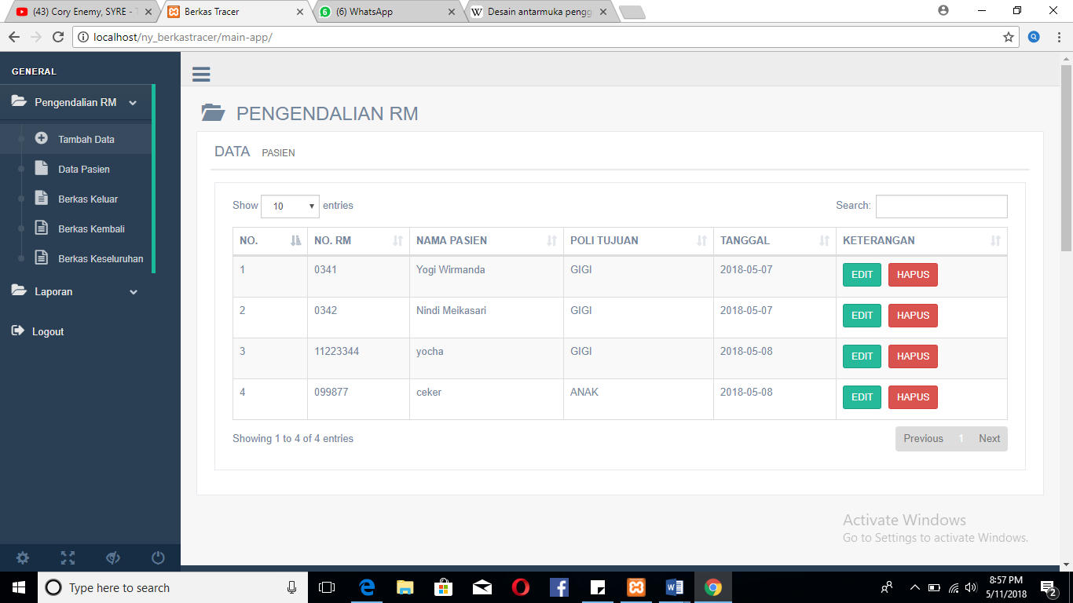

D. PENGENDALIAN DOKUMEN KELUAR

Pada proses ini klik menu berkas keluar, setelah muncul tampilan data keluar terdapat data data dokumen rekam medis yang telah keluar dari rak beserta tanggal dan poli tujuan. Jika salah satu dokumen telah kembali maka klik kotak pada kolom kembali. Maka secara otomatis data akan masuk ke menu berkas kembali dan berkas keseluruhan. Berikut tampila data keluar:

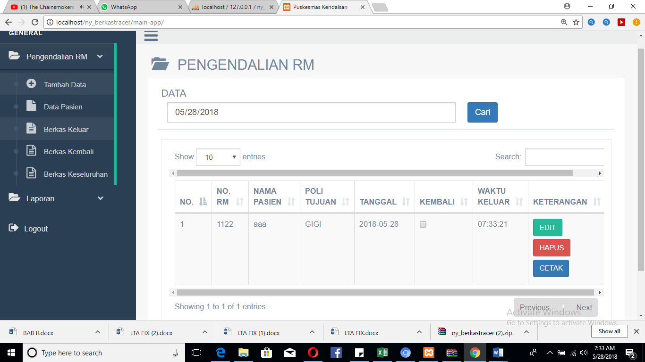

E. PELAPORAN

Pada proses ini klik menu laporan, setelah itu akan muncul tampilan dengan 2 pilihan yaitu laporan harian dan laporan bulanan. Jika ingin melihat hasil rekapan data dokumen rekam medis yang sudah kembali maupun belum kembai dalam harian, klik laporan harian. Jika ingin melihat hasil rekapan data dokumen rekam medis yang sudah kembali maupun belum kembai dalam bulanan, klik laporan bulanan. Berikut tampilan dari menu laporan:

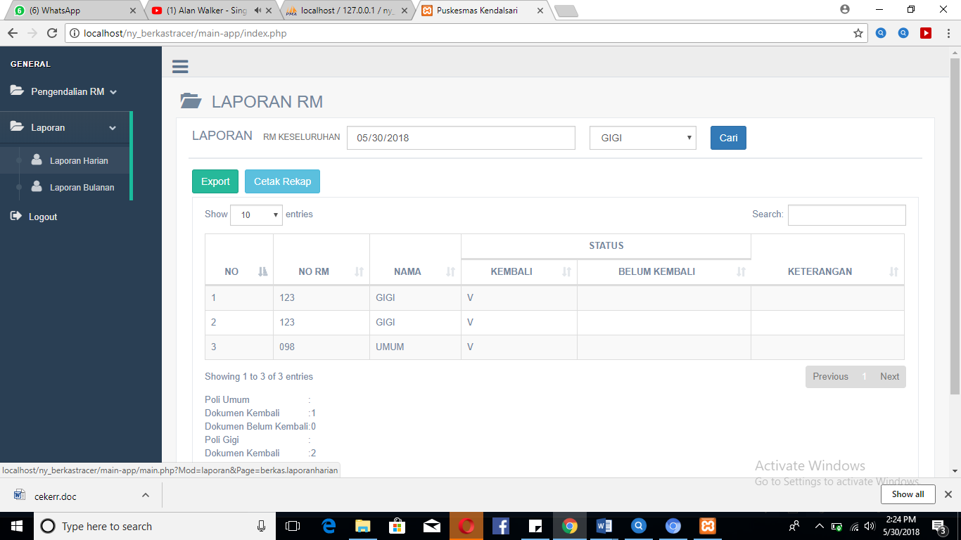

F. LOGOUT

Jika sudah selesai atau keluar dari aplikasi, klik menu logout pada sisi kiri aplikasi, dan secara otomatis akan keluar dan kembali ke menu log in. Berikut tampilan jika berhasil log out aplikasi:

