Lampiran 1. Form Persetujuan Responden
Judul Penelitian :
PENGARUH KONSELING GIZI TERHADAP POLA MAKAN, TINGKAT KONSUMSI, DAN KENAIKAN BERAT BADAN
IBU HAMIL KEK TRIMESTER II
DI DESA KALISONGO KECAMATAN DAU MALANG

Setelah mendapatkan penjelasan secara rinci dan memahami penelitian ini, saya yang bertanda tangan di bawah ini bersedia berpartisipadi menjadi responden dalam penelitian yang dilakukan oleh Dita Kesuma, Program Studi DIII Gizi, Politeknik Kesehatan Kemenkes Malang.
Nama :
Alamat :
Umur :
Dengan demikian pernyataan ini kami buat dengan sesungguhnya tanpa ada paksaan dari siapapun

Malang, 2019
Saksi, Responden

(Bisa petugas gizi/bisa bidan) (……………………..)

Lampiran 2. Formulir Frekwensi Makanan

FORM FREKWENSI MAKANAN RESPONDEN
Nama : BB minggu I/II/III/IV :
Jenis Kelamin : Tanggal :
Umur :
Jenis Makanan | Frekwensi |  |  |  |  |  |  |  |  |  | Ukuran |  |  | Berat
 | Tidak Pernah < 1x per bulan | 1 kali per bulan | 2-3x per bulan | 1x per minggu | 2x per minggu | 3-4x per minggu | 5-6 x per minggu | 1x per hari | 2x per hari | 3x per hari | Kecil | Sedang | Besar | Gram
1). Sumber Karbohidrat
a. Beras
b. Jagung
c. Ubi
d. Singkong
f. kentang
g. ............
2). Sumber Protein Hewani
a. Daging sapi
b. Ayam
c. Udang
d. Ikan
e. Telur
f. Hati
g. .......................
3). Sumber Protein Nabati
a. Tempe
b. Tahu
c. Kacang Kedele
d. Kacang Hijau
e. ...........
4). Sumber Vitamin
a. Sayur-sayuran
1. Wortel
2. Kacang Panjang
3. Buncis
4. Sawi
5. Kangkung
6. Bayam
7. Kubis
8. Kecambah
9. ...............
b. Buah-buahan
1. Pisang
2. Pepaya
3. Jeruk
4. Mangga
5. Apukat
6. Apel
7. Semangka
8. ............
5). Susu
a. Susu bubuk
b. Susu Segar
c. SKM
d. .............
6). Minuman
a. Teh
b. Kopi
c. .....
Lampiran 3. Formulir Food Recall
FORM FOOD RECALL 24 JAM
Nama responden : Umur : tahun
Waktu | Menu | Bahan Makanan | Jumlah |  | Energi (Kkal) | Protein (gram) | Lemak (gram) | KH (gram)
 |  |  | URT | Gram
Pagi
Snack
Siang
Snack
Malam
Total

Lampiran 4. Hasil Uji Statistik Terhadap Pola Makan Ibu Hamil
Paired Samples Statistics
 |  | Mean | N | Std. Deviation | Std. Error Mean
Pair 1 | pola makan sebelum konseling | 38,3333 | 6 | 27,31788 | 11,15248
 | pola makan sesudah konseling | 48,5000 | 6 | 31,99219 | 13,06076

Paired Samples Correlations
 |  | N | Correlation | Sig.
Pair 1 | pola makan sebelum konseling & pola makan sesudah konseling | 6 | ,971 | ,001

Paired Samples Test
 |  | Paired Differences
 |  | Mean | Std. Deviation | Std. Error Mean | 95% Confidence Interval of the Difference
 |  |  |  |  | Lower
Pair 1 | pola makan sebelum konseling - pola makan sesudah konseling | -10,16667 | 8,51861 | 3,47771 | -19,10640

Lampiran 5. Hasil Analisis Statistik Tk. Konsumsi Energi
Paired Samples Statistics
 |  | Mean | N | Std. Deviation | Std. Error Mean
Pair 1 | Tk.Konsumsi Energi sebelum | 42,5167 | 6 | 22,65572 | 9,24916
 | Tk.Konsumsi Energi sesudah | 48,1200 | 6 | 31,61077 | 12,90504

Paired Samples Correlations
 |  | N | Correlation | Sig.
Pair 1 | Tk.Konsumsi Energi Sebelum & Tk.Konsumsi Energi Sesudah | 6 | ,960 | ,002

Paired Samples Test
 |  | Paired Differences
 |  | Mean | Std. Deviation | Std. Error Mean | 95% Confidence Interval of the Difference
 |  |  |  |  | Lower
Pair 1 | Tk.Konsumsi Energi Sebelum - Tk.Konsumsi Energi Sesudah | -5,60333 | 11,72403 | 4,78631 | -17,90695

Lampiran 6. Hasil Analisis Statistik Tk. Konsumsi Protein
Paired Samples Statistics
 |  | Mean | N | Std. Deviation | Std. Error Mean
Pair 1 | protein sebelum | 29,4800 | 10 | 9,39596 | 2,97126
 | protein sesudah | 51,8700 | 10 | 9,79536 | 3,09756

Paired Samples Correlations
 |  | N | Correlation | Sig.
Pair 1 | protein sebelum & protein sesudah | 10 | ,693 | ,026

Paired Samples Test
 |  | Paired Differences
 |  | Mean | Std. Deviation | Std. Error Mean | 95% Confidence Interval of the Difference
 |  |  |  |  | Lower
Pair 1 | protein sebelum - protein sesudah | -22,39000 | 7,52897 | 2,38087 | -27,77590

Lampiran 7. Hasil Analisis Statistik Tk. Konsumsi Lemak
Paired Samples Statistics
 |  | Mean | N | Std. Deviation | Std. Error Mean
Pair 1 | lemak sebelum | 18,5000 | 3 | 3,89744 | 2,25019
 | lemak sesudah | 16,1667 | 3 | 10,11945 | 5,84247

Paired Samples Correlations
 |  | N | Correlation | Sig.
Pair 1 | lemak sebelum & lemak sesudah | 3 | ,979 | ,131

Paired Samples Test
 |  | Paired Differences
 |  | Mean | Std. Deviation | Std. Error Mean | 95% Confidence Interval of the Difference
 |  |  |  |  | Lower
Pair 1 | lemak sebelum - lemak sesudah | 2,33333 | 6,35400 | 3,66848 | -13,45088

Lampiran 8. Hasil Analisis Statistik Tk. Konsumsi Karbohidrat
Paired Samples Statistics
 |  | Mean | N | Std. Deviation | Std. Error Mean
Pair 1 | KH sebelum | 94,6667 | 3 | 53,12103 | 30,66944
 | KH sesudah | 209,5000 | 3 | 50,95007 | 29,41604

Paired Samples Correlations
 |  | N | Correlation | Sig.
Pair 1 | KH sebelum & KH sesudah | 3 | -,957 | ,188

Paired Samples Test
 |  | Paired Differences
 |  | Mean | Std. Deviation | Std. Error Mean | 95% Confidence Interval of the Difference
 |  |  |  |  | Lower
Pair 1 | KH sebelum - KH sesudah | -114,83333 | 102,94155 | 59,43333 | -370,55433

Lampiran 9. Hasil Analisis Statistik Kenaikan Berat Badan
Paired Samples Statistics
 |  | Mean | N | Std. Deviation | Std. Error Mean
Pair 1 | kenaikan BB sebelum | 51,8000 | 10 | 4,41714 | 1,39682
 | kenaikan BB sesudah | 52,7500 | 10 | 4,43127 | 1,40129

Paired Samples Correlations
 |  | N | Correlation | Sig.
Pair 1 | kenaikan BB sebelum & kenaikan BB sesudah | 10 | ,993 | ,000

Paired Samples Test
 |  | Paired Differences
 |  | Mean | Std. Deviation | Std. Error Mean | 95% Confidence Interval of the Difference
 |  |  |  |  | Lower
Pair 1 | kenaikan BB sebelum - kenaikan BB sesudah | -,95000 | ,50827 | ,16073 | -1,31359

Descriptive Statistics
 | N | Minimum | Maximum | Mean | Std. Deviation
kenaikan BB sebelum | 10 | 47,00 | 61,00 | 51,8000 | 4,41714
kenaikan BB sesudah | 10 | 48,00 | 61,90 | 52,7500 | 4,43127
Valid N (listwise) | 10

Lampiran 10. Media Konseling

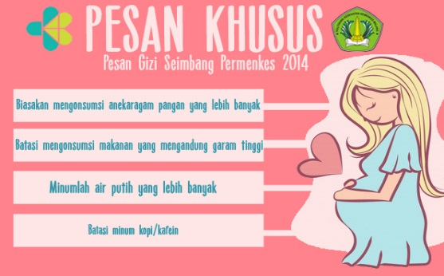
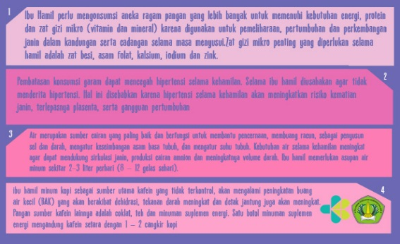

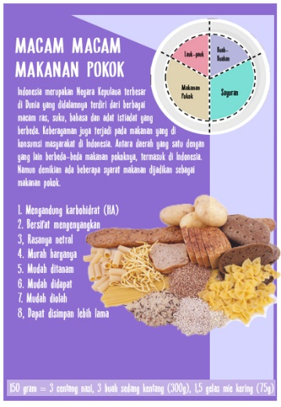 | 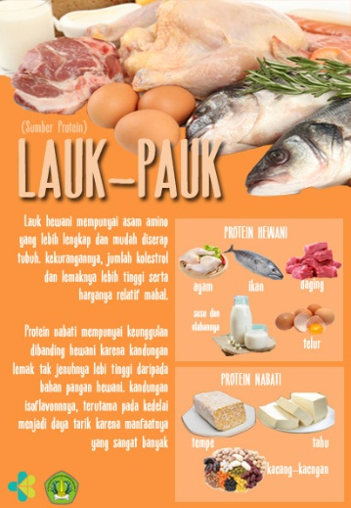
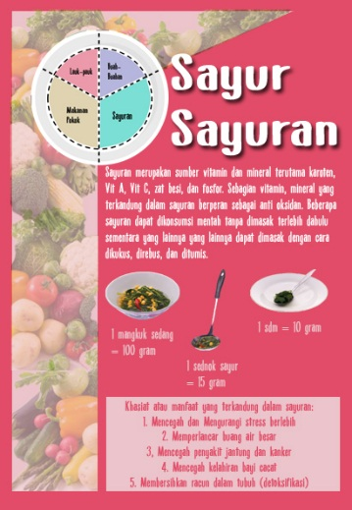 | 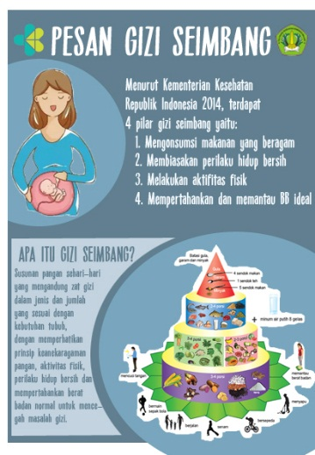
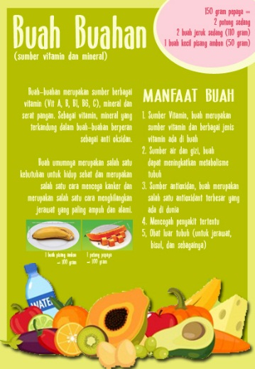 | 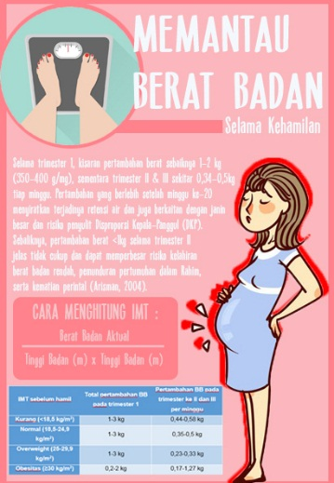

Lampiran 11. Dokumentasi
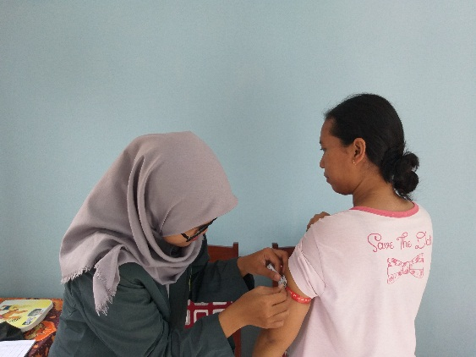 | 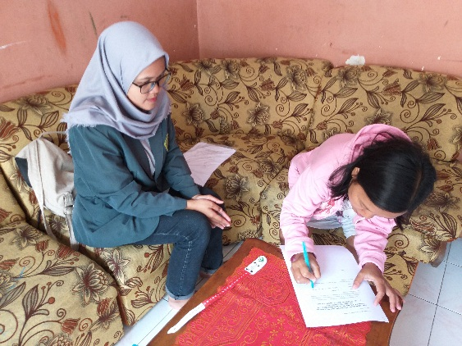
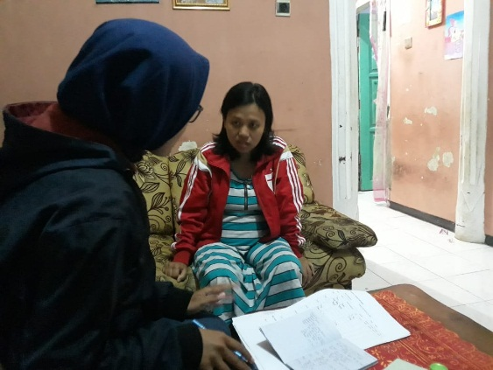 | 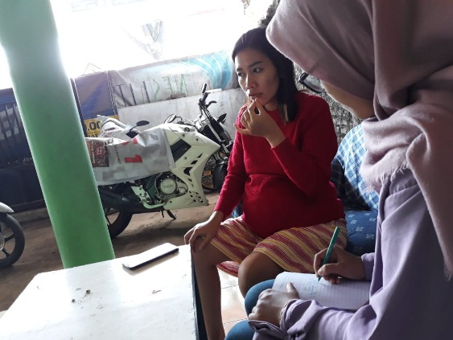
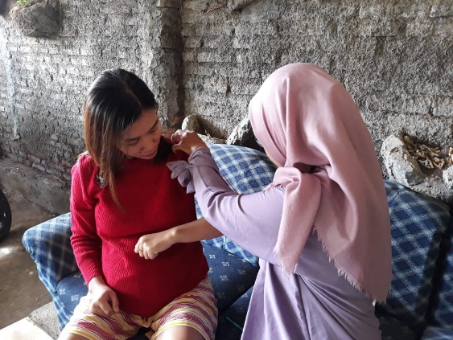 | 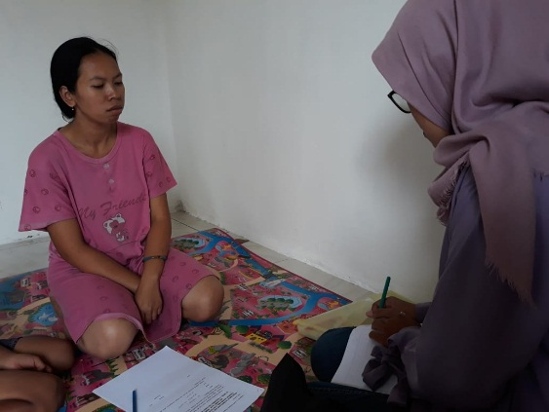
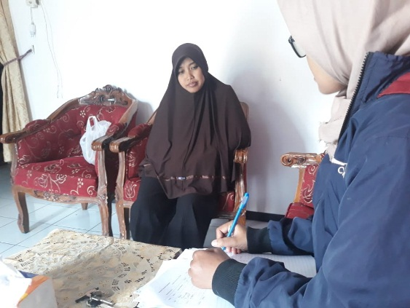 | 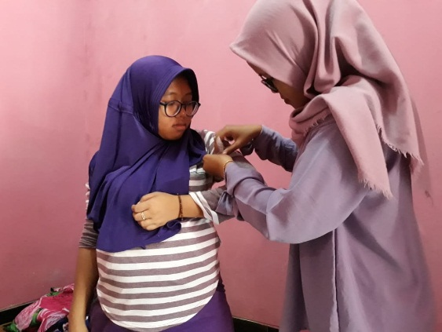
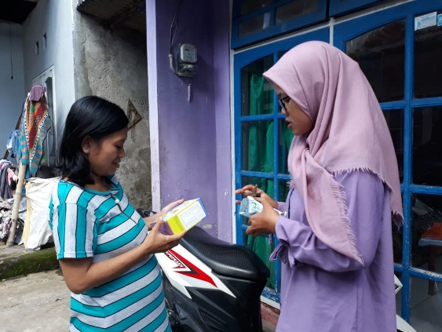 | 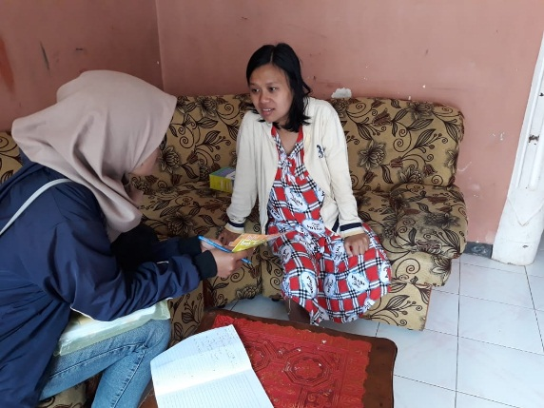
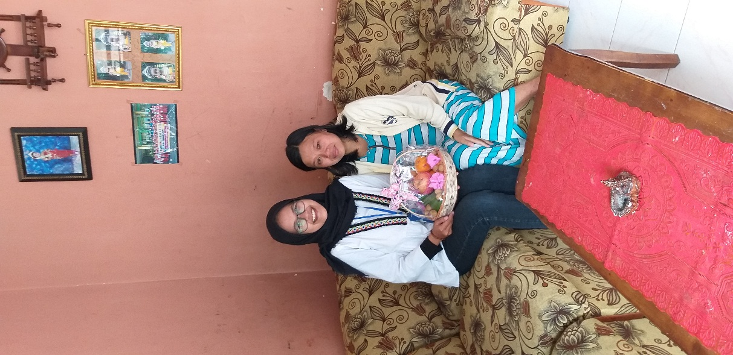 | 