**Lampiran 1. Surat Keterangan Izin Peneltian**

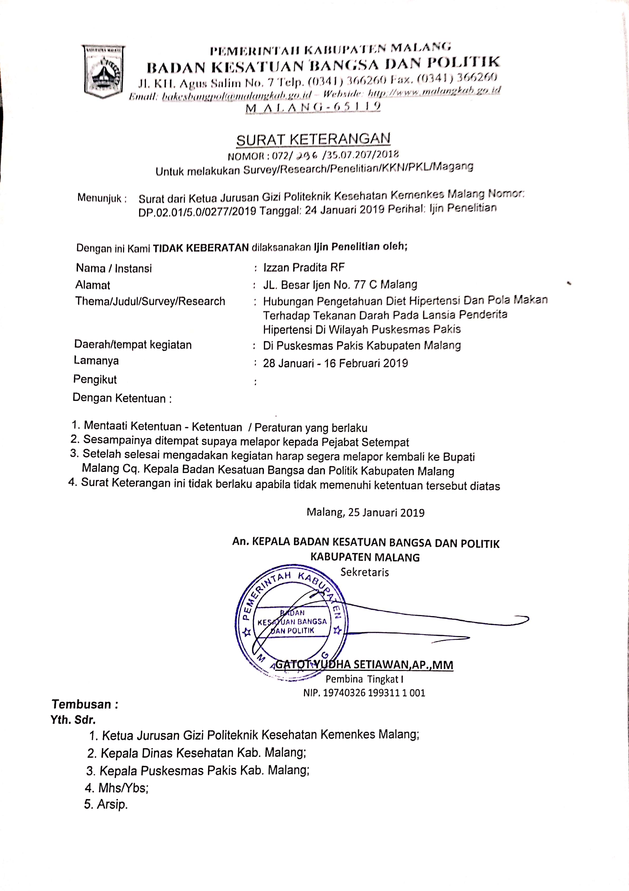

**Lampiran 2. Surat Izin Peneltian Dinas Kesehatan**

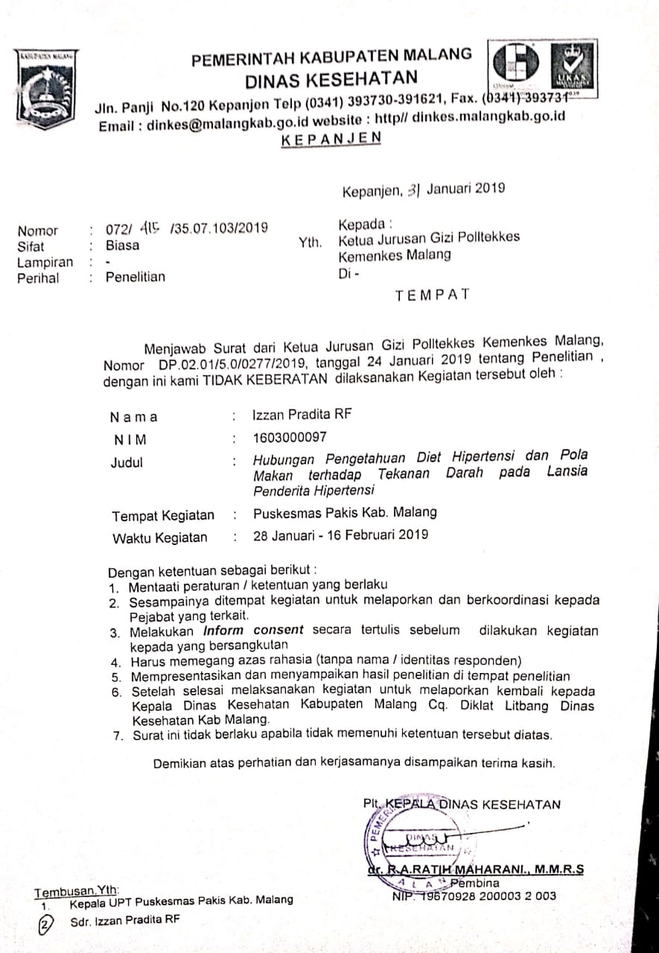

**Lampiran 3. Kuisioner Pengetahuan Diet Hipertensi**

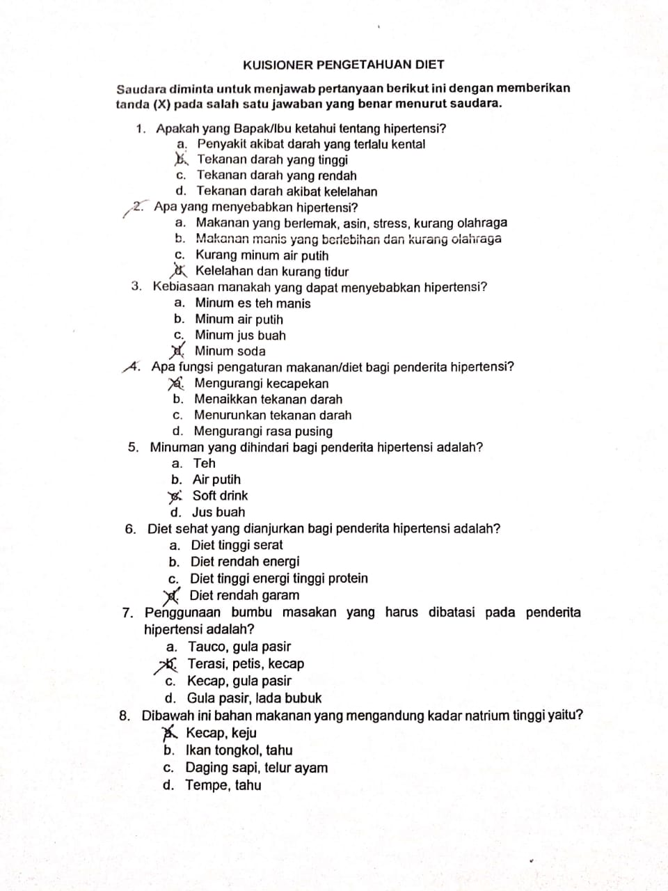

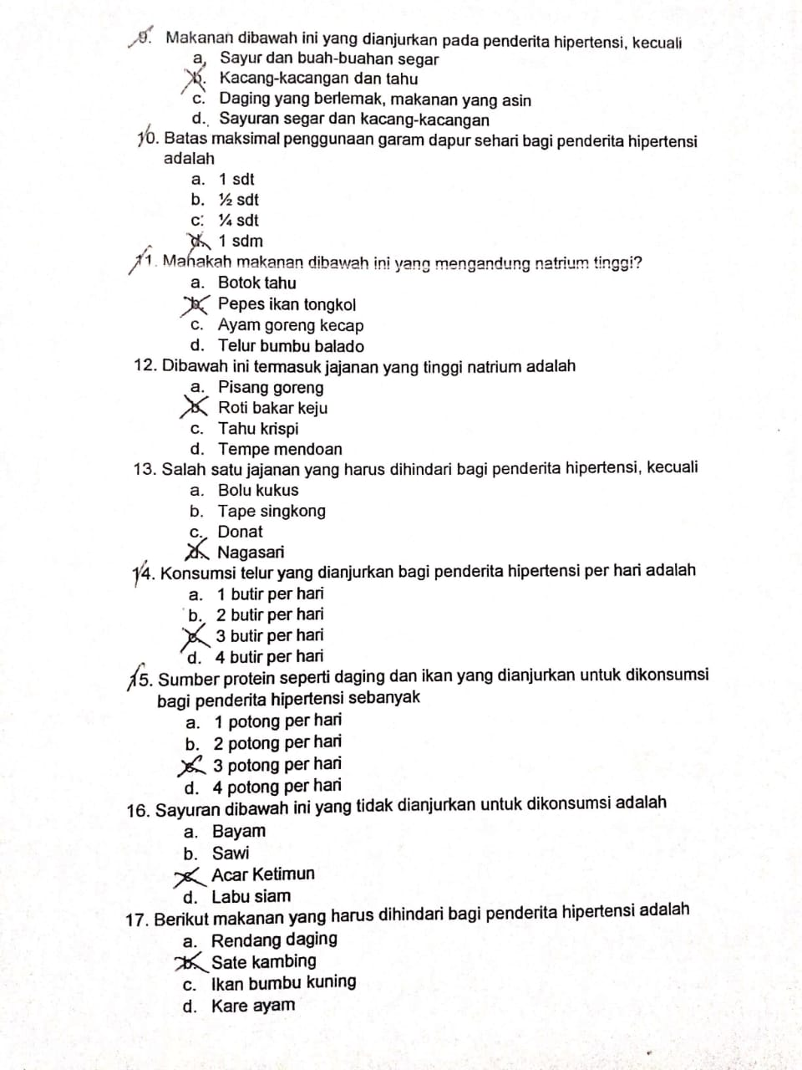

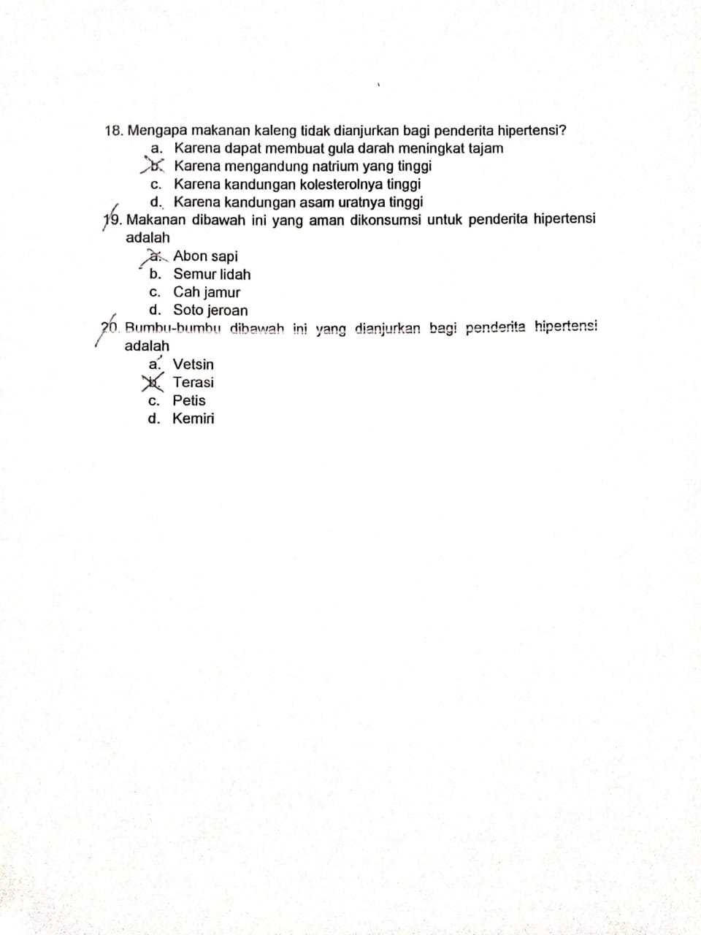

Kunci Jawaban :

1. B. 11. C.

2. A. 12. B.

3. D. 13. D.

4. C. 14. A.

5. C. 15. B.

6. D. 16. C.

7. B. 17. B.

8. A. 18. B.

9. C. 19. C.

10. A. 20. D.

**Lampiran 4. Data Karakteristik Responden**

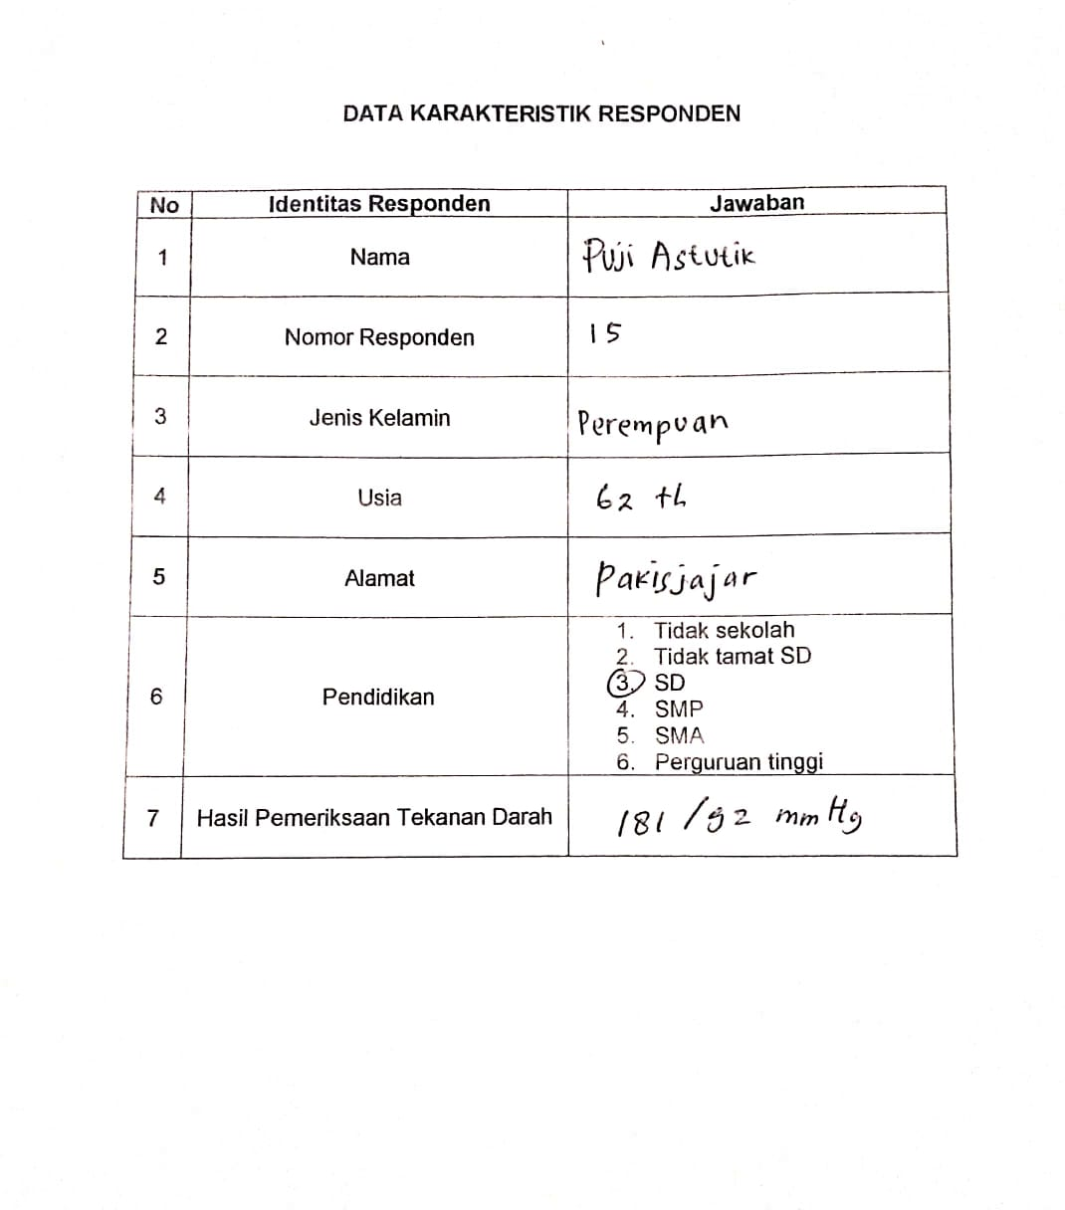

**Lampiran 5. *Informed Consent***

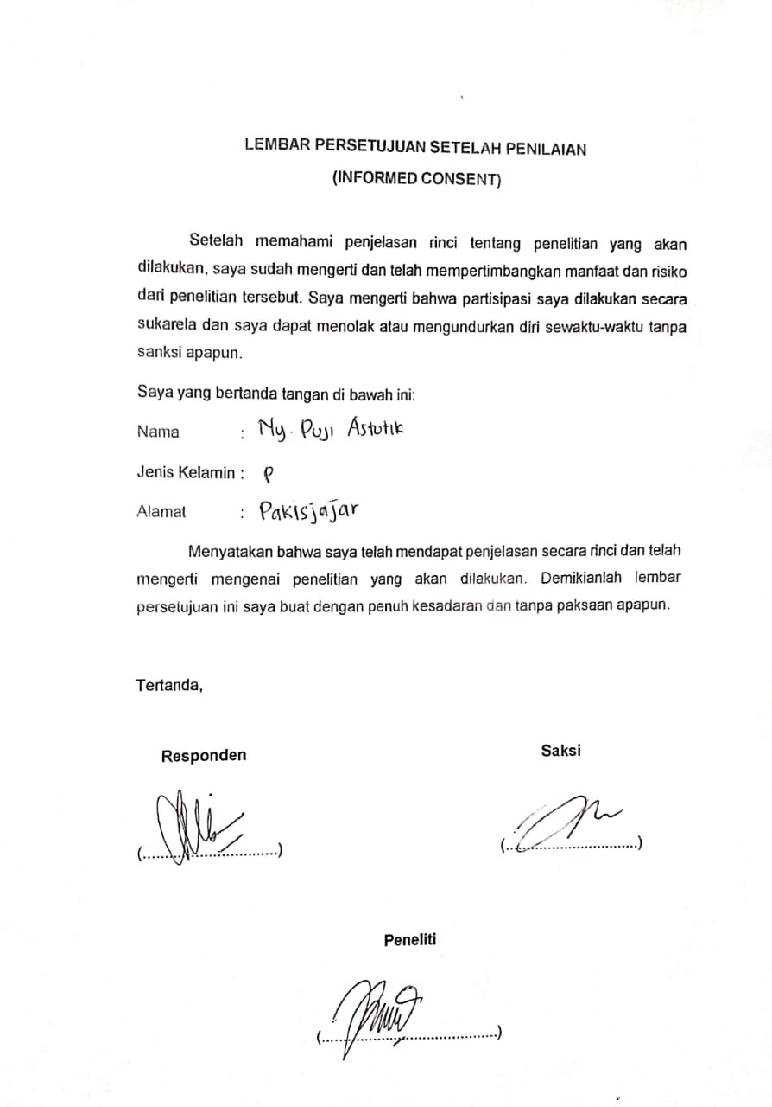

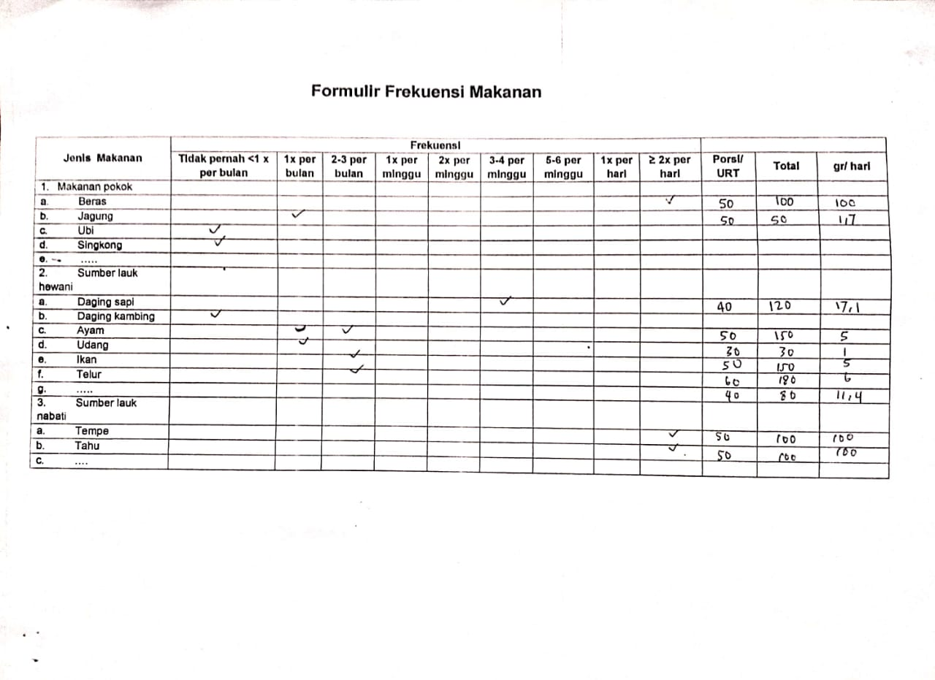**Lampiran 6. Formulir *Food Frequency Quisioner***

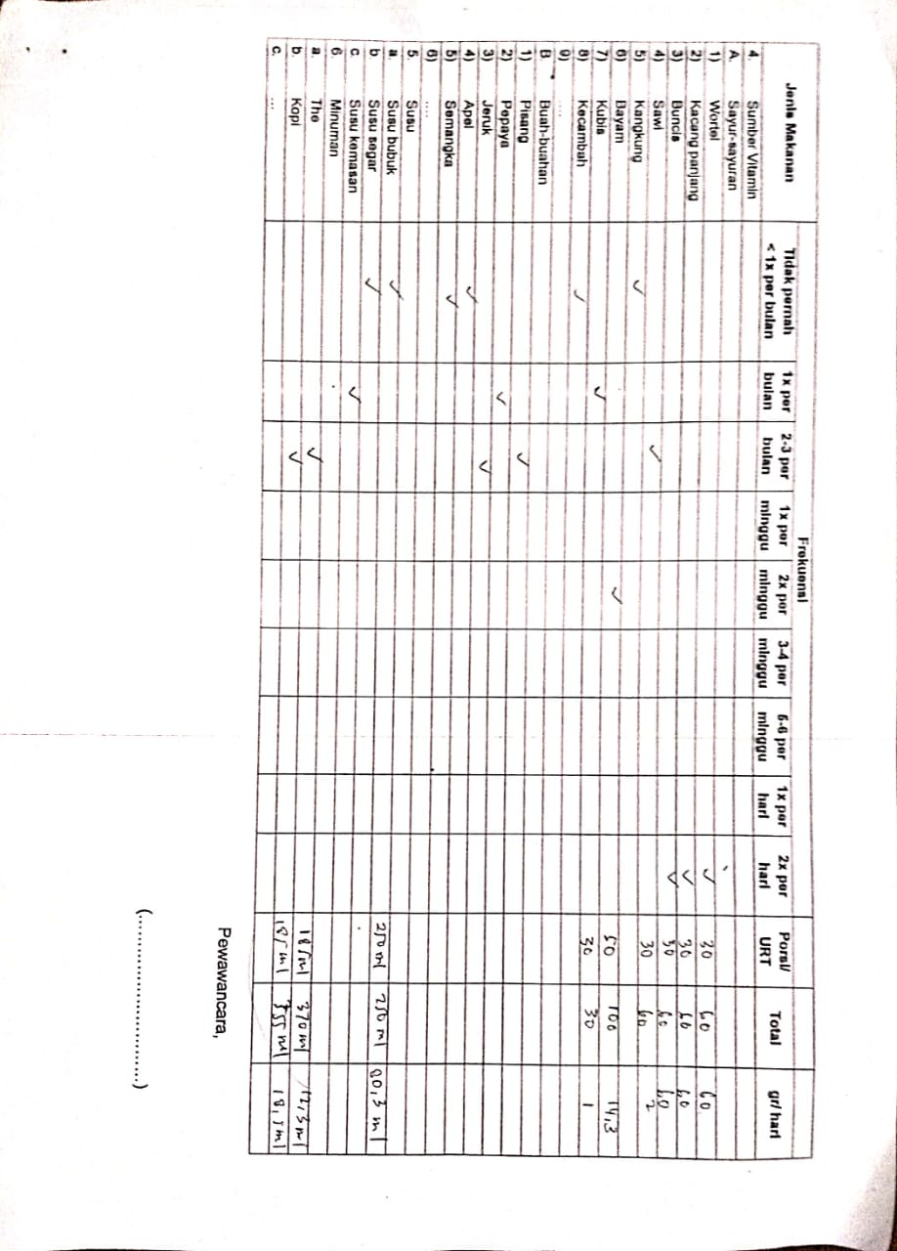

**Lampiran 7. Skor Pola Makan Makanan Pokok Responden**

|  |  |  |  |  |  |
| --- | --- | --- | --- | --- | --- |
| **Responden** | **Beras** | **Jagung** | **Ubi** | **Singkong** | **Lain-Lain** |
| 1 | 50 | 0 | 10 | 0 | 1 |
| 2 | 50 | 0 | 10 | 0 | 0 |
| 3 | 50 | 0 | 0 | 0 | 1 |
| 4 | 50 | 0 | 0 | 0 | 0 |
| 5 | 25 | 0 | 0 | 0 | 0 |
| 6 | 25 | 0 | 0 | 0 | 0 |
| 7 | 25 | 0 | 0 | 0 | 0 |
| 8 | 50 | 0 | 0 | 10 | 0 |
| 9 | 50 | 15 | 0 | 1 | 0 |
| 10 | 25 | 0 | 0 | 1 | 0 |
| 11 | 25 | 0 | 0 | 0 | 0 |
| 12 | 25 | 0 | 0 | 0 | 0 |
| 13 | 50 | 0 | 0 | 0 | 0 |
| 14 | 50 | 0 | 0 | 0 | 0 |
| 15 | 50 | 1 | 1 | 0 | 0 |
| 16 | 50 | 1 | 0 | 0 | 0 |
| 17 | 50 | 0 | 0 | 0 | 0 |
| 18 | 50 | 1 | 0 | 0 | 0 |
| 19 | 25 | 0 | 0 | 0 | 0 |
| 20 | 50 | 1 | 0 | 0 | 0 |
| 21 | 25 | 1 | 0 | 10 | 0 |
| 22 | 25 | 15 | 0 | 10 | 0 |
| 23 | 50 | 0 | 0 | 0 | 0 |
| 24 | 50 | 0 | 0 | 0 | 0 |
| 25 | 50 | 0 | 0 | 0 | 0 |
| 26 | 50 | 25 | 0 | 0 | 0 |
| 27 | 50 | 0 | 0 | 0 | 0 |
| 28 | 50 | 0 | 0 | 0 | 0 |
| 29 | 50 | 0 | 0 | 0 | 1 |
| 30 | 25 | 0 | 0 | 0 | 0 |
| 31 | 25 | 0 | 0 | 0 | 0 |
| 32 | 25 | 15 | 0 | 1 | 0 |
| 33 | 50 | 0 | 0 | 0 | 1 |
| 34 | 50 | 0 | 0 | 0 | 0 |
| 35 | 50 | 0 | 0 | 10 | 0 |
| 36 | 50 | 0 | 0 | 0 | 0 |
| 37 | 25 | 0 | 0 | 0 | 0 |
| 38 | 25 | 1 | 0 | 0 | 0 |
| **Responden** | **Beras** | **Jagung** | **Ubi** | **Singkong** | **Lain-Lain** |
| 39 | 25 | 1 | 10 | 0 | 0 |
| 40 | 25 | 10 | 1 | 0 | 0 |
| 41 | 25 | 0 | 0 | 0 | 0 |
| 42 | 50 | 0 | 0 | 0 | 0 |
| 43 | 50 | 0 | 0 | 0 | 0 |
| 44 | 50 | 0 | 0 | 0 | 0 |
| 45 | 50 | 15 | 15 | 0 | 0 |
| 46 | 25 | 0 | 0 | 1 | 0 |
| 47 | 25 | 0 | 0 | 0 | 0 |
| 48 | 25 | 0 | 0 | 1 | 0 |
| 49 | 25 | 0 | 0 | 0 | 0 |
| 50 | 25 | 15 | 0 | 0 | 0 |
| 51 | 50 | 10 | 0 | 0 | 0 |
| 52 | 50 | 0 | 15 | 10 | 0 |
| 53 | 50 | 0 | 0 | 0 | 0 |
| 54 | 50 | 0 | 0 | 0 | 0 |
| 55 | 25 | 0 | 0 | 0 | 0 |
| 56 | 25 | 0 | 0 | 1 | 0 |
| 57 | 50 | 0 | 0 | 0 | 0 |
| 58 | 25 | 0 | 0 | 0 | 0 |
| 59 | 50 | 0 | 0 | 10 | 0 |
| 60 | 25 | 0 | 0 | 0 | 0 |
| 61 | 50 | 0 | 0 | 0 | 0 |
| 62 | 50 | 0 | 0 | 0 | 0 |
| 63 | 50 | 0 | 0 | 0 | 0 |
| 64 | 50 | 0 | 0 | 0 | 0 |
| 65 | 25 | 0 | 0 | 0 | 0 |
| 66 | 25 | 0 | 0 | 0 | 0 |

**Lampiran 8. Skor Pola Makan Lauk Hewani Responden**

|  |  |  |  |  |  |  |  |
| --- | --- | --- | --- | --- | --- | --- | --- |
| **Responden** | **Daging Sapi** | **Daging Kambing** | **Ayam** | **Udang** | **Ikan** | **Telur** | **Lain-Lain** |
| 1 | 10 | 10 | 25 | 0 | 1 | 10 | 0 |
| 2 | 1 | 0 | 15 | 0 | 1 | 15 | 0 |
| 3 | 1 | 0 | 10 | 1 | 15 | 10 | 10 |
| 4 | 1 | 0 | 15 | 0 | 1 | 10 | 0 |
| 5 | 1 | 0 | 1 | 1 | 1 | 15 | 0 |
| 6 | 25 | 0 | 1 | 1 | 10 | 15 | 0 |
| 7 | 1 | 0 | 25 | 1 | 10 | 15 | 0 |
| 8 | 1 | 0 | 10 | 1 | 0 | 10 | 0 |
| 9 | 0 | 1 | 1 | 1 | 0 | 10 | 25 |
| 10 | 1 | 0 | 1 | 0 | 0 | 0 | 10 |
| 11 | 1 | 0 | 10 | 0 | 0 | 1 | 0 |
| 12 | 1 | 1 | 10 | 0 | 1 | 15 | 0 |
| 13 | 15 | 1 | 10 | 0 | 1 | 0 | 0 |
| 14 | 1 | 1 | 10 | 0 | 1 | 0 | 10 |
| 15 | 15 | 0 | 1 | 1 | 1 | 1 | 10 |
| 16 | 25 | 0 | 10 | 1 | 1 | 1 | 0 |
| 17 | 1 | 0 | 10 | 15 | 1 | 15 | 0 |
| 18 | 1 | 0 | 15 | 0 | 10 | 10 | 0 |
| 19 | 1 | 1 | 15 | 0 | 1 | 15 | 0 |
| 20 | 15 | 15 | 1 | 1 | 1 | 25 | 15 |
| 21 | 1 | 0 | 1 | 10 | 1 | 15 | 0 |
| 22 | 1 | 0 | 15 | 1 | 10 | 25 | 10 |
| 23 | 10 | 0 | 1 | 1 | 1 | 10 | 0 |
| 24 | 1 | 15 | 25 | 0 | 1 | 10 | 10 |
| 25 | 1 | 10 | 1 | 1 | 10 | 0 | 0 |
| 26 | 1 | 1 | 10 | 0 | 0 | 1 | 0 |
| 27 | 15 | 1 | 10 | 0 | 1 | 1 | 0 |
| 28 | 1 | 0 | 0 | 0 | 15 | 1 | 0 |
| 29 | 1 | 0 | 0 | 0 | 1 | 15 | 0 |
| 30 | 1 | 0 | 1 | 0 | 15 | 10 | 0 |
| 31 | 1 | 0 | 15 | 0 | 0 | 15 | 0 |
| 32 | 15 | 0 | 10 | 0 | 10 | 0 | 1 |
| 33 | 10 | 0 | 1 | 0 | 0 | 15 | 0 |
| 34 | 1 | 0 | 10 | 0 | 0 | 15 | 0 |
| 35 | 1 | 1 | 10 | 0 | 0 | 25 | 0 |
| 36 | 10 | 1 | 10 | 15 | 0 | 10 | 0 |
| 37 | 1 | 15 | 10 | 0 | 0 | 1 | 0 |
| 38 | 1 | 0 | 10 | 0 | 1 | 10 | 0 |
| **Responden** | **Daging Sapi** | **Daging Kambing** | **Ayam** | **Udang** | **Ikan** | **Telur** | **Lain-Lain** |
| 39 | 1 | 0 | 1 | 10 | 15 | 10 | 1 |
| 40 | 1 | 0 | 1 | 0 | 1 | 15 | 0 |
| 41 | 1 | 0 | 10 | 10 | 1 | 10 | 0 |
| 42 | 1 | 0 | 10 | 1 | 15 | 10 | 1 |
| 43 | 15 | 0 | 15 | 0 | 0 | 1 | 0 |
| 44 | 1 | 0 | 1 | 0 | 15 | 10 | 0 |
| 45 | 0 | 0 | 10 | 0 | 1 | 10 | 0 |
| 46 | 1 | 10 | 15 | 0 | 1 | 10 | 0 |
| 47 | 10 | 15 | 10 | 0 | 1 | 15 | 15 |
| 48 | 1 | 0 | 10 | 0 | 10 | 15 | 0 |
| 49 | 1 | 0 | 1 | 0 | 25 | 10 | 0 |
| 50 | 15 | 0 | 0 | 0 | 1 | 1 | 0 |
| 51 | 1 | 0 | 10 | 0 | 15 | 10 | 0 |
| 52 | 1 | 0 | 1 | 15 | 1 | 10 | 0 |
| 53 | 1 | 0 | 15 | 1 | 1 | 15 | 0 |
| 54 | 1 | 1 | 15 | 1 | 10 | 1 | 0 |
| 55 | 1 | 1 | 10 | 0 | 10 | 10 | 1 |
| 56 | 1 | 1 | 1 | 0 | 1 | 1 | 0 |
| 57 | 1 | 25 | 10 | 1 | 1 | 15 | 0 |
| 58 | 1 | 1 | 10 | 10 | 15 | 10 | 0 |
| 59 | 1 | 1 | 10 | 0 | 15 | 10 | 0 |
| 60 | 1 | 1 | 15 | 0 | 0 | 0 | 0 |
| 61 | 0 | 1 | 10 | 0 | 0 | 0 | 0 |
| 62 | 15 | 1 | 10 | 1 | 10 | 10 | 0 |
| 63 | 1 | 15 | 1 | 1 | 15 | 15 | 1 |
| 64 | 1 | 0 | 1 | 15 | 1 | 25 | 1 |
| 65 | 1 | 0 | 10 | 0 | 15 | 15 | 0 |
| 66 | 10 | 0 | 1 | 0 | 25 | 1 | 0 |

**Lampiran 9. Skor Pola Makan Lauk Nabati Responden**

|  |  |  |  |
| --- | --- | --- | --- |
| **Responden** | **Tempe** | **Tahu** | **Lain-Lain** |
| 1 | 50 | 50 | 0 |
| 2 | 50 | 50 | 0 |
| 3 | 50 | 50 | 0 |
| 4 | 50 | 50 | 0 |
| 5 | 25 | 10 | 0 |
| 6 | 25 | 15 | 0 |
| 7 | 25 | 25 | 0 |
| 8 | 50 | 50 | 0 |
| 9 | 10 | 10 | 0 |
| 10 | 50 | 50 | 1 |
| 11 | 50 | 50 | 0 |
| 12 | 25 | 25 | 0 |
| 13 | 25 | 25 | 0 |
| 14 | 25 | 25 | 0 |
| 15 | 50 | 50 | 0 |
| 16 | 25 | 15 | 0 |
| 17 | 25 | 25 | 0 |
| 18 | 25 | 25 | 0 |
| 19 | 25 | 25 | 1 |
| 20 | 25 | 25 | 0 |
| 21 | 50 | 50 | 0 |
| 22 | 50 | 50 | 0 |
| 23 | 50 | 50 | 0 |
| 24 | 25 | 15 | 0 |
| 25 | 25 | 25 | 0 |
| 26 | 50 | 50 | 0 |
| 27 | 50 | 50 | 0 |
| 28 | 15 | 15 | 0 |
| 29 | 10 | 10 | 0 |
| 30 | 25 | 15 | 0 |
| 31 | 25 | 25 | 0 |
| 32 | 10 | 10 | 1 |
| 33 | 10 | 10 | 0 |
| 34 | 15 | 15 | 0 |
| 35 | 25 | 50 | 0 |
| 36 | 25 | 25 | 0 |
| 37 | 50 | 50 | 0 |
| 38 | 50 | 50 | 0 |
| **Responden** | **Tempe** | **Tahu** | **Lain-Lain** |
| 39 | 50 | 50 | 0 |
| 40 | 50 | 50 | 0 |
| 41 | 25 | 15 | 0 |
| 42 | 25 | 25 | 0 |
| 43 | 50 | 50 | 0 |
| 44 | 50 | 15 | 0 |
| 45 | 50 | 50 | 1 |
| 46 | 50 | 50 | 0 |
| 47 | 50 | 15 | 0 |
| 48 | 50 | 50 | 0 |
| 49 | 25 | 25 | 0 |
| 50 | 25 | 25 | 0 |
| 51 | 50 | 50 | 0 |
| 52 | 15 | 25 | 0 |
| 53 | 50 | 50 | 0 |
| 54 | 50 | 50 | 0 |
| 55 | 25 | 25 | 0 |
| 56 | 25 | 25 | 1 |
| 57 | 50 | 50 | 0 |
| 58 | 50 | 50 | 0 |
| 59 | 50 | 50 | 0 |
| 60 | 50 | 50 | 0 |
| 61 | 25 | 25 | 0 |
| 62 | 15 | 15 | 0 |
| 63 | 10 | 25 | 0 |
| 64 | 15 | 15 | 0 |
| 65 | 25 | 25 | 10 |
| 66 | 50 | 50 | 0 |

**Lampiran 10. Skor Pola Makan Sayur Responden**

|  |  |  |  |  |  |  |  |  |  |
| --- | --- | --- | --- | --- | --- | --- | --- | --- | --- |
| **Responden** | **Wortel** | **Kacang Panjang** | **Buncis** | **Sawi** | **Kangkung** | **Bayam** | **Kubis** | **Kecambah** | **Lain-Lain** |
| 1 | 25 | 25 | 25 | 10 | 1 | 10 | 0 | 1 | 1 |
| 2 | 25 | 25 | 25 | 10 | 10 | 10 | 0 | 0 | 1 |
| 3 | 25 | 25 | 25 | 10 | 1 | 15 | 0 | 1 | 0 |
| 4 | 25 | 25 | 25 | 1 | 1 | 10 | 0 | 1 | 0 |
| 5 | 25 | 25 | 25 | 1 | 1 | 10 | 1 | 0 | 1 |
| 6 | 10 | 10 | 10 | 0 | 1 | 1 | 1 | 0 | 1 |
| 7 | 10 | 10 | 10 | 0 | 1 | 1 | 0 | 0 | 0 |
| 8 | 10 | 10 | 10 | 1 | 0 | 1 | 0 | 0 | 0 |
| 9 | 25 | 25 | 25 | 0 | 0 | 1 | 0 | 0 | 1 |
| 10 | 25 | 25 | 25 | 0 | 0 | 1 | 1 | 0 | 0 |
| 11 | 10 | 10 | 10 | 1 | 0 | 1 | 0 | 0 | 0 |
| 12 | 10 | 10 | 10 | 0 | 1 | 10 | 0 | 1 | 1 |
| 13 | 25 | 25 | 25 | 1 | 0 | 10 | 0 | 0 | 0 |
| 14 | 50 | 50 | 50 | 0 | 0 | 1 | 1 | 0 | 0 |
| 15 | 50 | 50 | 50 | 1 | 0 | 1 | 1 | 0 | 1 |
| 16 | 25 | 25 | 25 | 10 | 1 | 1 | 0 | 0 | 0 |
| 17 | 10 | 10 | 10 | 10 | 0 | 15 | 0 | 1 | 1 |
| 18 | 10 | 10 | 10 | 0 | 10 | 15 | 1 | 1 | 0 |
| 19 | 15 | 15 | 15 | 0 | 10 | 10 | 0 | 0 | 0 |
| 20 | 15 | 15 | 15 | 0 | 0 | 10 | 0 | 0 | 1 |
| 21 | 15 | 15 | 15 | 0 | 0 | 10 | 0 | 0 | 0 |
| 22 | 15 | 15 | 15 | 1 | 0 | 1 | 0 | 0 | 1 |
| **Responden** | **Wortel** | **Kacang Panjang** | **Buncis** | **Sawi** | **Kangkung** | **Bayam** | **Kubis** | **Kecambah** | **Lain-Lain** |
| 23 | 10 | 10 | 10 | 1 | 0 | 1 | 0 | 0 | 0 |
| 24 | 10 | 10 | 10 | 1 | 0 | 1 | 0 | 10 | 1 |
| 25 | 15 | 15 | 15 | 1 | 0 | 1 | 0 | 0 | 0 |
| 26 | 15 | 15 | 15 | 0 | 0 | 1 | 1 | 0 | 0 |
| 27 | 10 | 10 | 10 | 10 | 0 | 0 | 1 | 0 | 0 |
| 28 | 10 | 10 | 10 | 10 | 0 | 0 | 0 | 0 | 0 |
| 29 | 25 | 25 | 25 | 0 | 0 | 0 | 0 | 0 | 0 |
| 30 | 10 | 10 | 10 | 0 | 0 | 1 | 0 | 0 | 0 |
| 31 | 10 | 10 | 10 | 0 | 0 | 1 | 0 | 1 | 0 |
| 32 | 10 | 10 | 10 | 1 | 0 | 1 | 0 | 1 | 0 |
| 33 | 1 | 1 | 1 | 1 | 0 | 10 | 0 | 1 | 0 |
| 34 | 10 | 10 | 10 | 1 | 0 | 1 | 0 | 1 | 1 |
| 35 | 1 | 1 | 1 | 1 | 0 | 0 | 1 | 0 | 0 |
| 36 | 15 | 15 | 15 | 0 | 0 | 1 | 1 | 0 | 0 |
| 37 | 10 | 10 | 10 | 0 | 0 | 10 | 1 | 0 | 0 |
| 38 | 1 | 1 | 1 | 0 | 0 | 10 | 0 | 1 | 0 |
| 39 | 10 | 10 | 10 | 0 | 0 | 10 | 0 | 1 | 0 |
| 40 | 10 | 10 | 10 | 0 | 0 | 10 | 0 | 1 | 1 |
| 41 | 10 | 10 | 10 | 1 | 1 | 1 | 0 | 1 | 0 |
| 42 | 25 | 25 | 25 | 0 | 0 | 1 | 0 | 0 | 0 |
| 43 | 1 | 1 | 1 | 1 | 0 | 10 | 0 | 0 | 0 |
| 44 | 15 | 15 | 15 | 1 | 0 | 10 | 1 | 1 | 0 |
| 45 | 15 | 15 | 15 | 1 | 0 | 1 | 0 | 0 | 0 |
| **Responden** | **Wortel** | **Kacang Panjang** | **Buncis** | **Sawi** | **Kangkung** | **Bayam** | **Kubis** | **Kecambah** | **Lain-Lain** |
| 46 | 10 | 10 | 10 | 0 | 0 | 10 | 0 | 1 | 10 |
| 47 | 15 | 15 | 15 | 0 | 0 | 10 | 0 | 1 | 0 |
| 48 | 10 | 10 | 10 | 0 | 1 | 10 | 1 | 1 | 0 |
| 49 | 10 | 10 | 10 | 0 | 0 | 10 | 0 | 1 | 0 |
| 50 | 15 | 15 | 15 | 0 | 0 | 10 | 0 | 10 | 0 |
| 51 | 15 | 15 | 15 | 0 | 0 | 10 | 0 | 1 | 0 |
| 52 | 15 | 15 | 15 | 0 | 0 | 10 | 0 | 1 | 0 |
| 53 | 25 | 25 | 25 | 0 | 0 | 15 | 0 | 1 | 0 |
| 54 | 15 | 15 | 15 | 0 | 0 | 15 | 1 | 1 | 0 |
| 55 | 15 | 15 | 15 | 1 | 0 | 10 | 1 | 1 | 1 |
| 56 | 25 | 25 | 25 | 1 | 0 | 10 | 1 | 1 | 0 |
| 57 | 10 | 10 | 10 | 0 | 0 | 10 | 0 | 1 | 0 |
| 58 | 15 | 15 | 15 | 0 | 0 | 10 | 0 | 1 | 0 |
| 59 | 15 | 15 | 15 | 1 | 0 | 10 | 0 | 1 | 0 |
| 60 | 15 | 15 | 15 | 0 | 0 | 10 | 0 | 1 | 0 |
| 61 | 15 | 15 | 15 | 0 | 1 | 10 | 0 | 0 | 0 |
| 62 | 15 | 15 | 15 | 1 | 0 | 10 | 0 | 0 | 0 |
| 63 | 25 | 25 | 25 | 1 | 0 | 10 | 1 | 0 | 0 |
| 64 | 10 | 10 | 10 | 10 | 0 | 0 | 0 | 0 | 1 |
| 65 | 15 | 15 | 15 | 0 | 0 | 1 | 0 | 0 | 1 |
| 66 | 15 | 15 | 15 | 1 | 0 | 1 | 0 | 0 | 0 |

**Lampiran 11. Skor Pola Makan Buah Responden**

|  |  |  |  |  |  |  |
| --- | --- | --- | --- | --- | --- | --- |
| **Responden** | **Pisang** | **Pepaya** | **Jeruk** | **Apel** | **Semangka** | **Lain-Lain** |
| 1 | 10 | 1 | 1 | 0 | 1 | 0 |
| 2 | 1 | 1 | 1 | 0 | 10 | 0 |
| 3 | 1 | 1 | 10 | 0 | 1 | 10 |
| 4 | 10 | 10 | 1 | 1 | 1 | 0 |
| 5 | 1 | 1 | 1 | 0 | 1 | 0 |
| 6 | 1 | 1 | 1 | 0 | 1 | 0 |
| 7 | 1 | 1 | 1 | 0 | 10 | 1 |
| 8 | 1 | 0 | 1 | 0 | 0 | 1 |
| 9 | 1 | 0 | 1 | 1 | 0 | 1 |
| 10 | 10 | 0 | 0 | 0 | 1 | 1 |
| 11 | 1 | 0 | 1 | 0 | 1 | 1 |
| 12 | 1 | 1 | 1 | 0 | 1 | 0 |
| 13 | 1 | 1 | 1 | 0 | 0 | 0 |
| 14 | 1 | 0 | 1 | 1 | 1 | 0 |
| 15 | 1 | 1 | 1 | 0 | 0 | 0 |
| 16 | 1 | 1 | 1 | 0 | 1 | 0 |
| 17 | 0 | 1 | 1 | 0 | 1 | 0 |
| 18 | 1 | 10 | 1 | 1 | 1 | 10 |
| 19 | 1 | 1 | 0 | 0 | 0 | 0 |
| 20 | 1 | 0 | 1 | 0 | 1 | 1 |
| 21 | 1 | 10 | 1 | 0 | 0 | 0 |
| 22 | 1 | 0 | 1 | 0 | 1 | 1 |
| 23 | 1 | 0 | 1 | 0 | 0 | 1 |
| 24 | 1 | 0 | 1 | 0 | 1 | 0 |
| 25 | 1 | 0 | 10 | 0 | 0 | 0 |
| 26 | 1 | 1 | 1 | 0 | 10 | 0 |
| 27 | 10 | 0 | 1 | 0 | 0 | 0 |
| 28 | 1 | 0 | 1 | 0 | 1 | 0 |
| 29 | 10 | 0 | 10 | 0 | 0 | 0 |
| 30 | 0 | 10 | 1 | 0 | 10 | 1 |
| 31 | 1 | 0 | 1 | 0 | 0 | 0 |
| 32 | 0 | 0 | 1 | 1 | 1 | 0 |
| 33 | 0 | 1 | 0 | 0 | 1 | 0 |
| 34 | 0 | 1 | 1 | 0 | 0 | 1 |
| 35 | 0 | 0 | 1 | 0 | 1 | 0 |
| 36 | 1 | 0 | 1 | 0 | 0 | 0 |
| 37 | 0 | 0 | 1 | 0 | 1 | 1 |
| 38 | 10 | 10 | 0 | 0 | 0 | 0 |
| **Responden** | **Pisang** | **Pepaya** | **Jeruk** | **Apel** | **Semangka** | **Lain-Lain** |
| 39 | 0 | 0 | 1 | 0 | 1 | 0 |
| 40 | 0 | 0 | 1 | 1 | 1 | 0 |
| 41 | 0 | 1 | 1 | 1 | 1 | 0 |
| 42 | 0 | 1 | 1 | 0 | 1 | 10 |
| 43 | 1 | 0 | 1 | 0 | 0 | 0 |
| 44 | 1 | 0 | 1 | 0 | 1 | 0 |
| 45 | 10 | 0 | 1 | 0 | 0 | 0 |
| 46 | 0 | 0 | 1 | 0 | 1 | 0 |
| 47 | 0 | 1 | 1 | 0 | 0 | 0 |
| 48 | 1 | 0 | 1 | 0 | 1 | 1 |
| 49 | 0 | 1 | 1 | 1 | 1 | 0 |
| 50 | 0 | 0 | 0 | 0 | 0 | 0 |
| 51 | 1 | 0 | 1 | 0 | 1 | 0 |
| 52 | 1 | 0 | 1 | 0 | 1 | 0 |
| 53 | 1 | 1 | 1 | 0 | 1 | 1 |
| 54 | 0 | 0 | 1 | 0 | 1 | 0 |
| 55 | 0 | 10 | 1 | 0 | 1 | 0 |
| 56 | 0 | 0 | 1 | 0 | 0 | 0 |
| 57 | 1 | 0 | 0 | 0 | 1 | 1 |
| 58 | 1 | 0 | 0 | 0 | 1 | 0 |
| 59 | 1 | 0 | 0 | 0 | 1 | 0 |
| 60 | 1 | 1 | 1 | 0 | 10 | 0 |
| 61 | 10 | 0 | 1 | 0 | 0 | 0 |
| 62 | 10 | 0 | 10 | 0 | 1 | 0 |
| 63 | 0 | 0 | 1 | 0 | 1 | 10 |
| 64 | 0 | 1 | 1 | 0 | 1 | 0 |
| 65 | 0 | 0 | 1 | 0 | 0 | 1 |
| 66 | 0 | 0 | 1 | 1 | 1 | 0 |

**Lampiran 12. Skor Pola Makan Susu, Kopi dan Teh**

|  |  |  |  |  |  |  |  |
| --- | --- | --- | --- | --- | --- | --- | --- |
| **Responden** | **Susu Bubuk** | **Susu Segar** | **Susu Kemasan** | **Lain-Lain** | **Teh** | **Kopi** | **Lain-Lain** |
| 1 | 0 | 0 | 0 | 0 | 1 | 1 | 0 |
| 2 | 0 | 0 | 0 | 0 | 1 | 1 | 0 |
| 3 | 0 | 0 | 0 | 0 | 1 | 0 | 0 |
| 4 | 0 | 0 | 0 | 0 | 1 | 0 | 0 |
| 5 | 0 | 0 | 0 | 0 | 1 | 0 | 0 |
| 6 | 0 | 0 | 0 | 0 | 1 | 10 | 0 |
| 7 | 0 | 0 | 0 | 0 | 1 | 1 | 0 |
| 8 | 0 | 0 | 0 | 0 | 1 | 10 | 0 |
| 9 | 0 | 0 | 1 | 0 | 1 | 1 | 0 |
| 10 | 0 | 0 | 0 | 0 | 1 | 1 | 0 |
| 11 | 0 | 0 | 0 | 0 | 1 | 0 | 0 |
| 12 | 0 | 0 | 0 | 0 | 1 | 10 | 0 |
| 13 | 0 | 0 | 0 | 0 | 1 | 1 | 0 |
| 14 | 0 | 0 | 0 | 0 | 1 | 1 | 0 |
| 15 | 0 | 0 | 1 | 1 | 1 | 1 | 0 |
| 16 | 0 | 0 | 0 | 0 | 1 | 1 | 0 |
| 17 | 0 | 1 | 0 | 0 | 1 | 1 | 0 |
| 18 | 0 | 0 | 0 | 0 | 1 | 0 | 0 |
| 19 | 0 | 0 | 0 | 0 | 1 | 0 | 0 |
| 20 | 0 | 0 | 1 | 0 | 1 | 0 | 0 |
| 21 | 0 | 0 | 0 | 0 | 1 | 0 | 0 |
| 22 | 0 | 0 | 0 | 0 | 1 | 0 | 0 |
| 23 | 0 | 0 | 0 | 0 | 0 | 0 | 0 |
| 24 | 0 | 0 | 0 | 0 | 1 | 0 | 0 |
| 25 | 0 | 0 | 0 | 0 | 0 | 0 | 0 |
| 26 | 0 | 0 | 0 | 0 | 1 | 0 | 0 |
| 27 | 0 | 0 | 0 | 0 | 1 | 1 | 0 |
| 28 | 0 | 0 | 0 | 0 | 1 | 1 | 0 |
| 29 | 0 | 0 | 0 | 0 | 1 | 10 | 0 |
| 30 | 0 | 0 | 1 | 0 | 1 | 1 | 0 |
| 31 | 0 | 0 | 0 | 0 | 1 | 0 | 0 |
| 32 | 0 | 0 | 0 | 0 | 1 | 0 | 0 |
| 33 | 0 | 0 | 0 | 0 | 1 | 0 | 0 |
| 34 | 0 | 0 | 0 | 0 | 1 | 0 | 0 |
| 35 | 0 | 0 | 0 | 0 | 1 | 0 | 0 |
| 36 | 0 | 0 | 0 | 0 | 1 | 0 | 0 |
| 37 | 0 | 0 | 0 | 0 | 1 | 0 | 0 |
| 38 | 0 | 0 | 0 | 0 | 1 | 1 | 0 |
| **Responden** | **Susu Bubuk** | **Susu Segar** | **Susu Kemasan** | **Lain-Lain** | **Teh** | **Kopi** | **Lain-Lain** |
| 39 | 0 | 0 | 0 | 0 | 1 | 1 | 0 |
| 40 | 0 | 0 | 0 | 0 | 1 | 1 | 0 |
| 41 | 0 | 0 | 1 | 0 | 1 | 0 | 0 |
| 42 | 0 | 0 | 0 | 0 | 1 | 1 | 0 |
| 43 | 0 | 0 | 0 | 0 | 1 | 10 | 0 |
| 44 | 0 | 0 | 0 | 0 | 1 | 1 | 0 |
| 45 | 0 | 0 | 0 | 0 | 1 | 1 | 0 |
| 46 | 0 | 0 | 0 | 0 | 1 | 1 | 0 |
| 47 | 0 | 0 | 0 | 0 | 1 | 1 | 0 |
| 48 | 0 | 0 | 0 | 0 | 1 | 1 | 0 |
| 49 | 0 | 0 | 0 | 0 | 1 | 1 | 0 |
| 50 | 0 | 0 | 0 | 0 | 1 | 10 | 0 |
| 51 | 0 | 0 | 0 | 0 | 1 | 1 | 0 |
| 52 | 0 | 0 | 0 | 0 | 1 | 1 | 0 |
| 53 | 0 | 0 | 0 | 0 | 1 | 0 | 0 |
| 54 | 0 | 0 | 0 | 0 | 1 | 0 | 0 |
| 55 | 0 | 0 | 0 | 0 | 1 | 0 | 0 |
| 56 | 0 | 0 | 0 | 0 | 1 | 1 | 0 |
| 57 | 0 | 0 | 0 | 0 | 1 | 0 | 0 |
| 58 | 0 | 0 | 1 | 0 | 1 | 1 | 0 |
| 59 | 0 | 0 | 0 | 0 | 1 | 1 | 0 |
| 60 | 0 | 0 | 0 | 0 | 1 | 1 | 0 |
| 61 | 0 | 0 | 0 | 0 | 1 | 1 | 0 |
| 62 | 0 | 0 | 0 | 0 | 0 | 0 | 0 |
| 63 | 0 | 0 | 0 | 0 | 1 | 0 | 0 |
| 64 | 0 | 0 | 0 | 0 | 1 | 0 | 0 |
| 65 | 0 | 0 | 1 | 0 | 1 | 1 | 0 |
| 66 | 0 | 0 | 0 | 0 | 1 | 1 | 0 |

**Lampiran 13. Rekapitulasi Skor Pola Makan Responden**

|  |  |  |
| --- | --- | --- |
| **Responden** | **Total** | **Kategori** |
| 1 | 330 | 2 |
| 2 | 313 | 2 |
| 3 | 324 | 2 |
| 4 | 289 | 2 |
| 5 | 173 | 3 |
| 6 | 166 | 3 |
| 7 | 175 | 3 |
| 8 | 228 | 3 |
| 9 | 308 | 2 |
| 10 | 230 | 2 |
| 11 | 174 | 3 |
| 12 | 161 | 3 |
| 13 | 238 | 2 |
| 14 | 282 | 2 |
| 15 | 342 | 2 |
| 16 | 222 | 3 |
| 17 | 205 | 3 |
| 18 | 239 | 2 |
| 19 | 177 | 3 |
| 20 | 236 | 2 |
| 21 | 232 | 3 |
| 22 | 265 | 2 |
| 23 | 208 | 3 |
| 24 | 199 | 3 |
| 25 | 181 | 3 |
| 26 | 249 | 2 |
| 27 | 232 | 3 |
| 28 | 242 | 2 |
| 29 | 194 | 3 |
| 30 | 148 | 3 |
| 31 | 141 | 3 |
| 32 | 135 | 3 |
| 33 | 115 | 3 |
| 34 | 144 | 3 |
| 35 | 180 | 3 |
| 36 | 196 | 3 |
| 37 | 197 | 3 |
| 38 | 184 | 3 |
| 39 | 219 | 3 |
| **Responden** | **Total** | **Kategori** |
| 40 | 201 | 3 |
| 41 | 137 | 3 |
| 42 | 229 | 3 |
| 43 | 208 | 3 |
| 44 | 205 | 3 |
| 45 | 262 | 2 |
| 46 | 218 | 3 |
| 47 | 216 | 3 |
| 48 | 211 | 3 |
| 49 | 159 | 3 |
| 50 | 183 | 3 |
| 51 | 257 | 2 |
| 52 | 204 | 3 |
| 53 | 280 | 2 |
| 54 | 244 | 3 |
| 55 | 180 | 3 |
| 56 | 173 | 3 |
| 57 | 248 | 2 |
| 58 | 233 | 3 |
| 59 | 258 | 2 |
| 60 | 213 | 3 |
| 61 | 180 | 3 |
| 62 | 204 | 3 |
| 63 | 234 | 3 |
| 64 | 169 | 3 |
| 65 | 178 | 3 |
| 66 | 214 | 3 |

Keterangan :

1. Pola Makan Baik
2. Pola Makan Cukup
3. Pola Makan Kurang

**Lampiran 14. Hasil Uji Statistik Pengetahuan Diet Terhadap Tekanan Darah**

**Nonparametric Correlations**

|  |  |  |
| --- | --- | --- |
| **Notes** | | |
| Output Created | | 13-MAY-2019 06:32:31 |
| Comments | |  |
| Input | Active Dataset | DataSet0 |
| Filter | <none> |
| Weight | <none> |
| Split File | <none> |
| N of Rows in Working Data File | 66 |
| Missing Value Handling | Definition of Missing | User-defined missing values are treated as missing. |
| Cases Used | Statistics for each pair of variables are based on all the cases with valid data for that pair. |
| Syntax | | NONPAR CORR  /VARIABLES=PD TD  /PRINT=SPEARMAN TWOTAIL NOSIG  /MISSING=PAIRWISE. |
| Resources | Processor Time | 00:00:00.00 |
| Elapsed Time | 00:00:00.00 |
| Number of Cases Allowed | 174762 casesa |

|  |
| --- |
| a. Based on availability of workspace memory |

[DataSet0]

|  |  |  |  |  |
| --- | --- | --- | --- | --- |
| **Correlations** | | | | |
|  | | | Pengetahuan Diet | Tekanan Darah |
| Spearman's rho | Pengetahuan Diet | Correlation Coefficient | 1.000 | .291* |
| Sig. (2-tailed) | . | .018 |
| N | 66 | 66 |
| Tekanan Darah | Correlation Coefficient | .291* | 1.000 |
| Sig. (2-tailed) | .018 | . |
| N | 66 | 66 |

|  |
| --- |
| *. Correlation is significant at the 0.05 level (2-tailed). |

**Lampiran 15. Hasil Uji Statistk Pola Makan Terhadap Tekanan Darah**

**Nonparametric Correlations**

|  |  |  |
| --- | --- | --- |
| **Notes** | | |
| Output Created | | 13-MAY-2019 09:00:02 |
| Comments | |  |
| Input | Active Dataset | DataSet0 |
| Filter | <none> |
| Weight | <none> |
| Split File | <none> |
| N of Rows in Working Data File | 66 |
| Missing Value Handling | Definition of Missing | User-defined missing values are treated as missing. |
| Cases Used | Statistics for each pair of variables are based on all the cases with valid data for that pair. |
| Syntax | | NONPAR CORR  /VARIABLES=PM TD  /PRINT=SPEARMAN TWOTAIL NOSIG  /MISSING=PAIRWISE. |
| Resources | Processor Time | 00:00:00.00 |
| Elapsed Time | 00:00:00.00 |
| Number of Cases Allowed | 174762 casesa |

|  |
| --- |
| a. Based on availability of workspace memory |

[DataSet0]

|  |  |  |  |  |
| --- | --- | --- | --- | --- |
| **Correlations** | | | | |
|  | | | Pola Makan | Tekanan Darah |
| Spearman's rho | Pola Makan | Correlation Coefficient | 1.000 | .244* |
| Sig. (2-tailed) | . | .048 |
| N | 66 | 66 |
| Tekanan Darah | Correlation Coefficient | .244* | 1.000 |
| Sig. (2-tailed) | .048 | . |
| N | 66 | 66 |

|  |
| --- |
| *. Correlation is significant at the 0.05 level (2-tailed). |

**Lampiran 16. Hasil Uji Statistik Pengetahuan Diet dan Pola Makan Terhadap Tekanan Darah**

**Nonparametric Correlations**

|  |  |  |
| --- | --- | --- |
| **Notes** | | |
| Output Created | | 13-MAY-2019 09:32:02 |
| Comments | |  |
| Input | Active Dataset | DataSet0 |
| Filter | <none> |
| Weight | <none> |
| Split File | <none> |
| N of Rows in Working Data File | 66 |
| Missing Value Handling | Definition of Missing | User-defined missing values are treated as missing. |
| Cases Used | Statistics for each pair of variables are based on all the cases with valid data for that pair. |
| Syntax | | NONPAR CORR  /VARIABLES=PM TD  /PRINT=SPEARMAN TWOTAIL NOSIG  /MISSING=PAIRWISE. |
| Resources | Processor Time | 00:00:00.00 |
| Elapsed Time | 00:00:00.01 |
| Number of Cases Allowed | 174762 casesa |

|  |
| --- |
| a. Based on availability of workspace memory |

[DataSet0]

|  |  |  |  |  |
| --- | --- | --- | --- | --- |
| **Correlations** | | | | |
|  | | | Pola Makan | Tekanan Darah |
| Spearman's rho | Pola Makan | Correlation Coefficient | 1.000 | .244* |
| Sig. (2-tailed) | . | .048 |
| N | 66 | 66 |
| Tekanan Darah | Correlation Coefficient | .244* | 1.000 |
| Sig. (2-tailed) | .048 | . |
| N | 66 | 66 |

|  |
| --- |
| *. Correlation is significant at the 0.05 level (2-tailed). |

**Lampiran 17. Hasil Uji Statistik Hubungan Pengetahuan Diet Hipertensi dan Pola Makan Terhadap Tekanan Darah**

NEW FILE.

DATASET NAME DataSet1 WINDOW=FRONT.

REGRESSION

/MISSING LISTWISE

/STATISTICS COEFF OUTS R ANOVA CHANGE

/CRITERIA=PIN(.05) POUT(.10)

/NOORIGIN

/DEPENDENT TD

/METHOD=ENTER PD PM.

**Regression**

|  |  |  |
| --- | --- | --- |
| **Notes** | | |
| Output Created | | 13-MAY-2019 10:26:08 |
| Comments | |  |
| Input | Active Dataset | DataSet1 |
| Filter | <none> |
| Weight | <none> |
| Split File | <none> |
| N of Rows in Working Data File | 66 |
| Missing Value Handling | Definition of Missing | User-defined missing values are treated as missing. |
| Cases Used | Statistics are based on cases with no missing values for any variable used. |
| Syntax | | REGRESSION  /MISSING LISTWISE  /STATISTICS COEFF OUTS R ANOVA CHANGE  /CRITERIA=PIN(.05) POUT(.10)  /NOORIGIN  /DEPENDENT TD  /METHOD=ENTER PD PM. |
| Resources | Processor Time | 00:00:00.00 |
| Elapsed Time | 00:00:00.01 |
| Memory Required | 1636 bytes |
| Additional Memory Required for Residual Plots | 0 bytes |

[DataSet1]

|  |  |  |  |
| --- | --- | --- | --- |
| **Variables Entered/Removeda** | | | |
| Model | Variables Entered | Variables Removed | Method |
| 1 | Pola Makan, Pengetahuan Dietb | . | Enter |

|  |  |  |  |  |  |
| --- | --- | --- | --- | --- | --- |
| a. Dependent Variable: Tekanan Darah | | | | | |
| b. All requested variables entered. | | | | | |
| **Model Summary** | | | | | | | | |
| Model | R | R Square | Adjusted R Square | Std. Error of the Estimate | Change Statistics | | | |
| R Square Change | | F Change | df1 |
| 1 | .882a | .777 | .770 | .23239 | .777 | | 109.905 | 2 |

|  |  |  |
| --- | --- | --- |
| **Model Summary** | | |
| Model | Change Statistics | |
| df2 | Sig. F Change |
| 1 | 63a | .000 |

|  |  |  |  |  |  |  |  |
| --- | --- | --- | --- | --- | --- | --- | --- |
| a. Predictors: (Constant), Pola Makan, Pengetahuan Diet | | | | | | | |
| **ANOVAa** | | | | | | |
| Model | | Sum of Squares | df | Mean Square | F | Sig. |
| 1 | Regression | 11.871 | 2 | 5.935 | 109.905 | .000b |
| Residual | 3.402 | 63 | .054 |  |  |
| Total | 15.273 | 65 |  |  |  |

|  |  |  |  |  |  |  |
| --- | --- | --- | --- | --- | --- | --- |
| a. Dependent Variable: Tekanan Darah | | | | | | |
| b. Predictors: (Constant), Pola Makan, Pengetahuan Diet | | | | | | |
| **Coefficientsa** | | | | | | | |
| Model | | Unstandardized Coefficients | | Standardized Coefficients | t | Sig. | |
| B | Std. Error | Beta |
| 1 | (Constant) | .221 | .133 |  | 1.665 | .101 | |
| Pengetahuan Diet | .848 | .059 | .871 | 14.245 | .000 | |
| Pola Makan | .046 | .066 | .043 | .699 | .487 | |

|  |
| --- |
| a. Dependent Variable: Tekanan Darah |