Lampiran 1. Sertifikat Etik
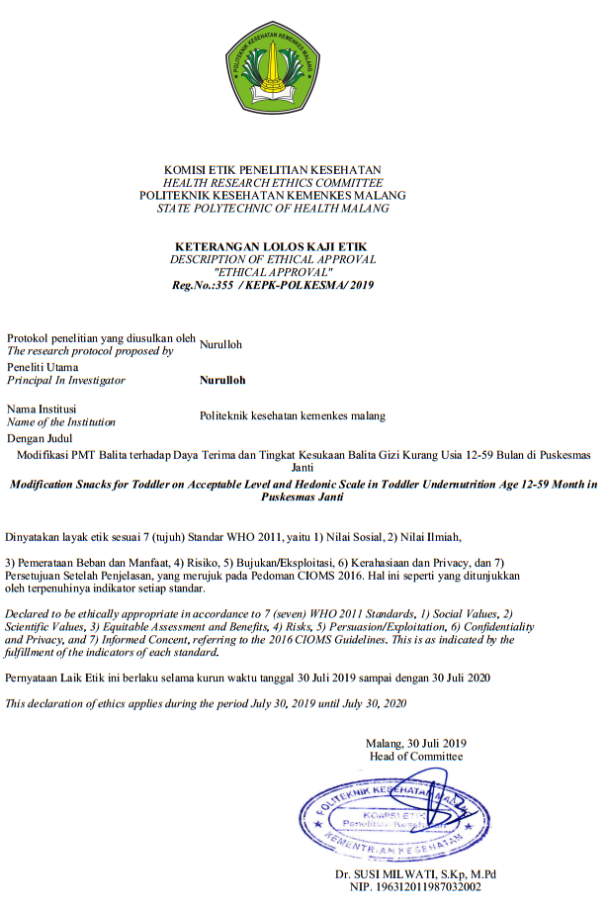
Lampiran 2. Surat Izin Penelitian
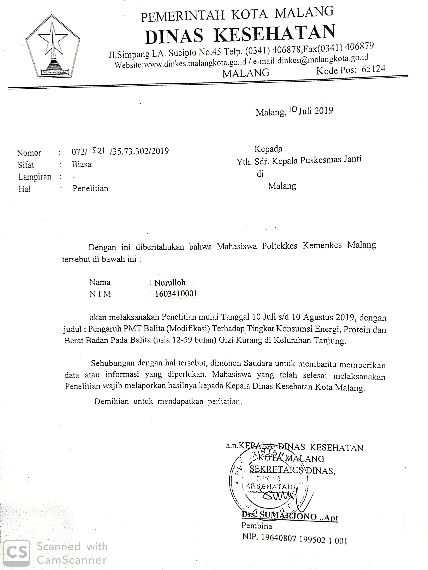
Lampiran 3. Lembar Persetujuan
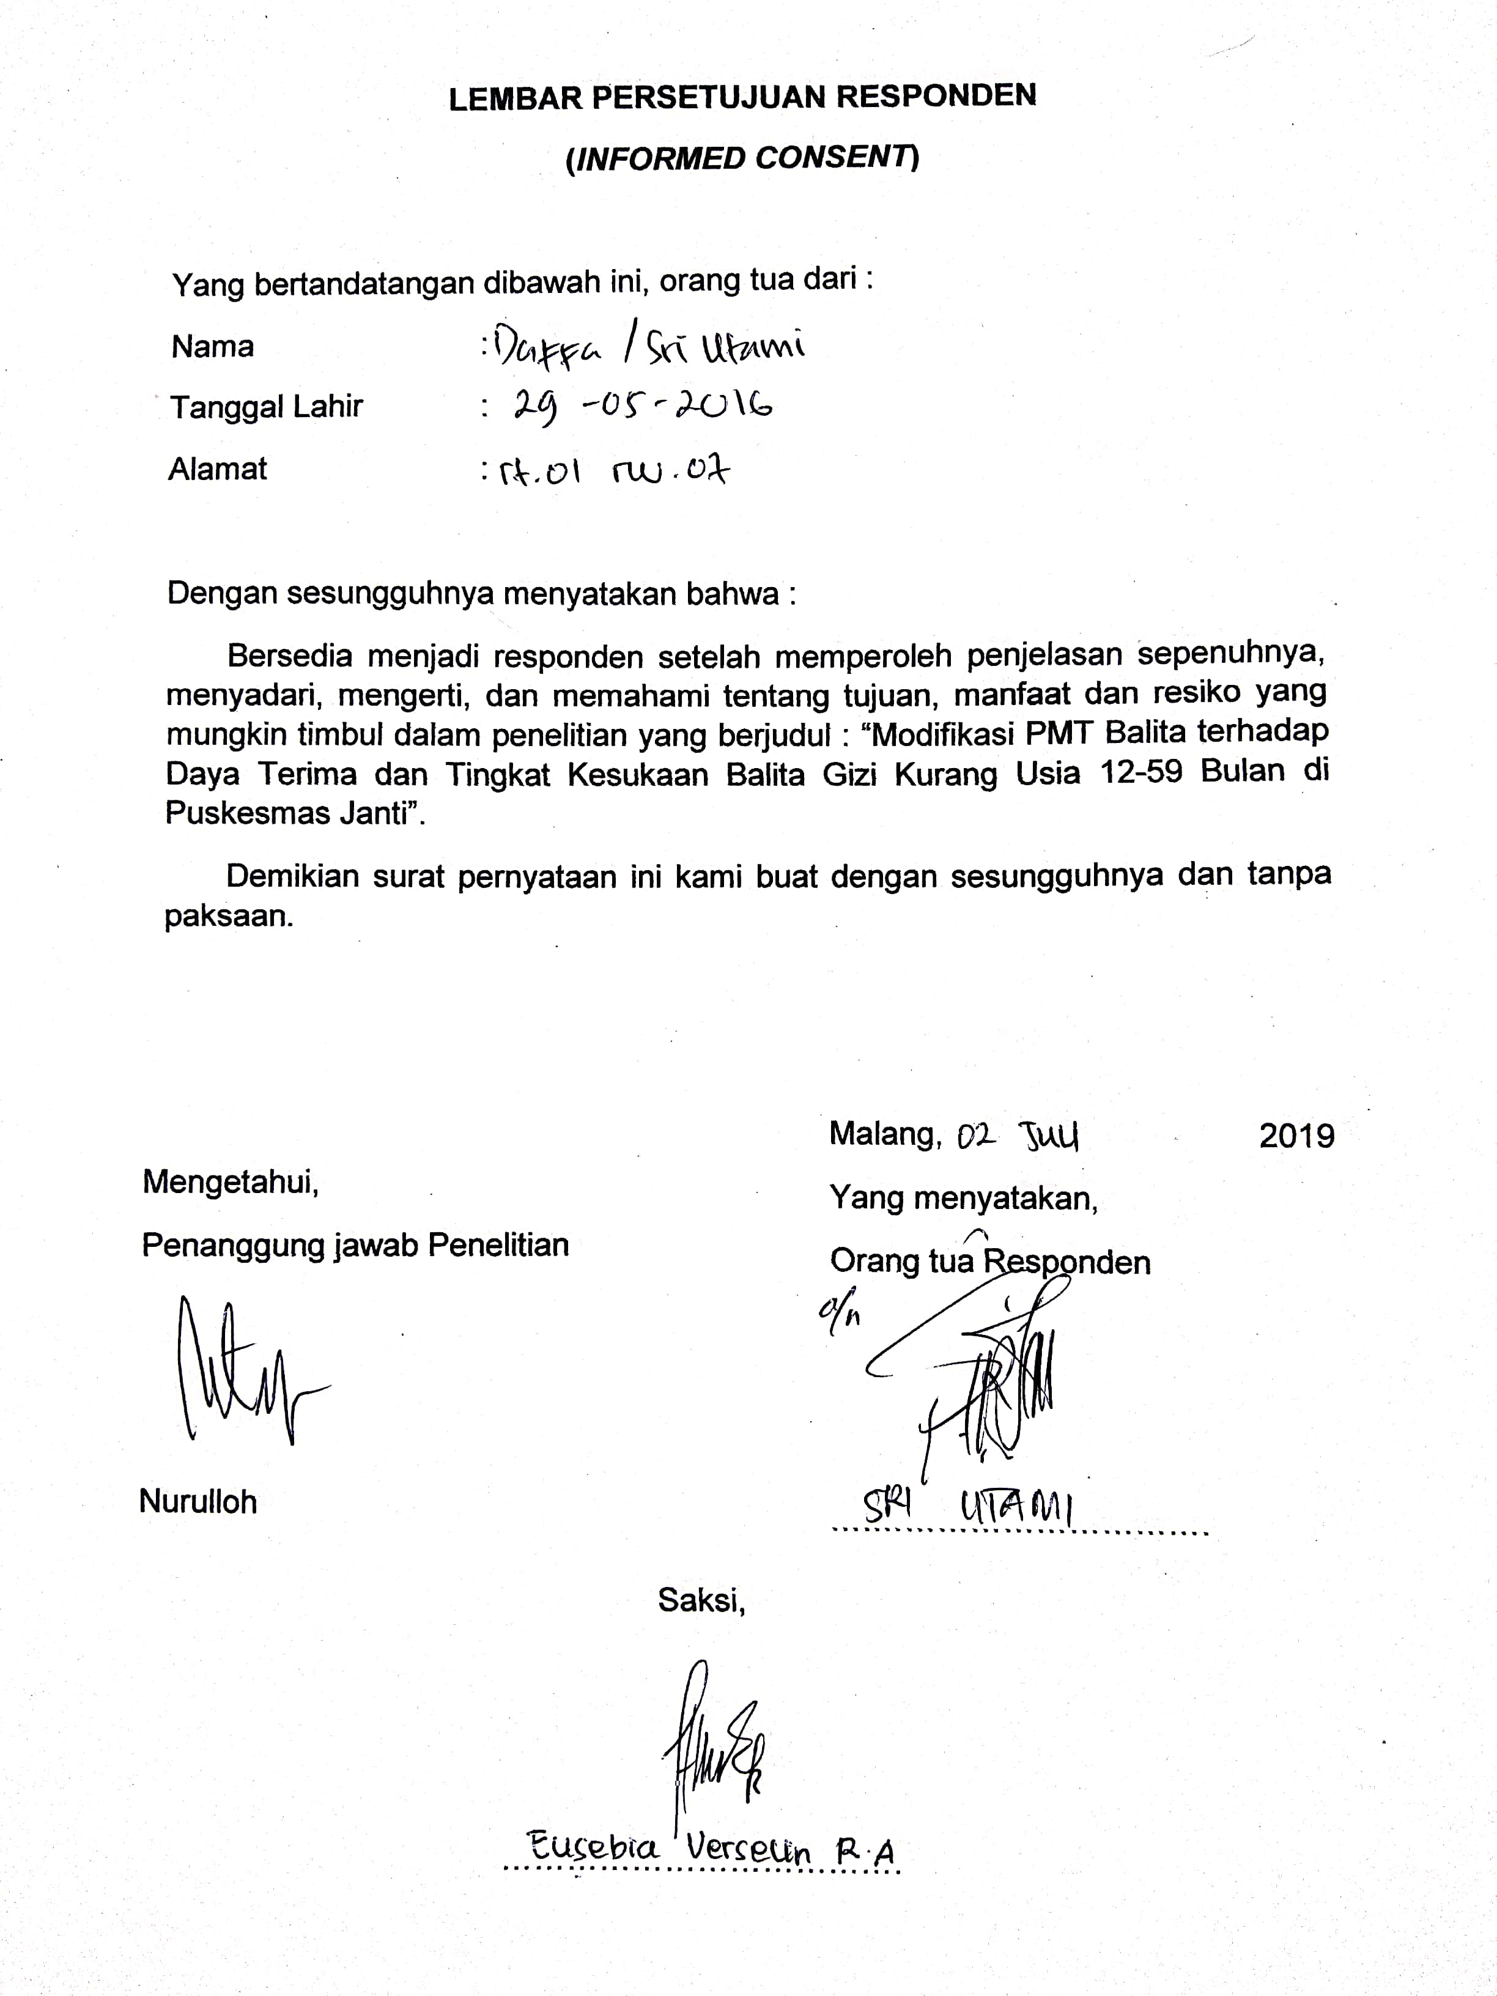

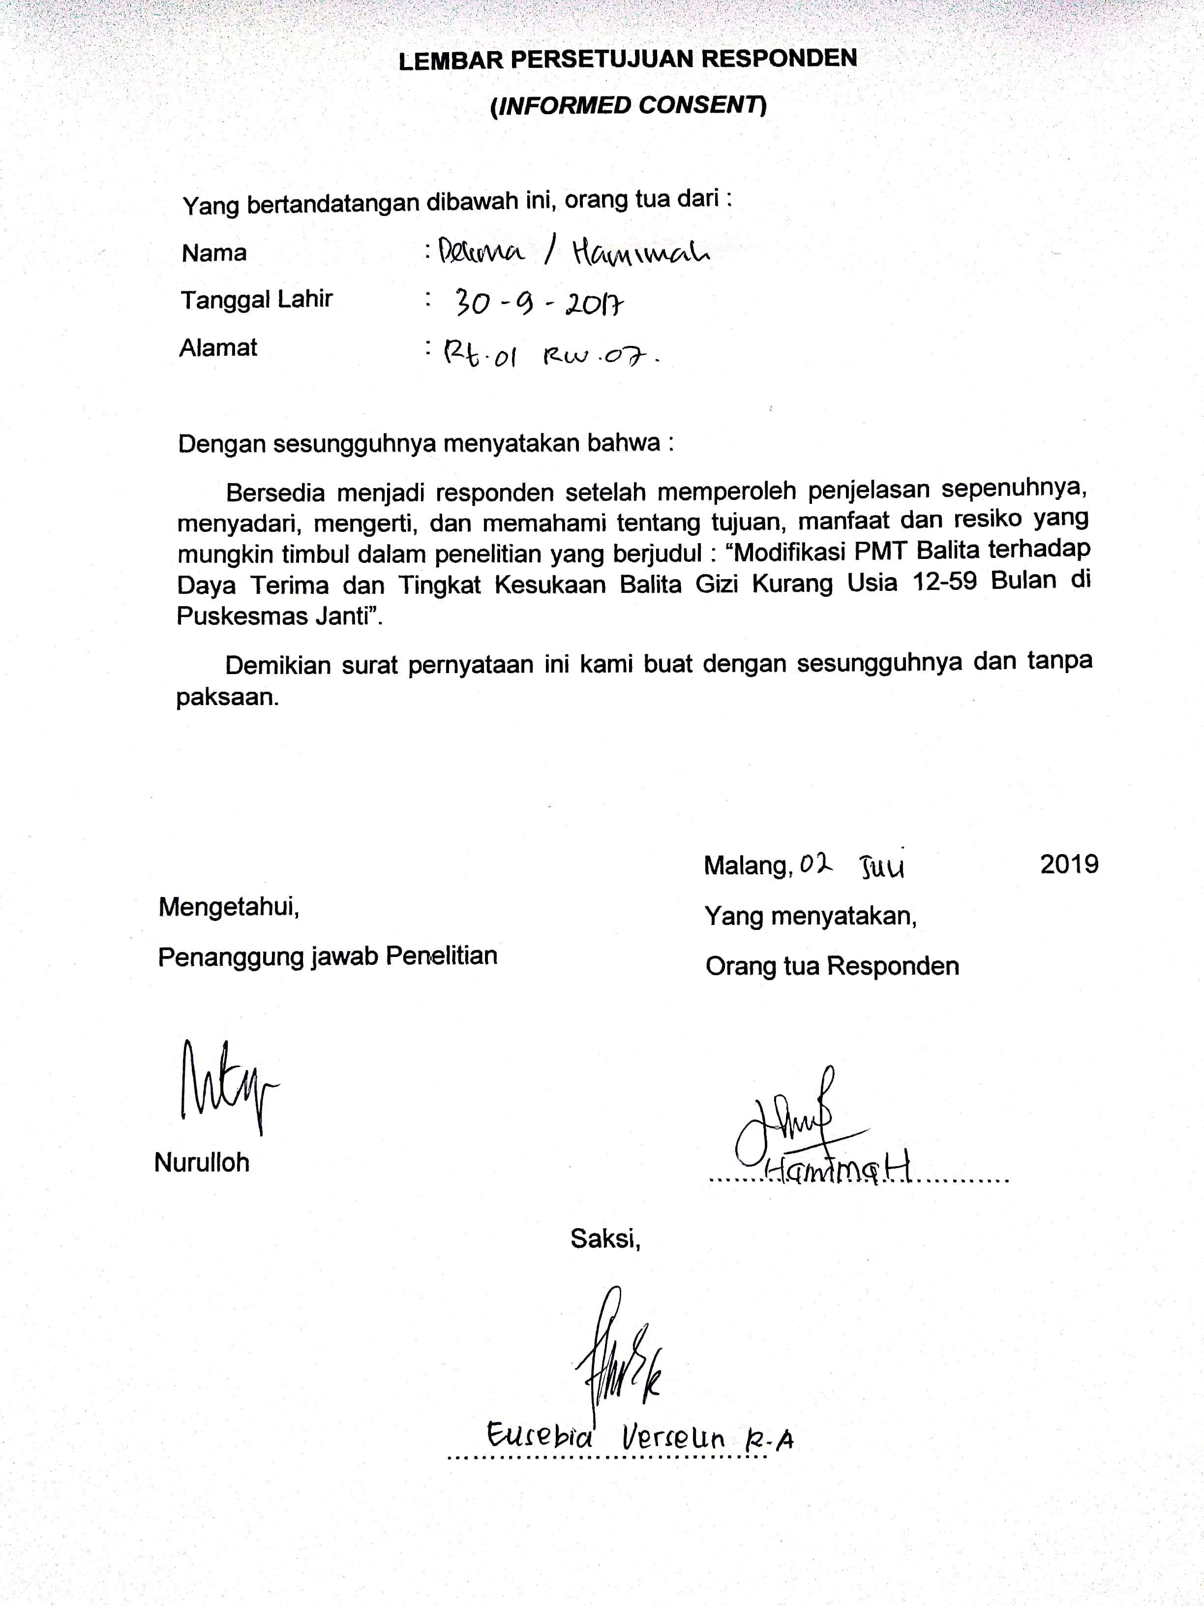

Lampiran 4. Form Uji Daya Terima
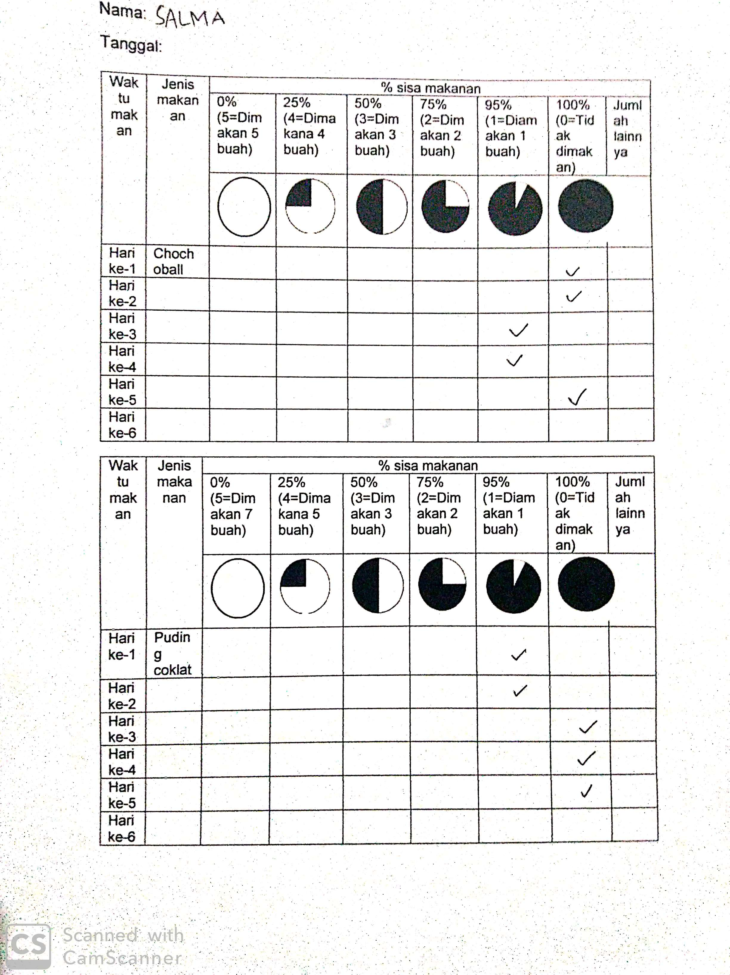

Lampiran 5. Form Uji Kesukaan
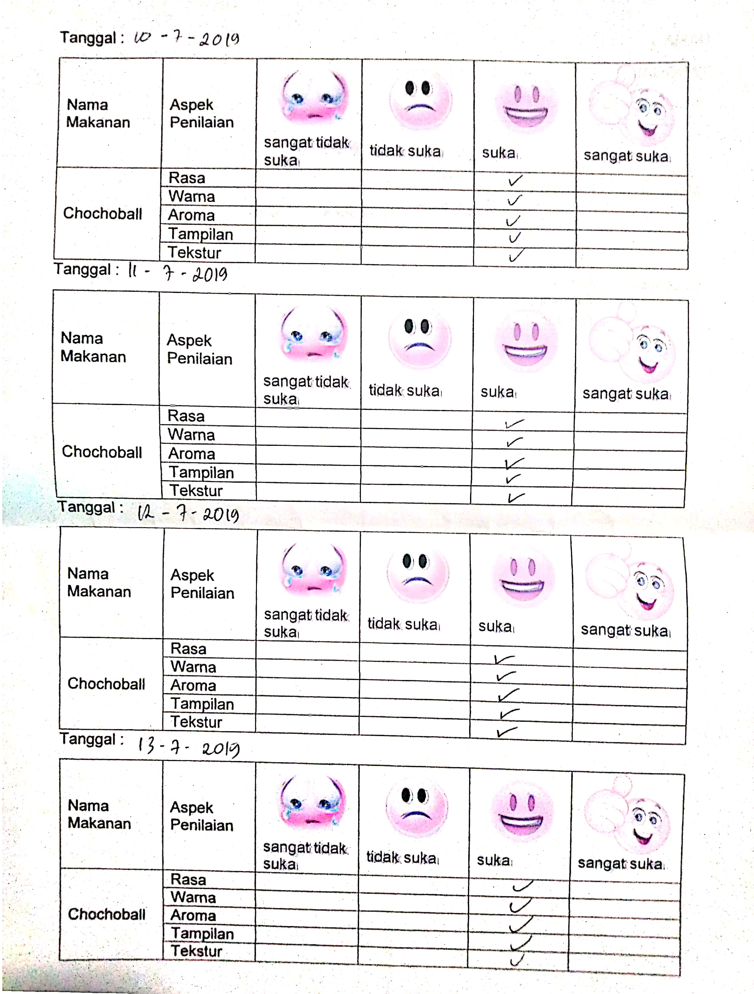
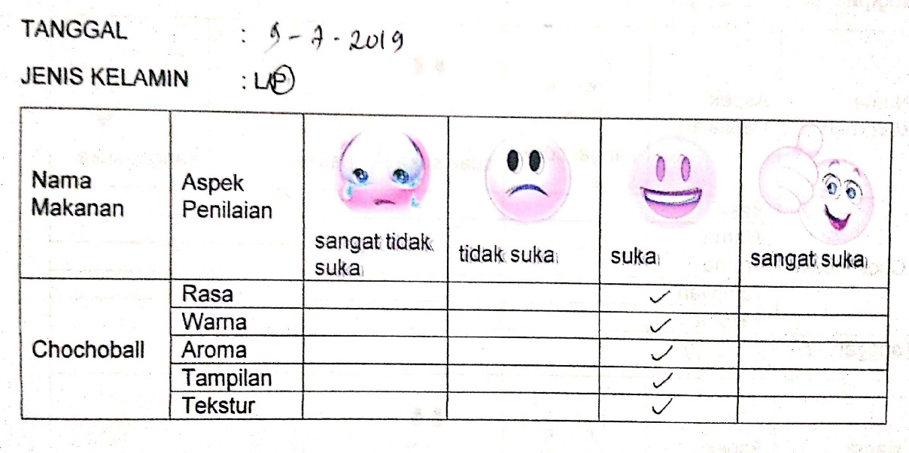

Lampiran 6. Pedoman Wawancara Awal
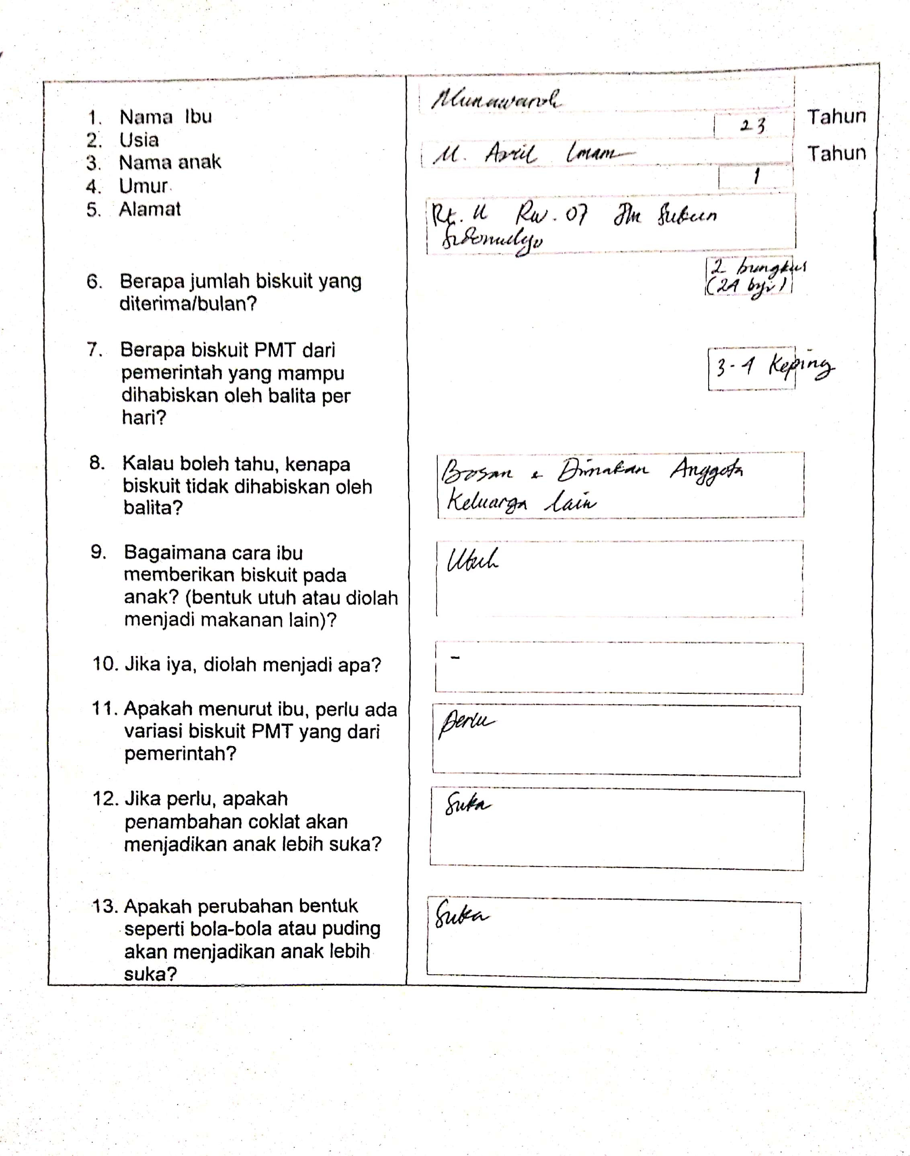

Lampiran 7. Pedoman Wawancara Akhir
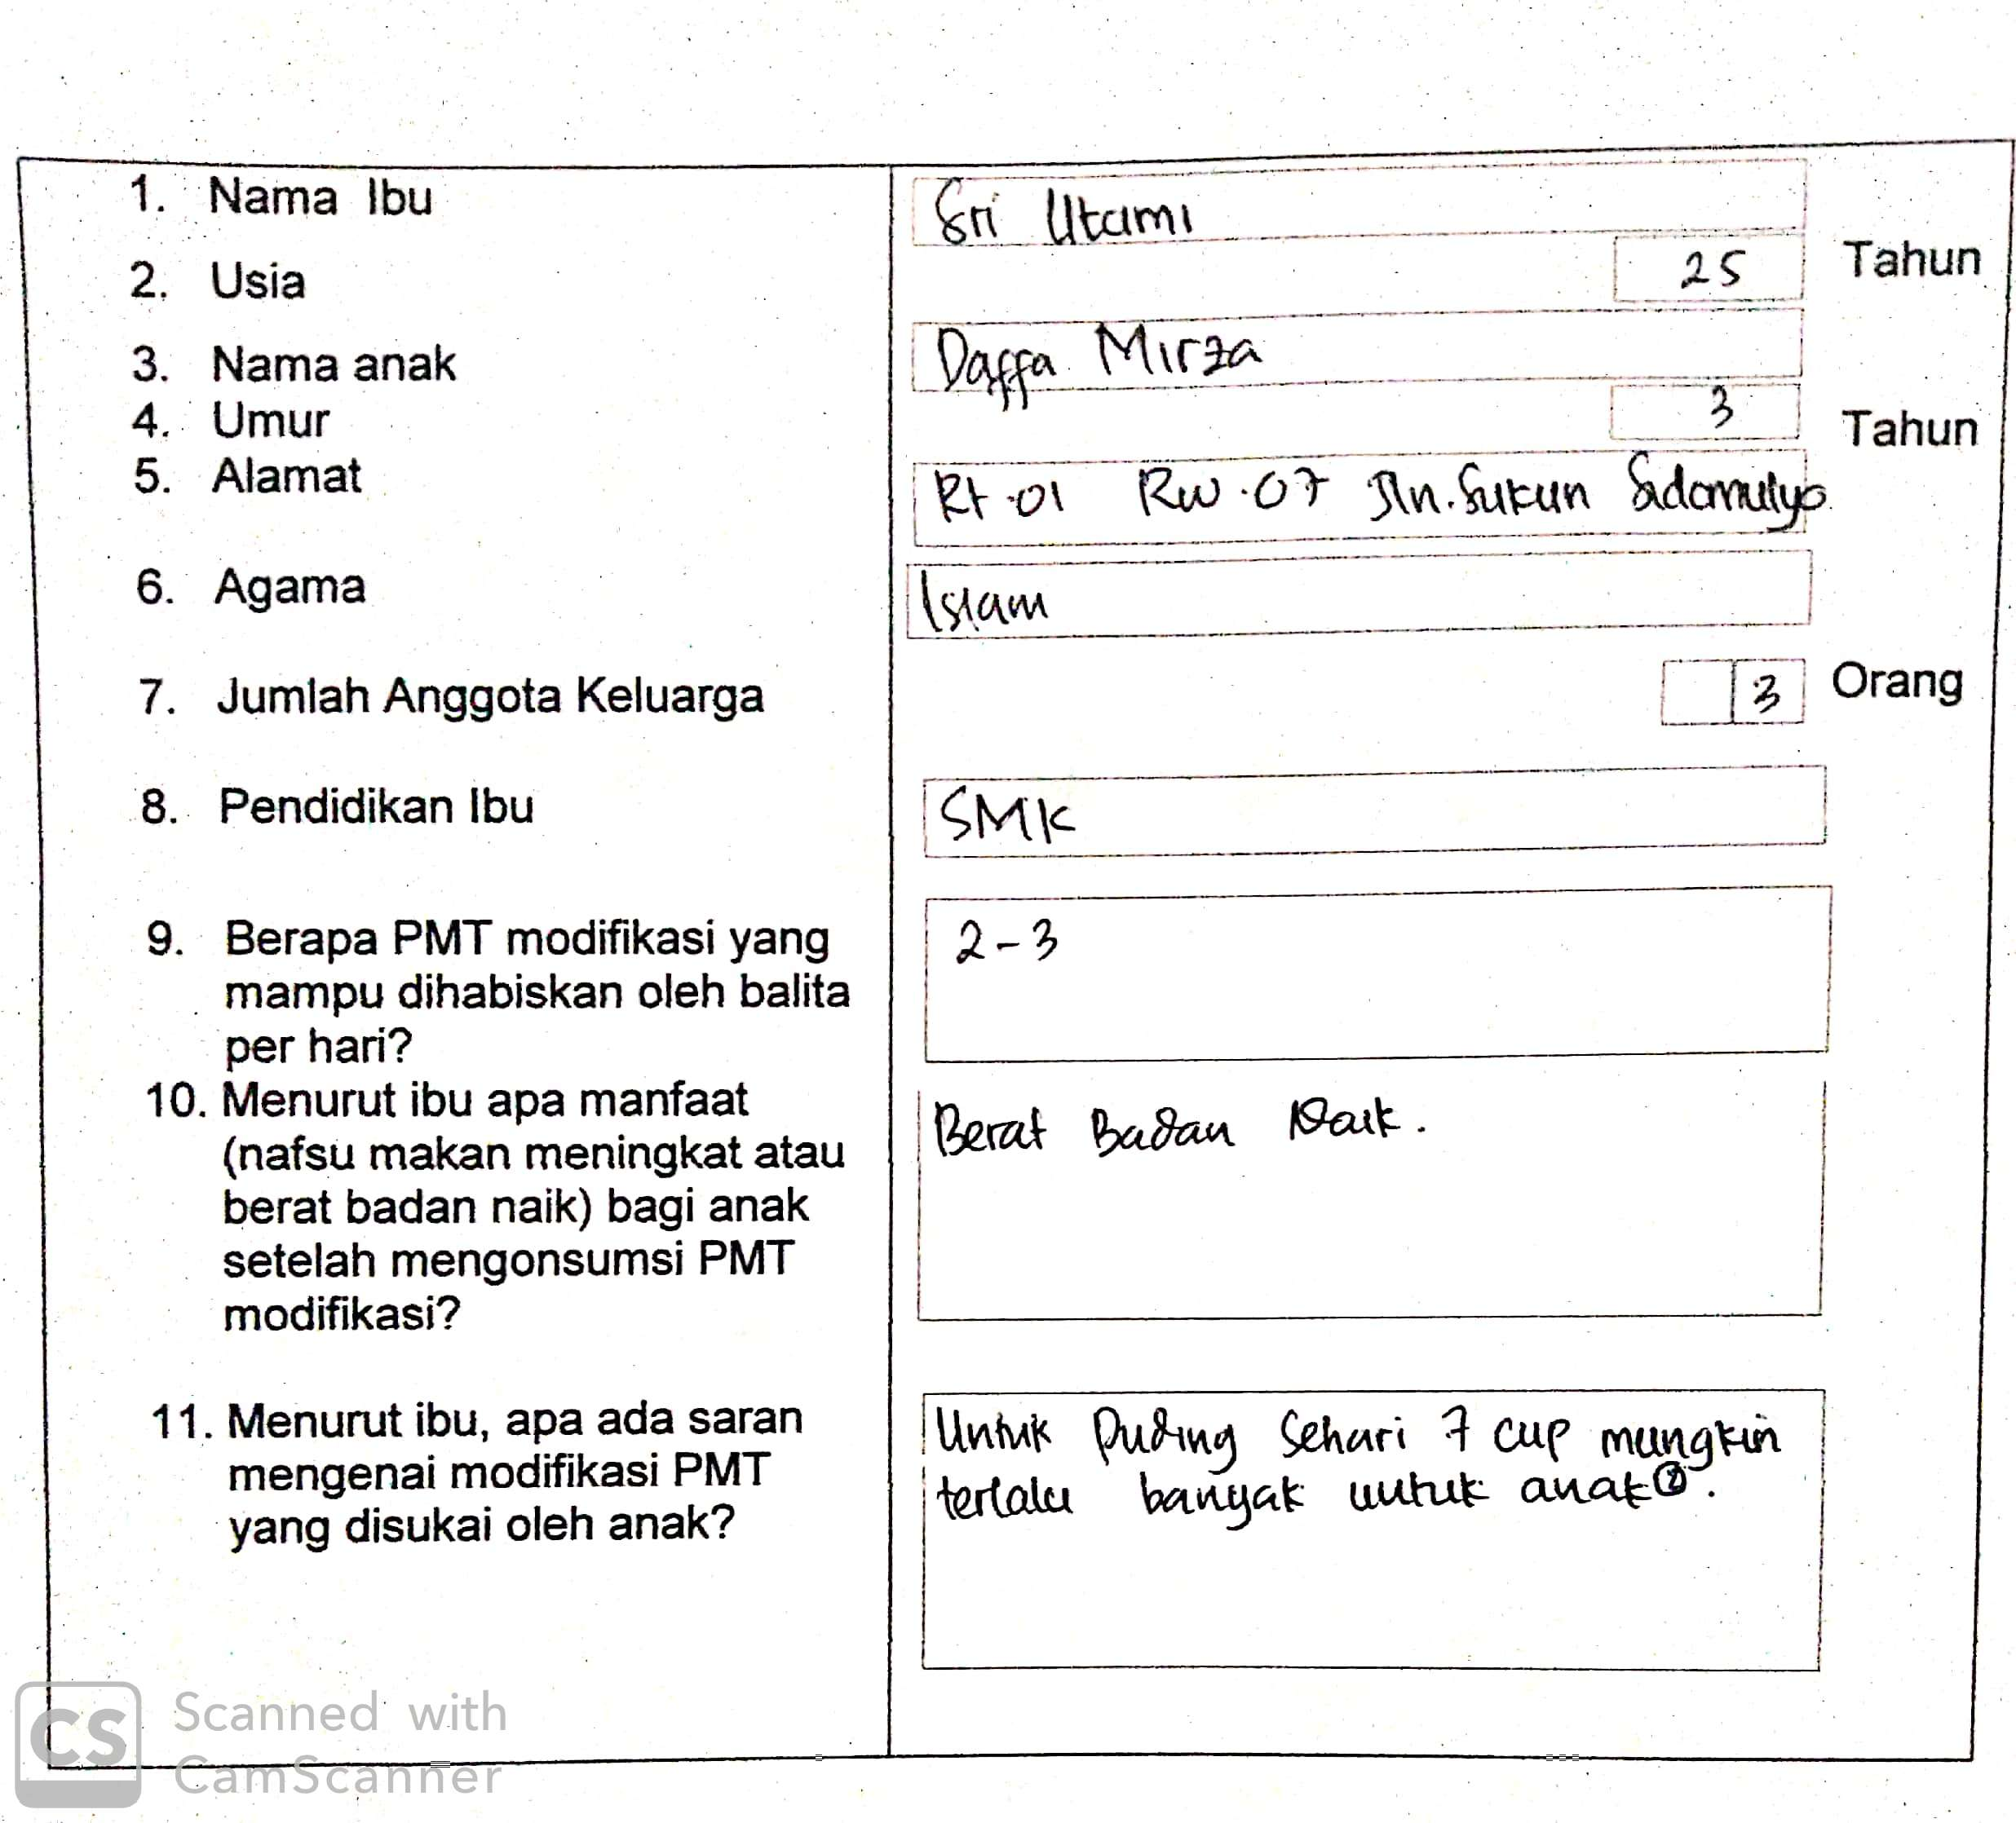
Lampiran 8. Hasil Uji Statistik
Lampiran 1. Hasil Uji Daya Terima Biskuit PMT Standar dengan Bola-Bola Coklat
Tests of Normality
 | Kolmogorov-Smirnovª |  |  | Shapiro-Wilk
 | Statistic | df | Sig. | Statistic | df | Sig.
biskuit | ,251 | 16 | ,008 | ,866 | 16 | ,023
bbc | ,183 | 16 | ,156 | ,922 | 16 | ,182
pc | ,220 | 16 | ,036 | ,842 | 16 | ,010

a. Lilliefors Significance Correction
Wilcoxon Signed Ranks Test
Ranks
 |  | N | Mean Rank | Sum of Ranks
bbc – biskuit | Negative Ranks | 4ª | 3,13 | 12,50
bbc – biskuit | Positive Ranks | 10^{b} | 9,25 | 92,50
bbc – biskuit | Ties | 2^{c}
bbc – biskuit | Total | 16

a. bbc < biskuit
b. bbc > biskuit
c. bbc = biskuit

Test Statisticsª
 | bbc - biskuit
Z | -2,521^{b}
Asymp. Sig. (2-tailed) | ,012

a. Wilcoxon Signed Ranks Test
b. Based on negative ranks.

Lampiran 2. Hasil Uji Daya Terima Biskuit PMT Standar dengan Puding Coklat
Wilcoxon Signed Ranks Test
Ranks
 |  | N | Mean Rank | Sum of Ranks
pc - biskuit | Negative Ranks | 6ª | 7,25 | 43,50
pc - biskuit | Positive Ranks | 9^{b} | 8,50 | 76,50
pc - biskuit | Ties | 1^{c}
pc - biskuit | Total | 16

a. pc < biskuit
b. pc > biskuit
c. pc = biskuit
Test Statisticsª
 | pc - biskuit
Z | -,942^{b}
Asymp. Sig. (2-tailed) | ,346

a. Wilcoxon Signed Ranks Test
b. Based on negative ranks.

Lampiran 3. Hasil Uji Daya Terima Bola-Bola Coklat dengan Puding Coklat
Wilcoxon Signed Ranks Test
Ranks
 |  | N | Mean Rank | Sum of Ranks
pc - bbc | Negative Ranks | 9ª | 6,61 | 59,50
pc - bbc | Positive Ranks | 2^{b} | 3,25 | 6,50
pc - bbc | Ties | 5^{c}
pc - bbc | Total | 16

a. pc < bbc
b. pc > bbc
c. pc = bbc

Test Statisticsª
 | pc - bbc
Z | -2,364^{b}
Asymp. Sig. (2-tailed) | ,018

a. Wilcoxon Signed Ranks Test
b. Based on positive ranks.
Lampiran 4. Hasil Uji Tingkat Kesukaan Rasa Biskuit PMT Standar dengan Bola-Bola Coklat
Tests of Normality
 | Kolmogorov-Smirnovª |  |  | Shapiro-Wilk
 | Statistic | df | Sig. | Statistic | df | Sig.
biskuit | ,267 | 16 | ,003 | ,862 | 16 | ,020
bbc | ,171 | 16 | ,200* | ,931 | 16 | ,251
pc | ,183 | 16 | ,155 | ,943 | 16 | ,383

*. This is a lower bound of the true significance.
a. Lilliefors Significance Correction
Wilcoxon Signed Ranks Test
Ranks
 |  | N | Mean Rank | Sum of Ranks
bbc - biskuit | Negative Ranks | 3ª | 5,00 | 15,00
bbc - biskuit | Positive Ranks | 13^{b} | 9,31 | 121,00
bbc - biskuit | Ties | 0^{c}
bbc - biskuit | Total | 16

a. bbc < biskuit
b. bbc > biskuit
c. bbc = biskuit
Test Statisticsª
 | bbc – biskuit
Z | -2,761^{b}
Asymp. Sig. (2-tailed) | ,006

a. Wilcoxon Signed Ranks Test
b. Based on negative ranks.
Lampiran 5. Hasil Uji Tingkat Kesukaan Rasa Biskuit PMT Standar dengan Puding Coklat
Wilcoxon Signed Ranks Test
Ranks
 |  | N | Mean Rank | Sum of Ranks
pc - biskuit | Negative Ranks | 8ª | 6,13 | 49,00
pc - biskuit | Positive Ranks | 5^{b} | 8,40 | 42,00
pc - biskuit | Ties | 3^{c}
pc - biskuit | Total | 16

a. pc < biskuit
b. pc > biskuit
c. pc = biskuit

Test Statisticsª
 | pc – biskuit
Z | -,246^{b}
Asymp. Sig. (2-tailed) | ,806

a. Wilcoxon Signed Ranks Test
b. Based on positive ranks.

Lampiran 6. Hasil Uji Tingkat Kesukaan Rasa Bola-Bola Coklat dengan Puding Coklat
Paired Samples Statistics
 |  | Mean | N | Std. Deviation | Std. Error Mean
Pair 1 | bbc | 2,8000 | 16 | ,37238 | ,09309
Pair 1 | pc | 2,3875 | 16 | ,58637 | ,14659

Paired Samples Correlations
 |  | N | Correlation | Sig.
Pair 1 | bbc & pc | 16 | ,537 | ,032

Paired Samples Test
 |  | Paired Differences
 |  | Mean | Std. Deviation | Std. Error Mean | 95% Confidence Interval of the Difference
 |  |  |  |  | Lower | Upper
Pair 1 | bbc - pc | ,41250 | ,49783 | ,12446 | ,14723 | ,67777

Paired Samples Test
 |  | t | df | Sig. (2-tailed)
Pair 1 | bbc - pc | 3,314 | 15 | ,005

Lampiran 7. Hasil Uji Tingkat Kesukaan Warna Biskuit PMT Standar dengan Bola-Bola Coklat
Tests of Normality
 | Kolmogorov-Smirnovª |  |  | Shapiro-Wilk
 | Statistic | df | Sig. | Statistic | df | Sig.
biskuit | ,218 | 16 | ,041 | ,889 | 16 | ,055
bbc | ,271 | 16 | ,003 | ,874 | 16 | ,032
pc | ,174 | 16 | ,200* | ,848 | 16 | ,013

*. This is a lower bound of the true significance.
a. Lilliefors Significance Correction
Wilcoxon Signed Ranks Test
Ranks
 |  | N | Mean Rank | Sum of Ranks
bbc - biskuit | Negative Ranks | 3ª | 3,00 | 9,00
bbc - biskuit | Positive Ranks | 11^{b} | 8,73 | 96,00
bbc - biskuit | Ties | 2^{c}
bbc - biskuit | Total | 16

a. bbc < biskuit
b. bbc > biskuit
c. bbc = biskuit

Test Statisticsª
 | bbc - biskuit
Z | -2,754^{b}
Asymp. Sig. (2-tailed) | ,006

a. Wilcoxon Signed Ranks Test
b. Based on negative ranks.
Lampiran 8. Hasil Uji Tingkat Kesukaan Warna Biskuit PMT Standar dengan Puding Coklat
Wilcoxon Signed Ranks Test
Ranks
 |  | N | Mean Rank | Sum of Ranks
pc - biskuit | Negative Ranks | 6ª | 9,00 | 54,00
pc - biskuit | Positive Ranks | 10^{b} | 8,20 | 82,00
pc - biskuit | Ties | 0^{c}
pc - biskuit | Total | 16

a. pc < biskuit
b. pc > biskuit
c. pc = biskuit

Test Statisticsª
 | pc - biskuit
Z | -,731^{b}
Asymp. Sig. (2-tailed) | ,465

a. Wilcoxon Signed Ranks Test
b. Based on negative ranks.
Lampiran 9. Hasil Uji Tingkat Kesukaan Warna Bola-Bola Coklat dengan Puding Coklat
Wilcoxon Signed Ranks Test
Ranks
 |  | N | Mean Rank | Sum of Ranks
pc - bbc | Negative Ranks | 9ª | 8,06 | 72,50
pc - bbc | Positive Ranks | 4^{b} | 4,63 | 18,50
pc - bbc | Ties | 3^{c}
pc - bbc | Total | 16

a. pc < bbc
b. pc > bbc
c. pc = bbc

Test Statisticsª
 | pc - bbc
Z | -1,896^{b}
Asymp. Sig. (2-tailed) | ,058

a. Wilcoxon Signed Ranks Test
b. Based on positive ranks.

Lampiran 10. Hasil Uji Tingkat Kesukaan Aroma Biskuit PMT Standar dengan Bola-Bola Coklat
Tests of Normality
 | Kolmogorov-Smirnovª |  |  | Shapiro-Wilk
 | Statistic | df | Sig. | Statistic | df | Sig.
biskuit | ,518 | 16 | ,000 | ,398 | 16 | ,000
bbc | ,296 | 16 | ,001 | ,780 | 16 | ,001
pc | ,301 | 16 | ,000 | ,873 | 16 | ,031

a. Lilliefors Significance Correction
Wilcoxon Signed Ranks Test
Ranks
 |  | N | Mean Rank | Sum of Ranks
bbc - biskuit | Negative Ranks | 8ª | 5,31 | 42,50
bbc - biskuit | Positive Ranks | 1^{b} | 2,50 | 2,50
bbc - biskuit | Ties | 7^{c}
bbc - biskuit | Total | 16

a. bbc < biskuit
b. bbc > biskuit
c. bbc = biskuit
Test Statisticsa
 | bbc - biskuit
Z | -2,412^{b}
Asymp. Sig. (2-tailed) | ,016

a. Wilcoxon Signed Ranks Test
b. Based on positive ranks.

Lampiran 11. Hasil Uji Tingkat Kesukaan Aroma Biskuit PMT Standar dengan Puding Coklat
Wilcoxon Signed Ranks Test
Ranks
 |  | N | Mean Rank | Sum of Ranks
pc – biskuit | Negative Ranks | 6ª | 8,50 | 51,00
pc – biskuit | Positive Ranks | 5^{b} | 3,00 | 15,00
pc – biskuit | Ties | 5^{c}
pc – biskuit | Total | 16

a. pc < biskuit
b. pc > biskuit
c. pc = biskuit
Test Statisticsa
 | pc - biskuit
Z | -1,608^{b}
Asymp. Sig. (2-tailed) | ,108

a. Wilcoxon Signed Ranks Test
b. Based on positive ranks.

Lampiran 12. Hasil Uji Tingkat Kesukaan Aroma Bola-Bola Coklat dengan Puding Coklat
Wilcoxon Signed Ranks Test
Ranks
 |  | N | Mean Rank | Sum of Ranks
pc - bbc | Negative Ranks | 5ª | 7,70 | 38,50
pc - bbc | Positive Ranks | 6^{b} | 4,58 | 27,50
pc - bbc | Ties | 5^{c}
pc - bbc | Total | 16

a. pc < bbc
b. pc > bbc
c. pc = bbc
Test Statisticsa
 | pc - bbc
Z | -,493^{b}
Asymp. Sig. (2-tailed) | ,622

a. Wilcoxon Signed Ranks Test
b. Based on positive ranks.
Lampiran 13. Hasil Uji Tingkat Kesukaan Tampilan Biskuit PMT Standar dengan Bola-Bola Coklat
Tests of Normality
 | Kolmogorov-Smirnovª |  |  | Shapiro-Wilk
 | Statistic | df | Sig. | Statistic | df | Sig.
biskuit | ,225 | 16 | ,029 | ,908 | 16 | ,109
Bbc | ,195 | 16 | ,107 | ,952 | 16 | ,526
Pc | ,180 | 16 | ,175 | ,950 | 16 | ,482

a. Lilliefors Significance Correction
Paired Samples Statistics
 |  | Mean | N | Std. Deviation | Std. Error Mean
Pair 1 | biskuit | 2,3000 | 16 | ,50067 | ,12517
Pair 1 | bbc | 2,9000 | 16 | ,57038 | ,14259

Paired Samples Correlations
 |  | N | Correlation | Sig.
Pair 1 | biskuit & bbc | 16 | ,579 | ,019

Paired Samples Test
 |  | Paired Differences
 |  | Mean | Std. Deviation | Std. Error Mean | 95% Confidence Interval of the Difference
 |  |  |  |  | Lower | Upper
Pair 1 | biskuit - bbc | -,60000 | ,49531 | ,12383 | -,86393 | -,33607

Paired Samples Test
 |  | t | df | Sig. (2-tailed)
Pair 1 | biskuit - bbc | -4,845 | 15 | ,000

Lampiran 14. Hasil Uji Tingkat Kesukaan Tampilan Biskuit PMT Standar dengan
Paired Samples Statistics
 |  | Mean | N | Std. Deviation | Std. Error Mean
Pair 1 | biskuit | 2,3000 | 16 | ,50067 | ,12517
Pair 1 | pc | 2,4625 | 16 | ,82533 | ,20633

Paired Samples Correlations
 |  | N | Correlation | Sig.
Pair 1 | biskuit & pc | 16 | ,636 | ,008

Paired Samples Test
 |  | Paired Differences
 |  | Mean | Std. Deviation | Std. Error Mean | 95% Confidence Interval of the Difference
 |  |  |  |  | Lower | Upper
Pair 1 | biskuit - pc | -,16250 | ,63757 | ,15939 | -,50224 | ,17724

Paired Samples Test
 |  | t | Df | Sig. (2-tailed)
Pair 1 | biskuit - pc | -1,019 | 15 | ,324

Lampiran 15. Hasil Uji Tingkat Kesukaan Tampilan Bola-Bola Coklat dengan Puding Coklat
Paired Samples Statistics
 |  | Mean | N | Std. Deviation | Std. Error Mean
Pair 1 | bbc | 2,9000 | 16 | ,57038 | ,14259
Pair 1 | pc | 2,4625 | 16 | ,82533 | ,20633

Paired Samples Correlations
 |  | N | Correlation | Sig.
Pair 1 | bbc & pc | 16 | ,558 | ,025

Paired Samples Test
 |  | Paired Differences
 |  | Mean | Std. Deviation | Std. Error Mean | 95% Confidence Interval of the Difference
 |  |  |  |  | Lower | Upper
Pair 1 | bbc - pc | ,43750 | ,69366 | ,17342 | ,06787 | ,80713

Paired Samples Test
 |  | t | df | Sig. (2-tailed)
Pair 1 | bbc - pc | 2,523 | 15 | ,023

Lampiran 16. Hasil Uji Tingkat Kesukaan Tekstur Biskuit PMT Standar dengan Bola-Bola Coklat
Tests of Normality
 | Kolmogorov-Smirnovª |  |  | Shapiro-Wilk
 | Statistic | df | Sig. | Statistic | df | Sig.
biskuit | ,200 | 16 | ,088 | ,815 | 16 | ,004
Bbc | ,259 | 16 | ,005 | ,895 | 16 | ,066
Pc | ,177 | 16 | ,192 | ,886 | 16 | ,048

a. Lilliefors Significance Correction
Wilcoxon Signed Ranks Test
Ranks
 |  | N | Mean Rank | Sum of Ranks
bbc – biskuit | Negative Ranks | 3ª | 5,17 | 15,50
bbc – biskuit | Positive Ranks | 12^{b} | 8,71 | 104,50
bbc – biskuit | Ties | 1^{c}
bbc – biskuit | Total | 16

a. bbc < biskuit
b. bbc > biskuit
c. bbc = biskuit
Test Statisticsa
 | bbc - biskuit
Z | -2,549^{b}
Asymp. Sig. (2-tailed) | ,011

a. Wilcoxon Signed Ranks Test
b. Based on negative ranks.
Lampiran 17. Hasil Uji Tingkat Kesukaan Tekstur Biskuit PMT Standar dengan Puding Coklat
Wilcoxon Signed Ranks Test
Ranks
 |  | N | Mean Rank | Sum of Ranks
pc - biskuit | Negative Ranks | 8ª | 7,19 | 57,50
pc - biskuit | Positive Ranks | 7^{b} | 8,93 | 62,50
pc - biskuit | Ties | 1^{c}
pc - biskuit | Total | 16

a. pc < biskuit
b. pc > biskuit
c. pc = biskuit

Test Statisticsª
 | pc - biskuit
Z | -,145^{b}
Asymp. Sig. (2-tailed) | ,885

a. Wilcoxon Signed Ranks Test
b. Based on negative ranks.

Lampiran 18. Hasil Uji Tingkat Kesukaan Tekstur Bola-Bola Coklat dengan Puding Coklat
Wilcoxon Signed Ranks Test
Ranks
 |  | N | Mean Rank | Sum of Ranks
pc - bbc | Negative Ranks | 10ª | 7,05 | 70,50
pc - bbc | Positive Ranks | 2^{b} | 3,75 | 7,50
pc - bbc | Ties | 4^{c}
pc - bbc | Total | 16

a. pc < bbc
b. pc > bbc
c. pc = bbc

Test Statisticsª
 | pc - bbc
Z | -2,478^{b}
Asymp. Sig. (2-tailed) | ,013

a. Wilcoxon Signed Ranks Test
b. Based on positive ranks.

Lampiran 9. Data Excel Daya Terima
No.responden | Jenis Kelamin | Daya terima hari ke-
No.responden | Jenis Kelamin | biskuit PMT standar |  |  |  |  |  | Bola-bola coklat |  |  |  |  |  | Puding coklat
No.responden | Jenis Kelamin | 1 | 2 | 3 | 4 | 5 | Rata-rata | 1 | 2 | 3 | 4 | 5 | Rata-rata | 1 | 2 | 3 | 4 | 5 | Rata-rata
1. | perempuan | 2 | 2 | 2 | 2 | 2 | 2,0 | 2 | 2 | 2 | 2 | 2 | 2,0 | 1 | 1 | 1 | 1 | 1 | 1,0
2. | laki-laki | 0 | 1 | 1 | 1 | 1 | 0,8 | 2 | 2 | 2 | 2 | 2 | 2,0 | 3 | 3 | 2 | 2 | 2 | 2,4
3. | laki-laki | 0 | 0 | 0 | 0 | 0 | 0,0 | 1 | 2 | 1 | 0 | 0 | 0,8 | 1 | 0 | 0 | 0 | 0 | 0,2
4. | laki-laki | 1 | 1 | 1 | 1 | 1 | 1,0 | 2 | 1 | 1 | 0 | 0 | 0,8 | 1 | 1 | 1 | 1 | 0 | 0,8
5. | laki-laki | 1 | 1 | 1 | 1 | 1 | 1,0 | 2 | 1 | 1 | 0 | 0 | 0,8 | 1 | 0 | 1 | 1 | 1 | 0,8
6. | laki-laki | 0 | 0 | 0 | 0 | 0 | 0,0 | 2 | 2 | 2 | 2 | 2 | 2,0 | 2 | 2 | 1 | 1 | 1 | 1,4
7. | laki-laki | 0 | 1 | 1 | 1 | 1 | 0,8 | 5 | 2 | 2 | 3 | 2 | 2,8 | 3 | 3 | 3 | 3 | 3 | 3,0
8. | perempuan | 0 | 0 | 0 | 0 | 0 | 0,0 | 1 | 1 | 1 | 1 | 1 | 1,0 | 1 | 1 | 1 | 1 | 0 | 0,8
9. | laki-laki | 1 | 1 | 1 | 1 | 1 | 1,0 | 2 | 2 | 3 | 1 | 1 | 1,8 | 1 | 1 | 1 | 0 | 0 | 0,6
10. | laki-laki | 1 | 1 | 1 | 0 | 0 | 0,6 | 2 | 2 | 2 | 1 | 0 | 1,4 | 1 | 2 | 1 | 1 | 0 | 1,0
11. | perempuan | 1 | 1 | 1 | 1 | 1 | 1,0 | 2 | 2 | 2 | 2 | 2 | 2,0 | 2 | 2 | 1 | 1 | 0 | 1,2
No.responden | Jenis Kelamin | Daya terima hari ke-
No.responden | Jenis Kelamin | biskuit PMT standar |  |  |  |  |  | Bola-bola coklat |  |  |  |  |  | Puding coklat
No.responden | Jenis Kelamin | 1 | 2 | 3 | 4 | 5 | Rata-rata | 1 | 2 | 3 | 4 | 5 | Rata-rata | 1 | 2 | 3 | 4 | 5 | Rata-rata
12. | perempuan | 1 | 1 | 1 | 1 | 1 | 1,0 | 2 | 2 | 2 | 2 | 2 | 2,0 | 2 | 2 | 1 | 1 | 0 | 1,2
13. | laki-laki | 0 | 0 | 0 | 1 | 1 | 0,4 | 1 | 1 | 1 | 1 | 1 | 1,0 | 1 | 1 | 1 | 1 | 1 | 1,0
14. | perempuan | 1 | 1 | 1 | 1 | 1 | 1,0 | 1 | 1 | 1 | 0 | 0 | 0,6 | 1 | 1 | 0 | 0 | 0 | 0,4
15. | laki-laki | 1 | 1 | 1 | 1 | 1 | 1,0 | 1 | 0 | 0 | 0 | 0 | 0,2 | 0 | 1 | 0 | 0 | 0 | 0,2
16. | perempuan | 1 | 1 | 0 | 0 | 0 | 0,4 | 0 | 0 | 1 | 1 | 0 | 0,4 | 1 | 1 | 0 | 0 | 0 | 0,4
RATA-RATA |  | 0,7 | 0,8 | 0,8 | 0,8 | 0,8 | 0,8 | 1,8 | 1,4 | 1,5 | 1,1 | 0,9 | 1,4 | 1,4 | 1,4 | 0,9 | 0,9 | 0,6 | 1,0
Lampiran 10. Data Excel Tingkat Kesukaan
No.responden | Jenis Kelamin | Tingkat kesukaan rasa hari ke-
No.responden | Jenis Kelamin | biskuit PMT standar |  |  |  |  |  | Bola-bola coklat |  |  |  |  |  | Puding coklat
No.responden | Jenis Kelamin | 1 | 2 | 3 | 4 | 5 | Rata-Rata | 1 | 2 | 3 | 4 | 5 | Rata-Rata | 1 | 2 | 3 | 4 | 5 | Rata-Rata
1. | perempuan | 3 | 3 | 3 | 3 | 2 | 2,8 | 3 | 3 | 3 | 3 | 3 | 3 | 3 | 3 | 3 | 3 | 3 | 3
2. | laki-laki | 2 | 2 | 2 | 2 | 2 | 2 | 3 | 3 | 3 | 3 | 3 | 3 | 3 | 3 | 2 | 2 | 2 | 2,4
3. | laki-laki | 2 | 2 | 2 | 2 | 2 | 2 | 2 | 3 | 4 | 2 | 2 | 2,6 | 2 | 2 | 2 | 1 | 2 | 1,8
4. | laki-laki | 3 | 3 | 3 | 2 | 3 | 2,8 | 3 | 3 | 3 | 2 | 2 | 2,6 | 2 | 2 | 2 | 2 | 2 | 2
5. | laki-laki | 2 | 2 | 2 | 2 | 2 | 2 | 3 | 2 | 3 | 3 | 3 | 2,8 | 3 | 3 | 4 | 4 | 3 | 3,4
6. | laki-laki | 2 | 2 | 2 | 2 | 2 | 2 | 3 | 3 | 3 | 3 | 3 | 3 | 3 | 3 | 3 | 3 | 3 | 3
7. | laki-laki | 3 | 3 | 3 | 3 | 3 | 3 | 3 | 3 | 2 | 3 | 3 | 2,8 | 3 | 2 | 2 | 3 | 3 | 2,6
8. | perempuan | 2 | 2 | 2 | 2 | 1 | 1,8 | 2 | 2 | 2 | 2 | 2 | 2 | 2 | 2 | 2 | 2 | 1 | 1,8
9. | laki-laki | 3 | 2 | 3 | 3 | 2 | 2,6 | 3 | 3 | 3 | 3 | 3 | 3 | 3 | 3 | 3 | 2 | 2 | 2,6
10. | laki-laki | 3 | 3 | 2 | 2 | 3 | 2,6 | 3 | 3 | 4 | 4 | 3 | 3,4 | 3 | 3 | 4 | 4 | 3 | 3,4
11. | perempuan | 2 | 2 | 2 | 2 | 2 | 2 | 3 | 3 | 3 | 3 | 2 | 2,8 | 2 | 2 | 2 | 2 | 2 | 2
No.responden | Jenis Kelamin | Tingkat kesukaan rasa hari ke-
No.responden | Jenis Kelamin | biskuit PMT standar |  |  |  |  |  | Bola-bola coklat |  |  |  |  |  | Puding coklat
No.responden | Jenis Kelamin | 1 | 2 | 3 | 4 | 5 | Rata-Rata | 1 | 2 | 3 | 4 | 5 | Rata-Rata | 1 | 2 | 3 | 4 | 5 | Rata-Rata
12. | perempuan | 2 | 3 | 3 | 2 | 2 | 2,4 | 2 | 3 | 3 | 3 | 2 | 2,6 | 2 | 2 | 2 | 2 | 2 | 2
13. | laki-laki | 3 | 3 | 3 | 3 | 2 | 2,8 | 3 | 3 | 3 | 3 | 3 | 3 | 2 | 2 | 2 | 2 | 2 | 2
14. | perempuan | 2 | 2 | 2 | 2 | 2 | 2 | 3 | 3 | 3 | 2 | 2 | 2,6 | 2 | 2 | 1 | 1 | 1 | 1,4
15. | laki-laki | 3 | 3 | 2 | 3 | 2 | 2,6 | 3 | 2 | 2 | 2 | 2 | 2,2 | 3 | 3 | 2 | 2 | 2 | 2,4
16. | perempuan | 3 | 3 | 3 | 3 | 3 | 3 | 3 | 3 | 4 | 4 | 3 | 3,4 | 3 | 3 | 2 | 2 | 2 | 2,4
RATA-RATA |  | 2,5 | 2,5 | 2,4 | 2,4 | 2,2 | 2,4 | 2,8 | 2,8 | 3,0 | 2,8 | 2,6 | 2,8 | 2,6 | 2,5 | 2,4 | 2,3 | 2,2 | 2,4

No.responden | Jenis Kelamin | Tingkat kesukaan warna hari ke-
No.responden | Jenis Kelamin | Biskuit PMT standar |  |  |  |  |  | Bola-bola coklat |  |  |  |  |  | Puding coklat
No.responden | Jenis Kelamin | 1 | 2 | 3 | 4 | 5 | Rata-Rata | 1 | 2 | 3 | 4 | 5 | Rata-Rata | 1 | 2 | 3 | 4 | 5 | Rata-Rata
1. | perempuan | 3 | 3 | 3 | 3 | 2 | 2,8 | 3 | 3 | 3 | 3 | 3 | 3,0 | 3 | 3 | 3 | 3 | 3 | 3,0
2. | laki-laki | 2 | 2 | 2 | 2 | 2 | 2,0 | 3 | 3 | 2 | 2 | 3 | 2,6 | 2 | 2 | 1 | 1 | 1 | 1,4
3. | laki-laki | 2 | 2 | 2 | 2 | 2 | 2,0 | 2 | 3 | 4 | 4 | 2 | 3,0 | 2 | 2 | 1 | 1 | 1 | 1,4
4. | laki-laki | 3 | 3 | 3 | 2 | 3 | 2,8 | 3 | 3 | 3 | 2 | 2 | 2,6 | 2 | 2 | 2 | 2 | 2 | 2,0
5. | laki-laki | 2 | 2 | 2 | 2 | 2 | 2,0 | 2 | 3 | 4 | 3 | 3 | 3,0 | 3 | 3 | 3 | 2 | 2 | 2,6
6. | laki-laki | 2 | 2 | 2 | 2 | 2 | 2,0 | 3 | 3 | 3 | 3 | 3 | 3,0 | 3 | 3 | 2 | 2 | 2 | 2,4
7. | laki-laki | 3 | 3 | 3 | 3 | 3 | 3,0 | 3 | 3 | 2 | 3 | 3 | 2,8 | 3 | 3 | 3 | 4 | 3 | 3,2
8. | perempuan | 2 | 2 | 2 | 2 | 1 | 1,8 | 3 | 3 | 3 | 3 | 3 | 3,0 | 3 | 3 | 3 | 3 | 2 | 2,8
9. | laki-laki | 2 | 2 | 3 | 3 | 2 | 2,4 | 4 | 3 | 4 | 3 | 3 | 3,4 | 3 | 3 | 3 | 2 | 2 | 2,6
10. | laki-laki | 3 | 3 | 2 | 2 | 3 | 2,6 | 3 | 3 | 4 | 2 | 1 | 2,6 | 4 | 3 | 3 | 3 | 2 | 3,0
11. | perempuan | 3 | 2 | 2 | 2 | 2 | 2,2 | 3 | 3 | 3 | 3 | 2 | 2,8 | 4 | 4 | 3 | 3 | 2 | 3,2
No.responden | Jenis Kelamin | Tingkat kesukaan warna hari ke-
No.responden | Jenis Kelamin | Biskuit PMT standar |  |  |  |  |  | Bola-bola coklat |  |  |  |  |  | Puding coklat
No.responden | Jenis Kelamin | 1 | 2 | 3 | 4 | 5 | Rata-Rata | 1 | 2 | 3 | 4 | 5 | Rata-Rata | 1 | 2 | 3 | 4 | 5 | Rata-Rata
12. | perempuan | 3 | 3 | 3 | 2 | 2 | 2,6 | 3 | 3 | 3 | 3 | 3 | 3,0 | 4 | 3 | 3 | 3 | 3 | 3,2
13. | laki-laki | 3 | 3 | 3 | 3 | 2 | 2,8 | 3 | 3 | 3 | 3 | 3 | 3,0 | 3 | 3 | 3 | 3 | 3 | 3,0
14. | perempuan | 2 | 2 | 2 | 2 | 2 | 2,0 | 3 | 3 | 3 | 2 | 2 | 2,6 | 2 | 2 | 1 | 1 | 1 | 1,4
15. | laki-laki | 3 | 3 | 2 | 3 | 2 | 2,6 | 4 | 2 | 2 | 2 | 2 | 2,4 | 3 | 3 | 2 | 2 | 2 | 2,4
16. | perempuan | 3 | 3 | 3 | 3 | 3 | 3,0 | 4 | 3 | 3 | 3 | 2 | 3,0 | 4 | 4 | 2 | 2 | 2 | 2,8
RATA-RATA |  | 2,6 | 2,5 | 2,4 | 2,4 | 2,2 | 2,4 | 3,1 | 2,9 | 3,1 | 2,8 | 2,5 | 2,9 | 3,0 | 2,9 | 2,4 | 2,3 | 2,1 | 2,5

No.responden | Jenis Kelamin | Tingkat kesukaan aroma hari ke-
No.responden | Jenis Kelamin | Biskuit PMT standar |  |  |  |  |  | Bola-bola coklat |  |  |  |  |  | Puding coklat
No.responden | Jenis Kelamin | 1 | 2 | 3 | 4 | 5 | Rata-Rata | 1 | 2 | 3 | 4 | 5 | Rata-Rata | 1 | 2 | 3 | 4 | 5 | Rata-Rata
1. | perempuan | 3 | 3 | 3 | 3 | 3 | 3,0 | 3 | 3 | 3 | 3 | 3 | 3,0 | 3 | 3 | 3 | 3 | 3 | 3,0
2. | laki-laki | 3 | 3 | 3 | 3 | 3 | 3,0 | 3 | 3 | 2 | 2 | 3 | 2,6 | 3 | 3 | 3 | 3 | 3 | 3,0
3. | laki-laki | 3 | 3 | 3 | 3 | 3 | 3,0 | 2 | 3 | 4 | 2 | 2 | 2,6 | 2 | 2 | 2 | 2 | 2 | 2,0
4. | laki-laki | 3 | 3 | 3 | 3 | 3 | 3,0 | 3 | 3 | 3 | 2 | 2 | 2,6 | 2 | 2 | 2 | 2 | 2 | 2,0
5. | laki-laki | 3 | 3 | 3 | 3 | 3 | 3,0 | 3 | 3 | 3 | 3 | 3 | 3,0 | 4 | 4 | 3 | 3 | 3 | 3,4
6. | laki-laki | 3 | 3 | 3 | 3 | 3 | 3,0 | 3 | 3 | 3 | 3 | 3 | 3,0 | 3 | 3 | 2 | 2 | 2 | 2,4
7. | laki-laki | 3 | 3 | 3 | 3 | 3 | 3,0 | 3 | 3 | 3 | 3 | 3 | 3,0 | 3 | 3 | 3 | 3 | 3 | 3,0
8. | perempuan | 3 | 3 | 3 | 3 | 3 | 3,0 | 3 | 3 | 3 | 3 | 3 | 3,0 | 3 | 3 | 3 | 3 | 3 | 3,0
9. | laki-laki | 2 | 3 | 3 | 3 | 3 | 2,8 | 3 | 3 | 3 | 3 | 3 | 3,0 | 3 | 3 | 3 | 3 | 3 | 3,0
10. | laki-laki | 3 | 3 | 3 | 3 | 3 | 3,0 | 4 | 3 | 4 | 2 | 1 | 2,8 | 4 | 4 | 3 | 3 | 3 | 3,4
11. | perempuan | 3 | 3 | 3 | 3 | 3 | 3,0 | 3 | 3 | 3 | 3 | 3 | 3,0 | 4 | 4 | 3 | 3 | 2 | 3,2
No.responden | Jenis Kelamin | Tingkat kesukaan aroma hari ke-
No.responden | Jenis Kelamin | Biskuit PMT standar |  |  |  |  |  | Bola-bola coklat |  |  |  |  |  | Puding coklat
No.responden | Jenis Kelamin | 1 | 2 | 3 | 4 | 5 | Rata-Rata | 1 | 2 | 3 | 4 | 5 | Rata-Rata | 1 | 2 | 3 | 4 | 5 | Rata-Rata
12. | perempuan | 3 | 3 | 3 | 3 | 3 | 3,0 | 3 | 3 | 3 | 3 | 2 | 2,8 | 4 | 4 | 3 | 3 | 2 | 3,2
13. | laki-laki | 3 | 3 | 3 | 3 | 3 | 3,0 | 3 | 3 | 3 | 3 | 3 | 3,0 | 3 | 3 | 3 | 3 | 3 | 3,0
14. | perempuan | 2 | 3 | 3 | 3 | 3 | 2,8 | 3 | 3 | 3 | 2 | 2 | 2,6 | 2 | 2 | 1 | 1 | 1 | 1,4
15. | laki-laki | 3 | 3 | 3 | 3 | 3 | 3,0 | 3 | 2 | 2 | 2 | 2 | 2,2 | 3 | 3 | 2 | 2 | 2 | 2,4
16. | perempuan | 3 | 3 | 3 | 3 | 3 | 3,0 | 3 | 2 | 3 | 3 | 2 | 2,6 | 3 | 3 | 2 | 2 | 2 | 2,4
RATA-RATA |  | 2,9 | 3,0 | 3,0 | 3,0 | 3,0 | 3,0 | 3,0 | 2,9 | 3,0 | 2,6 | 2,5 | 2,8 | 3,1 | 3,1 | 2,6 | 2,6 | 2,4 | 2,7

No.responden | Jenis Kelamin | Tingkat kesukaan tampilan hari ke-
No.responden | Jenis Kelamin | Biskuit PMT standar |  |  |  |  |  | Bola-bola coklat |  |  |  |  |  | Puding coklat
No.responden | Jenis Kelamin | 1 | 2 | 3 | 4 | 5 | Rata-Rata | 1 | 2 | 3 | 4 | 5 | Rata-Rata | 1 | 2 | 3 | 4 | 5 | Rata-Rata
1. | perempuan | 3 | 3 | 2 | 3 | 2 | 2,6 | 3 | 3 | 3 | 3 | 3 | 3,0 | 3 | 3 | 3 | 3 | 3 | 3,0
2. | laki-laki | 2 | 3 | 2 | 2 | 2 | 2,2 | 3 | 3 | 3 | 3 | 3 | 3,0 | 3 | 3 | 3 | 3 | 3 | 3,0
3. | laki-laki | 2 | 2 | 2 | 2 | 2 | 2,0 | 2 | 2 | 3 | 2 | 2 | 2,2 | 2 | 2 | 1 | 1 | 1 | 1,4
4. | laki-laki | 2 | 3 | 2 | 2 | 1 | 2,0 | 3 | 3 | 3 | 2 | 2 | 2,6 | 2 | 2 | 2 | 2 | 2 | 2,0
5. | laki-laki | 3 | 3 | 3 | 2 | 2 | 2,6 | 3 | 4 | 2 | 2 | 2 | 2,6 | 3 | 3 | 2 | 2 | 2 | 2,4
6. | laki-laki | 2 | 2 | 2 | 2 | 2 | 2,0 | 3 | 3 | 3 | 3 | 3 | 3,0 | 3 | 3 | 3 | 3 | 3 | 3,0
7. | laki-laki | 3 | 3 | 3 | 3 | 3 | 3,0 | 3 | 3 | 3 | 3 | 3 | 3,0 | 3 | 3 | 3 | 3 | 3 | 3,0
8. | perempuan | 2 | 2 | 2 | 1 | 2 | 1,8 | 3 | 3 | 3 | 3 | 3 | 3,0 | 3 | 3 | 3 | 3 | 2 | 2,8
9. | laki-laki | 2 | 2 | 2 | 2 | 2 | 2,0 | 4 | 3 | 4 | 3 | 3 | 3,4 | 2 | 1 | 1 | 0 | 0 | 0,8
10. | laki-laki | 2 | 2 | 2 | 2 | 2 | 2,0 | 3 | 2 | 2 | 1 | 1 | 1,8 | 3 | 2 | 2 | 1 | 1 | 1,8
11. | perempuan | 3 | 3 | 3 | 3 | 2 | 2,8 | 4 | 4 | 4 | 4 | 3 | 3,8 | 4 | 4 | 3 | 3 | 2 | 3,2
No.responden | Jenis Kelamin | Tingkat kesukaan tampilan hari ke-
No.responden | Jenis Kelamin | Biskuit PMT standar |  |  |  |  |  | Bola-bola coklat |  |  |  |  |  | Puding coklat
No.responden | Jenis Kelamin | 1 | 2 | 3 | 4 | 5 | Rata-Rata | 1 | 2 | 3 | 4 | 5 | Rata-Rata | 1 | 2 | 3 | 4 | 5 | Rata-Rata
12. | perempuan | 3 | 3 | 3 | 3 | 3 | 3,0 | 4 | 4 | 4 | 4 | 4 | 4,0 | 4 | 4 | 4 | 4 | 4 | 4,0
13. | laki-laki | 3 | 3 | 2 | 3 | 2 | 2,6 | 3 | 3 | 3 | 3 | 3 | 3,0 | 3 | 3 | 3 | 3 | 3 | 3,0
14. | perempuan | 2 | 2 | 1 | 1 | 1 | 1,4 | 3 | 3 | 3 | 2 | 2 | 2,6 | 2 | 2 | 1 | 1 | 1 | 1,4
15. | laki-laki | 2 | 2 | 2 | 1 | 2 | 1,8 | 3 | 2 | 2 | 2 | 2 | 2,2 | 2 | 3 | 2 | 2 | 2 | 2,2
16. | perempuan | 3 | 3 | 3 | 3 | 3 | 3,0 | 3 | 3 | 4 | 4 | 2 | 3,2 | 3 | 3 | 2 | 2 | 2 | 2,4
RATA-RATA |  | 2,4 | 2,6 | 2,3 | 2,2 | 2,1 | 2,3 | 3,1 | 3,0 | 3,1 | 2,8 | 2,6 | 2,9 | 2,8 | 2,8 | 2,4 | 2,3 | 2,1 | 2,5

No.responden | Jenis Kelamin | Tingkat kesukaan tekstur hari ke-
No.responden | Jenis Kelamin | Biskuit PMT standar |  |  |  |  |  | Bola-bola coklat |  |  |  |  |  | Puding coklat
No.responden | Jenis Kelamin | 1 | 2 | 3 | 4 | 5 | Rata-Rata | 1 | 2 | 3 | 4 | 5 | Rata-Rata | 1 | 2 | 3 | 4 | 5 | Rata-Rata
1. | perempuan | 3 | 3 | 3 | 2 | 3 | 2,8 | 3 | 3 | 3 | 3 | 3 | 3,0 | 3 | 3 | 3 | 3 | 3 | 3,0
2. | laki-laki | 2 | 3 | 3 | 2 | 2 | 2,4 | 3 | 3 | 3 | 3 | 3 | 3,0 | 3 | 3 | 3 | 3 | 3 | 3,0
3. | laki-laki | 2 | 2 | 2 | 3 | 2 | 2,2 | 2 | 2 | 4 | 2 | 2 | 2,4 | 2 | 2 | 2 | 2 | 2 | 2,0
4. | laki-laki | 3 | 3 | 3 | 3 | 3 | 3,0 | 3 | 3 | 3 | 2 | 2 | 2,6 | 2 | 2 | 2 | 2 | 2 | 2,0
5. | laki-laki | 3 | 3 | 2 | 2 | 2 | 2,4 | 3 | 1 | 2 | 2 | 2 | 2,0 | 3 | 2 | 2 | 2 | 2 | 2,2
6. | laki-laki | 2 | 2 | 2 | 2 | 2 | 2,0 | 3 | 3 | 3 | 3 | 3 | 3,0 | 3 | 3 | 3 | 3 | 3 | 3,0
7. | laki-laki | 3 | 3 | 3 | 3 | 3 | 3,0 | 3 | 3 | 3 | 3 | 3 | 3,0 | 2 | 3 | 3 | 3 | 3 | 2,8
8. | perempuan | 2 | 2 | 2 | 2 | 2 | 2,0 | 3 | 3 | 3 | 3 | 3 | 3,0 | 3 | 3 | 3 | 3 | 3 | 3,0
9. | laki-laki | 2 | 2 | 2 | 2 | 2 | 2,0 | 3 | 3 | 4 | 3 | 2 | 3,0 | 2 | 1 | 1 | 1 | 1 | 1,2
10. | laki-laki | 2 | 2 | 2 | 2 | 2 | 2,0 | 3 | 3 | 4 | 3 | 2 | 3,0 | 3 | 3 | 3 | 2 | 2 | 2,6
11. | perempuan | 3 | 3 | 3 | 3 | 3 | 3,0 | 4 | 4 | 4 | 4 | 3 | 3,8 | 3 | 3 | 3 | 2 | 2 | 2,6
No.responden | Jenis Kelamin | Tingkat kesukaan tekstur hari ke-
No.responden | Jenis Kelamin | Biskuit PMT standar |  |  |  |  |  | Bola-bola coklat |  |  |  |  |  | Puding coklat
No.responden | Jenis Kelamin | 1 | 2 | 3 | 4 | 5 | Rata-Rata | 1 | 2 | 3 | 4 | 5 | Rata-Rata | 1 | 2 | 3 | 4 | 5 | Rata-Rata
12. | perempuan | 3 | 2 | 2 | 3 | 2 | 2,4 | 4 | 4 | 4 | 4 | 3 | 3,8 | 3 | 3 | 3 | 2 | 2 | 2,6
13. | laki-laki | 2 | 2 | 2 | 2 | 2 | 2,0 | 3 | 3 | 3 | 3 | 3 | 3,0 | 2 | 2 | 2 | 2 | 2 | 2,0
14. | perempuan | 2 | 2 | 3 | 2 | 2 | 2,2 | 3 | 3 | 3 | 2 | 2 | 2,6 | 2 | 2 | 2 | 2 | 2 | 2,0
15. | laki-laki | 3 | 3 | 3 | 3 | 3 | 3,0 | 3 | 2 | 2 | 2 | 2 | 2,2 | 3 | 4 | 2 | 2 | 3 | 2,8
16. | perempuan | 2 | 2 | 3 | 2 | 2 | 2,2 | 3 | 3 | 4 | 4 | 2 | 3,2 | 3 | 3 | 2 | 2 | 2 | 2,4
RATA-RATA |  | 2,4 | 2,4 | 2,5 | 2,4 | 2,3 | 2,4 | 3,1 | 2,9 | 3,3 | 2,9 | 2,5 | 2,9 | 2,6 | 2,6 | 2,4 | 2,3 | 2,3 | 2,5

Lampiran 11. Dokumentasi Kegiatan
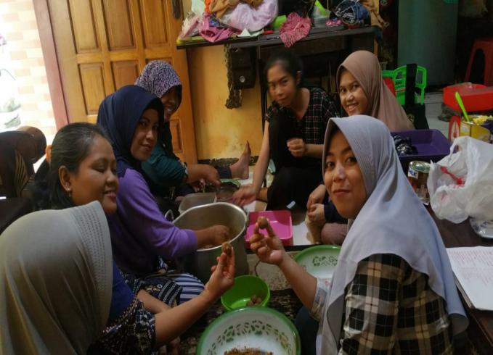

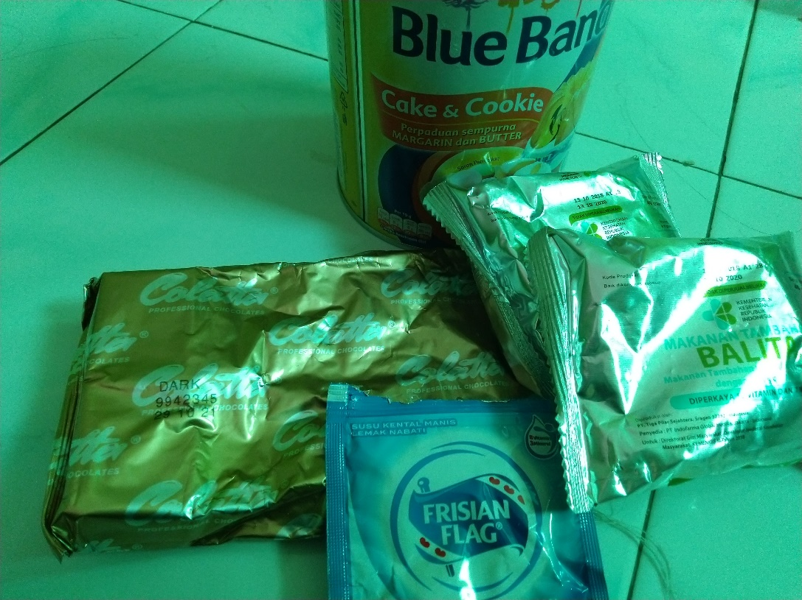
Proses Pembuatan Modifikasi Bersama Ibu-Ibu Kader

Bahan-Bahan Pembuatan Modifikasi Bola-Bola Coklat
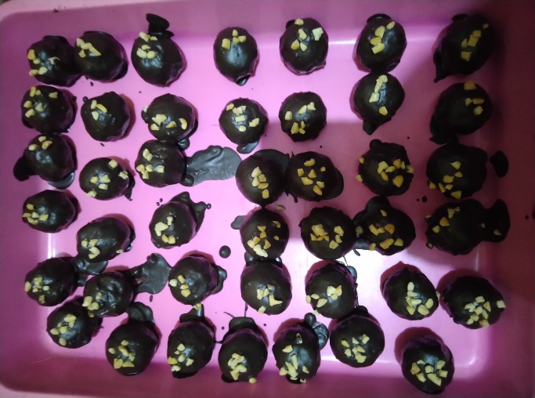

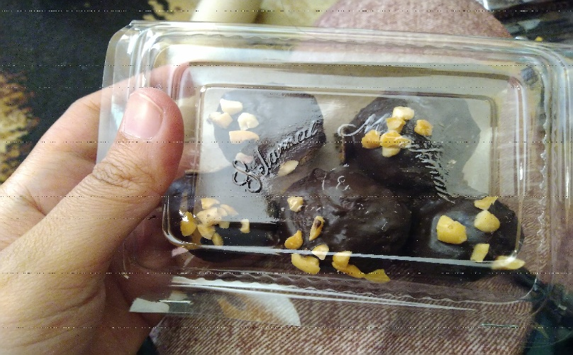
Hasil Pembuatan Modifikasi Bola-Bola coklat yang Belum Dikemas

Hasil Modifikasi Bola-Bola Coklat Sudah Dikemas
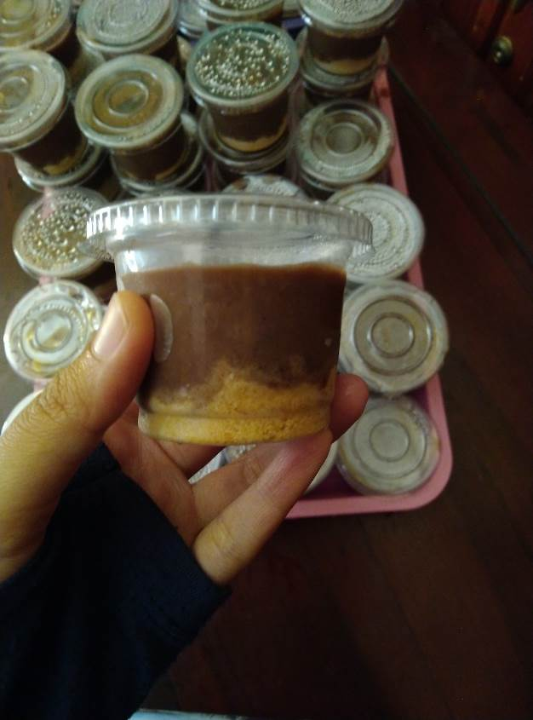

Hasil Modifikasi Puding Coklat

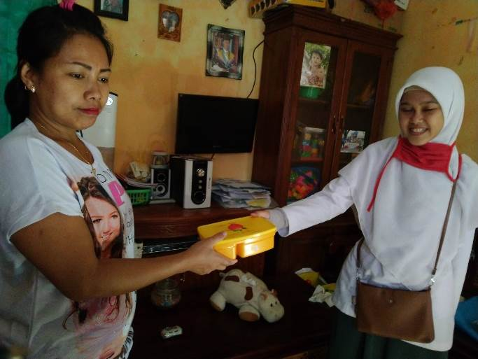

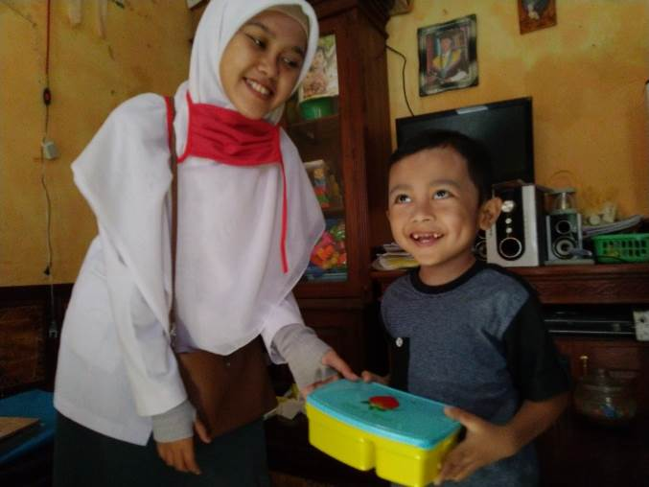
Pemberian Kenang-Kenganan Kepada Ibu Balita

Pemberian Kenang-Kenangan Kepada Balita

