**LAMPIRAN**

**Lampiran 1. Langkah Randomisasi dalam Penempatan Unit Penelitian**

Langkah Randomisasi dalam Penempatan Unit Penelitian adalah sebagai berikut:

1. Memberi nomor urut pada semua unit penelitian, yaitu 1 – 12.
2. Mengambil bilangan random dari kalkulator menggunakan digit sebanyak jumlah unit penelitian sebagaimana disajikan pada Gambar Lampiran 1.
3. Memberi ranking pada bilangan random (Gambar Lampiran 1)

**1 2 3**

377 178 974

*5 4 12*

**4 5 6**

909 381 863

*11 6 10*

**7 8 9**

494 781 172

*7 9 3*

**10 11 12**

171 593 163

*2 8 1*

Keterangan:

Baris Pertama : Nomor urut (penempatan unit penelitian sebelum randomisasi

Baris Kedua : Bilangan Random

Baris Ketiga : Rangking (penempatan unit penelitian sesudah randomisasi)

**Gambar Lampiran 1. Nomor Urut, Bilangan Random, dan Ranking**

1. Dengan menggunakan prinsip permutasi sederhana, maka nomor ranking dapat dianggap mewakili nomor urut sesuai dengan jumlah unit penelitian. Dengan demikian taraf perlakuan P0 akan diulangan 3 kali dan ditempatkan pada unit penelitian 5, 4, dan 12. Taraf perlakuan P1 akan diulangi 3 kali dan ditempatkan pada unit penelitian 11, 6, dan 10. Taraf perlakuan P2 akan diulangi 3 kali dan ditempatkan pada unit penelitian 7, 9, dan 3. Taraf perlakuan P3 akan diulangi 3 kali dan ditempatkan pada unit penelitian 2, 8, dan 1.
2. Memasukkan unit penelitian dalam *lay out*

Urutan 1 ditempati oleh unit penelitian X33, urutan 2 ditempati oleh unit penelitian X31, urutan 3 ditempati oleh unit penelitian X23, urutan 4 ditempati oleh unit penelitian X02, urutan 5 ditempati oleh unit penelitian X01, urutan 6 ditempati oleh unit penelitian X12, urutan 7 ditempati oleh unit penelitian X21, urutan 8 ditempati oleh unit penelitian X32, urutan 9 ditempati oleh unit penelitian X22, urutan 10 ditempati oleh unit penelitian X13, urutan 11 ditempati oleh unit penelitian X11, urutan 12 ditempati oleh unit penelitian X03 seperti yang disajikan pada Gambar Lampiran 2.

|  |  |  |
| --- | --- | --- |
| 1  X33 | 2  X31 | 3  X23 |
| 4  X02 | 5  X01 | 6  X12 |
| 7  X21 | 8  X32 | 9  X22 |
| 10  X13 | 11  X11 | 12  X03 |

Keterangan:

1 – 12 : Nomor Urut (Penempatan Unit Penelitian sebelum Penelitian)

X01 – X33 : Unit Penelitian

**Gambar Lampiran 2. Lay Out Penelitian dengan Desain RAL**

**Lampiran 2. Formulir Uji Skala Kesukaan (Hedonic Scale Test)**

UJI SKALA KESUKAAN (HEDONIC SCALE TEST)

Nama :

Tanggal Uji :

Nama Produk : *Muffin*Subtitusi Ubi Jalar Kuning dan Tepung Tempe sebagai PMT bagi Balita Gizi Kurang

Kriteria mutu yang dinilai : Warna, aroma, rasa, dan tekstur

Instruksi : Di hadapan saudara disajikan 4 buah contoh *Muffin*. Saudara diminta memberikan penilaian terhadap warna, aroma, rasa, dan tekstur dengan menggunakan skala penilai sebagai berikut:

1 = sangat tidak suka 3 = suka

2 = tidak suka 4 = sangat suka

Setelah saudara mencicipi salah satu sampel, saudara diminta berkumur dengan air yang telah disediakan sebelum mencicipi sampel yang lain. Selain itu saudara juga diminta memberikan kritik dan saran.

|  |  |  |  |  |
| --- | --- | --- | --- | --- |
| Kode sampel | Skor Penilaian Kesukaan | | | |
| Warna | Aroma | Rasa | Tekstur |
|  |  |  |  |  |
|  |  |  |  |  |
|  |  |  |  |  |
|  |  |  |  |  |

Kritik dan Saran:

...................................................................................................................................................................................................................................................................................................................................................................................................

Terima kasih atas partisipasinya.

**Lampiran 3. Formulir Penentuan Taraf Perlakuan Terbaik**

PENENTUAN TARAF PERLAKUAN TERBAIK

Nama :

Tanggal Uji :

Nama Produk : *Muffin*Subtitusi Ubi Jalar Kuning dan Tepung Tempe sebagai PMT bagi Balita Gizi Kurang

Petunjuk :

Bapak/Ibu/Saudara dimohon untuk mengemukakan pendapat tentang urutan (ranking) pentingnya variabel *Muffin* terhadap mutu produk *Muffin*subtitusi ubi jalar kuning dan tepung tempe, dengan menggunakan 10 variabel dari tertinggi ke terendah dengan mencantumkan angka 1 – 10. Angka terendah untuk variabel kurang penting dan angka tertinggi untuk variabel terpenting. Pemberian nilai boleh sama apabila dirasa variabel yang dinilai sama pentingnya

|  |  |
| --- | --- |
| **Variabel** | **Ranking** |
| Nilai Energi |  |
| Kadar Protein |  |
| Kadar Lemak |  |
| Kadar Karbohidrat |  |
| Kadar Abu |  |
| Kadar Air |  |
| Warna |  |
| Aroma |  |
| Rasa |  |
| Tekstur |  |

Terima kasih atas partisipasinya.

**Lampiran 4. Hasil Analisis Kimia *Muffin***

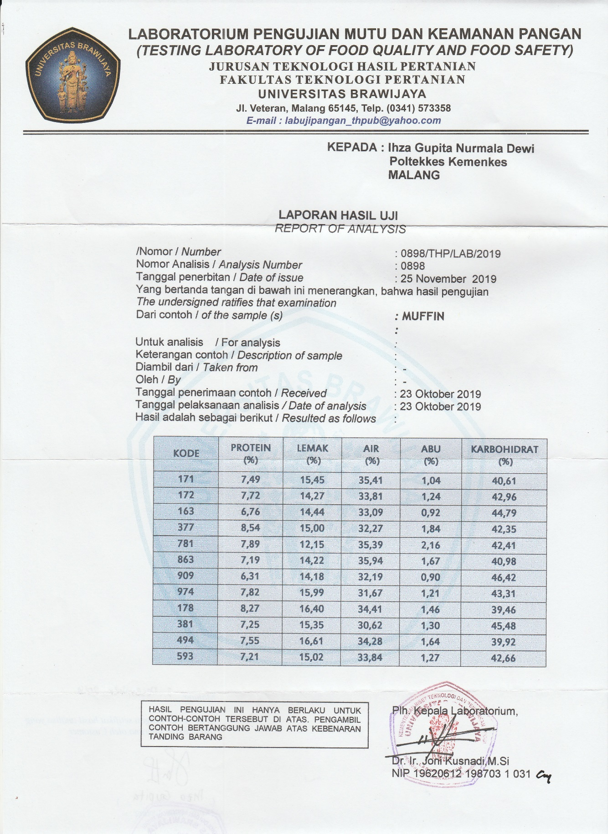

**Lampiran 5. Output SPSS Hasil Analisis Kadar Air *Muffin***

**Kadar Air Muffin PMT Balita Tiap Taraf Perlakuan**

|  |  |  |  |
| --- | --- | --- | --- |
| **Taraf Perlakuan** | **Kadar Air** | | |
| **1** | **2** | **3** |
| P0 | 30,62 | 32,19 | 33,09 |
| P1 | 33,84 | 35,94 | 35,41 |
| P2 | 34,28 | 33,81 | 31,67 |
| P3 | 34,41 | 35,39 | 32,27 |

**Hasil Analisis Kadar Air Muffin PMT Balita Subtitusi Pasta Ubi Jalar Kuning dan Tepung Tempe dengan Uji Statistik *One Way Anova* pada Tingkat Kepercayaan 95%**

|  |  |  |  |  |  |  |  |  |
| --- | --- | --- | --- | --- | --- | --- | --- | --- |
| **Descriptives** | | | | | | | | |
| Kadar Air | | | | | | | | |
|  | N | Mean | Std. Deviation | | Std. Error | 95% Confidence Interval for Mean | | Minimum |
| Lower Bound | Upper Bound |
| P0 | 3 | 31.9667 | 1.25005 | | .72172 | 28.8614 | 35.0720 | 30.62 |
| P1 | 3 | 35.0633 | 1.09208 | | .63051 | 32.3505 | 37.7762 | 33.84 |
| P2 | 3 | 33.2533 | 1.39120 | | .80321 | 29.7974 | 36.7093 | 31.67 |
| P3 | 3 | 34.0233 | 1.59554 | | .92118 | 30.0598 | 37.9869 | 32.27 |
| Total | 12 | 33.5767 | 1.64571 | | .47507 | 32.5310 | 34.6223 | 30.62 |
| **Descriptives** | | | | | | | | | |
| Kadar Air | | | | | | | | | |
|  | | | | Maximum | | | | | |
|
| P0 | | | | 33.09 | | | | | |
| P1 | | | | 35.94 | | | | | |
| P2 | | | | 34.28 | | | | | |
| P3 | | | | 35.39 | | | | | |
| Total | | | | 35.94 | | | | | |

**ANOVA**

|  |  |  |  |  |  |
| --- | --- | --- | --- | --- | --- |
| Kadar Air | | | | | |
|  | Sum of Squares | df | Mean Square | F | Sig. |
| Between Groups | 15.319 | 3 | 5.106 | 2.823 | .107 |
| Within Groups | 14.473 | 8 | 1.809 |  |  |
| Total | 29.792 | 11 |  |  |  |

**Lampiran 6. Output SPSS Hasil Analisis Kadar Abu Muffin**

**Kadar Abu Muffin PMT Balita Tiap Taraf Perlakuan**

|  |  |  |  |
| --- | --- | --- | --- |
| **Taraf Perlakuan** | **Kadar Abu** | | |
| **1** | **2** | **3** |
| P0 | 1,3 | 0,9 | 0,92 |
| P1 | 1,27 | 1,67 | 1,04 |
| P2 | 1,64 | 1,24 | 1,21 |
| P3 | 1,46 | 2,16 | 1,84 |

**Hasil Analisis Kadar Abu Muffin PMT Balita Subtitusi Pasta Ubi Jalar Kuning dan Tepung Tempe dengan Uji Statistik *One Way Anova* pada Tingkat Kepercayaan 95%**

|  |  |  |  |  |  |  |  |
| --- | --- | --- | --- | --- | --- | --- | --- |
| **Descriptives** | | | | | | | |
| Kadar Abu | | | | | | | |
|  | N | Mean | Std. Deviation | Std. Error | 95% Confidence Interval for Mean | | Minimum |
| Lower Bound | Upper Bound |
| P0 | 3 | 1.0400 | .22539 | .13013 | .4801 | 1.5999 | .90 |
| P1 | 3 | 1.3267 | .31880 | .18406 | .5347 | 2.1186 | 1.04 |
| P2 | 3 | 1.3633 | .24007 | .13860 | .7670 | 1.9597 | 1.21 |
| P3 | 3 | 1.8200 | .35043 | .20232 | .9495 | 2.6905 | 1.46 |
| Total | 12 | 1.3875 | .38163 | .11017 | 1.1450 | 1.6300 | .90 |

|  |  |
| --- | --- |
| **Descriptives** | |
| Kadar Abu | |
|  | Maximum |
|
| P0 | 1.30 |
| P1 | 1.67 |
| P2 | 1.64 |
| P3 | 2.16 |
| Total | 2.16 |

|  |  |  |  |  |  |
| --- | --- | --- | --- | --- | --- |
| **ANOVA** | | | | | |
| Kadar Abu | | | | | |
|  | Sum of Squares | df | Mean Square | F | Sig. |
| Between Groups | .936 | 3 | .312 | 3.750 | .060 |
| Within Groups | .666 | 8 | .083 |  |  |
| Total | 1.602 | 11 |  |  |  |

**Lampiran 7. Output SPSS Hasil Analisis Kadar Protein Muffin**

**Kadar Protein Muffin PMT Balita Tiap Taraf Perlakuan**

|  |  |  |  |
| --- | --- | --- | --- |
| **Taraf Perlakuan** | **Kadar Protein** | | |
| **1** | **2** | **3** |
| P0 | 7,25 | 6,31 | 6,76 |
| P1 | 7,21 | 7,19 | 7,49 |
| P2 | 7,55 | 7,72 | 7,82 |
| P3 | 8,27 | 7,89 | 8,54 |

**Hasil Analisis Kadar Protein Muffin PMT Balita Subtitusi Pasta Ubi Jalar Kuning dan Tepung Tempe dengan Uji Statistik *One Way Anova* pada Tingkat Kepercayaan 95%**

|  |  |  |  |  |  |  |  |
| --- | --- | --- | --- | --- | --- | --- | --- |
| **Descriptives** | | | | | | | |
| Protein | | | | | | | |
|  | N | Mean | Std. Deviation | Std. Error | 95% Confidence Interval for Mean | | Minimum |
| Lower Bound | Upper Bound |
| P0 | 3 | 6.7733 | .47014 | .27144 | 5.6054 | 7.9412 | 6.31 |
| P1 | 3 | 7.2967 | .16773 | .09684 | 6.8800 | 7.7133 | 7.19 |
| P2 | 3 | 7.6967 | .13650 | .07881 | 7.3576 | 8.0358 | 7.55 |
| P3 | 3 | 8.2333 | .32655 | .18853 | 7.4221 | 9.0445 | 7.89 |
| Total | 12 | 7.5000 | .61691 | .17809 | 7.1080 | 7.8920 | 6.31 |

|  |  |
| --- | --- |
| **Descriptives** | |
| Protein | |
|  | Maximum |
|
| P0 | 7.25 |
| P1 | 7.49 |
| P2 | 7.82 |
| P3 | 8.54 |
| Total | 8.54 |

|  |  |  |  |  |  |
| --- | --- | --- | --- | --- | --- |
| **ANOVA** | | | | | |
| Protein | | | | | |
|  | Sum of Squares | df | Mean Square | F | Sig. |
| Between Groups | 3.438 | 3 | 1.146 | 12.241 | .002 |
| Within Groups | .749 | 8 | .094 |  |  |
| Total | 4.186 | 11 |  |  |  |

**Post Hoc Tests**

**Homogeneous Subsets**

|  |  |  |  |  |
| --- | --- | --- | --- | --- |
| **Protein** | | | | |
| Duncana | | | | |
| Perlakuan | N | Subset for alpha = 0.05 | | |
| 1 | 2 | 3 |
| P0 | 3 | 6.7733 |  |  |
| P1 | 3 | 7.2967 | 7.2967 |  |
| P2 | 3 |  | 7.6967 | 7.6967 |
| P3 | 3 |  |  | 8.2333 |
| Sig. |  | .069 | .148 | .064 |

|  |
| --- |
| Means for groups in homogeneous subsets are displayed. |
| a. Uses Harmonic Mean Sample Size = 3.000. |

**Lampiran 8. Output SPSS Hasil Analisis Kadar Lemak Muffin**

**Kadar Lemak Muffin PMT Balita Tiap Taraf Perlakuan**

|  |  |  |  |
| --- | --- | --- | --- |
| **Taraf Perlakuan** | **Kadar Lemak** | | |
| **1** | **2** | **3** |
| P0 | 15,35 | 14,18 | 14,44 |
| P1 | 15,02 | 14,22 | 15,45 |
| P2 | 16,61 | 14,27 | 15,99 |
| P3 | 16,4 | 12,15 | 15 |

**Hasil Analisis Kadar Lemak Muffin PMT Balita Subtitusi Pasta Ubi Jalar Kuning dan Tepung Tempe dengan Uji Statistik *One Way Anova* pada Tingkat Kepercayaan 95%**

|  |  |  |  |  |  |  |  |
| --- | --- | --- | --- | --- | --- | --- | --- |
| **Descriptives** | | | | | | | |
| Lemak | | | | | | | |
|  | N | Mean | Std. Deviation | Std. Error | 95% Confidence Interval for Mean | | Minimum |
| Lower Bound | Upper Bound |
| P0 | 3 | 14.6567 | .61436 | .35470 | 13.1305 | 16.1828 | 14.18 |
| P1 | 3 | 14.8967 | .62421 | .36039 | 13.3461 | 16.4473 | 14.22 |
| P2 | 3 | 15.6233 | 1.21233 | .69994 | 12.6117 | 18.6349 | 14.27 |
| P3 | 3 | 14.5167 | 2.16583 | 1.25044 | 9.1364 | 19.8969 | 12.15 |
| Total | 12 | 14.9233 | 1.20743 | .34856 | 14.1562 | 15.6905 | 12.15 |

|  |  |
| --- | --- |
| **Descriptives** | |
| Lemak | |
|  | Maximum |
|
| P0 | 15.35 |
| P1 | 15.45 |
| P2 | 16.61 |
| P3 | 16.40 |
| Total | 16.61 |

|  |  |  |  |  |  |
| --- | --- | --- | --- | --- | --- |
| **ANOVA** | | | | | |
| Lemak | | | | | |
|  | Sum of Squares | df | Mean Square | F | Sig. |
| Between Groups | 2.182 | 3 | .727 | .420 | .744 |
| Within Groups | 13.855 | 8 | 1.732 |  |  |
| Total | 16.037 | 11 |  |  |  |

**Lampiran 9. Output SPSS Hasil Analisis Kadar Karbohidrat Muffin**

**Kadar Karbohidrat Muffin PMT Balita Tiap Taraf Perlakuan**

|  |  |  |  |
| --- | --- | --- | --- |
| **Taraf Perlakuan** | **Kadar Karbohidrat** | | |
| **1** | **2** | **3** |
| P0 | 45,48 | 46,42 | 44,79 |
| P1 | 42,66 | 40,98 | 40,61 |
| P2 | 39,92 | 42,96 | 43,31 |
| P3 | 39,96 | 42,41 | 42,35 |

**Hasil Analisis Kadar Karbohidrat Muffin PMT Balita Subtitusi Pasta Ubi Jalar Kuning dan Tepung Tempe dengan Uji Statistik *One Way Anova* pada Tingkat Kepercayaan 95%**

|  |  |  |  |  |  |  |  |
| --- | --- | --- | --- | --- | --- | --- | --- |
| **Descriptives** | | | | | | | |
| Karbohidrat | | | | | | | |
|  | N | Mean | Std. Deviation | Std. Error | 95% Confidence Interval for Mean | | Minimum |
| Lower Bound | Upper Bound |
| P0 | 3 | 45.5633 | .81819 | .47238 | 43.5308 | 47.5958 | 44.79 |
| P1 | 3 | 41.4167 | 1.09254 | .63078 | 38.7027 | 44.1307 | 40.61 |
| P2 | 3 | 42.0633 | 1.86441 | 1.07642 | 37.4319 | 46.6948 | 39.92 |
| P3 | 3 | 41.5733 | 1.39751 | .80685 | 38.1017 | 45.0449 | 39.96 |
| Total | 12 | 42.6542 | 2.11316 | .61002 | 41.3115 | 43.9968 | 39.92 |

|  |  |
| --- | --- |
| **Descriptives** | |
| Karbohidrat | |
|  | Maximum |
|
| P0 | 46.42 |
| P1 | 42.66 |
| P2 | 43.31 |
| P3 | 42.41 |
| Total | 46.42 |

|  |  |  |  |  |  |
| --- | --- | --- | --- | --- | --- |
| **ANOVA** | | | | | |
| Karbohidrat | | | | | |
|  | Sum of Squares | df | Mean Square | F | Sig. |
| Between Groups | 34.536 | 3 | 11.512 | 6.315 | .017 |
| Within Groups | 14.584 | 8 | 1.823 |  |  |
| Total | 49.120 | 11 |  |  |  |

**Post Hoc Tests**

**Homogeneous Subsets**

|  |  |  |  |
| --- | --- | --- | --- |
| **Karbohidrat** | | | |
| Duncana | | | |
| Perlakuan | N | Subset for alpha = 0.05 | |
| 1 | 2 |
| P1 | 3 | 41.4167 |  |
| P3 | 3 | 41.5733 |  |
| P2 | 3 | 42.0633 |  |
| P0 | 3 |  | 45.5633 |
| Sig. |  | .589 | 1.000 |

|  |
| --- |
| Means for groups in homogeneous subsets are displayed. |
| a. Uses Harmonic Mean Sample Size = 3.000. |

**Lampiran 10. Output SPSS Hasil Analisis Nilai Energi Muffin**

**Nilai EnergiMuffin PMT Balita Tiap Taraf Perlakuan**

|  |  |  |  |
| --- | --- | --- | --- |
| **Taraf Perlakuan** | **Nilai Energi** | | |
| **1** | **2** | **3** |
| P0 | 380,99 | 371,63 | 370,17 |
| P1 | 369,77 | 358,27 | 367,9 |
| P2 | 375,29 | 366,2 | 381,31 |
| P3 | 376,39 | 348,1 | 372,67 |

**Hasil Analisis Nilai EnergiMuffin PMT Balita Subtitusi Pasta Ubi Jalar Kuning dan Tepung Tempe dengan Uji Statistik *One Way Anova*pada Tingkat Kepercayaan 95%**

|  |  |  |  |  |  |  |  |
| --- | --- | --- | --- | --- | --- | --- | --- |
| **Descriptives** | | | | | | | |
| Energi | | | | | | | |
|  | N | Mean | Std. Deviation | Std. Error | 95% Confidence Interval for Mean | | Minimum |
| Lower Bound | Upper Bound |
| P0 | 3 | 374.2633 | 5.87102 | 3.38964 | 359.6789 | 388.8478 | 370.17 |
| P1 | 3 | 365.3133 | 6.17095 | 3.56280 | 349.9838 | 380.6428 | 358.27 |
| P2 | 3 | 374.2667 | 7.60680 | 4.39179 | 355.3703 | 393.1630 | 366.20 |
| P3 | 3 | 365.7200 | 15.37231 | 8.87521 | 327.5331 | 403.9069 | 348.10 |
| Total | 12 | 369.8908 | 9.35798 | 2.70142 | 363.9451 | 375.8366 | 348.10 |

|  |  |
| --- | --- |
| **Descriptives** | |
| Energi | |
|  | Maximum |
|
| P0 | 380.99 |
| P1 | 369.77 |
| P2 | 381.31 |
| P3 | 376.39 |
| Total | 381.31 |

|  |  |  |  |  |  |
| --- | --- | --- | --- | --- | --- |
| **ANOVA** | | | | | |
| Energi | | | | | |
|  | Sum of Squares | df | Mean Square | F | Sig. |
| Between Groups | 229.848 | 3 | 76.616 | .836 | .511 |
| Within Groups | 733.442 | 8 | 91.680 |  |  |
| Total | 963.290 | 11 |  |  |  |

**Lampiran 11. Output SPSS Hasil Analisis Mutu Organoleptik Warna Muffin**

**Hasil Mutu Organoleptik Warna Muffin PMT Balita**

|  |  |  |  |  |
| --- | --- | --- | --- | --- |
| **Panelis** | **Skor Penilaian Kesukaan** | | | |
| **Taraf Perlakuan** | | | |
| **P0** | **P1** | **P2** | **P3** |
| 1 | 3 | 3 | 3 | 3 |
| 2 | 3 | 4 | 4 | 3 |
| 3 | 3 | 4 | 4 | 3 |
| 4 | 3 | 4 | 4 | 4 |
| 5 | 4 | 4 | 4 | 3 |
| 6 | 3 | 3 | 4 | 3 |
| 7 | 3 | 3 | 3 | 3 |
| 8 | 3 | 3 | 3 | 3 |
| 9 | 4 | 3 | 4 | 4 |
| 10 | 3 | 3 | 4 | 4 |
| 11 | 4 | 4 | 4 | 4 |
| 12 | 3 | 3 | 3 | 3 |
| 13 | 3 | 3 | 3 | 3 |
| 14 | 3 | 3 | 3 | 3 |
| 15 | 3 | 3 | 3 | 3 |
| 16 | 2 | 3 | 3 | 2 |
| 17 | 2 | 4 | 4 | 3 |
| 18 | 3 | 4 | 3 | 3 |
| 19 | 3 | 3 | 2 | 3 |
| 20 | 3 | 2 | 4 | 3 |
| 21 | 4 | 3 | 4 | 2 |
| 22 | 4 | 3 | 3 | 3 |
| 23 | 4 | 3 | 4 | 3 |
| 24 | 3 | 4 | 3 | 3 |
| 25 | 4 | 4 | 4 | 3 |
| Jumlah | 80 | 83 | 87 | 77 |
| Rata-rata | 3.2 | 3.32 | 3.48 | 3.08 |

**Hasil Analisis Tingkat Kesukaan terhadap Warna Muffin PMT Balita Subtitusi Pasta Ubi Jalar Kuning dan Tepung Tempe dengan *Uji Kruskal-Wallis* pada Tingkat Keprcayaan 95%**

**Kruskal-Wallis Test**

|  |  |  |  |
| --- | --- | --- | --- |
| **Ranks** | | | |
|  | Perlakuan | N | Mean Rank |
| Warna | P0 | 25 | 47.48 |
| P1 | 25 | 52.58 |
| P2 | 25 | 60.10 |
| P3 | 25 | 41.84 |
| Total | 100 |  |

|  |  |
| --- | --- |
| **Test Statisticsa,b** | |
|  | Warna |
| Chi-Square | 7.279 |
| df | 3 |
| Asymp. Sig. | .064 |

|  |
| --- |
| a. Kruskal Wallis Test |
| b. Grouping Variable: Perlakuan |

**Lampiran 12. Output SPSS Hasil Analisis Mutu Organoleptik Aroma Muffin**

**Hasil Mutu Organoleptik Aroma Muffin PMT Balita**

|  |  |  |  |  |
| --- | --- | --- | --- | --- |
| **Panelis** | **Skor Penilaian Kesukaan** | | | |
| **Aroma** | | | |
| **P0** | **P1** | **P2** | **P3** |
| 1 | 3 | 3 | 3 | 3 |
| 2 | 3 | 4 | 3 | 3 |
| 3 | 4 | 4 | 2 | 3 |
| 4 | 4 | 4 | 4 | 4 |
| 5 | 3 | 4 | 4 | 3 |
| 6 | 2 | 4 | 4 | 3 |
| 7 | 4 | 3 | 4 | 3 |
| 8 | 3 | 4 | 3 | 4 |
| 9 | 2 | 4 | 4 | 3 |
| 10 | 4 | 4 | 4 | 4 |
| 11 | 3 | 4 | 3 | 3 |
| 12 | 4 | 3 | 4 | 4 |
| 13 | 3 | 4 | 3 | 3 |
| 14 | 2 | 3 | 2 | 3 |
| 15 | 3 | 3 | 3 | 3 |
| 16 | 3 | 3 | 3 | 3 |
| 17 | 2 | 3 | 4 | 3 |
| 18 | 3 | 4 | 3 | 3 |
| 19 | 3 | 3 | 3 | 3 |
| 20 | 3 | 2 | 4 | 3 |
| 21 | 2 | 3 | 4 | 3 |
| 22 | 2 | 3 | 4 | 3 |
| 23 | 3 | 3 | 3 | 3 |
| 24 | 3 | 3 | 3 | 4 |
| 25 | 3 | 2 | 4 | 2 |
| Jumlah | 74 | 84 | 85 | 79 |
| Rata-rata | 2.96 | 3.36 | 3.4 | 3.16 |

**Hasil Analisis Tingkat Kesukaan terhadap Aroma Muffin PMT Balita Subtitusi Pasta Ubi Jalar Kuning dan Tepung Tempe dengan *Uji Kruskal-Wallis* pada Tingkat Kepercayaan 95%**

**Kruskal-Wallis Test**

|  |  |  |  |  |  |
| --- | --- | --- | --- | --- | --- |
| **Ranks** | | | | | |
|  | Perlakuan | | N | | Mean Rank |
| Aroma | P0 | | 25 | | 40.36 |
| P1 | | 25 | | 56.40 |
| P2 | | 25 | | 58.18 |
| P3 | | 25 | | 47.06 |
| Total | | 100 | |  |
| **Test Statisticsa,b** | | | |
|  | | Aroma | |
| Chi-Square | | 7.865 | |
| df | | 3 | |
| Asymp. Sig. | | .049 | |

|  |
| --- |
| a. Kruskal Wallis Test |
| b. Grouping Variable: Perlakuan |

**Mann-Whitney Test**

|  |  |  |  |  |  |  |
| --- | --- | --- | --- | --- | --- | --- |
| **Ranks** | | | | | | |
|  | Perlakuan | N | | Mean Rank | | Sum of Ranks |
| Aroma | P0 | 25 | | 21.62 | | 540.50 |
| P1 | 25 | | 29.38 | | 734.50 |
| Total | 50 | |  | |  |
| **Test Statisticsa** | | | | |
|  | | | Aroma | |
| Mann-Whitney U | | | 215.500 | |
| Wilcoxon W | | | 540.500 | |
| Z | | | -2.075 | |
| Asymp. Sig. (2-tailed) | | | .038 | |

|  |
| --- |
| a. Grouping Variable: Perlakuan |

**Mann-Whitney Test**

|  |  |  |  |  |  |  |
| --- | --- | --- | --- | --- | --- | --- |
| **Ranks** | | | | | | |
|  | Perlakuan | N | | Mean Rank | | Sum of Ranks |
| Aroma | P0 | 25 | | 21.24 | | 531.00 |
| P2 | 25 | | 29.76 | | 744.00 |
| Total | 50 | |  | |  |
| **Test Statisticsa** | | | | |
|  | | | Aroma | |
| Mann-Whitney U | | | 206.000 | |
| Wilcoxon W | | | 531.000 | |
| Z | | | -2.266 | |
| Asymp. Sig. (2-tailed) | | | .023 | |

|  |
| --- |
| a. Grouping Variable: Perlakuan |

**Mann-Whitney Test**

|  |  |  |  |  |  |  |
| --- | --- | --- | --- | --- | --- | --- |
| **Ranks** | | | | | | |
|  | Perlakuan | N | | Mean Rank | | Sum of Ranks |
| Aroma | P0 | 25 | | 23.50 | | 587.50 |
| P3 | 25 | | 27.50 | | 687.50 |
| Total | 50 | |  | |  |
| **Test Statisticsa** | | | | |
|  | | | Aroma | |
| Mann-Whitney U | | | 262.500 | |
| Wilcoxon W | | | 587.500 | |
| Z | | | -1.158 | |
| Asymp. Sig. (2-tailed) | | | .247 | |

|  |
| --- |
| a. Grouping Variable: Perlakuan |

**Mann-Whitney Test**

|  |  |  |  |  |  |  |
| --- | --- | --- | --- | --- | --- | --- |
| **Ranks** | | | | | | |
|  | Perlakuan | N | | Mean Rank | | Sum of Ranks |
| Aroma | P1 | 25 | | 25.04 | | 626.00 |
| P2 | 25 | | 25.96 | | 649.00 |
| Total | 50 | |  | |  |
| **Test Statisticsa** | | | | |
|  | | | Aroma | |
| Mann-Whitney U | | | 301.000 | |
| Wilcoxon W | | | 626.000 | |
| Z | | | -.249 | |
| Asymp. Sig. (2-tailed) | | | .804 | |

|  |
| --- |
| a. Grouping Variable: Perlakuan |

**Mann-Whitney Test**

|  |  |  |  |  |  |  |
| --- | --- | --- | --- | --- | --- | --- |
| **Ranks** | | | | | | |
|  | Perlakuan | N | | Mean Rank | | Sum of Ranks |
| Aroma | P1 | 25 | | 27.98 | | 699.50 |
| P3 | 25 | | 23.02 | | 575.50 |
| Total | 50 | |  | |  |
| **Test Statisticsa** | | | | |
|  | | | Aroma | |
| Mann-Whitney U | | | 250.500 | |
| Wilcoxon W | | | 575.500 | |
| Z | | | -1.409 | |
| Asymp. Sig. (2-tailed) | | | .159 | |

|  |
| --- |
| a. Grouping Variable: Perlakuan |

**Mann-Whitney Test**

|  |  |  |  |  |  |  |
| --- | --- | --- | --- | --- | --- | --- |
| **Ranks** | | | | | | |
|  | Perlakuan | N | | Mean Rank | | Sum of Ranks |
| Aroma | P2 | 25 | | 28.46 | | 711.50 |
| P3 | 25 | | 22.54 | | 563.50 |
| Total | 50 | |  | |  |
| **Test Statisticsa** | | | | |
|  | | | Aroma | |
| Mann-Whitney U | | | 238.500 | |
| Wilcoxon W | | | 563.500 | |
| Z | | | -1.664 | |
| Asymp. Sig. (2-tailed) | | | .096 | |

|  |
| --- |
| a. Grouping Variable: Perlakuan |

**Lampiran 13. Output SPSS Hasil Analisis Mutu Organoleptik Rasa Muffin**

**Hasil Mutu Organoleptik Rasa Muffin PMT Balita**

|  |  |  |  |  |
| --- | --- | --- | --- | --- |
| **Panelis** | **Skor Penilaian Kesukaan** | | | |
| **Rasa** | | | |
| **P0** | **P1** | **P2** | **P3** |
| 1 | 3 | 3 | 3 | 4 |
| 2 | 3 | 4 | 4 | 3 |
| 3 | 2 | 4 | 2 | 3 |
| 4 | 3 | 4 | 3 | 3 |
| 5 | 3 | 3 | 4 | 3 |
| 6 | 3 | 4 | 4 | 3 |
| 7 | 3 | 3 | 4 | 3 |
| 8 | 4 | 4 | 3 | 3 |
| 9 | 3 | 3 | 3 | 3 |
| 10 | 3 | 4 | 4 | 4 |
| 11 | 3 | 4 | 4 | 3 |
| 12 | 4 | 4 | 4 | 4 |
| 13 | 3 | 3 | 4 | 3 |
| 14 | 3 | 4 | 4 | 3 |
| 15 | 4 | 4 | 4 | 3 |
| 16 | 3 | 3 | 3 | 2 |
| 17 | 3 | 4 | 3 | 3 |
| 18 | 3 | 4 | 3 | 3 |
| 19 | 4 | 3 | 3 | 3 |
| 20 | 3 | 2 | 4 | 3 |
| 21 | 3 | 3 | 4 | 3 |
| 22 | 2 | 4 | 3 | 3 |
| 23 | 3 | 4 | 4 | 3 |
| 24 | 3 | 4 | 4 | 3 |
| 25 | 4 | 4 | 4 | 3 |
| Jumlah | 78 | 90 | 89 | 77 |
| Rata-rata | 3.12 | 3.6 | 3.56 | 3.08 |

**Hasil Analisis Tingkat Kesukaan terhadap Rasa Muffin PMT Balita Subtitusi Pasta Ubi Jalar Kuning dan Tepung Tempe dengan *Uji Kruskal-Wallis* pada Tingkat Keprcayaan 95%**

**Kruskal-Wallis Test**

|  |  |  |  |  |  |
| --- | --- | --- | --- | --- | --- |
| **Ranks** | | | | | |
|  | Perlakuan | | N | | Mean Rank |
| Rasa | P0 | | 25 | | 40.56 |
| P1 | | 25 | | 62.68 |
| P2 | | 25 | | 60.78 |
| P3 | | 25 | | 37.98 |
| Total | | 100 | |  |
| **Test Statisticsa,b** | | | |
|  | | Rasa | |
| Chi-Square | | 19.785 | |
| df | | 3 | |
| Asymp. Sig. | | .000 | |

|  |
| --- |
| a. Kruskal Wallis Test |
| b. Grouping Variable: Perlakuan |

**Mann-Whitney Test**

|  |  |  |  |  |  |  |
| --- | --- | --- | --- | --- | --- | --- |
| **Ranks** | | | | | | |
|  | Perlakuan | N | | Mean Rank | | Sum of Ranks |
| Rasa | P0 | 25 | | 20.04 | | 501.00 |
| P1 | 25 | | 30.96 | | 774.00 |
| Total | 50 | |  | |  |
| **Test Statisticsa** | | | | |
|  | | | Rasa | |
| Mann-Whitney U | | | 176.000 | |
| Wilcoxon W | | | 501.000 | |
| Z | | | -2.988 | |
| Asymp. Sig. (2-tailed) | | | .003 | |

|  |
| --- |
| a. Grouping Variable: Perlakuan |

**Mann-Whitney Test**

|  |  |  |  |  |  |  |
| --- | --- | --- | --- | --- | --- | --- |
| **Ranks** | | | | | | |
|  | Perlakuan | N | | Mean Rank | | Sum of Ranks |
| Rasa | P0 | 25 | | 20.50 | | 512.50 |
| P2 | 25 | | 30.50 | | 762.50 |
| Total | 50 | |  | |  |
| **Test Statisticsa** | | | | |
|  | | | Rasa | |
| Mann-Whitney U | | | 187.500 | |
| Wilcoxon W | | | 512.500 | |
| Z | | | -2.749 | |
| Asymp. Sig. (2-tailed) | | | .006 | |

|  |
| --- |
| a. Grouping Variable: Perlakuan |

**Mann-Whitney Test**

|  |  |  |  |  |  |  |
| --- | --- | --- | --- | --- | --- | --- |
| **Ranks** | | | | | | |
|  | Perlakuan | N | | Mean Rank | | Sum of Ranks |
| Rasa | P0 | 25 | | 26.02 | | 650.50 |
| P3 | 25 | | 24.98 | | 624.50 |
| Total | 50 | |  | |  |
| **Test Statisticsa** | | | | |
|  | | | Rasa | |
| Mann-Whitney U | | | 299.500 | |
| Wilcoxon W | | | 624.500 | |
| Z | | | -.349 | |
| Asymp. Sig. (2-tailed) | | | .727 | |

|  |
| --- |
| a. Grouping Variable: Perlakuan |

**Mann-Whitney Test**

|  |  |  |  |  |  |  |
| --- | --- | --- | --- | --- | --- | --- |
| **Ranks** | | | | | | |
|  | Perlakuan | N | | Mean Rank | | Sum of Ranks |
| Rasa | P1 | 25 | | 25.98 | | 649.50 |
| P2 | 25 | | 25.02 | | 625.50 |
| Total | 50 | |  | |  |
| **Test Statisticsa** | | | | |
|  | | | Rasa | |
| Mann-Whitney U | | | 300.500 | |
| Wilcoxon W | | | 625.500 | |
| Z | | | -.274 | |
| Asymp. Sig. (2-tailed) | | | .784 | |

|  |
| --- |
| a. Grouping Variable: Perlakuan |

**Mann-Whitney Test**

|  |  |  |  |  |  |  |
| --- | --- | --- | --- | --- | --- | --- |
| **Ranks** | | | | | | |
|  | Perlakuan | N | | Mean Rank | | Sum of Ranks |
| Rasa | P1 | 25 | | 31.74 | | 793.50 |
| P3 | 25 | | 19.26 | | 481.50 |
| Total | 50 | |  | |  |
| **Test Statisticsa** | | | | |
|  | | | Rasa | |
| Mann-Whitney U | | | 156.500 | |
| Wilcoxon W | | | 481.500 | |
| Z | | | -3.495 | |
| Asymp. Sig. (2-tailed) | | | .000 | |

|  |
| --- |
| a. Grouping Variable: Perlakuan |

**Mann-Whitney Test**

|  |  |  |  |  |  |  |
| --- | --- | --- | --- | --- | --- | --- |
| **Ranks** | | | | | | |
|  | Perlakuan | N | | Mean Rank | | Sum of Ranks |
| Rasa | P2 | 25 | | 31.26 | | 781.50 |
| P3 | 25 | | 19.74 | | 493.50 |
| Total | 50 | |  | |  |
| **Test Statisticsa** | | | | |
|  | | | Rasa | |
| Mann-Whitney U | | | 168.500 | |
| Wilcoxon W | | | 493.500 | |
| Z | | | -3.253 | |
| Asymp. Sig. (2-tailed) | | | .001 | |

|  |
| --- |
| a. Grouping Variable: Perlakuan |

**Lampiran 14. Output SPSS Hasil Analisis Mutu Organoleptik Tekstur Muffin**

**Hasil Mutu Organoleptik Tekstur Muffin PMT Balita**

|  |  |  |  |  |
| --- | --- | --- | --- | --- |
| **Panelis** | **Skor Penilaian Kesukaan** | | | |
| **Tekstur** | | | |
| **P0** | **P1** | **P2** | **P3** |
| 1 | 3 | 3 | 3 | 3 |
| 2 | 3 | 4 | 4 | 3 |
| 3 | 2 | 3 | 3 | 4 |
| 4 | 3 | 3 | 3 | 3 |
| 5 | 3 | 4 | 4 | 3 |
| 6 | 2 | 4 | 4 | 3 |
| 7 | 3 | 4 | 3 | 3 |
| 8 | 3 | 3 | 3 | 3 |
| 9 | 2 | 4 | 3 | 3 |
| 10 | 3 | 4 | 4 | 3 |
| 11 | 2 | 3 | 4 | 3 |
| 12 | 3 | 3 | 3 | 3 |
| 13 | 2 | 4 | 3 | 3 |
| 14 | 2 | 4 | 3 | 3 |
| 15 | 2 | 4 | 4 | 3 |
| 16 | 2 | 3 | 3 | 3 |
| 17 | 2 | 3 | 4 | 3 |
| 18 | 1 | 4 | 3 | 3 |
| 19 | 4 | 3 | 2 | 3 |
| 20 | 2 | 2 | 3 | 2 |
| 21 | 2 | 3 | 3 | 3 |
| 22 | 3 | 4 | 3 | 3 |
| 23 | 3 | 4 | 4 | 3 |
| 24 | 2 | 4 | 4 | 3 |
| 25 | 3 | 3 | 4 | 2 |
| Jumlah | 62 | 87 | 84 | 74 |
| Rata-rata | 2.48 | 3.48 | 3.36 | 2.96 |

**Hasil Analisis Tingkat Kesukaan terhadap Tekstur Muffin PMT Balita Subtitusi Pasta Ubi Jalar Kuning dan Tepung Tempe dengan *Uji Kruskal-Wallis* pada Tingkat Keprcayaan 95%**

**Kruskal-Wallis Test**

|  |  |  |  |  |  |
| --- | --- | --- | --- | --- | --- |
| **Ranks** | | | | | |
|  | Perlakuan | | N | | Mean Rank |
| Tekstur | P0 | | 25 | | 28.58 |
| P1 | | 25 | | 66.60 |
| P2 | | 25 | | 61.62 |
| P3 | | 25 | | 45.20 |
| Total | | 100 | |  |
| **Test Statisticsa,b** | | | |
|  | | Tekstur | |
| Chi-Square | | 33.720 | |
| df | | 3 | |
| Asymp. Sig. | | .000 | |

|  |
| --- |
| a. Kruskal Wallis Test |
| b. Grouping Variable: Perlakuan |

**Mann-Whitney Test**

|  |  |  |  |  |  |  |
| --- | --- | --- | --- | --- | --- | --- |
| **Ranks** | | | | | | |
|  | Perlakuan | N | | Mean Rank | | Sum of Ranks |
| Tekstur | P0 | 25 | | 16.84 | | 421.00 |
| P1 | 25 | | 34.16 | | 854.00 |
| Total | 50 | |  | |  |
| **Test Statisticsa** | | | | |
|  | | | Tekstur | |
| Mann-Whitney U | | | 96.000 | |
| Wilcoxon W | | | 421.000 | |
| Z | | | -4.489 | |
| Asymp. Sig. (2-tailed) | | | .000 | |

**Mann-Whitney Test**

|  |  |  |  |  |  |  |
| --- | --- | --- | --- | --- | --- | --- |
| **Ranks** | | | | | | |
|  | Perlakuan | N | | Mean Rank | | Sum of Ranks |
| Tekstur | P0 | 25 | | 17.56 | | 439.00 |
| P2 | 25 | | 33.44 | | 836.00 |
| Total | 50 | |  | |  |
| **Test Statisticsa** | | | | |
|  | | | Tekstur | |
| Mann-Whitney U | | | 114.000 | |
| Wilcoxon W | | | 439.000 | |
| Z | | | -4.185 | |
| Asymp. Sig. (2-tailed) | | | .000 | |

|  |
| --- |
| a. Grouping Variable: Perlakuan |

**Mann-Whitney Test**

|  |  |  |  |  |  |  |
| --- | --- | --- | --- | --- | --- | --- |
| **Ranks** | | | | | | |
|  | Perlakuan | N | | Mean Rank | | Sum of Ranks |
| Tekstur | P0 | 25 | | 20.18 | | 504.50 |
| P3 | 25 | | 30.82 | | 770.50 |
| Total | 50 | |  | |  |
| **Test Statisticsa** | | | | |
|  | | | Tekstur | |
| Mann-Whitney U | | | 179.500 | |
| Wilcoxon W | | | 504.500 | |
| Z | | | -3.105 | |
| Asymp. Sig. (2-tailed) | | | .002 | |

|  |
| --- |
| a. Grouping Variable: Perlakuan |

**Mann-Whitney Test**

|  |  |  |  |  |  |  |
| --- | --- | --- | --- | --- | --- | --- |
| **Ranks** | | | | | | |
|  | Perlakuan | N | | Mean Rank | | Sum of Ranks |
| Tekstur | P1 | 25 | | 26.94 | | 673.50 |
| P2 | 25 | | 24.06 | | 601.50 |
| Total | 50 | |  | |  |
| **Test Statisticsa** | | | | |
|  | | | Tekstur | |
| Mann-Whitney U | | | 276.500 | |
| Wilcoxon W | | | 601.500 | |
| Z | | | -.792 | |
| Asymp. Sig. (2-tailed) | | | .428 | |

|  |
| --- |
| a. Grouping Variable: Perlakuan |

**Mann-Whitney Test**

|  |  |  |  |  |  |  |
| --- | --- | --- | --- | --- | --- | --- |
| **Ranks** | | | | | | |
|  | Perlakuan | N | | Mean Rank | | Sum of Ranks |
| Tekstur | P1 | 25 | | 31.50 | | 787.50 |
| P3 | 25 | | 19.50 | | 487.50 |
| Total | 50 | |  | |  |
| **Test Statisticsa** | | | | |
|  | | | Tekstur | |
| Mann-Whitney U | | | 162.500 | |
| Wilcoxon W | | | 487.500 | |
| Z | | | -3.502 | |
| Asymp. Sig. (2-tailed) | | | .000 | |

|  |
| --- |
| a. Grouping Variable: Perlakuan |

**Mann-Whitney Test**

|  |  |  |  |  |  |  |
| --- | --- | --- | --- | --- | --- | --- |
| **Ranks** | | | | | | |
|  | Perlakuan | N | | Mean Rank | | Sum of Ranks |
| Tekstur | P2 | 25 | | 30.12 | | 753.00 |
| P3 | 25 | | 20.88 | | 522.00 |
| Total | 50 | |  | |  |
| **Test Statisticsa** | | | | |
|  | | | Tekstur | |
| Mann-Whitney U | | | 197.000 | |
| Wilcoxon W | | | 522.000 | |
| Z | | | -2.855 | |
| Asymp. Sig. (2-tailed) | | | .004 | |

|  |
| --- |
| a. Grouping Variable: Perlakuan |

**Lampiran 15. Hasil Analisis Penentuan Taraf Perlakuan Terbaik**

|  |  |  |  |  |  |  |  |  |  |  |
| --- | --- | --- | --- | --- | --- | --- | --- | --- | --- | --- |
| **Responden** | **Nilai Energi** | **Kadar Protein** | **Kadar Lemak** | **Kadar Karbohidrat** | **Kadar Abu** | **Kadar Air** | **Warna** | **Aroma** | **Rasa** | **Tekstur** |
| 1 | 9 | 10 | 8 | 8 | 7 | 7 | 7 | 7 | 8 | 6 |
| 2 | 10 | 10 | 8 | 9 | 7 | 7 | 8 | 7 | 10 | 8 |
| 3 | 9 | 9 | 6 | 7 | 6 | 6 | 5 | 8 | 10 | 7 |
| 4 | 10 | 7 | 8 | 9 | 4 | 6 | 2 | 1 | 3 | 5 |
| 5 | 2 | 7 | 6 | 5 | 4 | 3 | 8 | 9 | 10 | 1 |
| 6 | 8 | 10 | 8 | 5 | 4 | 4 | 5 | 7 | 10 | 9 |
| 7 | 9 | 10 | 9 | 8 | 4 | 5 | 7 | 7 | 7 | 7 |
| 8 | 8 | 9 | 9 | 8 | 6 | 6 | 7 | 7 | 10 | 7 |
| 9 | 9 | 9 | 8 | 5 | 4 | 3 | 6 | 6 | 10 | 7 |
| 10 | 7 | 10 | 8 | 9 | 2 | 1 | 6 | 5 | 4 | 3 |
| Jumlah | 81 | 91 | 78 | 73 | 48 | 48 | 61 | 64 | 82 | 60 |
| Rata-rata | 8.1 | 9.1 | 7.8 | 7.3 | 4.8 | 4.8 | 6.1 | 6.4 | 8.2 | 6 |
| Ranking | III | I | IV | V | X | IX | VII | VI | II | VIII |
| Bobot Variabel | 0.89 | 1.00 | 0.86 | 0.80 | 0.62 | 0.53 | 0.67 | 0.70 | 0.90 | 0.66 |
| Bobot Normal | 0.12 | 0.13 | 0.11 | 0.11 | 0.08 | 0.07 | 0.09 | 0.09 | 0.12 | 0.09 |

|  |  |  |  |  |  |  |  |  |  |  |
| --- | --- | --- | --- | --- | --- | --- | --- | --- | --- | --- |
| **Perlakuan** | **Protein** | **Lemak** | **Kadar Air** | **Kadar Abu** | **Karbohidrat** | **Energi** | **Warna** | **Aroma** | **Rasa** | **Tekstur** |
| P0 | 6.77 | 14.66 | 31.97 | 1.04 | 45.56 | 374.26 | 3.2 | 2.96 | 3.12 | 2.48 |
| P1 | 7.30 | 14.90 | 35.06 | 1.33 | 41.42 | 365.31 | 3.32 | 3.36 | 3.6 | 3.48 |
| P2 | 7.70 | 15.62 | 33.25 | 1.36 | 42.06 | 374.27 | 3.48 | 3.4 | 3.56 | 3.36 |
| P3 | 8.23 | 14.52 | 34.02 | 1.82 | 41.57 | 365.72 | 3.08 | 3.16 | 3.08 | 2.96 |

|  |  |  |  |  |  |  |  |  |  |  |
| --- | --- | --- | --- | --- | --- | --- | --- | --- | --- | --- |
| **Variabel** | **BV** | **BN** | **P0** | | **P1** | | **P2** | | **P3** | |
| **Ne** | **Nh** | **Ne** | **Nh** | **Ne** | **Nh** | **Ne** | **Nh** |
| Nilai Energi | 0.89 | 0.12 | 1.00 | 0.12 | 0.00 | 0.00 | 1.00 | 0.12 | 0.05 | 0.01 |
| Protein | 1 | 0.13 | 0.00 | 0.00 | 0.36 | 0.05 | 0.63 | 0.08 | 1.00 | 0.13 |
| Lemak | 0.86 | 0.11 | 0.13 | 0.01 | 0.34 | 0.04 | 1.00 | 0.11 | 0.00 | 0.00 |
| Karbohidrat | 0.8 | 0.11 | 1.00 | 0.11 | 0.00 | 0.00 | 0.59 | 0.06 | 0.04 | 0.00 |
| abu | 0.62 | 0.08 | 0.00 | 0.00 | 0.37 | 0.03 | 0.41 | 0.03 | 1.00 | 0.08 |
| Air | 0.53 | 0.07 | 0.00 | 0.00 | 1.00 | 0.07 | 0.42 | 0.03 | 0.66 | 0.05 |
| Warna | 0.67 | 0.09 | 0.30 | 0.03 | 0.60 | 0.05 | 1.00 | 0.09 | 0.00 | 0.00 |
| Aroma | 0.7 | 0.09 | 0.00 | 0.00 | 0.91 | 0.08 | 1.00 | 0.09 | 0.45 | 0.04 |
| Rasa | 0.9 | 0.12 | 0.08 | 0.01 | 1.00 | 0.12 | 0.92 | 0.11 | 0.00 | 0.00 |
| Tekstur | 0.66 | 0.09 | 0.00 | 0.00 | 1.00 | 0.09 | 0.88 | 0.08 | 0.48 | 0.04 |
| **Jumlah** |  |  |  | **0.28** |  | **0.53** |  | **0.81** |  | **0.35** |

**Lampiran 16. Sertifikat Etik**



KOMISI ETIK PENELITIAN KESEHATAN

*HEALTH RESEARCH ETHICS COMMITTEE* POLITEKNIK KESEHATAN KEMENKES MALANG *STATE POLYTECHNIC OF HEALTH MALANG*

**KETERANGAN LOLOS KAJI ETIK** *DESCRIPTION OF ETHICAL APPROVAL "ETHICAL APPROVAL"*

# Reg.No.:587 / KEPK-POLKESMA/ 2020

Protokol penelitian yang diusulkan oleh

Ihza Gupita Nurmala Dewi

*The research protocol proposed by*

Peneliti Utama

*Principal In Investigator* **Ihza Gupita Nurmala Dewi**

Nama Institusi

*Name of the Institution*

Dengan Judul

Poltekkes Malang

Subtitusi Ubi Jalar Kuning (Ipomoea batatas L.) dan Tepung Tempe pada Pembuatan Muffin Sebagai Pemberian Makanan Tambahan (PMT) bagi Balita Gizi Kurang

# Substitution of Yellow Sweet Potato and Tempe Flour in Muffin as Additional Food for Under Nutrition Toodler

Dinyatakan layak etik sesuai 7 (tujuh) Standar WHO 2011, yaitu 1) Nilai Sosial, 2) Nilai Ilmiah,

3) Pemerataan Beban dan Manfaat, 4) Risiko, 5) Bujukan/Eksploitasi, 6) Kerahasiaan dan Privacy, dan 7) Persetujuan Setelah Penjelasan, yang merujuk pada Pedoman CIOMS 2016. Hal ini seperti yang ditunjukkan oleh terpenuhinya indikator setiap standar.

*Declared to be ethically appropriate in accordance to 7 (seven) WHO 2011 Standards, 1) Social Values, 2) Scientific Values, 3) Equitable Assessment and Benefits, 4) Risks, 5) Persuasion/Exploitation, 6) Confidentiality and Privacy, and 7) Informed Concent, referring to the 2016 CIOMS Guidelines. This is as indicated by the fulfillment of the indicators of each standard.*

Pernyataan Laik Etik ini berlaku selama kurun waktu tanggal 04 Maret 2020 sampai dengan 04 Maret 2021

*This declaration of ethics applies during the period March 4, 2020 until March 4, 2021*

Malang, 04 Maret 2020 Head of Committee

Dr. SUSI MILWATI, S.Kp, M.Pd NIP. 196312011987032002

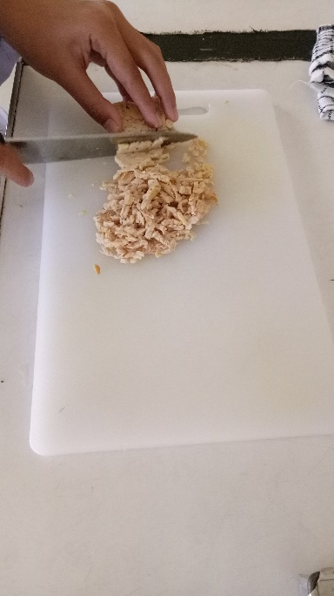**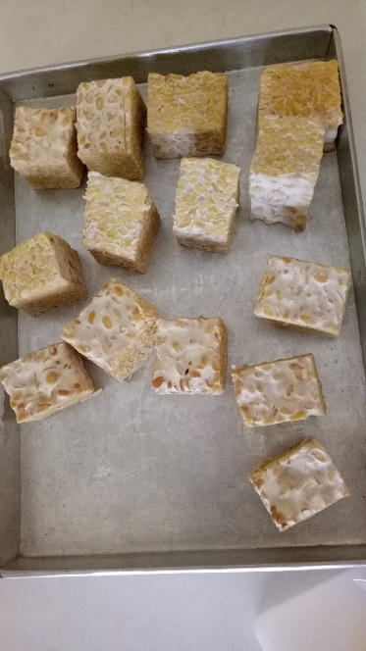Lampiran 17. Dokumentasi**

**Pembuatan Tepung Tempe**

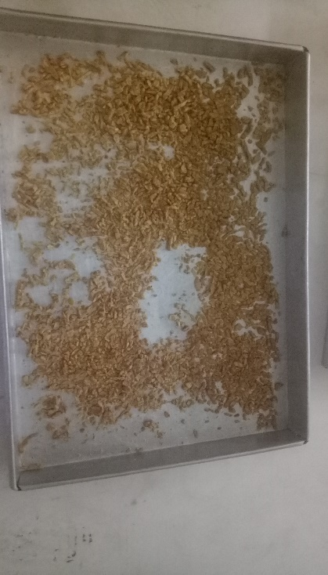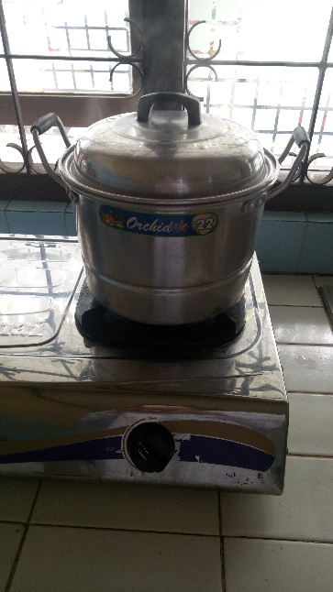

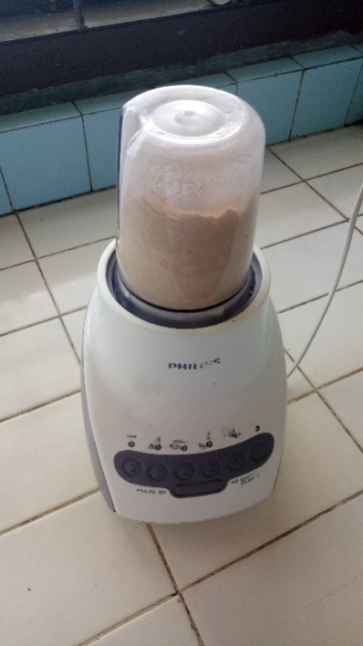

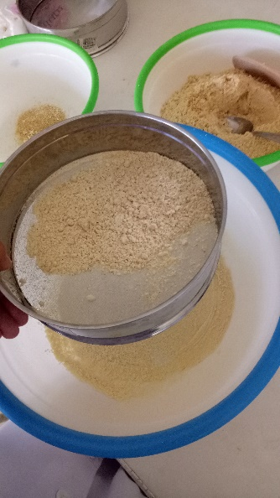

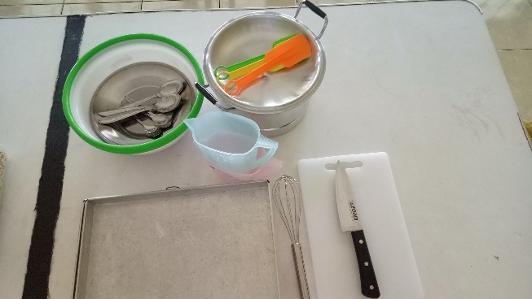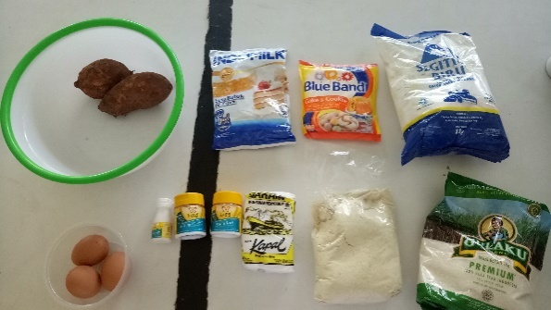**Pembuatan Muffin**

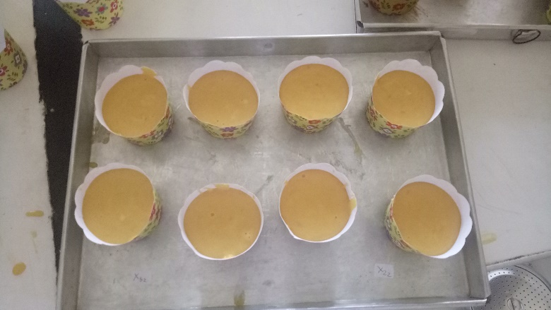

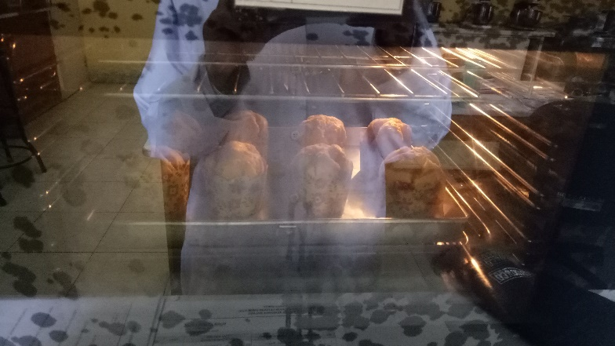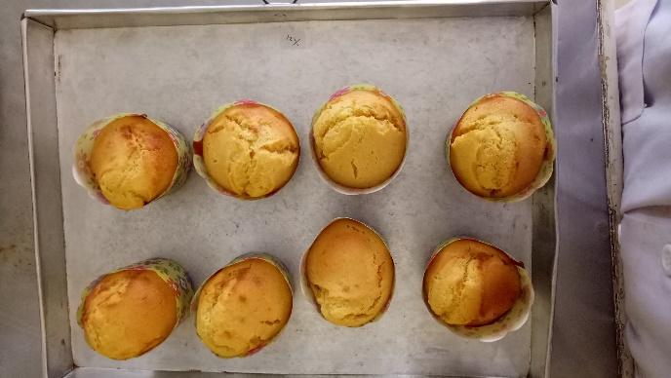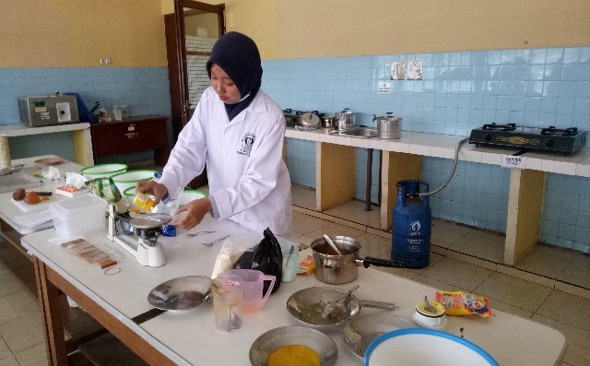

**Muffin Tiap Taraf Perlakuan**

|  |  |
| --- | --- |
| **Taraf Perlakuan** | **Gambar** |
| **P0** |  |
| **P1** |  |
| **P2** |  |
| **P3** |  |

**Uji Organoleptik**

