Lampiran 1 Etika Penelitian
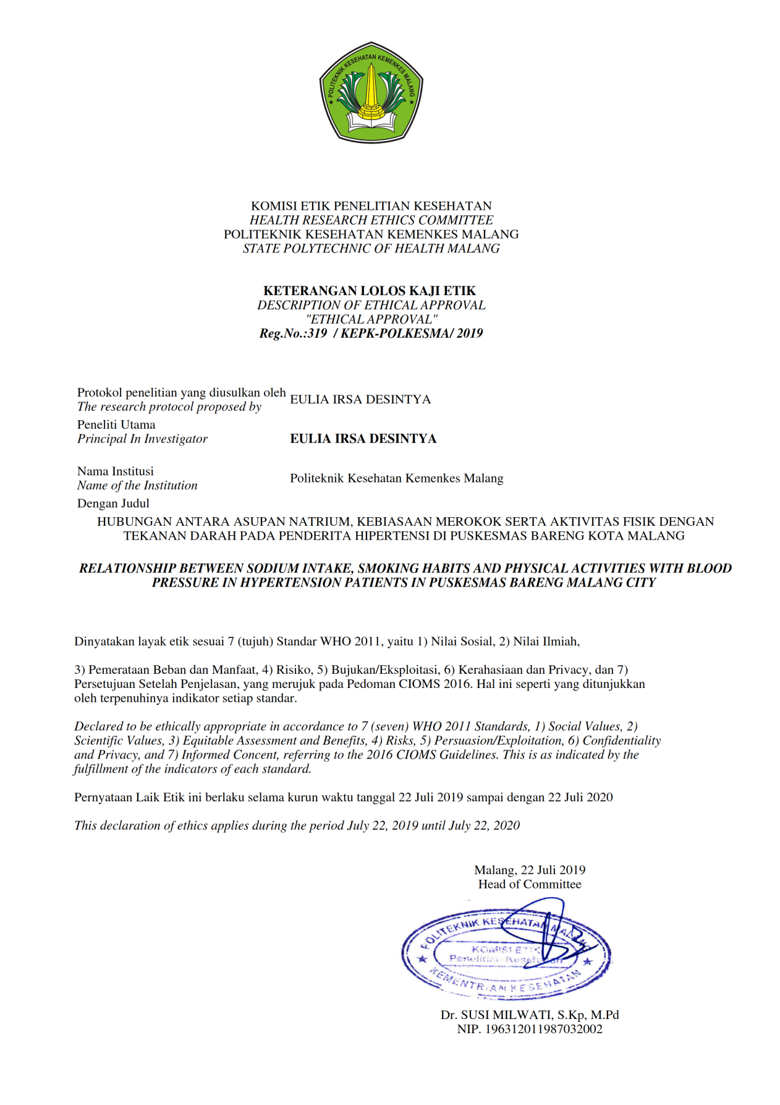

Lampiran 2 Surat ijin Penelitian Dinas Kesehatan

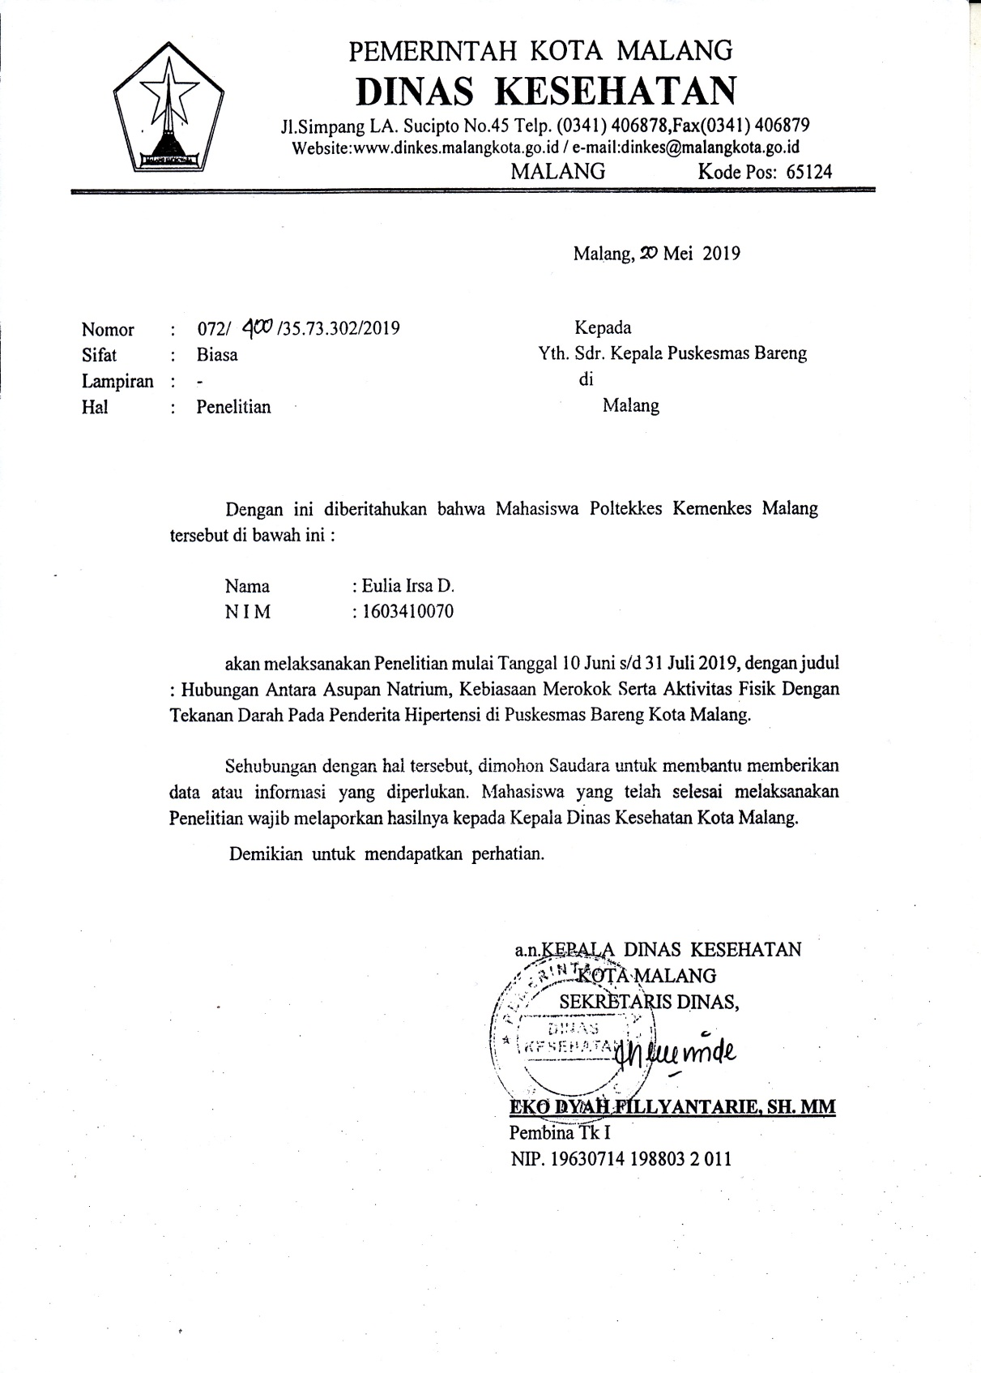

Lampiran 3 Surat Ijin Penelitian Puskesmas Bareng

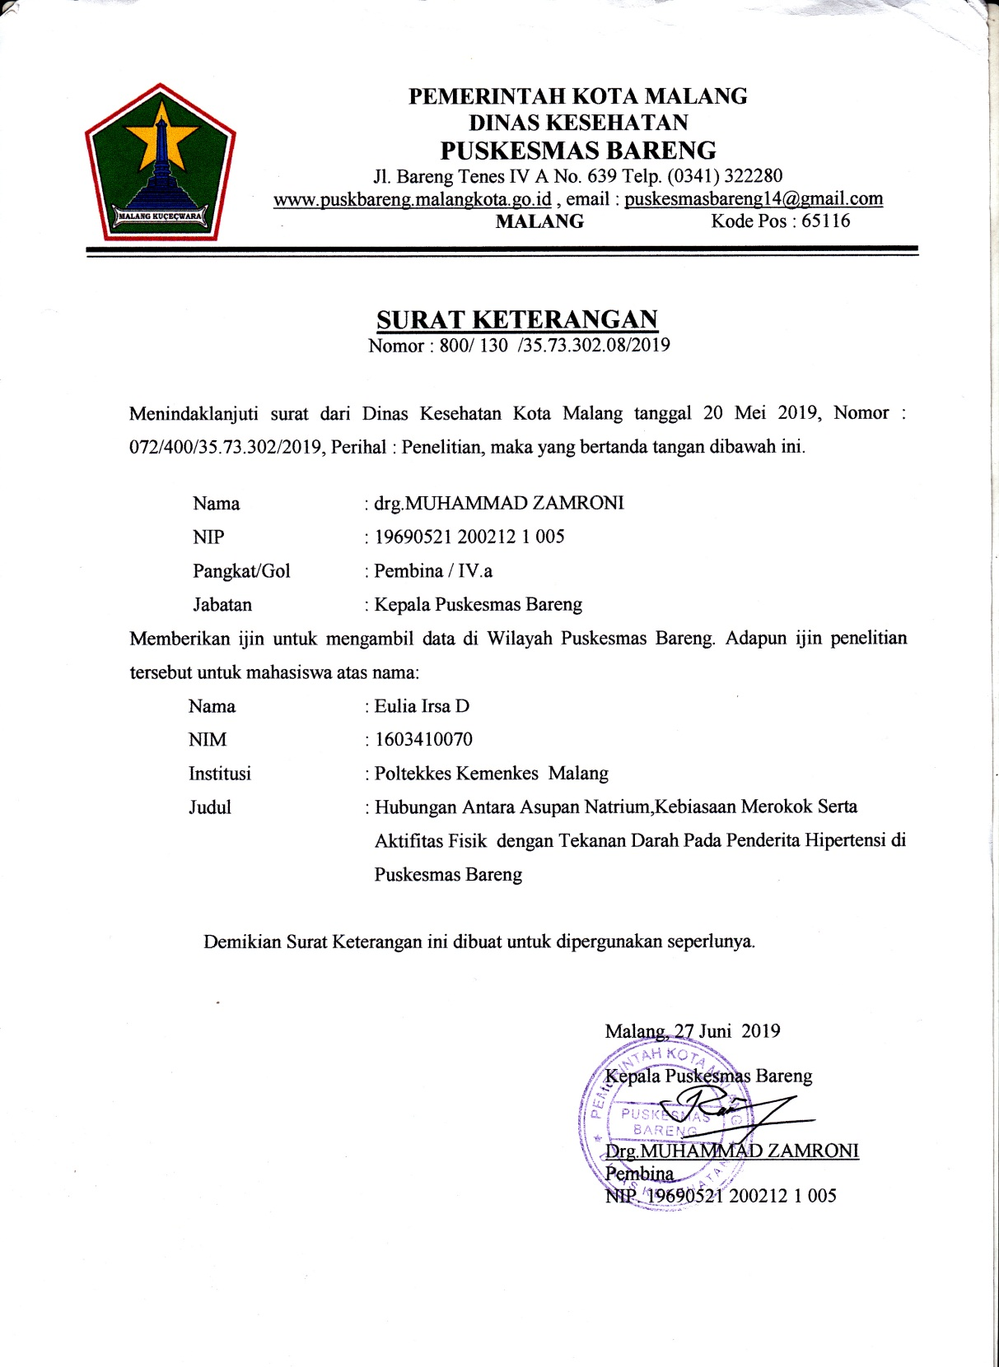

Lampiran 4 Surat Keterangan Selesai Penelitian

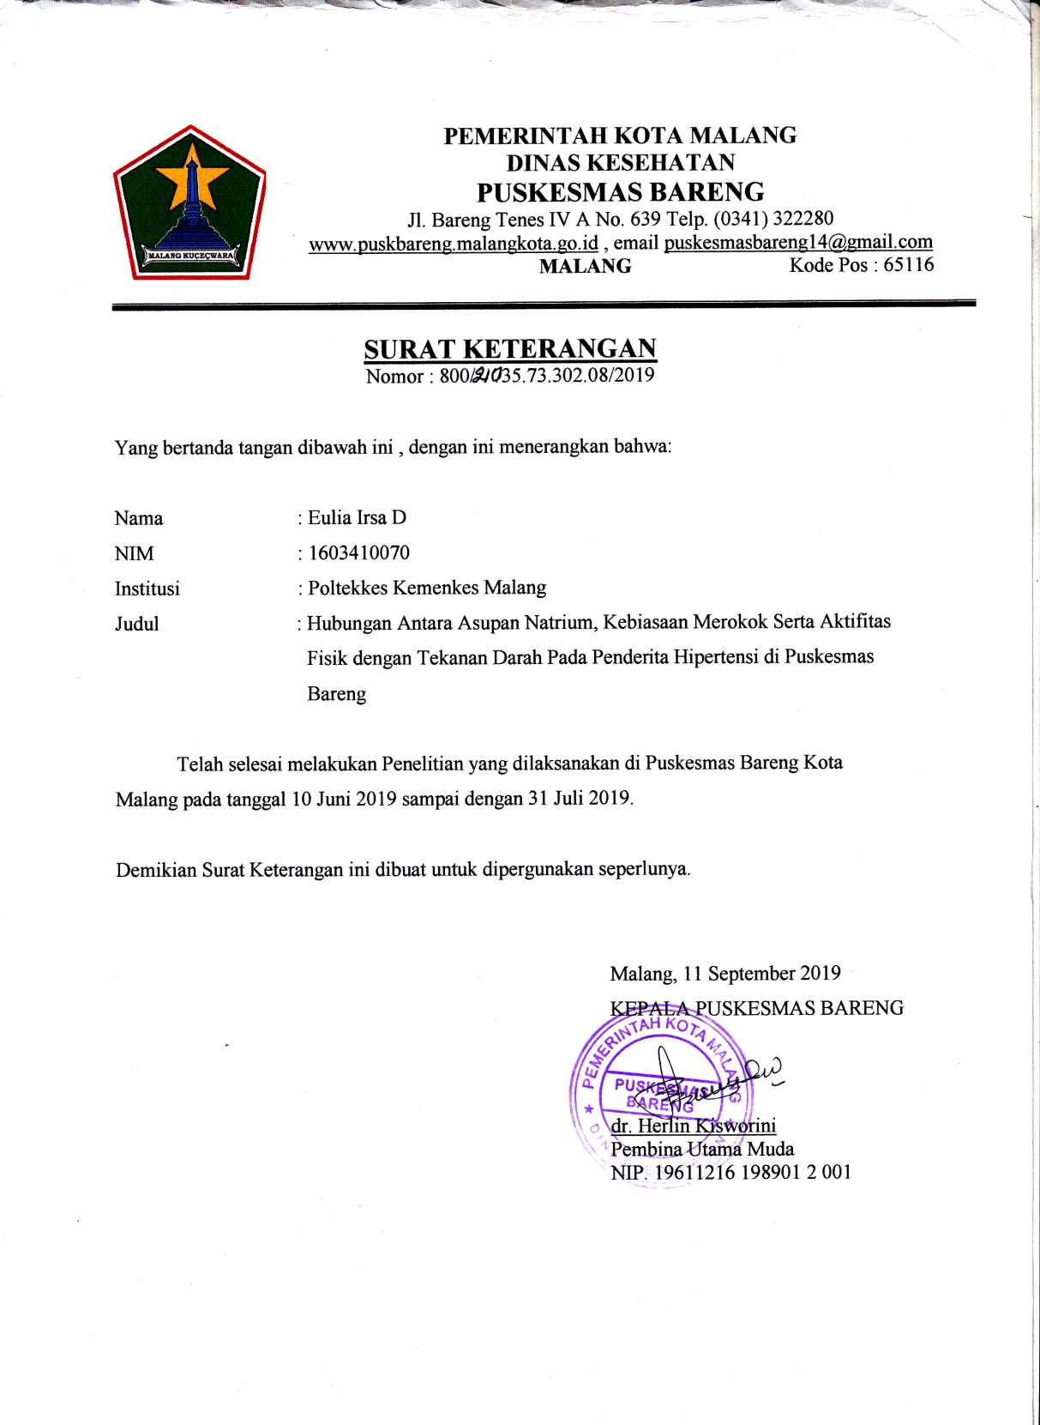

Lampiran 5 Lembar Persetujuan Responden

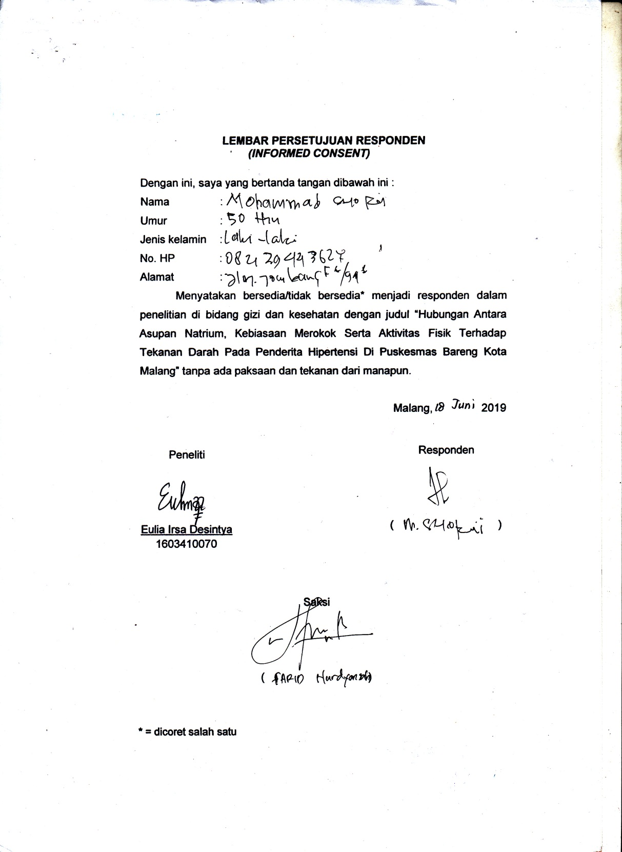

Lampiran 6 Lembar Identitas Responden

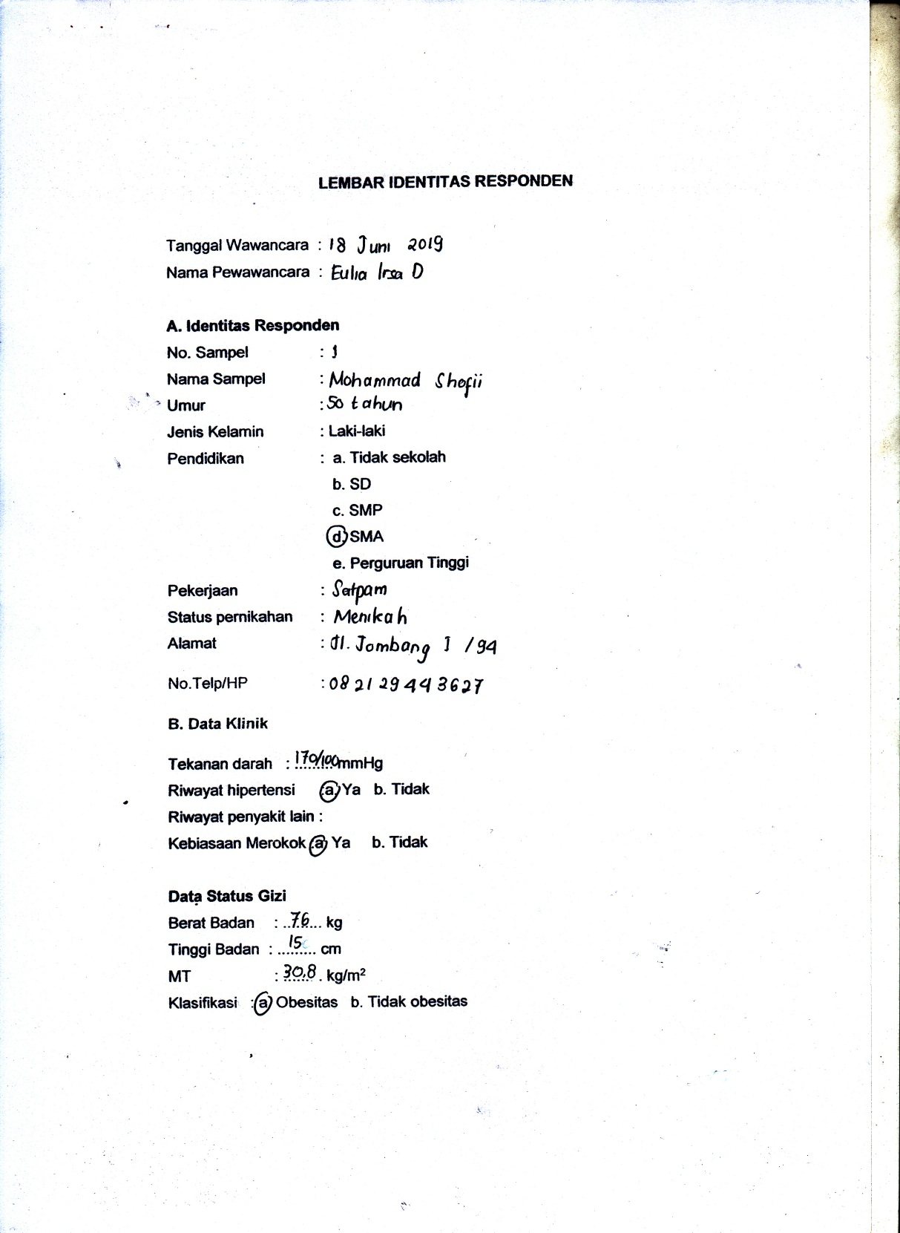

Lampiran 7 Formulir Food Recall 24 jam ke-1
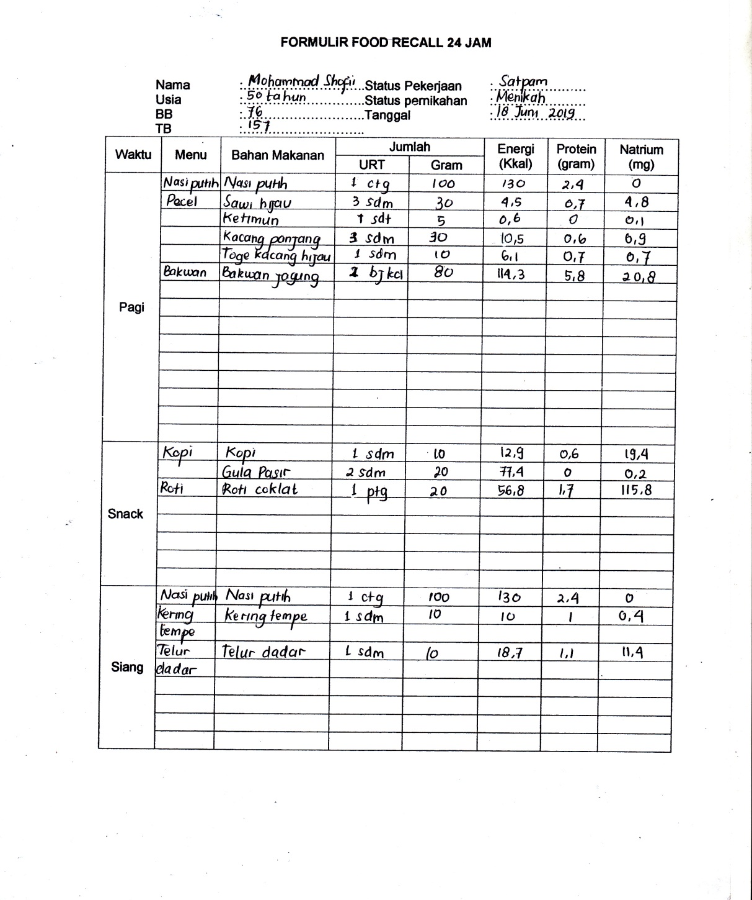

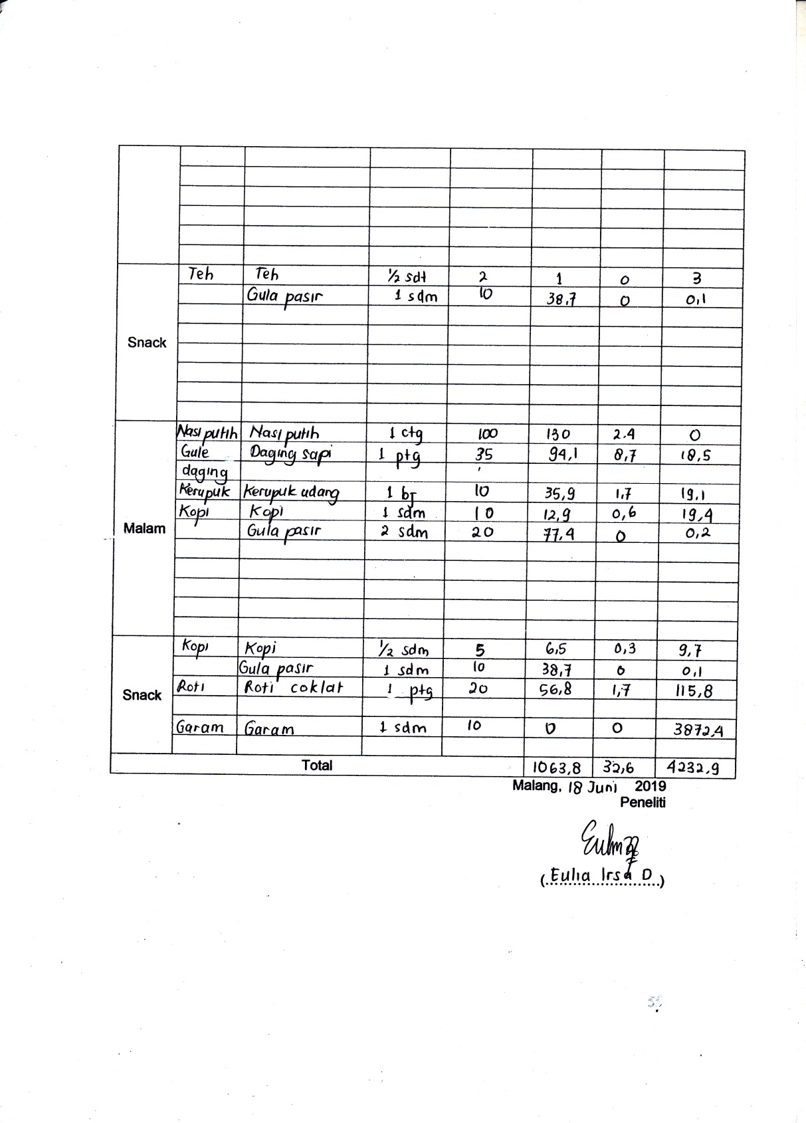

Lampiran 8 Food Recall 24 jam ke-2
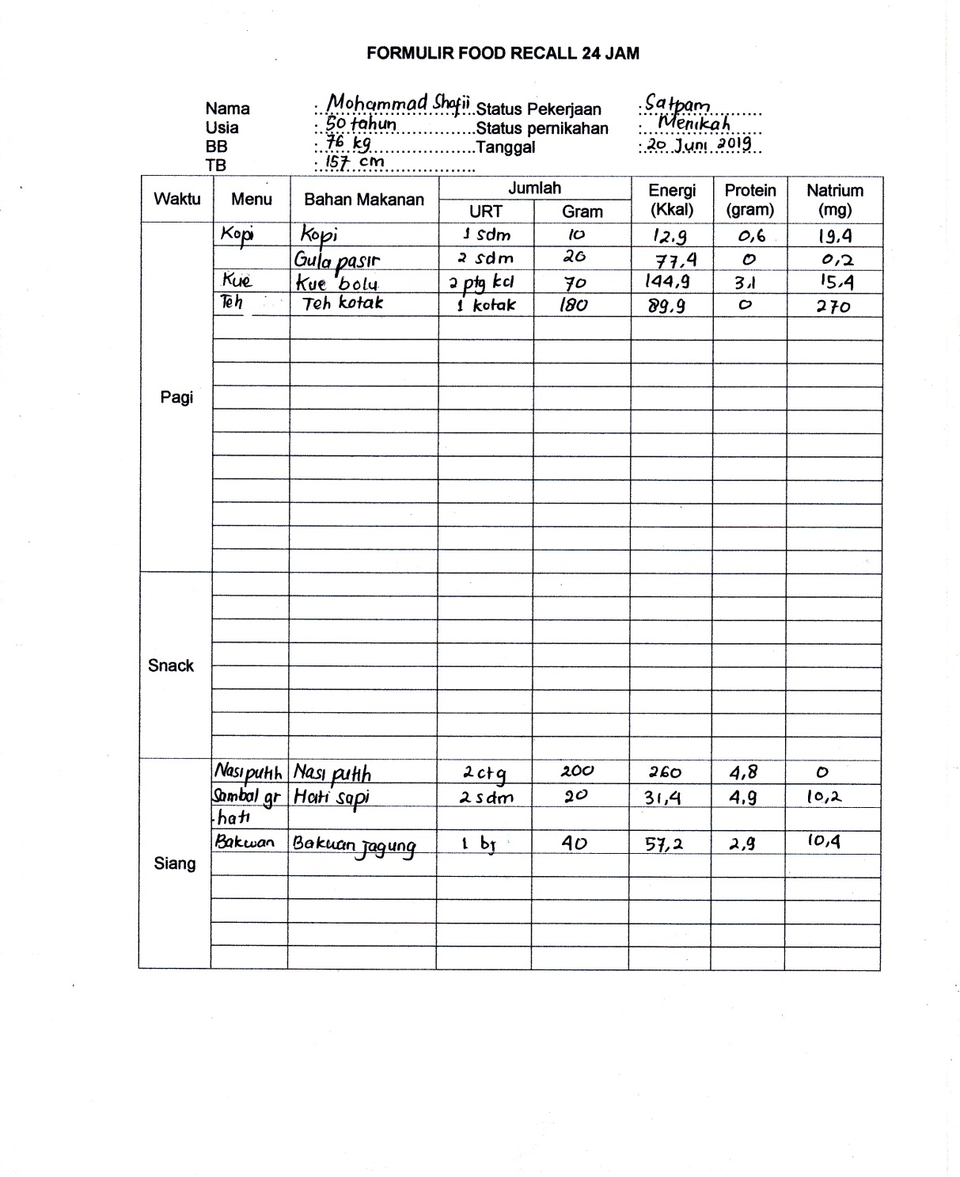

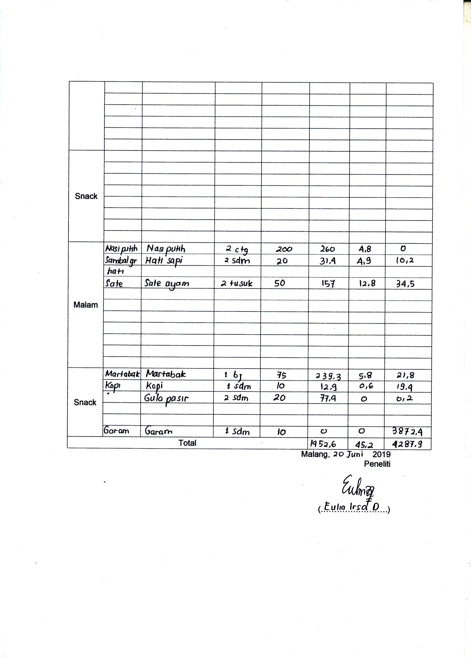

Lampiran 9 Formulir Kuesioner Kebiasaan Merokok
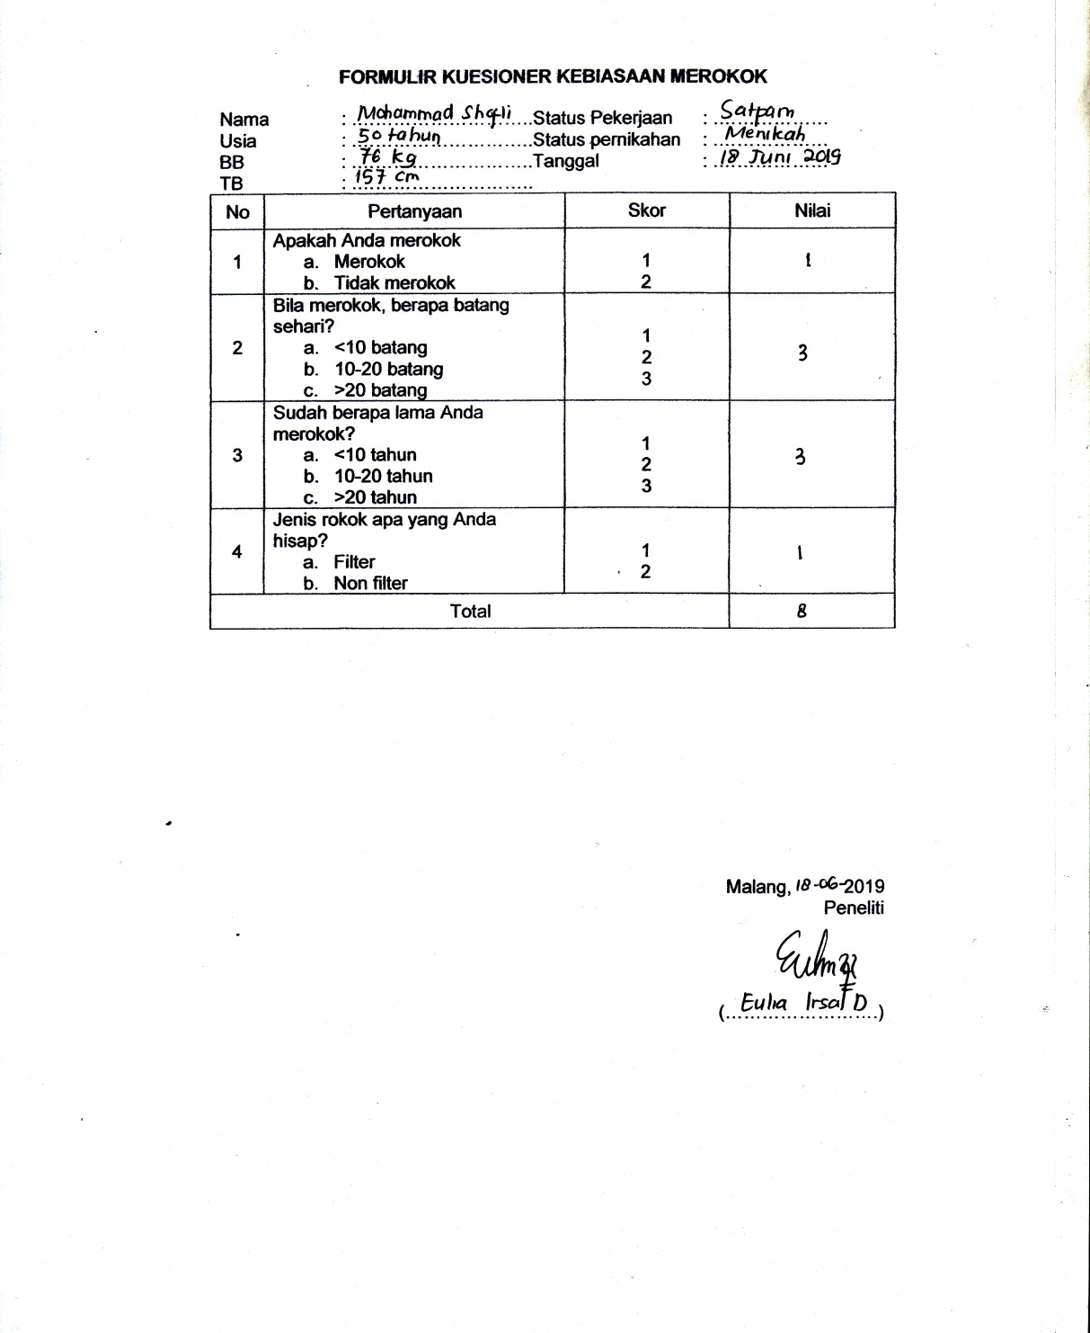

Lampiran 10 Formulir Aktivitas Fisik
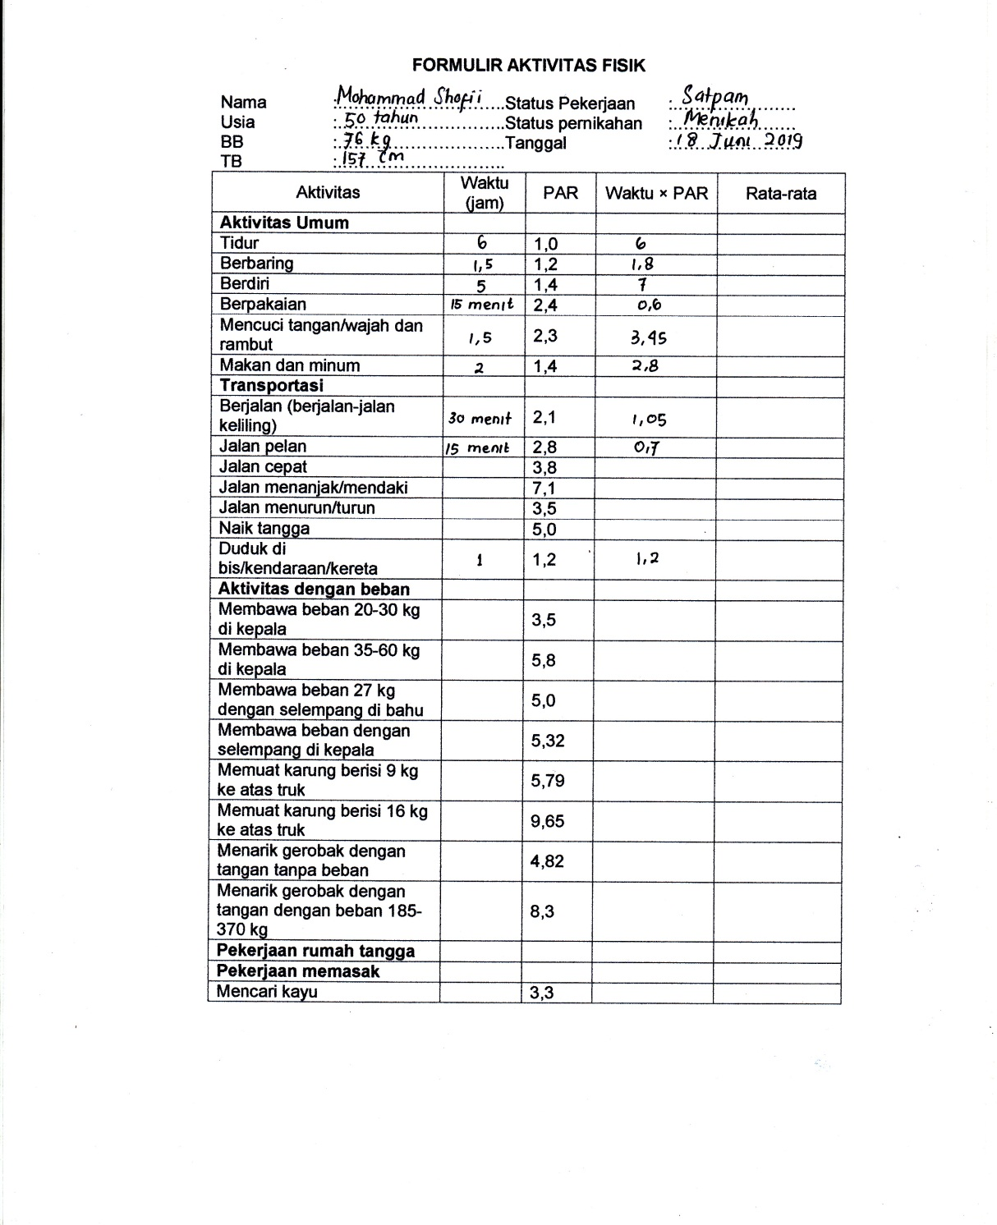

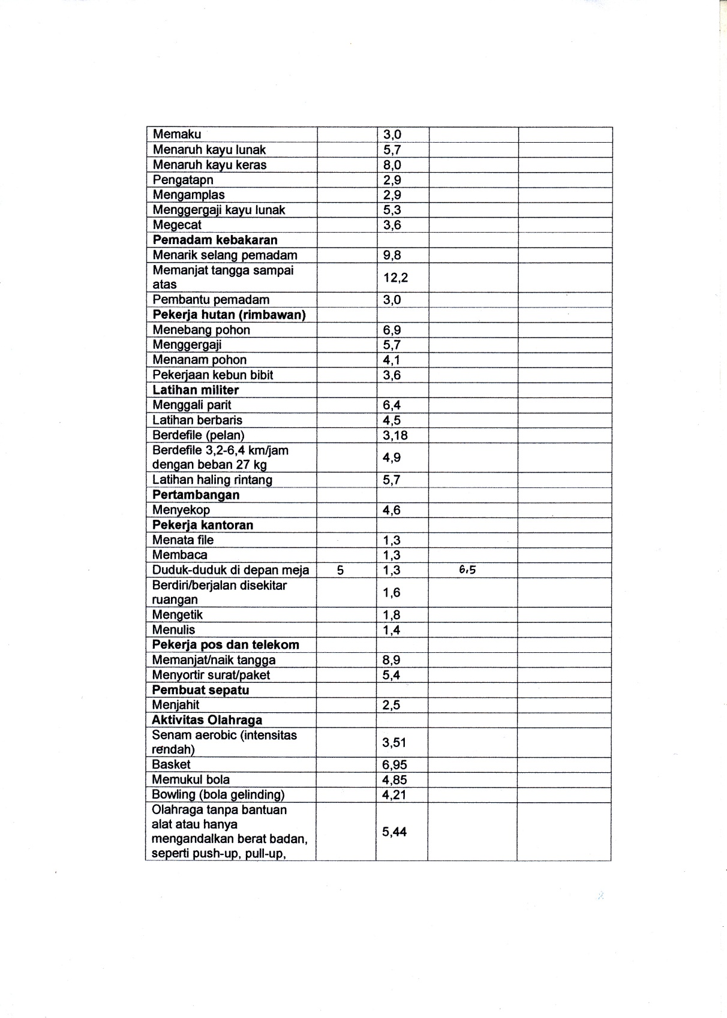

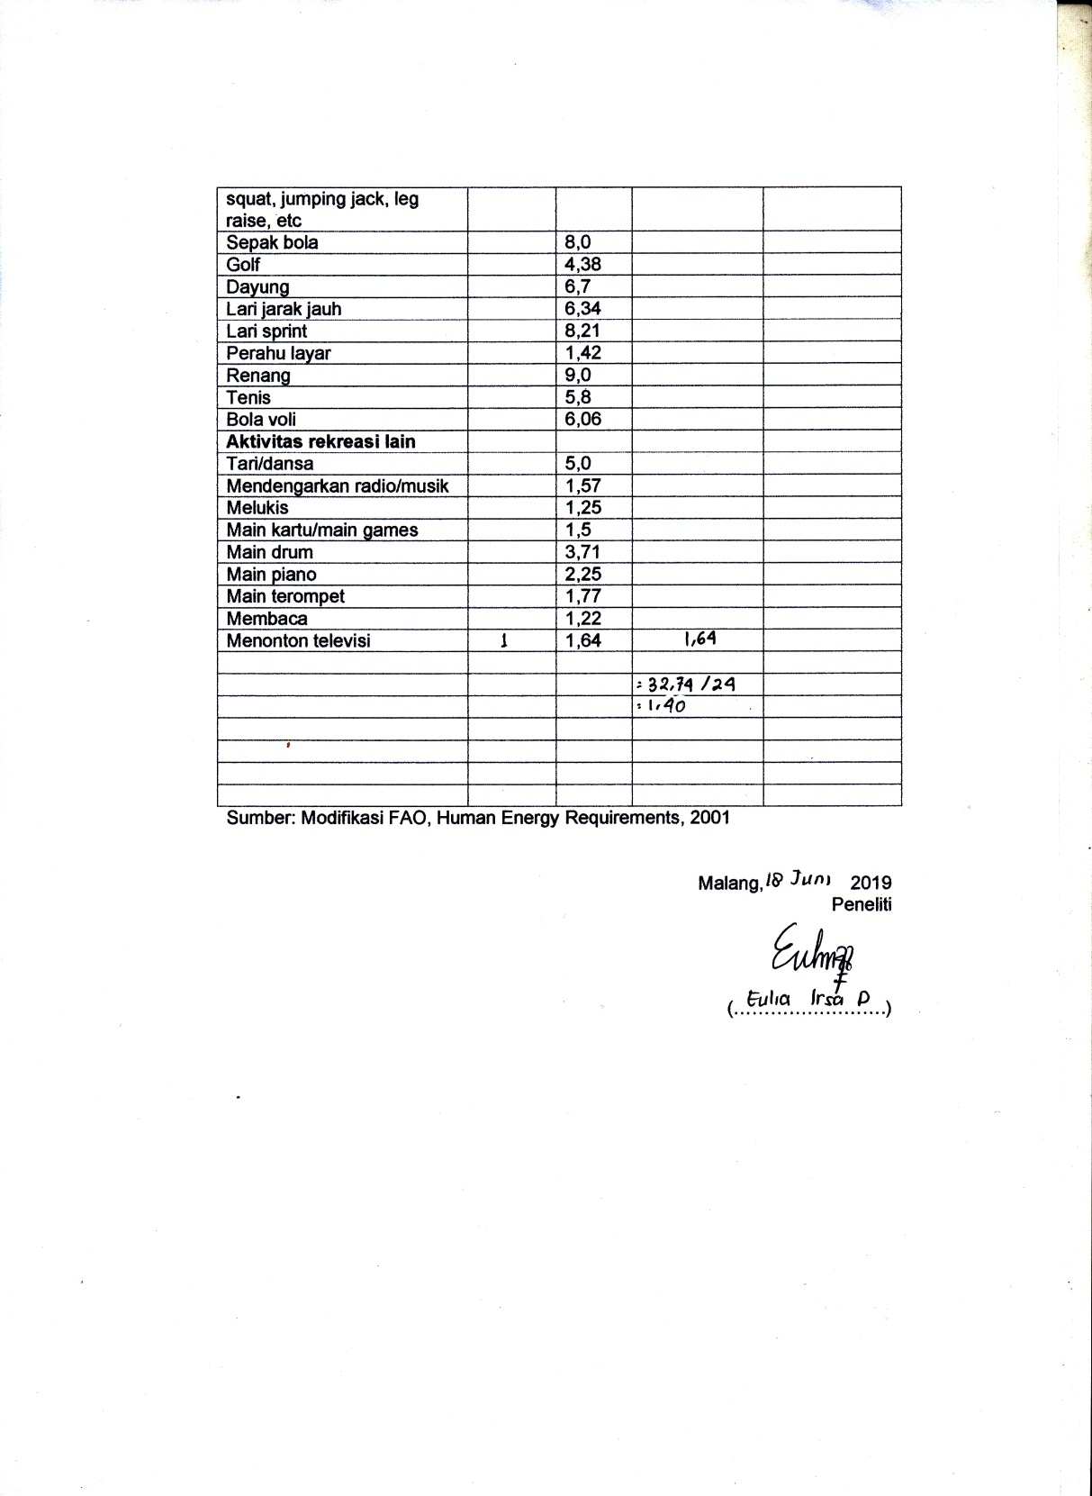

Lampiran 11 Data Responden Penelitian
Nama Responden | Usia | Riwayat HT | Status gizi | Tekanan darah | Klasifikasi Hipertensi | Asupan Natrium | Kebiasaan merokok | Aktivitas Fisik
Tn. MS | 50 | Ya | Obesitas | 170/100 | HT 2 | 4258.45 | 8 | 1.4
Tn. HB | 23 | Tidak | Obesitas | 130/80 | PRE HT | 2473 | 4 | 1.54
Tn. St | 59 | Tidak | Obesitas | 150/90 | HT 1 | 4084.65 | 6 | 1.41
Tn. Sh | 40 | Tidak | Tidak obes | 130/80 | PRE HT | 2130.3 | 4 | 1.5
Tn. MI | 50 | Ya | Obesitas | 130/80 | PRE HT | 2285.95 | 4 | 1.55
Tn. MA | 43 | Tidak | Tidak obes | 140/90 | HT 1 | 3917.25 | 6 | 1.42
Tn. TH | 54 | Tidak | Tidak obes | 140/90 | HT 1 | 3932.65 | 6 | 1.45
Tn. IK | 46 | Ya | Tidak obes | 130/80 | PRE HT | 2099.1 | 4 | 1.5
Tn. AH | 53 | Ya | Obesitas | 150/90 | HT 1 | 3971.4 | 4 | 1.47
Tn.DS | 48 | Ya | Obesitas | 160/100 | HT 2 | 4518.5 | 7 | 1.4
Tn. M | 57 | Tidak | Obesitas | 150/90 | HT 1 | 3944.7 | 6 | 1.47
Tn. HS | 42 | Tidak | Obesitas | 130/80 | PRE HT | 1992.7 | 4 | 1.6
Tn. I | 53 | Ya | Obesitas | 150/90 | HT 1 | 3916.9 | 6 | 1.47
Tn. Sw | 60 | Tidak | Tidak obes | 130/80 | PRE HT | 1954.05 | 2 | 1.65
Tn. Dt | 59 | Ya | Obesitas | 160/100 | HT 2 | 4042.1 | 7 | 1.4
Tn. Di | 53 | Tidak | Tidak obes | 140/90 | HT 1 | 3925 | 4 | 1.48
Tn. SM | 51 | Ya | Obesitas | 130/80 | PRE HT | 1950.95 | 4 | 1.64
Tn. GM | 59 | Tidak | Tidak obes | 130/80 | PRE HT | 1268 | 4 | 1.77
Tn. AI | 58 | Ya | Tidak obes | 150/90 | HT 1 | 2969.25 | 4 | 1.43
Tn. SA | 57 | Ya | Obesitas | 160/100 | HT 2 | 4109.9 | 7 | 1.4

Lampiran 12 Uji Normalitas dan Chi Square
Tests of Normality
 | Kebiasaan Merokok | Kolmogorov-Smirnovª |  |  | Shapiro-Wilk
 | Kebiasaan Merokok | Statistic | df | Sig. | Statistic | df | Sig.
Tekanan Darah | Ringan | .448 | 11 | .000 | .572 | 11 | .000
Tekanan Darah | Berat | .356 | 9 | .002 | .655 | 9 | .000

Tests of Normality^{b}
 | Aktifitas Fisik | Kolmogorov-Smirnovª |  |  | Shapiro-Wilk
 | Aktifitas Fisik | Statistic | Df | Sig. | Statistic | df | Sig.
Tekanan Darah | Ringan | .233 | 19 | .008 | .808 | 19 | .001

Tests of Normality^{b}
 | Asupan Natrium | Kolmogorov-Smirnovª |  |  | Shapiro-Wilk
 | Asupan Natrium | Statistic | df | Sig. | Statistic | df | Sig.
Tekanan Darah | Tidak Sesuai | .342 | 13 | .000 | .766 | 13 | .003

Uji Chi Square Tekanan Darah dengan Asupan Natrium
Case Processing Summary
 | Cases
 | Valid |  | Missing |  | Total
 | N | Percent | N | Percent | N | Percent
Tekanan Darah * Asupan Natrium | 20 | 100.0% | 0 | 0.0% | 20 | 100.0%

Tekanan Darah * Asupan Natrium Crosstabulation
Count
 |  | Asupan Natrium |  | Total
 |  | Tidak Sesuai | Sesuai | Total
Tekanan Darah | Pre Ht | 1 | 7 | 8
Tekanan Darah | Ht 1 | 8 | 0 | 8
Tekanan Darah | Ht 2 | 4 | 0 | 4
Total |  | 13 | 7 | 20

Chi-Square Tests
 | Value | df | Asymp. Sig. (2-sided)
Pearson Chi-Square | 16.154ª | 2 | .000
Likelihood Ratio | 19.870 | 2 | .000
Linear-by-Linear Association | 11.692 | 1 | .001
N of Valid Cases | 20
a. 4 cells (66.7%) have expected count less than 5. The minimum expected count is 1.40.
Uji Chi Square Tekanan Darah dengan Kebiasaan Merokok
Case Processing Summary
 | Cases
 | Valid |  | Missing |  | Total
 | N | Percent | N | Percent | N | Percent
Tekanan Darah * Kebiasaan Merokok | 20 | 100.0% | 0 | 0.0% | 20 | 100.0%

Tekanan Darah * Kebiasaan Merokok Crosstabulation
Count
 |  | Kebiasaan Merokok |  | Total
 |  | Ringan | Berat | Total
Tekanan Darah | Pre Ht | 8 | 0 | 8
Tekanan Darah | Ht 1 | 3 | 5 | 8
Tekanan Darah | Ht 2 | 0 | 4 | 4
Total |  | 11 | 9 | 20

Chi-Square Tests
 | Value | df | Asymp. Sig. (2-sided)
Pearson Chi-Square | 12.424ª | 2 | .002
Likelihood Ratio | 16.941 | 2 | .000

Linear-by-Linear Association | 11.529 | 1 | .001
N of Valid Cases | 20

a. 6 cells (100.0%) have expected count less than 5. The minimum expected count is 1.80.

Uji Chi Square Tekanan Darah dengan Aktivitas Fisik
Case Processing Summary
 | Cases
 | Valid |  | Missing |  | Total
 | N | Percent | N | Percent | N | Percent
Tekanan Darah * Aktifitas Fisik | 20 | 100.0% | 0 | 0.0% | 20 | 100.0%

Tekanan Darah * Aktifitas Fisik Crosstabulation
Count
 |  | Aktifitas Fisik |  | Total
 |  | Ringan | Sedang | Total
Tekanan Darah | Pre Ht | 7 | 1 | 8
Tekanan Darah | Ht 1 | 8 | 0 | 8
Tekanan Darah | Ht 2 | 4 | 0 | 4
Total |  | 19 | 1 | 20

Chi-Square Tests
 | Value | df | Asymp. Sig. (2-sided)
Pearson Chi-Square | 1.579ª | 2 | .454
Likelihood Ratio | 1.912 | 2 | .384
Linear-by-Linear Association | 1.143 | 1 | .285
N of Valid Cases | 20

a. 4 cells (66.7%) have expected count less than 5. The minimum expected count is .20.

