# LAMPIRAN

**Lampiran 1. Lembar Persetujuan menjadi Responden Penelitian**

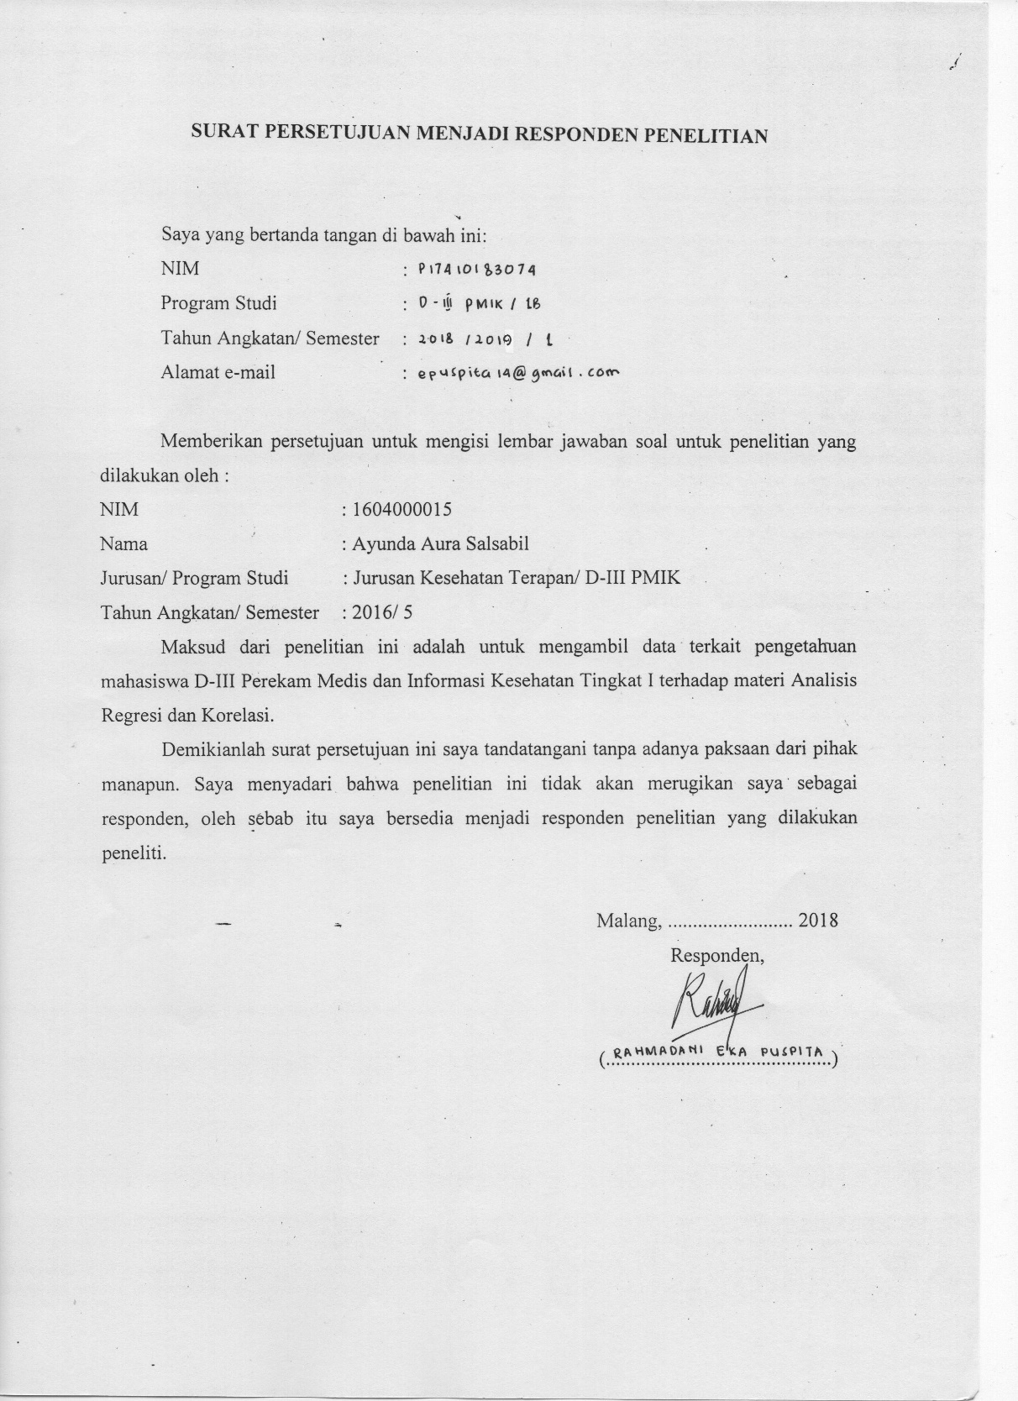

**Lampiran 2. Soal Ujian untuk Pre-Test dan Post-Test**

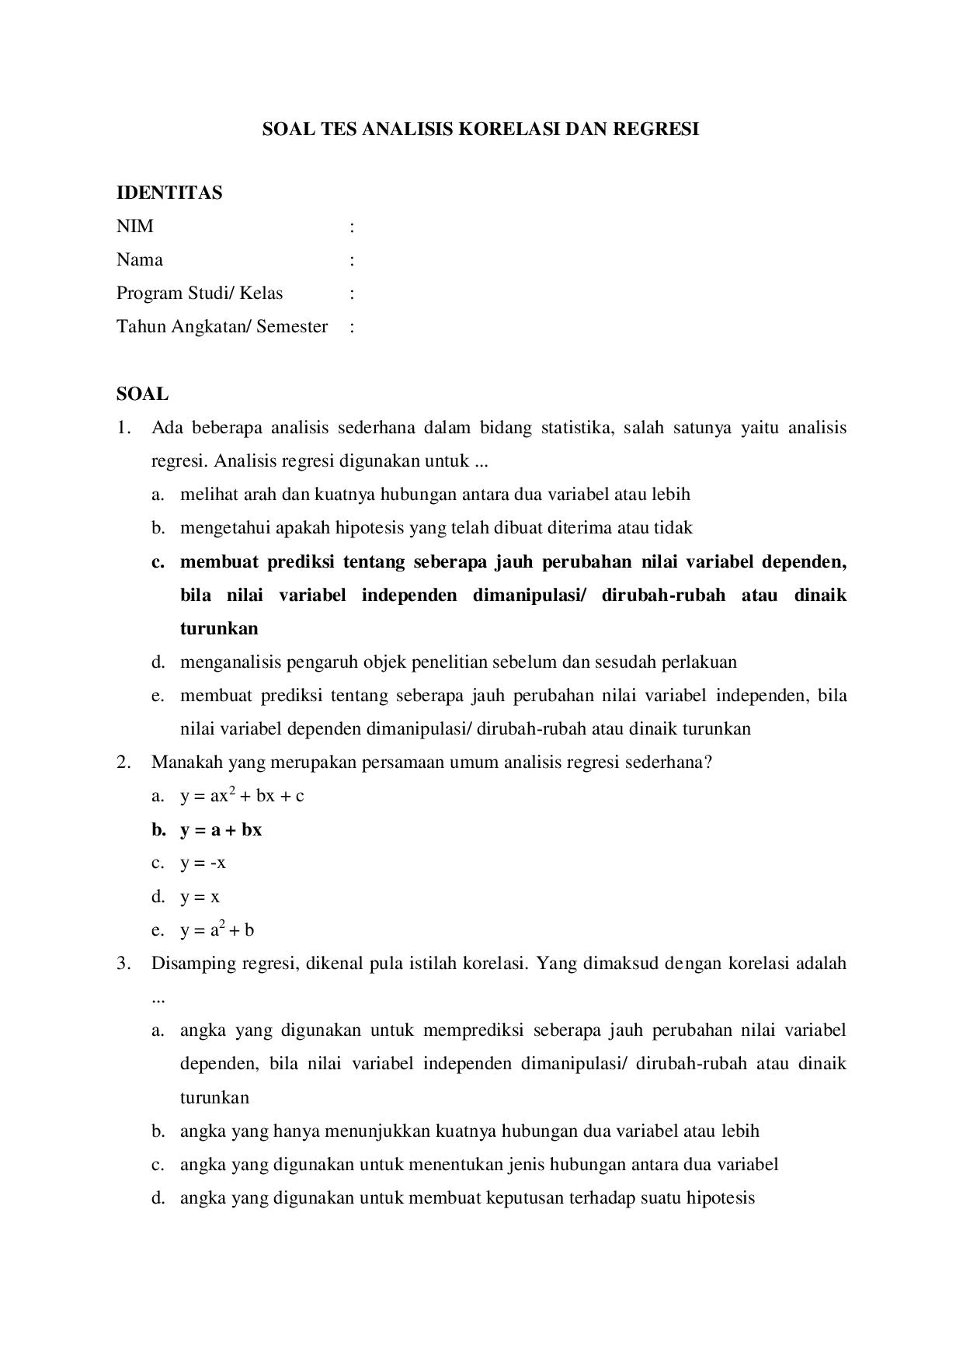

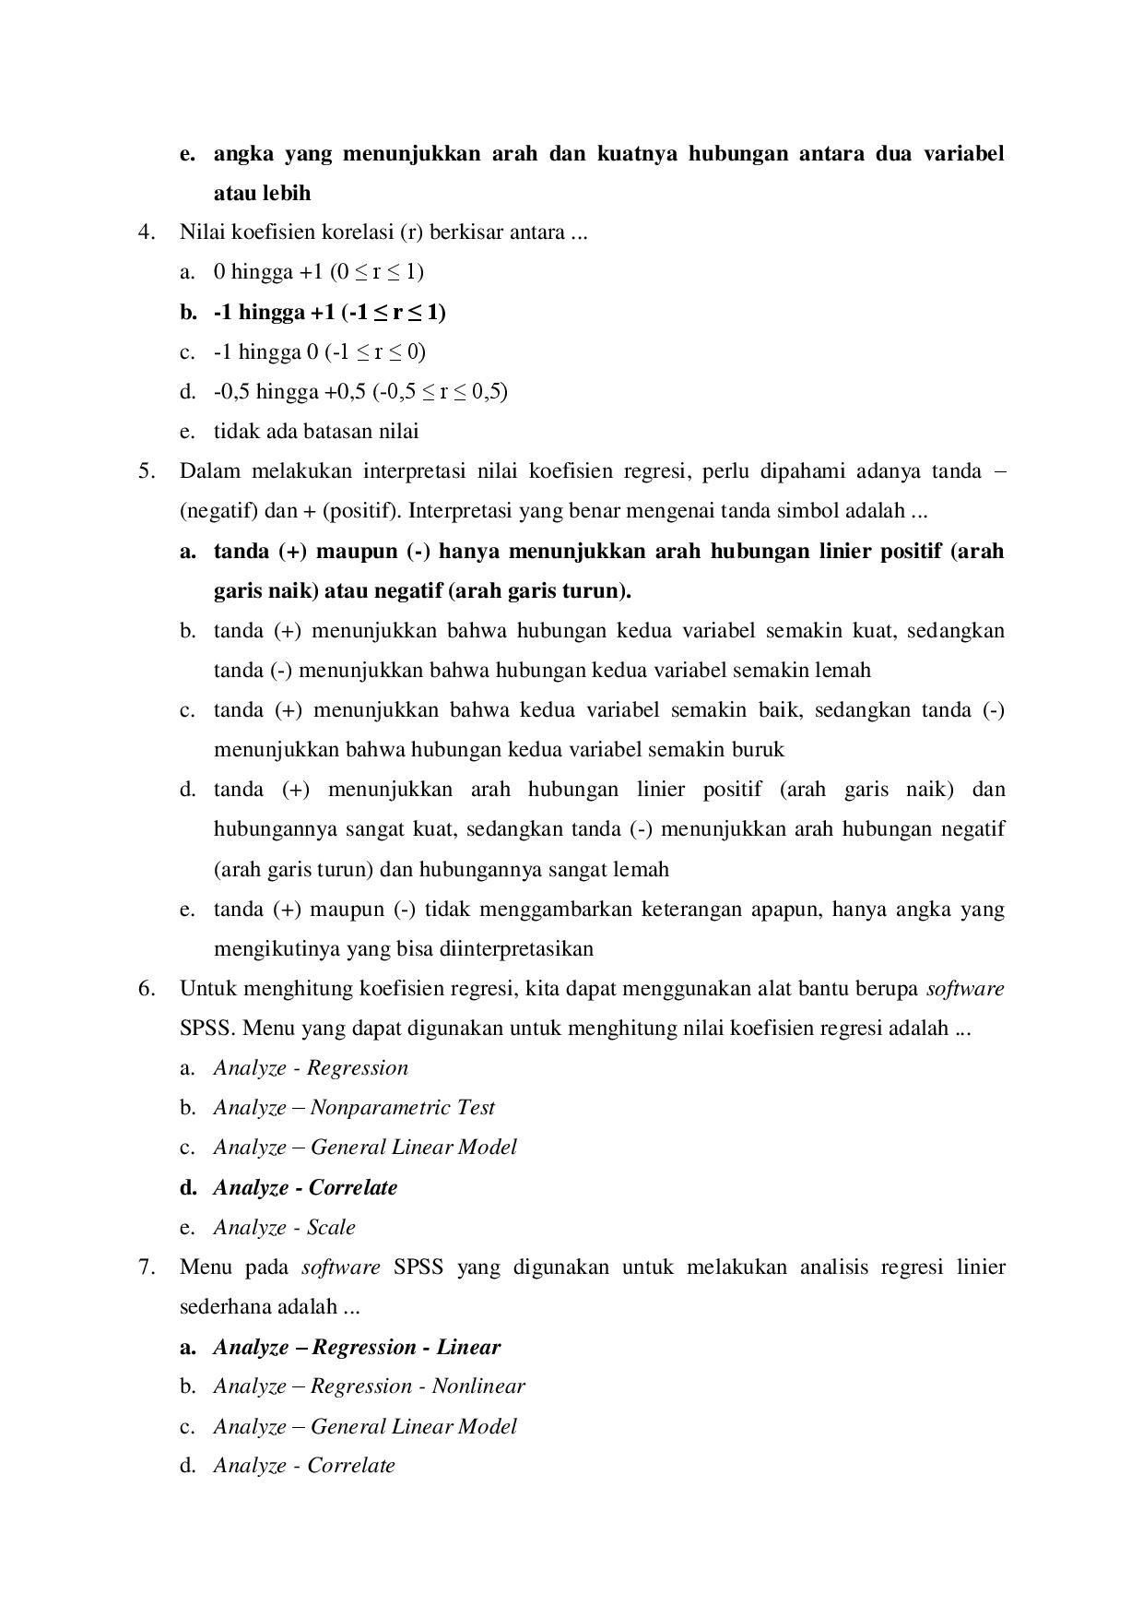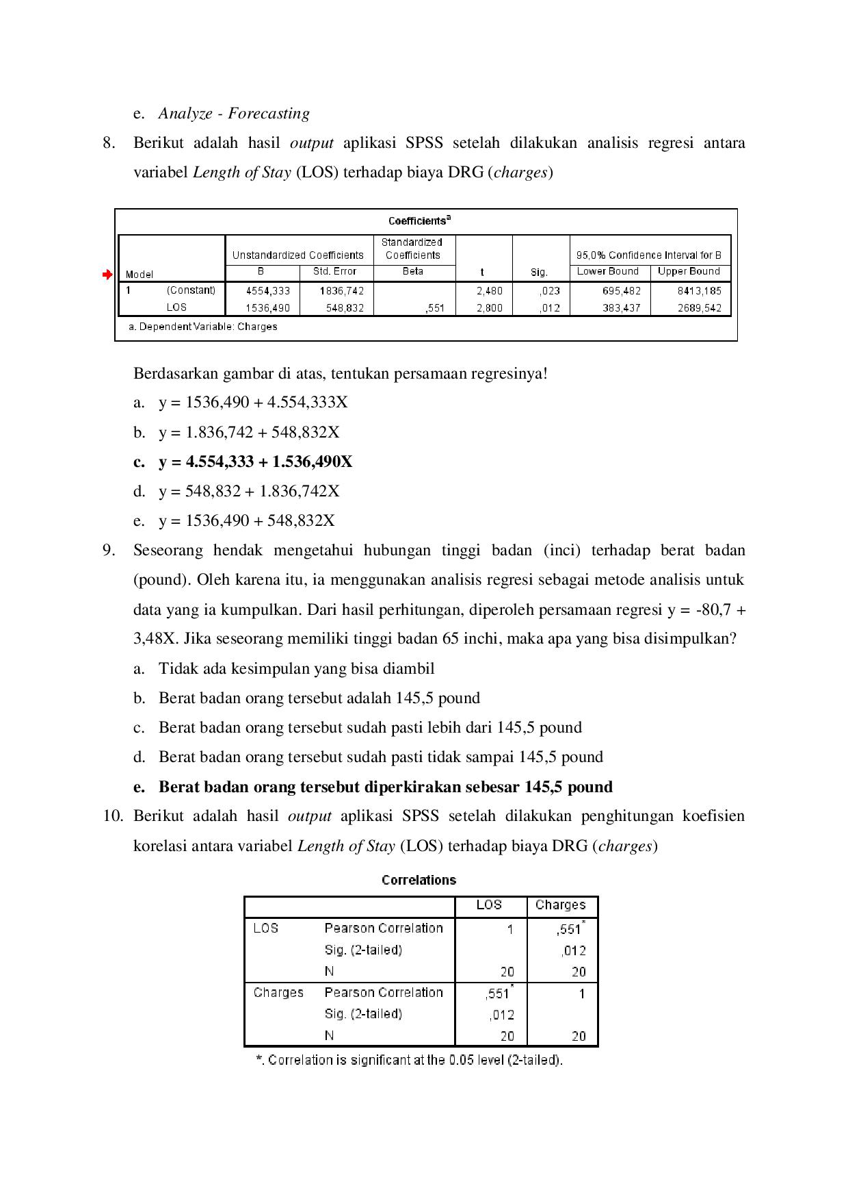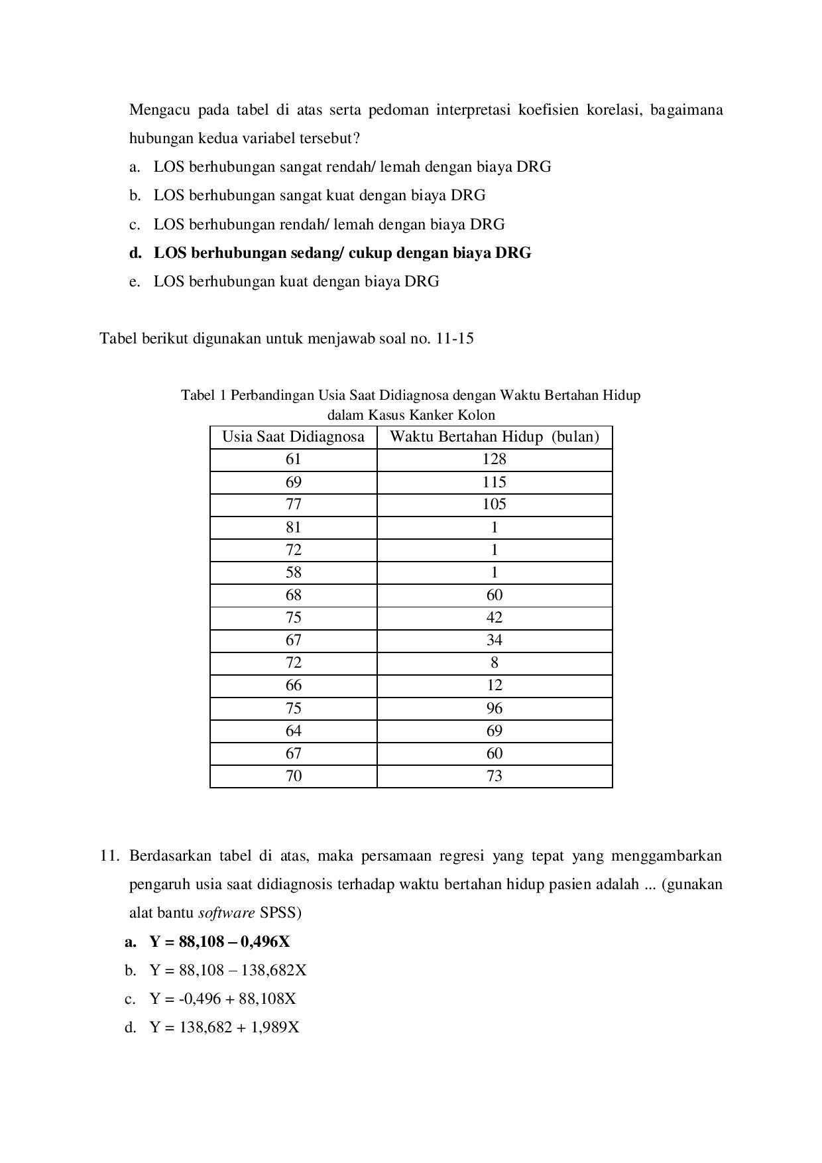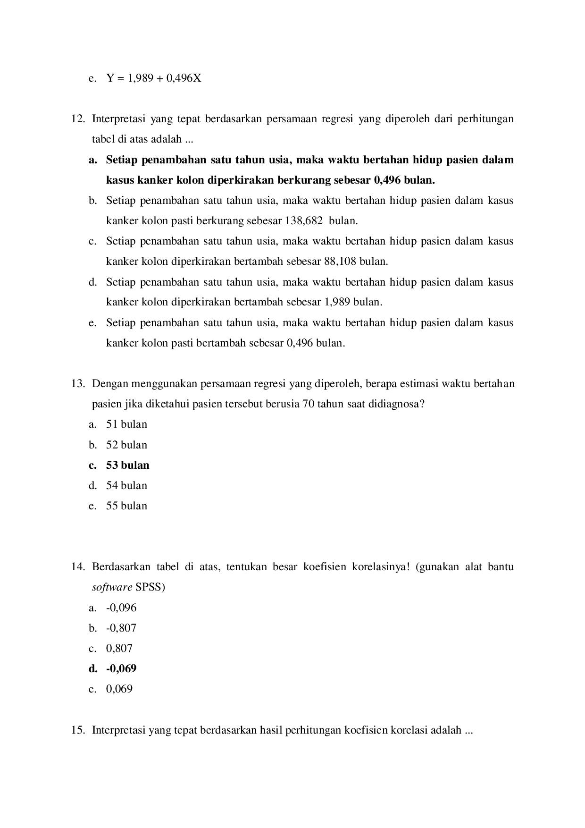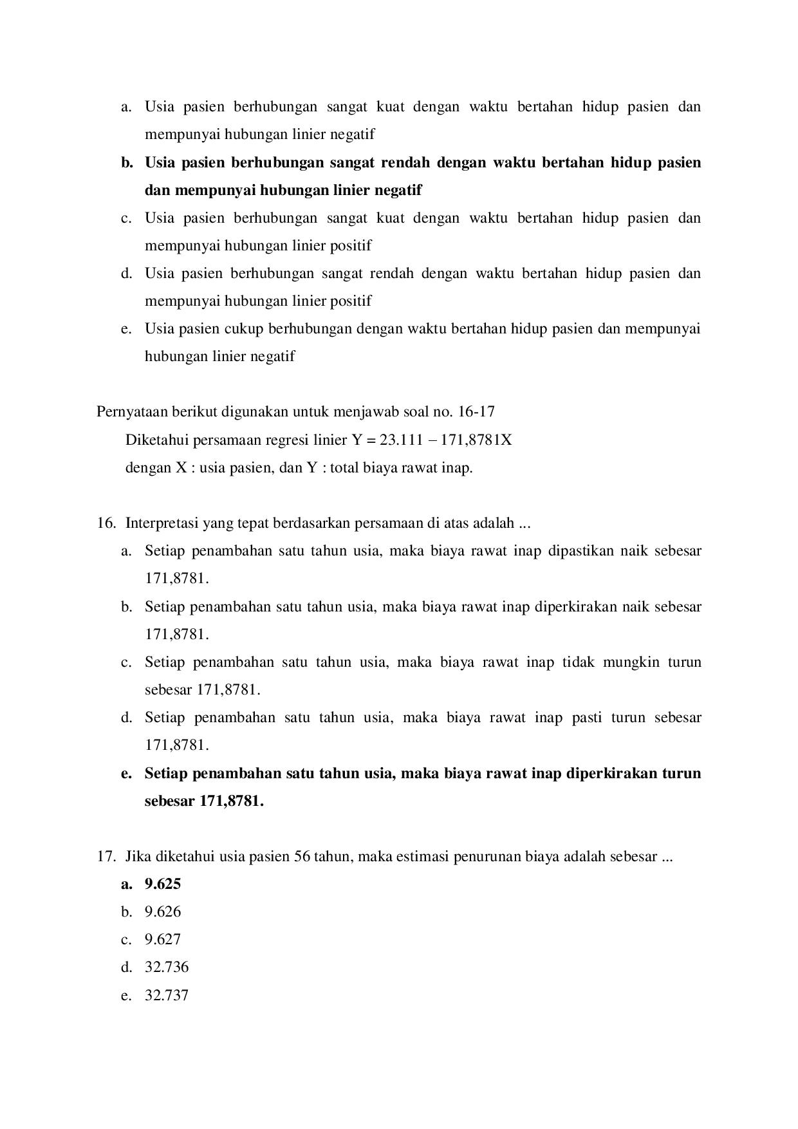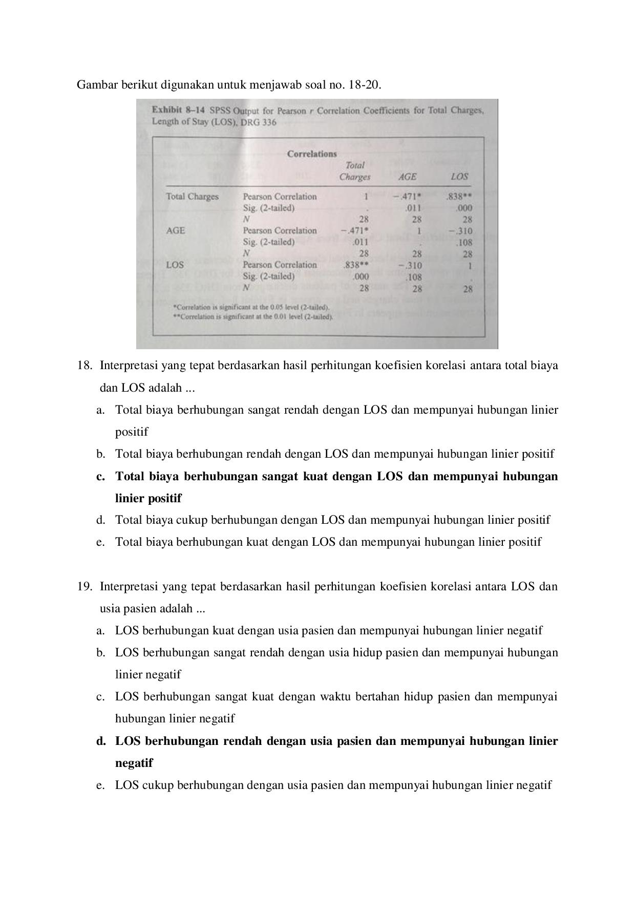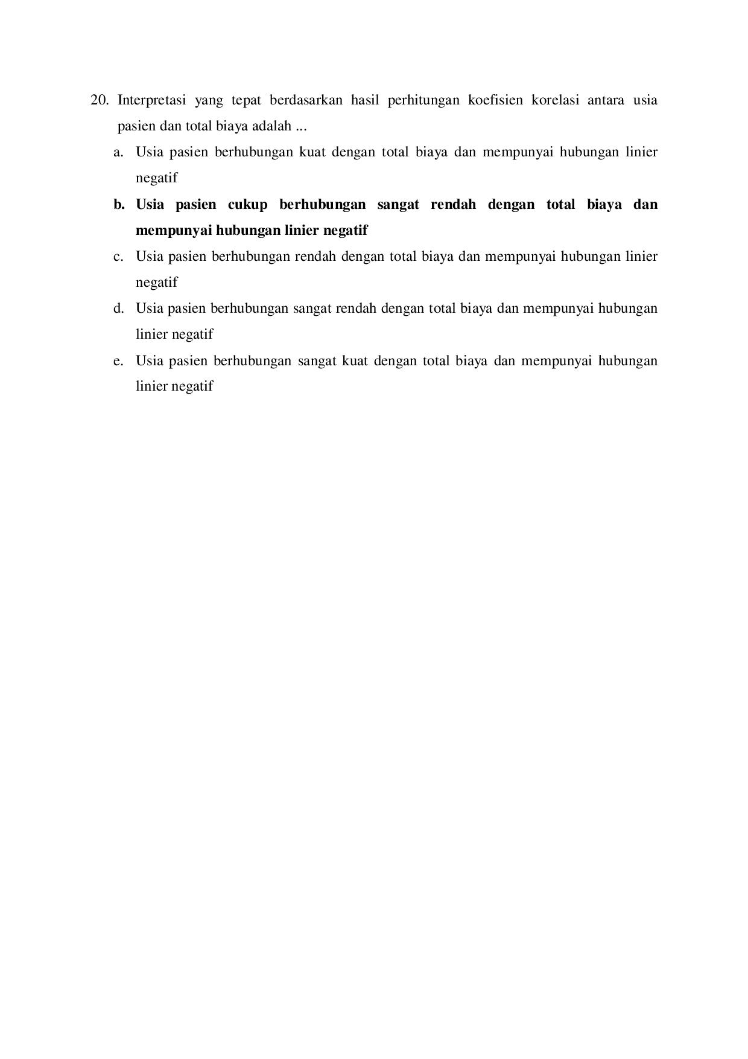

**Lampiran 3. Desain Modul Pembelajaran Statistika**



Sampul Depan

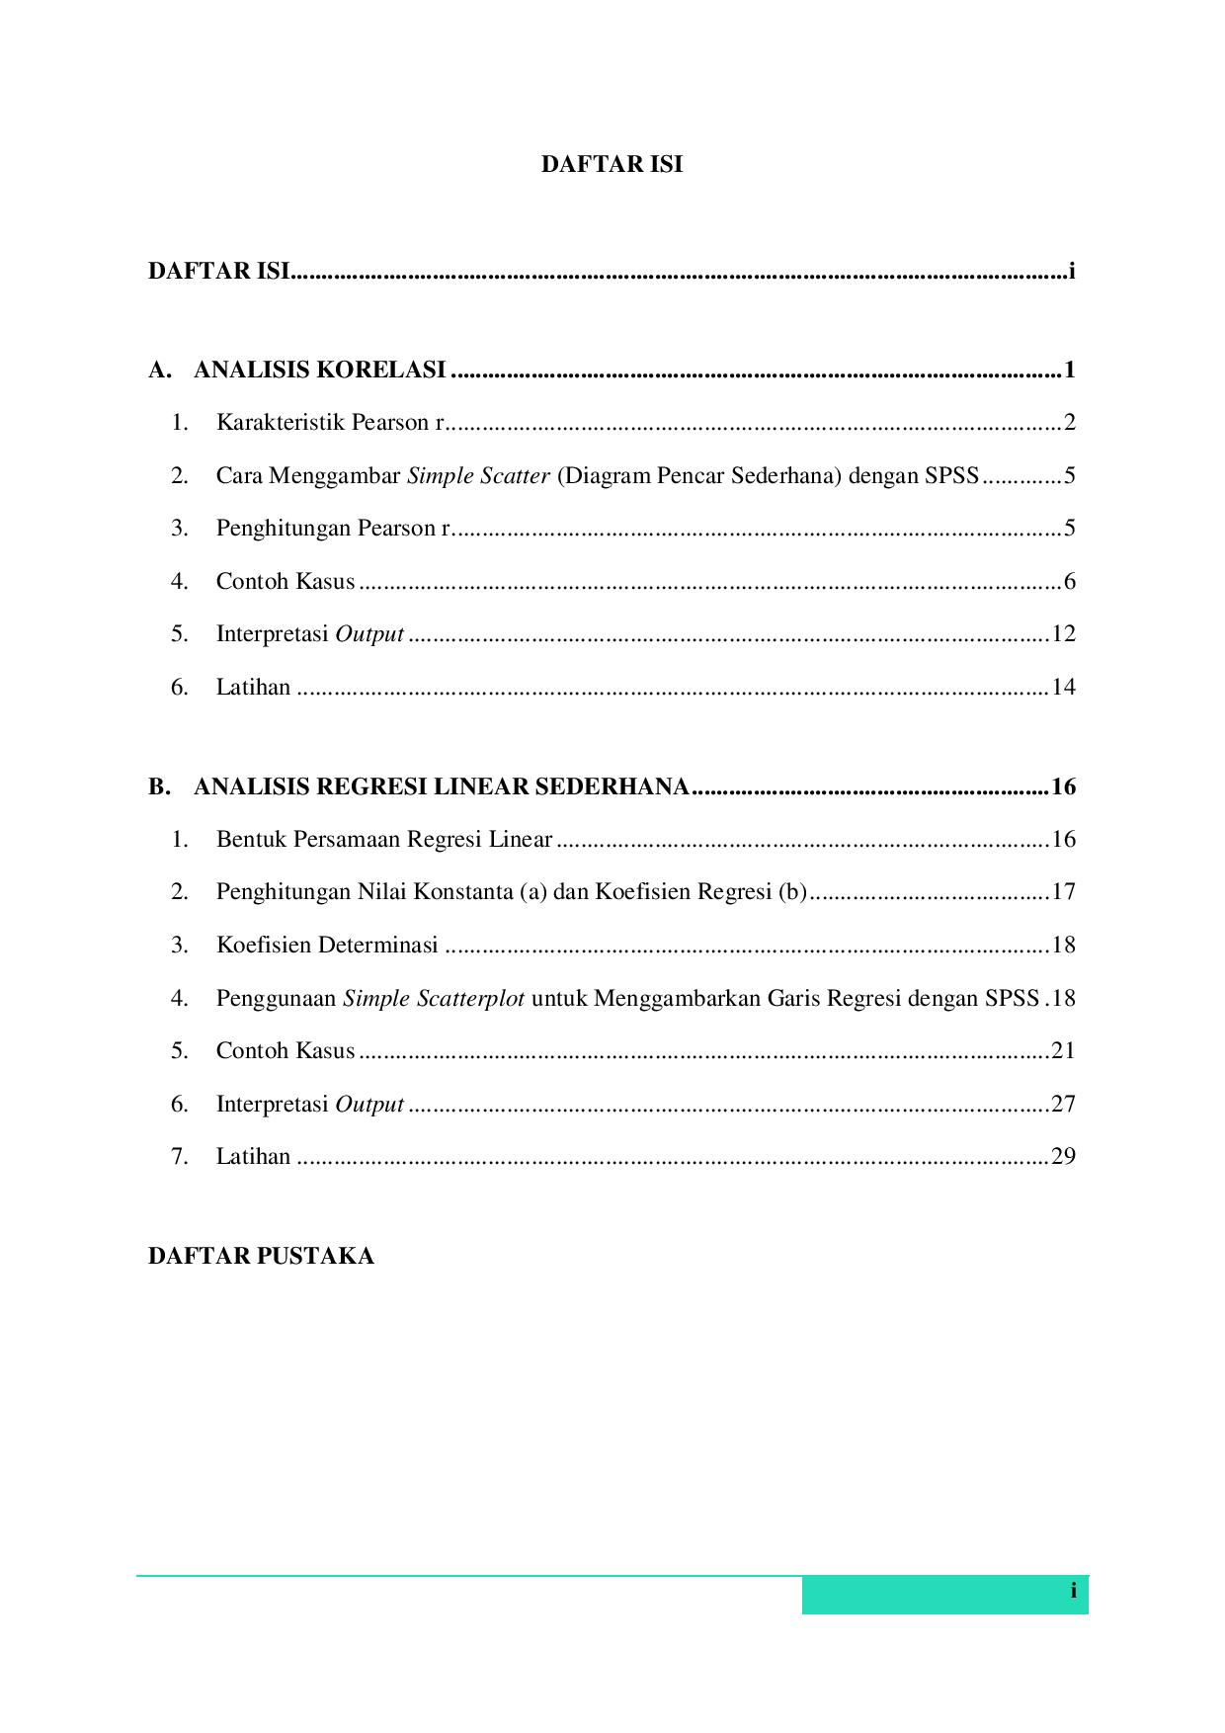

Daftar Isi

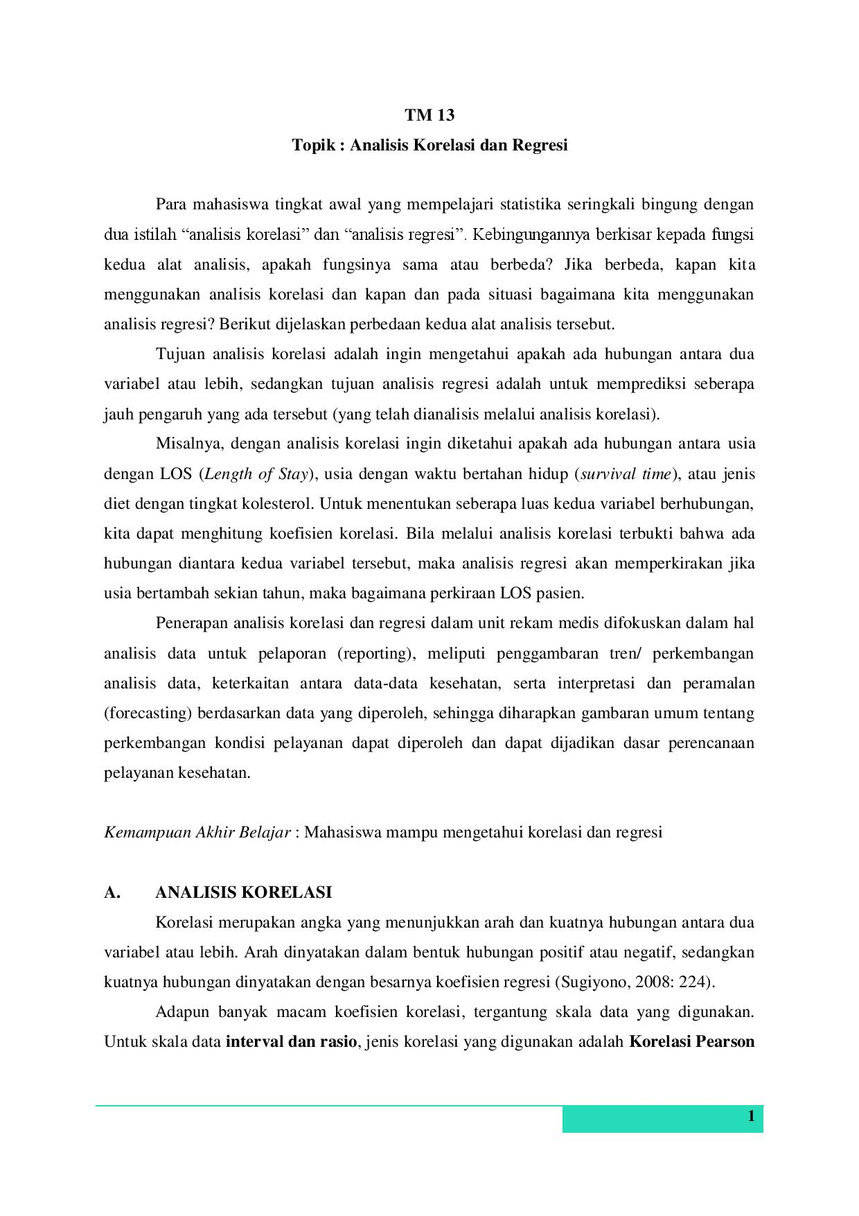

Pengantar dan Materi Analisis Korelasi

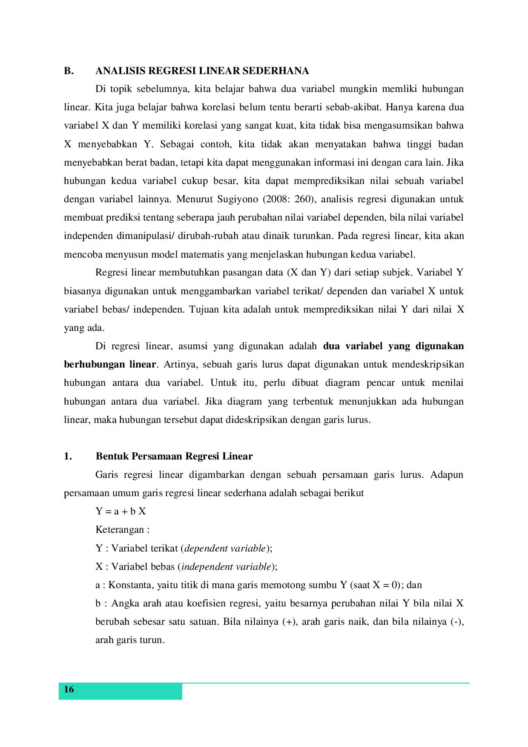

Materi Analisis Regresi Linear Sederhana

**Lampiran 4. Surat Izin Penelitian**

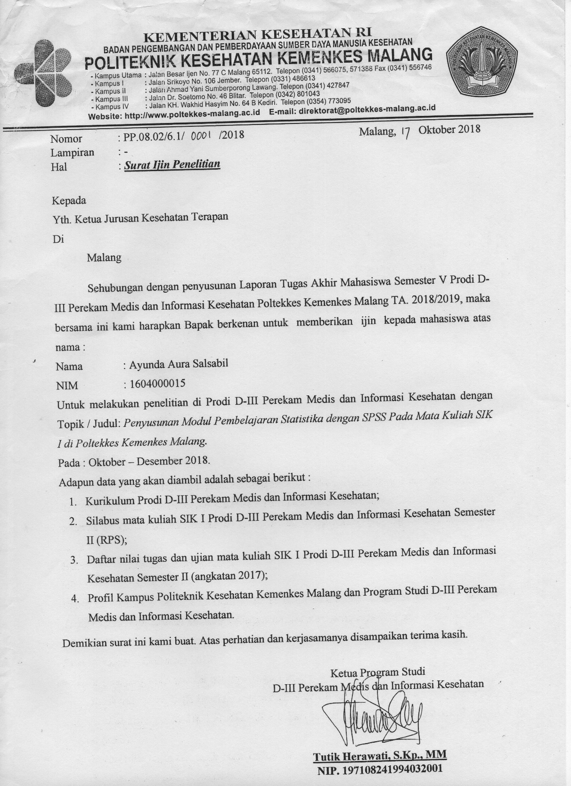

**Lampiran 5. Rekapitulasi Nilai Pre-Test dan Post-Test Responden**

|  |  |  |
| --- | --- | --- |
| Kode | Score Pre | Score Post |
| S1 | 25 | 70 |
| S2 | 25 | 65 |
| S3 | 30 | 85 |
| S4 | 25 | 65 |
| S5 | 15 | 65 |
| S6 | 20 | 80 |
| S7 | 15 | 70 |
| S8 | 35 | 70 |
| S9 | 25 | 65 |
| S10 | 10 | 65 |
| S11 | 25 | 85 |
| S12 | 40 | 80 |
| S13 | 10 | 70 |
| S14 | 20 | 75 |
| S15 | 25 | 75 |
| S16 | 15 | 70 |
| S17 | 15 | 65 |
| S18 | 40 | 85 |
| S19 | 10 | 70 |
| S20 | 30 | 75 |
| S21 | 35 | 70 |
| S22 | 15 | 75 |
| S23 | 30 | 80 |
| S24 | 25 | 80 |
| S25 | 25 | 70 |
| S26 | 25 | 70 |
| S27 | 30 | 75 |
| S28 | 30 | 75 |
| S29 | 35 | 80 |
| S30 | 20 | 80 |
| S31 | 25 | 65 |
| S32 | 30 | 75 |
| S33 | 0 | 50 |
| S34 | 10 | 70 |
| S35 | 35 | 60 |
| S36 | 30 | 75 |
| S37 | 15 | 75 |
| S38 | 10 | 35 |
| S39 | 20 | 75 |
| S40 | 25 | 85 |
| S41 | 15 | 65 |
| S42 | 15 | 75 |

**Lampiran 6. Rekapitulasi Data Demografi Responden**

| Kode | Jenis Kelamin | Usia | Asal Sekolah | Pendidikan Terakhir Orang Tua | Jarak Rumah/ Kost ke Kampus |
| --- | --- | --- | --- | --- | --- |
| S1 | Perempuan | 18 | SMA/ SMAN/ SMAK | S-1 | 25 |
| S2 | Perempuan | 19 | SMA/ SMAN/ SMAK | SMP/ MTs/ sederajat | 1 |
| S3 | Perempuan | 19 | SMA/ SMAN/ SMAK | SMA/ SMK/ MA/ sederajat | 1 |
| S4 | Perempuan | 19 | SMA/ SMAN/ SMAK | SMA/ SMK/ MA/ sederajat | 1 |
| S5 | Perempuan | 18 | SMA/ SMAN/ SMAK | S-1 | 1 |
| S6 | Perempuan | 19 | SMA/ SMAN/ SMAK | SMA/ SMK/ MA/ sederajat | 1 |
| S7 | Perempuan | 18 | SMA/ SMAN/ SMAK | S-1 | 4 |
| S8 | Perempuan | 19 | SMA/ SMAN/ SMAK | S-1 | 55 |
| S9 | Perempuan | 19 | MA/ MAN | SMA/ SMK/ MA/ sederajat | 0.7 |
| S10 | Laki-laki | 19 | SMA/ SMAN/ SMAK | SMA/ SMK/ MA/ sederajat | 1 |
| S11 | Perempuan | 18 | SMA/ SMAN/ SMAK | S-1 | 2 |
| S12 | Perempuan | 19 | SMA/ SMAN/ SMAK | SMA/ SMK/ MA/ sederajat | 15 |
| S13 | Perempuan | 18 | SMA/ SMAN/ SMAK | SMA/ SMK/ MA/ sederajat | 19 |
| S14 | Laki-laki | 19 | SMA/ SMAN/ SMAK | S-1 | 1 |
| S15 | Laki-laki | 19 | SMK/ SMKN | SD/ MI/ sederajat | 2 |
| S16 | Perempuan | 18 | SMA/ SMAN/ SMAK | SD/ MI/ sederajat | 2 |
| S17 | Perempuan | 18 | SMA/ SMAN/ SMAK | SMA/ SMK/ MA/ sederajat | 1 |
| S18 | Perempuan | 19 | SMA/ SMAN/ SMAK | SMA/ SMK/ MA/ sederajat | 2 |
| S19 | Laki-laki | 19 | SMA/ SMAN/ SMAK | S-1 | 29 |
| S20 | Perempuan | 19 | SMA/ SMAN/ SMAK | SMA/ SMK/ MA/ sederajat | 1 |
| S21 | Perempuan | 19 | SMA/ SMAN/ SMAK | SMA/ SMK/ MA/ sederajat | 5 |
| S22 | Perempuan | 19 | SMA/ SMAN/ SMAK | S-2 | 40 |
| S23 | Perempuan | 19 | SMA/ SMAN/ SMAK | SMA/ SMK/ MA/ sederajat | 1 |
| S24 | Perempuan | 18 | SMA/ SMAN/ SMAK | SMA/ SMK/ MA/ sederajat | 1 |
| S25 | Perempuan | 20 | SMA/ SMAN/ SMAK | SMA/ SMK/ MA/ sederajat | 1 |
| S26 | Perempuan | 19 | SMA/ SMAN/ SMAK | D-III | 11 |
| S27 | Perempuan | 19 | SMA/ SMAN/ SMAK | SMA/ SMK/ MA/ sederajat | 15 |
| S28 | Perempuan | 19 | MA/ MAN | S-2 | 1 |
| S29 | Perempuan | 19 | SMA/ SMAN/ SMAK | S-1 | 1 |
| S30 | Perempuan | 19 | SMA/ SMAN/ SMAK | SMP/ MTs/ sederajat | 1 |
| S31 | Perempuan | 19 | SMK/ SMKN | SMA/ SMK/ MA/ sederajat | 10 |
| S32 | Perempuan | 19 | SMK/ SMKN | SMP/ MTs/ sederajat | 1 |
| S33 | Laki-laki | 19 | SMA/ SMAN/ SMAK | SMA/ SMK/ MA/ sederajat | 1 |
| S34 | Perempuan | 19 | SMA/ SMAN/ SMAK | S-1 | 7 |
| S35 | Perempuan | 19 | SMK/ SMKN | SMP/ MTs/ sederajat | 2 |
| S36 | Perempuan | 20 | SMA/ SMAN/ SMAK | SMA/ SMK/ MA/ sederajat | 1 |
| S37 | Laki-laki | 19 | SMA/ SMAN/ SMAK | SMA/ SMK/ MA/ sederajat | 21 |
| S38 | Perempuan | 19 | SMA/ SMAN/ SMAK | S-1 | 0.1 |
| S39 | Perempuan | 19 | SMK/ SMKN | SD/ MI/ sederajat | 3 |
| S40 | Laki-laki | 19 | SMA/ SMAN/ SMAK | SMA/ SMK/ MA/ sederajat | 4 |
| S41 | Perempuan | 17 | SMA/ SMAN/ SMAK | SMP/ MTs/ sederajat | 12 |
| S42 | Perempuan | 19 | SMA/ SMAN/ SMAK | SMA/ SMK/ MA/ sederajat | 1 |

**Lampiran 7. Output SPSS Paired t-test**

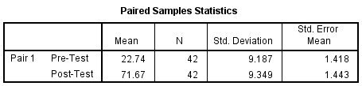

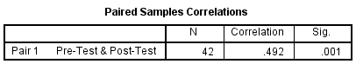

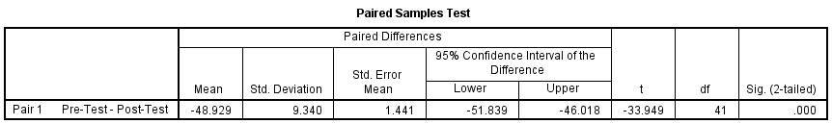

**Lampiran 8. Dokumentasi Penelitian**

