LAMPIRAN
Lampiran 1. Formulir Rekam Medis Pasien di NDC

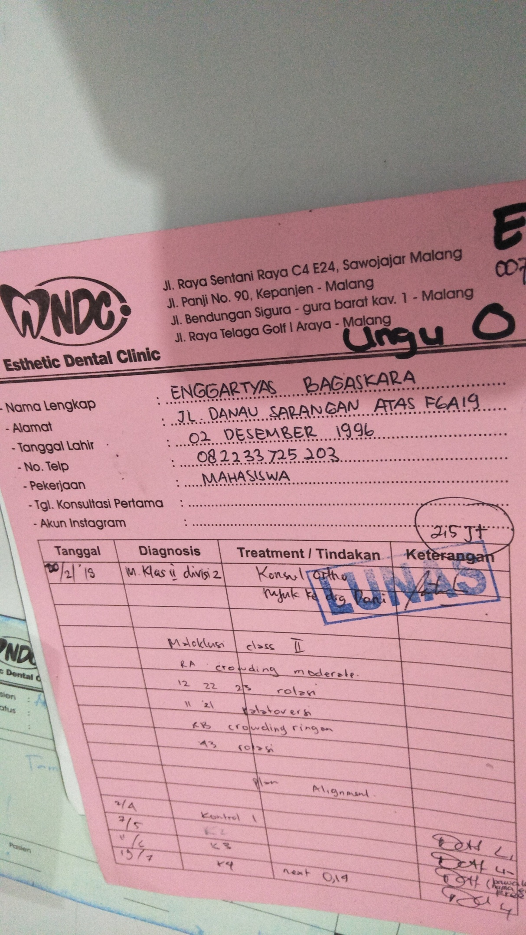

Lampiran 2. Hasil Uji Blackbox
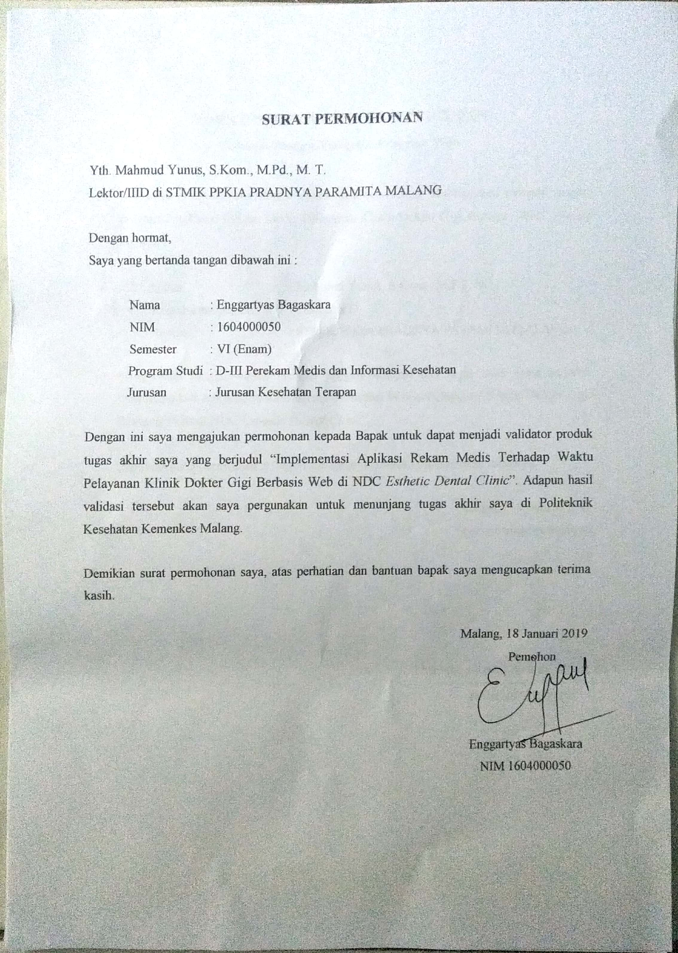
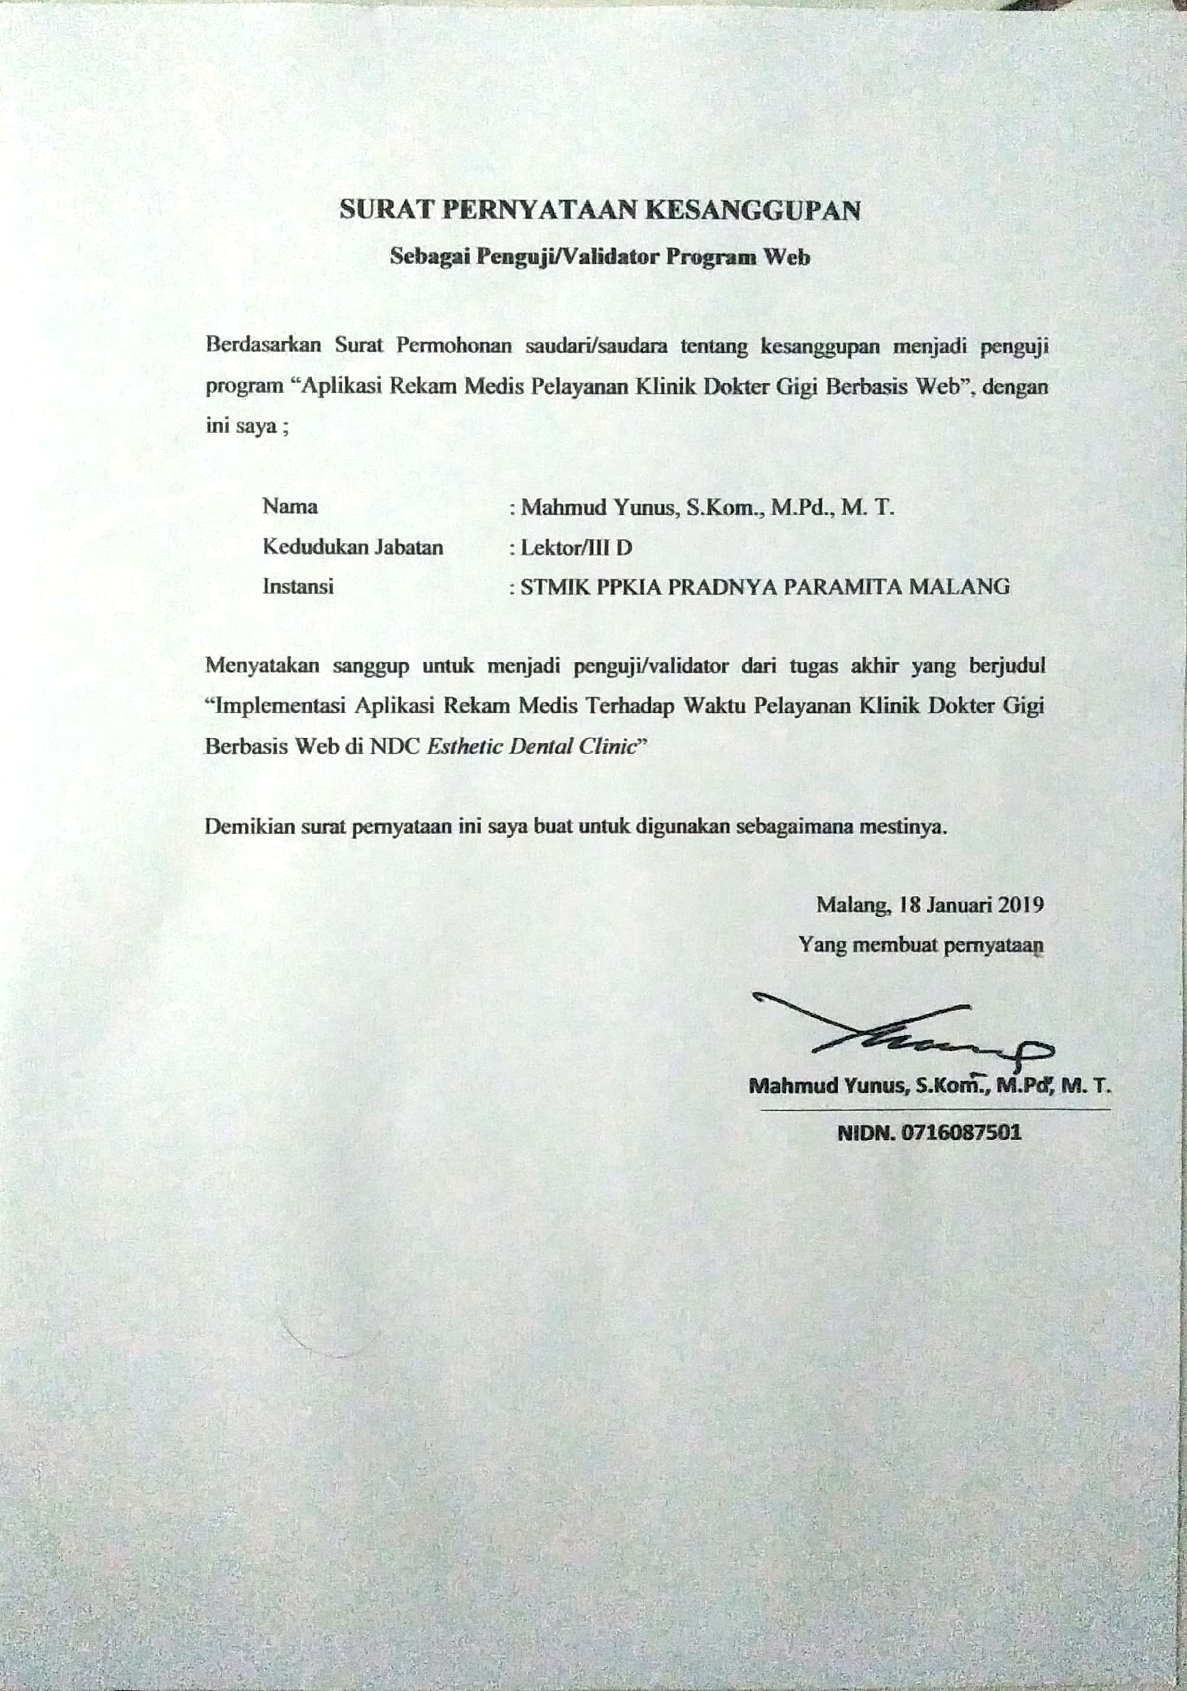
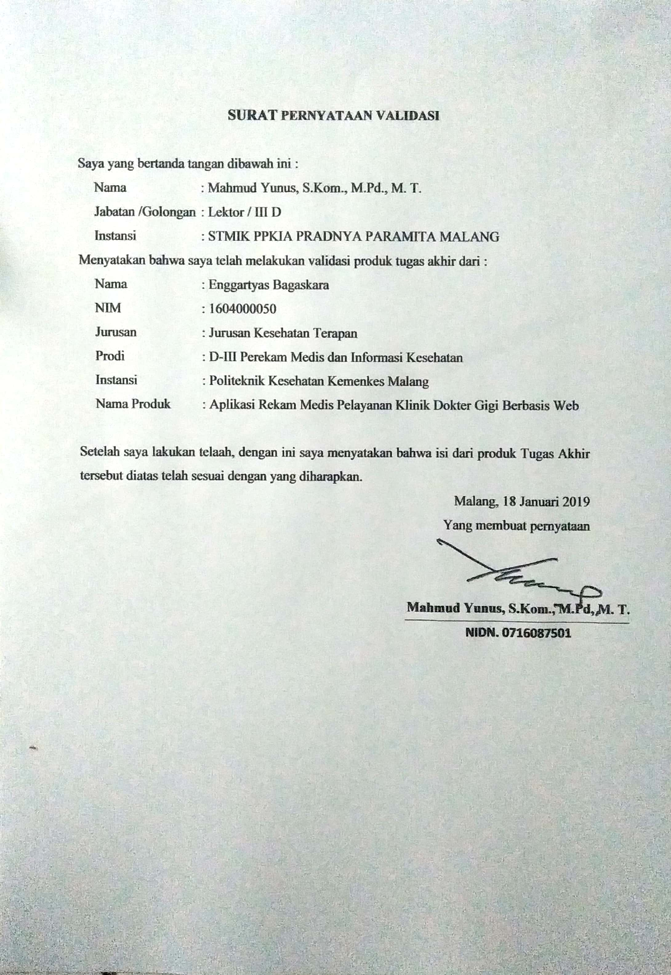

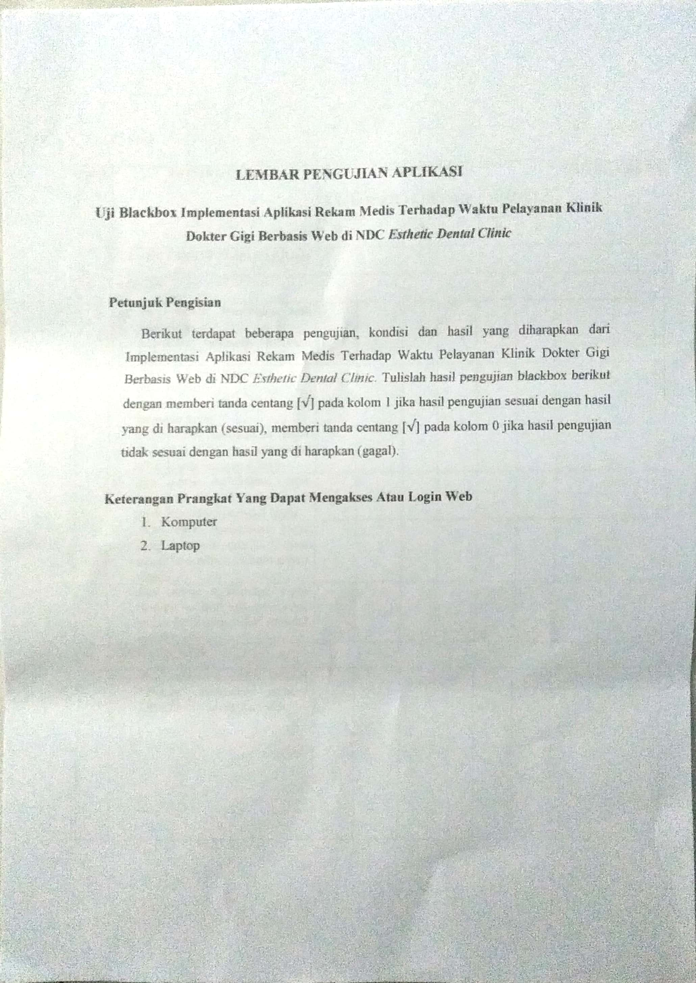

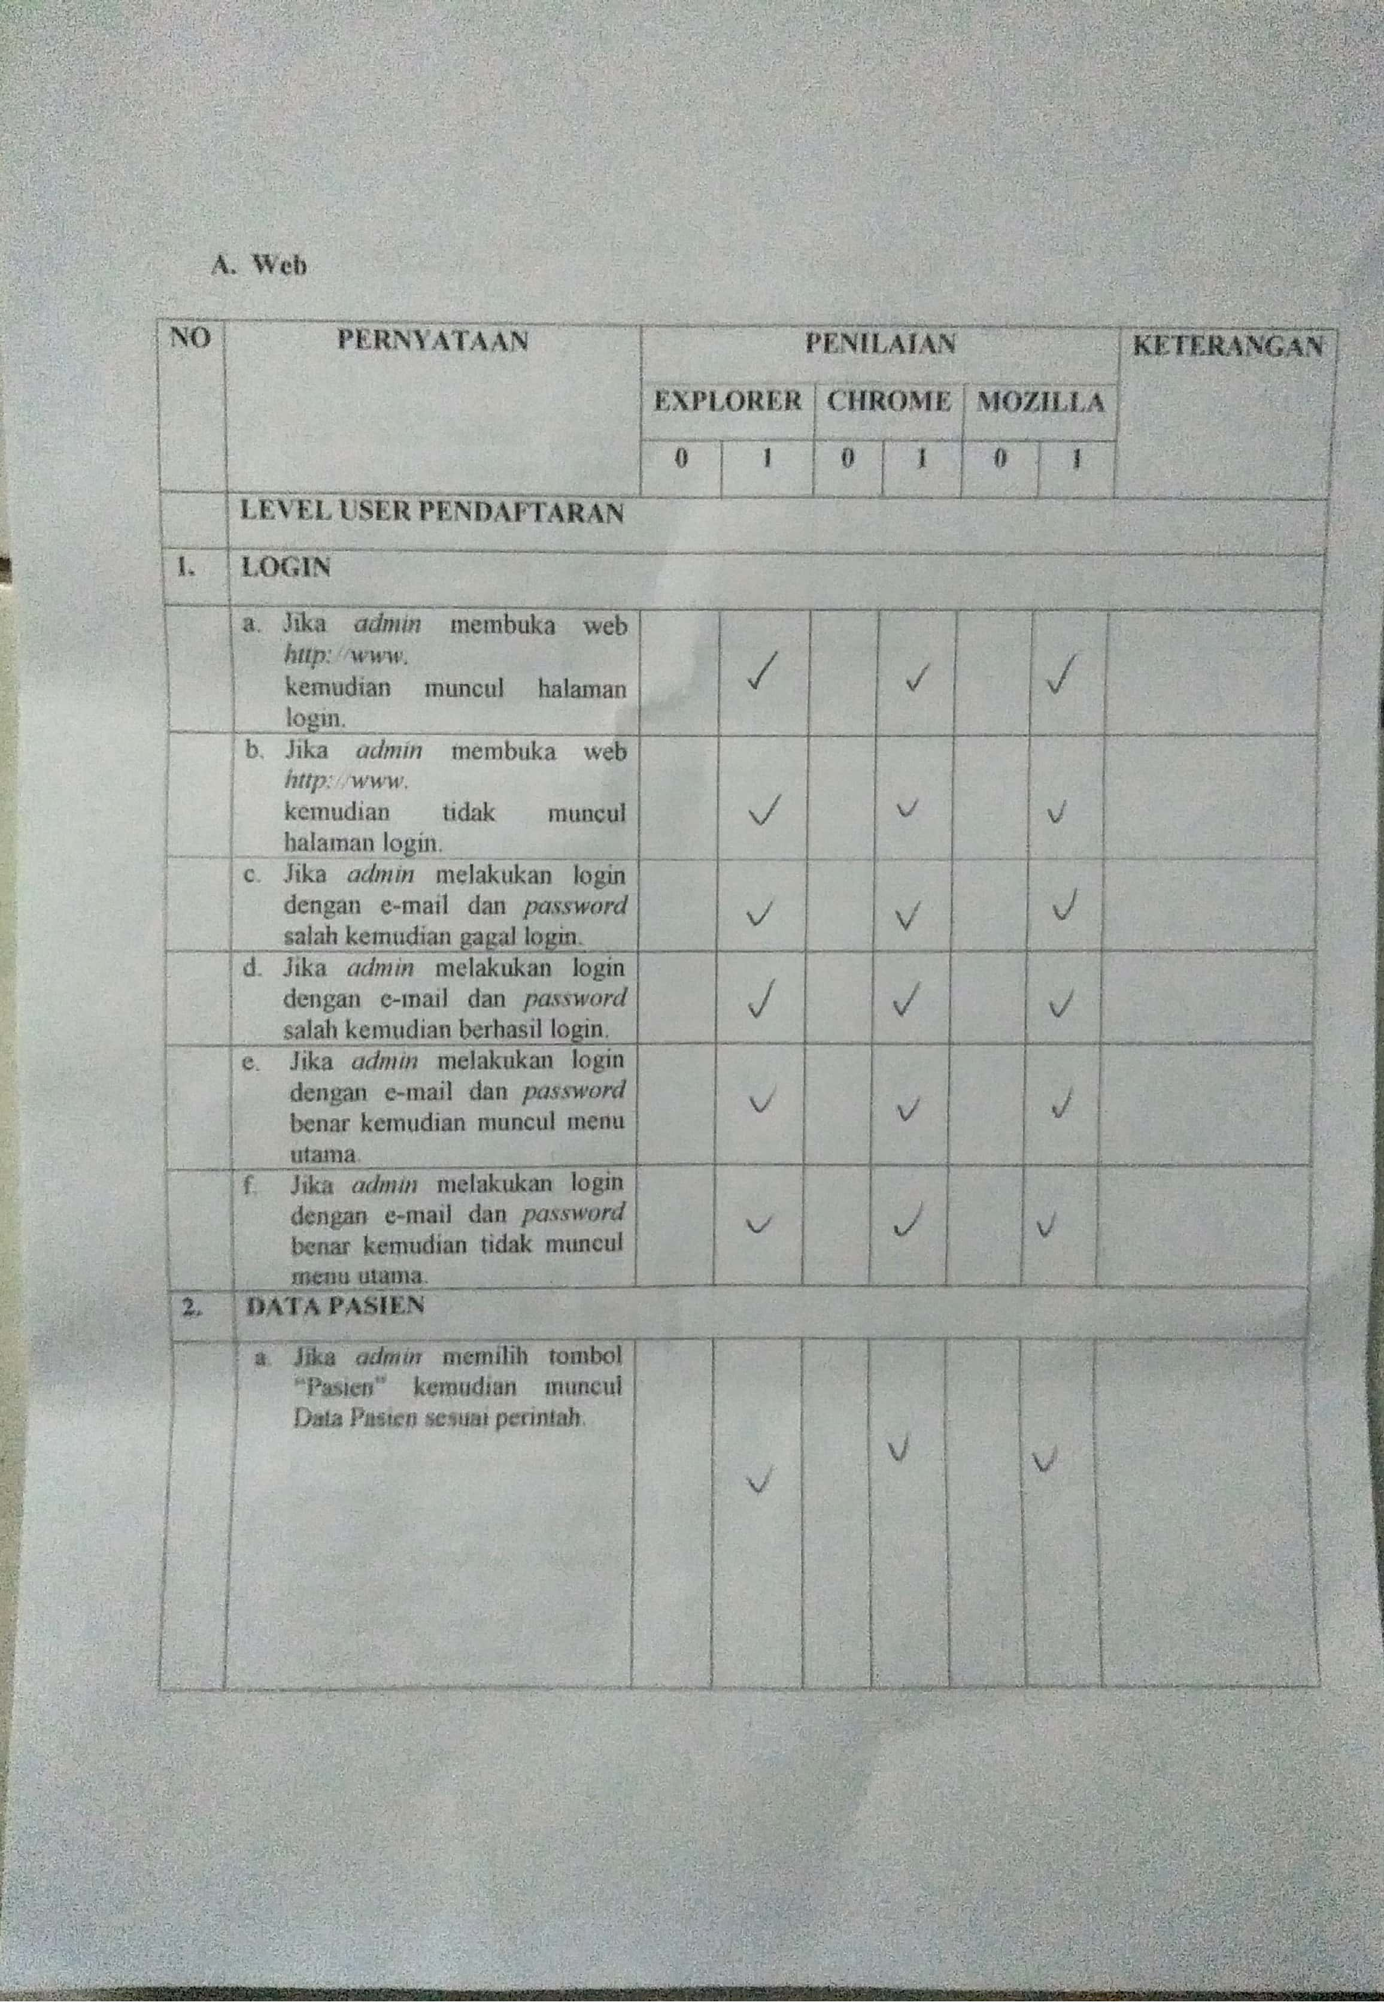

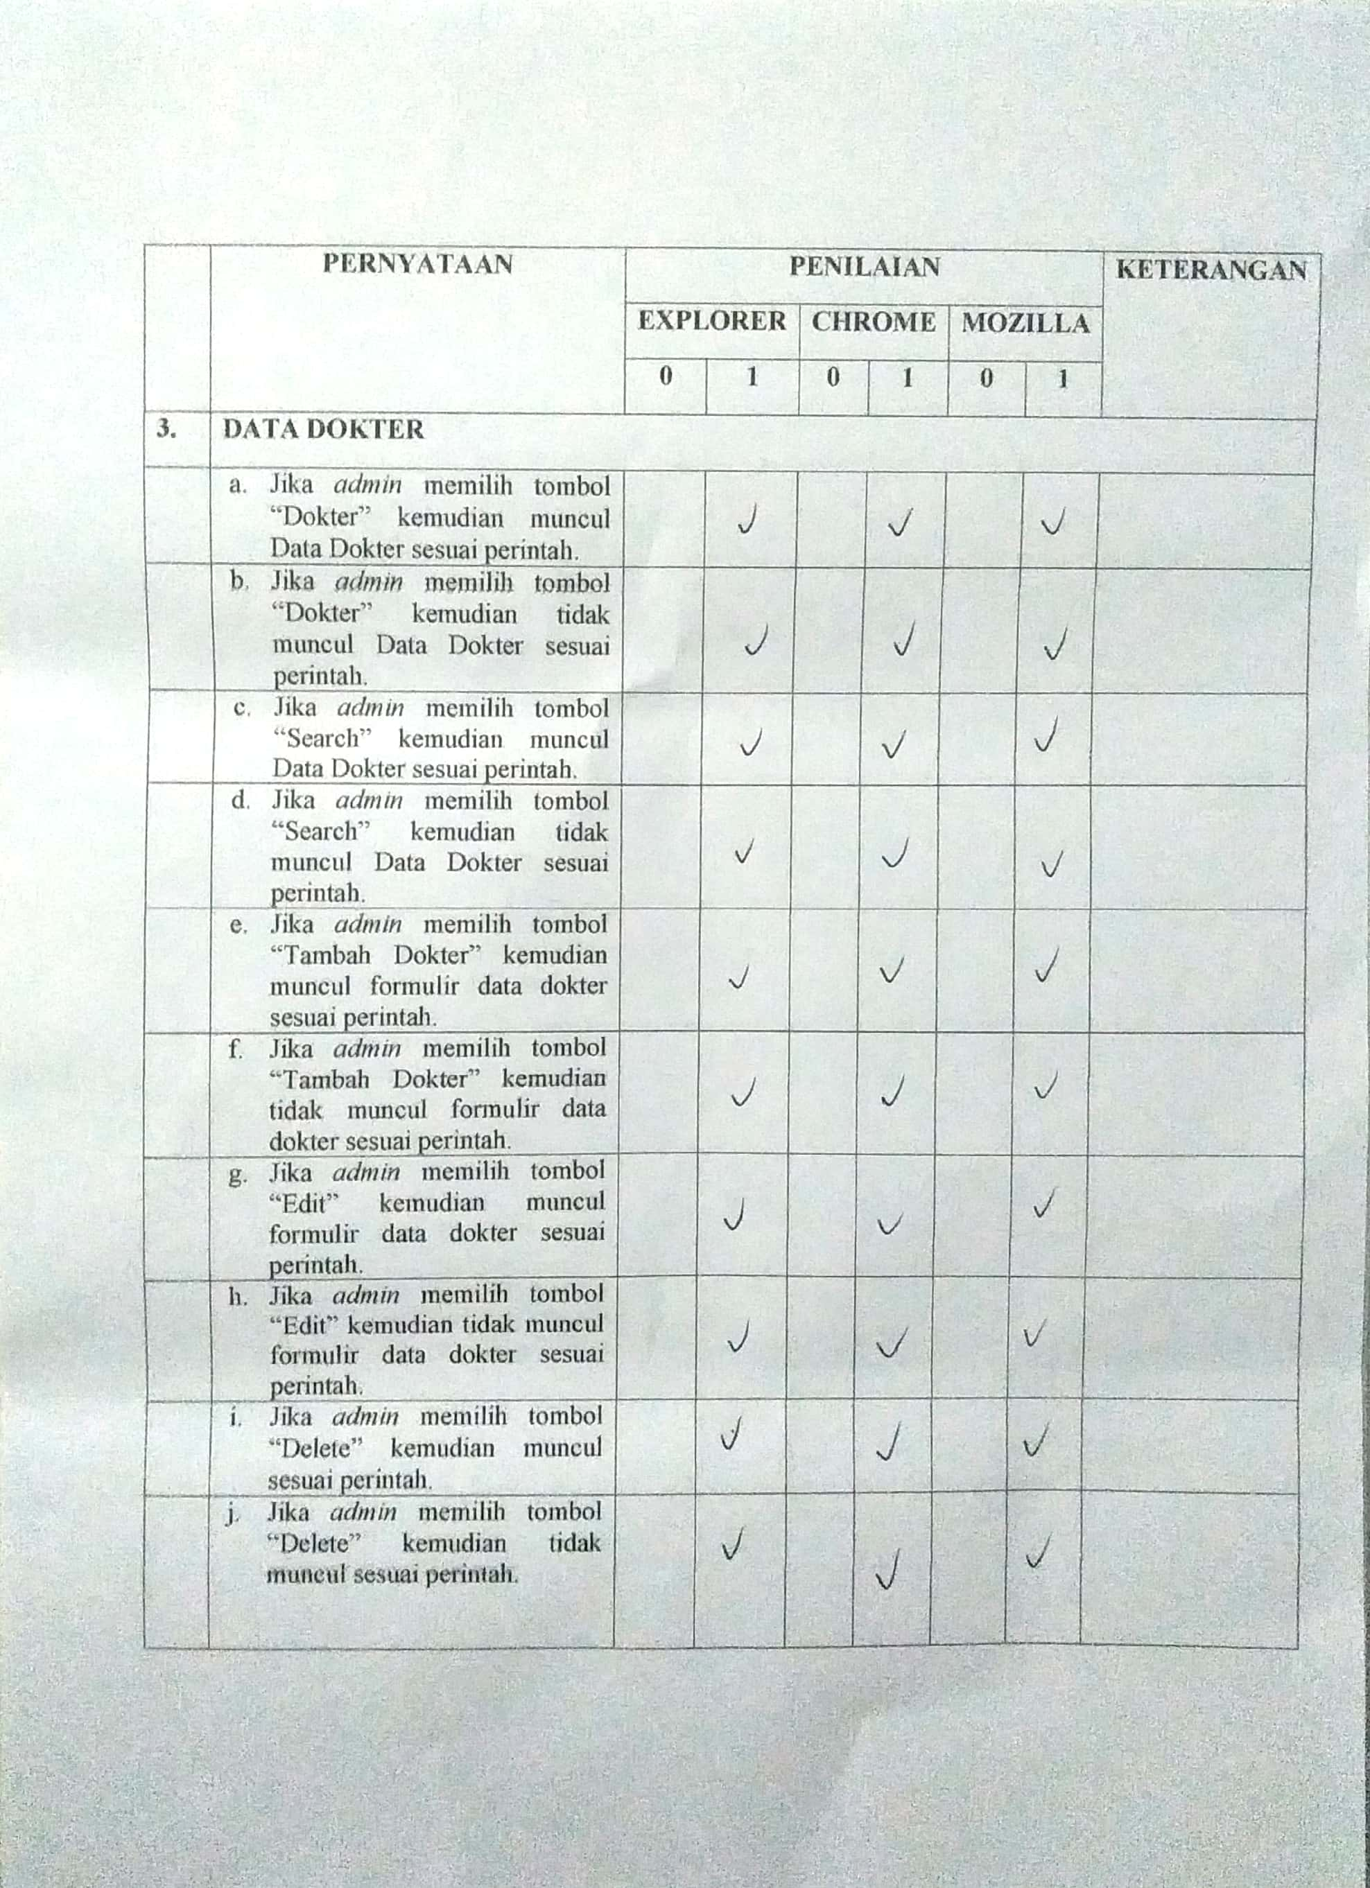

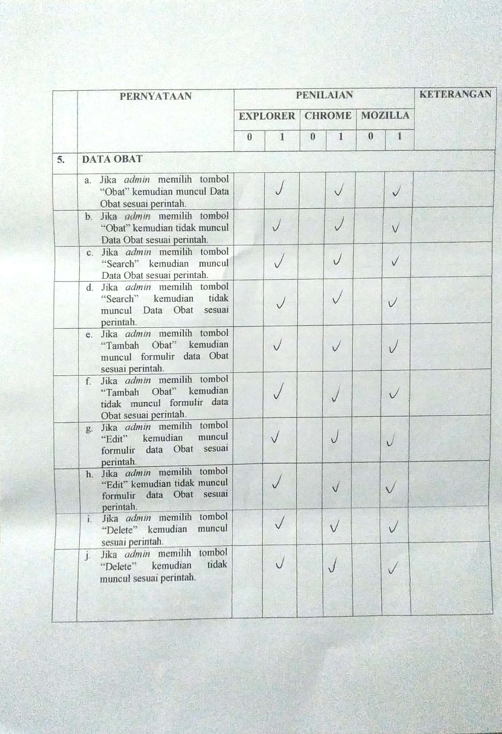
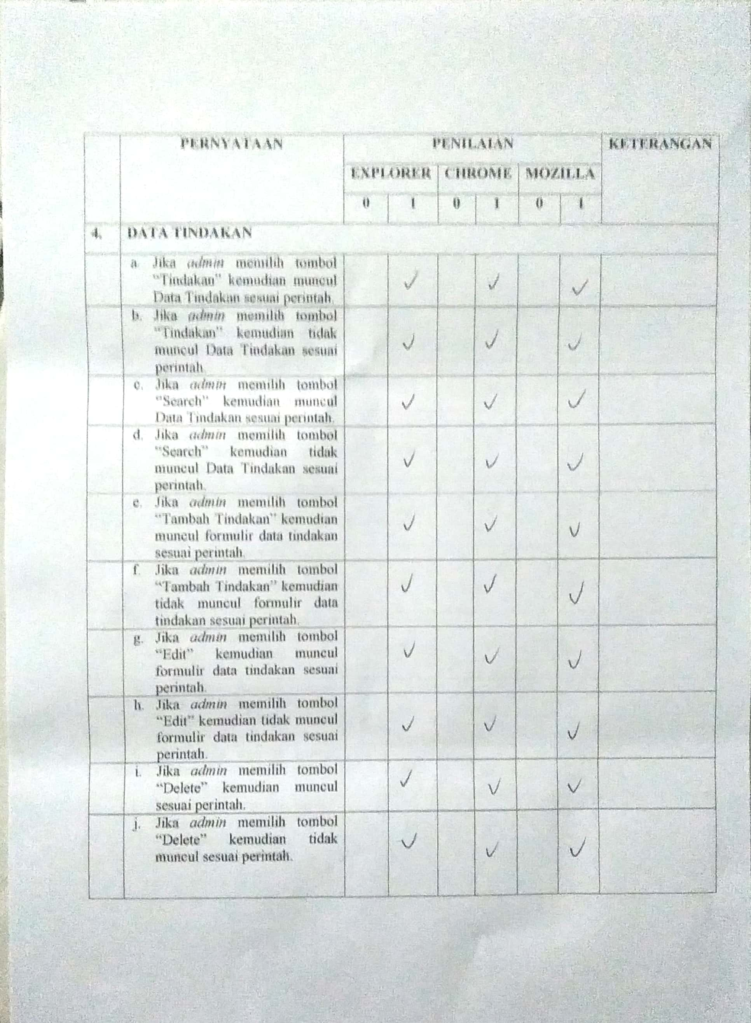

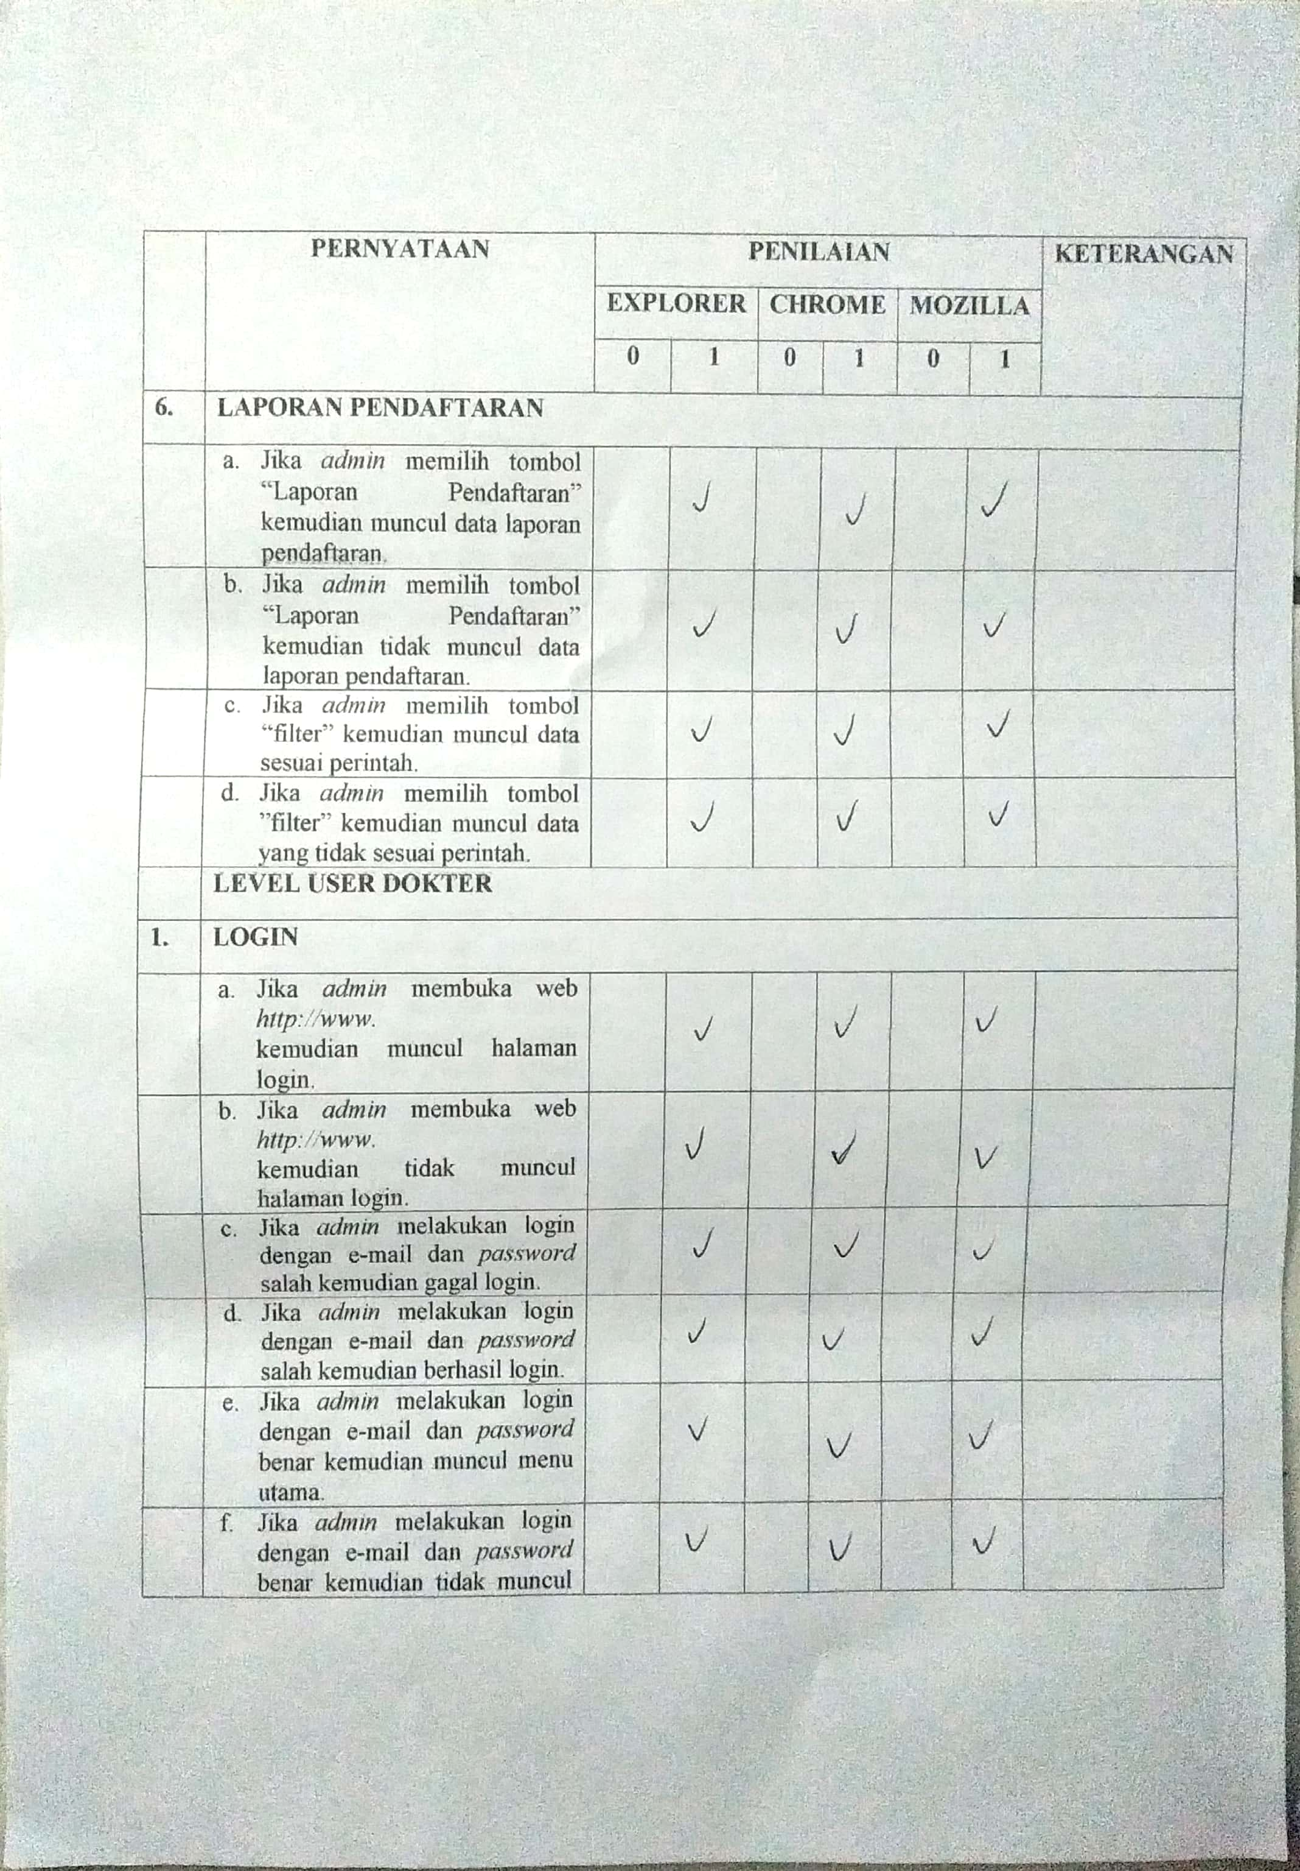

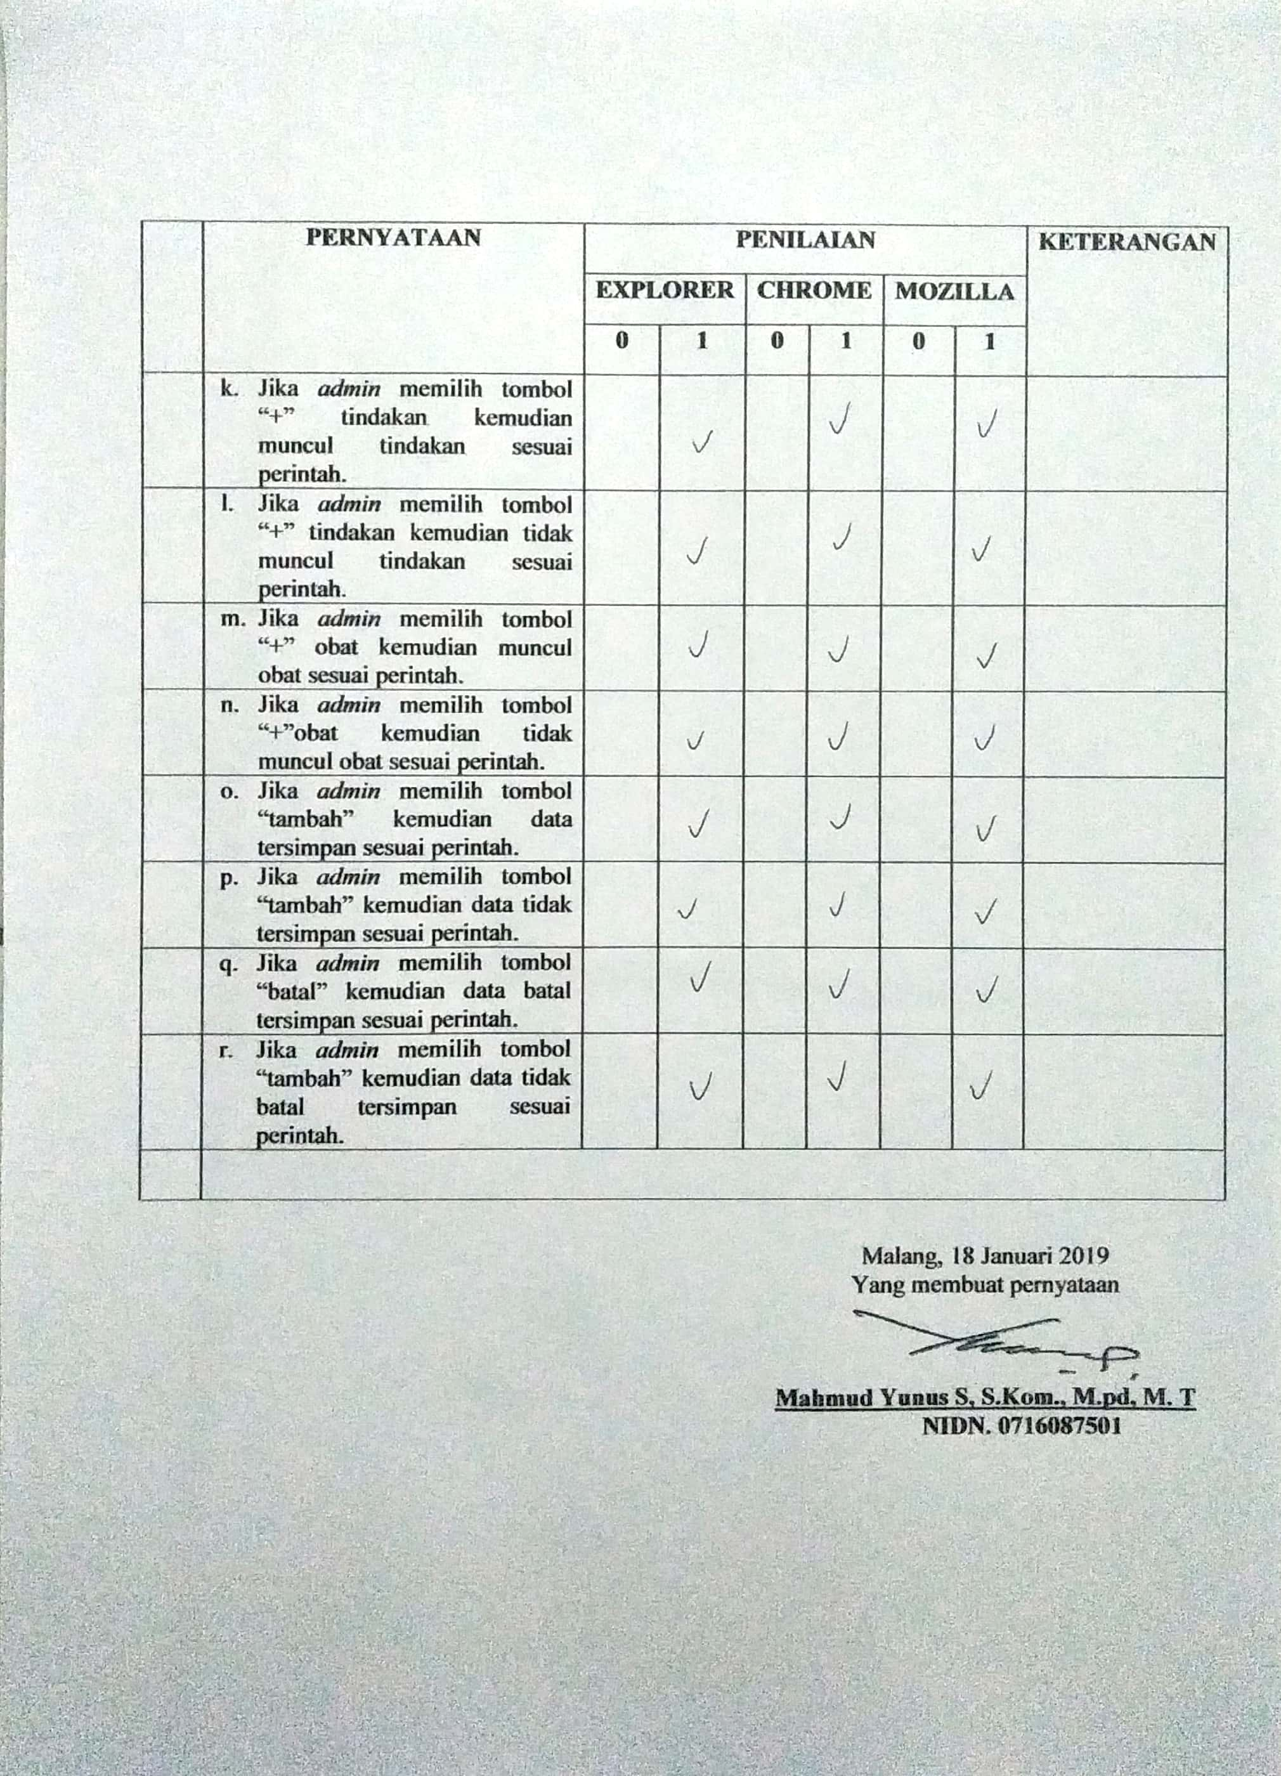

Lampiran 3. Manual Book

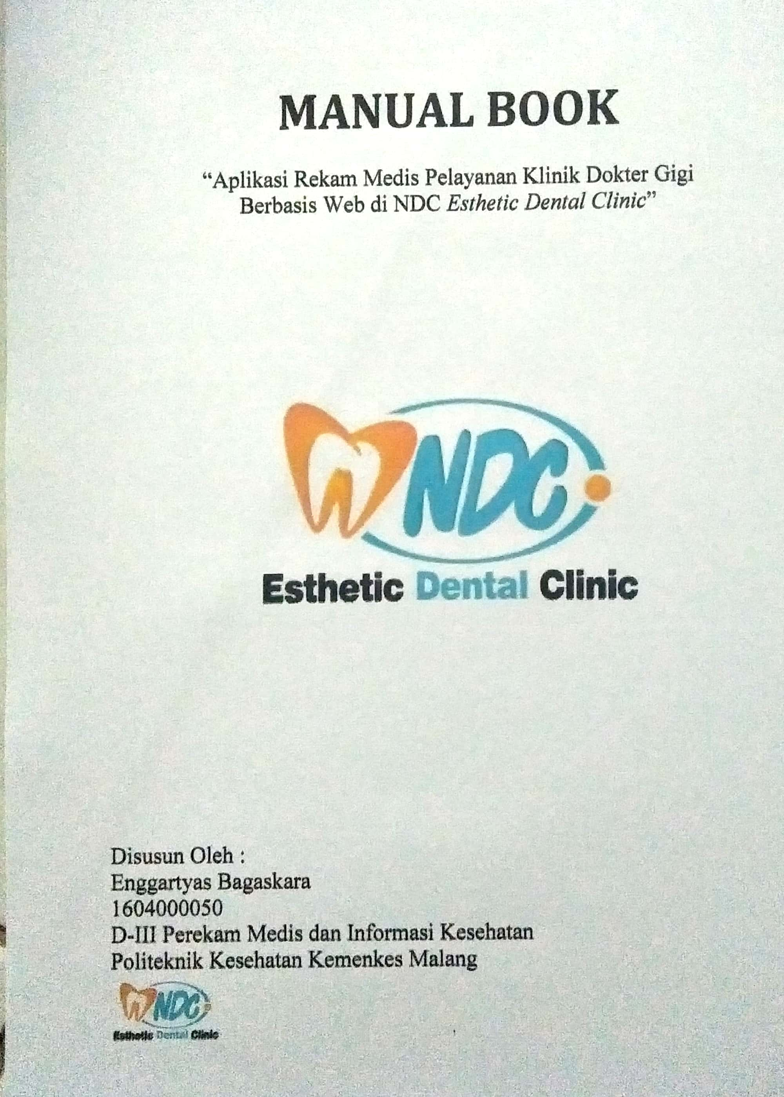

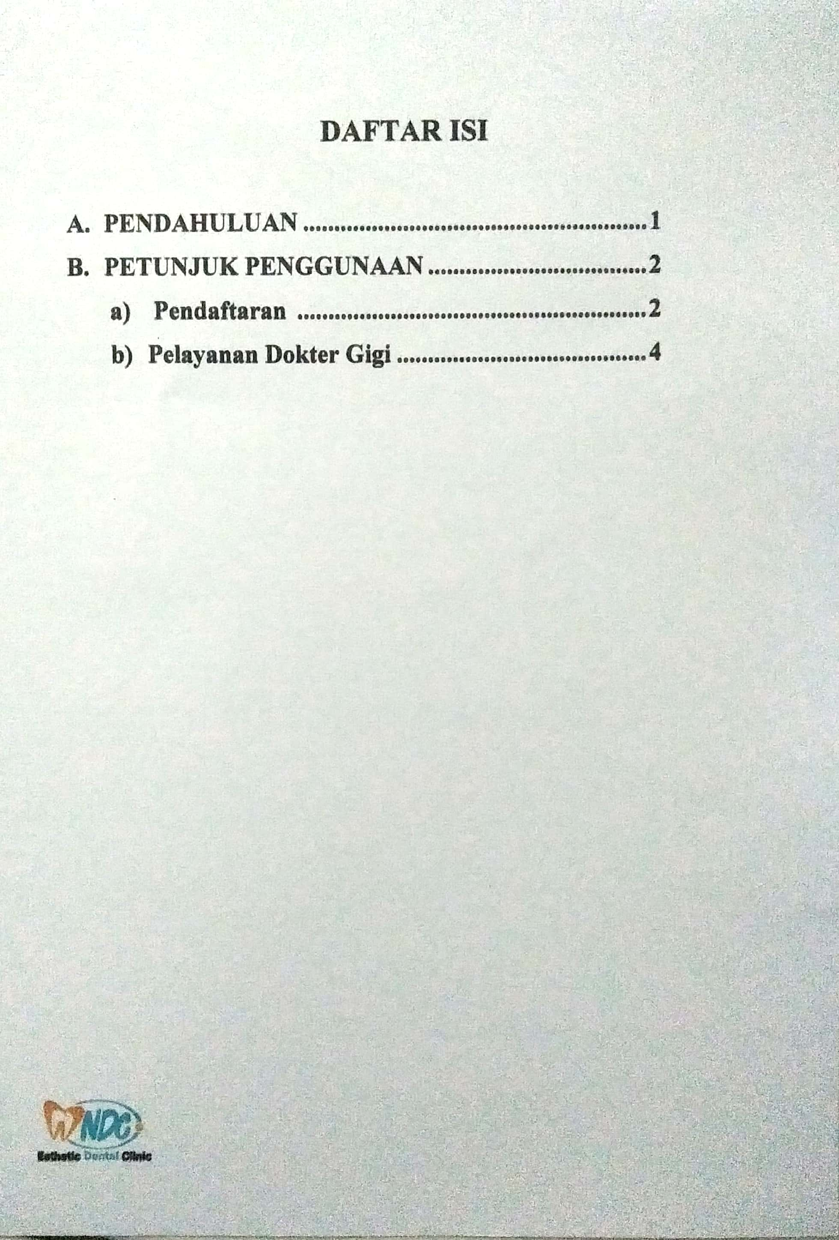

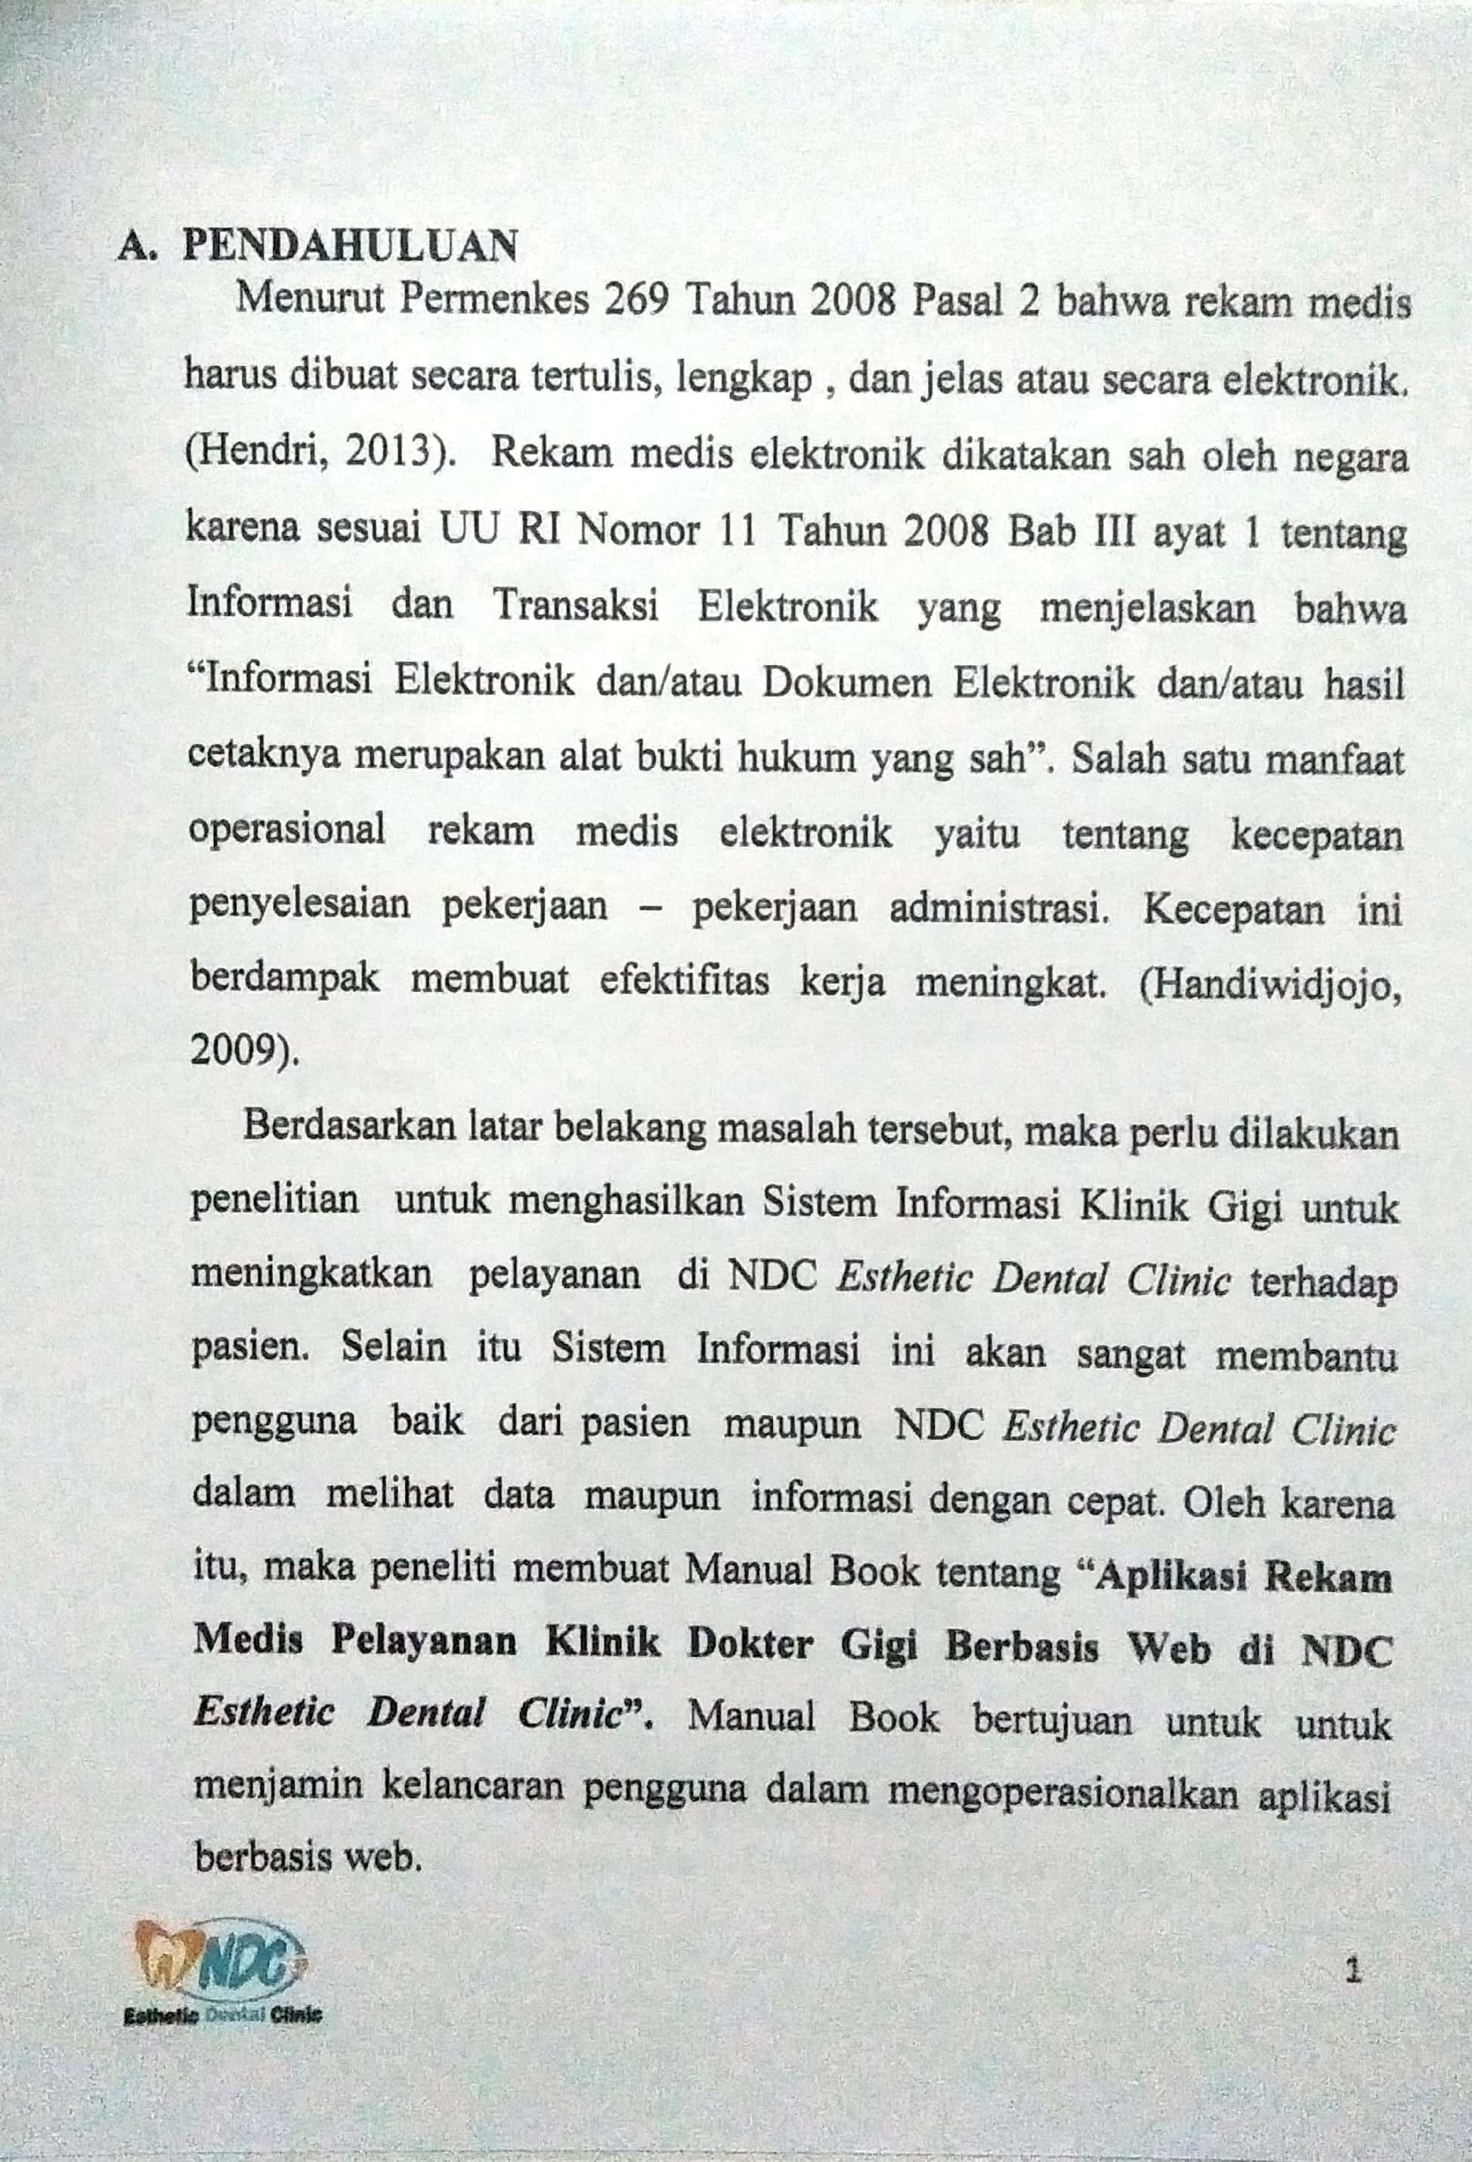

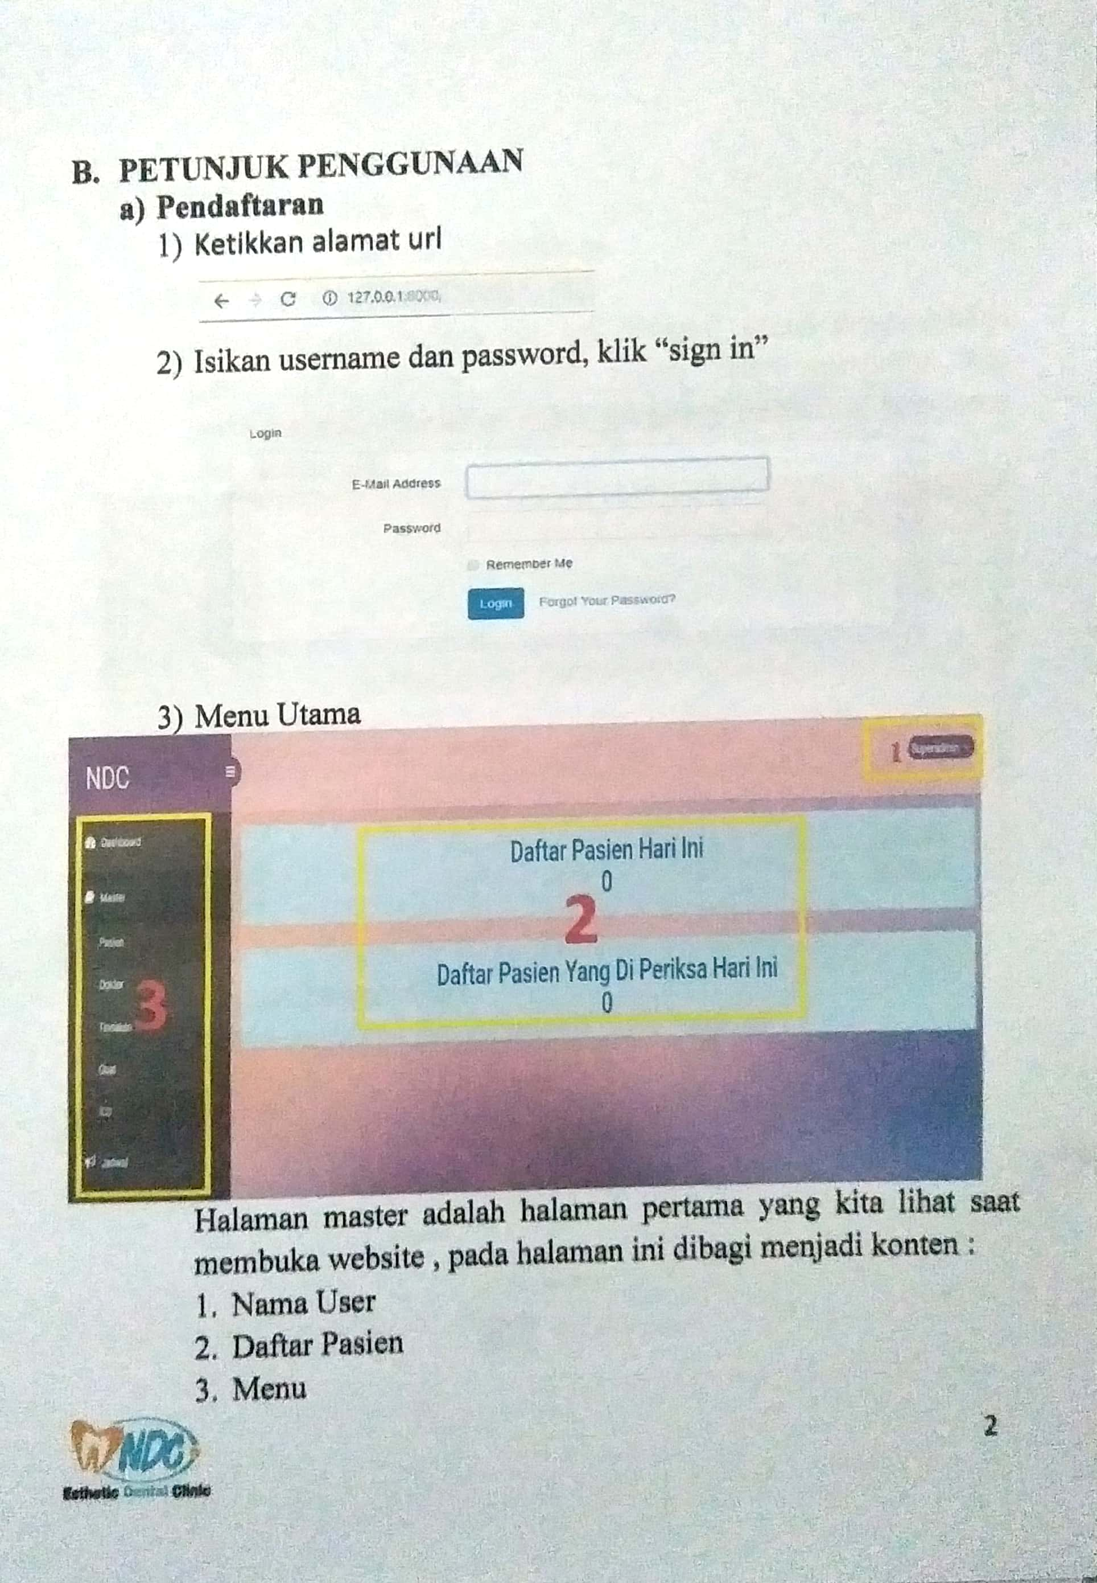

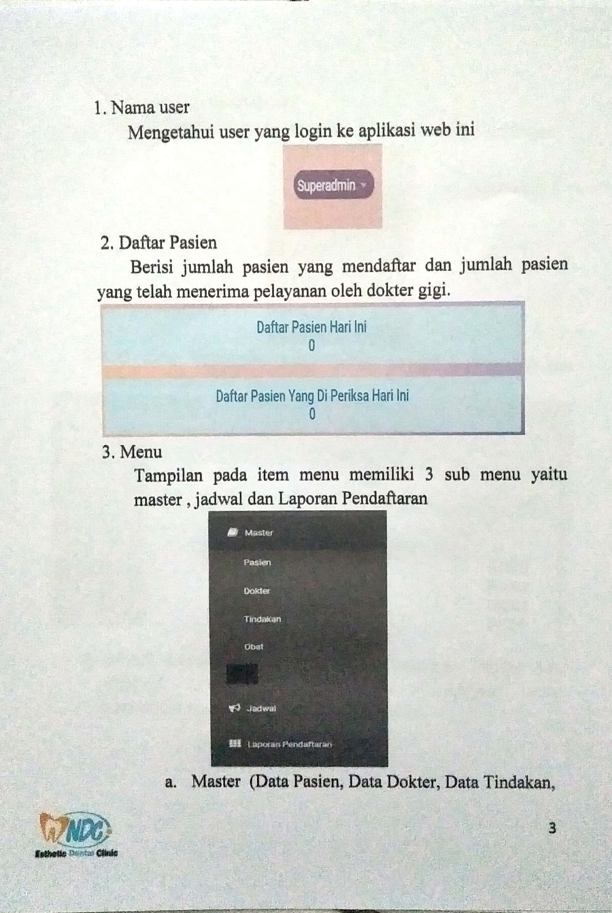

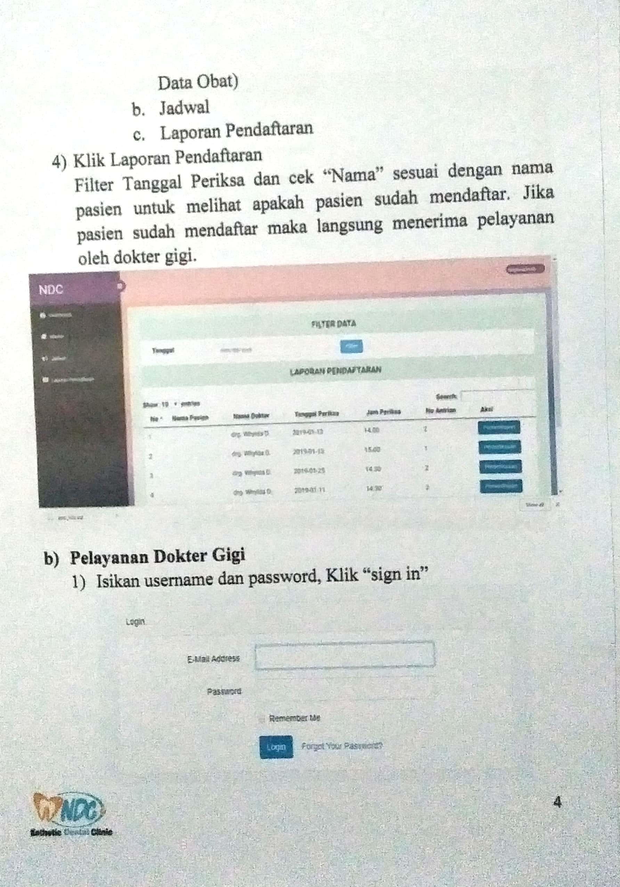

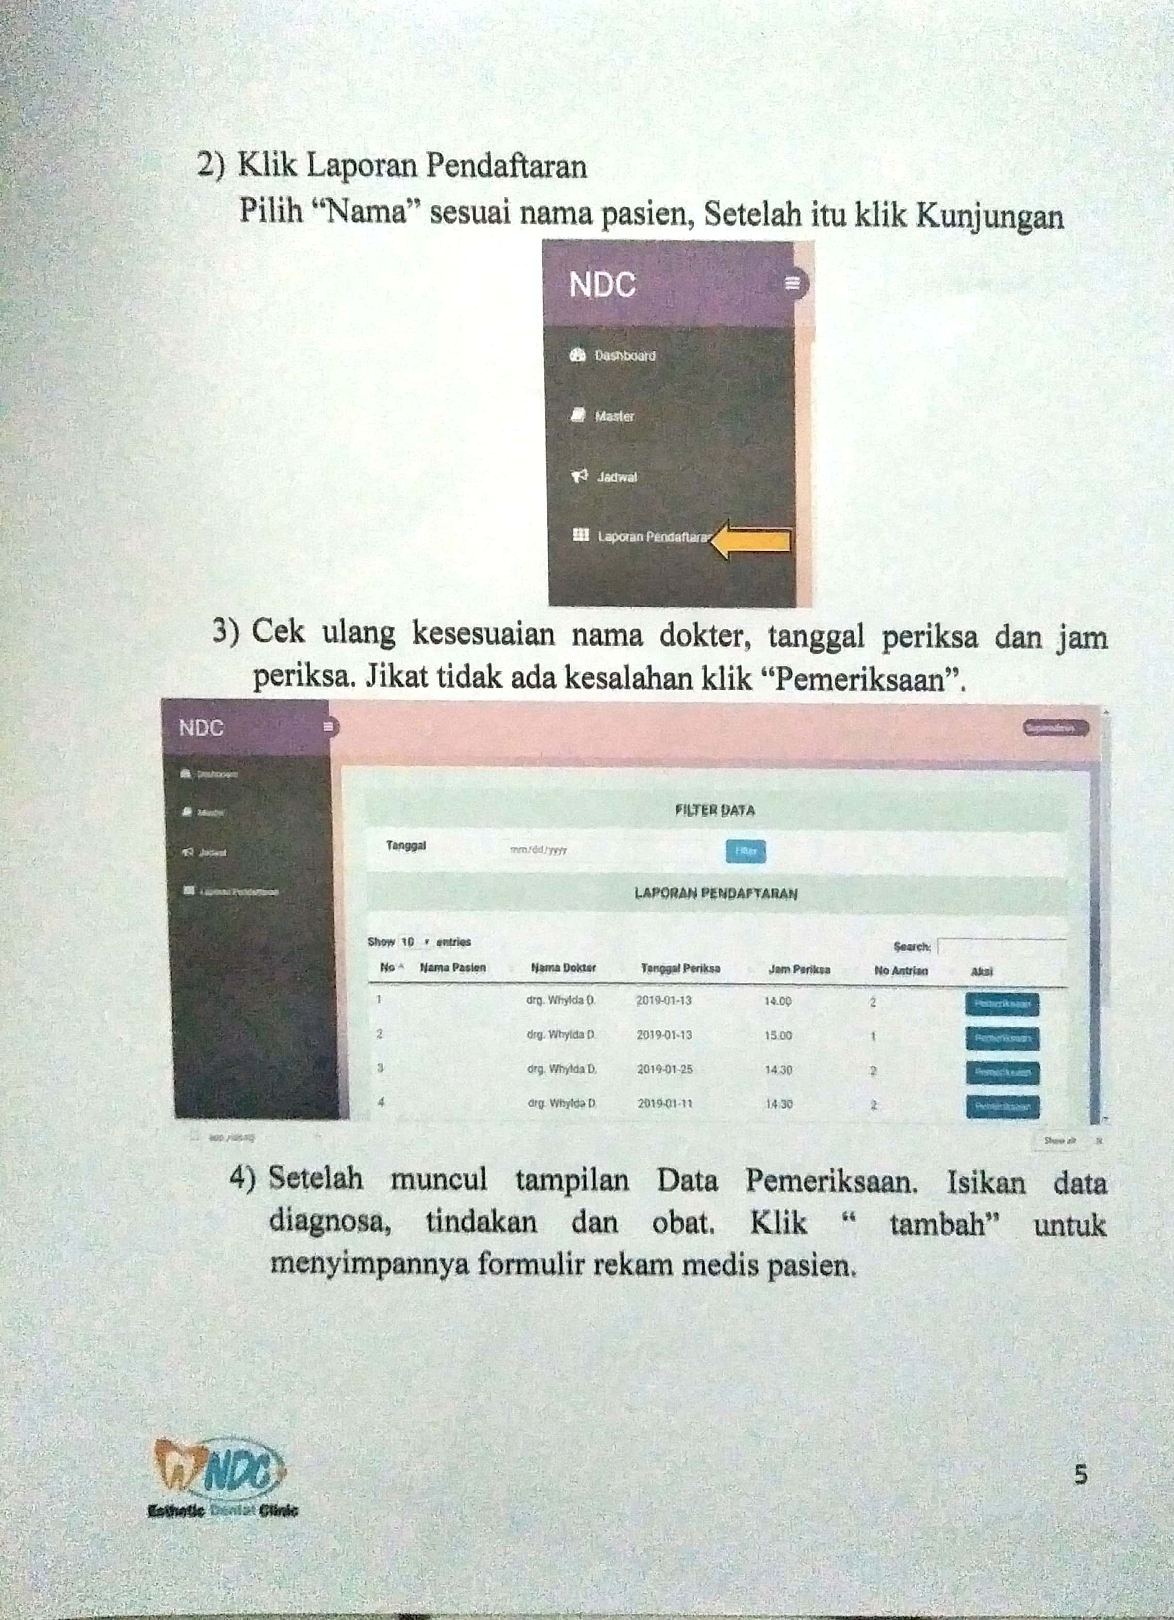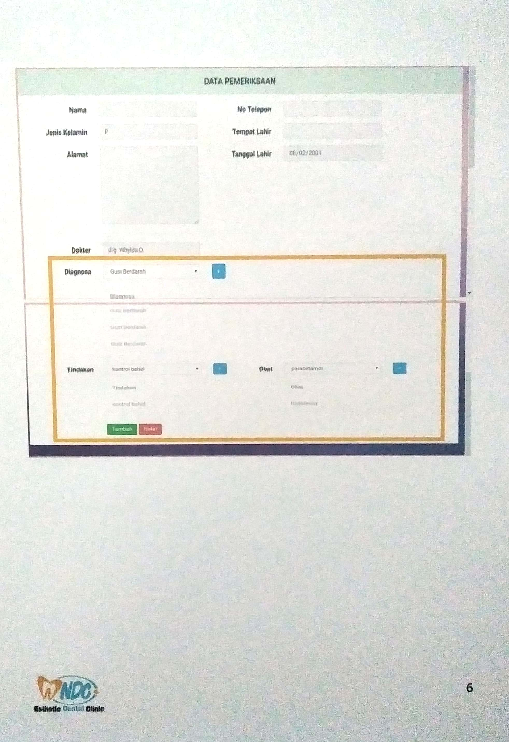

Lampiran 4. Dokumentasi Edukasi dan Implementasi
1. Edukasi kepada petugas pendaftaran
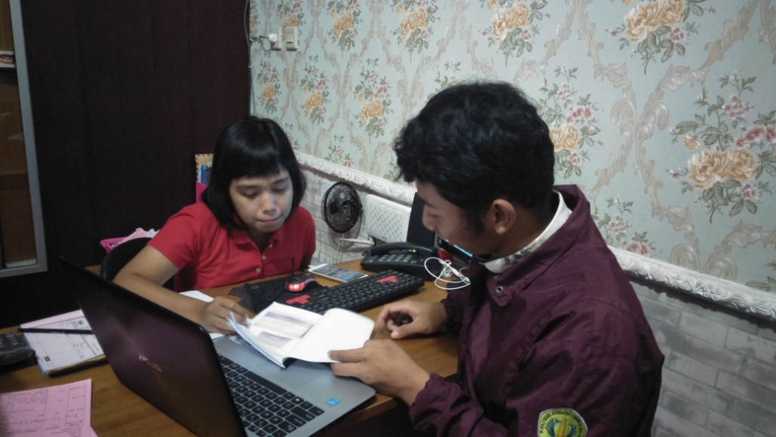
2. Edukasi Kepada Dokter Gigi
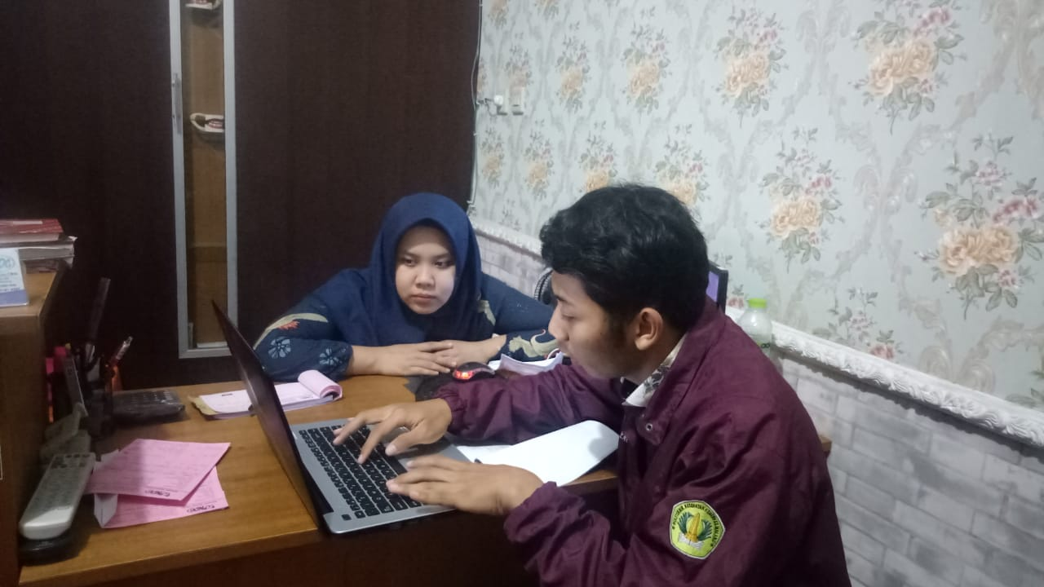

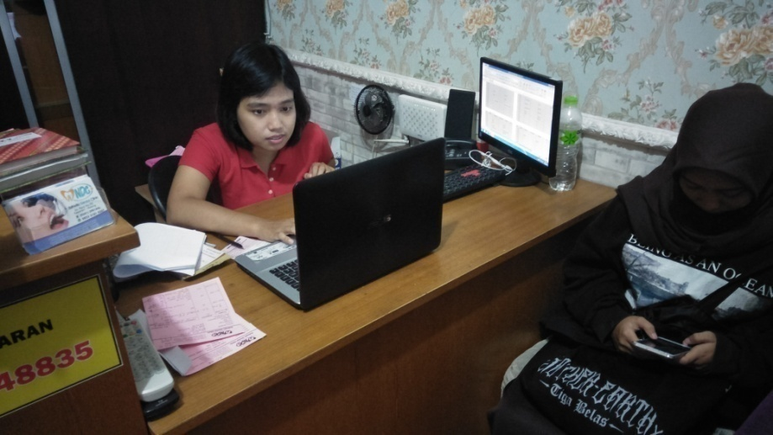

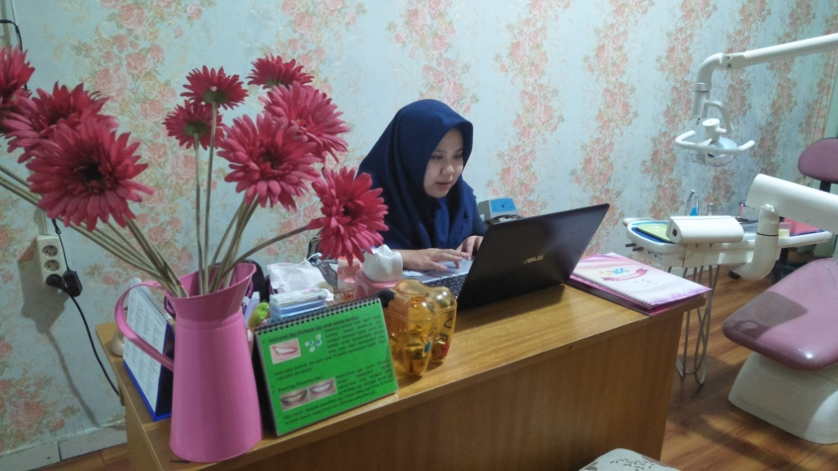

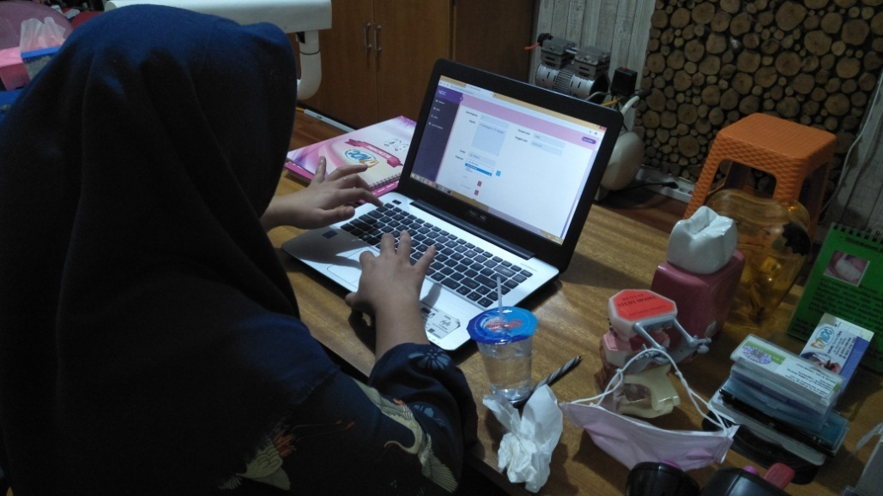

Lampiran 5. Hasil Pencatatan waktu pelayanan klinik dokter gigi sebelum
menggunakanaplikasi rekam medisberbasis web di NDC.

No | Pasien Ke- | Waktu Pelayanan (detik) | No | Pasien Ke- | Waktu Pelayanan (detik)
1 | Px1 | 1340 | 36 | Px36 | 1643
2 | Px2 | 1796 | 37 | Px37 | 1036
3 | Px3 | 1204 | 38 | Px38 | 1546
4 | Px4 | 1067 | 39 | Px39 | 1385
5 | Px5 | 1104 | 40 | Px40 | 1698
6 | Px6 | 1266 | 41 | Px41 | 1942
7 | Px7 | 1892 | 42 | Px42 | 1272
8 | Px8 | 2171 | 43 | Px43 | 1585
9 | Px9 | 1225 | 44 | Px44 | 2288
10 | Px10 | 1269 | 45 | Px45 | 1401
11 | Px11 | 1580 | 46 | Px46 | 1304
12 | Px12 | 1133 | 47 | Px47 | 2876
13 | Px13 | 2499 | 48 | Px48 | 1078
14 | Px14 | 1655 | 49 | Px49 | 1227
15 | Px15 | 1394 | 50 | Px50 | 1516
16 | Px16 | 1702 | 51 | Px51 | 1583
17 | Px17 | 1863 | 52 | Px52 | 1509
18 | Px18 | 1457 | 53 | Px53 | 1759
19 | Px19 | 1625 | 54 | Px54 | 1253
20 | Px20 | 2819 | 55 | Px55 | 1847
21 | Px21 | 1698 | 56 | Px56 | 1519
22 | Px22 | 1122 | 57 | Px57 | 1708
23 | Px23 | 1641 | Total |  | 90841
24 | Px24 | 1514 | Rata-rata |  | 1593,70
25 | Px25 | 2563
26 | Px26 | 1401
27 | Px27 | 2109
28 | Px28 | 1635
29 | Px29 | 1453
30 | Px30 | 1706
31 | Px31 | 1325
32 | Px32 | 1462
33 | Px33 | 1547
34 | Px34 | 1431
35 | Px35 | 1198

Lampiran 6. Hasil Pencatatan waktu pelayanan klinik dokter gigi sesudah
menggunakanaplikasi rekam medisberbasis web di NDC.

No | Pasien Ke- | Waktu Pelayanan (detik) | No | Pasien Ke- | Waktu Pelayanan (detik)
1 | Px1 | 1115 | 36 | Px36 | 1643
2 | Px2 | 1274 | 37 | Px37 | 1156
3 | Px3 | 922 | 38 | Px38 | 1006
4 | Px4 | 1389 | 39 | Px39 | 1399
5 | Px5 | 1275 | 40 | Px40 | 1553
6 | Px6 | 793 | 41 | Px41 | 1678
7 | Px7 | 1383 | 42 | Px42 | 1527
8 | Px8 | 2357 | 43 | Px43 | 1276
9 | Px9 | 1341 | 44 | Px44 | 1787
10 | Px10 | 1034 | 45 | Px45 | 1039
11 | Px11 | 1363 | 46 | Px46 | 808
12 | Px12 | 848 | 47 | Px47 | 1692
13 | Px13 | 1341 | 48 | Px48 | 1525
14 | Px14 | 884 | 49 | Px49 | 1343
15 | Px15 | 1136 | 50 | Px50 | 2349
16 | Px16 | 1325 | 51 | Px51 | 1160
17 | Px17 | 1619 | 52 | Px52 | 1613
18 | Px18 | 858 | 53 | Px53 | 1539
19 | Px19 | 1362 | 54 | Px54 | 1025
20 | Px20 | 1342 | 55 | Px55 | 1338
21 | Px21 | 887 | 56 | Px56 | 1462
22 | Px22 | 2571 | 57 | Px57 | 969
23 | Px23 | 1340 | Total |  | 75181
24 | Px24 | 776 | Rata-rata |  | 1318,96
25 | Px25 | 1744
26 | Px26 | 947
27 | Px27 | 1461
28 | Px28 | 1166
29 | Px29 | 1265
30 | Px30 | 864
31 | Px31 | 1386
32 | Px32 | 1472
33 | Px33 | 1211
34 | Px34 | 1465
35 | Px35 | 778

Lampiran 7. Lembar Informed Consent Responden
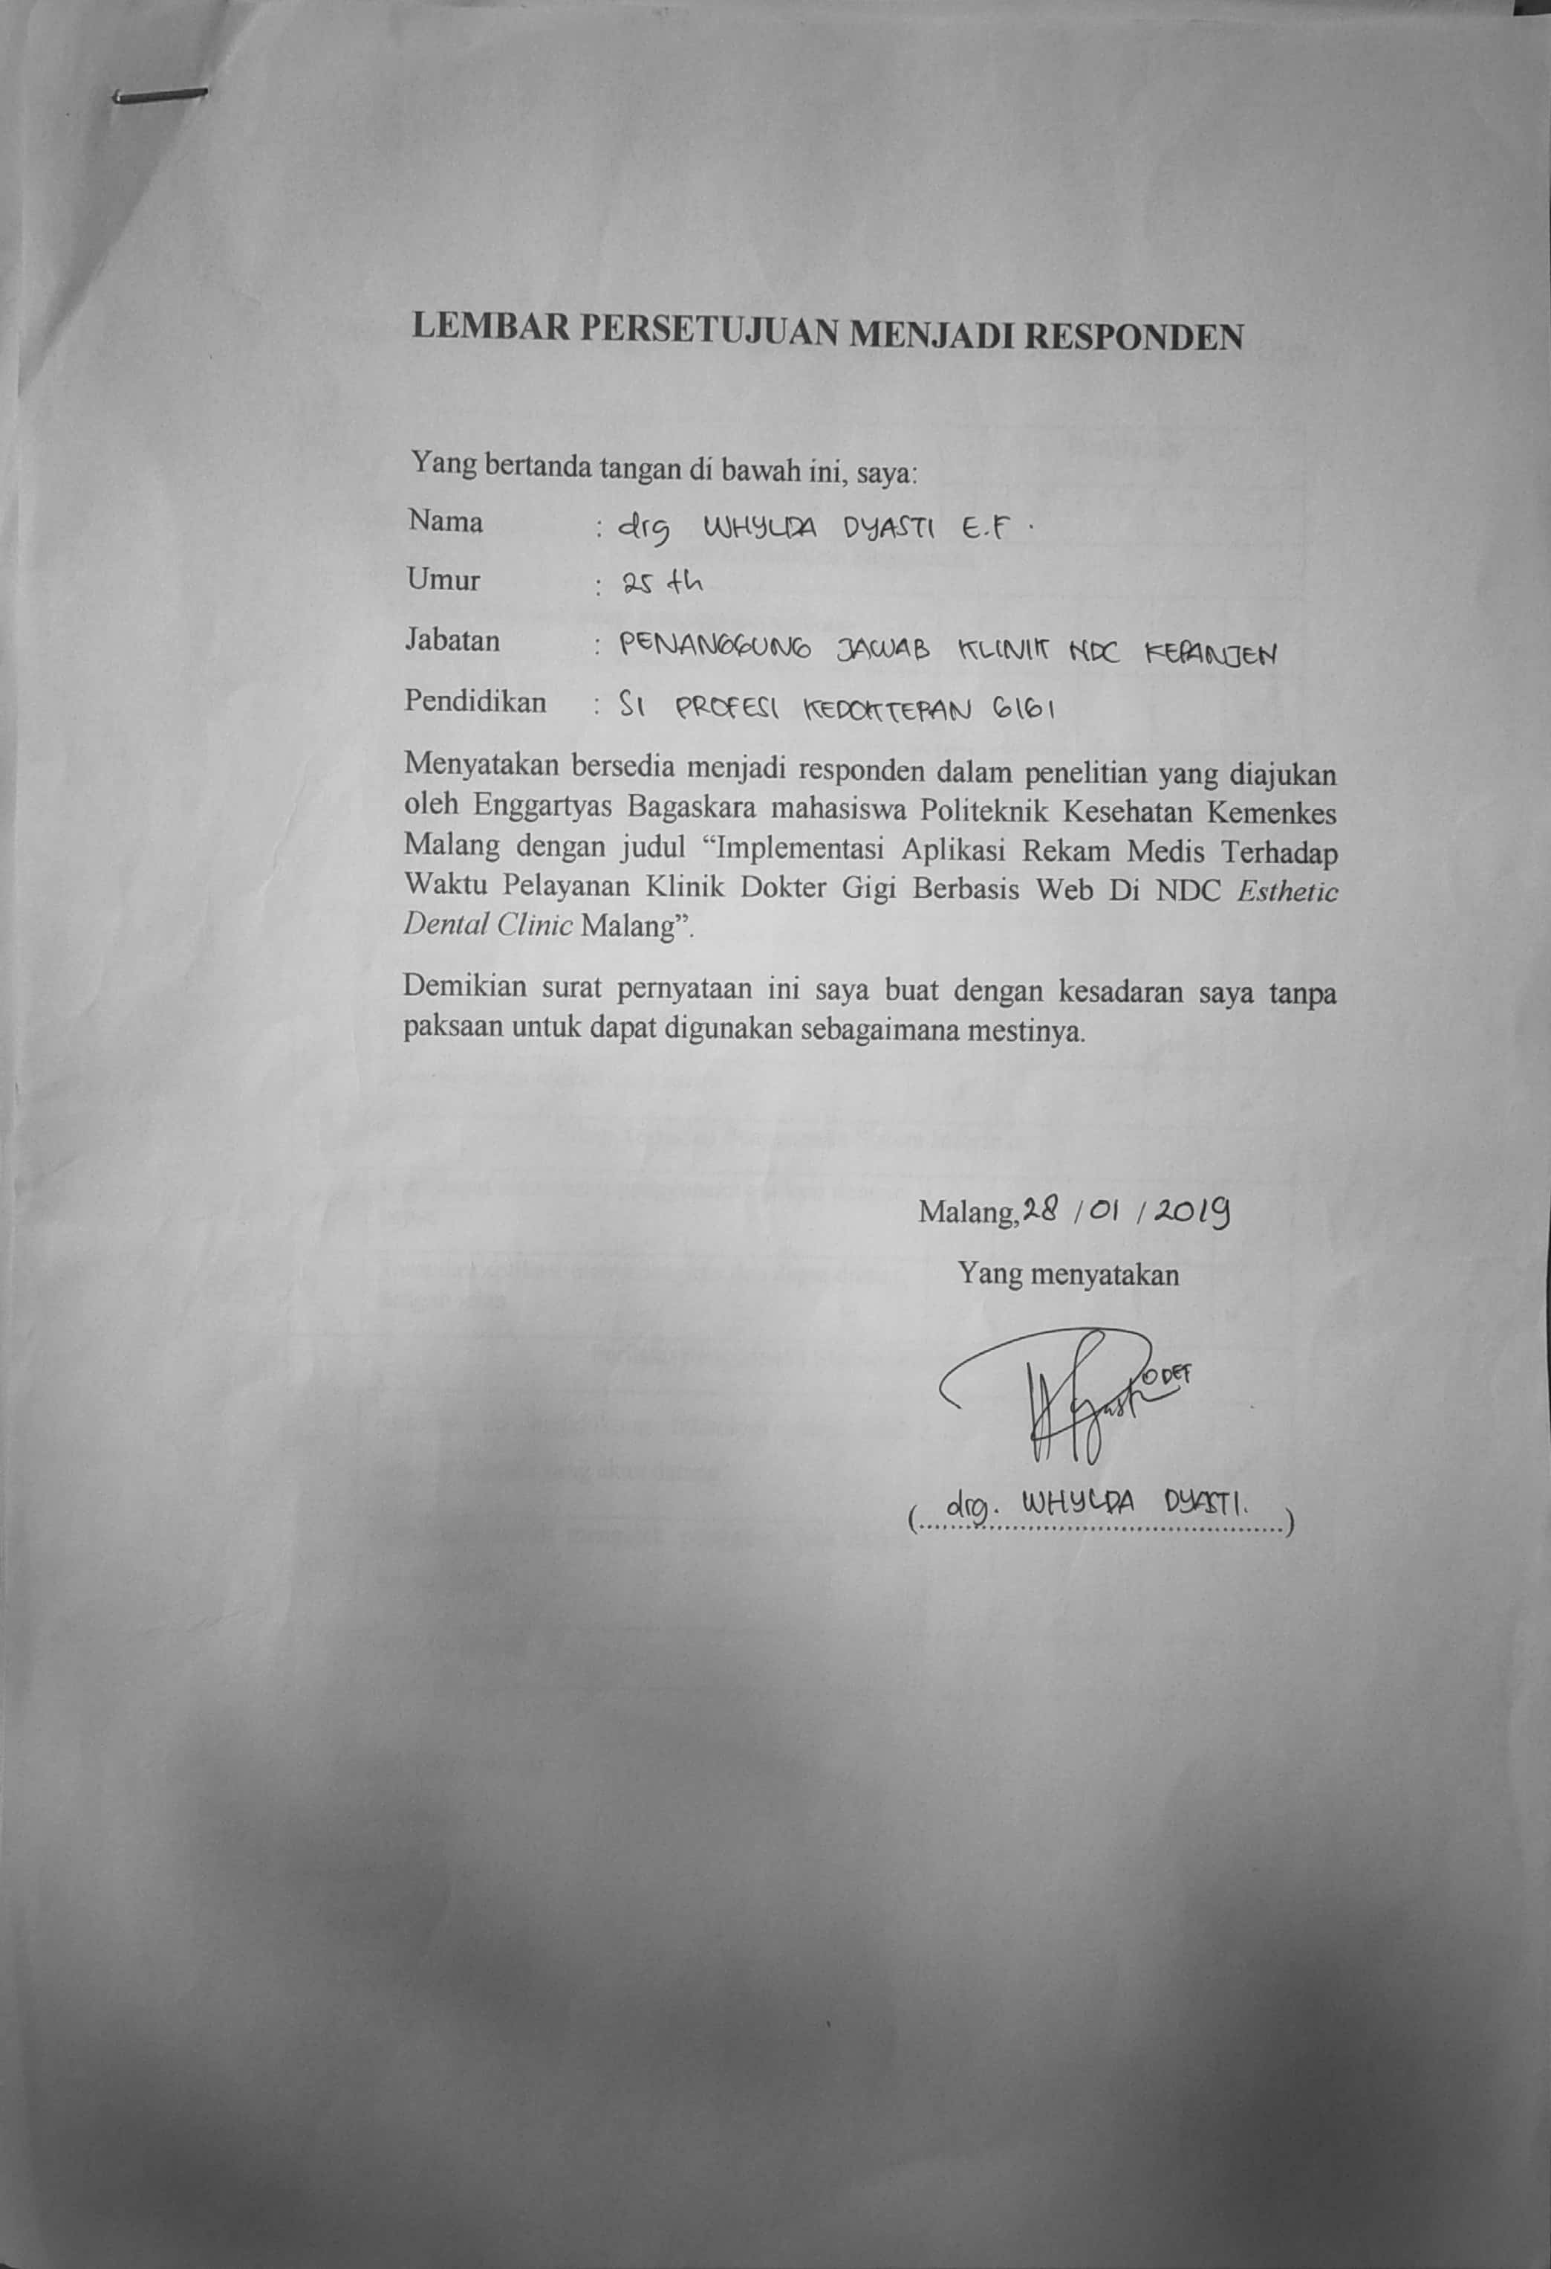
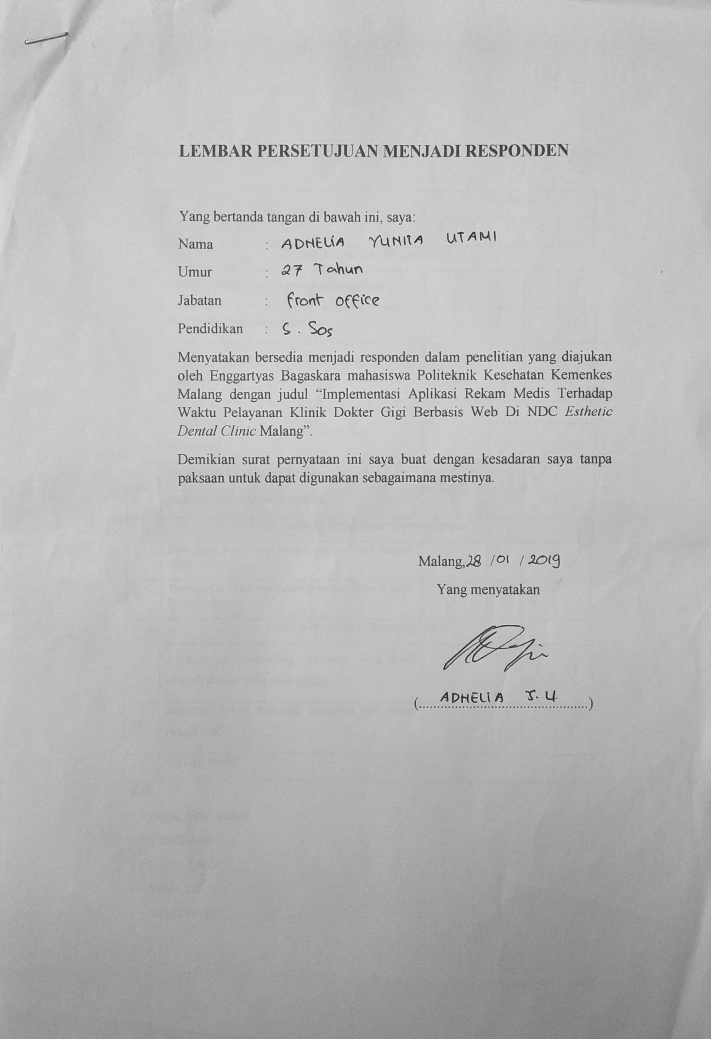

Lampiran 8.Kuisioner Penilaian Penggunaan Aplikasi Rekam Medis Masalah

Penyakit Gigi
- Responden Dokter Gigi
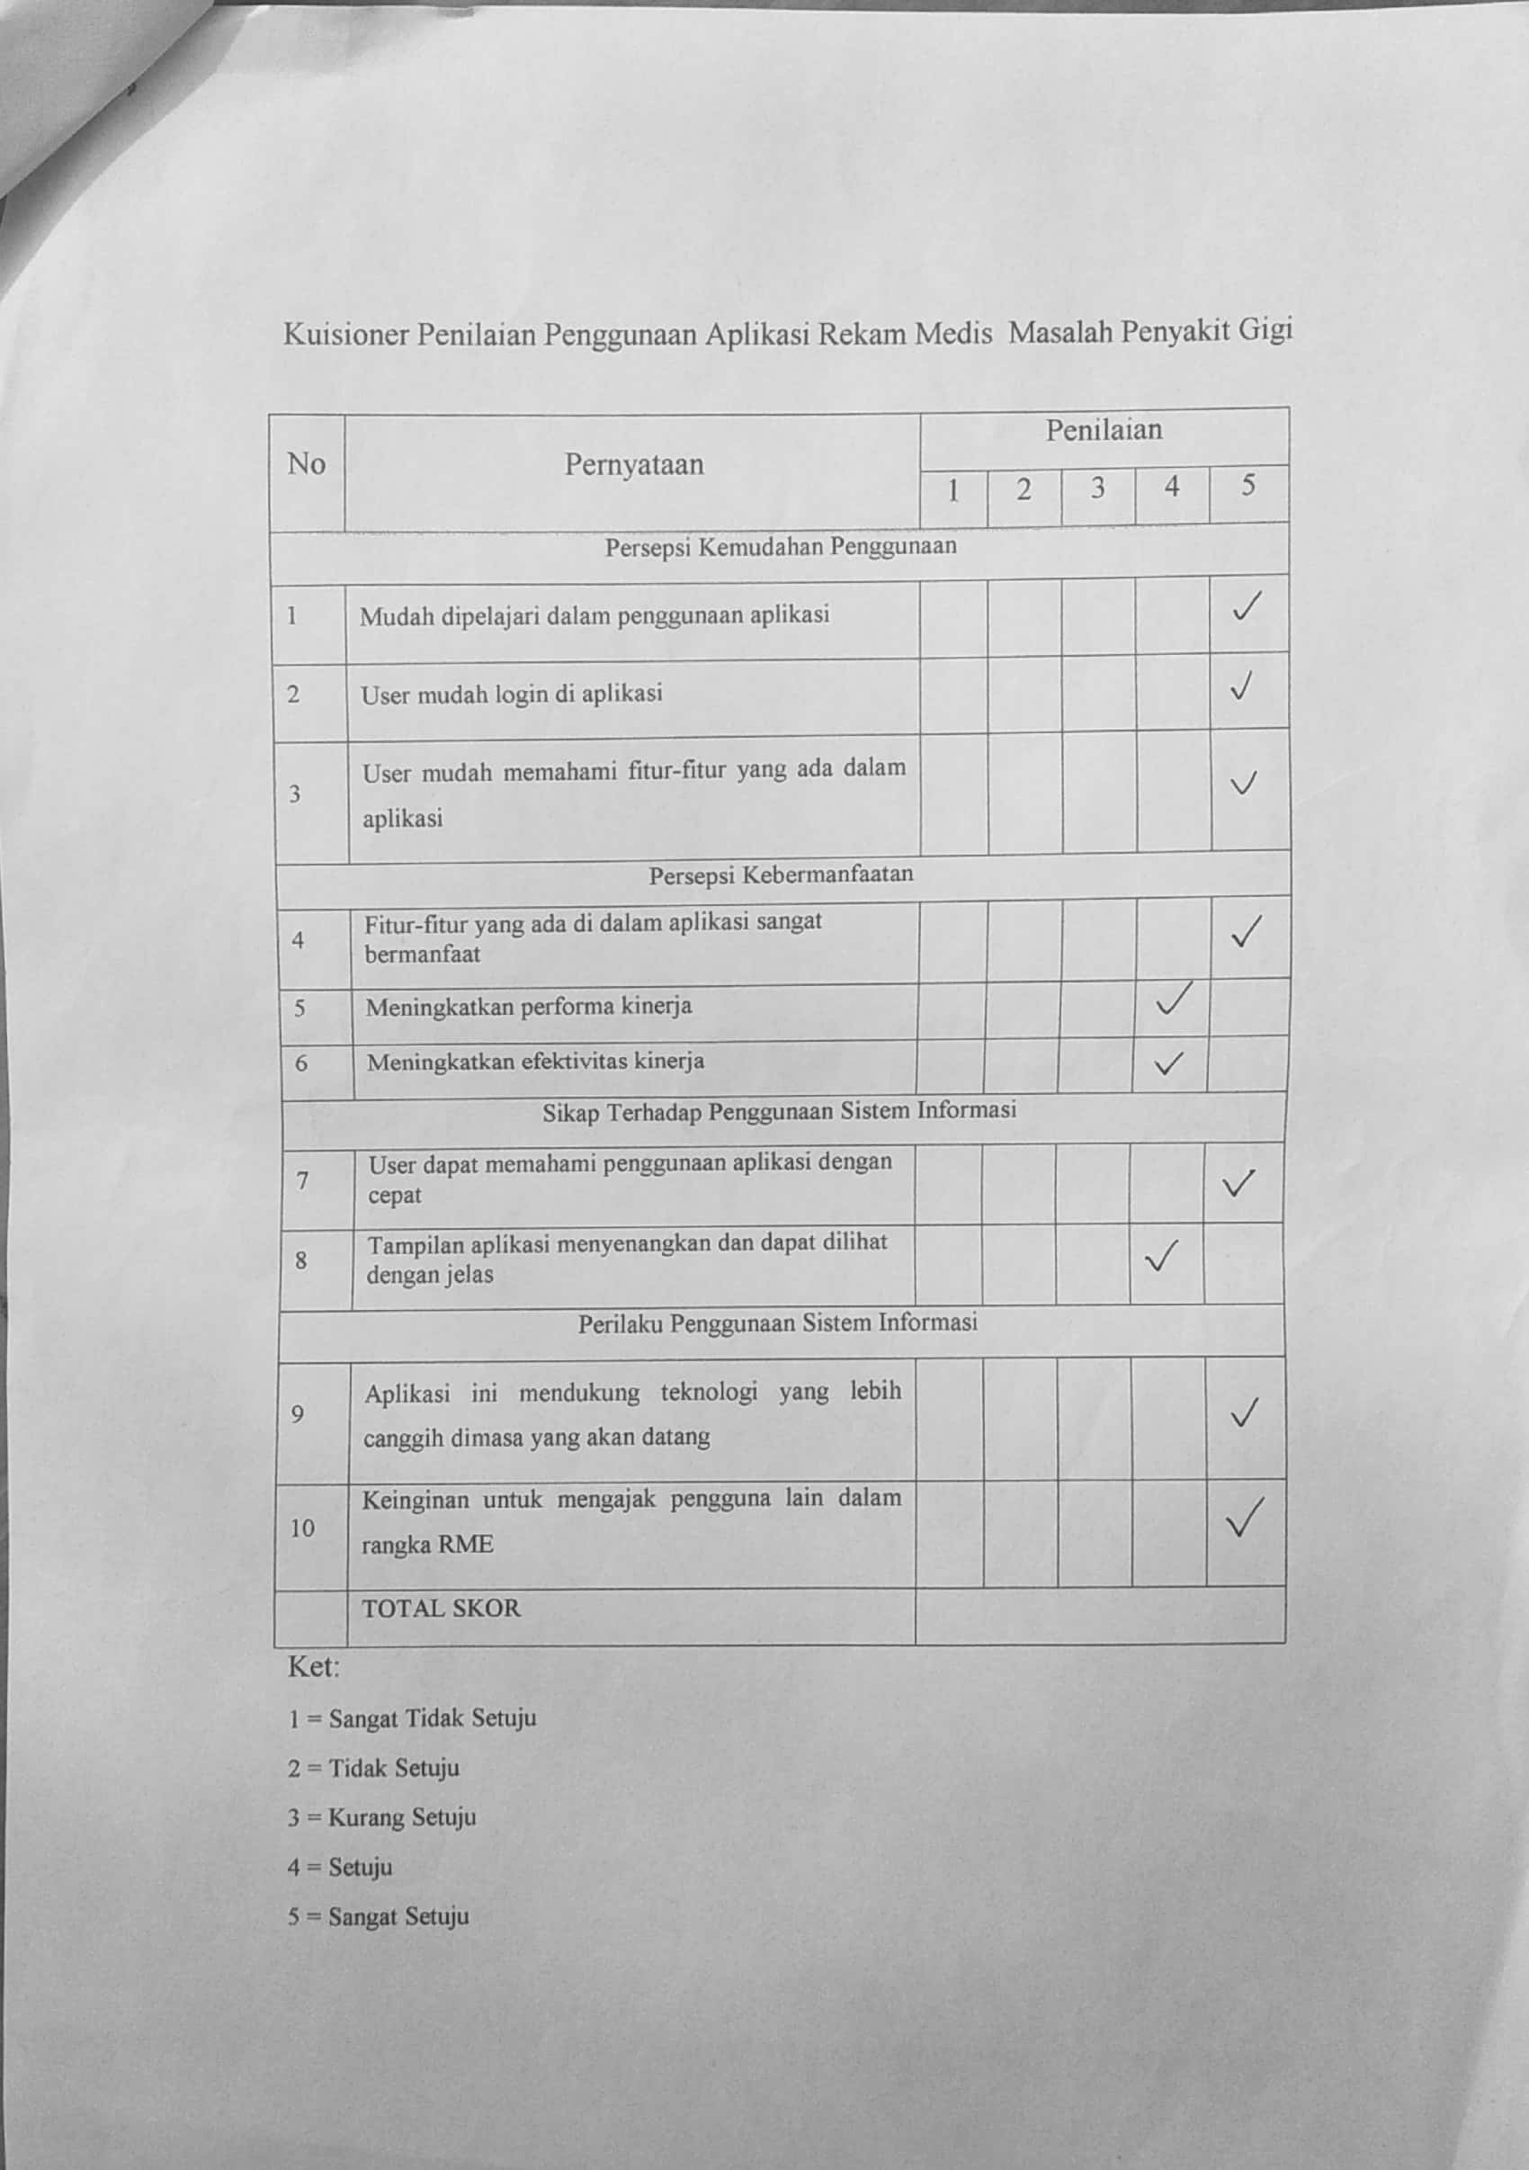
47

2) Responden Petugas Pendaftaran
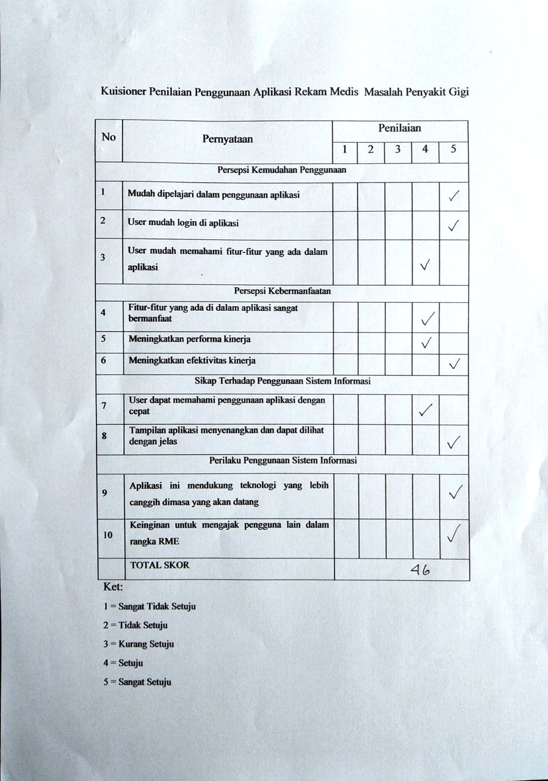
Lampiran 9. Hasil Perhitungan SPSS
UJI STATISTIK INDEPENDENT SAMPLE T-TEST
T-Test

Group Statistics
 | Jenis | N | Mean | Std. Deviation | Std. Error Mean
Waktu Pelayanan Pasien | Pretest | 57 | 1593,70 | 411,916 | 54,560
 | Posttest | 57 | 1318,96 | 378,709 | 50,161

Independent Samples Test
 |  | Levene's Test for Equality of Variances |  | t-test for Equality of Means
 |  | F | Sig. | t | df | Sig. (2-tailed) | Mean Difference | Std. Error Difference | 95% Confidence Interval of the Difference
 |  |  |  |  |  |  |  |  | Lower | Upper
Waktu Pelayanan Pasien | Equal variances assumed | ,208 | ,649 | 3,707 | 112 | ,000 | 274,737 | 74,114 | 127,889 | 421,584
 | Equal variances not assumed |  |  | 3,707 | 111,218 | ,000 | 274,737 | 74,114 | 127,878 | 421,596

