***Lampiran 1***

**JBI Critical Appraisal Checklist for Qualitative Research**

Reviewer : Khamidatul Ajizah

Date : 24 Januari 2022

Author : Muhammad Rosyidul ‘Ibad, Ahsan, Retno Lestari

Year : 2015 Record Number_________

|  |  |  |  |  |
| --- | --- | --- | --- | --- |
|  | Yes | No | Unclear | Not applicable |
| 1. Is there congruity between the stated philosophical perspective and the research methodology? | √ |  |  |  |
| 1. Is there congruity between the research methodology and the research question or objectives? | √ |  |  |  |
| 1. Is there congruity between the research methodology and the methods used to collect data? | √ |  |  |  |
| 1. Is there congruity between the research methodology and the representation and analysis of data? | √ |  |  |  |
| 1. Is there congruity between the research methodology and the interpretation of results? | √ |  |  |  |
| 1. Is there a statement locating the researcher culturally or theoretically? | √ |  |  |  |
| 1. Is the influence of the researcher on the research, and vice- versa, addressed? | √ |  |  |  |
| 1. Are participants, and their voices, adequately represented? | √ |  |  |  |
| 1. Is the research ethical according to current criteria or, for recent studies, and is there evidence of ethical approval by an appropriate body? | √ |  |  |  |
| 1. Do the conclusions drawn in the research report flow from the analysis, or interpretation, of the data? | √ |  |  |  |

Overall appraisal: Include √ Exclude ☐ Seek further info ☐

***Lampiran 2***

**JBI Critical Appraisal Checklist for Qualitative Research**

Reviewer : Khamidatul Ajizah

Date : 24 Januari 2022

Author : Missesa, Syam’ani

Year : 2017 Record Number_________

|  |  |  |  |  |
| --- | --- | --- | --- | --- |
|  | Yes | No | Unclear | Not applicable |
| 1. Is there congruity between the stated philosophical perspective and the research methodology? | √ |  |  |  |
| 1. Is there congruity between the research methodology and the research question or objectives? | √ |  |  |  |
| 1. Is there congruity between the research methodology and the methods used to collect data? | √ |  |  |  |
| 1. Is there congruity between the research methodology and the representation and analysis of data? | √ |  |  |  |
| 1. Is there congruity between the research methodology and the interpretation of results? | √ |  |  |  |
| 1. Is there a statement locating the researcher culturally or theoretically? | √ |  |  |  |
| 1. Is the influence of the researcher on the research, and vice- versa, addressed? | √ |  |  |  |
| 1. Are participants, and their voices, adequately represented? | √ |  |  |  |
| 1. Is the research ethical according to current criteria or, for recent studies, and is there evidence of ethical approval by an appropriate body? | √ |  |  |  |
| 1. Do the conclusions drawn in the research report flow from the analysis, or interpretation, of the data? | √ |  |  |  |

Overall appraisal: Include √ Exclude ☐ Seek further info ☐

***Lampiran 3***

**JBI Critical Appraisal Checklist for Qualitative Research**

Reviewer : Khamidatul Ajizah

Date : 24 Januari 2022

Author : Faiza Yuniati

Year : 2017 Record Number_________

|  |  |  |  |  |
| --- | --- | --- | --- | --- |
|  | Yes | No | Unclear | Not applicable |
| 1. Is there congruity between the stated philosophical perspective and the research methodology? | √ |  |  |  |
| 1. Is there congruity between the research methodology and the research question or objectives? | √ |  |  |  |
| 1. Is there congruity between the research methodology and the methods used to collect data? | √ |  |  |  |
| 1. Is there congruity between the research methodology and the representation and analysis of data? | √ |  |  |  |
| 1. Is there congruity between the research methodology and the interpretation of results? | √ |  |  |  |
| 1. Is there a statement locating the researcher culturally or theoretically? | √ |  |  |  |
| 1. Is the influence of the researcher on the research, and vice- versa, addressed? | √ |  |  |  |
| 1. Are participants, and their voices, adequately represented? | √ |  |  |  |
| 1. Is the research ethical according to current criteria or, for recent studies, and is there evidence of ethical approval by an appropriate body? | √ |  |  |  |
| 1. Do the conclusions drawn in the research report flow from the analysis, or interpretation, of the data? | √ |  |  |  |

Overall appraisal: Include √ Exclude ☐ Seek further info ☐

***Lampiran 4***

**JBI Critical Appraisal Checklist for Qualitative Research**

Reviewer : Khamidatul Ajizah

Date : 24 Januari 2022

Author : Marie-Conception Leocadie, Jean-Manuel Morvillers, Sophie Pautex, Monique Rothan-Tondeur

Year : 2020 Record Number_________

|  |  |  |  |  |
| --- | --- | --- | --- | --- |
|  | Yes | No | Unclear | Not applicable |
| 1. Is there congruity between the stated philosophical perspective and the research methodology? | √ |  |  |  |
| 1. Is there congruity between the research methodology and the research question or objectives? | √ |  |  |  |
| 1. Is there congruity between the research methodology and the methods used to collect data? | √ |  |  |  |
| 1. Is there congruity between the research methodology and the representation and analysis of data? | √ |  |  |  |
| 1. Is there congruity between the research methodology and the interpretation of results? | √ |  |  |  |
| 1. Is there a statement locating the researcher culturally or theoretically? | √ |  |  |  |
| 1. Is the influence of the researcher on the research, and vice- versa, addressed? | √ |  |  |  |
| 1. Are participants, and their voices, adequately represented? | √ |  |  |  |
| 1. Is the research ethical according to current criteria or, for recent studies, and is there evidence of ethical approval by an appropriate body? | √ |  |  |  |
| 1. Do the conclusions drawn in the research report flow from the analysis, or interpretation, of the data? | √ |  |  |  |

Overall appraisal: Include √ Exclude ☐ Seek further info ☐

***Lampiran 5***

**JBI Critical Appraisal Checklist for Qualitative Research**

Reviewer : Khamidatul Ajizah

Date : 24 Januari 2022

Author : Sridhar Vaitheswaran, Monisha Lakshminarayanan, Vaishnavi Ramanujam, Subashini Sargunan, Shreenila Venkatesan

Year : 2020 Record Number_________

|  |  |  |  |  |
| --- | --- | --- | --- | --- |
|  | Yes | No | Unclear | Not applicable |
| 1. Is there congruity between the stated philosophical perspective and the research methodology? | √ |  |  |  |
| 1. Is there congruity between the research methodology and the research question or objectives? | √ |  |  |  |
| 1. Is there congruity between the research methodology and the methods used to collect data? | √ |  |  |  |
| 1. Is there congruity between the research methodology and the representation and analysis of data? | √ |  |  |  |
| 1. Is there congruity between the research methodology and the interpretation of results? | √ |  |  |  |
| 1. Is there a statement locating the researcher culturally or theoretically? | √ |  |  |  |
| 1. Is the influence of the researcher on the research, and vice- versa, addressed? | √ |  |  |  |
| 1. Are participants, and their voices, adequately represented? | √ |  |  |  |
| 1. Is the research ethical according to current criteria or, for recent studies, and is there evidence of ethical approval by an appropriate body? | √ |  |  |  |
| 1. Do the conclusions drawn in the research report flow from the analysis, or interpretation, of the data? | √ |  |  |  |

Overall appraisal: Include √ Exclude ☐ Seek further info ☐

***Lampiran 6***

**PLAN OF ACTION**

Nama : Khamidatul Ajizah

NIM : P17210184129

|  |  |  |  |  |  |  |  |  |  |  |  |  |  |  |  |  |  |  |  |  |  |  |  |  |  |
| --- | --- | --- | --- | --- | --- | --- | --- | --- | --- | --- | --- | --- | --- | --- | --- | --- | --- | --- | --- | --- | --- | --- | --- | --- | --- |
| **No** | Pelaksanaan Kegiatan | September 2020 | | | | Oktober 2020 | | | | November 2020 | | | | Desember 2020 | | | | Januari 2021 | | | | Februari 2021 | | | |
| 1 | 2 | 3 | 4 | 1 | 2 | 3 | 4 | 1 | 2 | 3 | 4 | 1 | 2 | 3 | 4 | 1 | 2 | 3 | 4 | 1 | 2 | 3 | 4 |
| **I** | **Tahap Persiapan** |  |  |  |  |  |  |  |  |  |  |  |  |  |  |  |  |  |  |  |  |  |  |  |  |
|  | 1. Perencanaan judul |  |  |  |  |  |  |  |  |  |  |  |  |  |  |  |  |  |  |  |  |  |  |  |  |
|  | 1. Mencari literature |  |  |  |  |  |  |  |  |  |  |  |  |  |  |  |  |  |  |  |  |  |  |  |  |
|  | 1. Penyusunan proposal |  |  |  |  |  |  |  |  |  |  |  |  |  |  |  |  |  |  |  |  |  |  |  |  |
|  | 1. Konsultasi proposal |  |  |  |  |  |  |  |  |  |  |  |  |  |  |  |  |  |  |  |  |  |  |  |  |
|  | 1. Perbaikan proposal |  |  |  |  |  |  |  |  |  |  |  |  |  |  |  |  |  |  |  |  |  |  |  |  |
|  | 1. Penyusunan instrument |  |  |  |  |  |  |  |  |  |  |  |  |  |  |  |  |  |  |  |  |  |  |  |  |
|  | 1. Ujian sidang dan revisi |  |  |  |  |  |  |  |  |  |  |  |  |  |  |  |  |  |  |  |  |  |  |  |  |

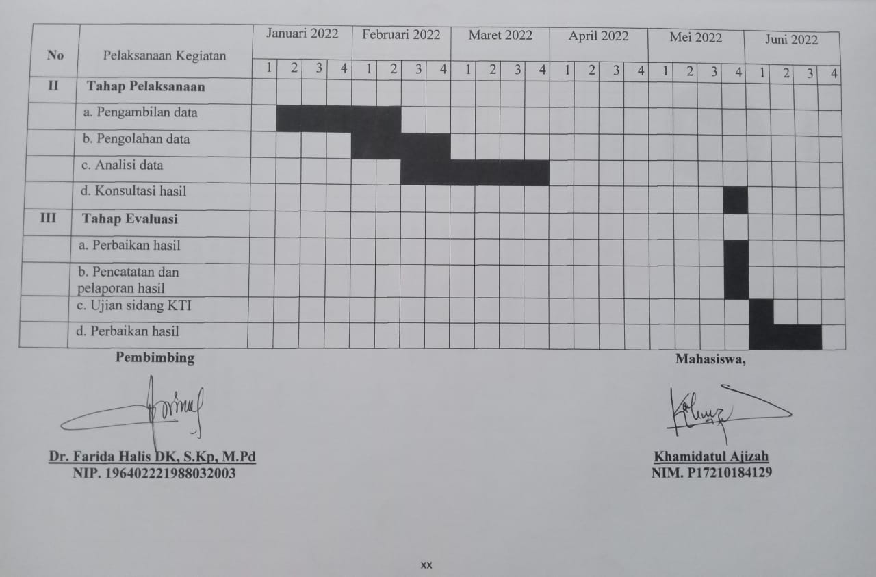

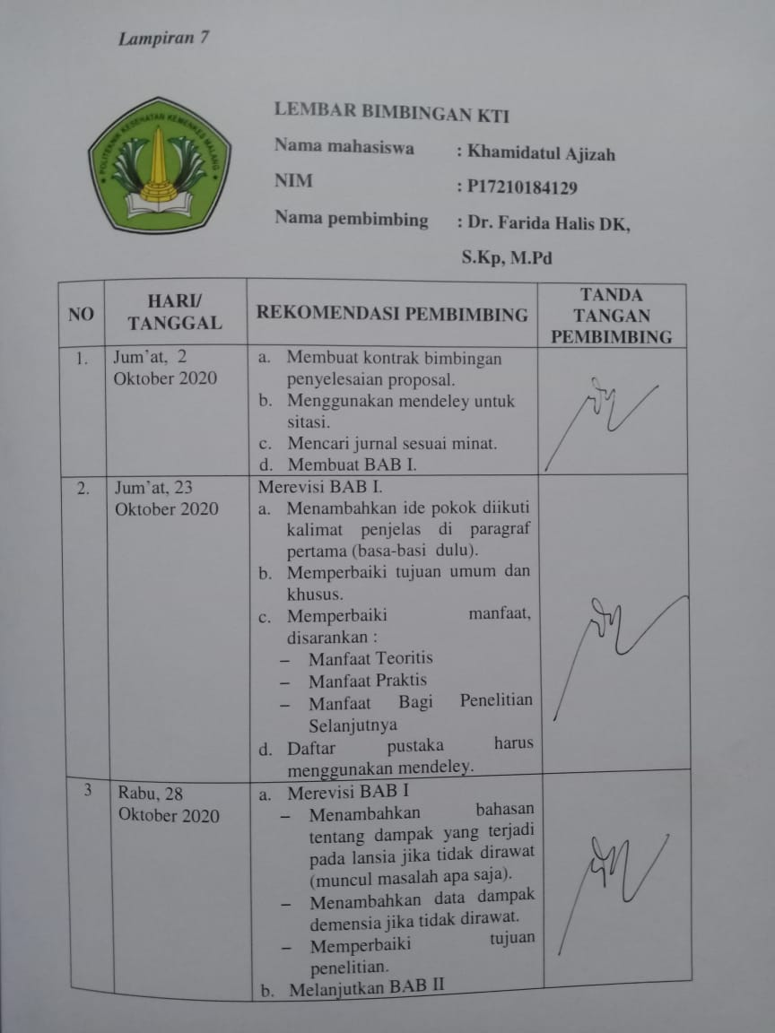

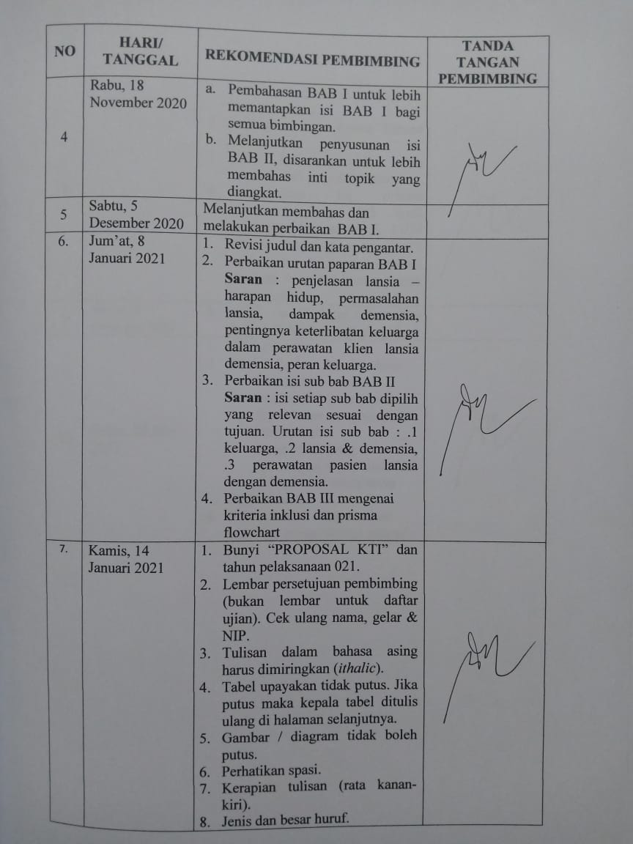

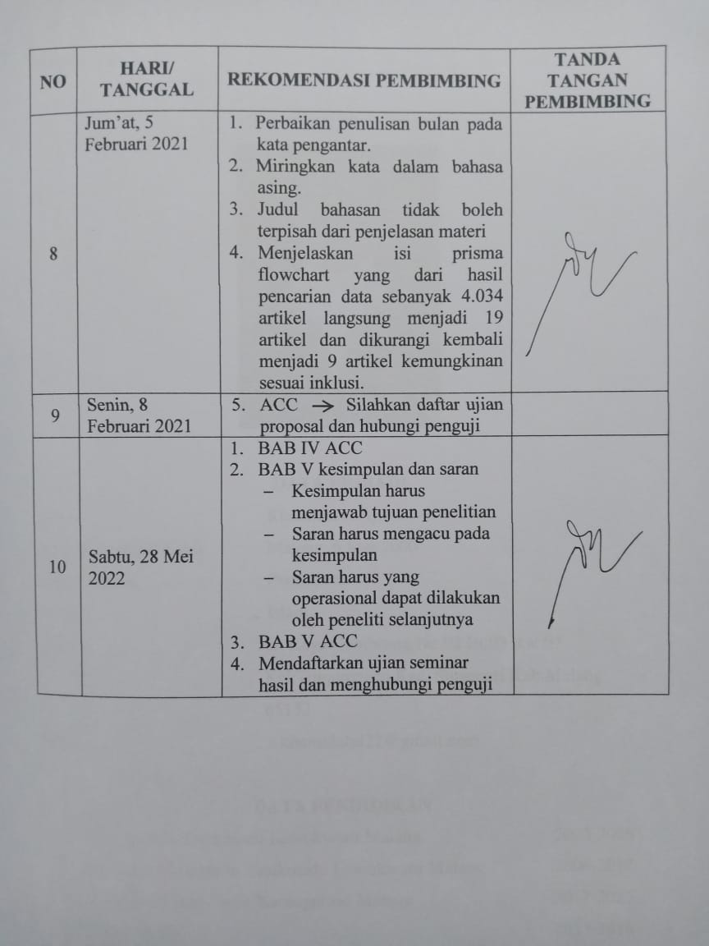

***Lampiran 8***

**CURRICULUM VITAE**



**DATA PRIBADI**

Nama : Khamidatul Ajizah

Tempat, Tanggal Lahir : Malang, 6 Mei 2000

Jenis Kelamin : Perempuan

Agama : Islam

Alamat : Jl. Raya Gembrung No.02 Rt.03 Rw.07

Kel.Tunjungtirto Kec. Singosari Kab.Malang 65153

Email : a.khamidatul22@gmail.com

**DATA PENDIDIKAN**

TK BA Paramita Tasikmadu Lowokwaru Malang 2005-2006

MI Hidayatul Mubtadi’in Tasikmadu Lowokwaru Malang 2006-2012

Mts Raudlatul Ulum Ngijo Karangploso Malang 2012-2015

MAN Kota Batu 2015-2018

Politeknik Kesehatan Kemenkes Malang 2018-2022