**Lampiran 1**

**JBI CRITICAL APPRAISAL CHECKLIST FOR ANALYTICAL CROSS SECTIONAL STUDIES**

Reviewer : Tya Dwi Anggraeni

Author : S. Abeway, B. Gebremichael, R. Murugan et al.

Year : 2018

Record Number : 01

Title : Stunting and Its Determinants among Children Aged 6–59

Months in Northern Ethiopia: A Cross-Sectional Study

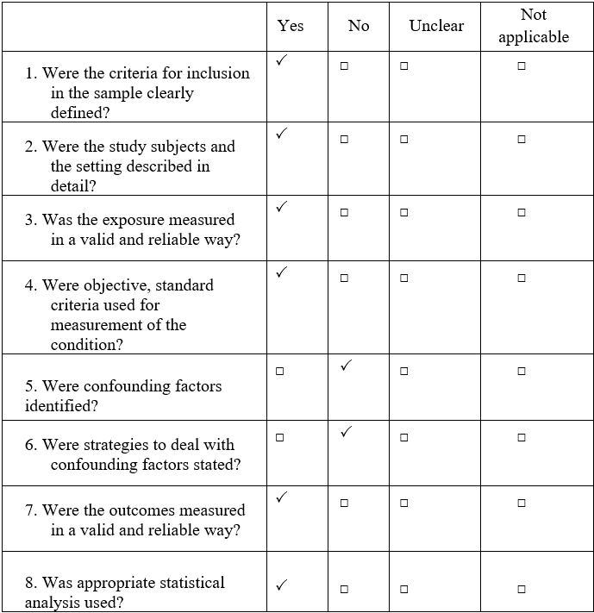

Overall appraisal: Include (🗸) Exclude ( ) Seek further info ( )

Comments (Including reason for exclusion)

6 jawaban YA = 75%

**Lampiran 2**

**JBI CRITICAL APPRAISAL CHECKLIST FOR CASE CONTROL STUDIES**

Reviewer : Tya Dwi Anggraeni

Author : H. Hijra, S. Fatimah-Muis, M. Katasurya

Year : 2016

Record Number : 02

Title : Inappropriate complementary feeding practice increases

risk of stunting in children aged 12-24 months

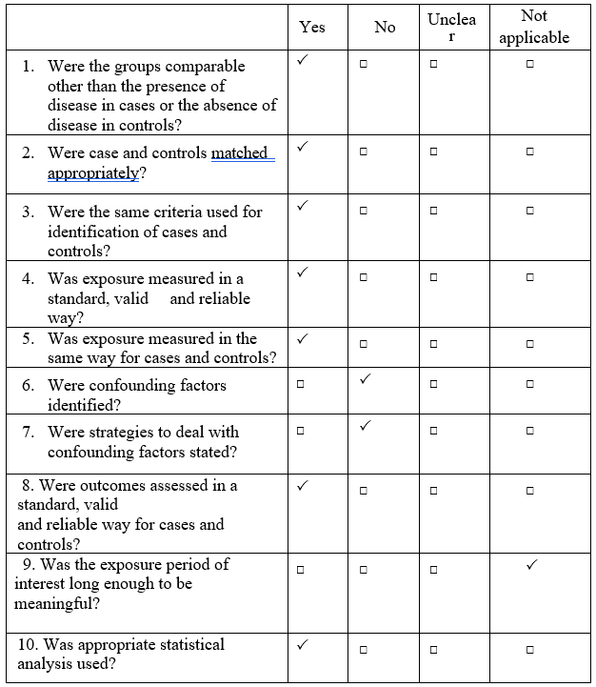

Overall appraisal: Include (🗸) Exclude ( ) Seek further info ( )

Comments (Including reason for exclusion)

7 atas 10 jawaban YA = 70%

**Lampiran 3**

**JBI CRITICAL APPRAISAL CHECKLIST FOR ANALYTICAL CROSS SECTIONAL STUDIES**

Reviewer : Tya Dwi Anggraeni

Author : A. Ahmad, S. Madanijah, C. Meti et al.

Year : 2018

Record Number : 03

Title : Complementary feeding practices and nutritional status of

children 6-23 months old: formative study in Aceh, Indonesia

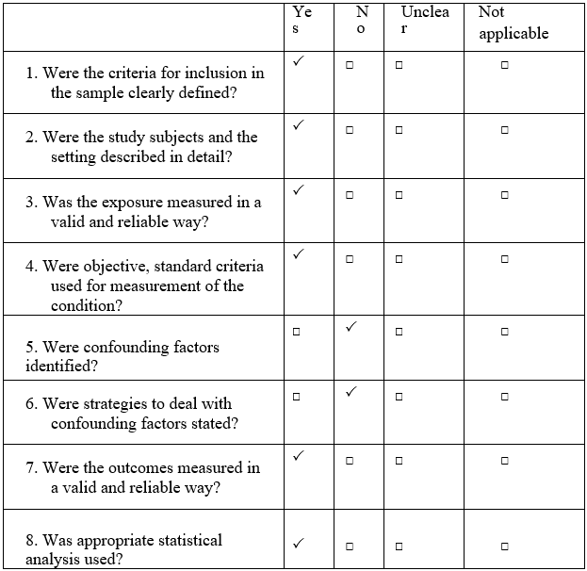

Overall appraisal: Include (🗸) Exclude ( ) Seek further info ( )

Comments (Including reason for exclusion)

6 jawaban YA = 75%

**Lampiran 4**

**JBI CRITICAL APPRAISAL CHECKLIST FOR ANALYTICAL CROSS SECTIONAL STUDIES**

Reviewer : Tya Dwi Anggraeni

Author : B. Paramashanti, Y. Paratmanitya, Marsiswati

Year : 2017

Record Number : 04

Title : Keanekaragaman Pola Makan Individu Berhubungan Erat

atas Stunting pada Bayi juga Anak

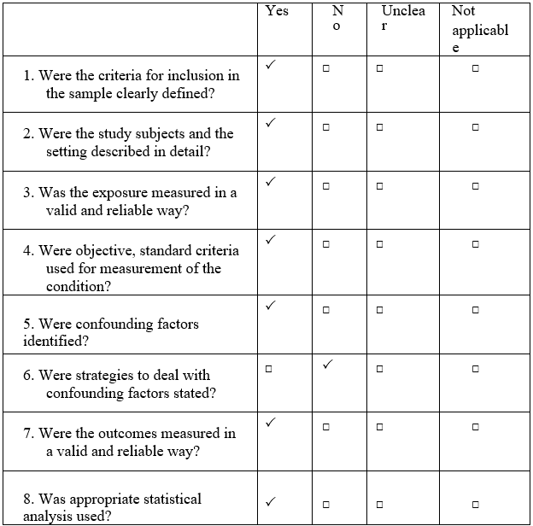

Overall appraisal: Include (🗸) Exclude ( ) Seek further info ( )

Comments (Including reason for exclusion)

7 jawaban YA = 87,5%

**Lampiran 5**

**JBI CRITICAL APPRAISAL CHECKLIST FOR ANALYTICAL CROSS SECTIONAL STUDIES**

Reviewer : Tya Dwi Anggraeni

Author : F. Alemayehu, A. Anato, Y. Berhan et al

Year : 2018

Record Number : 05

Title : Child Feeding Practice and Primary Health Care as Major

Correlates of Stunting and Underweight among 6- to 23-Month-Old Infants and Young Children in Food-Insecure Households in Ethiopia

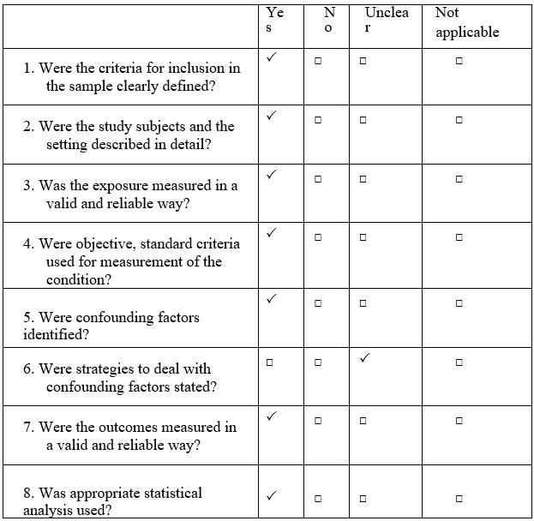

Overall appraisal: Include (🗸) Exclude ( ) Seek further info ( )

Comments (Including reason for exclusion)

7 jawaban YA = 87,5%

**Lampiran 6**

**JBI CRITICAL APPRAISAL CHECKLIST FOR ANALYTICAL CROSS SECTIONAL STUDIES**

Reviewer : Tya Dwi Anggraeni

Author : D. Mpigi, N. Tumwesigye et al.

Year : 2016

Record Number : 06

Title : Nutritional status, feeding practices and state of other

related indicators at onset of a multi-model community nutrition intervention program in Mpigi District, Uganda

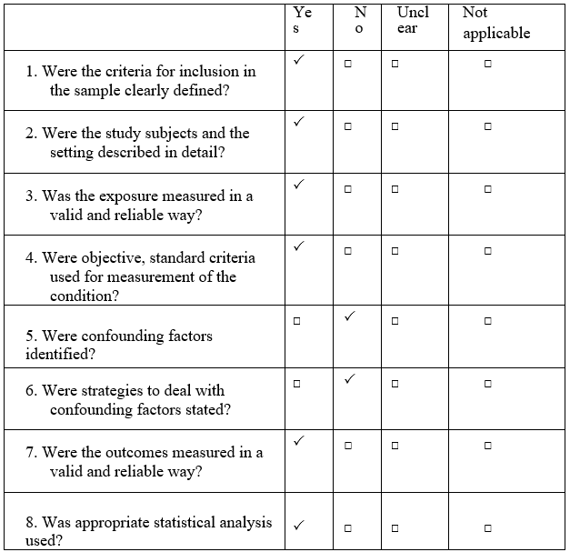

Overall appraisal: Include (🗸) Exclude ( ) Seek further info ( )

Comments (Including reason for exclusion)

6 jawaban YA = 75%

**Lampiran 7**

**JBI CRITICAL APPRAISAL CHECKLIST FOR ANALYTICAL CROSS SECTIONAL STUDIES**

Reviewer : Tya Dwi Anggraeni

Author : M. Roche, T. Gyorkos, B. Blouin et al.

Year : 2017

Record Number : 07

Title : Infant and young child feeding practices and stunting in

two highland provinces in Ecuador

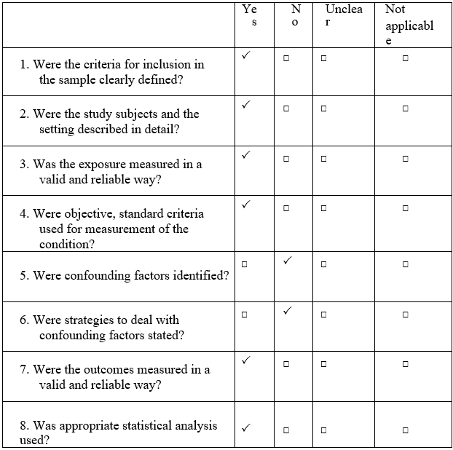

Overall appraisal: Include (🗸) Exclude ( ) Seek further info ( )

Comments (Including reason for exclusion)

6 jawaban YA = 75%

**Lampiran 8**

**JBI CRITICAL APPRAISAL CHECKLIST FOR ANALYTICAL CROSS SECTIONAL STUDIES**

Reviewer : Tya Dwi Anggraeni

Author : Torlesse et al.

Year : 2020

Record Number : 08

Title : Determinants of stunting in Indonesian children: Evidence

from a cross-sectional survey indicate a prominent role for the water, sanitation and hygiene sector in stunting reduction

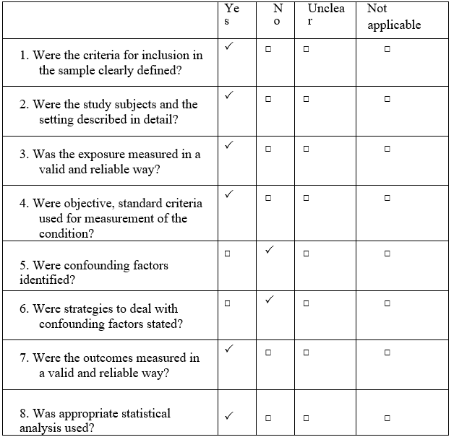

Overall appraisal: Include (🗸) Exclude ( ) Seek further info ( )

Comments (Including reason for exclusion)

6 jawaban YA = 75%

**Lampiran 9**

**JBI CRITICAL APPRAISAL CHECKLIST FOR CASE CONTROL STUDIES**

Reviewer : Tya Dwi Anggraeni

Author : W. Widyawati, F. Febry, S. Destriatania.

Year : 2016

Record Number : 09

Title : Analisis Pemberian MP-ASI Atas Status Gizi pada

Anak Umur 12-24 Bulan di Wilayah Kerja Puskesmas Lesung Batu, Empat Lawang

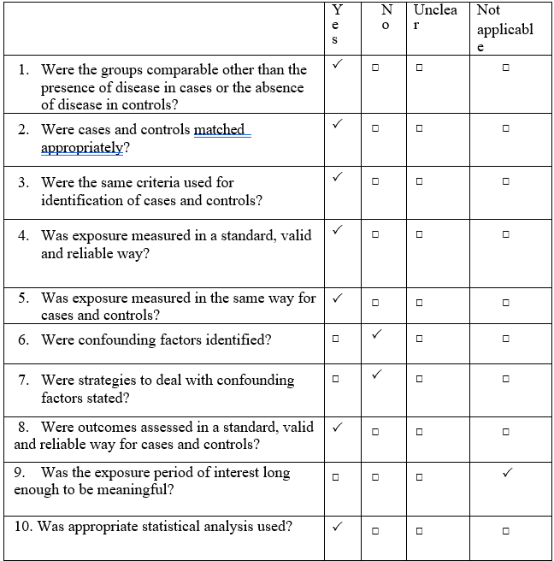

Overall appraisal: Include (🗸) Exclude ( ) Seek further info ( )

Comments (Including reason for exclusion)

7 atas 10 jawaban YA = 70%

**Lampiran 10**

**JBI CRITICAL APPRAISAL CHECKLIST FOR ANALYTICAL CROSS SECTIONAL STUDIES**

Reviewer : Tya Dwi Anggraeni

Author : Nurkomala, S., Nuryanto, N., & Panunggal, B., et al.

Year : 2018

Record Number : 10

Title : Praktik Pemberian MPASI (Makanan Pendamping Air

Susu Ibu) pada Anak Stunting juga Tidak Stunting Umur 6-24 Bulan

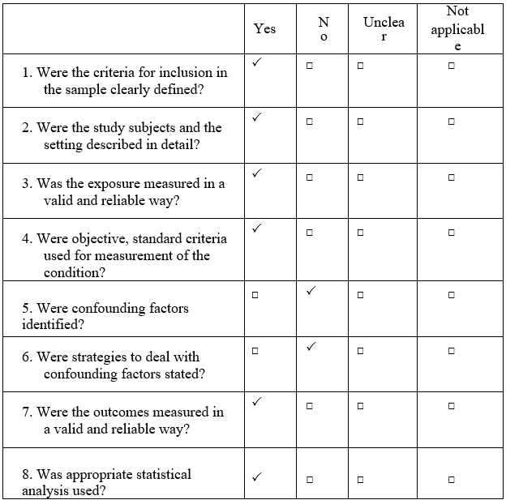

Overall appraisal: Include (🗸) Exclude ( ) Seek further info ( )

Comments (Including reason for exclusion)

6 jawaban YA = 75%