## *Lampiran I*

## JADWAL PELAKSANAAN STUDI KASUS

|  |  |  |  |  |  |  |  |  |  |  |  |  |  |  |  |  |  |  |  |  |  |  |  |  |  |  |  |  |  |  |  |  |  |  |  |  |  |  |  |  |  |  |  |  |  |  |  |  |
| --- | --- | --- | --- | --- | --- | --- | --- | --- | --- | --- | --- | --- | --- | --- | --- | --- | --- | --- | --- | --- | --- | --- | --- | --- | --- | --- | --- | --- | --- | --- | --- | --- | --- | --- | --- | --- | --- | --- | --- | --- | --- | --- | --- | --- | --- | --- | --- | --- |
| JADWAL PELAKSANAAN STUDI KASUS | | | | | | | | | | | | | | | | | | | | | | | | | | | | | | | | | | | | | | | | | | | | | | | | |
| Kegiatan | Juli | | | | Agustus | | | | September | | | | Oktober | | | | November | | | | Desember | | | | Januari | | | | Februari | | | | Maret | | | | April | | | | Mei | | | | Juni | | | |
| 1 | 2 | 3 | 4 | 1 | 2 | 3 | 4 | 1 | 2 | 3 | 4 | 1 | 2 | 3 | 4 | 1 | 2 | 3 | 4 | 1 | 2 | 3 | 4 | 1 | 2 | 3 | 4 | 1 | 2 | 3 | 4 | 1 | 2 | 3 | 4 | 1 | 2 | 3 | 4 | 1 | 2 | 3 | 4 | 1 | 2 | 3 | 4 |
| Informasi penyelenggaraan LTA |  |  |  |  |  |  |  |  |  |  |  |  |  |  |  |  |  |  |  |  |  |  |  |  |  |  |  |  |  |  |  |  |  |  |  |  |  |  |  |  |  |  |  |  |  |  |  |  |
| Informasi pembimbing |  |  |  |  |  |  |  |  |  |  |  |  |  |  |  |  |  |  |  |  |  |  |  |  |  |  |  |  |  |  |  |  |  |  |  |  |  |  |  |  |  |  |  |  |  |  |  |  |
| Proses bimbingan dan penyusunan proposal LTA |  |  |  |  |  |  |  |  |  |  |  |  |  |  |  |  |  |  |  |  |  |  |  |  |  |  |  |  |  |  |  |  |  |  |  |  |  |  |  |  |  |  |  |  |  |  |  |  |
| Pengumpulan proposal ke panitia/ pendaftaran seminar proposal |  |  |  |  |  |  |  |  |  |  |  |  |  |  |  |  |  |  |  |  |  |  |  |  |  |  |  |  |  |  |  |  |  |  |  |  |  |  |  |  |  |  |  |  |  |  |  |  |
| Seminar proposal |  |  |  |  |  |  |  |  |  |  |  |  |  |  |  |  |  |  |  |  |  |  |  |  |  |  |  |  |  |  |  |  |  |  |  |  |  |  |  |  |  |  |  |  |  |  |  |  |
| Revisi dan persetujuan proposal oleh penguji |  |  |  |  |  |  |  |  |  |  |  |  |  |  |  |  |  |  |  |  |  |  |  |  |  |  |  |  |  |  |  |  |  |  |  |  |  |  |  |  |  |  |  |  |  |  |  |  |
| Mengambil kasus dan penulisan laporan |  |  |  |  |  |  |  |  |  |  |  |  |  |  |  |  |  |  |  |  |  |  |  |  |  |  |  |  |  |  |  |  |  |  |  |  |  |  |  |  |  |  |  |  |  |  |  |  |
| Pendaftaran ujian sidang LTA |  |  |  |  |  |  |  |  |  |  |  |  |  |  |  |  |  |  |  |  |  |  |  |  |  |  |  |  |  |  |  |  |  |  |  |  |  |  |  |  |  |  |  |  |  |  |  |  |
| Pelaksanaan ujian sidang LTA |  |  |  |  |  |  |  |  |  |  |  |  |  |  |  |  |  |  |  |  |  |  |  |  |  |  |  |  |  |  |  |  |  |  |  |  |  |  |  |  |  |  |  |  |  |  |  |  |
| Revisi laporan LTA |  |  |  |  |  |  |  |  |  |  |  |  |  |  |  |  |  |  |  |  |  |  |  |  |  |  |  |  |  |  |  |  |  |  |  |  |  |  |  |  |  |  |  |  |  |  |  |  |
| Penyerahan laporan LTA |  |  |  |  |  |  |  |  |  |  |  |  |  |  |  |  |  |  |  |  |  |  |  |  |  |  |  |  |  |  |  |  |  |  |  |  |  |  |  |  |  |  |  |  |  |  |  |  |

***Lampiran 3***

**PERNYATAAN**

**KESEDIAAN PEMBIMBING**

Saya yang bertanda tangan di bawah ini:

1. Nama dan gelar : Nur Eva Aristina. SST. M. Keb
2. NIP/NIK : 198403152009122002
3. Pangkat dan golongan : Penata/ III C
4. Jabatan : Dosen
5. Asal institusi : Poltekkes Kemenkes Malang
6. Pendidikan terakhir : Magister Kebidanan
7. Alamat dan nomor yang bisa dihubungi
8. Rumah : Jl. Simpang Ijen Blok A No. 29 Oro-oro Dowo Klojen, Malang
9. Telepon/HP : 081331193829
10. Alamat kantor : Jalan Besar Ijen 77C Malang
11. Telepon kantor : 0341-558793

Dengan ini menyatakan (bersedia/~~tidak bersedia~~*) menjadi pembimbing bagi mahasiswa:

Nama : Alieffatul Nur Rahayu

NIM : P17310172019

Topik Studi Kasus : Karya Tulis Ilmiah Studi Literatur Evaluasi Pelaksanaan Asuhan kebidanan *Continuity Of Care*

*) Coret yang tidak dipilih

Malang, 20 Januari 2020



(Nur Eva Aristina. SST. M. Keb)

NIP. 198403152009122002

***Lampiran 4***

LEMBAR KONSULTASI

Nama : Alieffatul Nur Rahayu

NIM : P17310172019

Nama Pembimbing : Nur Eva Aristina. SST. M. Keb

Nama Penguji : Rita Yulifah, S.Kp., M.Kes

Judul : Karya Tulis Ilmiah Studi Literatur Evaluasi Pelaksanaan Asuhan Kebidanan Continuity Of Care

|  |  |  |  |
| --- | --- | --- | --- |
| BIMBINGAN KE | TANGGAL | SARAN | TTD |
| 7 | 11-03-2020 | ACC Proposal Lanjut Penelitian |  |
| 8 | 06-04-2020 | Penggantian Laporan Tugas Akhir Studi kasus ke Karya Tulis Ilmiyah Studi Literatur |  |
| 9 | 19-04-2020 | Pemilihan topik Studi Literatur |  |
| 10 | 23-06-2020 | Perbaikan BAB III dan BAB IV |  |
| 11 | 09-07-2020 | Perbaikan BAB I pada alasan penggantian ke Studi Literatur  Perbaikan BAB III data base yang digunakan  Perbaikan BAB IV  Segera mengirimkan dari Cover,BAB I-V dan lampiran dalam bentuk PDF |  |
| 12 | 13-07-2020 | ACC ujian Hasil tanggal 21-07-2020 |  |
| 13 | 23-07-2020 | Mengumpulkan revisi ke pembimbing dan penguji |  |
| 14 | 03-09-2020 | ACC Hasil LTA |  |

***Lampiran 5***

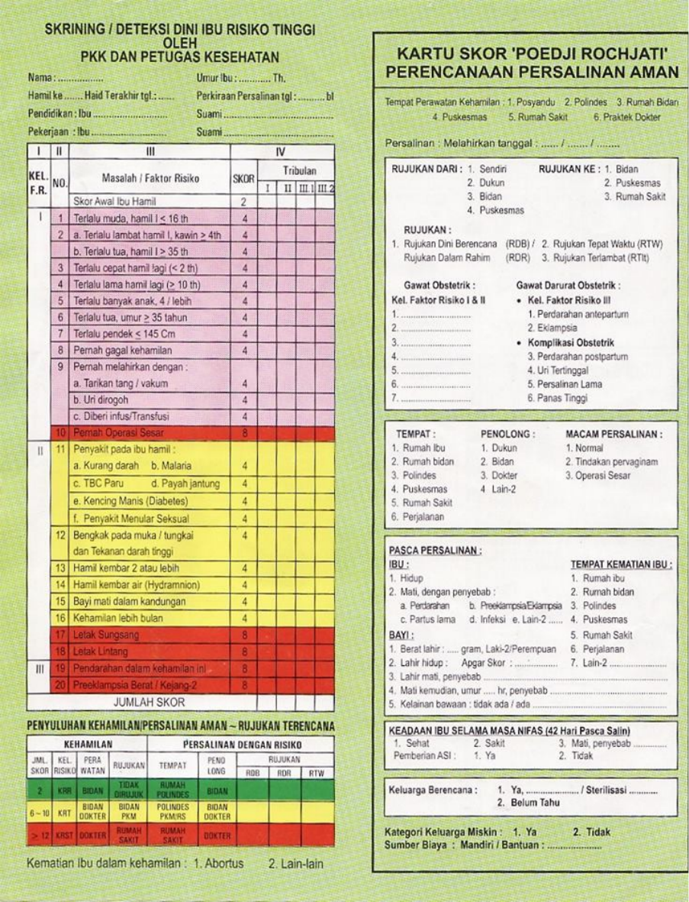

***Lampiran 6***

